March To Opulence

A SPECIAL ASSORTMENT OF CLASSICS, BIOGRAPHIES, HISTORIES, SPEECHES, AND MORE, FOR THE MAKERS OF A BRIGHT TOMORROW

Compiled and Edited by

Parikshit Nagesh Samant

Opulencesix Digital, India

Copyright © 2017 by OpulenceSix Digital Private Limited, India.

All rights reserved, including without limitation the right to reproduce this book or any portion thereof in any manner, without the express written permission of the publisher except for the use of brief quotations in a book review.

First Printing, 2017

Print Edition ISBN: 978-81-933853-0-2

EBook Edition ISBN: 978-81-933853-1-9

Please email feedback to: marchtoopulence@opulencesix.com

**Cover:**

1. Don Quixote by Gustave Dore: *A world of disorderly notions, picked out of his books, crowded into his imagination.*

2. By Dennis Jarvis from Halifax, Canada (France-003324 - Mona Lisa) [[CC BY-SA 2.0](http://creativecommons.org/licenses/by-sa/2.0) (http://creativecommons.org/licenses/by-sa/2.0)], [via Wikimedia Commons](https://commons.wikimedia.org/wiki/File%3AFrance-003324_-_Mona_Lisa_(16236519171).jpg).

3. An Archangel reveals the physical nature of the universe to Isaac Newton and other natural philosophers and mathematicians. See page for author [[CC BY 4.0](http://creativecommons.org/licenses/by/4.0) (http://creativecommons.org/licenses/by/4.0)], via [Wikimedia Commons](https://commons.wikimedia.org/wiki/File%3AAn_archangel_revealing_the_physical_nature_of_the_universe_t_Wellcome_L0022460.jpg).

4. Legendary Russian author, Fyodor Dostoevsky, 1876.

5. French Revolution. The Third Estate carrying the other two, the Clergy, and the Nobility, on its back.

6 Prince Yamato Take of Japan.

7. Death of Kumbhakarna, from the Ramayana.

Dedication

To those noble souls whose glorious lives became stores of invaluable learning for mankind, or who for the benefit of mankind, stored invaluable life learnings in their glorious writings.

# Contents

Dedication iv

Contents v

Introduction vii

Acknowledgements xv

Section I – Children And Young Teens 17

The Demon With Matted Hair, from The Jatakas 18

The Pea Blossom, by Hans Christian Andersen 24

Isaac Newton, by Nathaniel Hawthorne 29

About Cricket, by Arthur Conan Doyle 39

The Mouse Merchant, from The Jatakas 49

Day In The Country, by Anton Chekhov 55

The Ugly Duckling, by Hans Christian Andersen 64

What Is Godlike? From The Jatakas 76

Caterpillar’s Advice, from Alice In Wonderland 83

The Happy Prince, by Oscar Wilde 93

Rose Of The Evening, a Chinese Fairy Tale 106

Introducing Tom Sawyer, by Mark Twain 114

Story of Yamato Take, Japan’s Warrior Prince 129

Section II – Teens And Youth 145

Open Window, by H. H. Munro (‘Saki’) 146

Archimedes And The Defense Of Syracuse 150

Beethoven, The Master Composer 159

The Hand, by Guy de Maupassant 171

My First Efforts In Invention, by Nikola Tesla 178

Kumbhakarna’s Battle, from The Ramayana 189

The Meaning Of Health, by M. K. Gandhi 210

The Practical Farmer 221

Leonardo da Vinci, The Genius 231

Holiday Preparations, by Jerome K. Jerome 249

Wealth Generation, from The Panchatantra 258

Joan Of Arc, or The Maid Of Orleans 263

Cyrus McCormick, Ace Inventor-Businessman 285

The American Vandal, by Mark Twain 297

President Wilson’s Address To Naturalized US Citizens 308

Lgov, by Ivan Turgenev 315

Section III – Older Teens And Above 329

On Classical Education, by William Hazlitt 330

Education Of The Architect, by Vitruvius 336

Don Quixote, Adventure Of The Lions 346

Dr. Laennec, Father Of Clinical Auscultation 360

Sherlock Holmes, The Adventure Of The Speckled Band 397

The Great Stone Face, by Nathaniel Hawthorne 425

A Prisoner In The Caucasus, by Leo Tolstoy 447

Rama, On Governance, from The Ramayana 477

Micromegas, A Philosophical Sci-Fi, by Voltaire 491

Development Of Modern Social, Economic, And Political Ideas 513

Revolutions: France, Abhinav Bharat, Quit India 529

The Grand Inquisitor, by Fyodor Dostoevsky 563

Jalaluddin Rumi And The Masnavi 614

Moving Ahead From Here 639

Editor Bio 656

# 

Introduction

The OpulenceSix team is extremely glad to bring out this book for young readers, the sculptors of a bright tomorrow. In this book, we have collected some of the most amusing, inspiring, and instructive writings of the world. Most of them are writings of the past and cover a wide range of subjects. They are a mix of insightful stories, biographies of greats, motivational speeches, thought-provoking essays, histories of representative world events, or delightful passages from classic literature.

Just like the natural tendency of fire is to burn, we believe that the potency of these writings itself will propel our readers to strive toward scaling new heights of excellence and prosperity, for self and society.

Before heading off, we would like to elaborate on certain key aspects of the contents. It will set reader expectations correctly, and help extract maximum benefit from the book.

### Background

To begin with, we will provide a rationale that led to coming up with such a compilation in the first place.

We have always believed that, along with sound knowledge of one’s primary area of work, it is necessary for a person to have a broader view of the world. It is not so much about stuffing oneself with every bit of information floating around, but about developing a well-rounded personality. Exposure to varying thoughts and cultures foreign from one’s own goes a long way in building that personality. It is useful to have a fair understanding, at least of a few areas that have an overarching nature. For instance, general wisdom, wealth, social behavior, politics, or health.

We commonly observe that people, who have demonstrated brilliance in one area of expertise, have often shown keen interest in a few others. That probably gives them a different view of things, which helps them in their primary endeavors. Varied knowledge also helps a person better adjust to changes in environment and face tough situations confidently. It develops the wisdom needed to accurately analyze people, things, and situations, and react effectively. We have covered many such diverse topics here.

Another objective of this effort is to inspire people to strive for excellence relative to their current position. In an age where easy praise, hype, or noise play major roles in building perceptions, it is possible to mistake excellence for mediocrity, or even inferiority. Exposure to great creations that have stood the test of time, be it literature, science, economics, or others, goes a long way in clearing that mist. This clarity is a result of **independent thought and refined taste** that develop gradually.

All in all, it should help people independently work their way toward opulence. Opulence not just in a narrow sense of the word, referring to its popular manifestations such as wealth, power, fame, looks, or scholarship; but which includes the wisdom, prudence, and strength of mind **needed to acquire, as well as renounce** those former manifestations at will.

We have made sincere efforts to ensure that the selected content has properties that catalyze the above improvements. A combination of techniques was employed to achieve this, such as comparison of popularity lists, studies of popular and expert opinions, and finally, our own sense of reasoning, clearing ourselves of personal biases to the best of our ability.

Equipped with necessary inspiration, along with lofty examples to benchmark against, readers should be in a good position to aim high enough and work toward achieving those aims.

And what would be a better starting point to instill this attitude, than our young readers? They are in their most formative years, and hence ideal candidates for priority focus.

### Selection Of Passages

Passage selection for this compilation was done based on the following criteria:

* **Only Prose** passages were considered while selecting chapters for this book. We have not included Poetry due to various time and resource constraints.
* **Topics:** Art, Science, Nature, Social Behavior, Language, Relationships, Personal Improvement, Politics, Health, Travel, and Philosophy. Generally topics of an overarching nature, which typically concern most, irrespective of their primary area of focus.
* **Multi-Cultural:** European, Indian, American, East-Asian, Middle-Eastern, or Greek.
* **Top Picks from Various Categories**,be it biographies of the great, writings by top authors, accounts of important historical events, immortal speeches, or popular socio-political and economic theories.
* **Covering the Nine Emotions**, namely, Joy, Sorrow, Anger, Peace, Valor, Fear, Disgust, Wonder, and Love.
* **Varying Complexity**, from simple to complex with respect to varying reader maturity. A couple of passages are actually pretty difficult to comprehend even for adults, but we strongly encourage readers to attempt understanding those. **Not just because they are interesting, but also to get exposed to complex explanations, inevitable in every branch of study**.
* **Reading Time** for most chapters is under half an hour. A few can be read in less than 10 minutes, and some might need a couple of hours to go through.
* **Long-standing Nature and Current Relevance** was an important criterion for inclusion or exclusion of a passage. One might raise a concern about relevance and accuracy of old writings considering recent developments. Our opinion on this is, though it might be true in some instances, it is not a concern. The methods of thought and action described, the questions raised, the thought-provoking nature, the class of articulation itself, and the inspiration that the writings provide, are much more important than complete factual accuracy.[1] Especially with respect to independent thought, that this book is intended to imbibe. Of course, we have handled many scenarios of factual accuracy through extensive use of **footnotes** as applicable. In any case, we always want to take forward only the excellent, pleasant, and progressive elements of the past, and ruthlessly leave behind all that is otherwise.
* **Other Constraints** such as legal and copyright restrictions, maintenance of political decorum, or financial limitations, had to be respected. Needless to say, certain compromises had to be made.

We would like to make one important comment here. The reader might notice a bias toward **European and American** writings in the passages included. One reason for this obviously, is the English language, into which a lot of non-English European literature has already been translated. Secondly, it does not harm to openly accept the fact that Europe and America have dominated the world scene for the past four to five centuries, and therefore there is good reason to believe that thoughts originating from these parts are relatively more applicable to our current times. Other societies and cultures certainly had their golden periods. But a lot of that literature is either not available in English, or often, recent developments have rendered it less relevant in today’s times.

We still have made sincere attempts to include writings from many different cultures such as Greek, Chinese, Japanese, Indian, or Middle-Eastern, as appropriate.

### Audience

The main audience for the book is children, teenagers, and youth, roughly in the age band of 10 to 25 years. Some chapters are fairly light in nature, and as the book progresses, chapters get more and more mature, longer, and somewhat complex too.

Essentially, very young kids will be able to understand and appreciate only a bit more than the initial half of the book. They will have to revisit the remaining half after having reached a higher level of maturity. Older readers might find a few chapters somewhat simplistic in nature. Yet we have decided to maintain all chapters together, so that a single book can serve multiple members of a household over time.

Having said that, we also feel that the book is valuable to those adults who, for whatever reasons, never got a glimpse of such colorful lives and writings in the past. More so if they are **parents themselves**, for whom proper nurturing of children is a responsibility of prime importance.

### Content Sources And Modification

We have tried our best to maintain the text of selected passages in their original form. At times the reader might feel that some passages could have been shortened, summarized, or normalized to a common language and writing pattern.

But we realized that it is more useful to maintain content as is. Often, supplementary facts enhance the beauty of the main thread. In fact, for some, the main plot is just an excuse to allow knitting of interesting concepts, and other useful instruction over the underlying theme. Good authors also have a strong sense of **when to elaborate and when to summarize**, a judgment we did not want to meddle with. A quick comparison of the full translation of some Hans Christian Andersen or Jataka tale, with its shortened version, could easily clarify the point we are trying to make here.

Varying language styles might provide a bit of discomfort to some readers, but they also get to enjoy many different styles of writing in such a small compilation.

However, keeping the average English reader in mind, there were scenarios when it was necessary to modify the source text to some extent. Some of these follow:

* Archaic language was modified to an extent that a modern reader could comprehend it easily.
* We noticed that most parts of text that an average reader found difficult to understand were due to **complexity of language, not that of the concept being explained**. For such cases, we have slightly modified text or added footnotes as appropriate.
* We have not simplified uncommon words to simpler equivalents, considering the ease of **dictionary lookup in today’s digital world**. It doesn’t harm to know some new words anyway.
* Parts of a passage often needed modification or even deletion, considering suitability for our intended audience, legal and political considerations, or developments that have taken place since the time of the original writing.

Readers could refer to original sources of text as needed anyway, for further analysis or exploration. These are clearly specified in the References section of each chapter. Many of them are openly available over the internet, often in public domain, or in local libraries.

### Reading Guidelines

It is useful to keep the following guidelines in mind before starting off.

* Reading from start to end in order is the default way to read through. Another way, perhaps more preferable to some, is to go through the contents or chapter introductions, and read from that point depending upon mood or choice. In general, easier reads are toward the beginning, and more involved ones toward the end. Chapters are distributed across sections targeted toward different age groups, but randomly ordered within a section.
* Each chapter has a small introduction to get readers adjusted to what is coming up next. It is especially useful for such a compilation where adjacent chapters can have a marked difference with respect to nature of topic as well as style of language.
* Complexity of a chapter is given at the beginning. This will help readers judge whether to go ahead with it right away, or revisit later.
* Chapters also contain a ‘Food for Thought’ section. This should be considered as an **important extension** of the main text, rather than a separate ‘exercises’ section. It will drive readers to think independently on certain aspects related to that chapter. It is not necessary, and often not possible to find answers right away. What is useful though is having those queries at the back of your mind. The human mind works in magical ways to answer questions lying dormant in its hidden corners. We strongly encourage readers to have healthy discussions/debates on some of these questions with others. **For very young readers, this is more of a necessity,** considering the complexity of questions even in simpler chapters. They should discuss these more often with their elders.
* There is a significant variation in the nature of different chapters, and many of them demand serious reader attention. So it is not very easy to build up a tempo and ‘devour the book in one shot’, even for adults. **We strongly advise a patient and leisurely approach.**
* We have **highlighted important parts** to attract a reader’s attention, and also added a lot of footnotes to clarify important points as far as possible. Of course, those are just some pieces that caught our eye. There probably are many more valuable ideas scattered throughout the text, ideas that we might have failed to highlight. We urge readers to uncover those using their own sense of reason, or through discussions with others.
* A reader might not appreciate the odd thought expressed here, or maybe, on the other hand, get carried away by a passage with strong impact. We urge reading the book with an open but alert mind to the extent possible.

### Further Pointers

Obviously, a book of this size can get readers only somewhat started on working toward an ambitious goal. One needs to continue further on this track and march steadily toward it.

One way to continue further is to follow references embedded in the text as well as the **References** section at the end of each chapter. Additionally, we have also included a detailed **chapter on further reading references**. Our readers will find it useful.

It goes without saying that reading and understanding is just one small part of a big story. As Froude says:

The knowledge that a man can use is the only real knowledge, the only knowledge that has life and growth in it and converts itself into practical power. The rest hangs like dust about the brain, or dries like raindrops off the stones.

That state of knowledge hanging like dust is to be dreaded. The dust of ego, idle talk, and scholarly show-off, is an unnecessary burden and nuisance to self and society. So, what has to happen in parallel is imbibing those learnings, their abstraction and application to life situations.

OpulenceSix on its part will continue working on various initiatives and services focusing on human capability enhancement at different levels. Please refer to our website [www.opulencesix.com](http://www.opulencesix.com), for the latest updates.

Acknowledgements

We would like to take this opportunity to acknowledge the support of all those who participated in discussions, provided valuable suggestions, and who helped organize, design, edit, and review the book contents.

We would like to express our sincere gratitude to Shri Satyaki Savarkar, for generously providing copyright related permissions to incorporate a passage from Veer Savarkar’s Autobiography, in an important chapter of this book.

Section I – Children And Young Teens

The Demon With Matted Hair, from The Jatakas

Complexity: Low

Jatakas are tales of the Bodhisattva, narrated by Buddha to his disciples. The stories were written around 4th Century BCE. Bodhisattva refers to the Buddha in his previous human or animal lives, reaching the final enlightened state through noble deeds done then.

Buddha narrates this story about an encounter between a brave young Prince and the Demon With Matted Hair.

The teacher, Buddha, told this story in Jetavana[2] about a Brother who had ceased striving after righteousness.[3] The teacher said to him: "Is it really true that you have ceased all striving?"—"Yes, Blessed One," he replied. Then the teacher said: "O Brother, in former days wise men put effort in those places where effort should be put, and so attained unto royal power." And he told a story of long ago.

Once upon a time, when Brahmadatta was King of Benares[4], the Bodhisattva was born as son of his chief queen. On the day of his naming ceremony, they asked 800 Brahmans[5] having satisfied them with all their desires, about his lucky marks. The Brahmans skilled in predicting from such marks, observed his excellence and answered:

"Your son is full of goodness, great King, and when you die he will become king; he shall be famous and renowned for his skill with the five weapons, and shall be the chief man in all India." On hearing what the Brahmans had to say, they named him Prince ‘Panchayudha’, which means Prince of Five Weapons, sword, spear, bow, battle-axe, and shield.

When he came to years of discretion, and had attained the measure of sixteen years, the King said to him:

"My son, go and complete your education."

"Who shall be my teacher?" the lad asked.

"Go, my son; in the kingdom of Candahar, in the city of Takshasila[6], is a far-famed teacher from whom I wish you to learn. Take this, and give it to him for a fee." With that, he gave him a thousand pieces of money, and dismissed him.

The lad departed, and was educated by this teacher; he received the Five Weapons from him as a gift, bade him farewell, and leaving Takshasila, he began his journey to Benares, armed with the Five Weapons.

On his way, he came to a forest inhabited by the Demon with the Matted Hair. At the entrance of the forest, some men saw him and cried out:

"Hullo, young sir, keep clear of that wood! There's a Demon in it called he of the Matted Hair; he kills every man he sees!" And they tried to stop him. But the Bodhisattva, having confidence in himself, went straight on, fearless as a maned lion.

When he reached mid-forest, the Demon showed himself. He made himself as tall as a palm tree; his head was the size of a pagoda, his eyes as big as saucers, and he had two tusks, knobs and bulbs all over; he had the face of a hawk, a variegated belly, and blue hands and feet.

"Where are you going?" he shouted. "Stop! You'll make a meal for me!"

The Bodhisattva said: "Demon, I came here trusting in myself. I advise you to be careful how you come near me. Here's a poisoned arrow, which I'll shoot at you and knock you down!" With this menace, he fitted an arrow dipped in deadly poison to his bow, and let it fly. The arrow stuck fast in the Demon's hair. Then he shot and shot, till he had shot away fifty arrows; and they all stuck in the Demon's hair. The Demon snapped them all off short, and threw them down at his feet; then came up to the Bodhisattva, who drew his sword and struck the Demon, threatening him all the while. His sword—it was three-and-thirty inches long—stuck in the Demon's hair! The Bodhisattva struck him with his spear—that stuck too! He struck him with his club—and that stuck too!

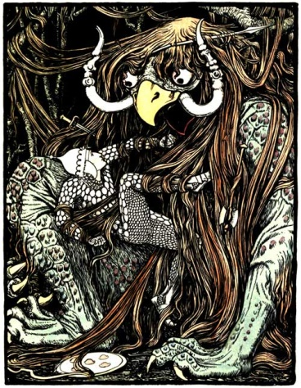

The Demon with Matted Hair

When the Bodhisattva saw that these had stuck fast, he addressed the Demon. "You, Demon!" said he, "Did you never hear of me before— Prince Panchayudha? When I came into the forest that you live in, I did not rely on my bow and other weapons. This day will I pound you and grind you to powder!" Thus did he declare his resolve, and with a shout, he hit the Demon with his right hand. It stuck fast in his hair! He hit him with his left hand—that stuck too! He kicked him with his right foot—that stuck too; then with his left—and that stuck too! Then he butted at him with his head, crying, "I'll pound you to powder!" and his head stuck fast like the rest.

Thus, the Bodhisattva was snared five times, caught fast in five places, hanging suspended; yet he felt no fear—was not even nervous.

The Demon thought to himself: "Here's a lion of a man! A noble man! More than man is he! Here he is, caught by a Demon like me; yet he does not fear a bit. Since I have ravaged this road, I never saw such a man. Now, why is it that he does not fear?" He was powerless to eat the man, but asked him: "Why is it, young sir, that you are not frightened to death?"

"Why should I fear, Demon?" replied he. "In one life a man can die but once. Besides, in my belly is a thunderbolt; if you eat me, you will never be able to digest it; this will tear your inwards into little bits, and kill you, so we shall both perish. That is why I fear nothing." (By this, the Bodhisattva probably meant the weapon of knowledge, which he had within him.)

When he heard this, the Demon thought: "This young man speaks the truth. A piece of the flesh of such a lion-man as he would be too much for me to digest, even if it were no bigger than a kidney-bean. I'll let him go!" So, being frightened to death, he let go the Bodhisattva, saying:

"Young sir, you are a lion of a man! I will not eat you up. I set you free from my hands, as the moon is disgorged from the jaws of Rahu after the eclipse.[7] Go back to the company of your friends and relations!"

And the Bodhisattva said: "Demon, I will go, as you say. You were born a Demon, cruel, blood-bibbing, devourer of the flesh and gore of others, because you did wickedly in former lives. If you still go on doing wicked deeds, you will go from darkness to darkness. But now that you have seen me, you will find it impossible to behave wickedly. Taking life of living creatures causes birth as an animal, in the world of Petas[8], or in the body of an Asura[9], or, if one is reborn as a man, it makes his life short." With this and similar warnings he told him the disadvantage of the **five** kinds of **wickedness**, and the benefit of the **five** kinds of **virtue**,[10] and frightened the Demon in various ways, discoursing to him until he subdued him and made him self-denying, and established him in the five kinds of virtue; he made him worship the deity to whom offerings were made in that wood, and having carefully admonished him, departed out of it.

At the entrance of the forest he told, everything to the people thereabout and went on to Benares, armed with his five weapons. Afterwards he became king, and ruled righteously; after giving alms and doing good, he passed away according to his deeds.

And the Teacher, when this tale ended, became perfectly enlightened, and repeated this verse:

Whose mind and heart from all desire is free,

Who seeks for peace by living virtuously,

He in due time will sever all the bonds

That bind him fast to life, and cease to be.

Thus, the Teacher reached the summit, through sainthood and teaching of the law, and thereupon he declared the Four Truths[11]. At the end of declaring of the Truths, this Brother also attained to sainthood. Then the Teacher made the connection and gave the key to the birth-tale, saying: "At that time Angulimala[12] was the Demon, but the Prince Panchayudha was I myself."

### Food for Thought

* So do we agree that mental strength and presence of mind are more important than bodily strength? How do you build them?
* Our hero dives into danger alone, even though he was previously warned. Is this called confidence, rashness, or foolishness?
* Did you notice that the Prince went a step ahead and tried to reform the demon even after danger had subsided?

### References

Indian Fairy Tales, Edited by Joseph Jacobs, 1892.

The Pea Blossom, by Hans Christian Andersen

Complexity: Low

This is a lovable fairy tale about five peas, how they grew up, their aspirations, and their destinies.

There were once five peas in one shell, they were green, the shell was green, and so they believed that the whole world must be green also, which was a very natural conclusion. The shell grew, and the peas grew, they accommodated themselves to their position and sat all in a row. The sun shone without and warmed the shell, and the rain made it clear and transparent; it was mild and agreeable in broad daylight, and dark at night, as it generally is; and the peas, as they sat there, grew bigger and bigger, and more thoughtful as they mused, for they felt there must be something else for them to do.

"Are we to sit here forever?" asked one; "shall we not become hard by sitting so long? It seems to me there must be something outside, and I feel sure of it."

And as weeks passed by, the peas became yellow, and the shell became yellow.

"All the world is turning yellow, I suppose," said they,—and perhaps they were right.

Suddenly they felt a pull at the shell; it was torn off, and held in human hands, then slipped into the pocket of a jacket in company with other full pods.

"Now we shall soon be opened," said one,—just what they all wanted.

"I should like to know which of us will travel furthest," said the smallest of the five, "we shall soon see now."

"What is to happen will happen," said the largest pea.

"Crack" went the shell as it burst, and the five peas rolled out into the bright sunshine. There they lay in a child's hand. A little boy was holding them tightly, and said they were fine peas for his pea-shooter. And immediately he put one in and shot it out.

"Now I am flying out into the wide world," said the pea, "catch me if you can;" and he was gone in a moment.

"I," said the second, "intend to fly straight to the sun, that is a shell that lets itself be seen, and it will suit me exactly;" and away he went.

"We will go to sleep wherever we find ourselves," said the two next, "we shall still be rolling onwards;" and they did certainly fall on the floor, and roll about before they got into the pea-shooter; but they were put in for all that. "We shall go farther than the others," said they.

"What is to happen will happen," exclaimed the last, as he was shot out of the pea-shooter, and as he spoke, he flew up against an old board under a garret-window, and fell into a little crevice, which was almost filled up with moss and soft earth. The moss closed itself round him, and there he lay, a captive indeed, but not unnoticed by God.

"What is to happen will happen," said he to himself.

Within the little garret lived a poor woman, who went out to clean stoves, chop wood into small pieces and perform such-like hard work, for she was strong and industrious. Yet she remained always poor, and at home in the garret lay her only daughter, not quite grown up, and very delicate and weak. For a whole year she had kept her bed, and it seemed as if she could neither live nor die.

"She is going to her little sister," said the woman; "I had but the two children, and it was not an easy thing to support both of them; but the good God helped me in my work, and took one of them to Himself and provided for her. Now I would gladly keep the other that was left to me, but I suppose they are not to be separated, and my sick girl will very soon go to her sister above." But the sick girl still remained where she was, quietly and patiently she lay all day long, while her mother was away from home at her work.

Spring came, and one early morning the sun shone brightly through the little window, and threw its rays over the floor of the room. Just as the mother was going to her work, the sick girl fixed her gaze on the lowest pane of the window—"Mother," she exclaimed, "what can that little green thing be that peeps in at the window? It is moving in the wind."

The mother stepped to the window and half opened it. "Oh!" she said, "There is actually a little pea which has taken root and is putting out its green leaves. How could it have got into this crack? Well now, here is a little garden for you to amuse yourself with." So the bed of the sick girl was drawn nearer to the window, that she might see the budding plant, and the mother went out to her work.

"Mother, I believe I shall get well," said the sick child in the evening, "the sun has shone in here so brightly and warmly today, and the little pea is thriving so well; I shall get on better too, and go out into the warm sunshine again."

"God grant it!" said the mother, but she did not believe it would be so. But she propped up with the little stick the green plant which had given her child such pleasant hopes of life, so that it might not be broken by the winds; she tied the piece of string to the window-sill and to the upper part of the frame, so that the pea-tendrils might twine round it when it shot up. And it did shoot up, indeed it might almost be seen to grow from day to day.

"Now really here is a flower coming," said the old woman one morning, and now at last she began to encourage the hope that her sick daughter might really recover. She remembered that for some time the child had spoken more cheerfully, and during the last few days had raised herself in bed in the morning to look with sparkling eyes at her little garden, which contained only a single pea-plant. A week after, the invalid sat up for the first time a whole hour, feeling quite happy by the open window in the warm sunshine, while outside grew the little plant, and on it a pink pea-blossom in full bloom. The little maiden bent down and gently kissed the delicate leaves. This day was to her like a festival.

"Our heavenly Father Himself has planted that pea, and made it grow and flourish, to bring joy to you and hope to me, my blessed child," said the happy mother, and she smiled at the flower, as if it had been an angel from God.

But what became of the other peas? Why, the one who flew out into the wide world and said, "Catch me if you can," fell into a gutter on the roof of a house and ended his travels in the crop[13] of a pigeon. The two lazy ones were carried quite as far, for they also were eaten by pigeons, so they were at least of some use; but the fourth, who wanted to reach the sun, fell into a sink and lay there in the dirty water for days and weeks, till he had swelled to a great size.

"I am getting beautifully fat," said the pea, "I expect I shall burst at last; no pea could do more than that, I think; **I am the most remarkable of all the five which were in the shell." And the sink confirmed the opinion.**

But the young maiden stood at the open garret window, with sparkling eyes and the rosy hue of health on her cheeks, she folded her thin hands over the pea-blossom and thanked God for what He had done.

**"I," said the sink, "shall stand up for my pea."**

### Food for Thought

* What is more important for success, hard and smart work, or good luck and destiny? Think a bit about it, you will find all kinds of examples.
* Is it incorrect to aim high? Is it incorrect to aim high in arrogance, without any clue about what one is aiming for and why?
* On the other hand, is it ok to have a low aim with respect to your capabilities? Will it lead to wastage of capabilities that could be put to better use? A kind of laziness?

### References

Fairy Tales Of Hans Christian Andersen, Produced by Al Haines.

Isaac Newton, by Nathaniel Hawthorne

Complexity: Low

This short biography of Isaac Newton is a part of Hawthorne’s book ‘The Whole History Of Grandfather’s Chair’. In that book, eminent characters and remarkable historical events are described through stories narrated by a grandfather to his grandchildren.

We are well aware that a small book chapter would never be able to do justice to the phenomenal contributions of this towering personality of science. The attempt here is only to introduce our young readers to the early life and key contributions of this genius.

Born 1642. Died 1727.

On Christmas-day, in the year 1642, Isaac Newton was born, in the small village of Woolsthorpe, England. Little did his mother think when she beheld her new-born babe, that he was destined to explain many matters that had been a mystery ever since the creation of the world.

Isaac's father being dead, Mrs. Newton was married again to a clergyman and went to reside at North Witham. Her son was left to the care of his good old grandmother, who was very kind to him and sent him to school. In his early years, Isaac did not appear to be a very bright scholar but was chiefly remarkable for his ingenuity in all mechanical occupations. He had a set of little tools and saws of various sizes, manufactured by himself. With the aid of these, Isaac contrived to make many curious articles, at which he worked with so much skill, that he seemed to have been born with a saw or chisel in his hand.

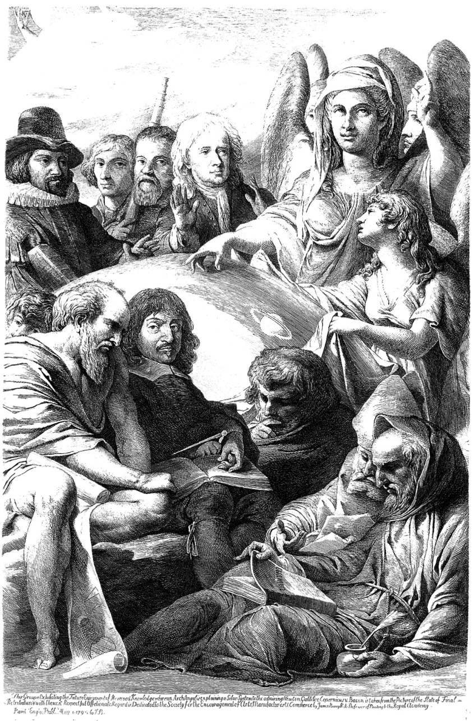

An archangel revealing the physical nature of the universe to a group of natural philosophers and mathematicians. Etching by James Barry, 1795, after his painting. The group contains Francis Bacon; Nicolaus Copernicus; Galileo Galilei; Isaac Newton; Thales; René Descartes; Archimedes; Robert Grosseteste; Roger Bacon; James Barry. Attribution in chapter References.

The neighbors looked with vast admiration at the things that Isaac manufactured. And his old grandmother, I suppose, was never weary of talking about him.

"He'll make a capital workman, one of these days," she would probably say. "No fear but what Isaac will do well in the world, and be a rich man before he dies."

It is amusing to conjecture what were the anticipations of his grandmother and the neighbors, about Isaac's future life. Some of them, perhaps, fancied that he would make beautiful furniture of mahogany, rose-wood, or polished oak, inlaid with ivory and ebony, and magnificently gilded. And then, doubtless, all the rich people would purchase these fine things, to adorn their drawing-rooms. Others probably thought that little Isaac was destined to be an architect, and would build splendid mansions for the nobility and gentry, and churches too, with the tallest steeples that had ever been seen in England.

Some of his friends, no doubt, advised Isaac's grandmother to apprentice him to a clockmaker; for, besides his mechanical skill, the boy seemed to have a taste for mathematics, which would be very useful to him in that profession. And then, in due time, Isaac would set up for himself, and would manufacture curious clocks, like those that contain sets of dancing figures which issue from the dial-plate when the hour is struck; or like those, where a ship sails across the face of the clock, and is seen tossing up and down on the waves, as often as the pendulum vibrates.

Indeed, there was some ground for supposing that Isaac would devote himself to the manufacture of clocks; since he had already made one, of a kind that nobody had ever heard of before. It was set a-going, not by wheels and weights, like other clocks, but by the dropping of water. This was an object of great wonderment to all the people roundabout; and it must be confessed that there are few boys, or men either, who could contrive to tell what o'clock it is, by means of a bowl of water.

Besides the water-clock, Isaac made a sun-dial. Thus, his grandmother was never at a loss to know the hour; for the water-clock would tell it in the shade, and the dial in the sunshine. The sun-dial is said to be still in existence at Woolsthorpe, on the corner of the house where Isaac dwelt. If so, it must have marked the passage of every sunny hour that has elapsed since Isaac Newton was a boy. It marked all the famous moments of his life; it marked the hour of his death; and still the sunshine creeps slowly over it, as regularly as when Isaac first set it up.

Yet we must not say that the sun-dial has lasted longer than its maker; for Isaac Newton will exist, long after the dial—yea, and long after the sun itself—shall have crumbled to decay.

Isaac possessed a wonderful faculty of acquiring knowledge by the simplest means. For instance, what method do you suppose he took, to find out the strength of the wind? You will never guess how the boy could compel that unseen, inconstant, and ungovernable wanderer, the wind, to tell him the measure of its strength. Yet nothing can be more simple. He jumped against the wind, and by the length of his jump, he could calculate the force of a gentle breeze, a brisk gale, or a tempest. Thus, even in his boyish sports, he was continually searching out the secrets of philosophy.

Not far from his grandmother's residence, there was a windmill, which operated on a new plan. Isaac was in the habit of going there frequently, and would spend whole hours in examining its various parts. While the mill was at rest, he pried into its internal machinery. When its broad sails were set in motion by the wind, he watched the process by which the mill-stones were made to revolve and crush the grain that was put into the hopper. After gaining a thorough knowledge of its construction, he was observed to be unusually busy with his tools.

It was not long before his grandmother, and all the neighborhood, knew what Isaac had been about. He had constructed a model of the windmill. Though not so large, I suppose as one of the box-traps that boys set to catch squirrels, yet every part of the mill and its machinery was complete. Its little sails were neatly made of linen and whirled round very swiftly when the mill was placed in a draught of air. Even a puff of wind from Isaac's mouth or from a pair of bellows was sufficient to set the sails in motion. And—what was most curious—if a handful of grains of wheat were put into the little hopper, they would soon be converted into snow-white flour.

Isaac's playmates were enchanted with his new windmill. They thought that nothing so pretty and so wonderful had ever been seen in the whole world.

"But, Isaac," said one of them, "you have forgotten one thing that belongs to a mill."

"What is that?" asked Isaac; for he supposed that, from the roof of the mill to its foundation, he had forgotten nothing.

"Why, where is the miller?" said his friend.

"That is true!—I must look out for one," said Isaac; and he set himself to consider how the deficiency should be supplied.

He might easily have made the miniature figure of a man, but then it would not have been able to move about and perform the duties of a miller. As Captain Lemuel Gulliver had not yet discovered the island of Lilliput[14], Isaac did not know that there were little men in the world, whose size was just suited to his windmill. It so happened, however, that a mouse had just been caught in the trap; as no other miller could be found, Mr. Mouse was appointed to that important office. The new miller made a very respectable appearance in his dark gray coat. To be sure, he had not a very good character for honesty, and was suspected of sometimes stealing a portion of the grain that was given him to grind. But perhaps some **two-legged millers are quite as dishonest** as this small quadruped.

As Isaac grew older, it was found that he had far more important matters in his mind than the manufacture of toys, like the little windmill. All day long, if left to himself, he was either absorbed in thought, or engaged in some book of mathematics or natural philosophy. At night, I think it probable, he looked up with reverential curiosity to the stars, and wondered whether they were worlds like our own,—and how great was their distance from the earth,—and what was the power that kept them in their courses. Perhaps, even so early in life, Isaac Newton felt a presentiment that he should be able, hereafter, to answer all these questions.

When Isaac was fourteen years old, his mother's second husband being now dead, she wished her son to leave school, and assist her in managing the farm at Woolsthorpe. For a year or two, therefore, he tried to turn his attention to farming. But his mind was so bent on becoming a scholar, that his mother sent him back to school and afterwards to the University of Cambridge.

I have now finished my anecdotes of Isaac Newton's boyhood. My story would be far too long, were I to mention all the splendid discoveries he made after he came to be a man. He was the first that found out the nature of Light, for, before his day, nobody could tell what the sunshine was composed of.[15] You remember, I suppose, the story of an apple's falling on his head, and thus leading him to discover the force of gravitation, which keeps the heavenly bodies in their courses.

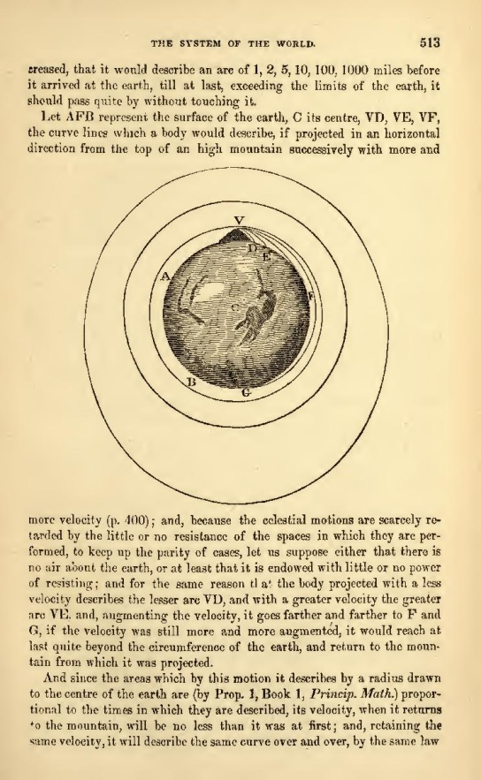

Image of a page from the English translation of Newton’s Philosophiae Naturalis Principia Mathematica, Book 3, De Mundi Systemate (On the System of the World). It depicts Newton’s Cannonball, a thought experiment he used to hypothesize that the force of gravity was universal, and a key force for planetary motion. Figure shows shapes of the orbits followed by canons fired horizontally, with different velocities, from a mountain of specific height. **If fired with enough speed, the gravitational force itself is enough to keep the ball rotating in that orbit forever. Satellites work on this principle.**

When he had once got hold of this idea, he never permitted his mind to rest until he had searched out all the laws by which the planets are guided through the sky. This he did as thoroughly as if he had gone up among the stars and tracked them in their orbits. The boy had found out the mechanism of a windmill; the man explained to his fellow-men the mechanism of the universe.

While making these researches, he was accustomed to spend night after night in a lofty tower, gazing at the heavenly bodies through a telescope. His mind was lifted far above the things of this world. He may be said, indeed, to have spent the greater part of his life in worlds that lie thousands and millions of miles away; for where the thoughts and the heart are, there is our true existence.

Did you never hear the story of Newton and his little dog Diamond? One day, when he was fifty years old and had been hard at work more than twenty years, studying the theory of Light, he went out of his chamber, leaving his little dog asleep before the fire. On the table lay a heap of manuscript papers, containing all the discoveries Newton had made during those twenty years. When his master was gone, up rose little Diamond, jumped upon the table and overthrew the lighted candle. The papers immediately caught fire.

Just as the destruction was completed, Newton opened the chamber-door, and perceived that the labors of twenty years were reduced to a heap of ashes. There stood little Diamond, the author of all the mischief. Almost any other man would have sentenced the dog to immediate death. But Newton patted him on the head with his usual kindness, although grief was at his heart.

"Oh, Diamond, Diamond," exclaimed he, "thou little knowest the mischief thou hast done."

This incident affected his health and spirits for some time afterwards; but, from his conduct towards the little dog, you may judge what was the sweetness of his temper.

Newton lived to be a very old man, acquired great renown, was made a Member of Parliament, and received the honor of knighthood from the king. But he cared little for earthly fame and honors, and felt no pride in the vastness of his knowledge. **All that he had learned only made him feel how little he knew in comparison to what remained to be known.**

**"I seem to myself like a child," he observed, "playing on the sea-shore, and picking up here and there a curious shell or a pretty pebble, while the boundless ocean of Truth lies undiscovered before me."**

At last, in 1727, when he was fourscore and five years old, Sir Isaac Newton died,—or rather he ceased to live on earth. We may be permitted to believe that he is still searching out the infinite wisdom and goodness of the Creator, as earnestly and with even more success than while his spirit animated a mortal body. He has left a fame behind him, which will be as endurable as if his name were written in letters of light, formed by the stars upon the midnight sky.

"I love to hear about mechanical contrivances—such as the water-clock and the little windmill," remarked George[16]. "I suppose if Sir Isaac Newton had only thought of it, he might have found out the steam-engine, railroads, and all the other famous inventions that have come into use since his day."

"Very possibly he might," replied Mr. Temple, "and, no doubt, a great many people would think it more useful to manufacture steam-engines, than to search out the system of the universe. Other great astronomers, besides Newton, have been endowed with mechanical genius. There was David Rittenhouse, an American,—he made a perfect little water-mill when he was only seven or eight years old. But this sort of ingenuity is but a mere trifle in comparison with the other talents of such men."

"It must have been beautiful," said Edward, "to spend whole nights in a high tower, as Newton did, gazing at the stars and the comets and the meteors. But what would Newton have done, had he been blind? Or if his eyes had been no better than mine?"

"Why, even then, my dear child," observed Mrs. Temple, "he would have found out some way of enlightening his mind, and of elevating his soul. But, come! Little Emily is waiting to bid you good night. You must go to sleep, and dream of seeing all our faces."

"But how sad it will be, when I awake!" murmured Edward.

### Food for Thought

* Newton is among that loftiest class of scientists who **discovered valuable principles of nature**. These discoveries were used as a base for hundreds of **inventions** that revolutionized every sphere of the society, the kitchens, factories, bedrooms, fields, skies, or shops. Those gave people the capability of accomplishing in a few minutes what their ancestors could not have achieved in years together. Just think about the enormous impact of such discoveries!
* Get to know a bit about Newton’s principal contributions such as the theory of colors and light, the laws of motion, and the theory of universal gravitation. Can you find examples of subsequent life-changing inventions having a direct or indirect dependency on Newton’s discoveries?

### References

* True Stories From History And Biography, by Nathaniel Hawthorne, 1851.
* An Archangel revealing the physical nature of the universe. See page for author [[CC BY 4.0](http://creativecommons.org/licenses/by/4.0) (http://creativecommons.org/licenses/by/4.0)], via [Wikimedia Commons](https://commons.wikimedia.org/wiki/File%3AAn_archangel_revealing_the_physical_nature_of_the_universe_t_Wellcome_L0022460.jpg).

About Cricket, by Arthur Conan Doyle

Complexity: Low

What is not so commonly known about Arthur Conan Doyle is his love for the game of cricket. It is clearly seen in this small cheerful chat between a cricket enthusiast and his sweet little kids, Laddie, and Dimples.

We take the liberty to assume that our readers are somewhat familiar with the game, and therefore well poised to enjoy this conversation.

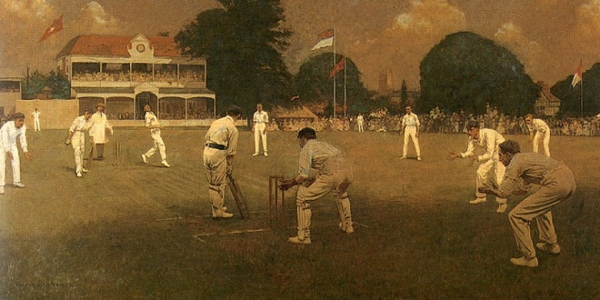

Kent vs. Lancashire, by Albert Chevallier Tayler 1907. Batsman taking stance in front of the wickets, waiting for the bowler to bowl. All fielders are in position to save runs or get batsmen out.

Supper was going on down below and all good children should have been long ago in the land of dreams. Yet a curious noise came from above.

“What on earth—?” asked Daddy.

“Laddie practising cricket,” said the Lady, with the **curious clairvoyance of motherhood**. “He gets out of bed to bowl. I do wish you would go up and speak seriously to him about it, for it takes quite an hour off his rest.”

Daddy departed upon his mission intending to be gruff, and my word, he can be quite gruff when he likes! When he reached the top of the stairs, however, and heard the noise still continue, he walked softly down the landing and peeped in through the half-opened door.

The room was dark save for a night-light. In the dim glimmer, he saw a little white-clad figure, slight and supple, taking short steps and swinging its arm in the middle of the room.

“Halloa!” said Daddy.

The white-clad figure turned and ran forward to him.

“Oh, Daddy, how jolly of you to come up!”

Daddy felt that gruffness was not quite so easy as it had seemed.

“Look here! You get into bed!” he said, with the best imitation he could manage.

“Yes, Daddy. But before I go, how is this?” He sprang forward and the arm swung round again in a swift and graceful gesture.

Daddy was a moth-eaten cricketer of sorts, and he took it in with a critical eye.

“Good, Laddie. I like a high action. That’s the real Spofforth[17] swing.”

“Oh, Daddy, come and talk about cricket!” He was pulled on the side of the bed, and the white figure dived between the sheets.

“Yes, tell us about cwicket!” came a cooing voice from the corner. Dimples was sitting up in his cot.

“You naughty boy! I thought one of you was asleep, anyhow. I mustn’t stay. I keep you awake.”

“Who was Popoff?” cried Laddie, clutching at his father’s sleeve. “Was he a very good bowler?”

“Spofforth was the best bowler that ever walked onto a cricket-field. He was the great Australian Bowler and he taught us a great deal.”

“Did he ever kill a dog?” from Dimples.

“No, boy. Why?”

“Because Laddie said there was a bowler so fast that his ball went frue a coat and killed a dog.”

“Oh, that’s an old yarn. I heard that when I was a little boy about some bowler whose name, I think, was Jackson.”

“Was it a big dog?”

“No, no, son; it wasn’t a dog at all.”

“It was a cat,” said Dimples.

“No; I tell you it never happened.”

“But tell us about Spofforth,” cried Laddie. Dimples, with his imaginative mind, usually wandered, while the elder came eagerly back to the point. “Was he very fast?”

“He could be very fast. I have heard cricketers who had played against him say that his yorker[18]—that is a ball, which is just short of a full pitch—was the fastest ball in England. I have myself seen his long arm swing round and the wicket go down before ever the batsman had time to ground his bat.”

“Oo!” from both beds.

“He was a tall, thin man, and they called him the Fiend. That means the Devil, you know.”

“And *was* he the Devil?”

“No, Dimples, no. They called him that because he did such wonderful things with the ball.”

“Can the Devil do wonderful things with a ball?”

Daddy felt that he was propagating devil-worship and hastened to get to safer ground.

“Spofforth taught us how to bowl, and Blackham taught us how to keep wicket. When I was young, we always had another fielder, called the long-stop, who stood behind the wicket-keeper. I used to be a thick, solid boy, so they put me as long-stop, and the balls used to bounce off me, I remember, as if I had been a mattress.”

Delighted laughter.

“But after Blackham came, wicket-keepers had to learn that they were there to stop the ball. Even in good second-class cricket, there were no more long-stops. We soon found plenty of good wicket-keeps—like Alfred Lyttelton and MacGregor—but it was Blackham who showed us how. To see Spofforth, all India-rubber and ginger, at one end bowling, and Blackham, with his black beard over the bails, waiting for the ball at the other end, was worth living for, I can tell you.”

Silence while the boys pondered over this. But Laddie feared Daddy would go, so he quickly got in a question. If Daddy’s memory could only be kept going there was no saying how long they might keep him.

“Was there no good bowler until Spofforth came?”

“Oh, plenty, my boy. But he brought something new with him. Especially change of pace—you could never tell by his action up to the last moment whether you were going to get a ball like a flash of lightning, or one that came slow but full of devil and spin. But for mere command of the pitch of a ball I should think Alfred Shaw, of Nottingham, was the greatest bowler I can remember. It was said that he could pitch a ball twice in three times upon a half-crown!”

“Oo!” And then from Dimples:—

“Whose half-crown?”

“Well, anybody’s half-crown.”

“Did he get the half-crown?”

“No, no; why should he?”

“Because he put the ball on it.”

“The half-crown was kept there always for people to aim at,” explained Laddie.

“No, no, there never was a half-crown.”

Murmurs of remonstrance from both boys.

“I only meant that he could pitch the ball on anything—a half-crown or anything else.”

“Daddy,” with the energy of one who has a happy idea, “could he have pitched it on the batsman’s toe?”

“Yes, boy, I think so.”

“Well, then, suppose he *always* pitched it on the batsman’s toe!”

Daddy laughed.

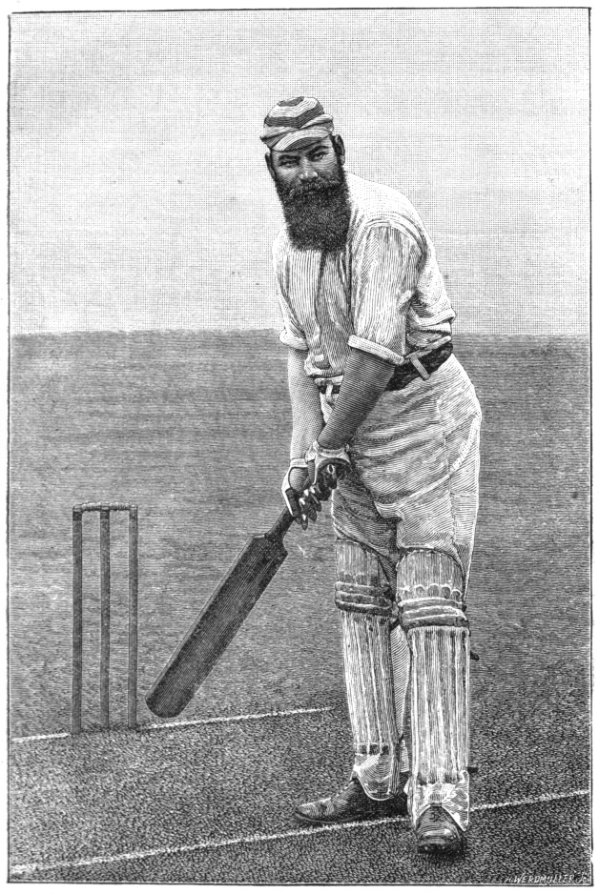

W. G. Grace, 1891, with his left toe cocked up in the air.

“Perhaps that is why dear old W. G. always stood with his left toe cocked up in the air.”

“On one leg?”

“No, no, Dimples. With his heel down and his toe up.”

“Did you know W. G., Daddy?”

“Oh, yes, I knew him quite well.”

“Was he nice?”

“Yes, he was splendid. He was always like a great jolly schoolboy who was hiding behind a huge black beard.”

“Whose beard?”

“I meant that he had a great bushy beard. He looked like the pirate chief in your picture-books, but he had as kind a heart as a child. I have been told that it was the terrible things in this war that really killed him. Grand old W. G.!”

“Was he the best bat in the world, Daddy?”

“Of course he was,” said Daddy, beginning to enthuse to the delight of the clever little plotter in the bed. “There never was such a bat—never in the world—and I don’t believe there ever could be again. He didn’t play on smooth wickets, as they do now. He played where the wickets were all patchy, and you had to watch the ball right on to the bat. You couldn’t look at it before it hit the ground and think, ‘That’s all right. I know where that one will be!’ My word, that was cricket. **What you got, you earned**.”

“Did you ever see W. G. make a hundred, Daddy?”

“See him! I’ve fielded out for him and melted on a hot August day while he made a hundred and fifty. There’s a pound or two of your Daddy somewhere on that field yet. But I loved to see it, and I was always sorry when he got out for nothing, even if I were playing against him.”

“Did he ever get out for nothing?”

“Yes, dear; the first time I ever played in his company he was given out leg-before-wicket before he made a run. And all the way to the pavilion—that’s where people go when they are out—he was walking forward, but his big black beard was backward over his shoulder as he told the umpire what he thought.”

“And what *did* he think?”

“More than I can tell you, Dimples. But I dare say he was right to be annoyed, for it was a left-handed bowler, bowling round the wicket, and it is very hard to get leg-before to that. However, that’s all Greek to you.”

“What’s Gweek?”

“Well, I mean you can’t understand that. Now I am going.”

“No, no, Daddy; wait a moment! Tell us about Bonner and the big catch.”

“Oh, you know about that!”

Two little coaxing voices came out of the darkness.

“Oh, please! Please!”

“I don’t know what your mother will say! What was it you asked?”

“Bonner!”

“Ah, Bonner!” Daddy looked out in the gloom and saw green fields and golden sunlight, and great sportsmen long gone to their rest. “Bonner was a wonderful man. He was a giant in size.”

“As big as you, Daddy?”

Daddy seized his elder boy and shook him playfully. “I heard what you said to Miss Cregan the other day. When she asked you what an acre was, you said ‘About the size of Daddy.’”

Both boys gurgled.

“But Bonner was five inches taller than I. He was a giant, I tell you.”

“Did nobody kill him?”

“No, no, Dimples. Not a story-book giant. But a great, strong man. He had a splendid figure and blue eyes and a golden beard, and altogether he was the finest man I have ever seen—except perhaps one.”

“Who was the one, Daddy?”

“Well, it was the Emperor Frederick of Germany.”

“A Jarman!” cried Dimples, in horror.

“Yes, a German. Mind you, boys, a man may be a very noble man and be a German—though what has become of the noble ones these last three years[19] is more than I can guess. But Frederick was noble and good, as you could see on his face. How he ever came to be the father of such a blasphemous braggart”—Daddy sank into reverie.

“Bonner, Daddy!” said Laddie, and Daddy came back from politics with a start.

“Oh, yes, Bonner. Bonner, in white flannels on the green sward, with an English June sun upon him. That was a picture of a man! But you asked me about the catch. It was in a test match at the Oval—England against Australia. Bonner said before he went in that he would hit Alfred Shaw into the next county, and he set out to do it. Shaw, as I have told you, could keep a very good length, so for some time Bonner could not get the ball he wanted, but at last he saw his chance, and he jumped out and hit that ball the most awful ker-wallop that ever was seen in a cricket-field.”

“Oo!” from both boys: and then, “Did it go into the next county, Daddy?” from Dimples.

“Well, I’m telling you!” said Daddy, who was always testy when one of his stories was interrupted. “Bonner thought he had made the ball a half-volley—that is the best ball to hit—but Shaw had deceived him and the ball was really on the short side. So when Bonner hit it, up and up it went, until it looked as if it were going out of sight into the sky.”

“Oo!”

“At first, everybody thought it was going far outside the ground. But soon, they saw that all the giant’s strength had been wasted in hitting the ball so high, and that there was a chance that it would fall within the ropes. The batsmen had run three runs and it was still in the air. Then it was seen that an English fielder was standing on the very edge of the field with his back on the ropes, a white figure against the black line of the people. He stood watching the mighty curve of the ball, and twice he raised his hands together above his head as he did so. Then, a third time, he raised his hands above his head, and the ball was in them and Bonner was out.”

“Why did he raise his hands twice?”

“I don’t know. He did so.”

“And who was the fielder, Daddy?”

“The fielder was G. F. Grace, the younger brother of W. G. Only a few months afterwards he was a dead man. But he had one grand moment in his life, with twenty thousand people all just mad with excitement. Poor G. F.! He died too soon.”

“Did you ever catch a catch like that, Daddy?”

“No, boy. I was never a particularly good fielder.”

“Did you never catch a good catch?”

“Well, I won’t say that. You see, the best catches are very often flukes, and I remember one awful fluke of that sort.”

“Do tell us, Daddy?”

“Well, dear, I was fielding at slip. That is very near the wicket, you know. Woodcock was bowling, and he had the name of being the fastest bowler of England at that time. It was just the beginning of the match and the ball was quite red. Suddenly, I saw something like a red flash and there was the ball stuck in my left hand. I had not time to move it. It simply came and stuck.”

“Oo!”

“I saw another catch like that. It was done by Ulyett, a fine Yorkshire player—such a big, upstanding fellow. He was bowling, and the batsman—it was an Australian in a test match—hit as hard as ever he could. Ulyett could not have seen it, but he just stuck out his hand and there was the ball.”

“Suppose it had hit his body?”

“Well, it would have hurt him.”

“Would he have cried?” from Dimples.

“No, boy. That is what games are for, to teach you to **take a knock and never show it**. Supposing that—”

A step was heard coming along the passage.

“Good gracious, boys, here’s Mumty. Shut your eyes this moment. It’s all right, dear. I spoke to them very severely and I think they are nearly asleep.”

“What have you been talking about?” asked the Lady.

“Cwicket!” cried Dimples.

“It’s natural enough,” said Daddy, “of course, when two boys—”

“Three,” said the Lady, as she tucked up the little beds.

### Food for Thought

* Some of your own heroes, faiths, hobbies, or even aversions might have roots in such conversations with your elders, teachers, and friends. Can you try to identify some of these in your case?
* Have you read about Jesse Owens, the great African-American athlete, and his friendship with the German athlete, Luz Long? The friendship formed during the 1936 Munich Olympics. Those were troubled times near the start of the Second World War. Both represented nations that eventually were pitted against one another. But this did not affect their friendship. The story depicts the true spirit of sportsmanship, worth a read!
* The field of sports has grown in importance, as a mechanism to stay fit, as entertainment, even as a mark of national pride and further as a professional sports industry. Do you notice changes in the relative popularity of different fields and public idols over time and place? Try to identify those waves when everyone wanted to become a scientist like Einstein, or a Dostoevsky, Lincoln, Bill Gates, or Michelangelo?

### References

Danger And Other Stories, Chapter 10, Three of Them, by Arthur Conan Doyle, 1918.

The Mouse Merchant, from The Jatakas

Complexity: Low

Jatakas are tales of the Bodhisattva narrated by Buddha, to his disciples. The stories were written around 4th Century BCE. Bodhisattva refers to Buddha in his previous human or animal lives, reaching the final enlightened state through noble deeds done then.

This story is about an intelligent and hardworking youth who climbs from rags to riches making use of basic business principles.

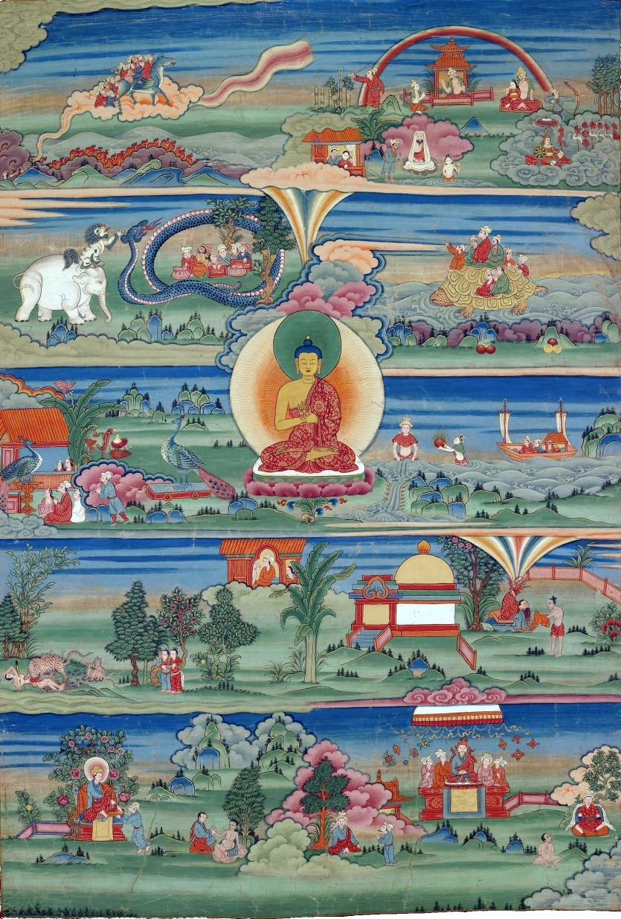

A Thanka, i.e. painting on cotton or silk, of the Jataka Tales, 18th-19th Century. Phajoding Gonpa, Thimpu, Bhutan.

Long ago, when Brahmadatta was reigning in Benares, in the land of Kasi, the Bodhisattva was born in a treasurer’s family. When he grew up, he received the post of treasurer, and was called Chullaka. He was wise and skillful, and understood all omens. One day as he was going to attend upon the king, he saw a dead mouse lying on the road; considering the state of the stars at the time, he said, “A young fellow with eyes in his head[20] might, by picking this thing up, start a trade and support a wife.”

Now, a certain young man of good birth, then fallen into poverty, heard what the official said, and thinking, “This is a man who wouldn’t say such a thing without good reason,” took the mouse and gave it away in a certain shop for the use of the cat, and got a farthing for it.

With the farthing he bought molasses, and took water in a pot. And seeing garland-makers returning from the forest, he gave them bits of molasses, with water by the ladle-full. They gave him each a bunch of flowers; and the next day, with the price of the flowers, he bought more molasses; and taking a potful of water, went to the flower garden. That day the garland-makers gave him, as they went away, flowering shrubs from which half the blossoms had been picked. In this way, in a little time, he gained eight pennies.

Sometime after, on a rainy windy day, a quantity of dry sticks, branches, and leaves were blown down by the wind in the king’s garden, and the gardener saw no way of getting rid of them. The young man went and said to the gardener, “If you will give me these sticks and leaves, I will get them out of the way.” The gardener agreed to this, and told him to take them.

Chullaka’s pupil went to the children’s playground, and by giving them molasses, he had all the leaves and sticks collected immediately and placed in a heap at the garden gate. Just then, the king’s potter was looking out for firewood to burn pots for the royal household, and seeing this heap, he bought it from him. That day Chullaka’s pupil got sixteen pennies and five vessels such as water-pots, etc. by selling his firewood.

Having thus obtained possession of twenty-four pennies, he thought, “This will be a good scheme for me,” and went to a place not far from the city gate and placing a pot of water there, supplied five hundred grass-cutters with drink.

“Friend! You have been of great service to us,” they said. “What shall we do for you?”

“You shall do me a good turn when need arises,” he said. And then, going about this way and that, he struck up a friendship with a trader by land and another trader by sea.

The trader by land told him, “Tomorrow a horse-dealer is coming to the town with five hundred horses.”

On hearing this, he said to the grass-cutters, “Today, each of you, give me a bundle of grass, and don’t sell your own grass till I have disposed off mine.”

“All right!” they cried in assent, brought five hundred bundles, and placed them in his house. The horse-dealer, not being able to get grass for his horses through the entire city, bought the young man’s grass for a thousand pence.

A few days afterwards, his friend, the trader by sea, told him that a large vessel had come to the port. He thought, “This will be a good plan,” and got a carriage on hire for eight pennies, with all its proper attendants; driving to the port with a great show of respectability, he gave his seal-ring as a deposit for the ship’s cargo. Then he had a tent pitched not far off, and taking his seat gave orders to his men that when merchants came from outside, he should be informed of it with triple ceremony[21].

On hearing that a ship had arrived, about a hundred merchants came from Benares to buy the goods.

They were told, “You can’t have the goods. A great merchant of such and such a place has already paid a deposit for them.”

On hearing this, they went to him; and his footmen announced their arrival, as had been agreed, upon three levels deep. Each of the merchants then gave him a thousand to become shareholders in the ship, and then another thousand for him to relinquish hisremaining share. Thus, they made themselves owners of the cargo.

So Chullaka’s pupil returned to Benares, taking with him two hundred thousand. And from a feeling of gratitude, he took a hundred thousand and went to Chullaka the treasurer. Then the treasurer asked him, “What have you been doing, my good man, to get all this wealth?”

“It was by adhering to what you said that I have acquired it within four months,” said he. He then told him the whole story, beginning with the dead mouse.

When Chullaka the high treasurer heard his tale, he thought, “It will never do to let such a lad as this get into somebody else’s hands.” So he gave him his grown-up daughter in marriage, and made him heir to all the family estates. And when the treasurer died, he received the post of city treasurer. But the Bodhisattva passed away according to his deeds.

It was when the Buddha had finished his discourse that he, as Buddha, uttered the following verse:

As one might nurse a tiny flame,

The able and far-seeing man,

Even with the smallest capital,

Can raise himself to wealth

### Food for Thought

* In the above story, try to spot where our hero has used these basic business principles: Understanding demand and supply, Alertness in spotting opportunities, Readiness to latch onto any opportunity that looks suitable, Hard work, Balancing worker cost and suitability for the job, Being courteous, Timeliness, Stocking/Locking goods for profit, Saving and reinvesting savings/profit into business, Taking goods or money on credit, Striking useful friendships, or even **Showing off** if the situation so demands. Anything else? Do any of these techniques border on the unethical or illegal?
* It seems like the hero of our story never faces any serious problem or failure on his way to wealth. He works hard and smart, does not blatantly steal or cheat, and yet becomes wealthy in four months. He must be one of those rare lucky fellows, others probably face many more challenges. But in general, a position of reasonable wealth is well within reach if we apply ourselves, isn't it?
* In general, does a poverty stricken person have the liberty to pursue the trade of liking or natural inclination?

### References

Jataka Tales, Volume 1 by V. Fausboll, translated by T. W. Rhys Davids, 1880.

Day In The Country, by Anton Chekhov

Complexity: Low

This short story contains Chekhov’s beautiful description of the Russian countryside during rains. It is a cheerful chat about various aspects of nature, between a good old man and two innocent children.

Between eight and nine o'clock in the morning.

A dark leaden-coloured mass is creeping over the sky towards the sun. Red zigzags of lightning gleam here and there across it. There is a sound of far-away rumbling. A warm wind frolics over the grass, bends the trees, and stirs up the dust. In a minute, there will be a spurt of May rain, and a real storm will begin.

Fyokla, a little beggar-girl of six, is running through the village, looking for Terenty the cobbler. The white-haired, barefoot child is pale. Her eyes are wide-open, her lips are trembling.

"Uncle, where is Terenty?" she asks everyone she meets. No one answers. They are all preoccupied with the approaching storm and take refuge in their huts. At last, she meets Silanty Silitch, the sacristan, Terenty's bosom friend. He is coming along, staggering from the wind.

"Uncle, where is Terenty?"

"At the kitchen-gardens," answers Silanty.

The beggar-girl runs behind the huts to the kitchen-gardens and there finds Terenty; the tall old man with a thin, pock-marked face, very long legs, and bare feet, dressed in a woman's tattered jacket, is standing near the vegetable plots, looking with drowsy, drunken eyes at the dark storm-cloud. On his long crane-like legs he sways in the wind like a starling-cote.

"Uncle Terenty!" the white-headed beggar-girl addresses him. "Uncle, darling!"

Terenty bends down to Fyokla, and his grim, drunken face is overspread with a smile, such as come into people's faces when they look at something little, foolish, and absurd, but warmly loved.

"Ah! Servant of God, Fyokla," he says, lisping tenderly, "where have you come from?"

"Uncle Terenty," says Fyokla, with a sob, tugging at the lapel of the cobbler's coat. "Brother Danilka has had an accident! Come along!"

"What sort of accident? Ough, what thunder! Holy, holy, holy. . . .

What sort of accident?"

"In the count's copse Danilka stuck his hand into a hole in a tree, and he can't get it out. Come along, uncle, do be kind and pull his hand out!"

"How was it he put his hand in? What for?"

"He wanted to get a cuckoo's egg out of the hole for me."

"The day has hardly begun and already you are in trouble. . . ." Terenty shook his head and spat deliberately. "Well, what am I to do with you now? I must come . . . I must, may the wolf gobble you up, you naughty children! Come, little orphan!"

Terenty comes out of the kitchen-garden and, lifting high his long legs, begins striding down the village street. He walks quickly without stopping or looking from side to side, as though he were shoved from behind or afraid of pursuit. Fyokla can hardly keep up with him.

They come out of the village and turn along the dusty road towards the count's copse that lies dark blue in the distance. It is about a mile and a half away. The clouds have by now covered the sun, and soon afterwards there is not a speck of blue left in the sky. It grows dark.

"Holy, holy, holy . . ." whispers Fyokla, hurrying after Terenty. The first raindrops, big and heavy, lie, dark dots on the dusty road. A big drop falls on Fyokla's cheek and glides like a tear down her chin.

"The rain has begun," mutters the cobbler, kicking up the dust with his bare, bony feet. "That's fine, Fyokla, old girl. The grass and the trees are fed by the rain, as we are by bread. As for the thunder, don't you be frightened, little orphan. Why should it kill a little thing like you?"

As soon as the rain begins, the wind drops. The only sound is the patter of rain dropping like fine shot on the young rye and the parched road.

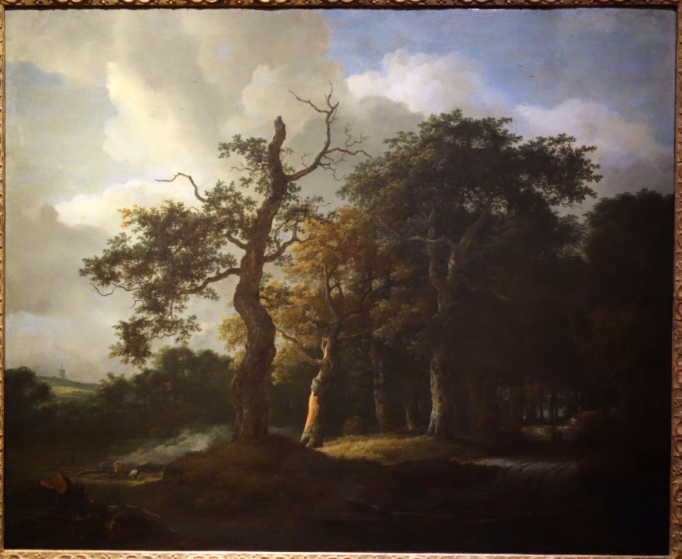

A Road through an Oak Wood by Jacob van Ruysdael (1650-1682). Attribution in chapter References.

"We shall get soaked, Fyokla," mutters Terenty. "There won't be a dry spot left on us. . . . Ho-ho, my girl! It's run down my neck! But don't be frightened, silly. . . . The grass will be dry again, the earth will be dry again, and we shall be dry again. There is the same sun for us all."

A flash of lightning, some fourteen feet long, gleams above their heads. There is a loud peal of thunder and it seems to Fyokla that something big, heavy, and round is rolling over the sky and tearing it open, exactly over her head.

"Holy, holy, holy . . ." says Terenty, crossing himself. "Don't be afraid, little orphan! It is not from spite that it thunders."

Terenty's and Fyokla's feet are covered with lumps of heavy, wet clay. It is slippery and difficult to walk, but Terenty strides on more and more rapidly. The weak little beggar-girl is breathless and ready to drop.

But, at last, they go into the count's copse. The washed trees, stirred by a gust of wind, drop a perfect waterfall upon them. Terenty stumbles over stumps and begins to slacken his pace.

"Whereabouts is Danilka?" he asks. "Lead me to him."

Fyokla leads him into a thicket, and, after going a quarter of a mile, points to Danilka. Her brother, a little fellow of eight, with hair as red as ochre and a pale sickly face, stands leaning against a tree, and, with his head on one side, looking sideways at the sky. In one hand, he holds his shabby old cap, the other is hidden in an old lime tree. The boy is gazing at the stormy sky, and apparently not thinking of his trouble. Hearing footsteps and seeing the cobbler, he gives a sickly smile and says:

"A terrible lot of thunder, Terenty. . . . I've never heard so much thunder in all my life."

"And where is your hand?"

"In the hole. . . . Pull it out, please, Terenty!"

The wood had broken at the edge of the hole and jammed Danilka's hand: he could push it farther in, but could not pull it out. Terenty snaps off the broken piece, and the boy's hand, red and crushed, is released.

"It's terrible how it's thundering," the boy says again, rubbing his hand. "What makes it thunder, Terenty?"

"One cloud runs against the other," answers the cobbler. The party comes out of the copse and walks along the edge of it towards the darkened road. The thunder gradually abates, and its rumbling is heard far away beyond the village.

"The ducks flew by here the other day, Terenty," says Danilka, still rubbing his hand. "They must be nesting in the Gniliya Zaimishtcha marshes. . . . Fyokla, would you like me to show you a nightingale's nest?"

"Don't touch it, you might disturb them," says Terenty, wringing the water out of his cap. "The nightingale is a singing-bird, without sin. He has had a voice given to him in his throat, to praise God and gladden the heart of man. It's a sin to disturb him."

"What about the sparrow?"

"The sparrow doesn't matter; he's a bad, spiteful bird. He is like a pickpocket in his ways. He doesn't like man to be happy. When Christ was crucified, it was the sparrow that brought nails to the Jews, and called 'Alive! Alive!'"

A bright patch of blue appears in the sky.

"Look!" says Terenty. "An ant-heap burst open by the rain! They've been flooded, the rogues!"

They bend over the ant-heap. The downpour has damaged it; the insects are scurrying to and fro in the mud, agitated and busily trying to carry away their drowned companions.

"You needn't be in such a taking, you won't die of it!" says Terenty, grinning. "As soon as the sun warms you, you'll come to your senses again. . . . It's a lesson to you, you stupids. You won't settle on low ground another time."

They go on.

"And here are some bees," cries Danilka, pointing to the branch of a young oak tree.

The drenched and chilled bees are huddled together on the branch.

There are so many of them that neither bark nor leaf can be seen.

Many of them are settled on one another.

"That's a swarm of bees," Terenty informs them. "They were flying looking for a home, and when the rain came down upon them they settled. If a swarm is flying, you need only sprinkle water on them to make them settle. Now if, say, you wanted to take the swarm, you would bend the branch into a sack and shake it, and they all fall in."

Little Fyokla suddenly frowns and rubs her neck vigorously. Her brother looks at her neck, and sees a big swelling on it.

"Hey-hey!" laughs the cobbler. "Do you know where you got that from,

Fyokla, old girl? There are Spanish flies on some tree in the wood.

The rain has trickled off them, and a drop has fallen on your neck

—that's what has made the swelling."

The sun appears from behind the clouds and floods the wood, the fields, and the three friends with its warm light. The dark menacing cloud has gone far away and taken the storm with it. The air is warm and fragrant. There is a scent of bird-cherry, meadowsweet, and lilies-of-the-valley.

"That herb is given when your nose bleeds," says Terenty, pointing to a woolly-looking flower. "It does good."

They hear a whistle and a rumble, but not such a rumble as the storm clouds carried away. A goods train races by before the eyes of Terenty, Danilka, and Fyokla. The engine, panting and puffing out black smoke, drags more than twenty vans after it. Its power is tremendous. The children are interested to know how an engine, not alive and without the help of horses, can move and drag such weights, and Terenty undertakes to explain it to them:

"It's all the steam's doing, children. . . . The steam does the work. . . . You see, it shoves under that thing near the wheels, and it . . . you see . . . it works. . . ."

They cross the railway line, and, going down from the embankment, walk towards the river. They walk not with any object, but just at random, and talk all the way. . . . Danilka asks questions, Terenty answers them. . . .

Terenty answers all his questions, and there is no secret in Nature which baffles him. He knows everything. Thus, for example, he knows the names of all the wild flowers, animals, and stones. He knows what herbs cure diseases, he has no difficulty in telling the age of a horse or a cow. Looking at the sunset, at the moon, or the birds, he can tell what sort of weather it will be next day. And indeed, it is not only Terenty who is so wise. Silanty Silitch, the innkeeper, the market-gardener, the shepherd, and all the villagers, generally speaking, know as much as he does. **These people have learned not from books, but in the fields, in the wood, on the river bank. Their teachers have been the birds themselves, when they sang to them, the sun when it left a glow of crimson behind it at setting, the very trees, and wild herbs.**

Danilka looks at Terenty and greedily drinks in every word. In spring, before one is weary of the warmth and the monotonous green of the fields, when everything is fresh and full of fragrance, who would not want to hear about the golden may-beetles, about the cranes, about the gurgling streams, and the corn mounting into ear?

The two of them, the cobbler and the orphan, walk about the fields, talk unceasingly, and are not weary. They could wander about the world endlessly. They walk, and in their talk of the beauty of the earth do not notice the frail little beggar-girl tripping after them. She is breathless and moves with a lagging step. There are tears in her eyes; she would be glad to stop these inexhaustible wanderers, but to whom and where can she go? She has no home or people of her own; whether she likes it or not, she must walk and listen to their talk.

Towards midday, all three sit down on the river bank. Danilka takes out of his bag a piece of bread, soaked and reduced to a mash, and they begin to eat. Terenty says a prayer when he has eaten the bread, then stretches himself on the sandy bank and falls asleep. While he is asleep, the boy gazes at the water, pondering. He has many different things to think of; he has just seen the storm, the bees, the ants, and the train. Now, before his eyes, fishes are whisking about. Some are two inches long and more, others are no bigger than one's nail. A viper, with its head held high, is swimming from one bank to the other.

Only towards the evening our wanderers return to the village. The children go for the night to a deserted barn, where the corn of the commune used to be kept, while Terenty, leaving them, goes to the tavern. The children lie huddled together on the straw, dozing.

The boy does not sleep. He gazes into the darkness, and it seems to him that he is seeing all that he has seen in the day: the storm-clouds, the bright sunshine, the birds, the fish, lanky Terenty. The number of his impressions, together with exhaustion and hunger, are too much for him; he is as hot as though he were on fire and tosses from side to side. He longs to tell someone all that is haunting him now, in the darkness, agitating his soul, but there is no one to tell. Fyokla is too little and could not understand.

"I'll tell Terenty tomorrow," thinks the boy.

The children fall asleep thinking of the homeless cobbler, and, in the night, Terenty comes to them, makes the sign of the cross over them, and puts bread under their heads. And no one sees his love. It is seen only by the moon, which floats in the sky and peeps caressingly through the holes in the wall of the deserted barn.

### Food for Thought

* Did you think that the poor and destitute are generally devoid of happy moments in life? Isn’t everyone, including the ants and bees above, well taken care of (and also bothered), in unique style?
* Did you think that beautiful moments always need to be purchased at a big cost? **“There are only three gems in this world, water, food, and sweet, meaningful speech. Fools consider pieces of stone as gems.”** *[Chanakya Niti-Sutra, 14.1]*
* We often go for treks to the countryside, climb mountains, visit famous landmarks, go shopping, and do so many different things. Have you focused on the end goal so much that you missed enjoying the path? Those trees, birds, playing children, casual discussions with a passer-by, queer sounds. Did you miss them and the strong impressions they often leave, while in hurry to reach the top of that hill, or make that particular purchase?

### References

* The Tales Of Chekhov, Volume 12, The Cook’s Wedding And Other Stories, translated by Constance Garnett, 1922.
* Road through an Oak Wood. By Daderot (Own work) [Public domain or [CC0](http://creativecommons.org/publicdomain/zero/1.0/deed.en) (http://creativecommons.org/publicdomain/zero/1.0/deed.en)], [via Wikimedia Commons](https://commons.wikimedia.org/wiki/File%3AA_Road_through_an_Oak_Wood_by_Jacob_van_Ruysdael%2C_1650-1682%2C_oil_on_canvas_-_National_Museum_of_Western_Art%2C_Tokyo_-_DSC08443.JPG).

The Ugly Duckling, by Hans Christian Andersen

Complexity: Low

A popular literary fairy tale from the Danish master of that genre. It is about how an ugly duckling overcomes a multitude of difficulties, to progress in life.

### The Duckling Is Born

It was glorious in the country. It was summer; the cornfields were yellow, the oats were green, the hay had been put up in stacks in the green meadows; and the stork went about on his long red legs, and chattered Egyptian, for this was the language he had learned from his mother. All around the fields and meadows were great woods, and in the midst of these woods deep lakes. Yes, it was right glorious in the country.

In the midst of the sunshine there lay an old farm, with deep canals about it; and from the wall down to the water grew great burdocks, so high that little children could stand upright under the tallest of them. It was just as wild there as in the deepest wood, and here sat a Duck upon her nest. She had to hatch her ducklings, but she was almost tired out before the little ones came and she seldom had visitors. The other ducks liked better to swim about in the canals than to run up to sit under a burdock and gabble with her.

At last, one egg-shell after another burst open. "Pip! pip!" each cried, and in all the eggs there were little things that stuck out their heads.

"Quack! quack!" said the Duck, and they all came quacking out as fast as they could, looking all around them under the green leaves; and the mother let them look as much as they liked, for **green is good for the eye**.

"How wide the world is!" said all the young ones; for they certainly had much more room now than when they were inside the eggs.

"D'ye think this is all the world?" said the mother. "That stretches far across the other side of the garden, quite into the parson's field; but I have never been there yet. I hope you are all together," and she stood up. "No, I have not all. The largest egg still lies there. How long is that to last? I am really tired of it." And so, she sat down again.

"Well, how goes it?" asked an old Duck who had come to pay her a visit.

"It lasts a long time with this one egg," said the Duck who sat there. "It will not open. Now, only look at the others! They are the prettiest little ducks I ever saw. They are all like their father, the rogue; he never comes to see me."

"Let me see the egg which will not burst," said the old Duck. "You may be sure it is a turkey's egg. I was once cheated in that way, and had much care and trouble with the young ones, for they are afraid of the water. Must I say it to you? I could not make them go in. I quacked, and I clacked, but it was no use. Let me see the egg. Yes, that's a turkey's egg. Let it lie there, and do you teach the other children to swim."

"I think I will sit on it a little longer," said the Duck. "I've sat so long now that I can sit a few days more."

"Just as you please," said the old Duck; and she went away.

At last, the great egg burst. "Pip! pip!" said the little one, and crept forth. He was so big and ugly. The Duck looked at him.

"It's a very large Duckling," said she. "None of the others looks like that, it really must be a turkey chick! Well, we shall soon find out. Into the water shall he go, even if I have to push him in."

### How The Duckling Was Treated At Home

The next day it was a bright, beautiful weather; the sun shone on all the green burdocks. The Mother-Duck, together with all her family, went down to the canal. Splash! she jumped into the water. "Quack! quack!" she said, and one duckling after another plumped in. The water closed over their heads, but they came up in an instant, and swam off finely; their legs went of themselves, and they were all in the water; even the ugly gray Duckling swam with them.

"No, it's not a turkey," said she: "look how well he uses his legs, how straight he holds himself. It is my own child! On the whole, he's quite pretty, when one looks at him rightly. Quack! quack! Come now with me, and I'll lead you out into the world, and present you in the duck-yard; but keep close to me all the time, so that no one may tread on you, and look out for the cats."

And so they came into the duck-yard. There was a terrible row going on in there, **for two families were fighting about an eel's head, and so the cat got it**.

"See, that's the way it goes in the world!" said the Mother-Duck; and she whetted her beak, for she too wanted the eel's head. "Only use your legs," she said. "See that you can bustle about, and bend your necks before the old Duck there. She's the grandest of all here; she's of Spanish blood--that's why she's so fat. And do you see? She has a red rag around her leg; that's something very, very fine, and the greatest mark of honor a duck can have: it means that one does not want to lose her, and that she's known by the animals and by men too. Hurry! Hurry!--don't turn in your toes, a well brought-up duck turns its toes quite out, just like father and mother,--so! Now bend your necks and say 'Quack!'"

And they did so; but the other ducks round about looked at them, and said quite boldly,--"Look there! now we're to have this crowd too! As if there were not enough of us already! And--fie!--how that Duckling there looks: we won't stand that!" And at once one Duck flew at him, and bit him in the neck.

"Leave him alone," said the mother: "he is not doing anything to anyone."

"Yes, but he's too large and odd," said the Duck who had bitten him, "and so he must be put down."

"Those are pretty children the mother has," said the old Duck with the rag round her leg. "They're all pretty but that one; that is rather unlucky. I wish she could have that one over again."

"That cannot be done, my lady," said the Mother-Duck. "He is not pretty, but he has a really good temper, and swims as well as any of the others; yes, I may even say it, a little better. I think he will grow up pretty, perhaps in time he will grow a little smaller; he lay too long in the egg, and therefore he has not quite the right shape." And she pinched him in the neck, and smoothed his feathers. "**Besides, he is a drake," she said, "and so it does not matter much**. I think he will be very strong; he makes his way already."

"The other ducklings are graceful enough," said the old Duck. "Make yourself at home; and if you find an eel's head, you may bring it to me."

And now they were at home. But the poor Duckling who had crept last out of the egg, and looked so ugly, was bitten and pushed and made fun of, as much by the ducks as by the chickens.

"He is too big!" they all said. And the turkey-cock, who had been born with spurs, and so thought he was an emperor, blew himself up, like a ship in full sail, and bore straight down upon him; then he gobbled and grew quite red in the face. The poor Duckling did not know where he dared stand or walk; he was quite unhappy because he looked ugly and was the sport of the whole duck-yard.

So it went on the first day; and then it grew worse and worse. The poor Duckling was hunted about by everyone; even his brothers and sisters were quite angry with him, and said, "If the cat would only catch you, you ugly creature!" And the ducks bit him, and the chickens beat him, and the girl who had to feed the poultry kicked at him with her foot.

### Out On The Moor

Then he ran and flew over the fence, and the little birds in the bushes flew up in fear.

"That is because I am so ugly!" thought the Duckling; and he shut his eyes, but flew on further; and so he came out into the great moor, where the wild ducks lived. Here he lay the whole night long; he was so tired and sad.

Toward morning, the wild ducks flew up, and looked at their new mate.

"What sort of a one are you?" they asked; and the Duckling turned about to each, and bowed as well as he could. "You are really very ugly!" said the Wild Ducks. "But that is all the same to us, so long as you do not marry into our family."

Poor thing! He certainly did not think of marrying, and only dared ask leave to lie among the reeds and drink some of the swamp water.

There he lay two whole days; then came thither two wild geese, or, more truly, two wild ganders. It was not long since each had crept out of an egg, and that's why they were so saucy.

**"Listen, comrade," said one of them. "You're so ugly that I like you. Will you go with us**, and become a bird of passage? Near here is another moor, where are a few sweet lovely wild geese, all unmarried, and all able to say 'Quack!' You've a chance of making your fortune, ugly as you are."

"Piff! paff!" sounded through the air; and both the ganders fell down dead in the reeds, and the water became blood-red. "Piff! paff!" it sounded again, and the whole flock of wild geese flew up from the reeds. And then, there was another report. A great hunt was going on. The gunners lay around in the moor, and some were even sitting up in the branches of the trees, which spread far over the reeds. The blue smoke rose like clouds among the dark trees and hung over the water; and the hunting dogs came--splash, splash!--into the mud, and the rushes and reeds bent down on every side. That was a fright for the poor Duckling! He turned his head to put it under his wing; and at that very moment, a frightful great dog stood close by the Duckling. His tongue hung far out of his mouth, and his eyes glared horribly. He put his nose close to the Duckling, showed his sharp teeth, and--splash, splash!--on he went without seizing it.

"Oh, Heaven be thanked!" sighed the Duckling. "I am so ugly that even the dog does not like to bite me!"

And so he lay quite quiet, while the shots rattled through the reeds and gun after gun was fired. At last, late in the day, all was still: but the poor little thing did not dare to rise up; he waited several hours still before he looked around, and then hurried away out of the moor as fast as he could. He ran on over field and meadow; there was a storm, so that he had hard work to get away.

### In The Peasant’s Hut

Toward evening, the Duckling came to a peasant's poor little hut: it was so tumbled down that it did not itself know on which side it should fall; and that's why it stood up. The storm whistled around the Duckling in such a way that he had to sit down to keep from blowing away; and the wind blew worse and worse. Then he noticed that one of the hinges of the door had given way, and the door hung so slanting that he could slip through the crack into the room; and that is what he did.

Here lived an old woman, with her Cat and her Hen. And the Cat, whom she called Sonnie, could arch his back and purr; he could even give out sparks--but for that, one had to stroke his fur the wrong way. The Hen had quite small, short legs, and therefore she was called Chickabiddy Shortshanks; she laid good eggs, and the woman loved her as her own child.

In the morning, they noticed at once the strange Duckling, and the Cat began to purr and the Hen to cluck.

"What's this?" said the woman, and looked all around; but she could not see well, and therefore she thought the Duckling was a fat duck that had strayed. "This is a rare prize!" she said. "Now I shall have duck's eggs. I hope it is not a drake. We must try that."

And so the Duckling was taken on trial for three weeks, but no eggs came. And the Cat was master of the house, and the Hen was the lady, and always said "We and the world!" for they thought they were half the world and by far the better half. It seemed to the Duckling that one might have another mind, but the Hen would not allow it.

"Can you lay eggs?"

"No."

"Then will you hold your tongue!"

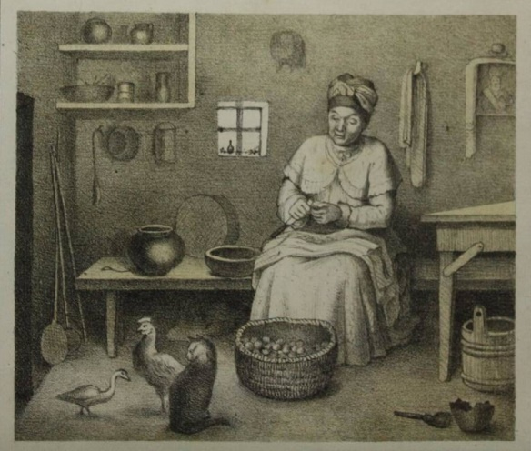

Ugly Duckling with the old woman, cat, and hen. From the first Ukrainian translation of Hans Christian Andersen’s fairy tales, by Mykola Murashko, 1873.

And the Cat said, "Can you curve your back, and purr, and give out sparks?"

"No."

"Then you will please have no opinion of your own when sensible folks are speaking!"

And the Duckling sat in a corner and was in low spirits; then he began to think of the fresh air and the sunshine; and he was seized with such a strange longing to swim on the water, that he could not help telling the Hen of it.

"What are you thinking of?" cried the Hen. "You have nothing to do, that's why you have these fancies. Lay eggs, or purr, and they will pass over."

"But it is so charming to swim in the water," said the Duckling, "so nice to feel it go over one's head, and to dive down to the bottom!"

"Yes, that's a fine thing, truly," said the Hen. "You are clean gone crazy. Ask the Cat about it,--he's the cleverest thing I know,--ask him if he likes to swim in the water, or to dive down: I won't speak about myself. Ask our mistress herself, the old woman; no one in the world knows more than she does. Do you think she wants to swim, and let the water close above her head?"

"You don't understand me," said the Duckling.

"We don't understand you! Then pray who is to understand you? You surely don't pretend to be cleverer than the Cat and the woman--I won't say anything of myself. Don't make a fool of yourself, child, and thank your Maker for all the good you have. Are you not come into a warm room, and have you not folks about you from whom you can learn something? But you are a goose, and it is not pleasant to have you about. You may believe me, I speak for your good. I tell you things you won't like, and by that, one may always know one's true friends! Only take care that you learn to lay eggs, or to purr, and to give out sparks!"

"I think I will go out into the wide world," said the Duckling.

"Yes, do go," replied the Hen.

And so the Duckling went away. He swam on the water, and dived, but he was shunned by every creature because he was so ugly.

### What Became Of The Duckling

Now came the fall of the year. The leaves in the wood turned yellow and brown; the wind caught them so that they danced about, and up in the air it was very cold. The clouds hung low, heavy with hail and snow-flakes, and on the fence stood the raven, crying "Croak! croak!" for mere cold; yes, one could freeze fast if one thought about it. The poor little Duckling certainly had not a good time. One evening--the sun was just going down in fine style--there came a whole flock of great handsome birds out of the bushes; they were shining white, with long, supple necks; they were swans. They uttered a very strange cry, spread forth their glorious great wings, and flew away from that cold region to warmer lands, to fair open lakes. They mounted so high, so high! And the ugly Duckling had such a strange feeling as he saw them! He turned round and round in the water like a wheel, stretched out his neck toward them, and uttered a cry so high, so strange, that he was frightened as he heard it.

Oh! he could not forget those beautiful, happy birds; and as soon as he could see them no longer, he dived down to the very bottom, and when he came up again, he was quite beside himself. **He did not know what the birds were, nor where they were flying to; but he loved them more than he had ever loved anyone.** He did not envy them at all. How could he think of wishing to have such loveliness as they had? He would have been glad if only the ducks would have let him be among them--the poor, ugly creature!

And the winter grew so cold, so cold! The Duckling had to swim about in the water, to keep it from freezing over; but every night the hole in which he swam about became smaller and smaller. It froze so hard that the icy cover sounded, and the Duckling had to use his legs all the time to keep the hole from freezing tight. At last he became worn out, and lay quite still, and thus froze fast in the ice.

Early in the morning, a peasant came by and found him there; he took his wooden shoe, broke the ice to pieces, and carried the Duckling home to his wife. Then the Duckling came to himself again. The children wanted to play with him; but he thought they wanted to hurt him, and in his terror he flew up into the milk-pan, so that the milk spilled over into the room. The woman screamed and shook her hand in the air, at which the Duckling flew down into the tub where they kept the butter, and then into the meal-barrel and out again. How he looked then! The woman screamed, and struck at him with the fire tongs; the children tumbled over one another as they tried to catch the Duckling; and they laughed and they screamed!--well was it that the door stood open, and the poor creature was able to slip out between the bushes into the newly-fallen snow--there he lay quite worn out.

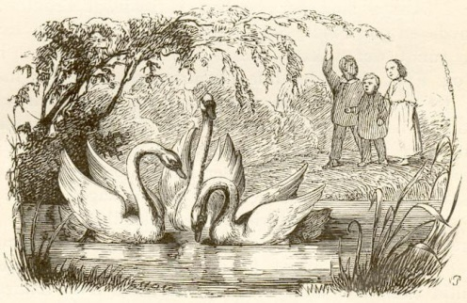

The Swans. Illustration by Vilhelm Pedersen, Andersen’s first illustrator, 1843.

But it would be too sad if I were to tell all the misery and care which the Duckling had to bear in the hard winter. He lay out on the moor among the reeds, when the sun began to shine again and the larks to sing; it was a beautiful spring.

Then all at once, the Duckling could flap his wings: they beat the air more strongly than before, and bore him stoutly away; and before he well knew it, he found himself in a great garden, where the elder-trees stood in flower and bent their long green branches down to the winding canal, and the lilacs smelt sweet. Oh, here it was beautiful, fresh, and springlike! And from the thicket came three glorious white swans; they rustled their wings, and sat lightly on the water. The Duckling knew the splendid creatures, and felt a strange sadness.

"I will fly away to them, to the royal birds! And they will beat me, because I, that am so ugly, dare to come near them. But it is all the same. Better to be killed by them than to be chased by ducks, and beaten by fowls, and pushed about by the girl who takes care of the poultry yard, and to suffer hunger in winter!" And he flew out into the water, and swam toward the beautiful swans; these looked at him, and came sailing down upon him with outspread wings. "Kill me!" said the poor creature, and bent his head down upon the water, and waited for death. But what saw he in the clear water? He saw below him his own image; and lo! It was no longer a clumsy dark-gray bird, ugly and hateful to look at, but--a swan!

It matters nothing if one is born in a duck-yard, if one has only lain in a swan's egg.

He felt quite glad at all the need and hard times he had borne; now he could joy in his good luck in all the brightness that was round him. And the great swans swam round him and stroked him with their beaks.

Into the garden came little children, who threw bread and corn into the water; and the youngest cried, "There is a new one!" and the other children shouted, "Yes, a new one has come!" And they clapped their hands and danced about, and ran to their father and mother; and bread and cake were thrown into the water; and they all said, "The new one is the most beautiful of all! So young and so handsome!" and the old swans bowed their heads before him.

Then he felt quite ashamed, and hid his head under his wings, for he did not know what to do; he was so happy, and yet not at all proud, for **a good heart is never proud**. He thought how he had been driven about and mocked and despised; and now he heard them all saying that he was the most beautiful of all beautiful birds. And the lilacs bent their branches straight down into the water before him, and the sun shone warm and mild. Then his wings rustled, he lifted his slender neck, and cried from the depths of his heart:--

"I never dreamed of so much happiness when I was the Ugly Duckling."

### Food for Thought

* You might have come across acquaintances with some unfortunate social position or abnormal physical or behavioral characteristic. You often made fun of them; your ‘easy targets’, just for the sake of it, or maybe, out of malice.
  + What impressions could possibly accumulate in their beings as time passes? Would they carefully nurture hatred, waiting for ‘their day’?
* If you are on the receiving side, is there a better way out? Perhaps you could focus on improvement of your position instead of nurturing hatred?
  + And if you reach a favorable condition through such self-effort, would you prefer to vent out your bitterness on those ignorant ones, or show magnanimity and let go?

### References

The Ugly Duckling, From 'Riverside Literature Series’: 1891. Part of ‘Library Of The World’s Best Literature Ancient And Modern’, edited by Charles Dudley Warner, Connoisseur Edition Vol. II, 1896.

What Is Godlike? From The Jatakas

Complexity: Low

Jatakas are tales of the Bodhisattva, narrated by Buddha to his disciples. The stories were written around 4th Century BCE. Bodhisattva refers to the Buddha in his previous human or animal lives, reaching the final enlightened state through noble deeds done then.

This is a story about relationship between three brothers and a demon’s question: “What is Godlike?”

This story was told by the Blessed One while at Jetavana, about a wealthy Brother.

Tradition tells us that, upon the death of his wife, a squire of Savatthi[22] joined the Brotherhood[23]. At the time of joining, he built for himself a chamber to live in, a room for the fire, and a store-room; and not till he had stocked his store-room with ghee[24], rice, and the like, did he finally join. Even after he had become a brother, he used to send for his servants and make them cook for him whatever he liked to eat. He was richly provided with the requisites[25], — having an entire change of clothing for night and another for day; and he dwelt aloof on the outskirts of the monastery.

One day, when he had taken out his cloths[26] and bedding and had spread them out to dry in his chamber, a number of Brethren from the country, who were on a pilgrimage from monastery to monastery, came in their journeying to his cell and found all these belongings.

"Whose are these?" they asked. "Mine, sirs," he replied. "What, sir?" they cried; "this upper-cloth and that as well; this under-cloth as well as that; and that bedding too, — is it all yours?" "Yes, nobody's but mine." "Sir," said they, "the Blessed One has only sanctioned three cloths; and yet, though the Buddha, to whose doctrine you have devoted yourself, is so simple in his wants, you forsooth have amassed all this stock of requisites. Come! We must take you before the Lord of Wisdom." And, so saying, they went off with him to the Master.

Becoming aware of their presence, the Master said, "For what reason is it, Brethren, that you have brought the Brother against his will?" "Sir, this Brother is well-off and has quite a stock of requisites." "Is it true, Brother, as they say, that you are so well-off?" "Yes, Blessed One." "But why, Brother, have you amassed these belongings? Do not I extol the virtues of wanting little, contentment, and so forth, solitude, and determined resolve?"

Angered by the Master's words, he cried, — "Then I'll go about like this!" And, flinging off his outer clothing, he stood in their midst clad only in his waist-cloth.

Then, as a moral support to him, the Master said, "Was it not you, Brother, who in bygone days were a seeker of shyness that is afraid of sin, and even when you were a water-demon, you lived for twelve years seeking that shyness?[27] How then is it that, after vowing to follow the weighty doctrine of the Buddha, you have flung off your outer robes and stand here devoid of shame?"

At the Master's word, his sense of shame was restored; he donned his robes again, and, saluting the Master, seated himself at the side.

The Brethren having asked the Blessed One to explain to them the matter he had mentioned, the Blessed One made clear what had been concealed from them due to re-birth.

Once upon a time Brahmadatta was reigning in Benares in Kasi[28]. The Bodhisattva, having born in those days as the king's son by the queen, was duly named Prince Mahimsasa. By the time he could run about, a second son was born to the king, and the name they gave this child was Prince Chandra[29]; but by the time he could run about, the Bodhisattva's mother died. Then the king took another queen, who was his joy and delight; and their love was crowned with the birth of yet another prince, whom they named Prince Surya[30]. In his joy at the birth of the boy, the king promised to grant her any boon she might ask on the child's behalf. But the queen treasured up the promise to be fulfilled at her own good time hereafter. Later, when her son had grown up, she said to the king, "Sire, when my boy was born, you granted me a boon to ask for him. Let him be king."

"Nay," said the king; "two sons have I, radiant as flaming fires; I cannot give the kingdom to your son."' But when he saw that, undaunted by this refusal, the queen kept plaguing him time after time, to grant her request; the king, fearing lest the woman should plot evil against his sons, sent for them and said, "My children, when Prince Surya was born, I granted a boon; and now his mother wants the kingdom for him. I have no wish to give him the kingdom, but women are naturally wicked, and she will be plotting evil against you. You had better retire to the forest, to return at my death to rule the city which belongs by right to our house." So saying, with tears and lamentations, the king kissed his two sons on the head and sent them forth.

As the princes were leaving the palace after their adieux to their father, who should see them but Prince Surya himself, who was playing in the courtyard? And no sooner did he learn what was the matter than he made up his mind to go with his brothers. So he too went off in their company.

The three came to the region of the Himalayas; and here the Bodhisattva (Prince Mahimsasa), who had turned aside from the road and was sitting at the foot of a tree, said to Prince Surya, "Run down to that distant pool. Surya dear; drink and bathe there; and then bring us too some water back in a lotus-leaf."

Now that pool had been delivered over to a certain water-sprite by Vessavana[31] who said to him, "With the exception of one who knows what is truly godlike, all that go down into this pool are yours to devour. Over those that do not enter the waters, you have no power granted to you."

And thenceforth the water-sprite used to ask all who went down into the pool what was truly godlike, devouring everyone who did not know.

Now it was into this pool that Prince Surya went down, quite unsuspiciously, with the result that he was seized by the water-sprite, who said to him, "Do you know what is truly godlike?" "O yes," said he, "the sun and moon." "You do not know," said the monster, and hauling the prince down into the depths of the water, imprisoned him there in his own abode. Finding that his brother was a long time gone, the Bodhisattva sent Prince Chandra. He too was seized by the water-sprite and asked whether he knew what was truly godlike. "Oh yes, I know," said he, "the four quarters of heaven are." "You do not know," said the water-sprite as he hauled this second victim off to the same prison-house.

Finding that this second brother tarried long too, the Bodhisattva felt sure that something had happened to them. So away he went after them and tracked their footsteps down into the water. Realising at once that the pool must be the domain of a water-sprite, he girded on his sword and took his bow in his hand, and waited. Now, when the demon found that the Bodhisattva had no intention of entering the water, he assumed the shape of a forester, and in this guise he thus addressed the Bodhisattva: "You're tired with your journey, mate; why don't you go in and have a bathe and a drink, and deck yourself with lotuses? You would travel on comfortably afterwards." Recognising him at once for a demon, the Bodhisattva said, "It is you who have seized my brothers." "Yes, it was," was the reply. "Why?" "Because all who go down into this pool belong to me." "What, all?" "Not those who know what is truly godlike; all save these are mine." "And do you want to know the godlike?" "I do." "If this be so, I will tell you what is truly godlike." "Do so, and I will listen."

"I should like to begin," said the Bodhisattva, "but I am travel-stained with my journey." Then the water-sprite bathed the Bodhisattva, and gave him food to eat and water to drink, decked him with flowers, sprinkled him with scents, and laid out a couch for him in the midst of a gorgeous pavilion. Seating himself on this couch, and making the water-sprite sit at his feet, the Bodhisattva said, "Listen then and you shall hear what the truly godlike is." And he repeated this stanza: —

Those only 'godlike' call who shrink from sin.

The white-souled tranquil votaries of Good.

And when the demon heard this, he was pleased, and said to the Bodhisattva, "Man of wisdom, I am pleased with you, and give you up one of your brothers. Which shall I bring?" "The youngest." "Man of wisdom, though you know so well what the truly godlike is, you don't act on your knowledge." "How so?" "Why, you take the younger in preference to the elder, without regard to his seniority." "Demon, I not only know but practise the godlike. It was on this boy's account that we sought refuge in the forest; it was for him that his mother asked the kingdom from our father, and our father, refusing to fulfil her demand, consented to our flight to the refuge of the forest. With us came this boy, never thought of turning back again. Not a soul would believe me if I were to say that he had been devoured by a demon in the forest; and it is the fear of odium that impels me to demand him at your hands."

"Excellent! Excellent! O man of wisdom," cried the demon in approval, "you not only know but practise the godlike." And in token of his pleasure and approval he brought forth the two brothers and gave them both to the Bodhisattva.

Then said the latter to the water-sprite, "Friend, it is in consequence of your own evil deeds in times past that you have now been born a demon subsisting on the flesh and blood of other living creatures; and in this present birth too you are continuing to do evil. This evil conduct will forever bar you from escaping re-birth in hell and the other evil states. Wherefore, from this time forth renounce evil and live virtuously."

Having worked the demon's conversion, the Bodhisattva continued to dwell at that spot under his protection, until one day he read in the stars that his father was dead. Then taking the water-sprite with him, he returned to Benares and took possession of the kingdom, making Prince Chandra his viceroy and Prince Surya his generalissimo. For the water-sprite, he made a home in a pleasant spot and took measures to ensure his being provided with the choicest garlands, flowers, and food. He himself ruled in righteousness until he **passed away to fare according to his deeds**.

His lesson ended, the Master preached the Truths, at the close whereof that Brother won the Fruit of the First Path.[32] And the All-knowing Buddha, having told the two stories, made the connection linking the two together, and identified the Birth, by saying, "The well-to-do Brother was the water-demon of those days; Ananda was Prince Surya, Sariputta Prince Chandra, and I myself the eldest brother, Prince Mahimsasa."

### Food for Thought

* Religions like Buddhism or Hinduism believe in rebirth in surroundings depending upon good or bad deeds done in previous lives. Others like Christianity and Islam do not mention rebirth, and talk about judgment day where one gets rewards or punishment based on good or bad deeds done when alive.
  + Irrespective of what the **real or full** truth about death and beyond is, most religious schools agree on this one point: *“***One should maintain righteous conduct and stay away from evil.***”* Agree/Disagree?
  + **In most cases practically observed**, it is easy to determine what is good and evil based on common sense. That generally concurs with directives of most religions and common rules of law too. Avoiding theft and violence, serving parents, being compassionate, feeding the hungry, etc. Agree/Disagree?
* Family for most means self, spouse, and children. You might have heard about the institution of joint or undivided families, (though it is getting rarer day by day). Can you try to find more about their benefits, drawbacks, what makes them work, what destroys them? Can the same principles apply to larger societies and nations?

### References

Jatakas or Stories of the Buddha’s Former Births, Vol. 1, translated from Pali by Robert Chalmers, under the editorship of Professor E. B. Oowell, Cambridge 1895.

Caterpillar’s Advice, from Alice In Wonderland

Complexity: Medium

The following is an amusing extract from Lewis Carroll's ‘Alice In Wonderland’. It will introduce you to ‘**Literary Nonsense**’, a category of literature where things that make sense are balanced with others that just do not. The **excellent play of words** is a striking feature of this book. However, it **needs special attention** to enjoy and appreciate such pieces of art, if not exposed to similar ones before.

The story before the below episode goes somewhat like this:

Our little Alice has followed a rabbit down the rabbit hole, and reached a ‘**Wonderland**’. There, she ends up doing crazy things. She drinks potions that make her huge, and eats cakes that make her short. After many funny encounters (including **several changes to her height** in the process) she almost **forgets who she was** originally. Currently she has reached a wood opposite a caterpillar. Her height at this time is **three inches**.

The Caterpillar and Alice looked at each other for some time in silence: at last, the Caterpillar took the hookah out of its mouth, and addressed her in a languid, sleepy voice.

‘Who are *you*?’ said the Caterpillar.

This was not an encouraging opening for a conversation. Alice replied, rather shyly, ‘I—I hardly know, sir, just at present—at least I know who I *was* when I got up this morning, but I think I must have been changed several times since then.’

‘What do you mean by that?’ said the Caterpillar sternly. ‘Explain yourself!’

‘I can’t explain *myself*, I’m afraid, sir,’ said Alice, ‘because I’m not myself, you see.’

‘I don’t see,’ said the Caterpillar.

‘I’m afraid I can’t put it more clearly,’ Alice replied very politely, ‘for I can’t understand it myself to begin with; and being so many different sizes in a day is very confusing.’

‘It isn’t,’ said the Caterpillar.

‘Well, perhaps you haven’t found it so yet,’ said Alice; ‘but when you have to turn into a chrysalis—you will someday, you know—and then after that into a butterfly, I should think you’ll feel it a little queer, won’t you?’

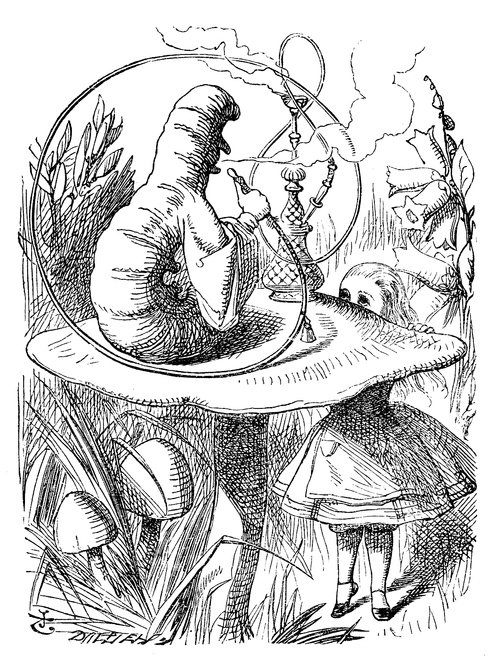

Alice and the Caterpillar, by Sir John Tenniel, circa 1865. The illustration is noted for its ambiguous central figure, whose head can be viewed as being a human male's face with pointed nose and protruding lower lip. Alternatively, it can be considered as the head end of an actual caterpillar, with the right three "true" legs visible. That along with nose and chin being two more of the many legs that a caterpillar has.

‘Not a bit,’ said the Caterpillar.

‘Well, perhaps your feelings may be different,’ said Alice; ‘all I know is, it would feel very queer to *me*.’

‘You!’ said the Caterpillar contemptuously. ‘Who are *you*?’

Which brought them back again to the beginning of the conversation. Alice felt a little irritated at the Caterpillar’s making such *very* short remarks, and she drew herself up and said, very gravely, ‘I think, you ought to tell me who *you* are, first.’

‘Why?’ said the Caterpillar.

Here was another puzzling question; and as Alice could not think of any good reason, and as the Caterpillar seemed to be in a *very* unpleasant state of mind, she turned away.

‘Come back!’ the Caterpillar called after her. ‘I’ve something important to say!’

This sounded promising, certainly: Alice turned and came back again.

‘Keep your temper,’ said the Caterpillar.

‘Is that all?’ said Alice, swallowing down her anger as well as she could.

‘No,’ said the Caterpillar.

Alice thought she might as well wait, as she had nothing else to do, and perhaps after all it might tell her something worth hearing. For some minutes it puffed away without speaking, but at last it unfolded its arms, took the hookah out of its mouth again, and said, ‘So you think you’re changed, do you?’

‘I’m afraid I am, sir,’ said Alice; ‘I can’t remember things as I used—and I don’t keep the same size for ten minutes together!’

‘Can’t remember *what* things?’ said the Caterpillar.

‘Well, I’ve tried to say “How doth the little busy bee,” but it all came different!’ Alice replied in a very melancholy voice.

‘Repeat, “*You are old, Father William*,”[33]’ said the Caterpillar.

Alice folded her hands, and began:—

‘You are old, Father William,’ the young man said,  
‘And your hair has become very white;  
And yet you incessantly stand on your head—  
Do you think, at your age, it is right?’   
  
‘In my youth,’ Father William replied to his son,  
‘I feared it might injure the brain;  
But, now that I’m perfectly sure I have none,  
Why, I do it again and again.’   
  
‘You are old,’ said the youth, ‘as I mentioned before,  
And have grown most uncommonly fat;  
Yet you turned a back-somersault in at the door—  
Pray, what is the reason of that?’   
  
‘In my youth,’ said the sage, as he shook his grey locks,  
‘I kept all my limbs very supple  
By the use of this ointment—one shilling the box—  
Allow me to sell you a couple?’   
  
‘You are old,’ said the youth, ‘and your jaws are too weak  
For anything tougher than suet;  
Yet you finished the goose, with the bones and the beak—  
Pray how did you manage to do it?’   
  
‘In my youth,’ said his father, ‘I took to the law,  
And argued each case with my wife;  
And the muscular strength, which it gave to my jaw,  
Has lasted the rest of my life.’   
  
‘You are old,’ said the youth, ‘one would hardly suppose  
That your eye was as steady as ever;  
Yet you balanced an eel on the end of your nose—  
What made you so awfully clever?’   
  
‘I have answered three questions, and that is enough,’   
Said his father; ‘don’t give yourself airs!  
Do you think I can listen all day to such stuff?  
Be off, or I’ll kick you down stairs!’

‘That is not said right,’ said the Caterpillar.

‘Not *quite* right, I’m afraid,’ said Alice, timidly; ‘some of the words have got altered.’

‘It is wrong from beginning to end,’[34] said the Caterpillar decidedly, and there was silence for some minutes.

The Caterpillar was the first to speak.

‘What size do you want to be?’ it asked.

‘Oh, I’m not particular as to size,’ Alice hastily replied; ‘only one doesn’t like changing so often, you know.’

‘I *don’t* know,’ said the Caterpillar.

Alice said nothing; she had never been so much contradicted in her life before, and she felt that she was losing her temper.

‘Are you content now?’ said the Caterpillar.

‘Well, I should like to be a *little* larger, sir, if you wouldn’t mind,’ said Alice; ‘three inches is such a wretched height to be.’

‘It is a very good height indeed!’ said the Caterpillar angrily, rearing itself upright as it spoke (it was exactly three inches high).

‘But I’m not used to it!’ pleaded poor Alice in a piteous tone. And she thought of herself, ‘I wish the creatures wouldn’t be so easily offended!’

‘You’ll get used to it in time,’ said the Caterpillar; and it put the hookah into its mouth and began smoking again.

This time Alice waited patiently until it chose to speak again. In a minute or two, the Caterpillar took the hookah out of its mouth and yawned once or twice, and shook itself. Then it got down off the mushroom, and crawled away in the grass, merely remarking as it went, ‘One side will make you grow taller, and the other side will make you grow shorter.’

‘One side of *what*? The other side of *what*?’ thought Alice to herself.

‘Of the mushroom,’ said the Caterpillar, just as if she had asked it aloud; and in another moment, it was out of sight.

Alice remained looking thoughtfully at the mushroom for a minute, trying to make out which were the two sides of it; and as it was perfectly round, she found this a very difficult question. However, at last she stretched her arms round it as far as they would go, and broke off a bit of the edge with each hand.

‘And now which is which?’ she said to herself, and nibbled a little of the right-hand bit to try the effect: the next moment she felt a violent blow **underneath her chin: it had struck her foot**!

She was a good deal frightened by this very sudden change, but she felt that there was no time to be lost, as she was shrinking rapidly; so she set to work at once to eat some of the other bit. Her chin was pressed so closely against her foot, that there was hardly room to open her mouth; but she did it at last, and managed to swallow a morsel of the left-hand bit.

‘Come, my head’s free at last!’ said Alice in a tone of delight, which changed into alarm in another moment, when she found that her shoulders were nowhere to be found: all she could see, when she looked down, was an immense length of neck, which seemed to rise like a stalk out of a sea of green leaves that lay far below her.

‘What *can* all that green stuff be?’ said Alice. ‘And where *have* my shoulders got to? And oh, my poor hands, how is it I can’t see you?’ She was moving them about as she spoke, but no result seemed to follow, except a little shaking among the distant green leaves.

As there seemed to be no chance of getting her hands up to her head, she tried to get her head down to them, and was delighted to find that her neck would bend about easily in any direction, like a serpent. She had just succeeded in curving it down into a graceful zigzag, and was going to dive in among the leaves, which she found to be nothing but the tops of the trees under which she had been wandering, when a sharp hiss made her draw back in a hurry; a large pigeon had flown into her face, and was beating her violently with its wings.

‘Serpent!’ screamed the Pigeon.

‘I’m *not* a serpent!’ said Alice indignantly. ‘Let me alone!’

‘Serpent, I say again!’ repeated the Pigeon, but in a more subdued tone, and added with a kind of sob, ‘I’ve tried every way, and nothing seems to suit them!’

‘I haven’t the least idea what you’re talking about,’ said Alice.

‘I’ve tried the roots of trees, and I’ve tried banks, and I’ve tried hedges,’ the Pigeon went on, without attending to her, ‘but those serpents! There’s no pleasing them!’

Alice was more and more puzzled, but she thought there was no use in saying anything more till the Pigeon had finished.

‘As if it wasn’t trouble enough hatching the eggs,’ said the Pigeon; ‘but I must be on the look-out for serpents night and day! Why, I haven’t had a wink of sleep these three weeks!’

‘I’m very sorry you’ve been annoyed,’ said Alice, who was beginning to see its meaning.

‘And just as I’d taken the highest tree in the wood,’ continued the Pigeon, raising its voice to a shriek, ‘and just as I was thinking I should be free of them at last, they must needs come wriggling down from the sky! Ugh, Serpent!’

‘But I’m *not* a serpent, I tell you!’ said Alice. ‘I’m a—I’m a—’

‘Well! *What* are you?’ said the Pigeon. ‘I can see you’re trying to invent something!’

‘I—I’m a little girl,’ said Alice, rather doubtfully, as she remembered the number of changes she had gone through that day.

‘A likely story indeed!’ said the Pigeon in a tone of the deepest contempt. ‘I’ve seen a good many little girls in my time, but never *one* with such a neck as that! No, no! You’re a serpent; and there’s no use denying it. I suppose you’ll be telling me next that you never tasted an egg!’

‘I *have* tasted eggs, certainly,’ said Alice, who was a very truthful child; ‘but little girls eat eggs quite as much as serpents do, you know.’

‘I don’t believe it,’ said the Pigeon; ‘but if they do, why then, they’re a kind of serpent, that’s all I can say.’

This was such a new idea to Alice, that she was quite silent for a minute or two, which gave the Pigeon the opportunity of adding, ‘You’re looking for eggs, I know *that* well enough; and what does it matter to me whether you’re a little girl or a serpent?’

‘It matters a good deal to *me*,’ said Alice hastily; ‘but I’m not looking for eggs, as it happens; and if I was, I shouldn’t want *yours*: I don’t like them raw.’

‘Well, be off, then!’ said the Pigeon in a sulky tone, as it settled down again into its nest. Alice crouched down among the trees as well as she could, for her neck kept getting entangled among the branches, and every now and then she had to stop and untwist it. After a while, she remembered that she still held the pieces of mushroom in her hands, and she set to work very carefully, nibbling first at one and then at the other, and growing sometimes taller and sometimes shorter, until she had succeeded in bringing herself down to her usual height.

It was so long since she had been anything near the right size, that it felt quite strange at first; but she got used to it in a few minutes, and began talking to herself, as usual. ‘Come, there’s half my plan done now! How puzzling all these changes are! I’m never sure what I’m going to be, from one minute to another! However, I’ve got back to my right size: the next thing is, to get into that beautiful garden—how *is* that to be done, I wonder?’ As she said this, she came suddenly upon an open place, with a little house in it about four feet high. ‘Whoever lives there,’ thought Alice, ‘it’ll never do to come upon them *this* size: why, I should frighten them out of their wits!’ So she began nibbling at the right-hand bit again, and did not venture to go near the house till she had brought herself down to nine inches high.

### Food for Thought

* How did you find this account? Funny, Witty, Senseless, Philosophical?
* Can you think of examples of movies or books in which enthusiastic fans uncovered some ‘deep meaning or enlightening concepts’, which probably even their creator never dreamt of?

### References

Chapter 5, Alice’s Adventures in Wonderland, by Lewis Carroll, 1865.

The Happy Prince, by Oscar Wilde

Complexity: Low

This is one of Oscar Wilde’s most beautiful stories, very delicately told. It is about a bird that helps the Happy Prince spread happiness into lives of miserable people in town.

And yes, do not overlook the description of Egypt’s charm therein.

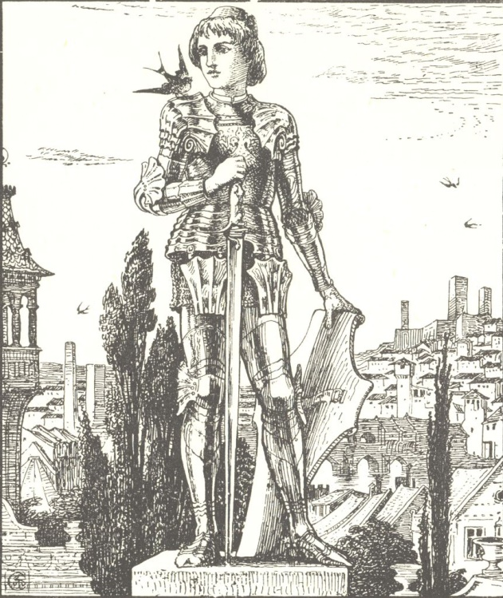

The Happy Prince

High above the city, on a tall column, stood the statue of the Happy Prince. He was gilded all over with thin leaves of fine gold, for eyes he had two bright sapphires, and a large red ruby glowed on his sword-hilt.

He was very much admired indeed. “He is as beautiful as a weathercock,” remarked one of the Town Councillors, who wished to gain a reputation for having artistic tastes; “only not quite so useful,” he added, fearing lest people should think him unpractical, which he really was not.

“Why can’t you be like the Happy Prince?” asked a sensible mother of her little boy who was crying for the moon. “The Happy Prince never dreams of crying for anything.”

“I am glad there is someone in the world who is quite happy,” muttered a disappointed man as he gazed at the wonderful statue.

“He looks just like an angel,” said the Charity Children as they came out of the cathedral in their bright scarlet cloaks and their clean white pinafores.

“How do you know?” said the Mathematical Master, “you have never seen one.”

“Ah! but we have, in our dreams,” answered the children; and the Mathematical Master frowned and looked very severe, for he did not approve of children dreaming.

One night there flew over the city a little Swallow. His friends had gone away to Egypt six weeks before, but he had stayed behind, for he was in love with the most beautiful Reed. He had met her early in the spring as he was flying down the river after a big yellow moth, and had been so attracted by her slender waist that he had stopped to talk to her.

“Shall I love you?” said the Swallow, who liked to come to the point at once, and the Reed made him a low bow. So he flew round and round her, touching the water with his wings, and making silver ripples. This was his courtship, and it lasted all through the summer.

“It is a ridiculous attachment,” twittered the other Swallows; “**she has no money, and far too many relations**”; and indeed the river was quite full of Reeds. Then, when the autumn came, they all flew away.

After they had gone, he felt lonely, and began to tire of his lady-love. “She has no conversation,” he said, “and I am afraid that she is a coquette, for she is always flirting with the wind.” And certainly, whenever the wind blew, the Reed made the most graceful curtseys. “I admit that she is domestic,” he continued, “but I love travelling, and my wife, consequently, should love travelling also.”

“Will you come away with me?” he said finally to her; but the Reed shook her head, she was so attached to her home.

“You have been trifling with me,” he cried. “I am off to the Pyramids. Good-bye!” and he flew away.

All day long he flew, and at night-time he arrived at the city. “Where shall I put up?” he said, “I hope the town has made preparations.”

Then he saw the statue on the tall column.

“I will put up there,” he cried; “it is a fine position, with plenty of fresh air.” So he alighted just between the feet of the Happy Prince.

“I have a golden bedroom,” he said softly to himself as he looked round, and he prepared to go to sleep; but just as he was putting his head under his wing, a large drop of water fell on him. “What a curious thing!” he cried; “there is not a single cloud in the sky, the stars are quite clear and bright, and yet it is raining. The climate in the North of Europe is really dreadful. The Reed used to like the rain, but that was merely her selfishness.”

Then another drop fell.

“What is the use of a statue if it cannot keep the rain off?” he said; “I must look for a good chimney-pot,” and he determined to fly away.

But before he had opened his wings, a third drop fell, and he looked up, and saw—Ah! What did he see?

The eyes of the Happy Prince were filled with tears, and tears were running down his golden cheeks. His face was so beautiful in the moonlight that the little Swallow was filled with pity.

“Who are you?” he said.

“I am the Happy Prince.”

“Why are you weeping then?” asked the Swallow; “you have quite drenched me.”

“When I was alive and had a human heart,” answered the statue, “I did not know what tears were, for I lived in the Palace of Sans-Souci, where sorrow is not allowed to enter. In the daytime I played with my companions in the garden, and in the evening I led the dance in the Great Hall. Round the garden ran a very lofty wall, but I never cared to ask what lay beyond it, everything about me was so beautiful. My courtiers called me the Happy Prince, and happy indeed I was, **if pleasure be happiness**. So I lived, and so I died. And now that I am dead they have set me up here so high that I can see all the ugliness and all the misery of my city, and though my heart is made of lead, yet I cannot choose but weep.”

“What! Is he not solid gold?” said the Swallow to himself. He was too polite to make any personal remarks out loud.

“Far away,” continued the statue in a low musical voice, “far away in a little street there is a poor house. One of the windows is open, and through it I can see a woman seated at a table. Her face is thin and worn, and she has coarse, red hands, all pricked by the needle, for she is a seamstress. She is embroidering passion-flowers on a satin gown for the loveliest of the Queen’s maids-of-honour to wear at the next Court-ball. In a bed in the corner of the room, her little boy is lying ill. He has a fever, and is asking for oranges. His mother has nothing to give him but river water, so he is crying. Swallow, Swallow, little Swallow, will you not bring her the ruby out of my sword-hilt? My feet are fastened to this pedestal and I cannot move.”

“I am waited for in Egypt,” said the Swallow. “My friends are flying up and down the Nile, and talking to the large lotus flowers. Soon they will go to sleep in the tomb of the great King. The King is there himself in his painted coffin. He is wrapped in yellow linen, and embalmed with spices. Round his neck is a chain of pale green jade, and his hands are like withered leaves.”

“Swallow, Swallow, little Swallow,” said the Prince, “will you not stay with me for one night, and be my messenger? The boy is so thirsty and the mother so sad.”

“I don’t think I like boys,” answered the Swallow. “Last summer, when I was staying on the river, there were two rude boys, the miller’s sons, who were always throwing stones at me. They never hit me, of course; we swallows fly far too well for that, and besides, I come of a family famous for its agility; but still, it was a mark of disrespect.”

But the Happy Prince looked so sad that the little Swallow was sorry. “It is very cold here,” he said; “but I will stay with you for one night, and be your messenger.”

“Thank you, little Swallow,” said the Prince.

So the Swallow picked out the great ruby from the Prince’s sword, and flew away with it in his beak over the roofs of the town.

He passed by the cathedral tower, where the white marble angels were sculptured. He passed by the palace and heard the sound of dancing. A beautiful girl came out on the balcony with her lover. “How wonderful the stars are,” he said to her, “and how wonderful is the power of love!”

“I hope my dress will be ready in time for the State-ball,” she answered; “I have ordered passion-flowers to be embroidered on it, but the seamstresses are so lazy.”

He passed over the river, and saw the lanterns hanging to the masts of the ships. He passed over the Ghetto, and saw the old Jews bargaining with each other, and weighing out money in copper scales. At last, he came to the poor house and looked in. The boy was tossing feverishly on his bed, and the mother had fallen asleep, she was so tired. In he hopped, and laid the great ruby on the table beside the woman’s thimble. Then he flew gently round the bed, fanning the boy’s forehead with his wings. “How cool I feel,” said the boy, “I must be getting better”; and he sank into a delicious slumber.

Then the Swallow flew back to the Happy Prince, and told him what he had done. “It is curious,” he remarked, “but I feel quite warm now, although it is so cold.”

“That is because you have done a good action,” said the Prince. And the little Swallow began to think, and then he fell asleep. Thinking always made him sleepy.

When day broke, he flew down to the river and had a bath. “What a remarkable phenomenon,” said the Professor of Ornithology as he was passing over the bridge. “A swallow in winter!” And he wrote a long letter about it to the local newspaper. **Every one quoted it, it was full of so many words that they could not understand**.

“Tonight I go to Egypt,” said the Swallow, and he was in high spirits at the prospect. He visited all the public monuments, and sat a long time on top of the church steeple. Wherever he went the Sparrows chirruped, and said to each other, “What a distinguished stranger!” so he enjoyed himself very much.

When the moon rose, he flew back to the Happy Prince. “Have you any commissions for Egypt?” he cried, “I am just starting.”

“Swallow, Swallow, little Swallow,” said the Prince, “will you not stay with me one night longer?”

“I am waited for in Egypt,” answered the Swallow. “Tomorrow my friends will fly up to the Second Cataract. The river-horse couches there among the bulrushes, and on a great granite throne sits the God Memnon. All night long he watches the stars, and when the morning star shines, he utters one cry of joy, and then he is silent. At noon, the yellow lions come down to the water’s edge to drink. They have eyes like green beryls, and their roar is louder than the roar of the cataract.”

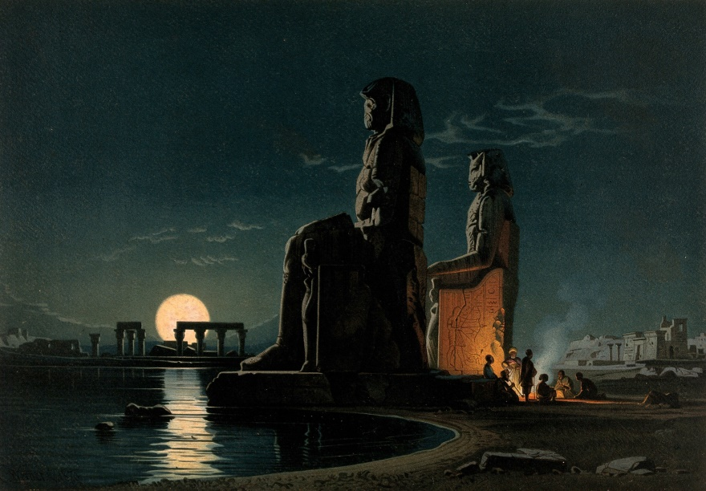

Egypt: the ‘Statues of Memnon’, By Karl Friedrich Heinrich Werner; G. W. Seitz, 1878. Attribution in chapter References.

“Swallow, Swallow, little Swallow,” said the Prince, “far away across the city I see a young man in a garret. He is leaning over a desk covered with papers, and in a tumbler by his side there is a bunch of withered violets. His hair is brown and crisp, and his lips are red as a pomegranate, and he has large and dreamy eyes. He is trying to finish a play for the Director of the Theatre, but he is too cold to write any more. There is no fire in the grate, and hunger has made him faint.”

“I will wait with you one night longer,” said the Swallow, who really had a good heart. “Shall I take him another ruby?”

“Alas! I have no ruby now,” said the Prince; “my eyes are all that I have left. They are made of rare sapphires, which were brought out of India a thousand years ago. Pluck out one of them and take it to him. He will sell it to the jeweller, and buy food and firewood, and finish his play.”

“Dear Prince,” said the Swallow, “I cannot do that”; and he began to weep.

“Swallow, Swallow, little Swallow,” said the Prince, “do as I command you.”

So the Swallow plucked out the Prince’s eye, and flew away to the student’s garret. It was easy enough to get in, as there was a hole in the roof. Through this he darted, and came into the room. The young man had his head buried in his hands, so he did not hear the flutter of the bird’s wings, and when he looked up, he found the beautiful sapphire lying on the withered violets.

“I am beginning to be appreciated,” he cried, “this is from some great admirer. Now I can finish my play,” and he looked quite happy.

The next day the Swallow flew down to the harbour. He sat on the mast of a large vessel and watched the sailors hauling big chests out of the hold with ropes. “Heave a-hoy!” they shouted as each chest came up. “I am going to Egypt”! cried the Swallow, but nobody minded, and when the moon rose he flew back to the Happy Prince.

“I have come to bid you good-bye,” he cried.

“Swallow, Swallow, little Swallow,” said the Prince, “will you not stay with me one night longer?”

“It is winter,” answered the Swallow, “and the chill snow will soon be here. In Egypt, the sun is warm on the green palm-trees, and the crocodiles lie in the mud and look lazily about them. My companions are building a nest in the Temple of Baalbec, and the pink and white doves are watching them, and cooing to each other. Dear Prince, I must leave you, but I will never forget you, and next spring I will bring you back two beautiful jewels in place of those you have given away. The ruby shall be redder than a red rose, and the sapphire shall be as blue as the great sea.”

“In the square below,” said the Happy Prince, “there stands a little match-girl. She has let her matches fall in the gutter, and they are all spoiled. Her father will beat her if she does not bring home some money, and she is crying. She has no shoes or stockings, and her little head is bare. Pluck out my other eye, and give it to her, and her father will not beat her.”

“I will stay with you one night longer,” said the Swallow, “but I cannot pluck out your eye. You would be quite blind then.”

“Swallow, Swallow, little Swallow,” said the Prince, “do as I command you.”

So he plucked out the Prince’s other eye, and darted down with it. He swooped past the match-girl, and slipped the jewel into the palm of her hand. “What a lovely bit of glass,” cried the little girl, and she ran home, laughing.

Then the Swallow came back to the Prince. “You are blind now,” he said, “so I will stay with you always.”

“No, little Swallow,” said the poor Prince, “you must go away to Egypt.”

“I will stay with you always,” said the Swallow, and he slept at the Prince’s feet.

All the next day he sat on the Prince’s shoulder, and told him stories of what he had seen in strange lands. He told him of the red ibises, who stand in long rows on the banks of the Nile and catch gold-fish in their beaks; of the Sphinx, who is as old as the world itself and lives in the desert, and knows everything; of the merchants, who walk slowly by the side of their camels and carry amber beads in their hands; of the King of the Mountains of the Moon, who is as black as ebony and worships a large crystal; of the great green snake that sleeps in a palm-tree and has twenty priests to feed it with honey-cakes; and of the pygmies who sail over a big lake on large flat leaves and are always at war with the butterflies.

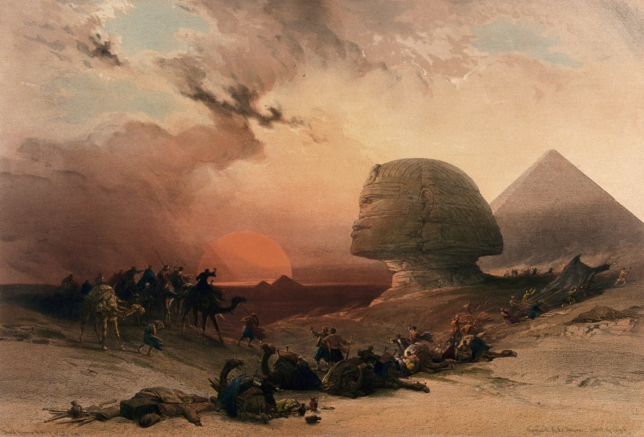

The Simoon (Sandstorm) approaching the Sphinx at sunset, Giza Egypt, by David Roberts, 1838. Attribution in chapter References.

“Dear little Swallow,” said the Prince, “you tell me of marvellous things, but more marvellous than anything is the suffering of men and of women. There is no Mystery as great as Misery. Fly over my city, little Swallow, and tell me what you see there.”

So the Swallow flew over the great city, and saw the rich making merry in their beautiful houses, while the beggars were sitting at the gates. He flew into dark lanes, and saw the white faces of starving children looking out listlessly at the black streets. Under the archway of a bridge, two little boys were lying in one another’s arms trying to keep themselves warm. “How hungry we are!” they said. “You must not lie here,” shouted the Watchman, and they wandered out into the rain.

Then he flew back and told the Prince what he had seen.

“I am covered with fine gold,” said the Prince, “you must take it off, leaf by leaf, and give it to my poor; the living always think that gold can make them happy.”

Leaf after leaf of the fine gold the Swallow picked off, till the Happy Prince looked quite dull and grey. Leaf after leaf of the fine gold he brought to the poor, and the children’s faces grew rosier, and they laughed and played games in the street. “We have bread now!” they cried.

Then the snow came, and after the snow came the frost. The streets looked as if they were made of silver, they were so bright and glistening; long icicles like crystal daggers hung down from the eaves of the houses, everybody went about in furs, and the little boys wore scarlet caps and skated on the ice.

The poor little Swallow grew colder and colder, but he would not leave the Prince, he loved him too well. He picked up crumbs outside the baker’s door when the baker was not looking and tried to keep himself warm by flapping his wings.

But at last he knew that he was going to die. He had just strength to fly up to the Prince’s shoulder once more. “Good-bye, dear Prince!” he murmured, “will you let me kiss your hand?”

“I am glad that you are going to Egypt at last, little Swallow,” said the Prince, “you have stayed too long here; but you must kiss me on the lips, for I love you.”

“It is not to Egypt that I am going,” said the Swallow. “I am going to the House of Death. Death is the brother of Sleep, is he not?”

And he kissed the Happy Prince on the lips, and fell down dead at his feet.

At that moment, a curious crack sounded inside the statue, as if something had broken. The fact is that the leaden heart had snapped right in two. It certainly was a dreadfully hard frost.

Early the next morning, the Mayor was walking in the square below in company with the Town Councillors. As they passed the column, he looked up at the statue: “Dear me! How shabby the Happy Prince looks!” he said.

“How shabby indeed!” cried the Town Councillors, **who always agreed with the Mayor;** and they went up to look at it.

“The ruby has fallen out of his sword, his eyes are gone, and he is golden no longer,” said the Mayor in fact, “he is little better than a beggar!”

“Little better than a beggar,” said the Town Councillors.

“And here is actually a dead bird at his feet!” continued the Mayor. “We must really issue a proclamation that birds are not to be allowed to die here.” And the Town Clerk made a note of the suggestion.

So they pulled down the statue of the Happy Prince. “As he is no longer beautiful he is no longer useful,” said the Art Professor at the University.

Then they melted the statue in a furnace, and the Mayor held a meeting of the Corporation to decide what was to be done with the metal. “We must have another statue, of course,” he said, “and it shall be a statue of myself.”

“Of myself,” said each of the Town Councillors, and they quarrelled. When I last heard of them, they were quarrelling still.

“What a strange thing!” said the overseer of the workmen at the foundry. “This broken lead heart will not melt in the furnace. We must throw it away.” So they threw it on a dust-heap where the dead Swallow was also lying.

“Bring me the two most precious things in the city,” said God to one of His Angels; and the Angel brought Him the leaden heart and the dead bird.

“You have rightly chosen,” said God, “for in my garden of Paradise this little bird shall sing for evermore, and in my city of gold the Happy Prince shall praise me.”

### Food for Thought

* Here is someone doing good deeds simply because it feels nice to do so, even at the cost of life. Not for any benefit of economic or social status, not to repay some old debt, not because people praise benefactors, not even for a good afterlife[35]. Rare isn’t it? Can this state of mind be developed, or it has to be an inborn character trait?

### References

* The Happy Prince And Other Tales, by Oscar Wilde, 1910.
* Egypt, the ‘Statues of Memnon’, See page for author [[CC BY 4.0](http://creativecommons.org/licenses/by/4.0) (http://creativecommons.org/licenses/by/4.0)], [via Wikimedia Commons](https://commons.wikimedia.org/wiki/File%3AEgypt%3B_the_%22statues_of_Memnon%22._Wellcome_V0050139.jpg).
* Sandstorm approaching the sphinx at Gîza at sunset, Egypt. C Wellcome. See page for author [[CC BY 4.0](http://creativecommons.org/licenses/by/4.0) (http://creativecommons.org/licenses/by/4.0)], [via Wikimedia Commons](https://commons.wikimedia.org/wiki/File%3ASandstorm_approaching_the_sphinx_at_G%C3%AEza_at_sunset%2C_Egypt._C_Wellcome_V0049386.jpg).

Rose Of The Evening, a Chinese Fairy Tale

Complexity: Low

This is a love story of Aduan and the Rose Of The Evening. It is among the most idyllic of Chinese art fairy-tales, extremely peaceful and picturesque.

On the fifth day of the fifth month, the festival of the Dragon Junk is held along the *Yangtze-kiang*. A dragon is hollowed out of wood, painted with an armor of scales, and adorned with gold and bright colors. A carved red railing surrounds this ship, and its sails and flags are made of silks and brocade. The after part of the vessel is called the dragon’s tail. It rises ten feet above the water, and a board which floats in the water is tied to it by means of a cloth. Upon this board sit boys who turn somersaults, stand on their heads, and perform all sorts of tricks. Yet, being so close to the water, their danger is very great. It is the custom, therefore, when a boy is hired for this purpose, to give his parents money before he is trained. Then, if he falls into the water and is drowned, no one has him on their conscience. Farther South, the custom differs in so much that instead of boys, beautiful girls are chosen for this purpose.

In *Dschen-Giang* there once lived a widow named *Dsiang*, who had a son called *Aduan*. When he was no more than seven years of age, he was extraordinarily skilful, and no other boy could equal him. And his reputation increasing as he grew, he earned more and more money. So it happened that he was still called upon at the Dragon Junk Festival, when he was already sixteen.

But one day he fell into the water below the Gold Island and was drowned. He was the only son of his mother, and she sorrowed over him, and that was the end of it.

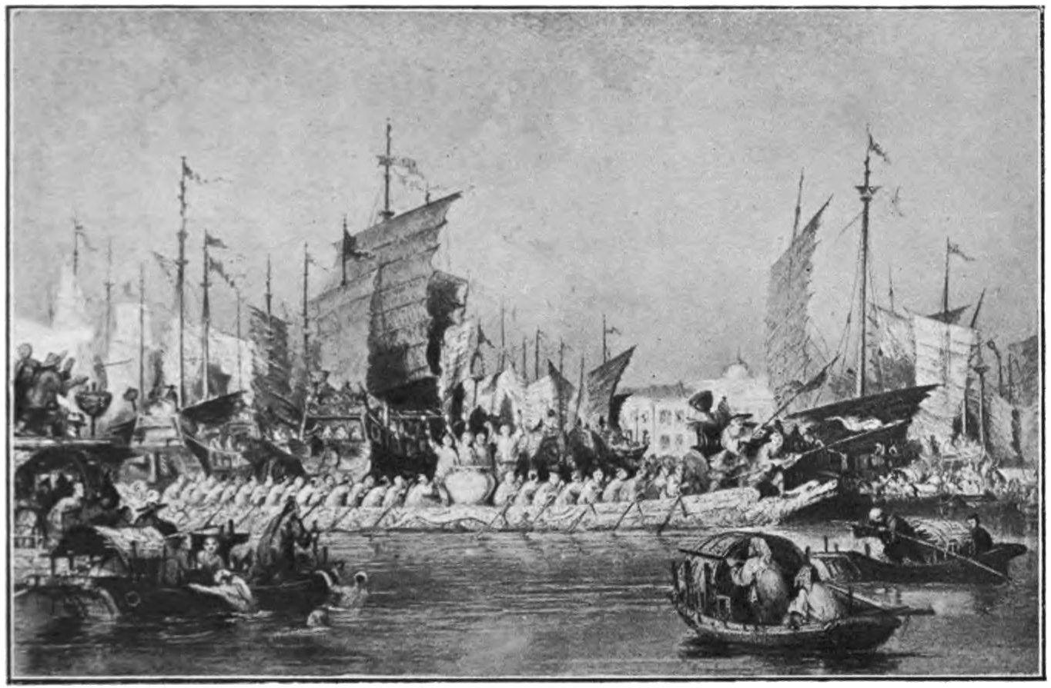

Festival of the Dragon Boat

Yet Aduan did not know that he had been drowned. He met two men who took him along with them, and he saw a new world in the midst of the waters of the Yellow River. When he looked around, the waves of the river towered steeply about him like walls, and a palace was visible, in which sat a man wearing armor and a helmet. His two companions said to him: “That is the Prince of the Dragon’s Cave!” and bade him kneel.

The Prince of the Dragon’s Cave seemed to be of a mild and kindly disposition and said: “We can make use of such a skilful lad. He may take part in the dance of the willow branches!”

So he was brought to a spot surrounded by extensive buildings. He entered and was greeted by a crowd of boys who were all about fourteen years of age.

An old woman came in and they all called out: “This is Mother *Hia*!” And she sat down and had Aduan show his tricks. Then she taught him the dance of the flying thunders of *Tsian-Tang* River, and the music that calms the winds on the sea of *Dung-Ting*. When the cymbals and kettledrums re-echoed through all the courts, they deafened the ear. Then, again, all the courts would fall silent. Mother Hia thought that Aduan would not be able to grasp everything the very first time, so she taught him with great patience. But Aduan had understood everything from the first, and that pleased old Mother Hia. “This boy,” said she, “equals our own Rose of Evening!”

The following day the Prince of the Dragon’s Cave held a review of his dancers. When all the dancers had assembled, the dance of the Ogres was danced first. Those who performed it all wore devil-masks and garments of scales. They beat upon enormous cymbals, and their kettledrums were so large that four men could just about span them. Their sound was like the sound of a mighty thunder, and the noise was so great that nothing else could be heard. When the dance began, tremendous waves spouted up to the very skies, and then fell down again like star-glimmer which scatters in the air.

The Prince of the Dragon Cave hastily bade the dance cease, and had the dancers of the nightingale round step forth. These were all lovely young girls of sixteen. They made a delicate music with flutes, so that the breeze blew and the roaring of the waves was stilled in a moment. The water gradually became as quiet as a crystal world, transparent to its lowest depths. When the nightingale dancers had finished, they withdrew and posted themselves in the western courtyard.

Then came the turn of the swallow dancers. These were all little girls. One among them, who was about fifteen years of age, danced the dance of the giving of flowers with flying sleeves and waving locks. And as their garments fluttered, many-colored flowers dropped from their folds, and were caught up by the wind and whirled about the whole courtyard. When the dance had ended, this dancer also went off with the rest of the girls to the western courtyard. Aduan looked at her from out the corner of his eye, and fell deeply in love with her. He asked his comrades who she might be and they told him she was named “Rose of Evening.”

But the willow-spray dancers were now called out. The Prince of the Dragon Cave was especially desirous of testing Aduan. So Aduan danced alone, and he danced with joy or defiance, according to the music. When he looked up, and when he looked down, his glances held the beat of the measure. The Dragon Prince, enchanted with his skill, presented him with a garment of five colors, and gave him a carbuncle set in golden threads of fish-beard for a hair-jewel. Aduan bowed his thanks for the gift, and then also hastened to the western courtyard. There, all the dancers stood in rank and file. Aduan could only look at Rose of Evening from a distance, but still, Rose of Evening returned his glances.

After a time Aduan gradually slipped to the end of his file and Rose of Evening also drew near to him, so that they stood only a few feet away from each other. But the strict rules allowed no confusion in the ranks, so they could only gaze and let their souls go out to each other.

Now the butterfly dance followed the others. This was danced by the boys and girls together, and the pairs were equal in size, age and the color of their garments. When all the dances had ended, the dancers marched out with the goose-step. The willow-spray dancers followed the swallow dancers, and Aduan hastened in advance of his company, while Rose of Evening lingered along after hers. She turned her head, and when she spied Aduan, she purposely let a coral pin fall from her hair. Aduan hastily hid it in his sleeve.

When he had returned, he was sick with longing and could neither eat nor sleep. Mother Hia brought him all sorts of dainties, looked after him three or four times a day, and stroked his forehead with loving care. But his illness did not yield in the least. Mother Hia was unhappy, and yet helpless.

“The birthday of the King of the *Wu* River is at hand,” said she. “What is to be done?”

In the twilight, there came a boy, who sat down on the edge of Aduan’s bed and chatted with him. He belonged to the butterfly dancers, said he, and asked casually: “Are you sick because of Rose of Evening?” Aduan, frightened, asked him how he came to guess it. The other boy said, with a smile: “Well, because Rose of Evening is in the same situation as yourself.”

Disconcerted, Aduan sat up and begged the boy to advise him. “Are you able to walk?” asked the latter. “If I exert myself,” said Aduan, “I think I could manage it.”

So the boy led him to the South. There, he opened a gate and they turned the corner, to the West. Once more, the doors of the gate flew open, and now Aduan saw a lotus field about twenty acres in size. The lotus flowers were all growing on level earth, and their leaves were as large as mats and their flowers like umbrellas. The fallen blossoms covered the ground beneath the stalks to the depth of a foot or more. The boy led Aduan in and said, “Now, first of all, sit down for a little while!” Then he went away.

After a time a beautiful girl thrust aside the lotus flowers and came into the open. It was Rose of Evening. They looked at each other with happy timidity, and each told the other how they had longed for each other. And they also told each other of their former life. Then they weighted the lotus-leaves with stones so that they made a cozy retreat in which they could be together, and promised to meet each other there every evening. And then they parted.

Aduan came back and his illness left him. From that time on, he met Rose of Evening every day in the lotus field.

After a few days had passed, they had to accompany the Prince of the Dragon Cave to the birthday festival of the King of the Wu River. The festival came to an end, and all the dancers returned home. Only, the King had kept back Rose of Evening and one of the nightingale dancers to teach the girls in his castle.

Months passed and no news came from Rose of Evening, so that Aduan went about full of longing and despair. Now Mother Hia went every day to the castle of the god of the Wu River. So Aduan told her that Rose of Evening was his cousin, and entreated her to take him along with her so that he could at least see her a single time. So she took him along, and let him stay at the lodge-house of the river-god for a few days. But the indwellers of the castle were so strictly watched, that he could not see Rose of Evening even a single time. Sadly, Aduan went back again.

Another month passed and Aduan, filled with gloomy thoughts, wished that death might be his portion.

One day, Mother Hia came to him full of pity, and began to sympathize with him. “What a shame,” said she, “that Rose of Evening has cast herself into the river!”

Aduan was extremely frightened, and his tears flowed resistless. He tore his beautiful garments, took his gold and his pearls, and went out with the sole idea of following his beloved in death. Yet the waters of the river stood up before him like walls, and no matter how often he ran against them, head down, they always flung him back.

He did not dare return, since he feared he might be questioned about his festival garments, and severely punished because he had ruined them. So he stood there and knew not what to do, while the perspiration ran down to his ankles. Suddenly, at the foot of the water-wall he saw a tall tree. Like a monkey, he climbed up to its very top, and then, with all his might, he shot into the waves.

And then, without being wet, he found himself suddenly swimming on the surface of the river. Unexpectedly, the world of men rose up once more before his dazzled eyes. He swam to the shore, and as he walked along the river-bank, his thoughts went back to his old mother. He took a ship and traveled home.

When he reached the village, it seemed to him as though all the houses in it belonged to another world. The following morning he entered his mother’s house, and as he did so, heard a girl’s voice beneath the window saying: “Your son has come back again!” The voice sounded like the voice of Rose of Evening, and when she came to greet him at his mother’s side, sure enough, it was Rose of Evening herself.

And in that hour, the joy of these two who were so fond of each other overcame all their sorrow. But in the mother’s mind sorrow and doubt, terror and joy mingled in constant succession in a thousand different ways.

When Rose of Evening had been in the palace of the river-king, and had come to realize that she would never see Aduan again, she determined to die, and flung herself into the waters of the stream. But she was carried to the surface, and the waves carried and cradled her till a ship came by and took her aboard. They asked whence she came. Now Rose of Evening had originally been a celebrated singing girl of Wu, who had fallen into the river and whose body had never been found. So she thought to herself that, after all, she could not return to her old life again. So she answered: “Madame Dsiang, in Dschen-Giang, is my mother-in-law.” Then the travelers took passage for her in a ship, which brought her to the place she had mentioned. The widow Dsiang first said she must be mistaken, but the girl insisted that there was no mistake and told Aduan’s mother her whole story. Yet, though the latter was charmed by her surpassing loveliness, she feared that Rose of Evening was too young to live a widow’s life. But the girl was respectful and industrious, and when she saw that poverty ruled in her new home, she took her pearls and sold them for a high price. Aduan’s old mother was greatly pleased to see how seriously the girl took her duties.

Now that Aduan had returned again, Rose of Evening could not control her joy. And even Aduan’s old mother cherished the hope that, after all, perhaps her son had not died. She secretly dug up her son’s grave, yet all his bones were still lying in it. So she questioned Aduan. And then, for the first time, the latter realized that he was a departed spirit. Then he feared that Rose of Evening might regard him with disgust because he was no longer a human being. So he ordered his mother on no account to speak of it, and this his mother promised. Then she spread the report in the village that the body which had been found in the river had not been that of her son at all. Yet she could not rid herself of the fear that, since Aduan was a departed spirit, heaven might refuse to send him a child.

In spite of her fear, however, she was able to hold a grandson in her arms in course of time. When she looked at him, he was no different from other children, and then her cup of joy was filled to overflowing.

Rose of Evening gradually became aware of the fact that Aduan was not really a human being. “Why did you not tell me at once?” said she. “Departed spirits who wear the garments of the dragon castle, surround themselves with a soul-casing so heavy in texture that they can no longer be distinguished from the living. And if one can obtain the lime made of dragon-horn, which is in the castle, then the bones may be glued together in such wise that flesh and blood will grow over them again. What a pity that we could not obtain the lime while we were there!”

Aduan sold his pearl, for which a merchant from foreign parts gave him an enormous sum. Thus his family grew very wealthy. Once, on his mother’s birthday, he danced and sang with his wife, in order to please her. The news reached the castle of the Dragon Prince, and he thought to carry off Rose of Evening by force. But Aduan, alarmed, went to the Prince, and declared that both he and his wife were departed spirits. They examined him, and since he cast no shadow, his word was taken, and he was not robbed of Rose of the Evening.

### Food for Thought

* It is good to analyze people and phenomena regularly, learn from them, and use learnings to improve self. But very often, even the strong impressions left behind, have an impact much more than such a conscious analysis. Every other situation need not (perhaps cannot) be analyzed to glean morals from it, right?

### References

The Chinese Fairy Book, Edited by Dr. R. Wilhelm, Translated after original sources by Frederick H. Martens, 1921.

Introducing Tom Sawyer, by Mark Twain

Complexity: Medium

Tom Sawyer is one of Mark Twain’s most popular fictional characters. This imaginative, adventurous twelve year old boy is among the most mischievous kids one will ever come across. Yet, he has a good heart and strong moral conscience. It is probably the unique combination of all these traits that made generations of young readers fall in love with this wonderful creation of the great humorist.

What can be a better introduction to Tom, than these opening chapters of his debut, ‘Adventures Of Tom Sawyer’.

(Note: Readers might need to strain themselves a bit, to enjoy the language employed here. It varies as per character, but clearly enhances the overall humor of the narration.)

### Introducing Tom

TOM!”

No answer.

“TOM!”

No answer.

“What’s gone with that boy, I wonder? You TOM!”

No answer.

The old lady pulled her spectacles down and looked over them about the room; then she put them up and looked out under them. She seldom or never looked through them for so small a thing as a boy; they were her state pair, the pride of her heart, and were **built for “style,” not service**—she could have seen through a pair of stove-lids just as well. She looked perplexed for a moment, and then said, not fiercely, but still loud enough for the furniture to hear:

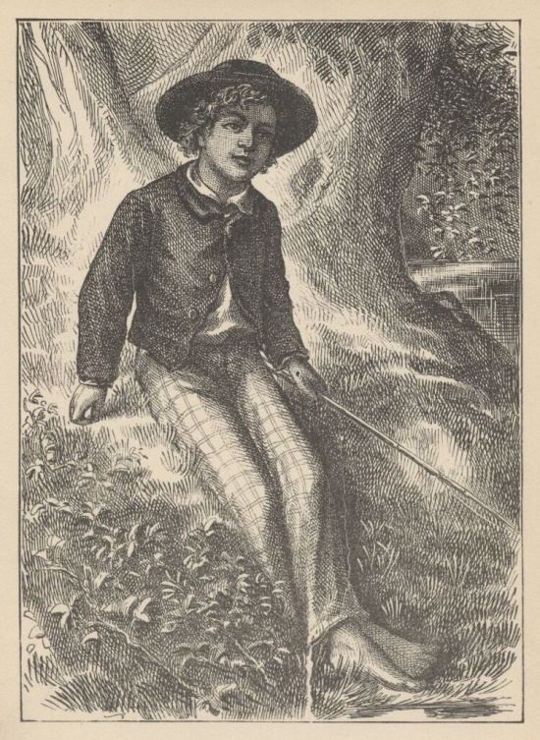

Tom Sawyer fishing.

'

“Well, I lay if I get hold of you, I’ll—”

She did not finish, for by this time she was bending down and punching under the bed with the broom, and so she needed breath to punctuate the punches with. She resurrected nothing but the cat.

“I never did see the beat of that boy!”

She went to the open door and stood in it and looked out among the tomato vines and “jimpson” weeds that constituted the garden. No Tom. So she lifted up her voice at an **angle calculated for distance** and shouted:

“Y-o-u-u TOM!”

There was a slight noise behind her and she turned just in time to seize a small boy by the slack of his roundabout and arrest his flight.

“There! I might ‘a’ thought of that closet. What you been doing in there?”

“Nothing.”

“Nothing! Look at your hands. And look at your mouth. What is that truck?”

“I don’t know, aunt.”

“Well, I know. It’s jam—that’s what it is. Forty times I’ve said if you didn’t let that jam alone I’d skin you. Hand me that switch.”

The switch hovered in the air—the peril was desperate—

“My! Look behind you, aunt!”

The old lady whirled round and snatched her skirts out of danger. The lad fled on the instant, scrambled up the high board-fence, and disappeared over it.

His aunt Polly stood surprised a moment, and then broke into a gentle laugh.

“Hang the boy, can’t I never learn anything? Ain’t he played me tricks enough like that for me to be looking out for him by this time? But old fools is the biggest fools there is. Can’t learn an old dog new tricks, as the saying is. But my goodness, he never plays them alike, two days, and how is a body to know what’s coming? He ‘pears to know just how long he can torment me before I get my dander up, and he knows if he can make out to put me off for a minute or make me laugh, it’s all down again and I can’t hit him a lick. I ain’t doing my duty by that boy, and that’s the Lord’s truth, goodness knows. **Spare the rod and spile the child**, as the Good Book says. I’m a laying up sin and suffering for us both, I know. He’s full of the Old Scratch, but laws-a-me! He’s my own dead sister’s boy, poor thing, and I ain’t got the heart to lash him, somehow. Every time I let him off, my conscience does hurt me so, and every time I hit him, my old heart most breaks. Well-a-well, man that is born of woman is of few days and full of trouble, as the Scripture says, and I reckon it’s so. He’ll play hookey this evening (Southwestern for “afternoon”), and I’ll just be obleeged to make him work, tomorrow, to punish him. It’s mighty hard to make him work Saturdays, when all the boys is having holiday, but he hates work more than he hates anything else, and I’ve got to do some of my duty by him, or I’ll be the ruination of the child.”

Tom did play hookey, and he had a very good time. He got back home barely in season to help Jim, the small colored boy, saw next-day’s wood and split the kindlings before supper—at least he was there in time to tell his adventures to Jim, while Jim did three-fourths of the work. Tom’s younger brother (or rather half-brother), Sid, was already through with his part of the work (picking up chips), for he was a quiet boy, and had no adventurous, troublesome ways.

While Tom was eating his supper, and stealing sugar as opportunity offered, Aunt Polly asked him questions that were full of guile, and very deep—for she wanted to trap him into damaging revealments. Like many other simple-hearted souls, it was her pet vanity to believe she was endowed with a talent for dark and mysterious diplomacy, and she loved to contemplate her most transparent devices as marvels of low cunning. Said she:

“Tom, it was middling warm in school, warn’t it?”

“Yes’m.”

“Powerful warm, warn’t it?”

“Yes’m.”

“Didn’t you want to go in a-swimming, Tom?”

A bit of a scare shot through Tom—a touch of uncomfortable suspicion. He searched Aunt Polly’s face, but it told him nothing. So he said:

“No’m—well, not very much.”

The old lady reached out her hand and felt Tom’s shirt, and said:

“But you ain’t too warm now, though.” And it flattered her to reflect that she had discovered that the shirt was dry without anybody knowing that that was what she had in her mind. But in spite of her, Tom knew where the wind lay now. So he forestalled what might be the next move:

“Some of us pumped on our heads—mine’s damp yet. See?”

Aunt Polly was vexed to think she had overlooked that bit of circumstantial evidence, and missed a trick. Then she had a new inspiration:

“Tom, you didn’t have to undo your shirt collar where I sewed it, to pump on your head, did you? Unbutton your jacket!”

The trouble vanished out of Tom’s face. He opened his jacket. His shirt collar was securely sewed.

“Bother! Well, go ‘long with you. I’d made sure you’d played hookey and been a-swimming. But I forgive ye, Tom. I reckon you’re a kind of a singed cat, as the saying is—better’n you look. This time.”

She was half sorry her sagacity had miscarried, and half glad that Tom had stumbled into obedient conduct for once.

But Sidney said:

“Well, now, if I didn’t think you sewed his collar with white thread, but it’s black.”

“Why, I did sew it with white! Tom!”

But Tom did not wait for the rest. As he went out at the door, he said:

“Siddy, I’ll lick you for that.”

In a safe place Tom examined two large needles that were thrust into the lapels of his jacket, and had thread bound about them—one needle carried white thread and the other black. He said:

“She’d never noticed if it hadn’t been for Sid. Confound it! Sometimes she sews it with white, and sometimes she sews it with black. I wish to gee-miny she’d stick to one or t’other—I can’t keep the run of ‘em. But I bet you, I’ll lam Sid for that. I’ll learn him!”

He was not the Model Boy of the village. He knew the model boy very well though—and loathed him.

Within two minutes, or even less, he had forgotten all his troubles. Not because his troubles were one whit less heavy and bitter to him than a man’s are to a man, but because a new and powerful interest bore them down and drove them out of his mind for the time—just as men’s **misfortunes are forgotten in the excitement of new enterprises**. This new interest was a valued novelty in whistling, which he had just acquired from a negro, and he was suffering to practise it undisturbed. It consisted in a peculiar bird-like turn, a sort of liquid warble, produced by touching the tongue to the roof of the mouth at short intervals in the midst of the music—the reader probably remembers how to do it, if he has ever been a boy. Diligence and attention soon gave him the knack of it, and he strode down the street with his mouth full of harmony and his soul full of gratitude. He felt much as an astronomer feels who has discovered a new planet—no doubt, as far as strong, deep, unalloyed pleasure is concerned, the advantage was with the boy, not the astronomer.

The summer evenings were long. It was not dark yet. Presently Tom checked his whistle. A stranger was before him—a boy a shade larger than himself. A newcomer of any age or either sex was an impressive curiosity in the poor little shabby village of St. Petersburg. This boy was well-dressed, too—well-dressed on a week-day. This was simply astounding. His cap was a dainty thing, his close-buttoned blue cloth roundabout was new and natty, and so were his pantaloons. He had shoes on—and it was only Friday. He even wore a necktie, a bright bit of ribbon. He had a citified air about him that ate into Tom’s vitals. The more Tom stared at the splendid marvel, the higher he turned up his nose at his finery and the shabbier and shabbier his own outfit seemed to him to grow. Neither boy spoke. If one moved, the other moved—but only sidewise, in a circle; they kept face to face and eye to eye all the time. Finally Tom said:

“I can lick you!”

“I’d like to see you try it.”

“Well, I can do it.”

“No you can’t, either.”

“Yes I can.”

“No you can’t.”

“I can.”

“You can’t.”

“Can!”

“Can’t!”

An uncomfortable pause. Then Tom said:

“What’s your name?”

“‘Tisn’t any of your business, maybe.”

“Well I ‘low I’ll make it my business.”

“Well why don’t you?”

“If you say much, I will.”

“Much—much—much. There now.”

“Oh, you think you’re mighty smart, don’t you? I could lick you with one hand tied behind me, if I wanted to.”

“Well why don’t you do it? You say you can do it.”

“Well I will, if you fool with me.”

“Oh yes—I’ve seen whole families in the same fix.”

“Smarty! You think you’re some, now, don’t you? Oh, what a hat!”

“You can lump that hat if you don’t like it. I dare you to knock it off—and anybody that’ll take a dare will suck eggs.”

“You’re a liar!”

“You’re another.”

“You’re a fighting liar and dasn’t take it up.”

“Aw—take a walk!”

“Say—if you give me much more of your sass I’ll take and bounce a rock off’n your head.”

“Oh, of course you will.”

“Well I will.”

“Well why don’t you do it then? What do you keep saying you will for? Why don’t you do it? It’s because you’re afraid.”

“I ain’t afraid.”

“You are.”

“I ain’t.”

“You are.”

Another pause, and more eying and sidling around each other. Presently they were shoulder to shoulder. Tom said:

“Get away from here!”

“Go away yourself!”

“I won’t.”

“I won’t either.”

So they stood, each with a foot placed at an angle as a brace, and both shoving with might and main, and glowering at each other with hate. But neither could get an advantage. After struggling till both were hot and flushed, each relaxed his strain with watchful caution, and Tom said:

“You’re a coward and a pup. I’ll tell my big brother on you, and he can thrash you with his little finger, and I’ll make him do it, too.”

“What do I care for your big brother? I’ve got a brother that’s bigger than he is—and what’s more, he can throw him over that fence, too.” [Both brothers were imaginary.]

“That’s a lie.”

“Your saying so don’t make it so.”

Tom drew a line in the dust with his big toe, and said:

“I dare you to step over that, and I’ll lick you till you can’t stand up. Anybody that’ll take a dare will steal sheep.”

The new boy stepped over promptly, and said:

“Now you said you’d do it, now let’s see you do it.”

“Don’t you crowd me now; you better look out.”

“Well, you said you’d do it—why don’t you do it?”

“By jingo! For two cents I will do it.”

The new boy took two broad coppers out of his pocket and held them out with derision. Tom struck them to the ground. In an instant both boys were rolling and tumbling in the dirt, gripped together like cats; and for the space of a minute they tugged and tore at each other’s hair and clothes, punched and scratched each other’s nose and covered themselves with dust and glory. Presently the confusion took form, and through the fog of battle Tom appeared, seated astride the new boy and pounding him with his fists. “Holler ‘nuff!” said he.

The boy only struggled to free himself. He was crying—mainly from rage.

“Holler ‘nuff!”—and the pounding went on.

At last, the stranger got out a smothered “‘Nuff!” and Tom let him up and said:

“Now that’ll learn you. Better look out who you’re fooling with next time.”

The new boy went off brushing the dust from his clothes, sobbing, snuffling, and occasionally looking back and shaking his head and threatening what he would do to Tom the “next time he caught him out.” To which Tom responded with jeers, and started off in high feather, and as soon as his back was turned the new boy snatched up a stone, threw it and hit him between the shoulders and then turned tail and ran like an antelope. Tom chased the traitor home, and thus found out where he lived. He then held a position at the gate for some time, daring the enemy to come outside, but the enemy only made faces at him through the window and declined. At last the enemy’s mother appeared, and called Tom a bad, vicious, vulgar child and ordered him away. So he went away; but he said he “‘lowed” to “lay” for that boy.

He got home pretty late that night, and when he climbed cautiously in at the window, he uncovered an ambuscade, in the person of his aunt; and when she saw the state his clothes were in, her resolution to turn his Saturday holiday into captivity at hard labor became adamantine in its firmness.

### Whitewashing the Fence

Saturday morning was come, and all the summer world was bright and fresh, and brimming with life. There was a song in every heart; and if the heart was young, the music issued at the lips. There was cheer in every face and a spring in every step. The locust-trees were in bloom, and the fragrance of the blossoms filled the air. Cardiff Hill, beyond the village and above it, was green with vegetation, and it lay just far enough away to seem a Delectable Land, dreamy, reposeful, and inviting.

Tom appeared on the sidewalk with a bucket of whitewash and a long-handled brush. He surveyed the fence, and all gladness left him and a deep melancholy settled down upon his spirit. Thirty yards of board fence nine feet high. Life to him seemed hollow, and existence but a burden. Sighing, he dipped his brush and passed it along the topmost plank; repeated the operation; did it again; compared the insignificant whitewashed streak with the far-reaching continent of unwhitewashed fence, and sat down on a tree-box discouraged. Jim came skipping out at the gate with a tin pail, and singing Buffalo Gals. Bringing water from the town pump had always been hateful work in Tom’s eyes, before, but now it did not strike him so. He remembered that there was company at the pump. White, mulatto, and negro boys and girls were always there waiting their turns, resting, trading playthings, quarrelling, fighting, skylarking. And he remembered that although the pump was only a hundred and fifty yards off, Jim never got back with a bucket of water under an hour—and even then somebody generally had to go after him. Tom said:

“Say, Jim, I’ll fetch the water if you’ll whitewash some.”

Jim shook his head and said:

“Can’t, Mars Tom. Ole missis, she tole me I got to go an’ git dis water an’ not stop foolin’ roun’ wid anybody. She say she spec’ Mars Tom gwine to ax me to whitewash, an’ so she tole me go ‘long an’ ‘tend to my own business—she ‘lowed she’d ‘tend to de whitewashin’.”

“Oh, never you mind what she said, Jim. That’s the way she always talks. Gimme the bucket—I won’t be gone only a minute. She won’t ever know.”

“Oh, I dasn’t, Mars Tom. Ole missis she’d take an’ tar de head off’n me. ‘Deed she would.”

“She! She never licks anybody—whacks ‘em over the head with her thimble,—and who cares for that, I’d like to know. She talks awful, but talk don’t hurt—anyways it don’t if she don’t cry. Jim, I’ll give you a marvel. I’ll give you a white alley!”[36]

Jim began to waver.

“White alley, Jim! And it’s a bully taw.”

“My! Dat’s a mighty gay marvel, I tell you! But Mars Tom I’s powerful ‘fraid ole missis—”

“And besides, if you will I’ll show you my sore toe.”

Jim was only human—this attraction was too much for him. He put down his pail, took the white alley, and bent over the toe with absorbing interest while the bandage was being unwound. In another moment, he was flying down the street with his pail and a tingling rear, Tom was whitewashing with vigor, and Aunt Polly was retiring from the field with a slipper in her hand and triumph in her eye.

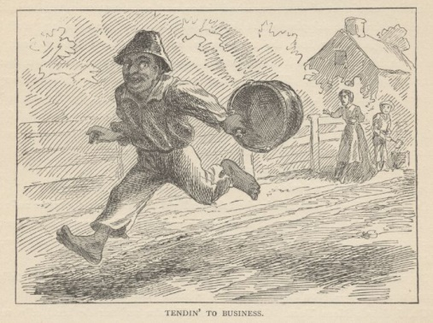

But Tom’s energy did not last. He began to think of the fun he had planned for this day, and his sorrows multiplied. Soon the free boys would come tripping along on all sorts of delicious expeditions, and they would make a world of fun of him for having to work—the very thought of it burnt him like fire. He got out his worldly wealth and examined it—bits of toys, marbles, and trash; enough to buy an exchange of work, maybe, but not half enough to buy so much as half an hour of pure freedom. So he returned his straitened means to his pocket, and gave up the idea of trying to buy the boys. At this dark and hopeless moment, an inspiration burst upon him! Nothing less than a great, magnificent inspiration.

He took up his brush and went tranquilly to work. Ben Rogers hove in sight presently—the very boy, of all boys, whose ridicule he had been dreading. Ben’s gait was the hop-skip-and-jump—proof enough that his heart was light and his anticipations high. He was eating an apple, and giving a long, melodious whoop at intervals, followed by a deep-toned ding-dong-dong, ding-dong-dong, for he was personating a steamboat. As he drew near, he slackened speed, took the middle of the street, leaned far over to starboard and rounded to ponderously and with laborious pomp and circumstance—for he was personating the Big Missouri, and considered himself to be drawing nine feet of water. He was boat and captain and engine-bells combined, so he had to imagine himself standing on his own hurricane-deck giving the orders and executing them:

“Stop her, sir! Ting-a-ling-ling!” The headway ran almost out, and he drew up slowly toward the sidewalk.

“Ship up to back! Ting-a-ling-ling!” His arms straightened and stiffened down his sides.

“Set her back on the stabboard! Ting-a-ling-ling! Chow! ch-chow-wow! Chow!” His right hand, meantime, describing stately circles—for it was representing a forty-foot wheel.

“Let her go back on the labboard! Ting-a-ling-ling! Chow-ch-chow-chow!” The left hand began to describe circles.

“Stop the stabboard! Ting-a-ling-ling! Stop the labboard! Come ahead on the stabboard! Stop her! Let your outside turn over slow! Ting-a-ling-ling! Chow-ow-ow! Get out that head-line! Lively now! Come—out with your spring-line—what’re you about there! Take a turn round that stump with the bight of it! Stand by that stage, now—let her go! Done with the engines, sir! Ting-a-ling-ling! SH’T! S’H’T! SH’T!” (trying the gauge-cocks).

Tom went on whitewashing—paid no attention to the steamboat. Ben stared a moment and then said: “Hi-Yi! You’re up a stump, ain’t you!”

No answer. Tom surveyed his last touch with the eye of an artist, then he gave his brush another gentle sweep and surveyed the result, as before. Ben ranged up alongside of him. Tom’s mouth watered for the apple, but he stuck to his work. Ben said:

“Hello, old chap, you got to work, hey?”

Tom wheeled suddenly and said:

“Why, it’s you, Ben! I warn’t noticing.”

“Say—I’m going in a-swimming, I am. Don’t you wish you could? But of course you’d druther work—wouldn’t you? Course you would!”

Tom contemplated the boy a bit, and said:

“What do you call work?”

“Why, ain’t that work?”

Tom resumed his whitewashing, and answered carelessly:

“Well, maybe it is, and maybe it ain’t. All I know, is, it suits Tom Sawyer.”

“Oh come, now, you don’t mean to let on that you like it?”

The brush continued to move.

“Like it? Well, I don’t see why I oughtn’t to like it. Does a boy get a chance to whitewash a fence every day?”

That put the thing in a new light. Ben stopped nibbling his apple. Tom swept his brush daintily back and forth—stepped back to note the effect—added a touch here and there—criticised the effect again—Ben watching every move and getting more and more interested, more and more absorbed. Presently he said:

“Say, Tom, let me whitewash a little.”

Tom considered, was about to consent; but he altered his mind:

“No—no—I reckon it wouldn’t hardly do, Ben. You see, Aunt Polly’s awful particular about this fence—right here on the street, you know—but if it was the back fence I wouldn’t mind and she wouldn’t. Yes, she’s awful particular about this fence; it’s got to be done very careful; I reckon there ain’t one boy in a thousand, maybe two thousand, that can do it the way it’s got to be done.”

“No—is that so? Oh come, now—lemme just try. Only just a little—I’d let you, if you was me, Tom.”

“Ben, I’d like to, honest injun; but Aunt Polly—well, Jim wanted to do it, but she wouldn’t let him; Sid wanted to do it, and she wouldn’t let Sid. Now don’t you see how I’m fixed? If you was to tackle this fence and anything was to happen to it—”

“Oh, shucks, I’ll be just as careful. Now lemme try. Say—I’ll give you the core of my apple.”

“Well, here—No, Ben, now don’t. I’m afeard—”

“I’ll give you all of it!”

Tom gave up the brush with reluctance in his face, but alacrity in his heart. And while the late steamer Big Missouri worked and sweated in the sun, the retired artist sat on a barrel in the shade close by, dangled his legs, munched his apple, and planned the slaughter of more innocents. There was no lack of material; boys happened along every little while; they came to jeer, but remained to whitewash. By the time Ben was fagged out, Tom had traded the next chance to Billy Fisher for a kite, in good repair; and when he played out, Johnny Miller bought in for a dead rat and a string to swing it with—and so on, and so on, hour after hour. And when the middle of the afternoon came, from being a poor poverty-stricken boy in the morning, Tom was literally rolling in wealth. He had besides the things before mentioned, twelve marbles, part of a jews-harp, a piece of blue bottle-glass to look through, a spool cannon, a key that wouldn’t unlock anything, a fragment of chalk, a glass stopper of a decanter, a tin soldier, a couple of tadpoles, six fire-crackers, a kitten with only one eye, a brass door-knob, a dog-collar—but no dog—the handle of a knife, four pieces of orange-peel, and a dilapidated old window sash.

He had had a nice, good, idle time all the while—plenty of company—and the fence had three coats of whitewash on it! If he hadn’t run out of whitewash, he would have bankrupted every boy in the village.

Tom said to himself that it was not such a hollow world, after all. He had discovered a great law of human action, without knowing it—namely, that in order to make a man or a boy covet a thing, it is only necessary to make the thing difficult to attain. If he had been a great and wise philosopher, like the writer of this book, he would now have comprehended that **Work consists of whatever a body is obliged to do, and that Play consists of whatever a body is not obliged to do**. And this would help him to understand why constructing artificial flowers or performing on a tread-mill is work, while rolling ten-pins or climbing Mont Blanc is only amusement. There are wealthy gentlemen in England who drive four-horse passenger coaches twenty or thirty miles on a daily line, in the summer, because the privilege costs them considerable money; but if they were offered wages for the service, that would turn it into work and then they would resign.

The boy mused awhile over the substantial change which had taken place in his worldly circumstances, and then wended toward headquarters to report.

### Food for Thought

* Would it be a global disaster, if all young readers tried to emulate Tom? Toms are ‘Cool’, but only as long as they are limited; in their mischief, as well as numbers.

### References

Adventures Of Tom Sawyer, by Mark Twain, 1884.

Story of Yamato Take, Japan’s Warrior Prince

Complexity: Low

Following is an adventurous story of Yamato Take (AD 72 - 114), the legendary prince of Japan’s Yamato dynasty. Those were times of heroic Shogun Kings and Samurai warriors. Prince Yamato was a role model for many such Samurais. These experts of martial arts from Japan, the nation of warriors, are admired all over the world.

The insignia of the great Japanese Empire is composed of three treasures, which have been considered sacred, and guarded with jealous care from time immemorial. These are the *Yata-no-Kagami* or the Mirror of Yata, the *Yasakami-no-Magatama* or the Jewel of Yasakami, and the *Murakumo-no-Tsurugi* or the Sword of Murakumo.

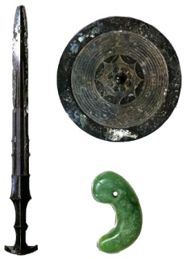

An artist’s impression of the imperial regalia of Japan.

Of these three treasures of the Empire, the sword of Murakumo, afterwards known as *Kusanagi-no-Tsrugi*, or the grass-cleaving sword, is considered the most precious and most highly to be honored, for it is the symbol of strength to this nation of warriors and the talisman of invincibility for the Emperor, while he holds it sacred in the shrine of his ancestors.

Nearly two thousand years ago, this sword was kept at the shrines of *Ite*, the temples dedicated to the worship of *Amaterasu*, the great and beautiful Sun Goddess from whom the Japanese Emperors are said to have descended.

There is a story of knightly adventure and daring that explains why the name of the sword was changed from that of Murakumo to Kasanagi, which means grass clearing.

Once, many, many years ago, a son was born to the Emperor *Keiko*, the twelfth in descent from the great *Jimmu*, the founder of the Japanese dynasty. This Prince was the second son of the Emperor Keiko, and he was named *Yamato*. From his childhood, he proved himself to be of remarkable strength, wisdom, and courage, and his father noticed with pride that he gave a promise of great things, and he loved him even more than he did his elder son.

Now when Prince Yamato had grown to manhood (in the olden days of Japanese history, a boy was considered to have reached man's estate at the early age of sixteen) the realm was much troubled by a band of outlaws whose chiefs were two brothers, *Kumaso* and *Takeru[37]*. These rebels seemed to delight in rebelling against the King, in breaking the laws and defying all authority.

At last King Keiko ordered his younger son Prince Yamato to subdue the brigands and, if possible, to rid the land of their evil lives. Prince Yamato was only sixteen years of age, he had but reached his manhood according to the law, yet though he was such a youth in years, he possessed the dauntless spirit of a warrior of fuller age and knew not what fear was. Even then, there was no man who could rival him for courage and bold deeds, and he received his father's command with great joy.

He got ready to start at once. Great was the stir in the precincts of the Palace as he and his trusty followers gathered together and prepared for the expedition, and polished up their armor and donned it. Before he left his father's court, he went to pray at the shrine of *Ise* and to take leave of his aunt, the Princess Yamato, for his heart was somewhat heavy at the thought of the dangers he had to face, and he felt that he needed the protection of his ancestress, Amaterasu, the Sun Goddess. The Princess, his aunt, came out to give him a glad welcome, and congratulated him on being trusted with so great a mission by his father, the King. She then gave him one of her gorgeous robes as a keepsake to go with him and to bring him good luck, saying that it would surely be of service to him on this adventure. She then wished him all success in his undertaking and bade him good speed.

The young Prince bowed low before his aunt, and received her gracious gift with much pleasure and many respectful bows.

"I will now set out," said the Prince, and returning to the Palace, he put himself at the head of his troops. Thus cheered by his aunt's blessing, he felt ready for all that might befall, and marching through the land he went down to the Southern Island of *Kiushiu*, the home of the brigands.

Before many days had passed, he reached the Southern Island, and then slowly but surely made his way to the headquarters of the chiefs Kumaso and Takeru. He now met with great difficulties, for he found the country exceedingly wild and rough. The mountains were high and steep, the valleys dark and deep, and huge trees and boulders of rock blocked up the road and stopped the progress of his army. It was all but impossible to go on.

Though the Prince was but a youth, he had the wisdom of years, and, seeing that it was vain to try and lead his men further, he said to himself:

"To attempt to fight a battle in this impassable country unknown to my men only makes my task harder. We cannot clear the roads and fight as well. It is wiser for me to resort to a stratagem and come upon my enemies unawares. In that way I may be able to kill them without much exertion."

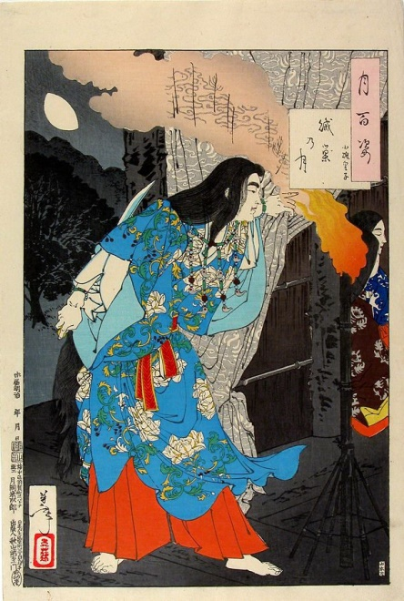

Prince Yamato Take dresses himself as a woman

So he now bade his army halt by the way. His wife, the Princess *Ototachibana*, had accompanied him, and he bade her bring him the robe his aunt, the priestess of Ise, had given him, and to help him attire himself as a woman. With her help he put on the robe, and let his hair down till it flowed over his shoulders. Ototachibana then brought him her comb, which he put in his black tresses, and then adorned himself with strings of strange jewels just as you see in the picture. When he had finished his unusual toilet, Ototachibana brought him her mirror. He smiled as he gazed at himself—the disguise was so perfect.

He hardly knew himself, so changed was he. All traces of the warrior had disappeared, and in the shining surface only a beautiful lady looked back at him.

Thus completely disguised, he set out for the enemy's camp alone. In the folds of his silk gown, next his strong heart, was hidden a sharp dagger.

The two chiefs, Kumaso and Takeru, were sitting in their tent, resting in the cool of the evening, when the Prince approached. They were talking of the news which had recently been carried to them, that the King's son had entered their country with a large army determined to exterminate their band. They had both heard of the young warrior's renown, and for the first time in their wicked lives, they felt afraid. In a pause in their talk, they happened to look up, and saw through the door of the tent a beautiful woman robed in sumptuous garments coming towards them. Like an apparition of loveliness she appeared in the soft twilight. Little did they dream that it was their enemy, whose coming they so dreaded, who now stood before them in this disguise.

"What a beautiful woman! Where has she come from?" said the astonished Kumaso, forgetting war and council and everything as he looked at the gentle intruder.

He beckoned to the disguised Prince and bade him sit down and serve them with wine. Yamato Take felt his heart swell with a fierce glee, for he now knew that his plan would succeed. However, he dissembled cleverly, and putting on a sweet air of shyness, he approached the rebel chief with slow steps and eyes glancing like a frightened deer. Charmed to distraction by the girl's loveliness, Kumaso drank cup after cup of wine for the pleasure of seeing her pour it out for him, till at last he was quite overcome with the quantity he had drunk.

This was the moment for which the brave Prince had been waiting. Flinging down the wine jar, he seized the tipsy and astonished Kumaso and quickly stabbed him to death with the dagger which he had secretly carried hidden in his breast.

Takeru, the brigand's brother, was terror-struck as soon as he saw what was happening and tried to escape, but Prince Yamato was too quick for him. Before he could reach the tent door the Prince was at his heel, his garments were clutched by a hand of iron, a dagger flashed before his eyes, and he lay stabbed to the earth, dying but not yet dead.

"Wait one moment!" gasped the brigand painfully, and he seized the Prince's hand.

Yamato relaxed his hold somewhat and said.

"Why should I pause, you villain?"

The brigand raised himself fearfully and said:

"Tell me from where you come, and whom I have the honor of addressing? Hitherto I believed that my dead brother and I were the strongest men in the land, and that there was no one who could overcome us. Alone you have ventured into our stronghold, alone you have attacked and killed us! Surely you are more than mortal?"

Then the young Prince answered with a proud smile:—"I am the son of the King and my name is Yamato, and I have been sent by my father as the avenger of evil to bring death to all rebels! No longer shall robbery and murder hold my people in terror!" and he held the dagger dripping red above the rebel's head.

"Ah," gasped the dying man with a great effort, "I have often heard of you. You are indeed a strong man to have so easily overcome us. Allow me to give you a new name. From henceforth you shall be known as *Yamato Take*. Our title I bequeath to you as the bravest man in Yamato."

And with these noble words, Takeru fell back and died.

The Prince having thus successfully put an end to his father's enemies in the world, was prepared to return to the capital. On the way back, he passed through the province of *Idum*. Here he met with another outlaw named *Idzumo Takeru,* whom he knew had done much harm in the land. He again resorted to stratagem, and feigned friendship with the rebel under an assumed name. Having done this, he made a sword of wood and jammed it tightly in the shaft of his own strong sword. This he purposely buckled to his side and wore on every occasion when he expected to meet the third robber Takeru.

He now invited Takeru to the bank of the River *Hinokawa*, and persuaded him to try a swim with him in the cool refreshing waters of the river.

As it was a hot summer's day, the rebel was nothing loath to take a plunge in the river; while his enemy was still swimming down the stream, the Prince turned back and landed with all possible haste. Unperceived, he managed to change swords, putting his wooden one in place of the keen steel sword of Takeru.

Knowing nothing of this, the brigand came up to the bank shortly. As soon as he had landed and donned his clothes, the Prince came forward and asked him to cross swords with him to prove his skill, saying:

"Let us two prove which is the better swordsman!"

The robber agreed with delight, feeling certain of victory, for he was famous as a fencer in his province, and he did not know who his adversary was. He seized quickly what he thought was his sword and stood on guard to defend himself. Alas! For the rebel the sword was the wooden one of the young Prince, and in vain Takeru tried to unsheathe it—it was jammed fast, not all his exerted strength could move it. Even if his efforts had been successful, the sword would have been of no use to him for it was of wood. Yamato Take saw that his enemy was in his power, and swinging high the sword he had taken from Takeru, he brought it down with great might and dexterity and cut off the robber's head.

In this way, sometimes by using his wisdom and sometimes by using his bodily strength, and at other times by resorting to craftiness, **which was as much esteemed in those days as it is despised in these**, he prevailed against all the King's foes one by one, and brought peace and rest to the land and the people.

When he returned to the capital, the King praised him for his brave deeds and held a feast in the Palace in honor of his safe coming home, and he was presented with many rare gifts. From this time forth the King loved him more than ever and would not let Yamato Take go from his side, for he said that his son was now as precious to him as one of his arms.

But the Prince was not allowed to live an idle life for long. When he was about thirty years old, news was brought that the *Ainu* race, the aborigines of the islands of Japan, who had been conquered and pushed northwards by the Japanese, had rebelled in the Eastern provinces, and, leaving the vicinity which had been allotted to them, were causing great trouble in the land. The King decided that it was necessary to send an army to battle with them and bring them to reason. But who was to lead the men?

Prince Yamato Take at once offered to go and bring the newly arisen rebels into subjection. Now as the King loved the Prince dearly, and could not bear to have him go out of his sight even for the length of one day, he was of course very loath to send him on his dangerous expedition. But in the whole army there was no warrior so strong or so brave as the Prince, his son, so that His Majesty, unable to do otherwise, reluctantly complied with Yamato's wish.

When the time came for the Prince to start, the King gave him a spear called the *Eight-Arms-Length-Spear of the Holly Tree* (the handle was probably made from the wood of the holly tree), and ordered him to set out to subjugate the Eastern Barbarians as the Ainu were then called.

The Eight-Arms-Length-Spear of the Holly Tree of those old days was prized by warriors just as much as the Standard or Banner is valued by a regiment in these modern days, when given by the King to his soldiers on the occasion of setting out for war.

The Prince respectfully and with great reverence received the King's spear, and leaving the capital, marched with his army to the East. On his way, he first visited all the temples of Ise for worship, and his aunt, the Princess of Yamato and High Priestess, came out to greet him. It was she who had given him her robe, which had proved such a boon to him before, in helping him to overcome and slay the brigands of the West.

He told her all that had happened to him, and of the great part her keepsake had played in the success of his previous undertaking and thanked her very heartily. When she heard that he was starting out once again to do battle with his father's enemies, she went into the temple, and reappeared bearing a sword and a beautiful bag which she had made herself, and which was full of flints, which in those times people used instead of matches for making fire. These she presented to him as a parting gift.

The sword was the sword of Murakumo, one of the three sacred treasures that comprise the insignia of the Imperial House of Japan. No more auspicious talisman of luck and success could she have given her nephew, and she bade him use it in the hour of his greatest need.

Yamato Take now bade farewell to his aunt, and once more placing himself at the head of his men, he marched to the farthest East through the province of *Owari*, and then he reached the province of *Suruga*. Here, the governor welcomed the Prince right heartily and entertained him royally with many feasts. When these were over, the governor told his guest that his country was famous for its fine deer, and proposed a deer hunt for the Prince's amusement. The Prince was utterly deceived by the cordiality of his host, which was all feigned, and gladly consented to join in the hunt.

The governor then led the Prince to a wild and extensive plain where the grass grew high and in great abundance. Quite ignorant that the governor had laid a trap for him with the desire to compass his death, the Prince began to ride hard and hunt down the deer, when all of a sudden, to his amazement, he saw flames and smoke bursting out from the bush in front of him. Realizing his danger, he tried to retreat, but no sooner did he turn his horse in the opposite direction, than he saw that even there the prairie was on fire. At the same time, the grass on his left and right burst into flames, and these began to spread swiftly towards him on all sides. He looked round for a chance of escape. There was none. He was surrounded by fire.

"This deer hunt was then only a cunning trick of the enemy!" said the Prince, looking round on the flames and the smoke that crackled and rolled in towards him on every side. "What a fool I was to be lured into this trap like a wild beast!" and he ground his teeth with rage as he thought of the governor's smiling treachery.

Dangerous as was his situation now, the Prince was not in the least confounded. In his dire extremity he remembered the gifts his aunt had given him when they parted, and it seemed to him as if she must, with prophetic foresight, have divined this hour of need. He coolly opened the flint-bag that his aunt had given him and set fire to the grass near him. Then, drawing the sword of Murakumo from its sheath, he set to work to cut down the grass on either side of him with all speed. **He was determined to die, if that were necessary, fighting for his life and not standing still waiting for death to come to him**.

Strange to say, the wind began to change and to blow from the opposite direction, and the fiercest portion of the burning bush, which had hitherto threatened to come upon him, was now blown right away from him, and the Prince, without even a scratch on his body or a single hair burned, lived to tell the tale of his wonderful escape, while the wind rising to a gale overtook the governor, and he was burned to death in the flames he had set alight to kill Yamato Take.

Now the Prince ascribed his escape entirely to the virtue of the sword of Murakumo, and to the protection of Amaterasu, the Sun Goddess of Ise, who controls the wind and all the elements and insures the safety of all who pray to her in the hour of danger. Lifting the precious sword, he raised it above his head many times in token of his great respect, and as he did this he re-named it *Kusanagi-no-Tsurugi* or the Grass-Cleaving Sword, and the place where he set fire to the grass round him and escaped from death in the burning prairie, he called *Yaidzu*. To this day, there is a spot along the great *Tokaido* railway named Yaidzu, which is said to be the very place where this thrilling event took place.

Thus did the brave Prince Yamato Take escape out of the snare laid for him by his enemy. He was full of resource and courage and finally outwitted and subdued all his foes. Leaving Yaidzu, he marched eastward and came to the shore at *Idzu* from where he wished to cross to *Kadzusa*.

In these dangers and adventures he had been followed by his faithful loving wife, the Princess Ototachibana. For his sake, she counted the weariness of the long journeys and the dangers of war as nothing, and her love for her warrior husband was so great that she felt well repaid for all her wanderings if she could but hand him his sword when he sallied forth to battle, or minister to his wants when he returned weary to the camp.

But the heart of the Prince was full of war and conquest, and he cared little for the faithful Ototachibana. From long exposure in traveling, and from care and grief at her lord's coldness to her, her beauty had faded, and her ivory skin was burnt brown by the sun, and the Prince told her one day that her place was in the Palace behind the screens at home and not with him upon the warpath. But in spite of rebuffs and indifference on her husband's part, Ototachibana could not find it in her heart to leave him. But perhaps it would have been better for her if she had done so, for on the way to Idzu, when they came to *Owari*, her heart was well-nigh broken.

Here dwelt in a Palace shaded by pine-trees and approached by imposing gates, the Princess *Miyadzu*, beautiful as the cherry blossom in the blushing dawn of a spring morning. Her garments were dainty and bright, and her skin was white as snow, for **she had never known what it was to be weary along the path of duty** or to walk in the heat of a summer's sun. And the Prince was ashamed of his sunburnt wife, in her travel-stained garments, and bade her remain behind while he went to visit the Princess Miyadzu. Day after day, he spent hours in the gardens and the Palace of his new friend, thinking only of his pleasure, and caring little for his poor wife, who remained behind to weep in the tent at the misery that had come into her life. Yet she was so faithful a wife, and her character so patient, that she never allowed a reproach to escape her lips, or a frown to mar the sweet sadness of her face, and she was ever ready with a smile to welcome her husband back or usher him forth wherever he went.

At last, the day came when Prince Yamato Take had to depart for Idzu and cross over the sea to Kadzusa, and he bade his wife follow in his retinue as an attendant while he went to take a ceremonious farewell of the Princess Miyadzu. She came out to greet him dressed in gorgeous robes, and she seemed more beautiful than ever, and when Yamato Take saw her he forgot his wife, his duty, and everything except the joy of the idle present, and swore that he would return to Owari and marry her when the war was over. And as he looked up when he had said these words, he met the large almond eyes of Ototachibana fixed full upon him in unspeakable sadness and wonder,and he knew that he had done wrong, but he hardened his heart and rode on, caring little for the pain he had caused her.

When they reached the seashore at Idzu, his men sought for boats in which to cross the straits to Kadzusa, but it was difficult to find enough boats to allow all the soldiers to embark. Then the Prince stood on the beach, and in the pride of his strength, he scoffed and said:

"This is not the sea! This is only a brook! Why do you men want so many boats? I could jump this if I would."

When at last they had all embarked and were fairly on their way across the straits, the sky suddenly clouded and a great storm arose. The waves rose mountains high, the wind howled, the lightning flashed, and the thunder rolled, and the boat which held Ototachibana and the Prince and his men was tossed from crest to crest of the rolling waves, till it seemed that every moment must be their last and that they must all be swallowed up in the angry sea. For *Kin Jin*, the Dragon King of the Sea, had heard Yamato Take jeer and had raised this terrible storm in anger, to show the scoffing Prince how awful the sea could be though it did but look like a brook.

The terrified crew lowered the sails and looked after the rudder, and worked for their dear lives' sake, but all in vain—the storm only seemed to increase in violence, and all gave themselves up for lost. Then the faithful Ototachibana rose, and forgetting all the grief that her husband had caused her, forgetting even that he had wearied of her, in the one great desire of her love to save him, she determined to sacrifice her life to rescue him from death if it were possible.

While the waves dashed over the ship and the wind whirled round them in fury she stood up and said:

"Surely all this has come because the Prince has angered Rin Jin, the God of the Sea, by his jesting. If so, I, Ototachibana, will appease the wrath of the Sea God who desires nothing less than my husband's life!"

Then, addressing the sea, she said:

"I will take the place of His Augustness, Yamato Take. I will now cast myself into your outraged depths, giving my life for his. Therefore hear me and bring him safely to the shore of Kadzusa."

With these words, she leaped quickly into the boisterous sea, and the waves soon whirled her away and she was lost to sight. Strange to say, the storm ceased at once, and the sea became as calm and smooth as the matting on which the astonished onlookers were sitting. The gods of the sea were now appeased, and the weather cleared, and the sun shone as on a summer's day.

Yamato Take soon reached the opposite shore and landed safely, just as his wife Ototachibana had prayed. His prowess in war was marvelous, and he succeeded after some time in conquering the Eastern Barbarians, the Ainu.

He ascribed his safe landing wholly to the faithfulness of his wife, who had so willingly and lovingly sacrificed herself in the hour of his utmost peril. His heart was softened at the remembrance of her, and he never allowed her to pass from his thoughts even for a moment. **Too late had he learned to esteem the goodness of her heart and the greatness of her love for him**.

As he was returning on his homeward way he came to the high pass of the *Usui Toge*, and here he stood and gazed at the wonderful prospect beneath him. The country, from this great elevation, all lay open to his sight, a vast panorama of mountain and plain and forest, with rivers winding like silver ribbons through the land; then far off he saw the distant sea, which shimmered like a luminous mist in the great distance, where Ototachibana had given her life for him, and as he turned towards it he stretched out his arms, and thinking of her love which he had scorned and his faithlessness to her, his heart burst out into a sorrowful and bitter cry:

"*Azuma, Azuma, Ya*!" (Oh! My wife, my wife!) And to this day there is a district in Tokio called Azuma, which commemorates the words of Prince Yamato Take, and the place where his faithful wife leapt into the sea to save him is still pointed out. So, though in life Princess Ototachibana was unhappy, history keeps her memory green, and the story of her unselfishness and heroic death will never pass away.

Yamato Take had now fulfilled all his father's orders, he had subdued all rebels, and rid the land of all robbers and enemies of peace, and his renown was great, for in the whole land there was no one who could stand up against him, he was so strong in battle and wise in council.

He was about to return straight home by the way he had come, when the thought struck him that he would find it more interesting to take another route, so he passed through the province of Owari and came to the province of *Omi*.

When the Prince reached Omi, he found the people in a state of great excitement and fear. In many houses, as he passed along, he saw the signs of mourning and heard loud lamentations. On inquiring the cause of this, he was told that a terrible monster had appeared in the mountains, which came down daily from there and made raids on the villages, devouring whoever he could seize. Many homes had been made desolate and the men were afraid to go out to their daily work in the fields, or the women to go to the rivers to wash their rice.

When Yamato Take heard this his wrath was kindled, and he said fiercely:

"From the western end of *Kiushiu* to the eastern corner of *Yezo* I have subdued all the King's enemies—there is no one who dares to break the laws or to rebel against the King. It is indeed a matter for wonder that here, in this place, so near the capital, a wicked monster has dared to take up his abode and be the terror of the King's subjects. Not long shall it find pleasure in devouring innocent folk. I will start out and kill it at once."

With these words, he set out for the *Ibuki* Mountain, where the monster was said to live. He climbed up a good distance, when all of a sudden, at a winding in the path, a monster serpent appeared before him and stopped the way.

"This must be the monster," said the Prince; "I do not need my sword for a serpent. I can kill him with my hands."

He thereupon sprang upon the serpent and tried to strangle it to death with his bare arms. It was not long before his prodigious strength gained the mastery and the serpent lay dead at his feet. Now a sudden darkness came over the mountain and rain began to fall, so that for the gloom and the rain the Prince could hardly see which way to take. In a short time, however, while he was groping his way down the pass, the weather cleared, and our brave hero was able to make his way quickly down the mountain.

When he got back, he began to feel ill and to have burning pains in his feet, so he knew that the serpent had poisoned him. So great was his suffering that he could hardly move, much less walk, so he had himself carried to a place in the mountains famous for its hot mineral springs, which rose bubbling out of the earth, and almost boiling from the volcanic fires beneath.

Yamato Take bathed daily in these waters, and gradually he felt his strength come again, and the pains left him, till at last, one day, he found with great joy that he was quite recovered. He now hastened to the temples of Ise, where you will remember that he prayed before undertaking this long expedition. His aunt, priestess of the shrine, who had blessed him on his setting out, now came to welcome him back. He told her of the many dangers he had encountered and of how marvelously his life had been preserved through all—and she praised his courage and his warrior's prowess, and then, putting on her most magnificent robes, she returned thanks to their ancestress the Sun Goddess Amaterasu, to whose protection they both ascribed the Prince's wonderful preservation.

Here ends the story of Prince Yamato Take of Japan.

### Food for Thought

* Histories of most nations are woven around kings, battles, and other such heroics. Periods of peaceful and harmonious co-existence, gradual progress in civility, art, science, or trade, are typically not considered key milestones. What do we infer? Have we been perennially engaged in conflicts only? Or do people (also the historians) naturally tend to love romantic descriptions of conflicts?

### References

Japanese Fairy Tales, by Yei Theodora Ozaki, 1908.

Section II – Teens And Youth

Open Window, by H. H. Munro (‘Saki’)

Complexity: Medium

This is an interesting account of Framton Nuttel’s visit to the Sappletons, somewhat scary, somewhat funny. Nuttel had recently come to town for a nerve cure, and wanted to make a few social acquaintances.

“My aunt will be down presently, Mr. Nuttel,” said a very self-possessed young lady of fifteen; “In the meantime you must try and put up with me.”

Framton Nuttel endeavoured to say the correct something that should duly flatter the niece of the moment without unduly discounting the aunt that was to come. Privately, he doubted more than ever whether these formal visits on a succession of total strangers would do much towards helping the nerve cure which he was supposed to be undergoing.

“I know how it will be,” his sister had said when he was preparing to migrate to this rural retreat, “you will bury yourself down there and not speak to a living soul, and your nerves will be worse than ever from moping. I shall just give you letters of introduction to all the people I know there. Some of them, as far as I can remember, were quite nice.”

Framton wondered whether Mrs. Sappleton, the lady to whom he was presenting one of the letters of introduction, came into the nice division.

“Do you know many of the people round here?” asked the niece, when she judged that they had had sufficient silent communion.

“Hardly a soul,” said Framton. “My sister was staying here, at the rectory, you know, some four years ago, and she gave me letters of introduction to some of the people here.”

He made the last statement in a tone of distinct regret.

“Then you know practically nothing about my aunt?” pursued the self-possessed young lady.

“Only her name and address,” admitted the caller. He was wondering whether Mrs. Sappleton was in the married or widowed state. An undefinable something about the room seemed to suggest **masculine habitation**.

“Her great tragedy happened just three years ago,” said the child; “That would be since your sister’s time.”

“Her tragedy?” asked Framton, somehow, in this restful country spot tragedies seemed out of place.

“You may wonder why we keep that window wide open on an October afternoon,” said the niece, indicating a large French window that opened on to a lawn.

“It is quite warm for the time of the year,” said Framton; “but has that window got anything to do with the tragedy?”

“Out through that window, three years ago to a day, her husband and her two young brothers went off for their day’s shooting. They never came back. In crossing the moor to their favourite snipe-shooting ground, they were all three engulfed in a treacherous piece of bog. It had been that dreadful wet summer, you know, and places that were safe in other years gave way suddenly without warning. Their bodies were never recovered. That was the dreadful part of it.” Here the child’s voice lost its self-possessed note and became falteringly human. “Poor aunt always thinks that they will come back some day, they and the little brown spaniel that was lost with them, and walk in at that window just as they used to do. That is why the window is kept open every evening till it is quite dusk. Poor dear aunt, she has often told me how they went out, her husband with his white waterproof coat over his arm, and Ronnie, her youngest brother, singing ‘Bertie, why do you bound?’ as he always did to tease her, because she said it got on her nerves. Do you know, sometimes on still, quiet evenings like this, I almost get a creepy feeling that they will all walk in through that window—”

She broke off with a little shudder. It was a relief to Framton when the aunt bustled into the room with a whirl of apologies for being late in making her appearance.

“I hope Vera has been amusing you?” she said.

“She has been very interesting,” said Framton.

“I hope you don’t mind the open window,” said Mrs. Sappleton briskly; “My husband and brothers will be home directly from shooting, and they always come in this way. They’ve been out for snipe in the marshes today, so they’ll make a fine mess over my poor carpets. So like you men-folk, isn’t it?”

She rattled on cheerfully about the shooting and the scarcity of birds, and the prospects for duck in the winter. To Framton it was all purely horrible. He made a desperate but only partially successful effort to turn the talk on to a less ghastly topic; he was conscious that his hostess was giving him only a fragment of her attention, and her eyes were constantly straying past him to the open window and the lawn beyond. It was certainly an unfortunate coincidence that he should have paid his visit on this tragic anniversary.

“The doctors agree in ordering me complete rest, an absence of mental excitement, and avoidance of anything in the nature of violent physical exercise,” announced Framton, who laboured under the tolerably widespread delusion that total strangers and chance acquaintances are hungry for the least detail of one’s ailments and infirmities, their cause and cure. “On the matter of diet they are not so much in agreement,” he continued.

“No?” said Mrs. Sappleton, in a voice which **only replaced a yawn at the last moment**. Then she suddenly brightened into alert attention—but not to what Framton was saying.

“Here they are at last!” she cried. “Just in time for tea, and don’t they look as if they were muddy up to the eyes!”

Framton shivered slightly and turned towards the niece with a look intended to convey sympathetic comprehension. **The child was staring out through the open window with dazed horror in her eyes**. In a chill shock of nameless fear, Framton swung round in his seat and looked in the same direction.

In the deepening twilight, three figures were walking across the lawn towards the window; they all carried guns under their arms, and one of them was additionally burdened with a white coat hung over his shoulders. A tired brown spaniel kept close at their heels. Noiselessly, they neared the house, and then a hoarse young voice chanted out of the dusk: “I said, Bertie, why do you bound?”

Framton grabbed wildly at his stick and hat; the hall-door, the gravel-drive, and the front gate were dimly-noted stages in his headlong retreat. A cyclist coming along the road had to run into the hedge to avoid an imminent collision.

“Here we are, my dear,” said the bearer of the white mackintosh, coming in through the window, “fairly muddy, but most of it’s dry. Who was that who bolted out as we came up?”

“A most extraordinary man, a Mr. Nuttel,” said Mrs. Sappleton; “Could only talk about his illnesses, and dashed off without a word of good-bye or apology when you arrived. One would think he had seen a ghost.”

“I expect it was the spaniel,” said the niece **calmly,** “he told me he had a horror of dogs. He was once hunted into a cemetery somewhere on the banks of the Ganges by a pack of pariah dogs, and had to spend the night in a newly dug grave with the creatures snarling and grinning and foaming just above him. Enough to make anyone lose their nerve.”

Romance at short notice was her speciality.

### References

Beasts and Super-Beasts by H. H. Munro, Saki, 1914.

Archimedes And The Defense Of Syracuse

Complexity: Medium

This is an account of the siege of Syracuse by the Roman Republic[38] in 214-212 BC, and the battle that ensued. The highlight of this battle was the fortification of the city through innovative machines designed by the great inventor and polymath, Archimedes.

Epicydes and Hippocrates had occupied Syracuse and had alienated the rest of the citizens as well as themselves, from the friendship of Rome.[39] The Romans had already been informed of the murder of Hieronymus, tyrant of Syracuse. They appointed Appius Claudius as Propraetor to command a land force, while Marcus Claudius Marcellus commanded the fleet.[40] These officers took up a position not far from Syracuse, and determined to assault the town from the land at Hexapylus, and by sea at what was called Stoa Scytice in Achradina. Here, the city wall had its foundation close down to the sea. Having prepared their wicker penthouses[41], and darts, and other siege material, they felt confident that, with so many hands employed, they would in five days get their work to such an advanced state as to give them the advantage over enemy.

But in this, they did not take the abilities of Archimedes into account; nor calculate on the truth that, **in certain circumstances, the genius of one man is more effective** than any numbers whatever. However, they now learned it by experience. The city was strong from the fact of its encircling wall lying along a chain of hills with overhanging peaks. The ascent of these peaks was no easy task, even with no one to hinder it, except at certain definite points. Taking advantage of this, Archimedes had constructed defenses both in the town, and at the places where an attack might be made by sea. The defenses were such that the garrison would have everything they might require at any moment at hand, and be ready to meet whatever the enemy might attempt against them, without delay.

The attack began by Appius bringing his pent-houses and scaling ladders, and attempting to fix the latter against the part of the wall adjacent to Hexapylus toward the east. At the same time, Marcus Claudius Marcellus was making a descent upon Achradina with sixty quinqueremes[42]. Each of these vessels was full of men armed with bows and slings and javelins, with which to dislodge those who fought on the battlements.

As well as these vessels, he had eight quinqueremes in pairs. Each pair had their oars removed, one on the larboard and the other on the starboard side[43], and then had been tied together on the sides thus left bare. On these double vessels, rowed by the outer oars of each of the pair, they brought up under the walls some engines called "Sambucae," the construction of which was as follows: A ladder was made four feet broad, and of a height to reach the top of the wall from the place where its foot had to rest; each side of the ladder was protected by a railing, and a covering or pent-house was added overhead. It was then placed so that its foot rested across the sides of the tied-together vessels, which touched each other with its other extremity protruding a considerable way beyond the prows.[44] Pulleys were fixed with ropes on the tops of the mast; and when the engines were about to be used, men standing on the sterns of the vessels drew the ropes tied to the head of the ladder, while others standing on the prows assisted the raising of the machine and kept it steady with long poles.



The Sambuca, a ship-borne siege engine used by the Romans during the siege of Syracuse. One end rests on a pair of quinqueremes (War ships. The second ship is not very clear in the side view), and the other end is raised and rested on the battlement (top of the city wall). Such a ladder is called Sambuca, meaning a “harp” because when the engine is raised, the combination looks like a Harp, the musical instrument. Sometimes, wooden penthouses (shelters) are mounted on the ladders. Rowers sit inside the main structure of the ship. The rows of oars can be seen protruding from the sides of the ship above.

Having then brought the ships close in shore by using the outer oars of both vessels they tried to let the machine down upon the wall. At the head of the ladder was fixed a wooden stage secured on three sides by wicker-shields, upon which stood four men who fought and struggled with those who tried to prevent the Sambuca from being made to rest on the battlements. But when they have fixed it and so got above the level of the top of the wall, the four men unfasten the wicker-shields from either side of the stage and walk out upon the battlements, or towers as the case may be; they are followed by their comrades coming up by the Sambuca, since the ladder's foot is safely secured with ropes and stands upon both the ships. This construction has got the name of "Sambuca," or "Harp," for the natural reason that, when it is raised, the combination of the ship and ladder has very much the appearance of such an instrument.

The Romans were intending to assault the towers with such contrivances and preparations. But Archimedes had constructed catapults to suit every range; and as the ships sailing up were still at a considerable distance, he so wounded the enemy with stones and darts, from the tighter wound and longer engines, as to harass and perplex them to the last degree; and when these began to carry over their heads,[45] he used smaller engines graduated according to the range required from time to time, and by these means caused so much confusion among them as to altogether check their advance and attack; and finally Marcellus was reduced in despair to bringing up his ships under cover of night.

But when they had come close to land, and so too near to be hit by the catapults, they found that Archimedes had prepared another contrivance against the soldiers who fought from the decks. He had pierced the wall as high as a man's stature with numerous loop-holes, which, on the outside, were about as big as the palm of the hand. Inside the wall, he stationed archers and crossbows, or scorpions, and by the volleys discharged through these, he made the marines useless. By these means he not only baffled the enemy, whether at a distance or close at hand, but also killed the greater number of them.

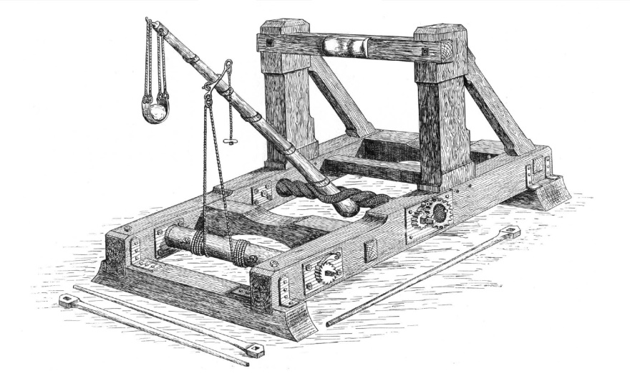

Projectile throwing engine: The Catapult

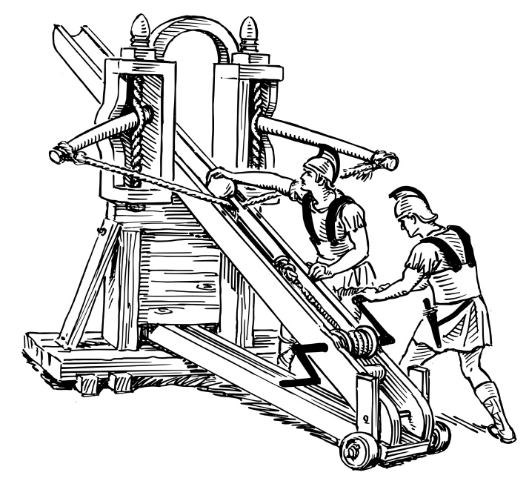

Projectile throwing engine: The Ballista

As often, too, as they tried to work their Sambucae, he had engines ready all along the walls, not visible at other times, but which suddenly reared themselves above the wall from the inside, when the moment for their use had come, and stretched their beams far over the battlements, some of them carrying stones weighing as much as ten talents, and others great masses of lead. So whenever the Sambucae were approaching, these beams swung round on their pivot the required distance, and by means of a rope running through a pulley, dropped the stone upon the Sambucae, with the result that it not only smashed the machine itself to pieces, but put the ship also, and all on board, into the most serious danger[46].

Other machines that he invented were directed against storming parties, advancing under the protection of penthouses. Penthouses were secured by them from being hurt by missiles shot through the walls. Against these he either shot stones big enough to drive the marines from the prow, or let down an iron hand swung on a chain, by which the man who guided the crane, having fastened (the hand, like a hook) on some part of the prow where he could get a hold, pressed down the lever of the machine inside the wall; and when he had thus lifted the prow and made the vessel rest upright on its stern, he fastened the lever of his machine so that it could not be moved; and then suddenly slackened the hand and chain by means of a rope and pulley. The result was that many of the vessels heeled over and fell on their sides, some completely capsized, while the greater number, by their prows coming down suddenly from a height, dipt low in the sea, shipped a great quantity of water and became a scene of the utmost confusion[47].

Though reduced almost to despair by these baffling inventions of Archimedes, and though he saw that all his attempts were repulsed by the garrison with mockery on their part and loss to himself, Marcellus could not yet refrain from making a joke at his own expense. He said that "Archimedes was using his ships to ladle out the sea-water, but that his 'harps' not having been invited to the party were buffeted and turned out with disgrace."[48] Such was the end of the attempt at storming Syracuse by sea.

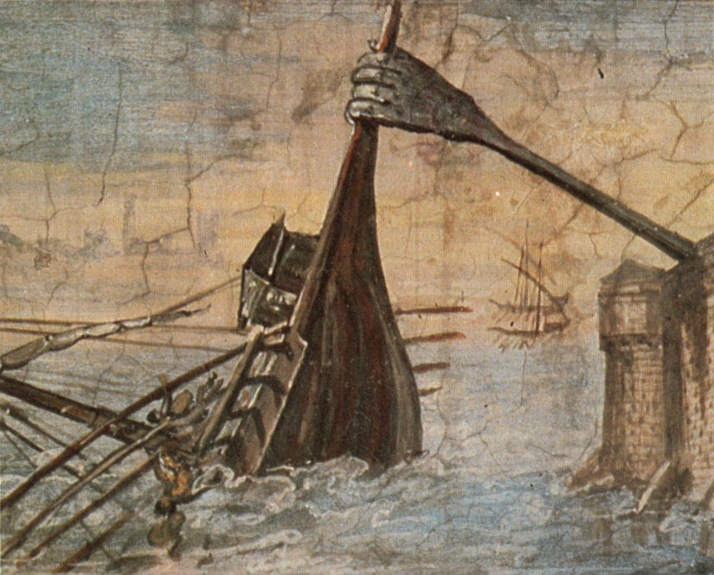

The claw of Archimedes sinking a ship, called the “Iron Hand”.

Nor was Appius Claudius more successful. He, too, was compelled by similar difficulties to desist from the attempt, for while his men were still at a considerable distance from the wall, they began falling by the stones and shots from the engines and catapults. The volleys of missiles, indeed, were extraordinarily rapid and sharp, for their construction had been provided for by all the liberality of a Hiero[49], and had been planned and engineered by the skill of an Archimedes.

Moreover, when they did at length get near the walls, they were prevented from making an assault by the unceasing fire through the loop-holes, which I mentioned before; or if they tried to carry the place under cover of pent-houses, they were killed by the stones and beams let down upon their heads. The garrison also did them no little damage with those hands at the end of their engines, for they used to lift the men, armor, and all, into the air, and then throw them down.

At last, Appius retired into the camp, and summoning the Tribunes to a council of war, decided to try every possible means of taking Syracuse except a storm. And they did carry out this decision, for during the eight months of siege which followed, though there was no stratagem or measure of daring which they did not attempt, they never again ventured to attempt a storm.

So true it is that one man and one intellect, properly qualified for the particular undertaking, is a host in itself, and of extraordinary efficacy. In this instance, at any rate, we find the Romans confident that their forces by land and sea would enable them to become masters of the town, if only one old man could be got rid of; while as long as he remained there, they did not venture even to think of making the attempt, at least by any method which made it possible for Archimedes to oppose them. They believed, however, that their best chance of reducing the garrison was by a failure of provisions sufficient for so large a number as were within the town; they therefore relied upon this hope, and with their ships tried to cut off their supplies by sea, and with their army by land.

### Food for Thought

* The Romans finally succeeded in taking Syracuse. It happened when the people of Syracuse went off-guard on a festival day. Can you comprehend the meaning of the statement “*You are as secure as the weakest link of your security chain*?”
* The Panchatantra says: “*A single royal fortress adds more military force than a thousand elephants or hundred thousand horses. A single archer from a wall can hold a hundred foes at bay.*”[50] Do you believe this to be true in today’s times?
  + Would you consider stocked and fortified bunkers, battle tanks, and other artillery vehicles as modern day fortresses?

### References

Polybius, From Book VIII of the ‘Histories’, translated by Evelyn S. Shuckburgh. Included in ‘The Best Of World Classics, Volume 1 Greece,’ Edited by Henry Cabot Lodge, 1909.

Beethoven, The Master Composer

Complexity: Medium

This biography of Ludwig van Beethoven, the German music composer and pianist, is an extract from Harriette Brower’s, ‘The World’s Great Men Of Music’. Beethoven is among the greatest names in Western art music, along with other icons such as Mozart and Bach. He was a key figure in the transition between Classical[51] and Romantic[52] periods.



Ludwig van Beethoven’s signature.

The Shakespeare of the realm of music, as he has been called, first saw the light on December 16, 1770, in the little University town of Bonn, on the Rhine. His father, Johann Beethoven, belonged to the court band of the Elector of Cologne. The family was extremely poor. The little room where the future great master was born was so low, that a good-sized man could barely stand upright in it. It was very small too, and not very light either, as it was at the back of the building and looked out on a walled garden.

The fame of young Mozart, who was acclaimed everywhere as a marvelous prodigy, had naturally reached the father's ears. He decided to train the little Ludwig as a pianist, so that he should also be hailed as a prodigy and win fame and best of all money for the poverty-stricken family. So the tiny child was made to practice scales and finger exercises for hours together. He was a musically gifted child, but how he hated those everlasting tasks of finger technique, when he longed to join his little companions who could run and play in the sunshine. If he stopped his practice to rest and dream a bit, the stern face of his father would appear at the doorway, and a harsh voice would call out, "Ludwig! What are you doing? Go on with your exercises at once. There will be no soup for you till they are finished."

The father, though harsh and stern, wished his boy to have as thorough a knowledge of music as his means would permit. The boy was also sent to the public school, where he picked up reading and writing, but did not make friends very quickly with the other children. The fact was the child seemed wholly absorbed in music; of music he dreamed constantly; in the companionship of music he never could be lonely.

When Ludwig was nine, his father, regarding him with satisfaction and some pride, declared he could teach him no more—and another master must be found. Those childhood years of hard toil had resulted in remarkable progress, even with the sort of teaching he had received. The circumstances of the family had not improved, for poverty had become acute as the father became more and more addicted to drinking. Just at this time, a new lodger appeared, who was something of a musician and arranged to teach the boy in part payment for his room. Ludwig wondered if he would turn out to be a more severe taskmaster than his father had been. The times and seasons when his instruction was given were at least unusual. Tobias Pfeiffer, as the new lodger was called, soon discovered that father Beethoven generally spent his evenings at the tavern. As an act of kindness, to keep his drunken landlord out of the way of the police, Tobias used to go to the tavern late at night and bring him safely home. Then he would go to the bedside of the sleeping boy and awake him by telling him it was time for practice. The two would go to the living room, where they would play together for several hours, improvising on original themes and playing duets. This went on for about a year; meanwhile, Ludwig studied Latin, French, Italian, and Logic. He also had organ lessons.

Things were going from bad to worse in the Beethoven home, and in the hope of bettering these unhappy conditions, Frau Beethoven undertook a trip through Holland with her boy, hoping that his playing in the homes of the wealthy might produce some money. The tour was successful in that it relieved the pressing necessities of the moment, but the sturdy, independent spirit of the boy showed itself even then. "The Dutch are very stingy, and I shall take care not to trouble them again," he remarked to a friend.

The boy Ludwig could play the organ fairly well, as he had studied it with Christian Neefe, who was organist at the Court church. He also could play the piano with force and finish, read well at sight and knew nearly the whole of Bach's "Well Tempered Clavichord." This was a pretty good record for a boy of 11, who, if he went on as he had begun, it was said, would become a second Mozart.

Neefe was ordered to proceed with the Elector and Court to Münster, which meant to leave his organ in Bonn for a time. Before starting, he called Ludwig to him and told him of his intended absence. "I must have an assistant to take my place at the organ here. Whom do you think I should appoint?" Seeing the boy had no inkling of his meaning, he continued: "I have thought of an assistant, one I am sure I can trust,—and that is you, Ludwig."

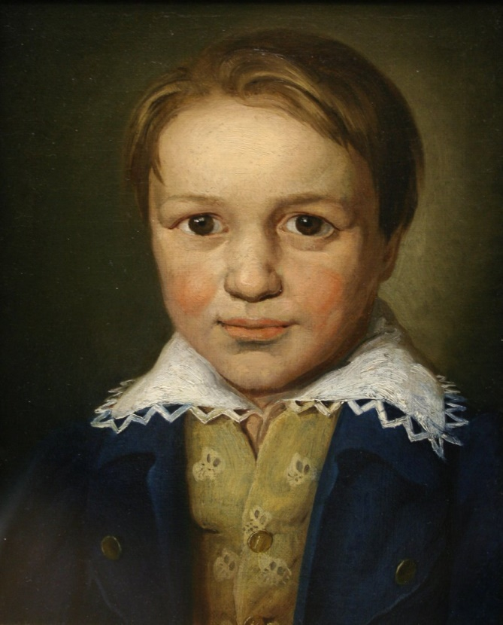

Thirteen year old Beethoven. The painting is described thus: "Ludwig van Beethoven was recognized as a child prodigy. He worked at the age of 13 as an organist, pianist/harpsichordist, and violist at the court in Bonn, and had published three early piano sonatas. This portrait in oils is the earliest authenticated likeness of Beethoven." Circa 1783. For attribution, see References.

The honor was great, for a boy of eleven and a half. To conduct the service and receive the respect and deference due to the position quite overwhelmed the lad. Honors of this kind were very pleasant, but, alas, there was no money attached to the position, and this was what the straitened family needed most sorely. The responsibilities of the position and the confidence of Neefe spurred Ludwig on to a passion of work which nothing could check. He began to compose; three sonatas for the pianoforte were written about this time.

Before completing his thirteenth year, Ludwig obtained his first official appointment from the Elector; he became what is called cembalist in the orchestra, which meant that he had to play the piano in the orchestra, and conduct the band at rehearsals. With this appointment there was no salary attached either, and it was not until a year later when he was made second organist to the Court, under the new Elector, Max Franz, that he began to receive a small salary, equal to about sixty-five dollars a year. We have seen that the straits of the family had not prevented Ludwig from pursuing his musical studies with great ardor. With his present attainments and his ambition for higher achievements, he longed to leave the little town of Bonn, and see something of the great world. Vienna was the center of the musical life of Germany; the boy dreamed of this magical city by day as he went about his routine of work, and by night as he lay on his poor narrow cot. Like Haydn[53], Vienna was the goal of his ambition. When a kind friend, knowing his great longing, came forward with an offer to pay the expenses of the journey, the lad knew his dream was to become a reality. In Vienna he would see the first composers of the day; best of all, he would see and meet the divine Mozart, the greatest of them all.

Ludwig, now seventeen, set out for the city of his dreams with the brightest anticipations. On his arrival in Vienna, he went at once to Mozart's house. He was received most kindly and asked to play, but Mozart seemed preoccupied and paid but little attention. Ludwig, seeing this, stopped playing and asked for a theme on which to improvise. Mozart gave a simple theme, and Beethoven, taking the slender thread, worked it up with so much feeling and power, that Mozart, who was now all attention and astonishment, stepped into the next room, where some friends were waiting for him, and said, "Pay attention to this young man; he will make a noise in the world someday."

Shortly after his return home, he was saddened by the loss of his good, kind, patient mother, and a few months later his little sister Margaretha passed away. No doubt these sorrows were expressed in some of his most beautiful compositions. But brighter days followed the dark ones. He became acquainted with the Breuning family, a widow lady and four children, three boys and a girl, all young people. The youngest boy and the girl became his pupils, and all were very fond of him. He would stay at their house for days at a time, and he was always treated as one of the family. They were cultured people, and in their society, Beethoven's whole nature expanded. He began to take an interest in the literature of his own country and in English authors as well. All his spare time was given to reading and composition.

A valuable acquaintance with the young Count Von Waldstein was made about this time. The Count called one day and found the composer at his old worn out piano, surrounded by signs of abject poverty. It went to his heart to see that the young man, whose music he so greatly admired, should have to struggle for the bare necessities of life while he himself enjoyed every luxury. It seemed to him terribly unjust. He feared to offend the composer's self-respect by sending him money, but shortly after the call, Beethoven was made happy by the gift of a fine new piano, in place of his old one. He was very grateful for this friendship and later dedicated to the Count one of his finest sonatas, the Op. 53, known as the "Waldstein Sonata."

With a view of aiding the growth of the opera and operatic art, the Elector founded a national theater, and Beethoven was appointed viola player in the orchestra besides still being assistant organist in the chapel. In July, 1792, the band arranged a reception for Haydn, who was to pass through Bonn on his way from London, where he had had a wonderful success, to his home in Vienna. Beethoven seized the opportunity to show the master a cantata he had just composed. Haydn praised the work and greatly encouraged the young musician to go forward in his studies. The Elector, hearing of Haydn's words of praise, felt that Beethoven should have the chance to develop his talents, that he might be able to produce greater works. Therefore, he decided to send the young composer, at his own expense, to study strict counterpoint with Haydn. He was now twenty-two, and his already published compositions had brought him considerable fame and appreciation in his vicinity. Now he was to have wider scope for his gifts.

He bade farewell to Bonn in November of this year and set out a second time for the city of his dreams—Vienna. He was never to see Bonn again. He arrived in Vienna comparatively unknown, but his fine piano playing and wonderful gift for improvising greatly impressed all who heard him. He constantly played in the homes of the wealthy aristocracy. Many who heard him play engaged lessons, and he was well on the road to social success. Yet his brusque manners often antagonized his patrons. He made no effort to please or conciliate; he was obstinate and self-willed. In spite of all this, the innate nobleness and truth of his character retained the regard of men and women belonging to the highest ranks of society. With the Prince and Princess Lichnowsky, Beethoven shortly became very intimate and was invited to stay at the Palace. The Princess looked after his personal comfort with as motherly an affection as Madame Breuning had done. The etiquette of the Palace, however, offended Ludwig's love of Bohemianism, especially the dressing for dinner at a certain time. He took to dining at a tavern quite frequently, and finally engaged lodgings. The Prince and his good lady, far from taking offense at this unmannerly behavior, forgave it and always kept for Beethoven a warm place in their hearts, while he, on his part, was sincere in his affection for his kind friends.

Beethoven began his lessons with Haydn, but they did not seem to get on well together. The pupil thought the master did not give him enough time and attention. When Haydn went to England, about a year after the lessons began, Beethoven studied with several of the best musicians of the city, **both in playing and composition**. Albrechtsberger, one of these, was a famous contrapuntist of his time, and the student gained much from his teaching. The young musician was irresistible when he seated himself at the piano to extemporize. "His improvisation was most brilliant and striking," wrote Carl Czerny, a pupil of Beethoven. "In whatever company he might be, he knew how to produce such an effect upon the listeners that frequently **all eyes would be wet**, and some listeners would sob; there was something wonderful in his expressive style, the beauty and originality of his ideas and his spirited way of playing." Strange to say the emotion he roused in his hearers seemed to find no response in Beethoven himself. He would sometimes laugh at it, at other times he would resent it, saying, "We artists don't want tears, we want applause." These expressions, however, only concealed his inner feelings—for he was very sympathetic with those friends he loved. His anger, though sharp, was of short duration, but his suspicions of those whose confidence he had won by his genius and force of character, were the cause of much suffering to himself and others.

Beethoven in appearance was short and stockily built; his face was not at all good looking. It is said he was generally meanly dressed and was homely, but full of nobility, fine feeling, and highly cultivated. The eyes were black and bright, and they dilated, when the composer was lost in thought, in a way that made him look inspired. A mass of dark hair surmounted a high, broad forehead. He often looked gloomy, but when he smiled, it was with a radiant brightness. His hands were strong and the fingers short and **pressed out with much practise**. He was very particular about hand position when playing. As a conductor, he made many movements, and is said to have crouched below the desk in soft passages; in Crescendos he would gradually lift himself up until at the loudest parts he would rise to his full height with arms extended, even springing into the air, as though he would float in space.

Beethoven, as a teacher, showed none of the impatience and carelessness that were seen in his personal habits. He insisted on a pupil repeating the passage carefully a number of times, until it could be played to his satisfaction. He did not seem to mind a few wrong notes, but the pupil must not fail to grasp the meaning or put in the right expression, or his anger would be aroused. The first was an accident, the other would be a lack of knowledge of feeling.

Beethoven loved nature as much or more than any musician ever did. How he hailed the spring because he knew the time would soon come when he could close the door of his lodgings in the hot city, and slip away to some quiet spot and hold sweet communion with nature. A forest was a paradise, where he could ramble among the trees and dream. Or, he would select a tree where a forking branch would form a seat near the ground. He would climb up and sit in it for hours, lost in thought. Leaning against the trunk of a lime tree, his eyes fixed upon the network of leaves and branches above him, he sketched the plan of his oratorio, "The Mount of Olives"; also that of his one opera, "Fidelio," and the third Symphony, known as the "Eroica." He wrote to a friend, "No man loves the country more than I. Woods, trees, and rocks give the response which man requires. Every tree seems to say 'Holy, holy.'"

Already, as a young man, symptoms of deafness began to appear, and the fear of becoming a victim of this malady made the composer more sensitive than ever. He was not yet thirty when this happened, and believing his life work at an end, he became deeply depressed. Various treatments were tried for this increasing deafness; at one time, it seemed to be cured by the skill of Dr. Schmidt, to whom out of gratitude he dedicated his Septet, arranged as a Trio. By his advice, the composer went for the summer of 1820 to the little village of Heiligenstadt (which means Holy City), in the hope that the calm, sweet environment would act as a balm to his troubled mind. During this period of rest and quiet his health improved somewhat, but from now on he had to give up conducting his works, on account of his deafness.

It may be thought that one so reticent and retiring, of such hasty temper and brusque manners, would scarcely be attracted to women. But Beethoven, it is said, was very susceptible to the charm of the opposite sex. He was however, most careful and high-souled in all his relations with women. He was frequently in love, but it was usually a Platonic affection. For the Countess Julie Guicciardi he protested the most passionate love, which was in a measure returned. She was doubtless his "immortal beloved," whose name vibrates through the Adagio of the "Moonlight Sonata," which is dedicated to her. He wrote her the most adoring letters; but the union, which he seemed to desire so intensely, was never brought about, though the reason is not known. For Bettina von Arnim, Goethe's little friend, he conceived a tender affection. Another love of his was for the Countess Marie Erdödy, to whom he dedicated the two fine Trios, Op. 70, but this was also a purely Platonic affection. The composer was unfortunate in his attachments, for the objects were always of a much higher social standing than himself. As he constantly associated with people of rank and culture, it was natural that the young girl nobly born, with all the fascinations of the high bred aristocrat, should attract him far more than the ordinary woman of his own class. And thus, it happened that several times he staked his chances of happiness on a love he knew could never be consummated. Yet no one needed a kind, helpful, sympathetic wife more than did our poet-musician. She would have soothed his sensitive soul when he suffered from fancied wrongs, shielded him from intrusion, shared his sorrows and triumphs and attended to his house-keeping arrangements, which were always in a sad state of confusion. This blissful state was seemingly not for him. It was best for the great genius to devote himself wholly to his divine art, and to create those masterpieces that will always endure.

In 1804, Beethoven completed one of his greatest symphonies, the "Eroica." He made a sketch, as we have seen, two years before. He had intended it to honor Napoleon, to whose character and career he was greatly attracted. But when Napoleon entered Paris in triumph and was proclaimed Emperor, Beethoven's worship was turned to contempt. He seized the symphony, tore the little page to shreds and flung the work to the other end of the room. It was a long time before he would look at the music again, but finally, he consented to publish it under the title by which it is now known.

When we consider the number and greatness of Beethoven's compositions, we stand aghast at the amount of labor he accomplished. "I live only in my music," he wrote, "and no sooner is one thing done than the next is begun. I often work at two or three things at once." Music was his language of expression, and through his music we can reach his heart and know the man as he really was. At heart, he was a man capable of loving deeply and most worthy to be loved.

Of the composer's two brothers, one had passed away and had left his boy Carl, named after himself, as a solemn charge, to be brought up by Uncle Ludwig as his own son. The composer took up this task generously and unselfishly. He was happy to have the little lad near him, one of his own kin to love. But as Carl grew to young manhood, he proved to be utterly unworthy of all this affection. He treated his good uncle shamefully, stole money from him, though he had been always generously supplied with it, and became a disgrace to the family. There is no doubt that his nephew's dissolute habits saddened the master's life, estranged him from his friends and hastened his death.

How simple and modest was this great master, in face of his mighty achievements! He wrote to a friend in 1824: "I feel as if I had scarcely written more than a few notes." These later years had been more than full of work and anxiety. Totally deaf, entirely thrown in upon himself, often weak and ill, the master kept on creating work after work of the highest beauty and grandeur.

Ludwig van Beethoven passed from this plane March 26, 1827, having recently completed his fifty-sixth year, and was laid to rest in the Währing Cemetery near Vienna. Unlike Mozart, he was buried with much honor. Twenty thousand people followed him to his grave. Among them was Schubert, who had visited him on his deathbed and was one of the torch bearers. Several of the Master's compositions were sung by a choir of male voices, accompanied by trombones. At the grave, Hummel laid three laurel wreaths on the casket.

### Food for Thought

* They say, music knows no boundaries, and connects hearts. What different kinds of the world’s music have you listened to? At least a few representative ones of popular types? If not, do so, but be careful! You might end up switching loyalties.
* Did you by any chance decide one fine day that your ‘real interest’ was art, sports, or music, and wanted to make a career in it? Was it just a temporary kick, maybe because you found studies boring? All fields of learning demand intellect, attentiveness, hard work, and significant sacrifice, right?

### References

* The World’s Great Men Of Music, by Harriette Brower, 1922.
* Thirteen year old Beethoven, By Anonymous [[CC-BY-SA-3.0](http://creativecommons.org/licenses/by-sa/3.0) (http://creativecommons.org/licenses/by-sa/3.0) or [CC BY-SA 2.5](http://creativecommons.org/licenses/by-sa/2.5) (http://creativecommons.org/licenses/by-sa/2.5)], [via Wikimedia Commons](https://commons.wikimedia.org/wiki/File%3AThirteen-year-old_Beethoven.jpg).

The Hand, by Guy de Maupassant

Complexity: Medium

This is a mysterious account of a deadly-looking ‘Hand’, from the French master of short stories.

All were crowding around M. Bermutier, the judge, who was giving his opinion about the Saint-Cloud mystery. For a month, this inexplicable crime had been the talk of Paris. Nobody could make head or tail of it. M. Bermutier, standing with his back to the fireplace, was talking, citing the evidence, discussing various theories, but arriving at no conclusion.

Some women had risen, in order to get nearer to him, and were standing with their eyes fastened on the clean-shaven face of the judge, who was saying such weighty things. They were shaking and trembling, moved by fear and curiosity, and by the eager and insatiable desire for the horrible, which haunts the soul of every woman. One of them, paler than the others, said during a pause:

"It's terrible. It verges on the supernatural. The truth will never be known."

The judge turned to her:

"True, madame, it is likely that the actual facts will never be discovered. As for the word 'supernatural', which you have just used, it has nothing to do with the matter. We are in the presence of a very cleverly conceived and executed crime, so well enshrouded in mystery that we cannot disentangle it from the involved circumstances which surround it. But once I had to take charge of an affair in which the uncanny seemed to play a part. In fact, the case became so confused that it had to be given up."

Several women exclaimed at once:

"Oh! Tell us about it!"

M. Bermutier smiled in a dignified manner, as a judge should, and went on:

"Do not think, however, that I, for one minute, ascribed anything in the case to supernatural influences. I believe only in normal causes. But if, instead of using the word 'supernatural' to express what we do not understand, we were simply to make use of the word 'inexplicable,' it would be much better. At any rate, in the affair of which I am about to tell you, it is especially the surrounding, preliminary circumstances which impressed me. Here are the facts:

"I was, at that time, a judge at Ajaccio, a little white city on the edge of a bay which is surrounded by high mountains.

"The majority of the cases which came up before me concerned vendettas. There are some that are superb, dramatic, ferocious, heroic. We find there the most beautiful causes for revenge of which one could dream, enmities hundreds of years old, quieted for a time but never extinguished; abominable stratagems, **murders becoming massacres and almost deeds of glory**. For two years I heard of nothing but the price of blood, of this terrible Corsican prejudice which compels revenge for insults meted out to the offending person and all his descendants and relatives. I had seen old men, children, cousins murdered; my head was full of these stories.

"One day I learned that an Englishman had just hired a little villa at the end of the bay for several years. He had brought with him a French servant, whom he had engaged on the way at Marseilles.

"Soon, this peculiar person, living alone, only going out to hunt and fish, aroused a widespread interest. He never spoke to anyone, never went to the town, and every morning he would practice for an hour or so with his revolver and rifle.

"Legends were built up around him. It was said that he was some high personage, fleeing from his fatherland for political reasons; then it was affirmed that he was in hiding after having committed some abominable crime. Some particularly horrible circumstances were even mentioned.

"In my judicial position I thought it necessary to get some information about this man, but it was impossible to learn anything. He called himself Sir John Rowell.

"I therefore had to be satisfied with watching him as closely as I could, but I could see nothing suspicious about his actions.

"However, as rumors about him were growing and becoming more widespread, I decided to try to see this stranger myself, and I began to hunt regularly in the neighborhood of his grounds.

"For a long time I watched without finding an opportunity. At last it came to me in the shape of a partridge which I shot and killed right in front of the Englishman. My dog fetched it for me, but, taking the bird, I went at once to Sir John Rowell and, begging his pardon, asked him to accept it.

"He was a big man, with red hair and beard, very tall, very broad, a kind of calm and polite Hercules. He had nothing of the so-called British stiffness, and, in a broad English accent, he thanked me warmly for my attention. At the end of a month we had had five or six conversations.

"One night, at last, as I was passing before his door, I saw him in the garden, seated astride a chair, smoking his pipe. I bowed and he invited me to come in and have a glass of beer. I needed no urging.

"He received me with the most punctilious English courtesy, sang the praises of France and of Corsica, and declared that he was quite in love with this country.

"Then, with great caution and under the guise of a vivid interest, I asked him a few questions about his life and his plans. He answered without embarrassment, telling me that he had travelled a great deal in Africa, in the Indies, in America. He added, laughing:

"'I have had many adventures.'

"Then I turned the conversation on hunting, and he gave me the most curious details on hunting the hippopotamus, the tiger, the elephant, and even the gorilla.

"I said:

"'Are all these animals dangerous?'

"He smiled:

"'Oh, no! Man is the worst.'

"And he laughed a good broad laugh, the wholesome laugh of a contented Englishman.

"'I have also frequently been man-hunting.'

"Then he began to talk about weapons, and he invited me to come in and see different makes of guns.

"His parlor was draped in black; black silk embroidered in gold. Big yellow flowers, as brilliant as fire, were worked on the dark material.

"He said:

"'It is a Japanese material.'

"But in the middle of the widest panel, a strange thing attracted my attention. A black object stood out against a square of red velvet. I went up to it; it was a hand, a human hand. Not the clean white hand of a skeleton, but a dried black hand, with yellow nails, the muscles exposed and traces of old blood on the bones, which were cut off as clean as though it had been chopped off with an axe, near the middle of the forearm.

"Around the wrist, an enormous iron chain, riveted and soldered to this unclean member, fastened it to the wall by a ring, strong enough to hold an elephant in leash.

"I asked:

"'What is that?'

"The Englishman answered quietly:

"'That is my best enemy. It comes from America, too. The bones were severed by a sword and the skin cut off with a sharp stone and dried in the sun for a week.'

"I touched these human remains, which must have belonged to a giant. The uncommonly long fingers were attached by enormous tendons, which still had pieces of skin hanging to them in places. This hand was terrible to see; it made one think of some savage vengeance.

"I said:

"'This man must have been very strong.'

"The Englishman answered quietly:

"'Yes, but I was stronger than he. I put on this chain to hold him.'

"I thought that he was joking. I said:

"'This chain is useless now, the hand won't run away.'

"Sir John Rowell answered seriously:

"'It always wants to go away. This chain is needed.'

"I glanced at him quickly, questioning his face, and I asked myself:

"'Is he an insane man or a practical joker?'

"But his face remained inscrutable, calm and friendly. I turned to other subjects, and admired his rifles.

"However, I noticed that he kept three loaded revolvers in the room, as though constantly in fear of some attack.

"I paid him several calls. Then I did not go any more. People had become used to his presence; everybody had lost interest in him.

"A whole year rolled by. One morning, toward the end of November, my servant awoke me and announced that Sir John Rowell had been murdered during the night.

"Half an hour later I entered the Englishman's house, together with the police commissioner and the captain of the gendarmes. The servant, bewildered and in despair, was crying before the door. At first I suspected this man, but he was innocent.

"The guilty party could never be found.

"On entering Sir John's parlor, I noticed the body, stretched out on its back, in the middle of the room.

"His vest was torn, the sleeve of his jacket had been pulled off, everything pointed to a violent struggle.

"The Englishman had been strangled! His face was black, swollen, and frightful, and seemed to express a terrible fear. He held something between his teeth, and his neck, pierced by five or six holes which looked as though they had been made by some iron instrument, was covered with blood.

"A physician joined us. He examined the finger marks on the neck for a long time and then made this strange announcement:

"'It looks as though he had been strangled by a skeleton.'

"A cold chill seemed to run down my back, and I looked over to where I had formerly seen the terrible hand. It was no longer there. The chain was hanging down, broken.

"I bent over the dead man and, in his contracted mouth, I found one of the fingers of this vanished hand, cut—or rather sawed off by his teeth down to the second knuckle.

"Then the investigation began. Nothing could be discovered. No door, window, or piece of furniture had been forced. The two watch dogs had not been aroused from their sleep.

"Here, in a few words, is the testimony of the servant:

"For a month his master had seemed excited. He had received many letters, which he would immediately burn.

"Often, in a fit of passion which approached madness, he had taken a switch and struck wildly at this dried hand riveted to the wall, and which had disappeared, no one knows how, at the very hour of the crime.

"He would go to bed very late and carefully lock himself in. He always kept weapons within reach. Often, at night, he would talk loudly, as though he were quarrelling with someone.

"That night, somehow, he had made no noise, and it was only on going to open the windows, that the servant had found Sir John murdered. He suspected no one.

"I communicated what I knew of the dead man to the judges and public officials. Throughout the whole island, a minute investigation was carried on. Nothing could be found out.

"One night, about three months after the crime, I had a terrible nightmare. I seemed to see the horrible hand running over my curtains and walls like an immense scorpion or spider. Three times I awoke, three times I went to sleep again; three times I saw the hideous object galloping round my room and moving its fingers like legs.

"The following day the hand was brought to me, found in the cemetery, on the grave of Sir John Rowell, who had been buried there because we had been unable to find his family. The first finger was missing.

"Ladies, there is my story. I know nothing more."

The women, deeply stirred, were pale and trembling. One of them exclaimed:

"But that is neither a climax nor an explanation! We will be unable to sleep unless you give us your opinion of what had occurred."

The judge smiled severely:

"Oh! Ladies, I shall certainly spoil your terrible dreams. I simply believe that the legitimate owner of the hand was not dead, that he came to get it with his remaining one. But I don't know how. It was a kind of vendetta."

One of the women murmured:

"No, it can't be that."

And the judge, still smiling, said:

"Didn't I tell you that my explanation would not satisfy you?"

### Food for Thought

* The ladies were disappointed with how it ended. What about you? We all love sensation right?

### References

From, The Original Short Stories, by Guy De Maupassant, translated by Albert M. C. McMaster and others, 1903.

My First Efforts In Invention, by Nikola Tesla

Complexity: Medium

Nikola Tesla was among the greatest inventors the world has ever seen. He has around 300 patents on his name. His Induction motor and Polyphase System for transmission of electricity is being used with great success worldwide, for over a century now.

This is an extract from his Autobiography, where he describes his first efforts at invention during childhood. These incidents now seem obvious indications to the fact that Tesla was all set to achieve something outstanding in life, right since the outset.

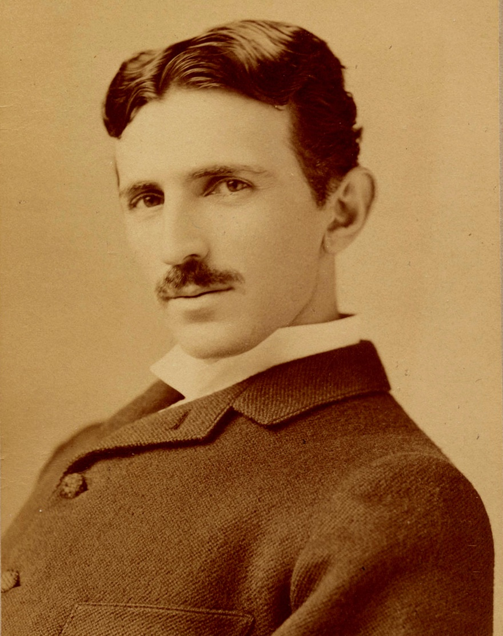

[Nikola Tesla](https://en.wikipedia.org/wiki/Nikola_Tesla), circa 1895.

An inventor's endeavor is essentially lifesaving. Whether he harnesses forces, improves devices, or provides new comforts and conveniences, he is adding to the safety of our existence. He is also better qualified than the average individual to protect himself in peril, for he is observant and resourceful. If I had no other evidence that I was, in a measure, possessed of such qualities I would find it in these personal experiences. The reader will be able to judge for himself if I mention one or two instances.

On one occasion, when about 14 years old, I wanted to scare some friends who were bathing with me. My plan was to dive under a long floating structure and slip out quietly at the other end. Swimming and diving came to me as naturally as to a duck, and I was confident that I could perform the feat. Accordingly, I plunged into the water and, when out of view, turned around and proceeded rapidly towards the opposite side. Thinking that I was safely beyond the structure, I rose to the surface, but to my dismay struck a beam. Of course, I quickly dived and forged ahead with rapid strokes until my breath was beginning to give out. Rising for the second time, my head came again in contact with a beam. Now I was becoming desperate. However, summoning all my energy, I made a third frantic attempt, but the result was the same. The torture of suppressed breathing was getting unendurable, my brain was reeling, and I felt myself sinking. At that moment, when my situation seemed absolutely hopeless, I experienced one of those flashes of light and the structure above me appeared before my vision. I either discerned or guessed that there was a little space between the surface of the water and the boards resting on the beams and, with consciousness nearly gone, I floated up, pressed my mouth close to the planks and managed to inhale a little air, unfortunately mingled with a spray of water which nearly choked me. Several times I repeated this procedure as in a dream, until my heart, which was racing at a terrible rate, quieted down and I gained composure. After that, I made a number of unsuccessful dives, having completely lost the sense of direction, but finally succeeded in getting out of the trap when my friends had already given me up and were fishing for my body.

That bathing season was spoiled for me thru recklessness, but I soon forgot the lesson and only two years later I fell into a worse predicament. There was a large flour mill with a dam[54] across the river near the city where I was studying at that time. As a rule, the height of the water was only two or three inches above the dam, and to swim out to it was a sport not very dangerous in which I often indulged. One day I went alone to the river to enjoy myself as usual. When I was a short distance from the masonry, however, I was horrified to observe that the water had risen and was carrying me along swiftly. I tried to get away but it was too late. Luckily, tho, I saved myself from being swept over by taking hold of the wall with both hands. The pressure against my chest was great and I was barely able to keep my head above the surface. Not a soul was in sight and my voice was lost in the roar of the fall. Slowly and gradually, I became exhausted and unable to withstand the strain longer.

Just as I was about to let go, to be dashed against the rocks below, I saw in a flash of light a familiar diagram illustrating the hydraulic principle that the pressure of a fluid in motion is proportionate to the area exposed, and automatically I turned on my left side. As if by magic the pressure was reduced, and I found it comparatively easy in that position to resist the force of the stream. But the danger still confronted me. I knew that sooner or later I would be carried down, as it was not possible for any help to reach me in time, even if I attracted attention. I am ambidextrous now but then I was left-handed and had comparatively little strength in my right arm. For this reason, I did not dare to turn on the other side to rest, and nothing remained but to slowly push my body along the dam. I had to get away from the mill towards which my face was turned, as the current there was much swifter and deeper. It was a long and painful ordeal and I came near to failing at its very end, for I was confronted with a depression in the masonry. I managed to get over with the last ounce of my force and fell in a swoon when I reached the bank, where I was found. I had torn virtually all the skin from my left side and it took several weeks before the fever subsided and I was well. These are only two of many instances but they may be sufficient to show that, had it not been for the inventor's instinct, I would not have lived to tell this tale.

Interested people have often asked me how and when I began to invent. This I can only answer from my present recollection in the light of which the first attempt I recall was rather ambitious, for it involved the invention of an apparatus and a method. In the former, I was anticipated but the latter was original. It happened in this way. One of my playmates had come into the possession of a hook and fishing-tackle, which created quite an excitement in the village, and the next morning all started out to catch frogs. I was left alone and deserted, owing to a quarrel with this boy. I had never seen a real hook and pictured it as something wonderful, endowed with peculiar qualities, and was despairing not to be one of the party. Urged by necessity, I somehow got hold of a piece of soft iron wire, hammered the end to a sharp point between two stones, bent it into shape, and fastened it to a strong string. I then cut a rod, gathered some bait, and went down to the brook where there were frogs in abundance. But I could not catch any and was almost discouraged when it occurred to me to dangle the empty hook in front of a frog sitting on a stump. At first he collapsed, but by and by his eyes bulged out and became bloodshot, he swelled to twice his normal size and made a vicious snap at the hook.

Immediately I pulled him up. I tried the same thing again and again and the method proved infallible. When my comrades, who in spite of their fine outfit had caught nothing, came to me, they were green with envy. For a long time I kept my secret and enjoyed the monopoly but finally yielded to the spirit of Christmas. Every boy could then do the same, and the following summer brought disaster to the frogs.

In my next attempt I seem to have acted under the first instinctive impulse which later dominated me - to **harness the energies of nature to the service of man**. I did this thru the medium of May-bugs - or June-bugs as they are called in America - which were a veritable pest in that country and sometimes broke the branches of trees by the sheer weight of their bodies. The bushes were black with them. I would attach[55] as many as four of them to a crosspiece, rotably arranged on a thin spindle, and transmit the motion of the same to a large disc[56] and so derive considerable "power." These creatures were remarkably efficient, for once they were started they had no sense to stop and continued whirling for hours and hours, and the hotter it was the harder they worked. All went well until a strange boy came to the place. He was the son of a retired officer in the Austrian Army. That urchin ate May-bugs alive and enjoyed them as tho they were the finest blue-point oysters. That disgusting sight terminated my endeavors in this promising field and I have never since been able to touch a May-bug, or any other insect for that matter.

After that, I believe, I undertook to take apart and assemble the clocks of my grandfather. In the former operation I was always successful but often failed in the latter. So it came that he brought my work to a sudden halt in a manner not too delicate and it took thirty years before I tackled another clockwork again.

Shortly thereafter, I went into the manufacture of a kind of pop-gun which comprised a hollow tube, a piston, and two plugs of hemp. When firing the gun, the piston was pressed against the stomach and the tube was pushed back quickly with both hands. The air between the plugs was compressed and raised to high temperature and one of them was expelled with a loud report. The art consisted in selecting a tube of the proper taper from the hollow stalks. I did very well with that gun but my activities interfered with the window panes in our house and met with painful discouragement. If I remember rightly, I then took to carving swords from pieces of furniture which I could conveniently obtain. At that time I was under the sway of the Serbian national poetry and full of admiration for the feats of the heroes. I used to spend hours in mowing down my enemies in the form of corn-stalks, which ruined the crops and netted me several spankings from my mother. Moreover, these were not of the formal kind but the genuine article.

I had all this and more behind me before I was six years old and had passed thru one year of elementary school in the village of Smiljan where I was born. At this juncture, we moved to the little city of Gospic nearby. This change of residence was like a calamity to me. It almost broke my heart to part from our pigeons, chickens, and sheep, and our magnificent flock of geese which used to rise to the clouds in the morning and return from the feeding grounds at sundown in battle formation, so perfect that it would have put a squadron of the best aviators of the present day to shame. In our new house I was but a prisoner, watching the strange people I saw thru the window blinds. My bashfulness was such that I would rather have faced a roaring lion than one of the city dudes who strolled about.

But my hardest trial came on Sunday when I had to dress up and attend the service. There I met with an accident, the mere thought of which made my blood curdle like sour milk for years afterwards. It was my second adventure in a church. Not long before I was entombed for a night in an old chapel on an inaccessible mountain which was visited only once a year. It was an awful experience, but this one was worse. There was a wealthy lady in town, a good but pompous woman, who used to come to the church gorgeously painted up and attired with an enormous train (i.e. long, back portion of the skirt) and attendants. One Sunday, I had just finished ringing the bell in the belfry and rushed downstairs when this grand dame was **sweeping out,** and I jumped on her train. It tore off with a ripping noise that sounded like a salvo of musketry fired by raw recruits. My father was livid with rage. He gave me a gentle slap on the cheek, the only corporal punishment he ever administered to me, but I almost feel it now. The embarrassment and confusion that followed are indescribable. I was practically ostracised until something else happened which redeemed me in the estimation of the community.

An enterprising young merchant had organized a fire department. A new fire engine was purchased, uniforms provided and the men drilled for service and parade. The engine was, in reality, a pump to be worked by sixteen men and was beautifully painted red and black. One afternoon, the official trial was prepared for, and the machine was transported to the river. The entire population turned out to witness the great spectacle. When all the speeches and ceremonies were concluded, the command was given to pump, but not a drop of water came from the nozzle. The professors and experts tried in vain to locate the trouble. The fizzle was complete when I arrived at the scene. My knowledge of the mechanism was nil, and I knew next to nothing of air pressure, but instinctively I felt for the suction hose in the water and found that it had collapsed. When I waded in the river and opened it up, the water rushed forth and not a few Sunday clothes were spoiled. Archimedes running naked thru the streets of Syracuse and shouting Eureka at the top of his voice did not make a greater impression than myself. I was carried on the shoulders and was the hero of the day.

Upon settling in the city I began a four-years' course in the so-called Normal School preparatory to my studies at the College, or *Real-Gymnasium*. During this period my boyish efforts and exploits, as well as troubles, continued. Among other things, I attained the unique distinction of champion crow catcher in the country. My method of procedure was extremely simple. I would go in the forest, hide in the bushes, and imitate the call of the bird. Usually I would get several answers and in a short while a crow would flutter down into the shrubbery near me. After that, all I needed to do was to throw a piece of cardboard to detract its attention, jump up and grab it before it could extricate itself from the undergrowth. In this way I would capture as many as I desired.

But on one occasion something occurred which made me respect them. I had caught a fine pair of birds and was returning home with a friend. When we left the forest, thousands of crows had gathered making a frightful racket. In a few minutes, they rose in pursuit and soon enveloped us. The fun lasted until, all of a sudden, I received a blow on the back of my head, which knocked me down. Then they attacked me viciously. I was compelled to release the two birds and was glad to join my friend who had taken refuge in a cave.



Nikola Tesla monument in Niagara Falls, Ontario, 2015. Nikola Tesla and George Westinghouse built the first hydroelectric power plant in Niagara Falls and started electrification of the world. Attribution in chapter References.

In the schoolroom, there were a few mechanical models which interested me and turned my attention to water turbines. I constructed many of these and found great pleasure in operating them. How extraordinary was my life, an incident may illustrate. My uncle had no use for this kind of pastime and more than once rebuked me. I was fascinated by a description of Niagara Falls I had perused, and pictured in my imagination a big wheel run by the Falls. I told my uncle that I would go to America and carry out this scheme. Thirty years later, I saw my ideas carried out at Niagara and **marveled at the unfathomable mystery of the mind**.

I made all kinds of other contrivances and contraptions but among these, the arbalists I produced were the best. My arrows, when shot, disappeared from sight and, at close range, traversed a plank of pine one inch thick. Thru the continuous tightening of the bows, I **developed skin on my stomach very much like that of a crocodile** and I am often wondering whether it is due to this exercise that I am able even now to digest cobble-stones!

Nor can I pass in silence my performances with the sling, which would have enabled me to give a stunning exhibit at the Hippodrome[57]. And now I will tell of one of my feats with this antique implement of war, which will strain to the utmost the credulity of the reader. I was practicing while walking with my uncle along the river. The sun was setting, the trout were playful, and from time to time one would shoot up into the air, its glistening body sharply defined against a projecting rock beyond. Of course, any boy might have hit a fish under these propitious conditions, but I undertook a much more difficult task and I foretold to my uncle, to the minutest detail, what I intended doing. I was to hurl a stone to meet the fish, press its body against the rock, and cut it in two. It was no sooner said than done. My uncle looked at me almost scared out of his wits and exclaimed "Vade retro Satanas!"[58] and it was a few days before he spoke to me again. Other records, however great, will be eclipsed, but I feel that I could peacefully rest on my laurels for a thousand years.

### Food for Thought

* Want to know more about this great man? Tesla has been generous enough to open out his life through his Autobiography. It was published as articles in the Electrical Experimenter magazine in 1919. A must read!
* A scientist should be a silent soul sitting in some corner, always dreaming about a problem pestering his mind. Isn’t it? Tesla, in his childhood, was the exact opposite! Full of mischief, alert to everything happening around him, all charged up to put his talent to real use. Contrast this with the change in his behavior, his dreaminess, his silence, as he progressed further to tackle more and more complex problems with complete dedication and focus.

### References

* My Inventions, by Nikola Tesla, Part 2. My First Efforts In Invention, from Electrical Experimenter Magazine, March 1919, pg 839-842.
* [Nikola Tesla](https://commons.wikimedia.org/wiki/Nikola_Tesla) monument in Niagara Falls, Ontario by Milan Suvajac (Own work) [[CC BY-SA 4.0](http://creativecommons.org/licenses/by-sa/4.0) (http://creativecommons.org/licenses/by-sa/4.0)], [via Wikimedia Commons](https://commons.wikimedia.org/wiki/File%3ANiagara-Falls_ON_Monument_Nikola-Tesla_2015-08-13.jpg).

Kumbhakarna’s Battle, from The Ramayana

Complexity: Medium

The Ramayana is an ancient Indian epic poem on the life of King Rama of Ayodhya, composed in Sanskrit by sage Valmiki. This is the English translation from the 67th Sarga (Chapter) of the sixth section of the epic, named ‘Yuddha Kaanda’ (Section on War).

It describes the battle between **Rama’s** army composed of **monkeys**, against the mighty demon **Kumbhakarna**, younger brother of Demon King **Ravana**.

Previously, Ravana had abducted Rama’s wife Sita, from the forest where Rama stayed during his exile from Ayodhya. The object of the battle was to rescue her and also put an end to Ravana’s tyrannical rule.

Literal prose translation of each verse is separately provided, to give a rough sense of how verses are structured in this epic.

(Note: Since Sanskrit is a compact language, sometimes multiple English words need to be used to express the meaning of a single compound Sanskrit word. On top of that, usage of adjectives and metaphors in the original poetic work adds more text to the prose translation.)

Hearing these words of Angada[59], all those huge-bodied monkeys arrived at a firm resolution, and returned with a determination to fight.[60] [verse-1]

On attaining confidence with the words of the mighty Angada, the monkeys summoned up their prowess and stayed in the field agreeably. [v-2]

The monkeys, inspired with spirit, determined to face their fate, rushed into conflict and, casting away all care for their lives, entered into a furious battle. [v-3]

The huge-bodied monkeys charged towards Kumbhakarna by speedily upraising trees and gigantic mountain-rocks. [v-4]

To which, the mighty and brave Kumbhakarna, full of anger, lifted up his mace and let it down upon his enemies. [v-5]

Seven or eight hundred, or even thousands of monkeys attacked by Kumbhakarna were scattered on earth. [v-6]

Casting about his arms in anger, Kumbhakarna, running about the battle-field, held sixteen, eight, ten, twenty, or even thirty monkeys in both his hands and ate them, like Garuda[61] swallowing up serpents. [v -7]

The monkeys gained confidence with difficulty and gathered together. They stood on the field of battle, taking trees and rocks in their hands. [v-8]

Dwivida, foremost of monkeys, uprooting a mountain, resembling an extended mass of clouds, rushed towards Kumbhakarna, who resembled a mountain-summit. [v-9]

Uprooting it, he threw it at Kumbhakarna. But the mountain missed him and fell down amidst the army. [v-10]

That mountain-peak smashed horses, elephants, and chariots of the demons. Taking another mountain top, Dwivida threw it at other demons, crushing them. [v-11]

Kumbhakarna’s horses and charioteers were also killed by the huge impact of that peak, and that great battlefield was dampened with demon blood. [v-12]

The demon car-warriors[62] with a terrific roar, cut off the heads of foremost monkeys with their arrows. These resembled Yama, the god of death at the time of universal dissolution. [v-13]

The high-souled monkeys too, uprooting giant trees, destroyed chariots, horses, elephants, camels, and demons. [v-14]

Hanuman[63], remaining in the sky, discharged mountain-peaks, rocks and various trees on Kumbhakarna's head. [v-15]

The mighty Kumbhakarna crushed all those mountain-tops, and also cut off the shower of trees, with his darts. [v-16]

Kumbhakarna, grasping his sharpened spear, darted towards that terrific array of monkeys. Hanuman stood before him, armed with a mountain-peak. [v-17]

The furious Hanuman vehemently struck Kumbhakarna with a mountain-peak. Kumbhakarna himself was bestowed with a splendid body and resembled the most elevated mountain. Thus overpowered by that blow, Kumbhakarna experienced great torments, and his body was covered with fat and blood. [v-18]

As Guha had pierced Krauncha with his fierce dart,[64] Kumbhakarna the mountain-like struck the wind-god's son[65] on the chest with his dart that resembled lightning or a glowing mountain-summit. [v-19]

Having his mighty chest pierced in the mighty encounter, Hanuman, overwhelmed and vomiting blood, roared wrathfully. It resembled the sound of the thunderous clouds at the time of universal disruption. [v-20]

Seeing Hanuman suffering, the demons suddenly rejoiced, emitted shouts; and the monkeys, aggrieved and overcome with fright, began to run away from the battlefield. [v-21]

Then the powerful Neel, cheering up the army and stopping them, discharged a mountain-peak at the intelligent Kumbhakarna. [v-22]

Seeing it descend, he hit it with a blow. Struck by that blow, the mountain-top was shattered to pieces and dropped to earth glowing and shooting like living flames. [v-23]

Then Rishabha, Sarabha, Neel, Gavaksha, and Gandhamadana—these five terrific monkeys, rushed towards Kumbhakarna. [v-24]

In that encounter, the mighty monkeys struck that huge-bodied Kumbhakarna from all sides, with rocks, trees, slaps, kicks and blows. [v-25]

But those blows seemed to him like mere caresses and did not pain him at all. He then fastened the spirited Rishabha with his arms. [v-26]

Being agonized on being fastened by Kumbhakarna's arms, that foremost of monkeys, the dreadful Rishabha, fell down to the earth vomiting blood. [v-27]

And then Kumbhakarna, the enemy of Indra[66], smit Sarabha with a blow, Neel with his thigh, struck a slap at Gavaksha and violently kicked Gandhamadana. [v-28, 29]

Suffering great pain due to those blows, the monkeys, deprived of their senses and bathed in blood, dropped down to the earth like the Kimsukas[67] cut down. [v-30]

On seeing those mighty monkey chiefs falling down, thousands of monkeys rushed towards Kumbhakarna. [v-31]

Those mighty monkeys, resembling a mountain-summit, sprang upon Kumbhakarna who himself was looking like a mountain, and tore him with their teeth. [v-32]

Those foremost of monkeys, attacked Kumbhakarna with their claws, teeth, blows, and arms. [v-33]

With thousands of monkeys on his body, that extraordinary one, that fearful demon resembling a hill, looked so graceful; like a mountain with trees on it. [v-34]

Just like Garuda (the divine eagle) furiously eats up serpents, the mighty Kumbhakarna seized all monkeys with his arms and ate them up. [v-35]

Forcefully thrown by Kumbhakarna into his mouth resembling the nether regions of the earth, the monkeys **again emerged from his nose and ears**. [v-36]

Kumbhakarna, the best among demons, resembling a hill, was fired up with rage, and in the process of eating up the monkeys, began breaking their bodies. [v-37]

Fired with passion, that demon, making the earth moist with flesh and blood, moved among the monkey-ranks like an excited fire at the time of Universal dissolution. [v-38]

In that encounter, the mighty Kumbhakarna holding his dart in his hand, resembled the thunder-wielding Indra,[68] or the noose-wielding Yama[69], the destroyer himself. [v-39]

Just as fire burns up a dry forest in summer, Kumbhakarna also destroyed that host of monkeys. [v-40]

Thus beaten by Kumbhakarna, without a commander and having their army killed, the monkeys were racked with anxiety and began to cry in unnatural tones. [v-41]

After innumerable monkeys were killed by Kumbhakarna in different ways, the troubled monkeys sought the shelter of Raghava[70] with sorrowful hearts. [v-42]

Seeing the monkeys destroyed in the terrific encounter, the son of the son of the thunder-handed[71] ran speedily towards Kumbhakarna. [v-43]

Taking up a mighty cliff, Angada, roaring continuously and thereby terrorizing all Rakshasas, discharged the mountain-peak right on Kumbhakarna's head. [v-44]

Struck on the head by that mountain-peak, Indra's enemy, Kumbhakarna, got excited and ran speedily towards the son of Vali (Angada) with tremendous fury. [v-45, 46]

The loud-throated Kumbhakarna, terrifying all monkeys, vehemently threw his spike at the son of Vali in anger. [v-47]

As the dart descended, that foremost of monkeys endowed with strength and skilled in battle, used his swiftness to evade the weapon. [v-48]

And then, swiftly springing up, he slapped Kumbhakarna in the chest. Thus beaten, Kumbhakarna, the one resembling a hill, lost his senses. [v-49]

Recovering his senses, that exceedingly strong Rakshasa[72] threw down Angada by tightening his fist, and the latter dropped down senseless. [v-50]

And when that powerful monkey fell down on the ground insensible, Kumbhakarna, taking his dart, rushed against Sugriva. [v-51]

On seeing the sudden approach of that exceedingly stout Kumbhakarna, Sugriva, the heroic king of monkeys, sprang up. [v-52]

Uplifting a mountain-top and tightly holding it, the powerful Sugriva rushed towards that mighty Kumbhakarna. [v-53]

Seeing that monkey rushing suddenly, Kumbhakarna stretched his limbs and stood before the lord of monkeys. [v-54]

Seeing Kumbhakarna, with his body bathed in the blood of monkeys and eating up mighty monkeys, Sugriva addressed him, saying: [v-55]

"You have struck down renowned monkeys. You have done deeds difficult of being performed, and have devoured warriors. You have thus attained renown. [v-56]

But let the monkey-army go now. What will you do with these common beings? O demon, now bear the descent of this Mountain." [v-57]

Hearing those words of the monkey-king blessed with strength and fortitude, that terrible Rakshasa, Kumbhakarna said: [v-58]

"O monkey, you are the grandson of Prajapati and the son of the king of bears, Riksharaja,[73] endowed with courage and skill. Why do you roar?" [v-59]

Hearing Kumbhakarna's speech, Sugriva, whirling that mountain-peak, suddenly let it go; and with that rock resembling Indra’s Vajra or the thunder-bolt, hit Kumbhakarna on the chest. [v-60]

On coming in contact with his wide breast, that mountain-peak was at once shattered to pieces. Thereupon the monkeys were disheartened, and the Rakshasas shouted in joy. [v-61]

Struck with the mountain-summit, Kumbhakarna was extremely angry and roared with his mouth wide open. And then, whirling his dart resembling lightning, he hurled it to bring about the destruction of the master of monkeys. [v-62]

Then swiftly jumping up, the Wind-god's son[74], resisting that sharp dart fastened with golden chains, violently snapped it into two with his hands. [v-63]

The delighted Hanuman placed that large dart composed of black iron and weighing a thousand measures, on his thighs, and broke it. [v-64]

Seeing the dart being broken by Hanuman, the monkey-army, growing delighted, gave countless shouts and rushed in all directions. [v-65]

The Rakshasa was seized with fear and turned away (from the field). The monkeys, excessively delighted, gave loud shouts, and finding the dart broken, praised the Wind-god's son. [v-66]

The mighty lord of demons seeing the dart thus broken, uprooted a peak from Malaya[75] and hit Sugriva with it. [v-67]

The king of monkeys, struck with the mountain-peak, fell senseless upon the field, and the demons finding him in this situation shouted out in great joy. [v-68]

Kumbhakarna then, coming to the wonderfully mighty master of monkeys, took him away, as a **violent blow of wind steals away a patch of cloud**. [v-69]

Kumbhakarna resembled a mountain in loftiness of stature. While marching from the battlefield taking Sugriva, who himself resembled a great cloud, Kumbhakarna seemed like Mount Meru with its frightening tall peaks. [v-70]

Thus, the lord of demons went on hearing praises (from other demons) and shouts from the lords of the heavens, who wondered at the capture of the foremost of monkeys. [v-71]

Thus Kumbhakarna, that mighty one **resembling Indra, (and also) the adversary of Indra, taking captive the one having the prowess of Indra** (Sugriva), thought that his death would destroy the entire host of the opponents together with Raghava. [v-72]

Hanuman, the shrewd son of Maruta, finding the whole host of monkeys scattered in all directions, as well as Sugriva captured by Kumbhakarna, thought as follows: [v-73]

"What is it that I should be doing, now that our king has been captured? I will certainly do what suits me now. Let me assume the shape of a mountain and kill the demons. [v-74, 75]

Let me kill the mighty Kumbhakarna, splitting his body with my strong fist and thus relieve the master of monkeys. Thus, let the whole host of monkeys be delighted. [v-76]

Or, even when captured by the whole host of gods, demons or serpents, he (Sugriva) is mighty enough to set himself free. [v-77]

The lord of monkeys, struck in battle by Kumbhakarna’s mountain peak, has not yet recovered his senses. [v-78]

Else, within a moment, he would do the needful for himself as well as the monkeys. [v-79]

If the relief of the mighty-minded Sugriva comes from me, I would incur his displeasure, and certainly would lead to the loss of his reputation for ever. [v-80]

I must wait a moment and see his own might that he himself displays, when relieved. Meanwhile let me cheer up the scattered monkey army." [v-81]

Thus thinking within himself, Hanuman, that son of Maruta, began to bring firmness to the mighty monkey army. [v-82]

In the meantime, Kumbhakarna entered Lanka with Sugriva, trembling. He was being honored with showers of beautiful flowers from the sky, buildings on the main roads, and the town-gate. [v-83]

Then the mighty one (Sugriva) slowly recovered his senses with the shower of fried paddy, the sweet scent, the sprinkling of water, as well as the coolness of the streets. [v-84]

That great souled Sugriva, caught in the arms of the powerful Rakshasa, came to his senses with great difficulty, and surveying the streets of the town around him, thought to himself: [v-85]

"When thus within the grasp of the enemy, what should I do now? Let me do what will be desirable and advantageous to our army." [v-86]

Then advancing all of a sudden, he cut off the ears and nose of Kumbhakarna with his nails and sharp teeth, and ribs with the blow of his feet. [v-87]

Kumbhakarna losing his ears and nose and having his sides split with nails and teeth, grew angry, and being all covered with blood, threw Sugriva to the ground and pressed him. [v-88]

While he was forcefully pressed upon the ground and severely struck by that enemy of the gods, Sugriva (gave Kumbhakarna the slip and) flew to the skies like a ball-rolling, and joined Rama once more. [v-89]

The mighty Kumbhakarna, having lost his nose and ears and drenched in blood, appeared like a mountain covered all over with streamlets. [v-90]

That huge-bodied Rakshasa, younger brother of Ravana, terrible in appearance, resembling a mass of deep black collyrium and covered all over with blood, appeared like an evening cloud. He (once more) made up his mind to appear in battle. [v-91, 92]

Sugriva, having thus escaped that dreadful enemy of the king of celestials (Indra), again rushed to battle in anger, and finding himself without any arms, took up a fearful mace. [v-93]

Then that mighty one, the demon Kumbhakarna, issuing out of the city, began to devour the terrific host of monkeys, as the mighty fire eats up people at the end of a Yuga[76]. [v-94]

On entering the mighty army of monkeys, the hungry Kumbhakarna, hankering after flesh and blood, ate up the monkeys, and with them, devoured many demons, monkeys, devils, and bears by mistake. Thus, he destroyed the mighty monkeys as Death eats creatures at the end of a Yuga. [v-95]

The furious Kumbhakarna, taking up monkeys along with demons with one hand, hurriedly threw them into his mouth, one, two, three, or many at a time. [v-96]

And even though struck by monkeys with peaks of mountains, the mighty one ate all of them, with their blood and fat abundantly flowing down his body; [v-97]

The monkeys, as they were being devoured, sought the shelter of Rama, while the furious Kumbhakarna, eating away monkeys, marched forward. [v-98]

Kumbhakarna chased hundreds of monkeys in the battlefield, eating up seven, eight, twenty, or thirty. [v-99]

Resembling Yama, the Destroyer of prodigious dimensions at the end of a Yuga, that one (Kumbhakarna) furnished with extremely sharp teeth, having his body covered with fat, marrow, and blood, and coiling intestines about his ears, began to discharge darts on monkeys. [v-100]

Immediately, the destroyer of hostile armies and conqueror of capital cities of foes, Sumitra's son, Lakshmana,[77] grew enraged, and entered into an encounter with the enemy. [v-101]

Lakshmana endued with prowess shot seven arrows at Kumbhakarna's body; and next, taking up other arrows, also discharged them. [v-102]

In response, the Rakshasa[78], aching with wounds inflicted by that weapon, destroyed it completely. Thereupon the powerful Lakshmana, the enhancer of Sumitra's joy, grew enraged. [v-103]

And then, as the wind envelopes evening clouds, he (Lakshmana) covered Kumbhakarna’s shining and graceful golden armour with his arrows. [v-104]

Smit with arrows equipped with gold, that one resembling a mass of black collyrium appeared beautiful like the ray-furnished Sun surrounded by clouds. [v-105]

Then that dreadful Rakshasa voiced like masses of clouds, scornfully addressed the enhancer of Sumitra's happiness,[79] saying: [v-106]

“You have displayed your heroism by dauntlessly fighting with me, the one who has effortlessly brought down the Destroyer himself in battle. [v-107]

Even when standing up in this encounter against me when equipped with arms, who in mighty conflict resembles Death itself, you deserve to be honored. What then should I say about your fighting? [v-108]

Not even lord Sakra (Indra) himself, mounted on his Airavata[80], and accompanied by all the immortals, had ever stayed before me in battle. [v-109]

But today, O Sumitra's son, though a boy, you have gratified me with your prowess. Now taking your leave, I wish to go to Raghava. [v-110]

As I have been well pleased in battle with your vigor, strength, and enthusiasm, I now wish to kill Rama alone, for when he is slain, all will be slain. [v-111]

On Rama being killed here by me, I will destroy the rest remaining on the battlefield, with my all-crushing vigor.” [v-112]

When the demon had spoken thus, Sumitra's son, laughing, answered him in firm words mixed with praise, saying: [v-113]

"O hero! It is true that Sakra (Indra) and other celestials are not capable of bearing your prowess. I myself have witnessed it today. But see Dasharatha’s son, Rama, standing there unmoved like a mountain." [v-114]

Hearing this, that mighty Kumbhakarna, the night-ranger, disregarding Lakshmana and passing beyond Sumitra's son, rushed towards Rama, making the earth tremble. [v-115, 116]

Thereupon Dasharatha's son, Rama, employing a terrific weapon called Raudra, discharged sharpened arrows at Kumbhakarna's breast. [v-117]

On that, flames of fire mixed with particles of charcoal shot out from the mouth of that enraged one suddenly rushing towards Rama. [v-118]

On being frightfully pierced by Rama's weapons, that foremost of Rakshasas, roaring wrathfully, chased away monkeys in the conflict and ran towards Rama. [v-119]

Those arrows decorated with peacock feathers, pierced his chest. His mace, escaping his hand, dropped to the earth. [v-120]

All his weapons were scattered on the ground. When that exceedingly powerful one saw himself deprived of all his weapons, he began to spread a huge havoc by means of his fists and hands. [v-121]

With his body entirely covered with arrows and bathed in blood, he began to bleed like a hill overflowing with fountains. [v-122]

Fired with anger and maddened with blood, he rushed on, devouring monkeys, Rakshasas, and bears. [v-123]

And that redoubtable one, possessed of dreadful prowess, resembling the Reaper (god of death, Yama) himself, whirling a mighty mountain-peak, hurled it aiming at Rama. [v-124]

At that, Bharata’s elder brother, the righteous Rama, before the prodigious peak had alighted, severed the same by means of seven straight-speeding arrows made of gold. [v-125, 126]

That mountain-top, resembling Mount Meru as if shining with grandeur, while falling, caused two hundred monkeys to fall. [v-127]

With an intention of finishing Kumbhakarna, the virtuous Lakshmana, thinking about different means of doing so, spoke to Rama as follows: [v-128]

"O king! He is not able to recognise monkeys from demons. Maddened with the smell of blood, he ate up his own, as well as his enemies. [v-129]

Now let the foremost monkeys, putting forth their best, mount on him; and let the leaders of monkeys, according to their ranks, stand surrounding him. [v-130]

Then this wicked-minded Rakshasa, oppressed with a mighty weight that will make him crawl on the floor, will no longer be able to eat up any more monkeys." [v-131]

Hearing the words of the intelligent prince, those exceedingly powerful monkeys ascended Kumbhakarna with cheerful readiness. [v-132]

Kumbhakarna, mounted by those monkeys, extremely furious, shook them with force just like mad elephants shake off their drivers. [v-133]

And Raghava, seeing them shaken and concluding that the Rakshasa was furious, took his bow and furiously sprang forward. [v-134]

The **gentle Raghava, angry with red-hot eyes, as if burning up the Rakshasa with his eyes**, rushed forth with great force and quickly marched towards the demon; thereby cheering up the leaders of monkeys that had been tormented by the might of Kumbhakarna. [v-135, 136]

Equipped with an excellent quiver and arrows, Rama, cheering up the monkeys, sprang forward, taking a terrific bow embellished in gold, having a stout string and resembling a serpent. [v-137]

Then surrounded by exceedingly invincible monkey-bands, that highly powerful hero, followed by Lakshmana, marched forth. [v-138]

He saw the redoubtable and high-souled Kumbhakarna, wearing a crown, with his body drenched in blood, with blood-shot eyes. [v-139]

Rushing wrathfully against all like the mythical elephant guarding one of the quarters;[81] searching for monkeys, surrounded by demons; [v-140] appearing like the Vindhya or the Mandara mountains, decorated with golden armlets; bleeding from his mouth, like clouds pouring showers; [v-141] licking the corners of his mouth that were bathed in blood; smashing the monkey-army and resembling Yama the Destroyer. [v-142]

(Note: In some Ramayana texts, there are a few more verses between these two. It concerns Kumbhakarna finding himself opposite his brother Vibhishana, who had already crossed over from the demon camp to Rama’s side. Kumbhakarna lauds Vibhishana on his decision to do so since the side of Rama was that of truth and virtue. He encourages Vibhishana to forget brotherly love and fight him like a true warrior. But also warns him that due to the deluded state of his (Kumbhakarna’s) mind, he might even slay Vibhishana, forgetting that he was his younger brother. And so, later advises Vibhishana to step aside. On this, tears start flowing from Vibhishana’s eyes, and being deeply worried, he moves aside to seclusion.)

That best of persons (Rama), seeing that foremost of Rakshasas having the splendour of a living fire, stretched his bow to its full extent. [v-143]

Fired with wrath at the twang of Rama’s bow, that foremost of Rakshasas, inflamed with wrath, not being able to bear the sound of that twang of the bow, rushed towards Raghava. [v-144]

Thereupon, the gentle Rama, endowed with arms resembling the body of the king of serpents (Vasuki), as he darted forward in that encounter, addressed Kumbhakarna, who resembled an elevated cloud and possessed the splendour of a mountain, saying: [v-145]

"Come, O king of demons! Do not regret. Here I stay, taking my bow in my hand. Know me as the destroyer of the race of demons. You will be deprived of your senses within a moment.” [v-146]

Knowing that this was Rama, (Kumbhakarna) laughed in frightful tone; and then, wrought up with wrath, rushed towards the monkeys in the encounter. [v-147]

As if tearing the breasts of all monkeys, the exceedingly energetic Kumbhakarna, laughing frightfully and in a terrific manner, addressed Raghava, saying: [v-148]

"Do not take me for Viradha, Kabandha, or Khara. I am not Vali or Maricha. I am Kumbhakarna, who has arrived here.[82] [v-149]

See my dreadful and mighty mace made entirely from iron. I had formerly brought down deities and Danavas[83] with the help of this. [v-150]

You need not treat me with contempt, as my ear and nose have been severed. I do not feel even a smallest torment in consequence of my ears and nose having been cut off. [v-151]

O tiger of the Ikshvaku[84] dynasty, O sinless one, show your prowess on my body. After you have displayed your prowess and power, I shall devour you up." [v-152]

Hearing Kumbhakarna's words, Rama discharged arrows furnished with knobs. And even when struck with these arrows having the force of the thunderbolt, that foe of the celestial deities was neither shaken nor troubled. [v-153]

Those arrows, which had chopped down the seven excellent Sala[85] trees and had killed Vali, the best of monkeys, could not impart any pain to Kumbhakarna's body resembling the thunderbolt itself. [v-154]

Sucking those arrows with his body, as mountains suck up showers of water, the enemy of the great Indra, whirling his mace possessed of fierce force, put out the arrowy discharge of Rama. [v-155]

Then that Rakshasa, whirling his mace washed in blood, possessed of fierce energy and capable of striking terror into the mighty hosts of gods and demons, made the monkey-army take to its heels. [v-156]

Rama in turn, taking a mighty Vayavya[86] weapon, used the same against the night-ranger; and cut off his arm holding the mace. And having his arm cut off, he set up tremendous roars. [v-157]

His arm with the mace, resembling a mountain-peak, cut off by Raghava's arrows, fell in the midst of the army of the monkey-king, and destroyed that army. [v-158]

The monkeys who had escaped being broken and slain, disheartened, and having their limbs wounded, moved aside and looked on the dreadful encounter between the demon and lord of men. [v-159]

Kumbhakarna, having his arm chopped, resembling the foremost of mountains with its peak chopped away by a mighty sword, tore up a tree with his (remaining) arm and in the conflict, rushed against the monarch of men. [v-160]

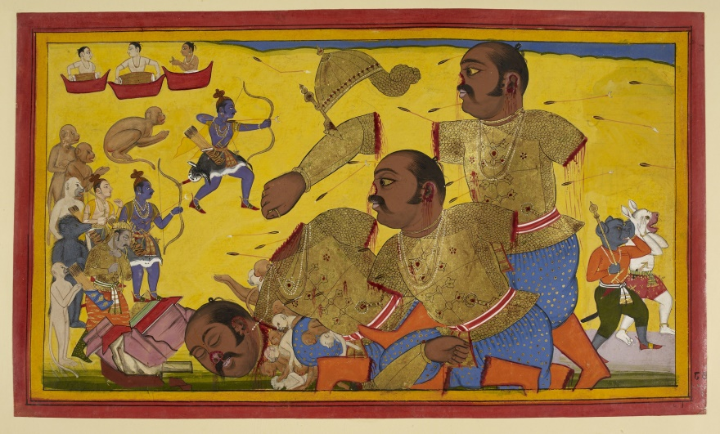

Kumbhakarna’s fall, by Sahib Din

Thereupon, with a gold plated arrow furnished with a mystic spell of Indra, Rama cut off his uplifted arm holding the tree that looked like the body of a serpent. [v-161]

That arm of Kumbhakarna, being severed, dropped inert on the earth like a hill, and crushed trees, rocks, monkeys, and demons. [v-162]

Rama, seeing the one shorn of his arms suddenly spring up, roaring, took up two sharp arrows having the shape of a half-moon each, and in the contest, cut off the legs of the Rakshasa. [v-163]

Creating a resound in all directions; in rocks, caves, the great ocean, the city of Lanka itself, the army of monkeys, and the demons, Kumbhakarna’s legs dropped down (to the ground). [v-164]

Having his arms cut off and his legs also severed, (Kumbhakarna) opened his mouth widely, resembling the Vadava Mukha[87]; and roaring aloud, swiftly darted (with thighs) towards Raghava, just as Rahu seizes the Moon in the sky.[88] [v-165]

Rama stuffed his mouth full of sharpened arrows having their feathered parts furnished with gold. And having his mouth filled; he could not speak; but with extreme effort, uttered indistinct sounds and fainted. [v-166]

Rama then took an arrow of Indra, quick as the wind, resembling the effulgence of the Sun, and like the very banner of Brahma, or the Destroyer himself, fatal to foes. [v-167]

Rama hurled the arrow, whose shaft was inlaid with diamonds and gold, at the ranger of the night[89]. That weapon hurled by Rama's arm was shining like rays of the dazzling sun, resembling a smokeless flame, lighting up ten directions with its own glory, and possessed of the dreadful energy of Sakra's (Indra’s) thunder-bolt. [v-168, 169]

Rama cut off the head of the lord of demons resembling a mountain-summit, having well rounded tusks and with charming and quivering ear-rings; just like Purandara had cut off the head of Vritra in the past.[90] [v-170]

Kumbhakarna's huge severed head with earrings on, appeared lustreless, just like the Moon in the morning, in the midst of the rising Sun. [v-171]

Struck with Rama's arrow, the head of the demon resembling a hill, fell down in the city of Lanka; and (in its fall) crushed buildings near the highways and gateways; elevated walls too were bore down to the ground. [v-172]

That Rakshasa of gigantic proportions just like Himalayas, fell into the sea; and crushing huge and mighty fishes and snakes, entered the depths (of the ocean). [v-173]

The earth and the mountains shook on that enemy of the Brahmanas[91] and gods endowed with immense strength having been killed in battle; and the celestials shouted aloud from excess of joy. [v-174]

And those deities, saints, sages, serpents, celestials, and (other) beings, birds and Guhyakas, together with Yakshas and Gandharvas[92] (celestial musicians), all these standing in the sky, were rejoiced at the prowess of Rama. [v-175]

At his (Kumbhakarna's) great destruction, the intelligent followers of the king of Nairitas[93] began to cry at the sight of Rama, like elephants cry at the sight of a lion. [v-176]

And like the Sun that emerged from Rahu’s mouth, destroying the darkness of the celestial fields, Rama, having killed Kumbhakarna in battle, shone in the midst of the monkey-army. [v-177]

Countless monkeys experienced the very height of delight. On their foe of terrific strength having been killed, their faces were glowing like full-blown lotuses; and they paid homage to Raghava, the sharer of good fortune. [v-178]

As Indra had rejoiced on slaying the mighty demon, Vritra, Bharata's elder brother rejoiced on having killed Kumbhakarna in battle, who had tormented the army of celestials and who was never defeated even in renowned encounters. [v-179]

### Food for Thought

* Think for a moment about the incident where Hanuman avoids freeing Sugriva. How can one train oneself to maintain such calmness, clarity, and foresight in thought, even in emergency situations?
* How can one spare time to genuinely appreciate the grand acts of one’s enemy, without compromising on the determined effort needed to secure victory? You have seen individuals on both sides doing this with seamless ease in the passage above.
* Did you notice the liberal use of meaningful adjectives and metaphors in this account? For example, ‘*one resembling a mass of black collyrium appeared beautiful like the ray-furnished Sun surrounded by clouds*’, ‘*Raghava, the sharer of good fortune*’. This pattern is consistent throughout the epic, and used in unbiased descriptions of characters irrespective of whether the character itself is positive or negative.

### References

* Ramayana, Yuddha Kanda, Sarga 67, Sanskrit Text, By Valmiki.
* Ramayana, Translated into English Prose, By Manmatha Nath Dutt, Book 3, Volume 6, 1893.

The Meaning Of Health, by M. K. Gandhi

Complexity: Low

What is not popular knowledge about this great personality is his insight into the topic of health. It was based on his study of numerous books on the subject, as well as first-hand experiences. He was neither a physician, nor did he qualify as a person of great physical strength. However, he exhibited sound health and high energy in all that he did, till his death at the age of 79.

This extract is the introductory part of his book ‘Guide To Health’. It just introduces the topic of health and talks about what exactly it means to have a good health that one should strive for.

We strongly encourage readers to **go through the entire book**. It is very short and simple. It describes key principles of health, diet, exercise, and simple home remedies. Though written almost a century back, most ideas described therein are relevant and can be followed easily even today; even simple things such as breathing through the nose, or moderation in eating.

### Introduction

For more than twenty years past, I have been paying special attention to the question of Health. While in England, I had to make my own arrangements for food and drink, and I can say, therefore, that my experience is quite reliable. I have arrived at certain definite conclusions from that experience, and I now set them down for the benefit of my readers.

As the familiar saying goes, ‘Prevention is better than cure.’ It is far easier and safer to prevent illness by the observance of the laws of health, than to set about curing the illness that has been brought on by our own ignorance and carelessness. Hence it is the duty of all thoughtful men to understand aright the laws of health, and the object of the following pages is to give an account of these laws. We shall also consider the best methods of cure for some of the most common diseases.

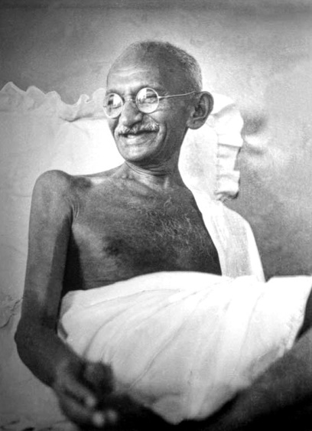

Gandhiji smiling. At Birla House, Mumbai, Age 72 years, August 1942.

As Milton says, the mind can make a hell of heaven or a heaven of hell. So heaven is not somewhere above the clouds, and hell somewhere underneath the earth! We have this same idea expressed in the Sanskrit saying, *Mana êva Manushayanâm Kâranam Bandha Mokshayoh*—man’s captivity or freedom is dependent on the state of his mind. From this, it follows that whether a man is healthy or unhealthy depends on himself. Illness is the result not only of our actions but also of our thoughts. As has been said by a famous doctor, more people die for fear of diseases like small-pox, cholera, and plague, than out of those diseases themselves.[94]

Ignorance is one of the root-causes of disease. Very often, we get bewildered at the most ordinary diseases out of sheer ignorance, and in our anxiety to get better, we simply make matters worse. Our ignorance of the most elementary laws of health leads us to adopt wrong remedies or drives us into the hands of the veriest quacks. How strange (and yet how true) it is that we know much less about things near at hand than things at a distance. We know hardly anything of our own village, but we can give by rote the names of the rivers and mountains of England! We take so much trouble to learn the names of the stars in the sky, while we hardly think it worthwhile to know the things that are in our own homes! **We never care a jot for the splendid pageantry of Nature before our very eyes, while we are so anxious to witness the puerile mummeries of the theatre!** And in the same way, we are not ashamed to be ignorant of the structure of our body, of the way in which the bones and muscles, grow, how the blood circulates and is rendered impure, how we are affected by evil thoughts and passions, how our mind travels over illimitable spaces and times while the body is at rest, and so on. There is nothing so closely connected with us as our body, but there is also nothing perhaps of which our ignorance is so profound, or our indifference so complete.

It is the duty of every one of us to get over this indifference. Everyone should regard it as his bounden duty to know something of the fundamental facts concerning his body. This kind of instruction should indeed be made compulsory in our schools. At present, we know not how to deal with the most ordinary scalds and wounds; we are helpless if a thorn runs into our foot; we are beside ourselves with fright and dismay if we are bitten by an ordinary snake! Indeed, if we consider the depth of our ignorance in such matters, we shall have to hang down our heads in shame. To assert that the average man cannot be expected to know these things is simply absurd. The following pages are intended for such as are willing to learn.

I do not pretend that the facts mentioned by me have not been said before. **But my readers will find here, in a nutshell, the substance of several books on the subject.**[95] I have arrived at my conclusions after studying these books, and after a series of careful experiments. Moreover, those who are new to this subject will also be saved the risk of being confounded by the conflicting views held by writers of such books. One writer says for instance, that hot water is to be used under certain circumstances, while another writer says that, exactly under the same circumstances, cold water is to be used. Conflicting views of this kind have been carefully considered by me, so that my readers may rest assured of the reliability of my own views.

We have got into the habit of calling in a doctor for the most trivial diseases. Where there is no regular doctor available, we take the advice of mere quacks. We labour under the fatal delusion that no disease can be cured without medicine. This has been responsible for more mischief to mankind than any other evil. It is of course, necessary that our diseases should be cured, but they cannot be cured by medicines. Not only are medicines merely useless, but at times even positively harmful.[96] For a diseased man to take drugs and medicines would be as foolish as to try to cover up the filth that has accumulated in the inside of the house. The more we cover up the filth, the more rapidly does putrefaction go on. The same is the case with the human body. Illness or disease is only nature’s warning that filth has accumulated in some portion or other of the body; and it would surely be the part of wisdom to allow nature to remove the filth, instead of covering it up by the help of medicines. Those who take medicines are really rendering the task of nature doubly difficult. It is, on the other hand, quite easy for us to help nature in her task by remembering certain elementary principles, by fasting, for instance, so that the filth may not accumulate all the more, and by vigorous exercise in the open air, so that some of the filth may escape in the form of perspiration. And the one thing that is supremely necessary is to keep our minds strictly under control.

We find from experience that, when once a bottle of medicine gets itself introduced into a home, it never thinks of going out, but only goes on drawing other bottles in its train. We come across numberless human beings who are afflicted by some disease or other all through their lives, in spite of their pathetic devotion to medicines. They are today under the treatment of this doctor, tomorrow of that. They spend all their life in a futile search after a doctor who will cure them for good. As the late Justice Stephen (who was for some time in India) said, it is really astonishing that drugs of which so little is known should be applied by doctors to bodies of which they know still less![97] Some of the greatest doctors of the West themselves have now come to hold this view. Sir Astley Cooper, for instance, admits that the ‘science’ of medicine is mostly mere guess-work; Dr. Baker and Dr. Frank hold that more people die of medicines than of diseases; and Dr. Masongood even goes to the extent of saying that more men have fallen victims to medicine than to war, famine, and pestilence combined!

It is also a matter of experience that diseases increase in proportion to the increase in the number of doctors in a place. The demand for drugs has become so widespread that even the meanest papers are sure of getting advertisements of quack medicines, if of nothing else. In a recent book on the Patent Medicines, we are told that the fruit salts and syrups, for which we pay from Rs. 2 to Rs. 5, cost to their manufacturers only from a quarter of an anna[98] to one anna! No wonder, then, that their compositions should be so scrupulously kept a secret.

We will, therefore, assure our readers that there is absolutely no necessity for them to seek the aid of doctors.[99] To those, however, who may not be willing to boycott doctors and medicines altogether, we will say, “As far as possible, possess your souls in patience, and do not trouble the doctors. In case you are forced at length to call in the aid of a doctor, be sure to get a good man; then, follow his directions strictly, and do not call in another doctor, unless by his own advice. But remember, above all, that the curing of your disease does not rest ultimately in the hands of any doctor.”

M. K. Gandhi.

### The Meaning Of Health

Ordinarily, that man is considered healthy who eats well and moves about, and does not resort to a doctor. But a little thought will convince us that this idea is wrong. There are many cases of men being diseased, in spite of their eating well and freely moving about. They are under the delusion that they are healthy, simply because they are too indifferent to think about the matter.

In fact, perfectly healthy men hardly exist anywhere over this wide world.

As has been well said, only that man can be said to be really healthy, who has a sound mind in a sound body. The relation between the body and the mind is so intimate that, if either of them got out of order, the whole system would suffer. Let us take the analogy of the rose-flower. Its colour stands to its fragrance in the same way as the body to the mind or the soul. No one regards an artificial paper-flower as a sufficient substitute for the natural flower, for the obvious reason that the fragrance, which forms the essence of the flower, cannot be reproduced. So too, we instinctively honour the man of a pure mind and a noble character in preference to the man who is merely physically strong. Of course, the body and the soul are both essential, but the latter is far more important than the former. No man whose character is not pure can be said to be really healthy. The body which contains a diseased mind can never be anything but diseased. Hence it follows that a pure character is the foundation of health in the real sense of the term; and we may say that all evil thoughts and evil passions are but different forms of disease.

Thus considered, we may conclude that that man alone is perfectly healthy whose body is well formed, whose teeth as well as eyes and ears are in good condition, whose nose is free from dirty matter, whose skin exudes perspiration freely and without any bad smell, whose mouth is also free from bad smells, whose hands and legs perform their duty properly, who is neither too fat nor too thin, and whose mind and senses are constantly under his control. As has already been said, it is very hard to gain such health, but it is harder still to retain it, when once it has been acquired. The chief reason why we are not truly healthy is that our parents were not. An eminent writer has said that, if the parents are in perfectly good condition, their children would certainly be superior to them in all respects. A perfectly healthy man has no reason to fear death; our terrible fear of death shows that we are far from being so healthy. It is, however, the clear duty of all of us to strive for perfect health.

***

### Epilogue, Surya Namaskars

After the above introductory extract from Gandhiji’s book on health, we will touch upon the exercise of Surya Namaskar or Sun Salutation in brief. This is a simple exercise comprising of a sequence of Yogic postures or ‘Asanas’, targeted towards strengthening the body, as well as mind. It needs no special equipment, and can be performed anywhere, by everyone, children or grown-ups, males or females. A striking feature, especially considering today’s fast life, is **the amount of benefit it provides with respect to the amount of time needed to perform it**.

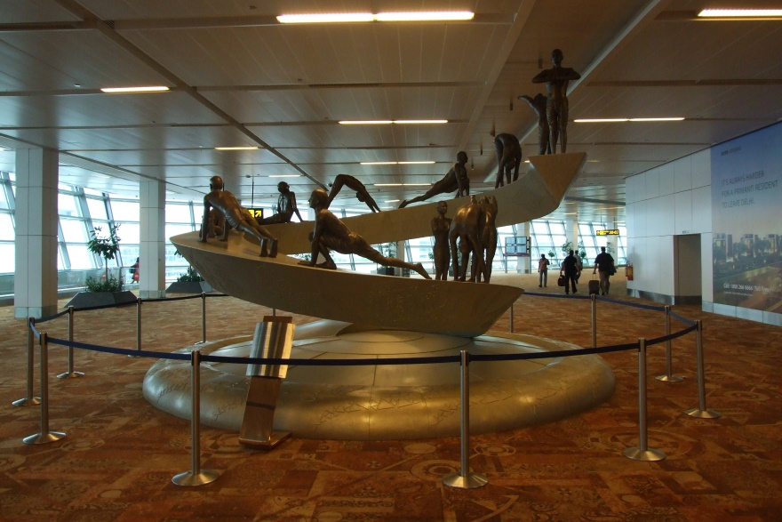

Twelve Surya Namaskar positions from the sculpture at Indira Gandhi International Airport New Delhi, India. Each position is an independent ‘Asana’ or posture of yogic exercise. Attribution in chapter References.

A few people might look upon Sun Salutations as a kind of idol worship, and therefore refuse to do it. We would request such people not to consider it as so, and instead, take full advantage of the benefits it provides. This point, along with many others, has been well expounded in a book, ‘The Ten Point Way To Health, Surya Namaskars’, by Shrimant Balasahib Pant Pratinidhi, Rajah of Aundh. Try to get hold of this book from the internet if possible. Not only will it clear all doubts, but also provide the necessary motivation to quickly embark on a mission to great all-round health via the Surya Namaskars.

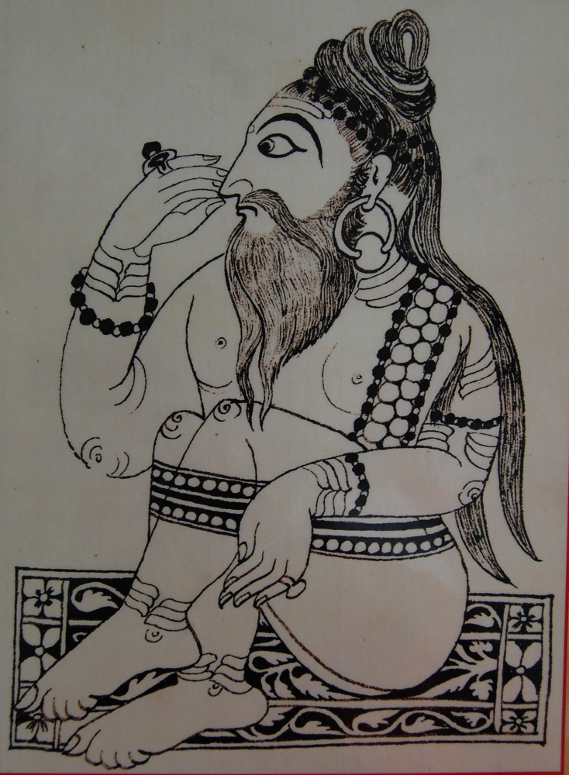

Kalyan Swami, among the foremost disciples of the Indian saint and spiritual poet, Samartha Ramdas. It is known that the main exercise of Ramdas and his disciples was the Surya Namaskars. The importance of bodily strength along with that of mind was a key tenet of Ramdas’s teachings. Attribution in chapter References.

### Food for Thought

* Did you ever think that maintaining good health was such a big deal? It is difficult to realize this while in youth. Ask your elders.
* Are you all set to embark on a mission to great lifelong health? It is never too early (or too late), right?
* Among other things described in Gandhiji’s book, one thing not commonly known is the practice of ‘Brahmacharya’, particularly in student life. Parallels can also be found in lives and writings of personalities such as Newton, Vivekananda, Tesla, or Napoleon Hill. We strongly suggest that young readers get to know more about its benefits and drawbacks, and then decide a suitable course for themselves, in consultation with knowledgeable well-wishers aware of modern medical science.
* Following a ‘Surya Namaskar only’ exercise regimen will never get you the 6-8 pack muscle tone. It will, however, provide you with ample bodily strength and flexibility, as well as freshness and vigor throughout the day. Is physique like that of ‘Kalyan Swami’ in the picture above, reasonably appealing?
* Benjamin Franklin said: “*Early to bed and early to rise makes a man healthy, wealthy, and wise.*” Another low hanging fruit waiting to be picked?

### References

* A Guide To Health, by M. K. Gandhi, Translated from Hindi, by Rama Iyer, 1921.
* The Ten Point Way To Health, Surya Namaskars, by Shrimant Balasahib Pant Pratinidhi, Rajah of Aundh, 1938.
* Sculpture depicting 12 Asana's of the Surya Namaskar at Terminal T3 at IGIA Airport, New Delhi, India, Design, Landor/Incubis Consultants, Delhi, Execution Ayush Kasliwal design Pvt. Ltd, Human figures sculpted by Nikhil Bhandari. By Wiki-uk (Own work) [[CC BY-SA 3.0](http://creativecommons.org/licenses/by-sa/3.0) (http://creativecommons.org/licenses/by-sa/3.0)], [via Wikimedia Commons](https://commons.wikimedia.org/wiki/File%3ASurya_Namaskar_sculpture_at_IGIA_T3.jpg).
* Shishya of Samarth Ramdas Swami by Jahagirdarsa (Own work) [[CC BY-SA 3.0](http://creativecommons.org/licenses/by-sa/3.0) (http://creativecommons.org/licenses/by-sa/3.0)], [via Wikimedia Commons](https://commons.wikimedia.org/wiki/File%3AKalyanswamioriginal.JPG).

The Practical Farmer

Complexity: Medium

This is the concluding chapter of Geo. E. Waring’s book for young farmers, ‘The Elements Of Agriculture’. Here, he gives tips to farmers on extracting maximum benefit from all avenues available, to make farming profitable. The ideas here are more specific to temperate rather than tropical regions.

What is important here is the habit of application of mind to optimize farming in every possible way. While this is true for every kind of work, it is especially important in farming, considering its heavy dependency on factors beyond human control, and the wafer thin margins under which farmers need to operate.

Who is the *practical farmer*? Let us look at two pictures and decide.

Here is a farm of 100 acres in ordinary condition. It is owned and tilled by a hard-working man, who, in the busy season, employs one or two assistants. The farm is free from debt, but it does not produce an abundant income; therefore, its owner cannot afford to purchase the best implements, or make other needed improvements; besides, he doesn't *believe* in such things. His father was a good solid farmer; so was his grandfather; and so is he, or thinks he is. He is satisfied that **'the good old way' is best**, and he sticks to it. He works from morning till night, from spring till fall. In the winter, he *rests*, as much as his lessened duties will allow. During this time, **he reads little, or nothing**. Least of all does he read about farming. He doesn't want to learn how to dig potatoes out of a book. Book farming is nonsense. Many other similar ideas keep him from agricultural reading. His house is comfortable, and his barns are quite as good as his neighbors', while his farm gives him a living. It is true that his soil does not produce as much as it did ten years ago; but prices are better, and he is satisfied.

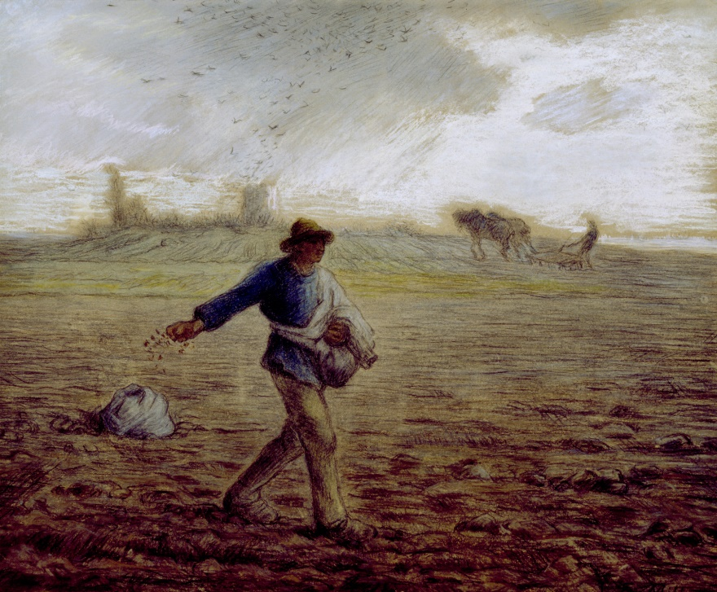

The Sower’, by Jean-Francois Millet, 1865. Attribution in chapter References.

Let us look at his premises, and see how his affairs are managed. First, examine the land. Well, it is good fair land. Some of it is a little springy[100], but is not to be called *wet*. It will produce a ton and a half of hay to the acre—it used to produce two tons. There are some stones on the land, but not enough in his estimation to do harm. The plowed fields are pretty good; they will produce 35 bushels of corn, 13 bushels of wheat, or 30 bushels of oats per acre, when the season is not dry. His father used to get more; but, somehow, the *weather* is not so favorable as it was in old times. He has thought of raising root crops, but they take more labor than he can afford to hire. Over, in the back part of the land, there is a muck-hole, which is the only piece of *worthless* land on the whole farm.

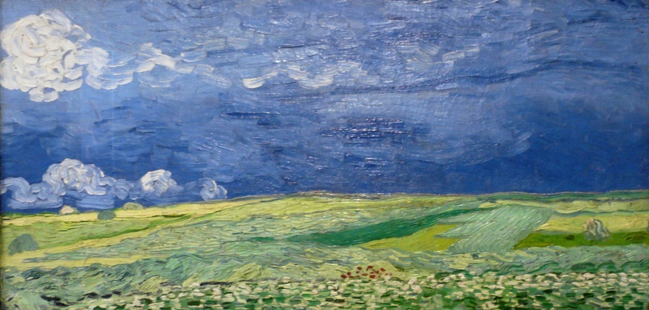

Irrigation: Wheatfield under thunderclouds, Vincent Van Gogh (1890). Attribution in chapter References.

Now, let us look at the barns and barn-yards. The stables are pretty good. There are some wide cracks in the siding, but they help to ventilate, and make it healthier for the cattle. The manure is thrown out of the back windows, and is left in piles under the eaves on the sunny side of the barn. The rain and sun make it nicer to handle. The cattle have to go some distance for water, and this gives them exercise. All of the cattle are not kept in the stable; the fattening stock[101] are kept in the various fields, where hay is fed out to them from the stack. The barnyard is often occupied by cattle, and is covered with their manure, which lies there until it is carted on to the land. In the shed are the tools of the farm, consisting of carts, plows—not deep plows, this farmer thinks it best to have roots near the surface of the soil where they can have the benefit of the sun's heat,—a harrow, hoes, rakes, etc. These tools are all in good order; and, unlike those of his less prudent neighbor, they are protected from the weather.

The crops are cultivated with the plow and hoe, as they have been since the land was cleared, and as they always will be until this man dies.

Here is the 'practical farmer' of the present day. Hard working, out of debt, and economical—of dollars and cents, if not of soil and manures. He is a better farmer than two thirds of the three millions of farmers in the country. He is one of the best farmers in his town—there are but few better in the county, not many in the State. He represents the better class of his profession.

With all this, he is, in matters relating to his business, an unreading, unthinking man. He knows nothing of the first principles of farming, and is successful by the *indulgence* of nature[102], **not because he understands it, and is able to make the most of its assistance**.

This is an unpleasant fact, but it is one that cannot be denied. We do not say this to disparage the farmer, but to arouse him to a realization of his position and of his power to improve it.

But let us see where he is wrong.

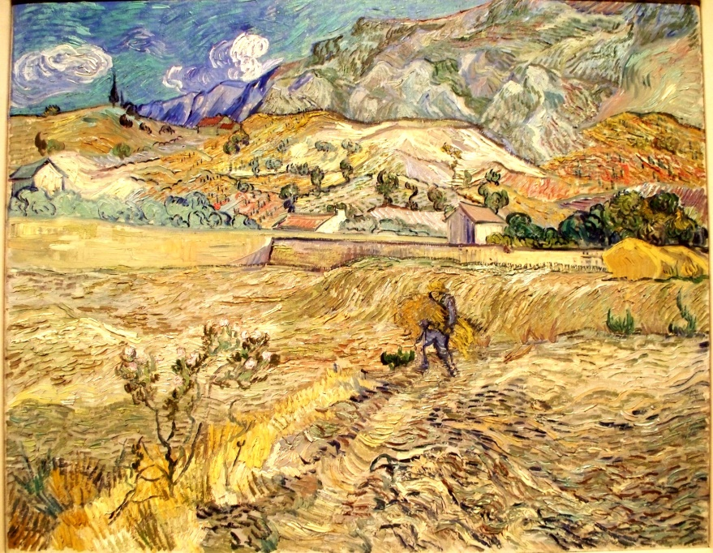

Harvest: Enclosed Wheat Field with Peasant / Landscape at Saint-Rémy. Vincent Van Gogh, 1889. Attribution in chapter References.

He is wrong in thinking that his land does not need draining. He is wrong in being satisfied with one and a half tons of hay to the acre when he might easily get two and a half. He is wrong in not removing as far as possible every stone that can interfere with the deep and thorough cultivation of his soil. He is wrong in reaping less than his father did, when he should get more. He is **wrong in ascribing to the weather, and similar causes**, what is due to the actual impoverishment of his soil. He is wrong in not raising turnips, carrots, and other roots, which his winter stock so much needs, when they might be raised at a cost of less than one third of their value as food.[103] He is wrong in considering worthless a deposit of muck, which is a mine of wealth if properly employed. He is wrong in *ventilating* his stables at the cost of *heat*. He is wrong in his treatment of his manures, for he loses more than one half of their value from evaporation, fermentation, and leaching. He is wrong in not having water at hand for his cattle—their exercise detracts from their accumulation of fat and their production of heat, and it exposes them to cold. He is wrong in not protecting his fattening stock from the cold of winter, for, under exposure to cold, the food, which would otherwise be used in the formation of *fat*, goes to the production of the animal heat necessary to counteract the chilling influence of the weather. He is wrong in allowing his manure to lie unprotected in the barnyard. He is wrong in not adding to his tools the deep surface plow, the subsoil plow, the cultivator, and many others of improved construction. He is wrong in cultivating with the plow and hoe those crops which could be better or more cheaply managed with the cultivator or horse-hoe.

He is wrong in many things more, as we shall see if we examine all of his yearly routine of work. He is right in a few things; and but a few, as he himself would admit, had he that knowledge of his business which he could obtain in the leisure hours of a single winter. Still, he thinks himself a *practical* farmer. In twenty years, we shall have fewer such, for our young men have the mental capacity and mental energy necessary to raise them to the highest point of practical education, and to that point they are gradually but surely rising.

Let us now place this same farm in the hands of an educated and understanding cultivator, and, at the end of five years, look at it again.

He has sold one half of it, and cultivates but fifty acres. The money for which the other fifty were sold has been used in the improvement of the farm. The land has all been under-drained, and shows the many improvements consequent on such treatment. The stones and small rocks have been removed, leaving the surface of the soil smooth, and allowing the use of the sub-soil plow, which, with the under-drains, has more than doubled the productive power of the farm. Sufficient labor is employed to cultivate with improved tools and extensive root crops, and they invariably give a large yield. The grassland produces a yearly average of 2½ tons of hay per acre. From 80 to 100 bushels of corn, 30 bushels of wheat, and 45 bushels of oats are the average of the crops reaped. The soil has been analyzed, and put in the best possible condition, while it is yearly supplied with manures containing everything taken away in the abundant crops. The analysis is never lost sight of in the regulation of crops and the application of manures. The *worthless* muck bed was retained, and is made worth one dollar a load to the compost heap, especially as the land requires an increase of organic matter. A new barn has been built large enough to store all of the hay produced on the farm. It has stables, which are tight and warm, and are well ventilated *above* the cattle. The stock being thus protected from the loss of their heat, give more milk, and make more fat on a less amount of food than they did under the old system. Water is near at hand, and the animals are not obliged to over exercise. The manure is carefully composted, either under a shed constructed for the purpose with a tank and pump, or is thrown into the cellar below, where the hogs mix it with a large amount of muck, which has been carted in after being thoroughly decomposed by the lime and salt mixture.

They are thus protected against all loss and are prepared for the immediate use of crops. No manures are allowed to lie in the barnyard, but they are all early removed to the compost heap, where they are preserved by being mixed with carbonaceous matter. In the tool shed, we find deep surface-plows, subsoil plows, cultivators, horse-hoes, seed-drills, and many other valuable improvements.

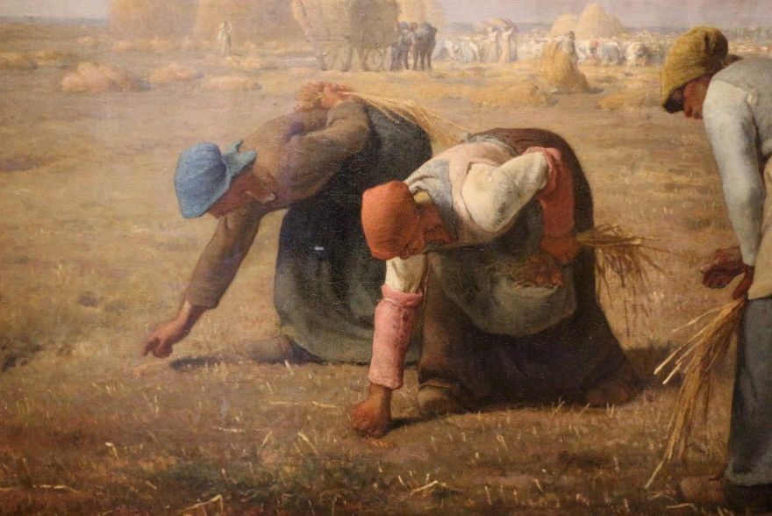

Finally: The Gleaners (Des glaneuses), by Jean-François Millet, 1857. Depicts three peasant women gleaning a field of stray wheat grains after the harvest. French upper classes of that time were not very happy with this painting, which featured the poor in a sympathetic way. Attribution in chapter References.

This farmer takes one or more agricultural papers, **from which he learns many new methods of cultivation**, while his knowledge of the *reasons* of various agricultural effects **enables him to discard the injudicious suggestions** of mere *book farmers* and uneducated dreamers.

Here are two specimens of farmers. Neither description is over-drawn. The first is much more careful in his operations than the majority of our rural population. The second is no better than many who may be found in America.

We appeal to the common sense of the reader of this work to know which of the two is the *practical farmer*—let him imitate, either as his judgment shall dictate.

### Food for Thought

* Just like the smart farmer above, we could also think about small improvements in day-to-day lives. Collectively, those could cause a significant improvement to our situation isn’t it? Try it out; we have so many resources lying idle that could be hitched to the wheel-work of the universe.
* This story is of a time when farming was primarily organic. Many changes have taken place since then. Think about these:
  + Pure organic farming methods with organic pesticides, fertilizers, and cattle have limitations, such as low productivity and high cost. Modern methods like machines, chemical fertilizers and pesticides, claim better productivity, but have their toll on environment, soil, and health. Where do we draw the line?
  + There are normal crops, then hybrids, and then the **genetically modified** (GM) ones. What is the difference between them? Have necessary mysteries of the gene been resolved and are GM crops ready for prime time? Are their benefits and drawbacks well understood and agreed upon by the scientific community?
* Many times, radically new, seemingly revolutionary methods are introduced in important sectors such as food and medicine. There have been situations when their introduction into mainstream was hurried without sufficient study of their ill-effects over the longer term. This was often done due to economic priorities, or other reasons. Can you identify such examples, their causes and possible ways to avoid them?

### References

* The Elements Of Agriculture, by Geo. E. Waring, Jr., 1854.
* Wheat Under Thunderclouds, By jankie [[CC BY-SA 2.0](http://creativecommons.org/licenses/by-sa/2.0) (http://creativecommons.org/licenses/by-sa/2.0)], [via Wikimedia Commons](https://commons.wikimedia.org/wiki/File%3AWLANL_-_jankie_-_Korenveld_onder_onweerslucht%2C_Vincent_van_Gogh_(1890).jpg).
* Enclosed Wheat Field with Peasant, Vincent van Gogh [[CC BY 2.5](http://creativecommons.org/licenses/by/2.5) (http://creativecommons.org/licenses/by/2.5)], [via Wikimedia Commons](https://commons.wikimedia.org/wiki/File%3AWLA_ima_Landscape_at_St_Remy.jpg).
* The Gleaners by Millet, Photograph, By Sailko (Own work) [[CC BY 3.0](http://creativecommons.org/licenses/by/3.0) (http://creativecommons.org/licenses/by/3.0)], [via Wikimedia Commons](https://commons.wikimedia.org/wiki/File%3AJean-fran%C3%A7ois_millet%2C_le_spigolatrici%2C_1857%2C_02.JPG).

Leonardo da Vinci, The Genius

Complexity: Medium

Leonardo Da Vinci (15 April 1452 - 2 May 1519) has become immortal in the history of art, thanks to his masterpieces such as ‘Mona Lisa’ and ‘The Last Supper’. In addition to that, he was well versed in many other fields of learning such as architecture, literature, science, mathematics, and music.

This biography of the great polymath, containing sweet and bitter experiences of his life, should serve as an inspiration and guide to ones treading the path to excellence.

(Note: We did not feel the need to simplify archaic language used in some parts here. Hope readers don’t find it too inconvenient.)

“Men of lofty genius, when they are doing the least work, are most active.”

– Leonardo da Vinci

On the sunny slopes of Monte Albano, between Florence and Pisa,[104] the little town of Vinci lay high among the rocks that crowned the steep hillside. It was but a little town. Only a few houses crowded together round an old castle in the midst, and it looked from a distance like a swallow's nest clinging to the bare steep rocks.

Here, in the year 1452 Leonardo, son of Ser Piero da Vinci, was born. It was in the age when people told fortunes by the stars, and when a baby was born, they would eagerly look up and decide whether it was a lucky or unlucky star that shone upon the child. Surely if it had been possible in this way to tell what fortune awaited the little Leonardo, a strange new star must have shone that night, brighter than the others and unlike the rest in the dazzling light of its strength and beauty.

Leonardo was always a strange child. Even his beauty was not like that of other children. He had the most wonderful waving hair, falling in regular ripples, like the waters of a fountain, the colour of bright gold, and soft as spun silk. His eyes were blue and clear, with a mysterious light in them, not the warm light of a sunny sky, but rather the blue that glints in the iceberg. They were merry eyes too, when he laughed, but underneath was always that strange cold look. There was a charm about his smile, which no one could resist, and he was a favourite with all. Yet people shook their heads sometimes as they looked at him, and they talked in whispers of the old witch who had lent her goat to nourish the little Leonardo when he was a baby. The woman was a dealer in black magic, and who knew but that the child might be a changeling?

It was the old grandmother, Mona Lena, who brought Leonardo up and spoilt him not a little. His father, Ser Piero, was a lawyer, and spent most of his time in Florence, but when he returned to the old castle of Vinci, he began to give Leonardo lessons and tried to find out what the boy was fit for. But Leonardo hated those lessons and would not learn, so when he was seven years old he was sent to school.

This did not answer any better. The rough play of the boys was not to his liking. When he saw them drag the wings off butterflies or torture any animal that fell into their hands, his face grew white with pain, and he would take no share in their games. The Latin grammar, too, was a terrible task, while the many things he longed to know no one taught him.

So it happened that many a time, instead of going to school, he would slip away and escape up into the hills, as happy as a little wild goat. Here was all the sweet fresh air of heaven, instead of the stuffy schoolroom. Here were no cruel, clumsy boys, but all the wild creatures that he loved. Here he could learn the real things his heart was hungry to know, not merely words which meant nothing and led to nowhere.

For hours he would lie perfectly still with his heels in the air and his chin resting in his hands, as he watched a spider weaving its web, breathless with interest to see how the delicate threads were turned in and out. The gaily painted butterflies, the fat buzzing bees, the little sharp-tongued green lizards, he loved to watch them all, but above everything, he loved the birds. Oh, if only he too had wings to dart like the swallows, and swoop and sail and dart again! What was the secret power in their wings? Surely by watching he might learn it. Sometimes it seemed as if his heart would burst with the longing to learn that secret. It was always the hidden reason of things that he desired to know. Much as he loved the flowers, he must pull their petals of, one by one, to see how each was joined, to wonder at the dusty pollen, and touch the honey-covered stamens. Then, when the sun began to sink, he would turn sadly homewards, very hungry, with torn clothes and tired feet, but with a store of sunshine in his heart.

His grandmother shook her head when Leonardo appeared after one of his days of wandering.

'I know thou shouldst be whipped for playing truant,' she said; 'and I should also punish thee for tearing thy clothes.'

'Ah! But thou wilt not whip me,' answered Leonardo, smiling at her with his curious quiet smile, for he had full confidence in her love.

'Well, I love to see thee happy, and I will not punish thee this time,' said his grandmother. 'But if these tales reach thy father's ears, he will not be so tender as I am towards thee.'

And, sure enough, the very next time that a complaint was made from the school, his father happened to be at home, and then the storm burst.

'Next time I will flog thee,' said Ser Piero sternly, with rising anger at the careless air of the boy. 'Meanwhile we will see what a little imprisonment will do towards making thee a better child.'

Then he took the boy by the shoulders and led him to a little dark cupboard under the stairs, and there shut him up for three whole days.

There was no kicking or beating at the locked door. Leonardo sat quietly there in the dark, thinking his own thoughts, and wondering why there seemed so little justice in the world. But soon, even that wonder passed away, and, as usual when he was alone, he began to dream dreams of the time when he should have learned the swallows' secrets and should have wings like theirs.

But if there were complaints about Leonardo's dislike of the boys and the Latin grammar, there would be none about the lessons he chose to learn. Indeed, some of the masters began to dread the boy's eager questions, which were sometimes more than they could answer. Scarcely had he begun the study of arithmetic than he made such rapid progress, and wanted to puzzle out so many problems, that the masters were amazed. His mind seemed always eagerly asking for more light, and was never satisfied.

But it was out on the hillside that he spent his happiest hours. He loved every crawling, creeping, or flying thing, however ugly. Curious beasts, which might have frightened another child, were to him charming and interesting. There, as he listened to the carolling of the birds and bent his head to catch the murmured song of the mountain-streams, the love of music began to steal into his heart.

He did not rest then until he managed to get a lute and learned how to play upon it. And when he had mastered the notes and learned the rules of music, he began to play airs which no one had ever heard before, and to sing such strange sweet songs that the golden notes flowed out as fresh and clear as the song of a lark in the early morning of spring.

'The child is a changeling,' said some, as they saw Leonardo tenderly lift a crushed lizard in his hand, or watched him play with a spotted snake or great hairy spider.

'A changeling perhaps,' said others, 'but one that hath the voice of an angel.' For everyone stopped to listen when the boy's voice was heard singing through the streets of the little town.

He was a puzzle to everyone, and yet a delight to all, even when they understood him least.

So time went on, and when Leonardo was thirteen, his father took him away to Florence that he might begin to be trained for some special work. But what work? Ah! That was the rub. The boy could do so many things well that it was difficult to fix on one.

At that time, there was living in Florence an old man who knew a great deal about the stars, and who made wonderful calculations about them. He was a famous astronomer, but he cared not at all for honour or fame, but lived a simple quiet life by himself and would not mix with the gay world.

Few visitors ever came to see him, for it was known that he would receive no one, and so it was a great surprise to old Toscanelli when one night a gentle knock sounded at his door, and a boy walked quietly in and stood before him.

Hastily the old man looked up, and his first thought was to ask the child how he dared enter without leave, and then ask him to be gone, but as he looked at the fair face he felt the charm of the curious smile, and the light in the blue eyes, and instead he laid his hand upon the boy's golden head and said: 'What dost thou seek, my son?'

'I would learn all that thou canst teach me,' said Leonardo, for it was he.

The old man smiled.

'Behold the boundless self-confidence of youth!' he said.

But as they talked together, and the boy asked his many eager questions, a great wonder awoke in the astronomer's mind, and his eyes shone with interest. This child-mind held depths of understanding such as he had never met with among his learned friends. Day after day, the old man and the boy bent eagerly together over their problems, and when night fell Toscanelli would take the child up with him to his lonely tower above Florence, and teach him to know the stars and to understand many things.

'This is all very well,' said Ser Piero, 'but the boy must do more than mere star-gazing. He must earn a living for himself, and methinks we might make a painter of him.'

That very day, therefore, he gathered together some of Leonardo's drawings, which lay carelessly scattered about, and took them to the studio of Verocchio the painter, who lived close by the Ponte Vecchio.

'Dost thou think thou canst make aught of the boy?' he asked, spreading out the drawings before Verocchio.

The painter's quick eyes examined the work with deep interest.

'Send him to me at once,' he said. 'This is indeed marvellous talent.'

So Leonardo entered the studio as a pupil, and learned all that could be taught to him with the same quickness with which he learned anything that he cared to know.

Everyone who saw his work declared that he would be the wonder of the age, but Verocchio shook his head.

'He is too wonderful,' he said. 'He aims at too great perfection. He wants to know everything and do everything, and life is too short for that. He finishes nothing, because he is ever starting to do something else.'

Verrocchio's words were true; the boy seldom worked long at one thing. His hands were never idle, and often, instead of painting, he would carve out tiny windmills and curious toys that worked with pulleys and ropes, or made exquisite little clay models of horses and all the other animals that he loved. But he never forgot the longing that had filled his heart when he was a child--the desire to learn the secret of flying.

For days he would sit idle and think of nothing but soaring wings, then he would rouse himself and begin to make some strange machine which he thought might hold the secret that he sought.

'A waste of time,' growled Verrocchio. 'See here, thou wouldst be better employed if thou shouldst set to work and help me finish this picture of the Baptism for the good monks of Vallambrosa. Let me see how thou canst paint in the kneeling figure of the angel at the side.'

For a while, the boy stood motionless before the picture as if he was looking at something far away. Then he seized the brushes with his left hand and began to paint with quick certain sweep. He never stopped to think, but worked as if the angel were already there, and he were but brushing away the veil that hid it from the light.

Then, when it was done, the master came and looked silently on. For a moment, a quick stab of jealousy ran through his heart. Year after year had he worked and striven to reach his ideal. Long days of toil and weary nights had he spent, winning each step upwards by sheer hard work. And here was this boy without an effort able to rise far above him. All the knowledge that the master had groped after, had been grasped at once by the wonderful mind of the pupil. But the envious feeling passed quickly away, and Verrocchio laid his hand upon Leonardo's shoulder.

'I have found my master,' he said quietly, 'and I will paint no more.'

Leonardo scarcely seemed to hear; he was thinking of something else now, and he seldom noticed if people praised or blamed him. His thoughts had fixed themselves upon something he had seen that morning which had troubled him. On the way to the studio he had passed a tiny shop in a narrow street, where a seller of birds was busy hanging his cages up on the nails fastened to the outside wall.

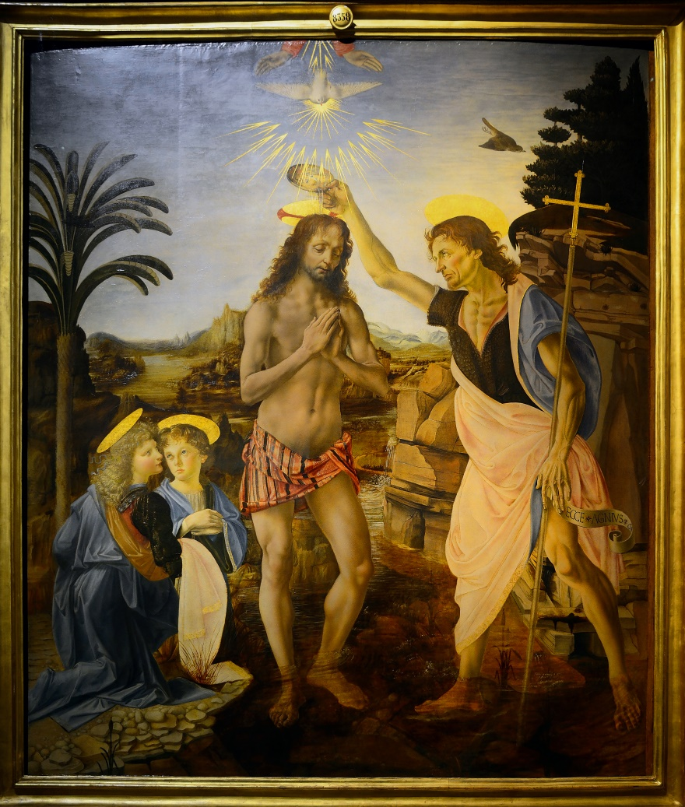

The Baptism of Christ, Uffizi, By Verrocchio and Leonardo, (1472–75). Attribution in chapter References.

The thought of those poor little prisoners beating their wings against the cruel bars and breaking their hearts with longing for their wild free life, had haunted him all day, and now he could bear it no longer. He seized his cap and hurried off, all forgetful of his kneeling angel and the master's praise.

He reached the little shop and called to the man within.

'How much wilt thou take for thy birds?' he cried, and pointed to the little wooden cages that hung against the wall.

'Plague on them,' answered the man, 'they will often die before I can make a sale by them. Thou canst have them all for one silver piece.'

In a moment, Leonardo had paid the money and had turned towards the row of little cages. One by one he opened the doors and set the prisoners free, and those that were too frightened or timid to fly away, he gently drew out with his hand and sent them gaily whirling up above his head into the blue sky.

The man looked with blank astonishment at the empty cages, and wondered if the handsome young man was mad. But Leonardo paid no heed to him, but stood gazing up until every one of the birds had disappeared.

'Happy things,' he said, with a sigh. 'Will you ever teach me the secret of your wings, I wonder?'

It was with great pleasure that Ser Piero heard of his son's success at Verrocchio's studio, and he began to have hopes that the boy would make a name for himself after all. It happened just then that he was on a visit to his castle at Vinci, and one morning a peasant who lived on the estate came to ask a great favour of him.

He had bought a rough wooden shield which he was very anxious should have a design painted on it in Florence, and he begged Ser Piero to see that it was done. The peasant was a faithful servant, and very useful in supplying the castle with fish and game, so Ser Piero was pleased to grant him his request.

'Leonardo shall try his hand upon it. It is time he became useful to me,' said Ser Piero to himself. So on his return to Florence he took the shield to his son.

It was a rough, badly-shaped shield, so Leonardo held it to the fire and began to straighten it. For though his **hands looked delicate and beautifully formed, they were as strong as steel**, and he could bend bars of iron without an effort. Then he sent the shield to a turner to be smoothed and rounded, and when it was ready, he sat down to think what he should paint upon it, for he loved to draw strange monsters.

'I will make it as terrifying as the head of Medusa,' he said at last, highly delighted with the plan that had come into his head.

Then he went out and collected together all the strangest animals he could find--lizards, hedgehogs, newts, snakes, dragon-flies, locusts, bats, and glow-worms. These he took into his own room, which no one was allowed to enter, and began to paint from them a curious monster, partly a lizard and partly a bat, with something of each of the other animals added to it.

When it was ready, Leonardo hung the shield in a good light against a dark curtain, so that the painted monster stood out in brilliant contrast, and looked as if its twisted curling limbs were full of life.

A knock sounded at the door, and Ser Piero's voice was heard outside asking if the shield was finished.

'Come in,' cried Leonardo, and Ser Piero entered.

He cast one look at the monster hanging there and then uttered a cry and turned to flee, but Leonardo caught hold of his cloak and laughingly told him to look closer.

'If I have really succeeded in frightening thee,' he said, 'I have indeed done all I could desire.'

His father could scarcely believe that it was nothing but a painting, and he was so proud of the work that he would not part with it, but gave the peasant of Vinci another shield instead.

Leonardo then began a drawing for a curtain, which was to be woven in silk and gold and given as a present from the Florentines to the King of Portugal, and he also began a large picture of the Adoration of the Shepherds, which was never finished.

The young painter grew restless after a while, and felt the life of the studio narrow and cramped. He longed to leave Florence and find work in some new place.

He was not a favourite at the court of Lorenzo the Magnificent as Filippino Lippi and Botticelli were. Lorenzo liked those who would flatter him and do as they were bid, while Leonardo took his own way in everything and never said what he did not mean.

But it happened that just then Lorenzo wished to send a present to Ludovico Sforza, the Duke of Milan, and the gift he chose was a marvellous musical instrument which Leonardo had just finished.

It was a silver lute, made in the form of a horse's head, the most curious and beautiful thing ever seen. Lorenzo was charmed with it.

'Thou shalt take it thyself, as my messenger,' he said to Leonardo. 'I doubt if another can be found who can play upon it as thou dost.'

So Leonardo set out for Milan, and was glad to shake himself free from the narrow life of the Florentine studio.

Before starting, however, he had written a letter to the Duke setting down in simple order all the things he could do, and telling of what use he could be in times of war and in days of peace.

There seemed nothing that he could not do. He could make bridges, blow up castles, dig canals, invent a new kind of cannon, build warships, and make underground passages. In days of peace he could design and build houses, make beautiful statues, and paint pictures 'as well as any man, be he who he may.'

The letter was written in curious writing from right to left like Hebrew or Arabic. This was how Leonardo always wrote, using his left hand, so that it could only be read by **holding the writing up to a mirror**.

The Duke was half amazed and half amused when the letter reached him.

'Either these are the words of a fool, or of a man of genius,' said the Duke. And when he had once seen and spoken to Leonardo he saw at once which of the two he deserved to be called.

Everyone at the court was charmed with the artist's beautiful face and graceful manners. His music alone, as he swept the strings of the silver lute and sang to it his own songs, would have brought him fame, but the Duke quickly saw that this was no mere minstrel.

It was soon arranged therefore that Leonardo should take up his abode at the court of Milan and receive a yearly pension from the Duke.

Sometimes the pension was paid, and sometimes it was forgotten, but Leonardo never troubled about money matters. Somehow or other he must have all that he wanted, and everything must be fair and dainty. His clothes were always rich and costly, but never bright-coloured or gaudy. There was no plume or jewelled brooch in his black velvet beretto or cap, and the only touch of colour was his golden hair, and the mantle of dark red cloth, which he wore in the fashion of the Florentines, thrown across his shoulder. Above all, he must always have horses in his stables, for he loved them more than human beings.

Many were the plans and projects that the Duke entrusted to Leonardo's care, but of all that he did, two great works stand out as greater than all the rest. One was the painting of the Last Supper on the walls of the refectory of Santa Maria delle Grazie, and the other the making of a model of a great equestrian statue, a bronze horse with the figure of the Duke upon its back.

'Year after year Leonardo worked at that wonderful fresco of the Last Supper. Sometimes for weeks or months he never touched it, but he always returned to it again. Then for days he would work from morning till night, scarcely taking time to eat, and able to think of nothing else, until suddenly he would put down his brushes and stand silently for a long, long time before the picture. It seemed as if he was wasting the precious hours doing nothing, but in truth, **he worked more diligently with his brain when his hands were idle**.

Often too when he worked at the model for the great bronze horse, he would suddenly stop, and walk quickly through the streets until he came to the refectory, and there, catching up his brushes, he would paint in one or perhaps two strokes, and then return to his modelling.

Besides all this, Leonardo was busy with other plans for the Duke's amusement, and no court fete was counted successful without his help. Nothing seemed too difficult for him to contrive, and what he did was always new and strange and wonderful.

Once, when the King of France came as a guest to Milan, Leonardo prepared a curious model of a lion, which by some inside machinery was able to walk forward several steps to meet the King, and then open wide its huge jaws and display inside a bed of sweet-scented lilies, the emblem of France, to do honour to her King. But while working at other things, Leonardo never forgot his longing to learn the secret art of flying. Every now and then a new idea would come into his head, and he would lay aside all other work until he had made the new machine which might perhaps act as the wings of a bird. Each fresh disappointment only made him more keen to try again.

'I know we shall someday have wings,' he said to his pupils, who sometimes wondered at the strange work of the master's hands. 'It is only a question of knowing how to make them. I remember once when I was a baby lying in my cradle, I fancied a bird flew to me, opened my lips and rubbed its feathers over them. So it seems to be my fate all my life to talk of wings.'

Very slowly the great fresco of the Last Supper grew under the master's hand until it was nearly finished. The statue, too, was almost completed, and then evil days fell upon Milan. The Duke was obliged to flee before the French soldiers, who forced their way into the town and took possession of it. Before anyone could prevent it, the soldiers began to shoot their arrows at the great statue, which they used as a target, and in a few hours the work of sixteen years was utterly destroyed. It is sadder still to tell the fate of Leonardo's fresco, the greatest picture perhaps that ever was painted. Dampness lurked in the wall and began to dim and blur the colours. The careless monks cut a door through the very centre of the picture, and, later on, when Napoleon's soldiers entered Milan, they used the refectory as a stable, and amused themselves by throwing stones at what remained of it. But **though little of it is left now to be seen, there is still enough to make us stand in awe and reverence** before the genius of the great master.

Not far from Milan, there lived a friend of Leonardo's, whom the master loved to visit. This Girolamo Melzi had a son called Francesco, a little motherless boy, who adored the great painter with all his heart.

Together, Leonardo and the child used to wander out to search for curious animals and rare flowers, and as they watched the spiders weave their webs and pulled the flowers to pieces to find out their secrets, the boy listened with wide wondering eyes to all the tales which the painter told him. And at night, Leonardo wrapped the little one close inside his warm cloak and carried him out to see the stars--those same stars which old Toscanelli had taught him to love long ago in Florence. Then, when the day of parting came, the child clung round the master's neck and would not let him go.

'Take me with thee,' he cried, 'do not leave me behind all alone.'

'I cannot take thee now, little one,' said Leonardo gently. 'Thou art still too small, but later on thou shalt come to me and be my pupil. This I promise thee.'

It was but a weary wandering life that awaited Leonardo after he was forced to leave his home in Milan. It seemed as if it was his fate to begin many things but to finish nothing. For a while, he lived in Rome, but he did little real work there.

For several years he lived in Florence and began to paint a huge battle-picture. There too he painted the famous portrait of Mona Lisa, which is now in Paris. Of all portraits that have ever been painted, this is counted the most wonderful and perfect piece of work, although Leonardo himself called it unfinished.

By this time, the master had fallen on evil days. All his pupils were gone, and his friends seemed to have forgotten him. He was sitting before the fire one stormy night, lonely and sad, when the door opened and a tall handsome lad came in.

'Master!' he cried, and kneeling down he kissed the old man's hands. 'Dost thou not know me? I am thy little Francesco, come to claim thy promise that I should one day be thy servant and pupil.

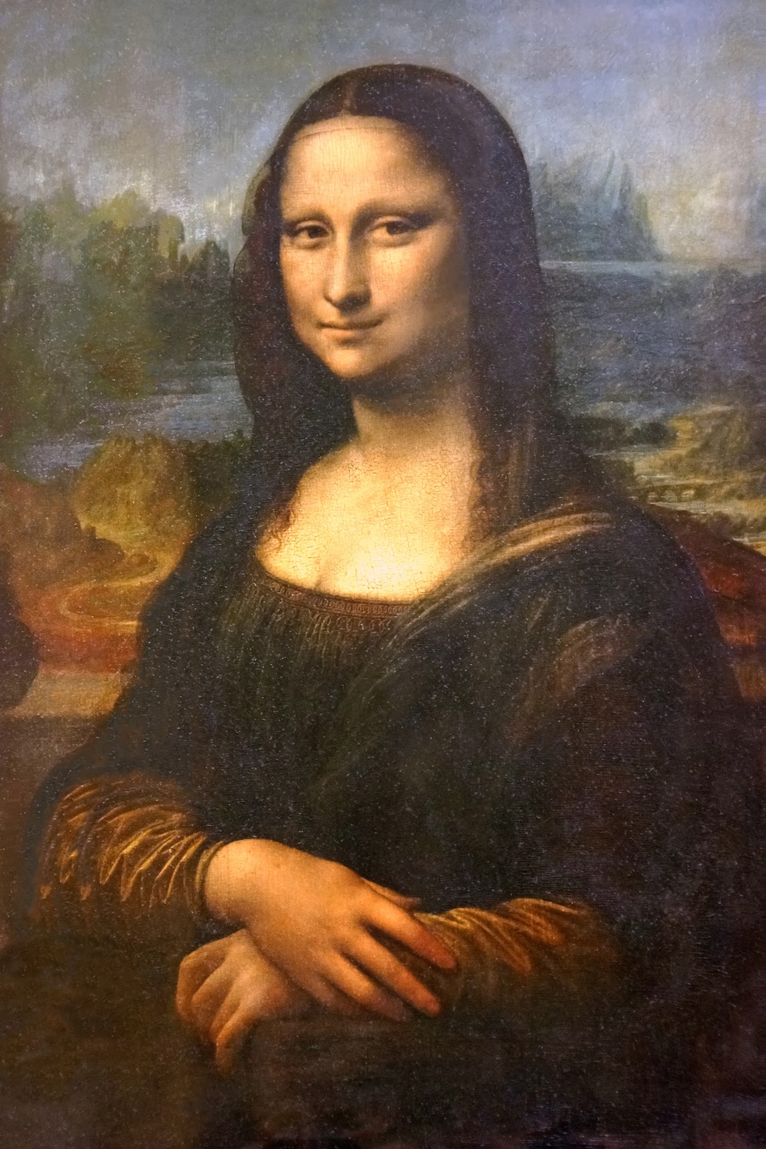

The immortal Mona Lisa (1503-1506). Attribution in chapter References.

Leonardo laid his hand upon the boy's fair head and looked into his face.

'I am growing old,' he said, 'and I can no longer do for thee what I might once have done. I am but a poor wanderer now. Dost thou indeed wish to cast in thy lot with mine?'

'I care only to be near thee,' said the boy. 'I will go with thee to the ends of the earth.'

So when, soon after, Leonardo received an invitation from the new King of France, he took the boy with him, and together they made their home in the little chateau of Claux, near the town of Amboise.

The master's hair was silvered now, and his long beard was as white as snow. His keen blue eyes looked weary and tired of life, and care had drawn many deep lines on his beautiful face. Sad thoughts were always his company. The one word 'failure' seemed to be written across his life. What had he done? He had begun many things and had finished but few. His great fresco was even now fading away and becoming dim and blurred. His model for the marvellous horse was destroyed. A few pictures remained, but these had never quite reached his ideal. The crowd, who had once hailed him as the greatest of all artists, could now only talk of Michelangelo and the young Raphael. **Michelangelo himself had once scornfully told him he was a failure and could finish nothing.**

He was glad to leave Italy and all its memories behind, and he hoped to begin work again in his quiet little French home. But Death was drawing near, and before many years had passed, he grew too weak to hold a brush or pencil.

It was in the springtime of the year that the end came. Francesco had opened the window and gently lifted the master in his strong young arms, that he might look once more on the outside world, which he loved so dearly. The trees were putting on their dainty dress of tender green, white clouds swept across the blue sky, and April sunshine flooded the room.

As he looked out, the master's tired eyes woke into life.

'Look!' he cried, 'the swallows have come back! Oh, that they would lend me their wings that I might fly away and be at rest!'

The swallows darted and circled about in the clear spring air, busy with their building plans, but Francesco thought he heard the rustle of other wings as the master's soul, freed from the tired body, was at last borne upwards higher than any earthly wings could soar.

### Food for Thought

* With the exception of a few, all works of this genius were left unfinished. Why do you feel this might have happened? Aiming for excellence beyond reach? Excessive intelligence due to which more fascinating challenges always distracted him? Ordinary fickle mindedness or **procrastination**? He probably could have answered this allegation, but never did. Maybe, one needs to be a true genius in order to understand it.
* Many artists, philosophers, or scientists who became immortal in history, had their share of unhappiness, even extreme tragedy at times. Some probably were more fortunate than others, but the path to excellence is certainly not for the faint-hearted. Isn’t it? In bad times, it is perhaps only the burning desire to scale new heights that keeps these people going.

### References

* Knights Of Art, Stories Of The Italian Painters, by Amy Steedman, 1907.
* Baptism of Christ by Andrea del Verrocchio [[CC BY-SA 4.0](http://creativecommons.org/licenses/by-sa/4.0) (http://creativecommons.org/licenses/by-sa/4.0)], [via Wikimedia Commons](https://commons.wikimedia.org/wiki/File%3AThe_Baptism_of_Christ_(Verrocchio_%26_Leonardo).jpg).
* By Dennis Jarvis from Halifax, Canada (France-003324 - Mona Lisa) [[CC BY-SA 2.0](http://creativecommons.org/licenses/by-sa/2.0) (http://creativecommons.org/licenses/by-sa/2.0)], [via Wikimedia Commons](https://commons.wikimedia.org/wiki/File%3AFrance-003324_-_Mona_Lisa_(16236519171).jpg).

Holiday Preparations, by Jerome K. Jerome

Complexity: Medium

A humorous incident from Jerome K. Jerome’s ever-green literary classic, ‘Three Men In A Boat (To Say Nothing Of The Dog)’. Three friends, author Jerome (J.), George, and Harris, are planning a boating holiday on river Thames and presently meeting to discuss arrangements.

The episode outline in J.’s own words can be given as:

Arrangements settled.—Harris’s method of doing work.—How the elderly, family-man puts up a picture.—George makes a sensible, remark.—Delights of early morning bathing.—Provisions for getting upset[105].

So, on the following evening, we again assembled, to discuss and arrange our plans. Harris said:

“Now, the first thing to settle is what to take with us. Now, you get a bit of paper and write down, J., and you get the grocery catalogue, George, and somebody give me a bit of pencil, and then I’ll make out a list.”

That’s Harris all over—so ready to take the burden of everything himself, and put it on the backs of other people.

He always reminds me of my poor Uncle Podger. You never saw such a commotion up and down a house, in all your life, as when my Uncle Podger undertook to do a job. A picture would have come home from the frame-maker’s, and be standing in the dining-room, waiting to be put up; and Aunt Podger would ask what was to be done with it, and Uncle Podger would say:

“Oh, you leave that to me. Don’t you, any of you, worry yourselves about that. I’ll do all that.”

And then he would take off his coat, and begin. He would send the girl out for sixpen’orth[106] of nails, and then one of the boys after her to tell her what size to get; and, from that, he would gradually work down, and start the whole house.

“Now you go and get me my hammer, Will,” he would shout; “and you bring me the rule, Tom; and I shall want the step-ladder, and I had better have a kitchen-chair, too. And, Jim! You run round to Mr. Goggles, and tell him, ‘Pa’s kind regards, and hopes his leg’s better; and will he lend him his spirit-level?’ And don’t you go, Maria, because I shall want somebody to hold me the light; and when the girl comes back, she must go out again for a bit of picture-cord; and Tom!—where’s Tom?—Tom, you come here; I shall want you to hand me up the picture.”

And then he would lift up the picture, and drop it, and it would come out of the frame, and he would try to save the glass, and cut himself; and then he would spring round the room, looking for his handkerchief. He could not find his handkerchief, because it was in the pocket of the coat he had taken off, and he did not know where he had put the coat, and all the house had to leave off looking for his tools, and start looking for his coat, while he would dance round and hinder them.

“Doesn’t anybody in the whole house know where my coat is? I never came across such a set in all my life—upon my word, I didn’t. Six of you!—and you can’t find a coat that I put down not five minutes ago! Well, of all the—”

Then he’d get up, and find that he had been sitting on it, and would call out:

“Oh, you can give it up! I’ve found it myself now. Might just as well ask the cat to find anything as expect you people to find it.”

And, when half an hour had been spent in tying up his finger, and a new glass had been got, and the tools, and the ladder, and the chair, and the candle had been brought, he would have another go, the whole family, including the girl and the charwoman, standing round in a semi-circle, ready to help. Two people would have to hold the chair, and a third would help him up on it and hold him there, and a fourth would hand him a nail, and a fifth would pass him up the hammer, and he would take hold of the nail and drop it.

“There!” he would say, in an injured tone, “Now the nail’s gone.”

And we would all have to go down on our knees and grovel for it, while he would stand on the chair, and grunt, and want to know if he was to be kept there all the evening.

The nail would be found at last, but by that time, he would have lost the hammer.

“Where’s the hammer? What did I do with the hammer? Great heavens! Seven of you, gaping round there, and you don’t know what I did with the hammer!”

We would find the hammer for him, and then he would have lost sight of the mark he had made on the wall, where the nail was to go in, and each of us had to get up on the chair, beside him, and see if we could find it; and we would each discover it in a different place, and he would call us all fools, one after another, and tell us to get down. And he would take the rule, and re-measure, and find that he wanted half thirty-one and three-eighths inches from the corner, and would try to do it in his head, and go mad.

And we would all try to do it in our heads, and all arrive at different results, and sneer at one another. And in the general row, the original number would be forgotten, and Uncle Podger would have to measure it again.

He would use a bit of string this time, and at the critical moment, when the old fool was leaning over the chair at an angle of forty-five, and trying to reach a point three inches beyond what was possible for him to reach, the string would slip, and down he would slide on to the piano, a really fine musical effect being produced by the suddenness with which his head and body struck all the notes at the same time.

And Aunt Maria would say that she would not allow the children to stand round and hear such language.

At last, Uncle Podger would get the spot fixed again, and put the point of the nail on it with his left hand, and take the hammer in his right hand. And, with the first blow, he would smash his thumb, and drop the hammer, with a yell, on somebody’s toes.

Aunt Maria would mildly observe that, next time Uncle Podger was going to hammer a nail into the wall, she hoped he’d let her know in time, so that she could make arrangements to go and spend a week with her mother while it was being done.

“Oh! You women, you make such a fuss over everything,” Uncle Podger would reply, picking himself up. “Why, I like doing a little job of this sort.”

And then he would have another try, and, at the second blow, the nail would go clean through the plaster, and half the hammer after it, and Uncle Podger be precipitated against the wall with force nearly sufficient to flatten his nose.

Then we had to find the rule and the string again, and a new hole was made; and, about midnight, the picture would be up—very crooked and insecure, the wall for yards round looking as if it had been smoothed down with a rake, and everybody dead beat and wretched—except Uncle Podger.

“There you are,” he would say, stepping heavily off the chair on to the charwoman’s corns, and surveying the mess he had made with evident pride. “Why, some people would have had a man in to do a little thing like that!”

Harris will be just that sort of man when he grows up, I know, and I told him so. I said I could not permit him to take so much labour upon himself. I said:

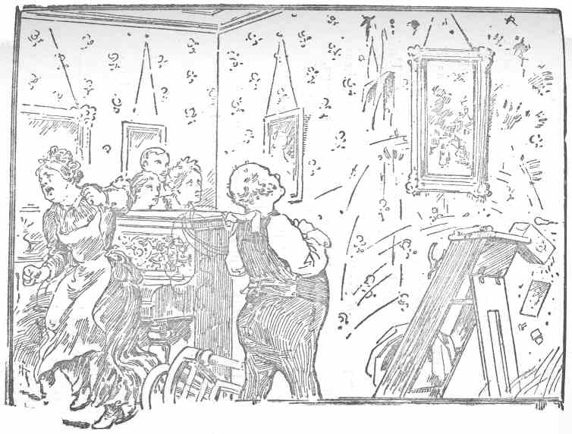

Uncle Podger admiring his work

“No; you get the paper, and the pencil, and the catalogue, and George, write down, and I’ll do the work.”

The first list we made out had to be discarded. It was clear that the upper reaches of the Thames would not allow of the navigation of a boat sufficiently large to take the things we had set down as indispensable, so we tore the list up, and looked at one another!

George said:

“You know we are on a wrong track altogether. We must not think of the things we could do with, but only of the things that we can’t do without.”

George comes out really quite sensible at times. You’d be surprised. I call that downright wisdom, not merely as regards the present case, but with reference to our trip up the river of life, generally. How many people, on that voyage, load up the boat till it is ever in danger of swamping with a store of foolish things, which they think essential to the pleasure and comfort of the trip, but which are really only useless lumber.

How they pile the poor little craft mast-high with fine clothes and big houses; with useless servants, and a host of swell friends that do not care twopence for them, and that they do not care three ha’pence for; with expensive entertainments that nobody enjoys, with formalities and fashions, with pretence and ostentation, and with—**oh, heaviest, maddest lumber of all!—the dread of what will my neighbour think, with luxuries that only cloy, with pleasures that bore, with empty show that, like the criminal’s iron crown of yore, makes to bleed and swoon the aching head that wears it!**

It is lumber, man—all lumber! Throw it overboard. It makes the boat so heavy to pull, you nearly faint at the oars. It makes it so cumbersome and dangerous to manage, you never know a moment’s freedom from anxiety and care, never gain a moment’s rest for dreamy laziness—no time to watch the windy shadows skimming lightly o’er the shallows, or the glittering sunbeams flitting in and out among the ripples, or the great trees by the margin looking down at their own image, or the woods all green and golden, or the lilies white and yellow, or the sombre-waving rushes, or the sedges, or the orchis, or the blue forget-me-nots.

Throw the lumber over, man! **Let your boat of life be light, packed with only what you need**—a homely home and simple pleasures, one or two friends, worth the name, someone to love and someone to love you, a cat, a dog, and a pipe or two, enough to eat and enough to wear, and a little more than enough to drink; for thirst is a dangerous thing.

You will find the boat easier to pull then, and it will not be so liable to upset, and it will not matter so much if it does upset; good, plain merchandise will stand water. You will have time to think as well as to work. Time to drink in life’s sunshine—time to listen to the Aeolian music that the wind of God draws from the human heart-strings around us—time to—

I beg your pardon, really. I quite forgot.

Well, we left the list to George, and he began it.

“We won’t take a tent,” suggested George, “we will have a boat with a cover. It is ever so much simpler, and more comfortable.”

It seemed a good thought, and we adopted it. I do not know whether you have ever seen the thing I mean. You fix iron hoops up over the boat, and stretch a huge canvas over them, and fasten it down all round, from stem to stern, and it converts the boat into a sort of little house, and it is beautifully cosy, though a trifle stuffy; but there, everything has its drawbacks, as the man said when his mother-in-law died, and they came down upon him for the funeral expenses.

George said that in that case we must take a rug each, a lamp, some soap, a brush and comb (between us), a toothbrush (each), a basin, some tooth-powder, some shaving tackle (sounds like a French exercise, doesn’t it?), and a couple of big-towels for bathing. I notice that people always make gigantic arrangements for bathing when they are going anywhere near the water, but that they don’t bathe much when they are there.

It is the same when you go to the sea-side. I always determine—when thinking over the matter in London—that I’ll get up early every morning, and go and have a dip before breakfast, and I religiously pack up a pair of drawers and a bath towel. I always get red bathing drawers. I rather fancy myself in red drawers. They suit my complexion so. But when I get to the sea, I don’t feel somehow that I want that early morning bathe nearly so much as I did when I was in town.

On the contrary, I feel more that I want to stop in bed till the last moment, and then come down and have my breakfast. Once or twice virtue has triumphed, and I have got out at six and half-dressed myself, and have taken my drawers and towel, and stumbled dismally off. But I haven’t enjoyed it. They seem to keep a specially cutting east wind, waiting for me, when I go to bathe in the early morning; and they pick out all the three-cornered stones, and put them on the top, and they sharpen up the rocks and cover the points over with a bit of sand so that I can’t see them, and they take the sea and put it two miles out, so that I have to huddle myself up in my arms and hop, shivering, through six inches of water. And when I do get to the sea, it is rough and quite insulting.

One huge wave catches me up and chucks me in a sitting posture, as hard as ever it can, down on to a rock that has been put there for me. And, before I’ve said “Oh! Ugh!” and found out what has gone, the wave comes back and carries me out to mid-ocean. I begin to strike out frantically for the shore, and wonder if I shall ever see home and friends again, and wish I’d been kinder to my little sister when a boy (when I was a boy, I mean). Just when I have given up all hope, a wave retires and leaves me sprawling like a star-fish on the sand, and I get up and look back and find that I’ve been swimming for my life in two feet of water. I hop back and dress, and crawl home, where I have to pretend I liked it.

In the present instance, we all talked as if we were going to have a long swim every morning.

George said it was so pleasant to wake up in the boat in the fresh morning, and plunge into the limpid river. Harris said there was nothing like a swim before breakfast to give you an appetite. He said it always gave him an appetite. George said that if it was going to make Harris eat more than Harris ordinarily ate, then he should protest against Harris having a bath at all.

He said there would be quite enough hard work in towing sufficient food for Harris up against stream, as it was.

I urged upon George, however, how much pleasanter it would be to have Harris clean and fresh about the boat, even if we did have to take a few more hundredweight of provisions; and he got to see it in my light, and withdrew his opposition to Harris’s bath.

Agreed, finally, that we should take three bath towels, so as not to keep each other waiting.

For clothes, George said two suits of flannel would be sufficient, as we could wash them ourselves, in the river, when they got dirty. We asked him if he had ever tried washing flannels in the river, and he replied: “No, not exactly himself like; but he knew some fellows who had, and it was easy enough;” and Harris and I were weak enough to fancy he knew what he was talking about, and that three respectable young men, without position or influence, and with no experience in washing, could really clean their own shirts and trousers in the river Thames with a bit of soap.

We were to learn in the days to come, when it was too late, that George was a miserable impostor, who could evidently have known nothing whatever about the matter. If you had seen these clothes after—but, as the shilling shockers say, we anticipate.

George impressed upon us to take a change of under-things and plenty of socks, in case we got upset and wanted a change; also plenty of handkerchiefs, as they would do to wipe things, and a pair of leather boots as well as our boating shoes, as we should want them if we got upset.

### Food for Thought

* Think a bit about the point on collection of ‘lumber’. Many things that initially look useful or lovable turn out to be less useful after a while, a burden or even nuisance. Do you remember piling up such nuisances, yourself?

### References

Three Men In A Boat (to say nothing of the dog), by Jerome K. Jerome, 1889.

Wealth Generation, from The Panchatantra

Complexity: Low

These are thoughts flowing from a merchant’s brain, from the first book of the Panchatantra, composed around 300 BCE. They stress upon the importance of wealth, and further, about various techniques of building, maintaining, and increasing it.

Now here begins the first technique (of the Panchatantra), named ‘Dissension Among Friends’ whose first verse is:

The strong bond of friendship growing between the Lion and the Bull was brought to an end by the slanderous greedy jackal.

It is heard that in the southern part of the country, there was a city named Mahilaropya[107]. In that city lived a merchant’s son named Vardhaman, who possessed **great wealth earned through virtuous means**. One night, while he was lying on the bed, the following thought started worrying him:

*“*Even if one has wealth in abundance, he should think, and also act on further means of increasing it. It is said:

‘There is nothing in this world that wealth cannot accomplish.’

And therefore, an intelligent person should try his best to earn one thing for sure, and that is wealth. One who has wealth has friends. One who has wealth, has relatives. One who has wealth is actually a man, and one who has wealth, is the learned Pandit! There is no such science, charity, art, craft, trade, or stability for which petitioners do not sing the praises of the wealthy.[108] In this world even strangers become intimate to a wealthy person, but a pauper is treated like a wicked being even by his own family members.

Just like different streams flowing down the mountains are responsible for all work done (e.g. irrigation, drinking or cleaning), collection of wealth from different sources and its increase is the source of all activities of the world.

It is the effect of this wealth indeed, which leads people to respect even the disrespectful, to visit someone not worth visiting, or even to greet someone not worth greeting. Just like food gives strength and vigor to all parts of the body, all activities are accomplished by wealth alone. Hence wealth is called a *universal means*. A person, for the sake of wealth, could inhabit even the crematorium, and the same person could cast away his poverty stricken father too. The wealthy maintain their youth even in old age, but the pauper looks aged while still in the years of youth!

Now this wealth comes to people in six ways. They are:

1. Begging for charity.
2. Serving at a king’s court, or some other master.
3. Working in the farms.
4. The learned professions or skills needing special training (e.g. doctors or mechanics).
5. Money lending business.
6. Trading, that is, buying and selling of goods or services.

However, among all these above methods of building wealth, trade is the only one where a person does not have to face abuse or insult. For, others have their drawbacks.

1. One needs to beg in many houses (and also bear many insults).
2. A master’s (or King’s) favor is unstable. Even the king does not pay appropriate wages to employees, what to talk of others?
3. Farming is ridden with so many difficulties.
4. Learning professions or skills is also filled with adversity. Since, we need to offer tedious services to teachers in order to please them and in turn, learn from them.
5. Lending money on interest could also bring about poverty if the borrower defaults in repayment.

Therefore, among all the above, trading seems to me the best[109] way to earn a living. Stocking and trading items worthy of selling is the greatest means of wealth creation, and every other means is to be looked upon with suspicion.

Now, profitable trade also has seven branches.

1. Trading in articles such as perfumes or special herbs.
2. Maintaining a pawnshop wherein one offers secured loans by keeping personal belongings of borrowers as collaterals.
3. Holding common stock (such as a bank that maintains people’s money and valuables safely).
4. Attracting familiar or loyal customers (to buy commodities being sold).
5. Boosting commodity prices well out of proportion to the cost.
6. Using fraud weights and balances.
7. Foreign trade in items, such as special utensils or household articles not available in the local market.[110]

Each of these too has their merits and drawbacks.

1. Among items worthy of selling, those like perfumes or special herbs are the best, since these can be bought very cheap and sold at huge profit margins due to their luxury value. What then, is the need to trade in costly items such as gold?
2. As soon as the pawn broker receives collateral, he prays to god: “If this borrower dies, I will worship you with all your favorite items of worship.” His eyes are fixed on pocketing the collateral.
3. The person holding common stock (which is not owned by him as such, like a banker) thinks complacently: “I am in charge of the entire wealth of this earth, and so, do not need anything else.”
4. When a trader sees a familiar customer approaching, he gets excited. And fixing his eyes on customer’s wealth, he becomes so happy, as if a son was just born to him!
5. & 6. : And further, the habit of deceiving customers using false weights or charging exorbitant rates for commodities is considered to be a quality of only the lowest class of traders.

And finally, thinking about foreign trade. By travelling to foreign lands and selling items in high demand there, such as utensils and others, an intelligent trader can earn double or even triple the usual amount.

Having thus set his mind in order, he collected merchandise bound for the city of Mathura. He assembled his servants, and after bidding farewell to his parents, at an auspicious time, set forth from the city.

### Food for Thought

* Apart from the wealth generation techniques described above, could you come up with more methods in light of modern times? Or are those still, in principle, the only techniques to earn wealth?
* Is money a means to achieve bigger goals, or a goal in itself, with various enterprises merely being ways to earn money?
* Can you think of situations under which, even a massive stock of wealth could diminish in no time? Social or Political turmoil, Gambling or Speculation, Health, Natural calamities, to name a few.
* What does the term ‘Financial Independence’ mean to you? Is it about having a sufficient stock of wealth for yourself and your dear ones to last a lifetime and more? Or is it about having sufficient strength of body, mind and intellect, readiness to work, and a few popular skills up your sleeve, to thrive well?

### References

Panchatantra, Translated from Sanskrit to Hindi by J. P. Mishra, 1910.

Joan Of Arc, or The Maid Of Orleans

Complexity: Medium

‘The Peasant Maiden who delivered her country and became a martyr in its cause.’

The kingdoms of England and France fought a series of wars for almost a hundred years, between the 14th and 15th centuries. Entry of the peasant warrior girl, ‘Joan Of Arc’, to the scene, marked the beginning of good times for France. It led to a revival of the French that eventually culminated in France successfully regaining control of its territories.

This story also describes **Joan’s supernatural experiences** believed to be the main driver for her taking up arms. Her contribution was commendable, considering the restrictions under which women all over the world had to live, during that period.

No story of heroism has greater attraction for youthful readers than that of Joan of Arc, the Maid of **Orleans**. It would be long to tell how greatest jealousy and mistrust existed between England and France for hundreds of years, and how constant disputes between their several sovereigns led to wars and tumults; how, in the time of **Henry the Fifth of England**, a state of wild confusion existed on the continent, and how **that king also claimed to be king of France**; how this fifth Henry was married to Catherine, daughter of King Charles, and how they were crowned king and queen of France;[111] how, in the midst of his triumphs, Henry died, and his son, an infant less than a year old, was declared king in his stead; how wars broke out, and how, at last, a simple maiden saved her country from the grasp of ambitious men. Hardly anything in history is more wonderful than the way in which she was raised up to serve her country's need, and, having served it, died a martyr in its cause.

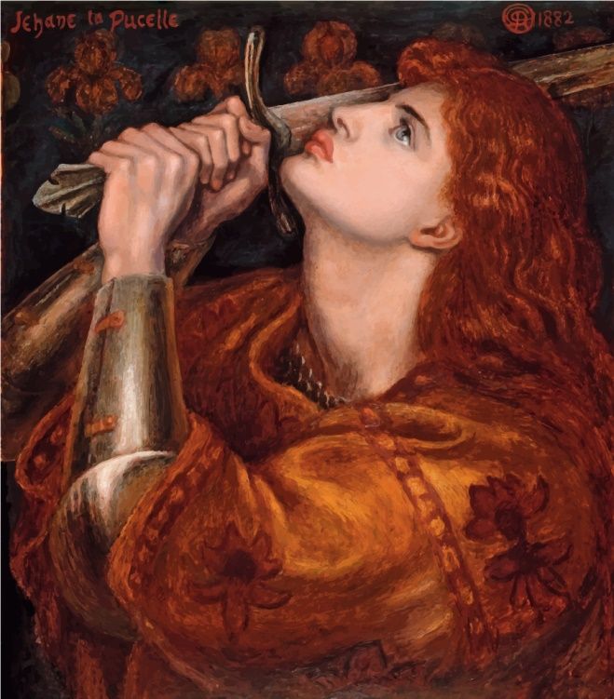

Joan of Arc, (Born 1412-Died 1431), by Daniel Gabriel Rossetti, 1882.

Joan of Arc, Maid of Orleans, was born in the forest of Greux, upon the Meuse, in the village of **Domremy, in Lorraine**,[112] in the year 1412. **At this time France was divided into two factions--the Burgundians and the Armagnacs--the former of whom favored the English cause, and the latter pledged to the cause of their country.**

Joan was the daughter of simple villagers. She was brought up religiously, and from her earliest youth is said to have seen visions[113] and dreamed dreams; the one great dream of her life was, however, the deliverance of her country from foreign invasions and domestic broils. When only about thirteen years of age, she announced to the astonished townspeople that **she had a mission**, and that she meant to fulfill it.

The disasters of the war reached Joan's home; a party of Burgundians dashed into Domremy, and the Armagnacs fled before them. Joan's family took refuge in the town of Neufchateau, and she paid for their lodging at an inn by helping the mistress of the house.

Here, in a more public place, it was soon seen and wondered at, that such a young girl was so interested in the war. Her parents were already angry that she would not marry. They began to be frightened now. Jacques D'Arc told one of his sons that sooner than let Joan go to the camp, he would drown her with his own hands. She could not, however, be kept back. Very cautiously, and as though afraid to speak of such high things, she began to let fall hints of what she saw. Half-frightened herself at what she said, she exclaimed to a neighbor, "There is now, between Colombey and Vaucouleurs, a maid who will cause the king of France to be crowned!"

Now came the turn in the war, when all the strength of both sides was to be gathered up into one great struggle, and it was to be shown whether the king was to have his right, or the usurper triumph. The real leaders of the war were the **Duke of Bedford, regent of England**, and the captains of the French army. Bedford gathered a vast force, chiefly from Burgundy, and gave its command to the **Earl of Salisbury**. The army went on; they gained, without a struggle, the towns of Rambouillet, Pithwier, Jargean, and others. Then they encamped before the city of Orleans. To this point, they drew their whole strength. Orleans taken, the whole country beyond was theirs, as it commanded the entrance to the River Loire and the southern provinces; and the only stronghold left to King Charles was the mountain country of Auvergne and Dauphine.

The men of Orleans well knew how much depended upon their city. They did all that could be done to prepare for a resolute defense. The siege of Orleans was one of the first in which cannons were used. When Salisbury was visiting the works, a cannon broke a splinter from a casement, which struck him and gave him his death wound. The **Earl of Suffolk**, who was appointed to succeed him, never had his full power.

Suffolk could not tame the spirit of the men of Orleans by regular attack, so he tried other means. He resolved to block it up by surrounding it with forts, and starve the people out. But for some time, before the works were finished, food was brought into the city; while the French troops, scouring the plains, often stopped the supplies coming to the English. Faster, however, than they were brought in, the provisions in Orleans wasted away. And through the dreary winter, the citizens watched one fort after another rise around them. The enemy was growing stronger, they were growing weaker; they had no prospect before them but defeat; when the spring came, would come the famine; their city would be lost, and then their country.

The eyes of all France were upon Orleans. News of the siege and of the distress came to Domremy, and Joan of Arc rose to action. Her mind was fixed to go and raise the siege of Orleans and crown Charles as king. Not for one moment did she think it impossible or even unlikely. She would carry out what God had called her to do. She made no secret of her call, but went to Vaucouleurs and told governor De Briancourt that she meant to save France. At first the governor treated her lightly, and told her to go home and **dream about a sweetheart**; but such was her earnestness that at last not only he, but thousands of other people believed in the mission of Joan of Arc. And so, soon after, she set out, with many noble attendants, to visit Charles at the castle of Chinon.

On all who saw her, Joan's earnestness, singleness of heart, and deep piety made but one impression. Only the king remained undecided; he could hardly be roused to see her, but at last he named a day, and Joan of Arc had her desire fulfilled, and stood before him in the great hall of **Chinon**[114]. Fifty torches lighted the hall, which was crowded with knights and nobles. Joan, too self-forgetful to feel abashed, walked forward firmly. Charles had placed himself among his courtiers, so that she should not know him. Not by inspiration, as they thought, but because with her enthusiasm she must have heard him described often and often, she at once singled him out and clasped his knees. Charles denied that he was the king. "In the name of God," Joan answered, "it is no other but yourself. Most noble Lord Dauphin[115], I am Joan, the maid sent on the part of God to aid you and your kingdom; and by his command I announce to you that you shall be crowned in the city of Rheims, and shall become his lieutenant in the realm of France." Charles led her aside, and told his courtiers afterward that in their private conversation she had revealed to him secrets.

But all that she said appears to have been, **"I tell thee from my Lord that thou art the true heir of France."** A few days before, the king had offered a prayer for help only on condition that he was the rightful sovereign, and it has been well said that, "Such a coincidence of idea on so obvious a topic seems very far from supernatural or even surprising." It is but one out of many **proofs how ready everyone in those days was to believe in signs and wonders**.

Her fame spread wide; there went abroad all kinds of reports about her miraculous powers. The French already began to hope and the English, to wonder.

The king still doubted, and so did his council. People in our own day, who admire the **wisdom of the Dark Ages**[116], would do well to study the story of Joan of Arc. She was taken to the University of Poictiers. The learned doctors took six weeks to **determine whether Joan was sent by God or in league with the devil. She never made any claim to supernatural help beyond what she needed to fulfill her mission.** She refused to give them a sign, saying that her sign would be at Orleans--the leading of brave men to battle. She boasted no attainments, declaring that she knew neither A nor B; only, she must raise the siege of Orleans and crown the Dauphin. The friars sent to her old home to inquire about her, brought back a spotless report of her life. So, after the tedious examination, the judgment of the learned and wise men of Poictiers was that Charles might accept her services without peril to his soul.

The vexatious delays over, Joan of Arc set out for Orleans. In the church of Fierbois she had seen, among other old weapons, a sword marked with five crosses. She sent for this. When she left Vaucouleurs she had put on a man's dress; now she was clad in white armor. A banner was prepared under her directions; this also was white, strewn with the lilies of France.

So much time had been lost that Joan was not at **Blois**[117] till the middle of April. She entered the town on horseback; her head was uncovered. All men admired her skillful riding and the poise of her lance. Joan carried all before her now; she brought spirit to the troops; the armor laid down was buckled on afresh when she appeared; the hearts of people were lifted up--they would have died for her. Charles, who had been with the army, slipped back to Chinon; but he left behind him better and braver men--his five bravest leaders. Joan began her work gloriously by clearing the camp of all bad characters. Father Pasquerel bore her banner through the streets, while Joan, with the priests who followed, sang the Litany and exhorted men to prepare for battle by repentance and prayer. She succeeded in this too, as in everything else.

When the English heard that Joan was really coming, they pretended to scorn her. Common report made Joan a prophet and a worker of miracles. Hearts beat faster in Orleans than they had done for months. Terror in the English camp was greater than ever before.

The English took no heed of Joan's order to submit. Little did they think that they would flee before a woman within a fortnight.

She entered the city at midnight. **LaHire** and two hundred men, with lances, were her **escort**. Though she had embarked close under an English fort, she was not assaulted. Untouched by the enemy, coming in the midst of the storm, bringing plenty, and the lights of her procession shining in the black night, we cannot wonder that the men of Orleans looked upon her as in very truth, the messenger of God. They flocked round her, and he who could touch but her horse, was counted happy.

Joan went straight to the cathedral, where she had the Te Deum[118] chanted. The people thought that they were already singing their thanksgivings for victory. Despair was changed to hope; fear to courage. She was known as "The Maid of Orleans." From the cathedral, she went to the house of one of the most esteemed ladies of the town, with whom she had chosen to live. A great supper had been prepared for her, but she took only a bit of bread sopped in wine before she went to sleep. By her orders, the next day an archer fastened to his arrow a letter of warning, and shot it into the English lines. She went herself along the bridge and exhorted the enemy to depart. **Sir William Gladsdale** tried to conceal his fright by answering her with such rude words as made her weep. Four days afterwards, the real terror of the English was shown. The Maid of Orleans and LaHire went to meet the second load of provisions. As it passed close under the English lines, not an arrow was shot against it; not a man appeared.

Joan of Arc was now to win as much glory by her courage as before her very name had brought. While she was lying down to rest, that same afternoon, the townspeople went out to attack the **English Bastile of St. Loup**. They had sent her no word of the fight. But Joan started suddenly from her bed, declaring that her voices told her to go against the English. She put on her armor, mounted her horse, and, with her banner in her hand, galloped through the streets. The French were retreating, but they gathered again round her white banner, and Joan led them on once more. Her spirit rose with the thickness of the fight. She dashed right into the midst. The battle raged for three hours round the Bastile of St. Loup, then Joan led on the French to storm it. Joan of Arc, the Maid of Orleans, had gained her first victory.

The day after, there was no fighting, for it was the Feast of the Ascension. Joan had been first in the fight yesterday; she was first in prayer today. She brought many of the soldiers to their knees for the first time in their lives.

All along, the captains had doubted the military skill of "the simplest girl they had ever seen," and they did not call her to the council they held that day. They resolved to attack the English forts on the southern and weakest side. After a little difficulty, Joan consented when she was told of it. The next day, before daybreak, she took her place with LaHire on a small island in the Loire, from where they crossed in boats to the southern bank. Their hard day's work was set about early. Joan would not wait for more troops, but began the fight at once. The English joined two garrisons together, and thus for a time overpowered the French as they attacked the Bastille of the Augustins.

Carried on for a little while with the flying, Joan soon turned round again upon the enemy. The sight of the witch, as they thought her, was enough. The English screened themselves from her and her charms behind their walls. Help was coming up for the French. They made a fresh attack; the bastille was taken and set on fire. Joan returned to the city slightly wounded in the foot.

The only fort left to the English was their first-made and strongest, the Bastille de Tournelles. It was held by the picked men of their army, Gladsdale and his company. The French leaders wished to delay its attack until they had fresh soldiers. This suited Joan little. "You have been to your council," she said, "and I have been to mine. Be assured that the council of my Lord will hold good, and that the council of men will perish." The hearts of the people were with her; the leaders thought it best to give in. Victory followed wherever she led, and, after several actions, at which she took active part, the siege was raised. It began on the 12th of October, 1428, and was raised on the 14th of May, 1429.

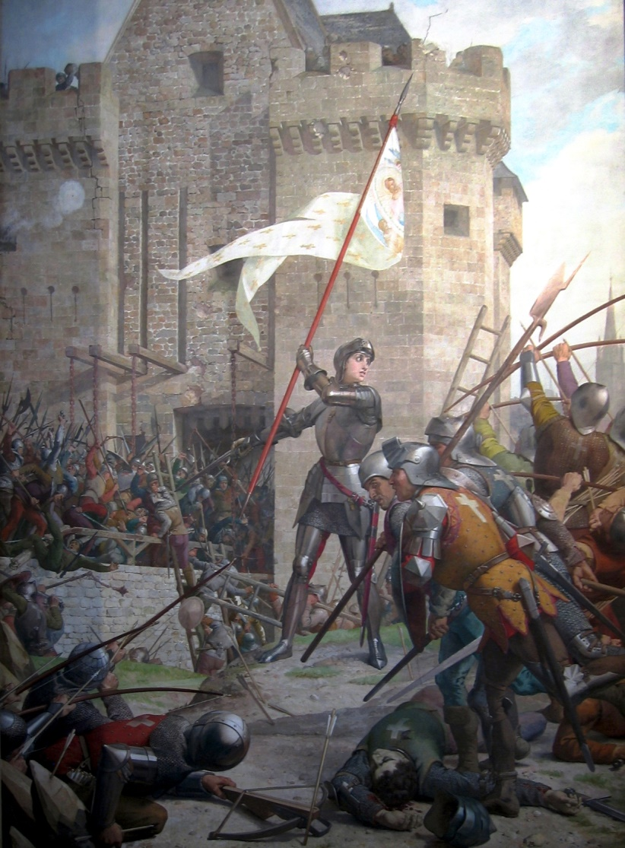

Joan of Arc at the Siege of Orleans, by Jules Eugene Lenepveu, 1886-1890. Attribution in chapter References.

Even now, in Orleans, the 14th of May is held sacred, that day on which, in 1429, the citizens watched the English lines growing less and less in the distance.

**Joan of Arc had even yet done but half her work. Neither Charles nor Henry had been crowned. That the crown should be placed on Charles's head was what she still had to accomplish. Though we have always spoken of him as "King," he was not so in reality until this had been done. He was strictly but the Dauphin. Bedford wished much that young Henry should be crowned**; for let Charles once have the holy crown on his brow, and the oil of anointing on his head, and let him stand where for hundreds of years his fathers had stood to be consecrated kings of France, in the **Cathedral of Rheims**, before his people as their king, any crowning afterwards would be a mockery. Charles was now with the Court of Tours. Rheims was a long way off in the north, and to get there would be a work of some difficulty; yet get there he must, for the coronation could not take place anywhere else. Joan went to Tours, and, falling before him, she begged him to go and receive his crown, saying that when her voices gave her this message, she was marvelously rejoiced. Charles did not seem much rejoiced to receive it. He said a great deal about the dangers of the way, and preferred that the other English posts on the Loire should be taken first. It must have been very trying for one so quick and eager as Joan to deal with such a person, but, good or bad, he was her king. She was not idle because she could not do exactly as she wished; she set out with the army at once.

The news flew onwards. The inhabitants of Chalons and of Rheims rose and turned out the Burgundian garrisons. The king's way to Rheims was one triumph, and, amidst the shouts of the people, he entered Rheims on the 16th of July. The next day, Charles VII was crowned. The visions of the Maid had been fulfilled. By her arm Orleans had been saved, through her means the king stood there. She was beside the king at the high altar, with her banner displayed; and when the service was over, she knelt before him with streaming eyes, saying, "Gentle king, now is done the pleasure of God, who willed that you should come to Rheims and be anointed, showing that you are the true king, and he to whom the kingdom should belong."

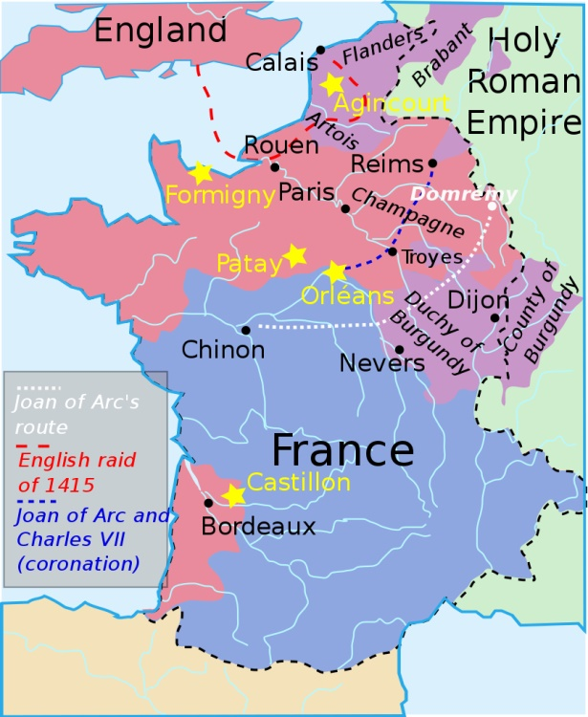

Map of France during the ‘[Hundred Years War](https://en.wikipedia.org/wiki/Hundred_Years_War)’, around the time of the Treaty of Troyes. Attribution in chapter References.

All eyes were upon her as the savior of her country. She might have secured everything for herself; but she asked no reward, she was content to have done her duty. And of all that was offered her, the only thing she would accept was that Domremy should be free forever from any kind of tax. So, until the time of the first French Revolution, the collectors wrote against the name of the village, as it stood in their books, **"Nothing, for the Maid's sake."**

Joan of Arc said that her work was done. She had seen her father and her uncle in the crowd, and, with many tears, she begged the king to let her go back with them, and keep her flocks and herds, and do all as she had been used to do. Never had man or woman done so much with so simple a heart. But the king and his advisers knew her power over the people, and their entreaties that she would stay with them prevailed. So she let her father and her uncle depart without her. They must have had enough to tell when they reached home.

We have little heart to tell the rest of the story. At length the king reached Paris, and the Duke of Bedford was away in Normandy. Joan wished to attack the city, and it was done. Many of the soldiers were jealous of her, and they fought only feebly. They crossed the first ditch round the city, but found the second full of water. Joan was trying its depth with her lance, when she was seriously wounded. She lay on the ground cheering the troops, calling for fagots and bundles of wood to fill the trench. She did not withdraw until the evening, when the Duke of Alencon persuaded her to give up the attempt, as it had prospered so badly.

Were it not so wicked and so shameful, it might be laughable to think of the king's idleness. It is really true that he longed for his lovely Chinon, and a quiet life, as a tired child longs to go to sleep. He made his misfortune at Paris, which would have stirred up almost anyone else to greater exertions, an excuse for getting away. The troops were sent to winter quarters; he went back across the Loire now, when the English leader was away, and the chief towns in the north ready to submit. Had he but shown himself a man, he might have gained his capital, and the whole of the north of France. The spirit that lately roused in him was down again. It seemed really not worthwhile to fight for a king who would not attend to business for more than two months together.

We know little more of the Maid of Orleans in the winter, than that she continued with the army. After her defeat at Paris, she hung her armor up in the church at St. Denis, and made up her mind to go home. The entreaties of the French leaders prevailed again; for, though they were jealous of her and slighted her on every occasion, they knew her power and were glad to get all out of her that they could. In December, Joan and all her family were made nobles by the king. They changed their name from Arc to Du Lys, "Lys" being French for lily, the flower of France, as the rose is of England, and they were given the lily of France for their coat of arms.

With the return of spring the king's troops marched into the Northern provinces. Charles would not leave Chinon. The army was utterly disorderly, and had no idea what to set about. Joan showed herself as brave as ever in such fighting as there was. But, doubting whether she was in her right place or the wrong one in the midst of fierce and lawless men, nothing pointed out for her to do, her situation was most miserable. The Duke of Gloucester sent out a proclamation to strengthen the hearts of the English troops against her. The title was "against the feeble-minded captains and soldiers who are terrified by the incantations of the Maid."

A long and troublesome passage had Joan of Arc from this bad world to her home in heaven, where dwelt those whom she called "her brothers of Paradise." Her faith was to be tried in the fire--purified seven times. All in the French army were jealous of her. The governor of the fortress of Compiègne was cruel and tyrannical beyond all others, even in that age. Compiègne was besieged by the English[119]; Joan threw herself bravely into the place. She arrived there on the 24th of May, and that same evening she headed a party who went out of the gates to attack the enemy. Twice they were driven back by her; but, seeing more coming up, she made the sign to go back. She kept herself the last; the city gate was partly closed, so that but few could pass in at once. In the confusion, she was separated from her friends; but she still fought bravely, until an archer from Picardy seized her and dragged her from her horse. She struggled, but was obliged to give up; and so the Maid of Orleans was taken prisoner.

Joan was first taken to the quarters of **John of Luxembourg**[120]. Her prison was changed many times, but the English were eager to have her in their own power. In November John of Luxemburg sold her to them for a large sum of money. When she was in his prison she had tried twice to escape. She could not try now; she was put in the great tower of the castle of Rouen, confined between iron gratings, with irons upon her feet. Her guards offered her all kinds of rudeness, and even John of Luxembourg was so mean as to go and rejoice over her in her prison.

It would have been a cruel thing to put her to death as a prisoner of war; but those were dark days, and such things were often done. The desire of the English was to hold Joan up to public scorn as a witch, and to prove that she had dealings with the devil[121]. They put her on her trial with this wicked object. They found Frenchmen ready enough to help them. One Canchon, bishop of Beauvais, even petitioned that the trial might be under his guidance. He had his desire; he was appointed the first judge, and a hundred and two other learned Frenchmen were found ready to join him.

Joan of Arc was called before these false judges--as simple a girl as she was when, just two years before, she left Domremy. All that malice and rage could do, was done against her. She was alone before her enemies. Day after day, they tried hard to find new and puzzling questions for her; to make her false on her own showing; to make her deny her visions or deny her God. They could not. Clearheaded and simple-hearted she had been always, and she was so still. She showed the faith of a Christian and the patience of a saint in all her answers. Piety and wisdom were with her, wickedness and folly with her enemies. They tried to make evil out of two things in particular: her banner, with which it was declared she worked charms, and the tree she used to dance around when she was a child, where they said she went to consult the fairies.

Concerning her banner, Joan said that she carried it on purpose to spare the sword, so she might not kill anyone with her own hand; of the tree, she denied that she knew anything about fairies, or was acquainted with anyone who had seen them there. She was tormented with questions as to whether the saints spoke English when she saw them, what they wore, how they smelt, whether she helped the banner or the banner helped her, whether she was in mortal sin when she rode the horse belonging to the bishop of Senlis, whether she could commit mortal sin, whether the saints hated the English. They laid every trap they could lay for her. She answered all clearly; if she had forgotten anything she said so; her patience never gave way; she was never confused. When asked whether she was in a state of grace, she said: "If I am not, I pray to God to bring me to it; and, if I am, may he keep me in it."

After all, they did not dare condemn her. Try as they could, they could draw nothing from her that was wrong. They teased her to give the matter into the hands of the Church. She put the Church in heaven, and its head, above the Church on earth and the pope. The English were afraid that after all she might escape, and pressed on the judgment. The lawyers at Rouen would say nothing, neither would the chapter. The only way to take was to send the report of the trial to the University of Paris, and wait the answer.

On the 19th of May arrived the answer from Paris. It was this: that the Maid of Orleans was either a liar or in alliance with Satan and with Behemoth; that she was given to superstition, most likely an idolater; that she lowered the angels, and vainly boasted and exalted herself; that she was a blasphemer and a traitor thirsting for blood, a heretic and an apostate. Yet they would not burn her at once; they would first disgrace her in the eyes of people. This was done on the 23d of May. A scaffold was put up behind the Cathedral of St. Onen; here in solemn state sat the cardinal of Winchester, two judges, and thirty-three helpers. On another scaffold was Joan of Arc, in the midst of guards, notaries to take reports, and the most famous preacher of France to admonish her. Below was seen the rack upon a cart.

The preacher began his discourse. Joan let him speak against herself, but she stopped him when he spoke against the king, that king for whom she had risked everything, but who was dreaming at Chinon, and had not stretched out a finger to save her. Their labor was nearly lost; her enemies became furious. Persuading was of no use; she refused to go back from anything she had said or done. Her instant death was threatened if she continued obstinate, but if she would recant, she was promised deliverance from the English. "I will sign," she said at last. The cardinal drew a paper from his sleeve with a short denial. She put her mark to it. They kept their promise of mercy by passing this sentence upon her: "Joan, we condemn you, through our grace and moderation, to pass the rest of your days in prison, to eat the bread of grief and drink the water of anguish, and to bewail your sins."

When she went back to prison there was published through Rouen, not the short denial she had signed, but one six pages long.

Joan was taken back to the prison from where she came. The next few days were the darkest and saddest of all her life, **yet they were the darkest before the dawn**. She had, in the paper that she had signed, promised to wear a woman's dress again, and she did so. Her enemies had now a sure hold on her. They could make her break her own oath. In the night, her woman's dress was taken away, and man's clothes put in their place. She had no choice in the morning what to do.

As soon as it was day, Canchon and the rest made haste to the prison to see the success of their plot. Canchon laughed, and said, "She is taken." No more hope for her on earth; no friend with her, save that in the fiery furnace was "One like unto the Son of God."

Brought before her judges, Joan only said why she had put on her old dress. They could not hide their delight, and joked and laughed among themselves. God sent her hope and comfort; she knew that the time of her deliverance was near. She was to be set free by fire. They appointed the day after the morrow for her burning. But a few hours' notice was given her. She wept when she heard that she was to be burnt alive, but after a while she exclaimed: "I shall be tonight in Paradise!"

Eight hundred Englishmen conducted her to the market-place! On her way, the wretched priest L'Oiseleur threw himself on the ground before her, and begged her to forgive him. Three scaffolds had been set up. On one sat the cardinal with all his train. Joan and her enemies were on another. The third, a great, towering pile, built up so high that what happened on it should be in the sight of all the town, had upon it the stake to which she was to be tied. Canchon began to preach to her. Her faith never wavered; her Saviour, her best friend, was with her. To him she prayed aloud before the gathered multitude. She declared that she forgave her enemies, and begged her friends to pray for her. Even Canchon and the cardinal shed tears. But they hastened to dry their eyes, and read the condemnation. All the false charges were named, and she was given over to death.

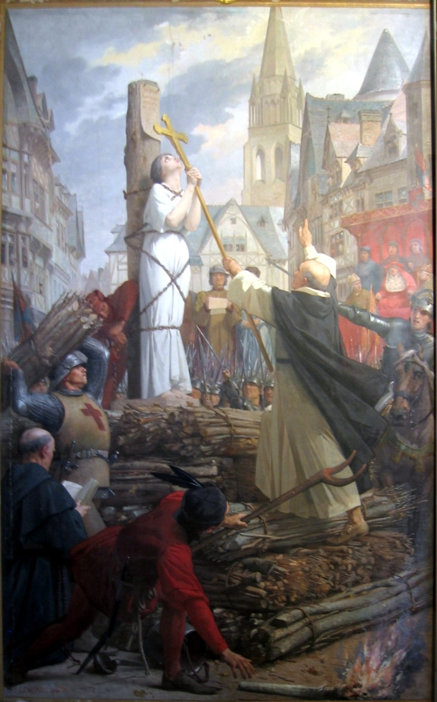

Joan of Arc being burned, By Jules Eugène Lenepveu, (1886 - 1890). Attribution in chapter References.

They put her on the scaffold and bound her fast to the stake. Looking round on the crowd of her countrymen, who stood looking over, she exclaimed: "O Rouen! I fear thou wilt suffer for my death!" A miter was placed on her head, with the words: **"Relapsed Heretic, Apostate, Idolater."** Canchon drew near, to listen whether even now she would not say something to condemn herself. Her only words were, "Bishop, I die through your means." Of the worthless king, she said: "That which I have well or ill done I did it of myself; the king did not advise me." These were her last words about earthly matters. The flames burnt from the foot of the pile, but the monk who held the cross before her did not move. He heard her from the midst of the fire call upon her Saviour. Soon she bowed her head and cried aloud "Jesus!" And she went to be with him forever.

We have little to add of the character of the Maid of Orleans. She was simple amid triumph and splendor; unselfish, when she might have had whatever she had asked; humane and gentle, even on the battlefield; patient in the midst of the greatest provocation; brave in the midst of suffering; firm in faith and hope, when all beside were cast down; blameless and holy in her life, when all beside were wicked and corrupt.

The English never recovered from the blow struck by the Maid. Their power in France gradually weakened. In 1435, peace was made between Charles VII and the Duke of Burgundy. One by one, the ill-gotten gains were given up, and the English king lost even the French provinces he inherited. In the year 1451, the only English possession in France was the town of Calais. This, too, was lost about a hundred years after, in the reign of Queen Mary. Yet the kings of England kept the empty title of kings of France, and put the lilies of France in their coat of arms until the middle of the reign of George III.

The last incident in the strange story of Joan of Arc remains to be told. Ten years after her execution, to the amazement of all who knew him, Charles VII suddenly shook off his idleness and blazed forth a wise king, an energetic ruler. Probably in this, his better state of mind, he thought with shame and sorrow of Joan of Arc. In the year 1456, he ordered a fresh inquiry to be made. At this, everyone was examined who had known or seen her at any period of her short life. The judgment passed on her before was contradicted, and she was declared a good and innocent woman. They would have given the whole world then to have had her back and to have made amends to her for their foul injustice. But the opinions of men no longer mattered to her. The twenty-five years since she had been burnt at Rouen had been the first twenty-five of her uncounted eternity of joy.

"The righteous perisheth, and no man layeth it to heart; and merciful men are taken away, none considering that the righteous is taken away from the evil to come."

### Food for Thought

* Many nations, communities, or races of this world have seen long periods of oppression, either by smaller groups within themselves, or foreign powers. Such a situation completely wipes out the spirit of society and pushes it deep into darkness. Sometimes, however, someone magically appears, and stands up for this lot. People naturally rally around that person, and a revolution is sparked. See if you can identify such periods in your own history and the changes that it brought about.
* If you think about it, Joan did not actually win too many wars or free a large part of France. She just ignited minds, provided confidence and inspiration. That was more than enough, and France reclaimed all her territories within the next 30 years, to end the hundred year long war. **Inspiration works wonders!**
* Do you believe that Joan actually had divine visions of Saints and Angels regarding a maid being destined to bring about the liberation of France? Or, do you think it was a myth, smartly constructed by Joan and/or other patriots around her?
  + Does it even matter that it was a myth, if that garb of mysticism was meant to evoke the dead spirit of France? Maybe, that was the language superstitious masses best understood? More elaboration on ‘*any act is valid for larger good of mankind*’, in the chapter on Revolutions.
  + Examples of mysticism or miracles for selfish ends are ample. There could be genuine instances of supernatural occurrences too. But now, try to think about examples that could qualify as ‘*probable myths necessary for larger good,*’ considering the general maturity of people at that time and place.

### References

* Brave Men And Women: Their Struggles, Failures, And Triumphs, by Fuller, Osgood E., 1886.
* Map of France during the [Hundred Years War](https://en.wikipedia.org/wiki/Hundred_Years_War), around the time of the Treaty of Troyes. By User:Aliesin (File:Traité de Troyes.svg) [[CC BY-SA 3.0](http://creativecommons.org/licenses/by-sa/3.0) (http://creativecommons.org/licenses/by-sa/3.0)], [via Wikimedia Commons](https://commons.wikimedia.org/wiki/File%3ATreaty_of_Troyes.svg).
* Image of Joan of Arc in the [Panthéon de Paris](https://commons.wikimedia.org/wiki/Panth%C3%A9on_de_Paris), by Jules Eugène Lenepveu (French, 1819-1898) - uploaded by Tijmen Stam (User:IIVQ) (Own work) [[CC BY-SA 2.5](http://creativecommons.org/licenses/by-sa/2.5) (http://creativecommons.org/licenses/by-sa/2.5)], [via Wikimedia Commons](https://commons.wikimedia.org/wiki/File%3AJeanne_d%27Arc_-_Panth%C3%A9on_II.jpg).
* Image of Joan of Arc in the [Panthéon de Paris](https://commons.wikimedia.org/wiki/Panth%C3%A9on_de_Paris), by E. Lenepveu (1889) by Tijmen Stam (User:IIVQ) (Own work) [[CC BY-SA 2.5](http://creativecommons.org/licenses/by-sa/2.5) (http://creativecommons.org/licenses/by-sa/2.5)], [via Wikimedia Commons](https://commons.wikimedia.org/wiki/File%3AJeanne_d%27Arc_-_Panth%C3%A9on_IV.jpg).

Cyrus McCormick, Ace Inventor-Businessman

Complexity: Medium

Reaping is probably one of the most cumbersome activities for a farmer during the life cycle of a crop. Tasks involved in this step, such as cutting, heaping, and binding crop, require fair amount of skill, even when done manually. Many inventors before McCormick had worked on designing that elusive reaper, and built prototypes. But it was this man who got it to a point that it could be manufactured at scale, and put to effective use by farmers all over the world.

He too was among those rare inventors like Edison, who had the characteristics of an ace inventor as well as a top-notch businessman. This biography of the American inventor, written by William Macdonald in 1913, demonstrates his business as well as scientific acumen, along with ups and downs on the road to success.

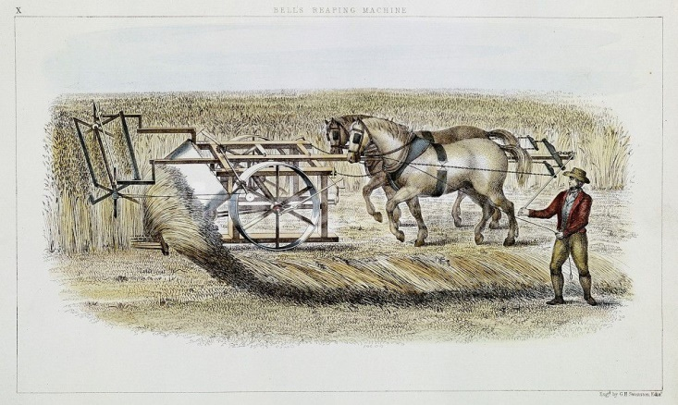

Patrick Bell´s reaping machine, 1851. In 1828, his machine was used with success on his father's farm and others in the district. Later, Cyrus McCormick made significant contributions to the Reaper design and manufactured it at scale.

"I expect to die in harness, because this is not the world for rest. This is the world for work. In the next world, we will have the rest." —Cyrus H. McCormick.

It is hardly to be expected that those people who devoutly chant in a million churches the fourth sentence of the Lord's Prayer should think with gratitude of any other person than the Divine Giver of all Good. Yet it is strange to reflect that, although every schoolboy knows something of the life of our least Poet Laureate, not one in ten thousand could tell you the career of the man who responded in a truly miraculous manner to the heartfelt, world-voiced matin of both rich and poor, "Give us this day our daily bread."

Cyrus H. McCormick, the inventor of the reaping machine, was born in the eventful year 1809. It was the birth year of Darwin and Tennyson, of Mendelssohn, Gladstone, and Lincoln. He was born on Walnut Grove Farm, amidst the mountains of Virginia, one hundred miles from the sea. He came of that virile stock that has proved to be the main strength of the Republic, that gave Washington thirty-nine of his generals, three out of four members of his Cabinet, and three out of the five judges of the Supreme Court—the Scots who migrated to Ulster, and from there to the United States. Robert McCormick, the father of Cyrus, was a fairly large farmer, and an inventor of no mean ability. The little log workshop is still shown to the enquiring tourist where father and son moulded and mended machinery on many a rainy day. Indeed, we are told that the McCormick homestead was more like a small factory than a farmer's home, so full was it of rural industries—spinning and weaving, soap and shoes, butter-making and bacon-curing. And it is more than likely that the ceaseless activity of his wise and Celtic mother taught Cyrus the value of each moment of time.

Ever since he was a child of seven, it was his father's ambition to invent a reaper. He made one, and tried it in the harvest of 1816, but it proved a failure. It was a fantastic machine, pushed from behind by two horses. It was highly ingenious, but it would not cut the corn, and was hauled off the field to become one of the jokes of the countryside. Hurt by the jests of his neighbours, he locked the door of his workshop and toiled away at night. Early in the summer of 1831 he had so improved his reaper that he gave it another trial. It failed again. True, the machine cut the corn fairly well, but it flung it on the ground in a tangled heap. Satisfied that there was something radically wrong, Robert McCormick gave up the reaper after having worked at it for over fifteen years.

At this point, Cyrus took up the task that his father had reluctantly abandoned. He showed his genius from the very start by adopting a new principle of operation. First of all, he invented the divider to separate the corn to be cut, from the corn left standing. Next came the reciprocating blade and the fingers, the revolving reel, platform, and side draught, and, lastly, the big driving wheel.[122] One day late in the month of July, in the summer of 1831, Cyrus put a horse between the shafts of his reaper. With no spectators save his father and mother, his brothers and sisters, he drove down to a patch of yellow grain. To that little family circle it must have been a moment of intense excitement. Click, click, click—the white blade shot to and fro. What a shout of joy! The wheat is cut and falls upon the platform in a golden, shimmering swathe!

Thus, at the early age of twenty-two, Cyrus had invented the first practical reaper that the world had seen. And now began his nine years' struggle with adversity, from which he emerged in triumph to become the greatest manufacturer of harvesting machines that America has produced. In order to obtain funds with which to manufacture reapers, he started to farm. But he soon found that it was impossible to raise sufficient capital by this means. Nearby was a large deposit of iron ore, and he forthwith resolved to build a furnace and make iron. He persuaded his father and the school teacher to become his partners. For several years the furnace did fairly well, when, suddenly, the price of iron fell. The McCormicks were bankrupt. Cyrus gave up the farm, and stuck grimly to his reaper. One day, the village constable rode up to the farm door with a summons for a debt of nineteen dollars, but he was so impressed with the industry of the McCormicks, that he had not the heart to serve the notice. It was the darkest hour before the dawn.

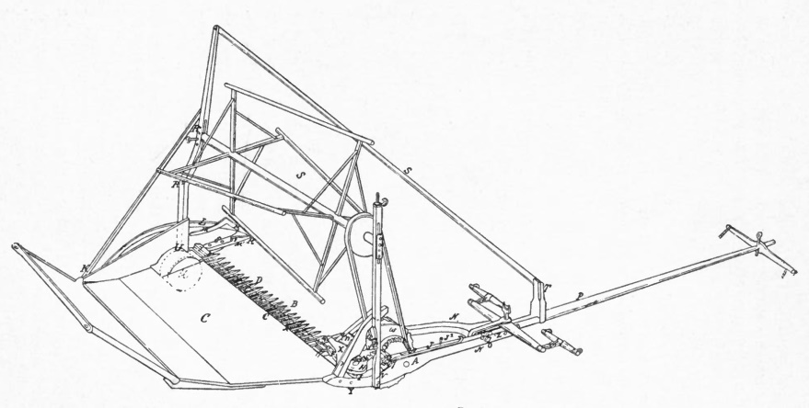

Sketch from 1845 patent of an improved grain reaper by Cyrus Hall McCormick.

The same year (1840), a stranger rode in from the north and drew rein in front of the little log workshop. He was a rough looking man with the homely name of Abraham Smith, but to Cyrus he came as an angel of light. He had come with fifty dollars in his pocket to buy a reaper—the first that was ever sold. A short time later, two other farmers came on the same errand, and that summer, three reaping machines were working in the wheat-fields of America. In 1842 McCormick sold seven machines, and in 1844 fifty. The home farm had now become a busy factory.

Three years later, a friend said to him, "Cyrus, why don't you go West with your reaper, where the land is level and labour cheap?"

It was the call of the West.

He travelled over the boundless prairies, and was quick to see that **this great land-ocean was the natural home of the reaper**. Straightway he transferred his factory to Chicago—then, in 1847, a forlorn little town of less than 10,000 souls. His business flourished. In the great fire of 1871, his factory, which was then turning out 10,000 harvesters a year, was totally destroyed. At the word of his wife, he rebuilt it anew with amazing rapidity. And so we find that the tiny workshop in the backwoods of Virginia has become the McCormick City in the heart of Chicago. In the sixty-five years of its life, this manufactory has produced over 6,000,000 harvesting machines, and is now pouring them out at the rate of over 7,000 per week. The McCormick Company is now known as the International Harvester Company, and his eldest son, Cyrus H. McCormick, is the President. The annual output is 75,000,000 dollars. It was the reaper that enabled the United States, during the four years of the civil war, not only to feed the armies in the field, but at the same time to export to foreign countries 200,000,000 bushels of wheat. And well might the savants of the French Academy of Science say, when electing Cyrus McCormick a member, that "he had done more for the cause of agriculture than any other living man."

And now we must trace the evolution of the reaper from its origin on the Walnut Grove Farm to the marvellous machine of today. For about thirty years it remained practically unaltered in design, save that seats had been added for the raker and the driver. It did no more than cut the grain and leave it in loose bundles on the ground. It had abolished the sickler and cradler, but there still remained the raker and binder.[123] Might it not be possible to do away with them also, and leave only the driver? Such was the fascinating problem that now confronted the inventor.

In the year 1852, a bedridden cripple called Jearum Atkins bought a McCormick reaper, and had it placed outside his window. To while away the weary hours, he actually devised an attachment with two revolving iron arms, which automatically raked off the cut grain from the platform to the ground. It was a grotesque contrivance, and was nicknamed by the farmers the "iron man." Nevertheless, this invention stimulated the manufacture of self-rake reapers, and soon the American farmer would buy no other kind. Thus part of the problem had been solved. The raker was abolished. But there still remained the harder task of supplanting the binder—the man or the woman who gathered up the bundles of cut corn and bound them tightly together with a wisp of straw into the sheaf.

And now another figure appears upon this ever-moving stage, a young man by the name of Charles B. Withington. Born at Akron, Ohio, a year before McCormick invented his reaper, this delicate youth was trained by his father to be a watchmaker. At the age of fifteen, in order to earn pocket-money, he went into the harvest field to bind corn. He was not robust, and the hard, stooping labour under a hot sun would sometimes bring the blood to his head in a haemorrhage. There were times after the day's work was done when he was too weary to walk home, and he would throw himself on the stubble to rest. At eighteen, he journeyed to the goldfields of California, drifted to Australia, and in the year 1855 arrived back in Wisconsin with 3,000 dollars in his belt. All this money he began to fritter away in trying to invent a self-rake reaper. Suddenly, inspired by the articles of a rural editor, who maintained that the binding of corn should be done by a machine, Withington dropped his self-rake and went straight to work to make a self-binder. He completed his first machine in 1872, but met with much discouragement until, two years later, he came across McCormick.

Their dramatic meeting is best told by Mr. Herbert M. Casson in his interesting volume, entitled "Cyrus Hall McCormick: His Life and Work."

"One evening in 1874, a tall man with a box under his arm walked diffidently up the steps of the McCormick home in Chicago, and rang the bell. He asked to see Mr. McCormick, and was shown into the parlour, where he found Mr. McCormick sitting, as usual, in a large and comfortable chair.

"'My name is Withington,' said the stranger; I live in Janesville, Wisconsin. I have here a model of a machine that will automatically bind grain.'

"Now, it so happened that McCormick had been kept awake nearly the whole of the previous night by a stubborn business problem. He could scarcely hold his eyelids apart. And when Withington was in the midst of his explanation, with the intentness of a born inventor, Mr. McCormick fell fast asleep. At such a reception to his cherished machine, Withington lost heart. He was a gentle, sensitive man, easily rebuffed, and so, when McCormick aroused from his nap, Withington had departed, and was on his way back to Wisconsin. For a few seconds McCormick was uncertain as to whether his visitor had been a reality or a dream. Then he awoke with a start into instant action. A great opportunity had come to him, and he had let it slip. He was at this time making self-rake reapers and Marsh harvesters; but what he wanted—what every reaper manufacturer wanted in 1871—was a self-binder. He at once called one of his trusted workmen.

"'I want you to go to Janesville,' he said. Find a man named Withington and bring him to me by the first train that comes back to Chicago.'

"The next day Withington was brought back, and treated with the utmost courtesy. McCormick studied his invention, and found it to be a most remarkable mechanism. Two steel arms caught each bundle of grain, whirled a wire tightly around it, fastened the two ends together with a twist, cut it loose, and tossed it to the ground. This self-binder was perfect in all its details—as neat and effective a machine as could be imagined. McCormick was delighted. At last, here was a machine that would abolish the binding of grain by hand."

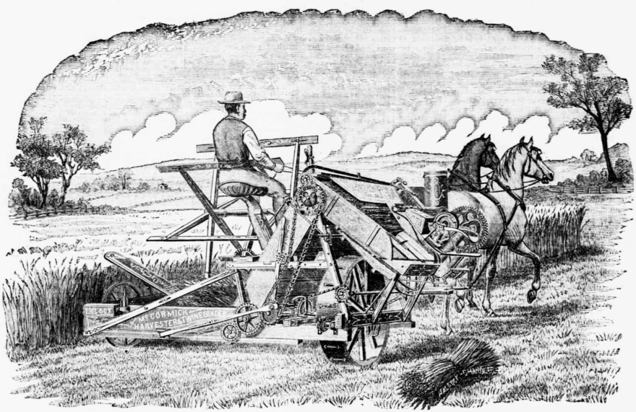

Advertisement for the twine binder version of the McCormick reaper. Caption reads: "The People's Favorite! The World-Renowned McCormick Twine Binder! Victorious in over 100 Field Trials! New and Valuable Improvements for 1884!"

For six years, all went well with the McCormick and Withington self-binder. This wonderful wire-twisting machine was working everywhere with clockwork precision, and was believed to be the best that human ingenuity could devise. All at once, the manufacturing world was startled with the news that William Deering had made and sold three thousand twine self-binders. Deering, by this dramatic move, became in a flash McCormick's most powerful competitor. He was not a farmer's son, like the latter, being bred in the city and trained in a factory. He had been a successful merchant at Maine, then left it to enter the harvester trade. He staked his whole fortune on making twine binders. He won, and McCormick was forced to follow in his wake. The evolution of the reaper into the twine self-binder was an epoch-making event in the agricultural world. It enormously increased the sales. In 1880, 60,000 reapers were sold; five years later, the figures had risen to 250,000. Since then, with the exception of the new knot-tying device, there has been no real change in the reaper. It remains the grandest of all agricultural machines, and one of the most astonishing mechanisms ever devised by the brain of man.



Sowing machine / Seed drill for grain and rapeseed, brand is Nordsten (brand of Kongskilde-company).



SAME Explorer tractor with a mounted field sprayer in Tsofit, Israel. Attribution in chapter References.



Wheat harvest with a CLAAS Lexion before sunset, near Branderslev, Lolland, Denmark. Attribution in chapter References.

McCormick died in 1884. In the span of his own life, the reaper was born and brought to perfection. He created it in a remote Virginian village, and he lived to see his catalogue printed in twenty languages, and to know that so long as the human race continues to eat bread, the sun will never set on the Empire of his reaper, for somewhere, in every month in all the year, you will find the corn white unto the harvest.

### Food for Thought

* The above is another example of a child being inspired and trained by parents to complete what they could not finish. With all due respect to individual talent and hard-work, we should admit that most of us build on achievements of others, **their successes as well as failures**. And there are a few who have an unfair advantage in this respect, isn’t it?
* There are those rare souls who **‘discover’** valuable principles of nature previously hidden from mankind.
  + Then those who use these principles as a foundation to **‘invent’** implements that will benefit mankind; perhaps slightly more in number.
  + And finally, there are so many of those ingenious **business folks**, who ensure that such life improving inventions are **effectively distributed**, **providing employment** to millions in the process. For them, profit is a means of growth, to bring about more of this distribution for the benefit of mankind. Use of earnings for personal enjoyment is incidental.
  + Of course, we cannot forget those millions of **Workers**, who meticulously follow directions laid down. They often do routine work for years together without showing any sign of tiredness or boredom. They perhaps have limited ambition and risk taking appetite, their efforts also go unnoticed at times, but it is only due to them, that ambitious minds can afford to focus on grand milestones of the future.
  + Isn’t it pretty clear then, that mankind cannot progress even if one of those is missing, and **everyone is important**?
* We all agree that new advances in farming need to be incorporated as far as possible. However, understanding their direct and indirect, social, economic, and environmental effects is also very important. Think about manual farm labor as well as modern machinery such as tractors, transplanters, harvesters along different aspects.
  + What factors affect the amount of time needed to cover machinery expenses by savings in labor cost? E.g. crop price, size of farm, number of crops per year?
  + In what ways could the ‘freed up’ labor be better utilized? E.g. switching to urban or industrial areas, getting trained to take up that new work. Can you think of ideas that could help farmers **‘move up the value chain’**?
  + What kind of education can better equip labor to confidently handle disruptions in their routine bread-and-butter sources? Due to say, factors such as layoffs caused by technology improvements or economy crashes?
  + Many farmers are well-to-do, and we are happy about it. Can a small farmer afford mechanized farming, given cost of machinery? Can we devise guidelines for healthy cooperation within a large group of small farmers, to benefit from cooperative effort? Try to learn more Cooperative Societies, and some success and failure stories related to those.

### References

* Chapter 5, Makers of Modern Agriculture, by William Macdonald, 1913.
* SAME Explorer tractor with a mounted field sprayer in Tsofit, Israel. ארכיון מושב צופית [[CC BY 2.5](http://creativecommons.org/licenses/by/2.5) (http://creativecommons.org/licenses/by/2.5)], [via Wikimedia Commons](https://commons.wikimedia.org/wiki/File%3APikiWiki_Israel_11945_tractor_sprayer_in_Tsofit.jpg).
* Wheat harvest with a Claas Lexion before sunset near Branderslev, Lolland, Denmark By Larsz/Lars Plougmann [[CC BY-SA 2.0](http://creativecommons.org/licenses/by-sa/2.0) (http://creativecommons.org/licenses/by-sa/2.0)], [via Wikimedia Commons](https://commons.wikimedia.org/wiki/File%3AClaas_combine_in_Denmark.jpg).

The American Vandal, by Mark Twain

Complexity: Medium

Following are amusing and insightful extracts from a lecture widely delivered by Mark Twain. It followed his return from the ‘Quaker City’ excursion, and prior to the publication of his 1869 book, ‘Innocents Abroad’.

These incidents should give readers a good insight into the spirit of travel. They describe the thrill, long-lasting impressions, and life-changing views that travel imbibes into a person.

I am to speak of the American Vandal this evening, but I wish to say in advance that I do not use this term in derision or apply it as a reproach, but I use it because it is convenient; and duly and properly modified, it best describes the roving, independent, free-and-easy character of that class of traveling Americans who are not elaborately educated, cultivated, and refined, and gilded and filigreed with the ineffable graces of the first society. The best class of our countrymen who go abroad keep us well posted about their doings in foreign lands, but their brethren vandals cannot sing their own praises or publish their adventures[124].

The American Vandal gallops over England, Scotland, Spain, and Switzerland, and finally brings up in Italy. He thinks it is the proper thing to visit Genoa, the stately old City of Palaces, whose vast marble edifices almost meet together over streets so narrow that three men can hardly walk abreast in them, and so crooked that a man generally comes out of them about the same place he went in. He only stays in Genoa long enough to see a few celebrated things and get some fragments of stone from the house Columbus was born in — for your genuine Vandal is an intolerable and incorrigible relic gatherer. It is estimated that if all the fragments of stone brought from Columbus's house by travelers were collected together, they would suffice to build a house fourteen thousand feet long and sixteen thousand feet high — and I suppose they would.

Next he hurries to Milan and takes notes of the Grand Cathedral (for he is always taking notes). Oh, I remember Milan and the noble cathedral well enough — that marble miracle of enchanting architecture. I remember how we entered and walked about its vast spaces and among its huge columns, gazing aloft at the monster windows all aglow with brilliantly colored scenes in the life of the Savior and his followers. And I remember the sideshows and curiosities there, too. The guide showed us a coffee-colored piece of sculpture, which he said was considered to have come from the hand of Phidias, since it was not possible that any other man, of any epoch, could have copied nature with such faultless accuracy. The figure was that of a man without a skin; with every vein, artery, muscle, every fiber and tendon and tissue of the human frame, represented in minute detail. It looked natural, because it looked somehow as if it were in pain. A skinned man would be likely to look that way — unless his attention were occupied by some other matter. . . .

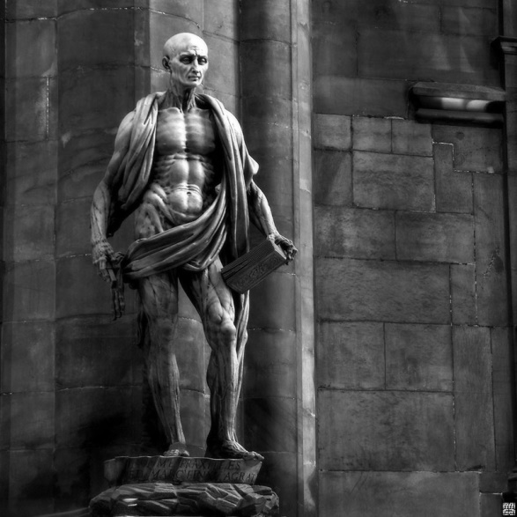

Sculpture of Saint Bartholomew in the Milan Cathedral. He was cruelly executed; skinned alive and then beheaded. The sculpture shows him holding his own skin. Attribution in chapter References.

The Vandal goes to see the ancient and most celebrated painting in the world, "The Last Supper."

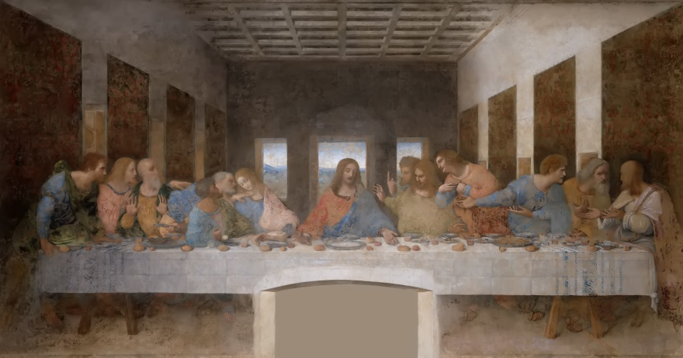

Leonardo Da Vinci’s, ‘The Last Supper’, depicting the final meal that Jesus shared with his Apostles in Jerusalem before crucifixion. Attribution in chapter References.

We all know it in engravings: the disciples all sitting on the side of a long, plain table and Christ with bowed head in the center — all the last suppers in the world are copied from this painting. It is so damaged now, by the wear and tear of three hundred years, that the figures can hardly be distinguished. The Vandal goes to see this picture — which all the world praises — looks at it with a critical eye, and says it's a perfect old nightmare of a picture, and he wouldn't give forty dollars for a million like it (and I indorse his opinion), and then he is done with Milan.

He paddles around the Lake of Como for a few days, and then takes the cars. He is bound for Venice, the oldest and the proudest and the princeliest republic that ever graced the earth. We put on a good many airs with our little infant of a Republic of a century's growth, but we grow modest when we stand before this gray, old imperial city that used to laugh the armies and navies of half the world to scorn, and was a haughty, invincible, magnificent Republic for fourteen hundred years! The Vandal is bound for Venice! He has a long, long, weary ride of it; but just as the day is closing, he hears someone shout, "Venice!" and puts his head out of the window; and sure enough, afloat on the placid sea, a league away, lies the great city with its towers and domes and steeples drowsing in a golden mist of sunset !

Have you been to Venice, and seen the winding canals and the stately edifices that border them all along, ornamented with the quaint devices and sculptures of a former age? And have you seen the great Cathedral of St. Mark's — and the Giant's Staircase — and the famous Bridge of Sighs — and the great Square of St. Mark's — and the ancient pillar with the winged Hon of St. Mark that stands in it, whose story and whose origin are a mystery — and the Rialto, where Shylock used to loan money on human flesh and other collateral[125]?

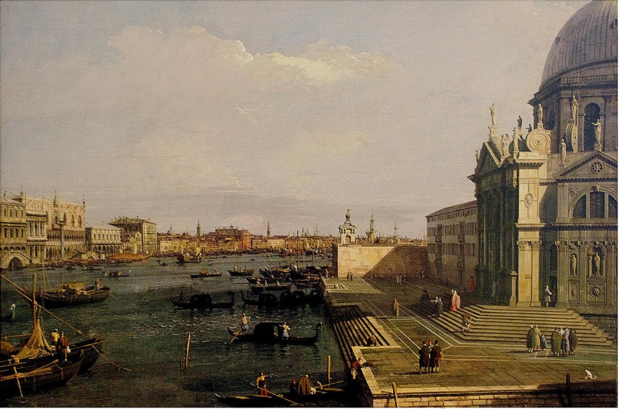

The Grand Canal at the Salute Church, Venice. Attribution in chapter References.

I had begun to feel that the old Venice of song and story had departed forever. But I was too hasty. When we swept gracefully out into the Grand Canal and under the mellow moonlight, the Venice of poetry and romance stood revealed. Right from the water's edge rose palaces of marble; gondolas were gliding swiftly hither and thither and disappearing suddenly through unsuspected gates and alleys; ponderous stone bridges threw their shadows athwart the glittering waves. There were life and motion everywhere, and yet everywhere there was a hush, a stealthy sort of stillness, that was suggestive of secret enterprises of bravos and of lovers; and clad half in moonbeams and half in mysterious shadows, the grim old mansions of the republic seemed to have an expression about them of having an eye out for just such enterprises as these. At that same moment music came stealing over the waters — Venice was complete.

Our Vandals hurried away from Venice and scattered abroad everywhere. You could find them breaking specimens from the dilapidated tomb of Romeo and Juliet at Padua — and infesting the picture galleries of Florence — and risking their necks on the Leaning Tower of Pisa — and snuffing sulphur fumes on the summit of Vesuvius — and burrowing among the exhumed wonders of Herculaneum and Pompeii — and you might see them with spectacles on, and blue cotton umbrellas under their arms, benignantly contemplating Rome from the venerable arches of the Coliseum.

And finally, we sailed from Naples, and in due time anchored before the Piraeus, the seaport of Athens in Greece. But the quarantine was in force[126], and so they set a guard of soldiers to watch us and would not let us go ashore. However, I and three other Vandals took a boat, and muffled the oars, and slipped ashore at 1—1.30 at night, and dodged the guard successfully. Then we made a wide circuit around the slumbering town, avoiding all roads and houses — for they'd about as soon hang a body as not, for violating the quarantine laws in those countries. We got around the town without any accident, and then struck out across the Attic Plain, steering straight for Athens — over rocks and hills and brambles and everything — with Mt. Helicon for a landmark. And so we tramped for five or six miles. The Attic Plain is a mighty uncomfortable plain to travel in, even if it is so historical. The armed guards got after us three times and flourished their gleaming gun barrels in the moonlight, because they thought we were stealing grapes occasionally — and the fact is we were — for we found by and by that the brambles that tripped us up so often were grape-vines — but these people in the country didn't know that we were quarantine-blockade runners, and so they only scared us and jawed Greek at us, and let us go, instead of arresting us.

We didn't care about Athens particularly, but we wanted to see the famous Acropolis and its ruined temples, and we did. We climbed the steep hill of the Acropolis about one in the morning and tried to storm that grand old fortress that had scorned the battles and sieges of three thousand years. We had the garrison out mighty quick — four Greeks — and we bribed them to betray the citadel and unlock the gates. In a moment, we stood in the presence of the noblest ruins we had ever seen — the most elegant, the most graceful, the most imposing. The renowned Parthenon towered above us, and about us were the wreck of what were once the snowy marble Temples of Hercules and Minerva, and another whose name I have forgotten. Most of the Parthenon's grand columns are still standing, but the roof is gone.

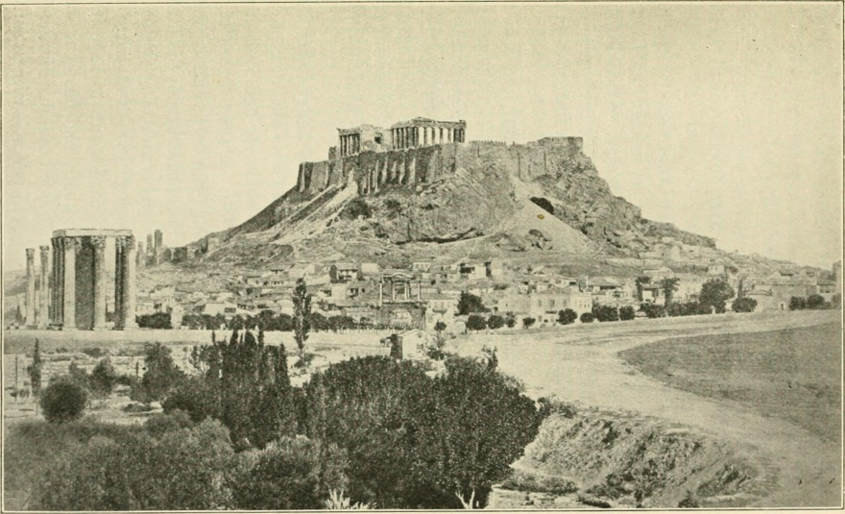

View of the Acropolis, Athens, Greece

As we wandered down the marble-paved length of this mighty temple, the scene was strangely impressive. Here and there, in lavish profusion, were gleaming white statues of men and women, propped against blocks of marble, some of them armless, some without legs, others headless, but all looking mournful and sentient and startlingly human! They rose up and confronted the midnight intruder on every side; they stared at him with stony eyes from unlooked-for nooks and recesses; they peered at him over fragmentary heaps far down the desolate corridors; they barred his way in the midst of the broad forum, and solemnly pointed with handless arms the way from the sacred fane; and through the roofless temple the moon looked down and banded the floor and darkened the scattered fragments and broken statues with the slanting shadows of the columns!

What a world of ruined sculpture was about us! Stood up in rows, stacked up in piles, scattered broadcast over the wide area of the Acropolis, were hundreds of crippled statues of all sizes and of the most exquisite workmanship; and vast fragments of marble that once belonged to the entablatures, covered with bas-reliefs representing battles and sieges, ships of war with three and four tiers of oars, pageants and processions — everything one could think of.

We walked out into the grass-grown, fragment-strewn court beyond the Parthenon. It startled us every now and then to see a stony white face stare suddenly up at us out of the grass, with its dead eyes. The place seemed alive with ghosts. We half expected to see the Athenian heroes of twenty centuries ago glide out of the shadows and steal into the old temple they knew so well and regarded with such boundless pride.

The full moon was riding high in the cloudless heavens now. We sauntered carelessly and unthinkingly to the edge of the lofty battlements of the citadel, and looked down, and, lo! A vision! And such a vision! Athens by moonlight! All the beauty in all the world combined could not rival it! The prophet that thought the splendors of the New Jerusalem were revealed to him, surely saw this instead. It lay in the level plain right under our feet — all spread abroad like a picture — and we looked down upon it as we might have looked from a balloon.

We saw no semblance of a street, but every house, every window, every clinging vine, every projection, was as distinct and sharply marked as if the time were noonday; and yet there was no glare, no glitter, nothing harsh or repulsive — the silent city was flooded with the mellowest light that ever streamed from the moon, and seemed like some living creature wrapped in peaceful slumber. On its farther side was a little temple whose delicate pillars and ornate front glowed with a rich luster that chained the eye like a spell; and, nearer by, the palace of the king reared its creamy walls out of the midst of a great garden of shrubbery that was flecked all over with a random shower of amber lights — a spray of golden sparks that lost their brightness in the glory of the moon and glinted softly upon the sea of dark foliage like the palled stars of the Milky Way! Overhead, the stately columns, majestic still in their ruin; underfoot, the dreaming city; in the distance, the silver sea — not on the broad earth is there another picture half so beautiful !

We got back to the ship safely, just as the day was dawning. We had walked upon pavements that had been pressed by Plato, Aristotle, Demosthenes, Socrates, Phocion, Euclid, Xenophon, Herodotus, Diogenes, and a hundred others of deathless fame[127], and were satisfied. We got to stealing grapes again on the way back, and half a dozen rascally guards with muskets and pistols captured us and marched us in the center of a hollow square nearly to the sea — till we were beyond all the graperies. Military escort — ah, I never traveled in so much state in all my life.

I leave the Vandal here. I have not time to follow him farther — nor our Vandals to Constantinople and Smyrna and the Holy Land, Egypt, the islands of the sea, and to Russia and his visit to the emperor. But I wish I could tell of that visit of our gang of Quaker City Vandals to the grandest monarch of the age, America's stanch, old steadfast friend, Alexander II, Autocrat of Russia!

In closing these remarks, I will observe that I could have said more about the American Vandal abroad, and less about other things, but I found that he had too many disagreeable points about him, and so I thought I would touch him lightly and let him go.

If there is a moral to this lecture, it is an injunction to all Vandals to travel. I am glad the American Vandal goes abroad. It does him good. It makes a better man of him. **It rubs out a multitude of his old unworthy biases and prejudices.** It aids his religion, for it enlarges his charity and his benevolence, it broadens his views of men and things; it deepens his generosity and his compassion for the failings and shortcomings of his fellow creatures. **Contact with men of various nations and many creeds teaches him that there are other people in the world besides his own little clique, and other opinions as worthy of attention and respect as his own. He finds that he and his are not the most momentous matters in the universe.** Cast into trouble and misfortune in strange lands and being mercifully cared for by those he never saw before, he begins to learn that best lesson of all — that one which culminates in the conviction that **God puts something good and something lovable in every man his hands create — that the world is not a cold, harsh, cruel, prison house, stocked with all manner of selfishness and hate and wickedness**. It liberalizes the Vandal to travel. You never saw a bigoted, opinionated, stubborn, narrow-minded, self-conceited, almighty mean man in your life, but he had stuck in one place ever since he was born, and thought God made the world and dyspepsia and bile for his especial comfort and satisfaction.[128]

So I say, by all means let the American[129] Vandal **go on traveling, and let no man discourage him**.

### Food for Thought

* Did this article inspire you enough to travel, to experience new worlds, to understand and appreciate people and cultures different from your own?
* Among your travels to foreign lands, how much time did you spend on visiting popular landmarks or participating in ‘must do’ events such as boat rides, etc.? Did you spare time for general exploration of the local culture via travel by local transport, walks around the town, its alleys, its market places and squares, observing people or interacting with them?

### References

* Mark Twain’s Speeches, Edited by Albert Bigelow Paine, 1923.
* Duomo di Milano St. Bartholomew San Bartolomeo by Marco D'Agrate, By Latente Flickr [[CC BY-SA 2.0](http://creativecommons.org/licenses/by-sa/2.0) (http://creativecommons.org/licenses/by-sa/2.0)], [via Wikimedia Commons](https://commons.wikimedia.org/wiki/File%3ASan_Bartolomeo_Scorticato.jpg).
* The Last Supper, By Leonardo Da Vinci (online) [[CC BY-SA 4.0](http://creativecommons.org/licenses/by-sa/4.0) (http://creativecommons.org/licenses/by-sa/4.0)], [via Wikimedia Commons](https://commons.wikimedia.org/wiki/File%3AThe_Last_Supper_Leonardo_Da_Vinci_-_High_Resolution.jpg).
* The Grand Canal at the Salute Church, Canaletto [[CC BY-SA 3.0](http://creativecommons.org/licenses/by-sa/3.0) (http://creativecommons.org/licenses/by-sa/3.0)], [via Wikimedia Commons](https://commons.wikimedia.org/wiki/File%3ACanaletto_-_The_Grand_Canal_at_the_Salute_Church.JPG).

President Wilson’s Address To Naturalized US Citizens

Complexity: Medium

This is President Woodrow Wilson’s address delivered to an audience of four thousand newly naturalized American citizens,[130] at Convention Hall, Philadelphia, May 10, 1915.

America then, was just over a hundred years old. Full of youth and vigor, eager to welcome all that was magnificent and forward-looking, with a broad mind and open arms. That was America of the early 20th century, the land of dreams, opportunity, and freedom.

Mr. Mayor, Fellow-Citizens:

It warms my heart that you should give me such a reception; but it is not of myself that I wish to think tonight, but of those who have just become citizens of the United States.

This is the only country in the world that experiences this constant and repeated rebirth. Other countries depend upon the multiplication of their own native people. This country is constantly drinking strength out of new sources by the voluntary association with it of great bodies of strong men and forward-looking women out of other lands.[131] And so, by the gift of the free will of independent people, it is being constantly renewed from generation to generation by the same process by which it was originally created. It is as if humanity had determined to see to it that this great Nation, founded for the benefit of humanity, should not lack for the allegiance of the people of the world.

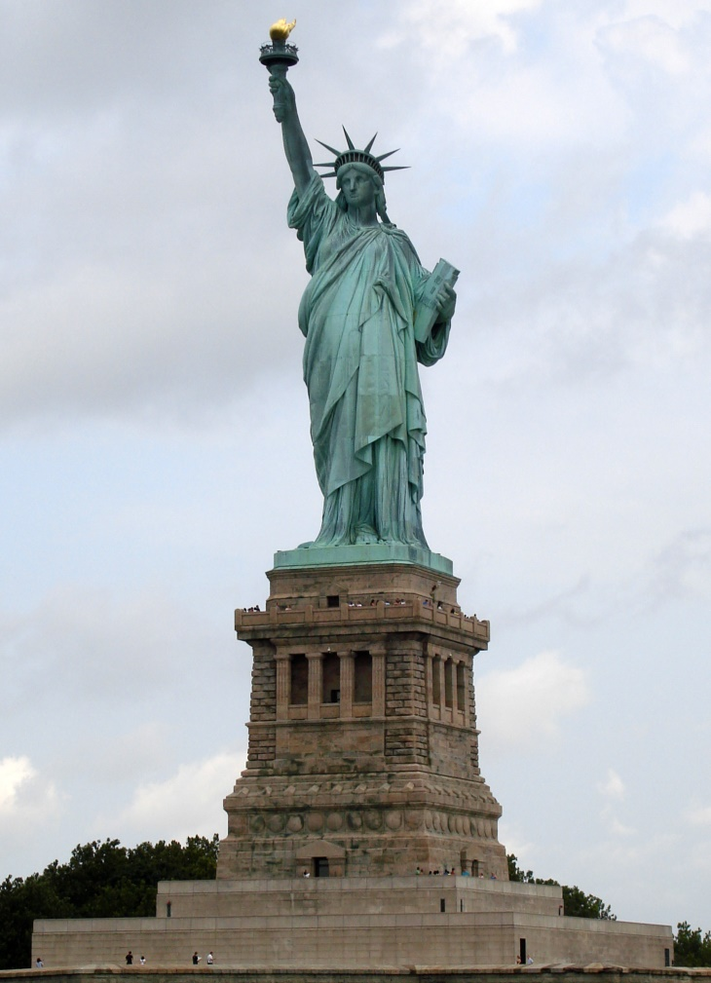

The Statue of Liberty, New York, USA, symbolizing the **American Dream**. The ideal that promises equal opportunity for every American, according to ability and achievement, regardless of social class or birth. Attribution in chapter References.

You have just taken an oath of allegiance to the United States. Of allegiance to whom? Of allegiance to no one, unless it be God—certainly not of allegiance to those who temporarily represent this great Government. You have taken an oath of allegiance to a great ideal, to a great body of principles, to a great hope of the human race. You have said, "We are going to America not only to earn a living, not only to seek the things which it was more difficult to obtain where we were born, but to help forward the great enterprises of the human spirit—to let men know that everywhere in the world there are men who will cross strange oceans and go where a speech is spoken which is alien to them, if they can but satisfy their quest for what their spirits crave; knowing that whatever the speech, there is but one longing and utterance of the human heart, and that is for liberty and justice."[132]

And while you bring all countries with you, you come with a purpose of leaving all other countries behind you—bringing what is best of their spirit, but not looking over your shoulders and seeking to perpetuate what you intended to leave behind in them. I certainly would not be one even to suggest that a man cease to love the home of his birth and the nation of his origin—these things are very sacred and ought not to be put out of our hearts—but it is one thing to love the place where you were born, and it is another thing to dedicate yourself to the place to which you go. You cannot dedicate yourself to America unless you become in every respect and with every purpose of your will thorough Americans. You cannot become thorough Americans if you think of yourselves in groups. America does not consist of groups. A man who thinks of himself as belonging to a particular national group in America has not yet become an American, and the man who goes among you to trade upon your nationality is no worthy son to live under the Stars and Stripes.[133]

My urgent advice to you would be, not only always to think first of America, but always, also, to think first of humanity. You do not love humanity if you seek to divide humanity into jealous camps. Humanity can be welded together only by love, by sympathy, by justice, not by jealousy and hatred. I am sorry for the man who seeks to make personal capital out of the passions of his fellow-men. He has lost the touch and ideal of America, for America was created to unite mankind by those passions which lift and not by the passions which separate and debase. We came to America either ourselves or in the persons of our ancestors, to better the ideals of men, to make them see finer things than they had seen before, to get rid of the things that divide and to make sure of the things that unite. It was but an historical accident, no doubt, that this great country was called the "United States"; yet I am very thankful that it has that word "United" in its title, and the man who seeks to divide man from man, group from group, interest from interest in this great Union, is striking at its very heart.

It is a very interesting circumstance to me, in thinking of those of you who have just sworn allegiance to this great Government, that you were drawn across the ocean by some beckoning finger of hope, by some belief, by some vision of a new kind of justice, by some expectation of a better kind of life. No doubt you have been disappointed in some of us. Some of us are very disappointing. No doubt you have found that justice in the United States goes only with a pure heart and a right purpose as it does everywhere else in the world. No doubt what you found here did not seem touched for you, after all, with the complete beauty of the ideal which you had conceived beforehand.[134] But remember this: If we had grown at all poor in the ideal, you brought some of it with you. A man does not go out to seek the thing that is not in him. A man does not hope for the thing that he does not believe in, and if some of us have forgotten what America believed in, you, at any rate, imported in your own hearts a renewal of the belief.

That is the reason that I, for one, make you welcome. If I have in any degree forgotten what America was intended for, I will thank God if you will remind me. I was born in America. You dreamed dreams of what America was to be, and I hope you brought the dreams with you. No man that does not see visions will ever realize any high hope or undertake any high enterprise. Just because you brought dreams with you, America is more likely to realize dreams such as you brought. You are enriching us if you came expecting us to be better than we are.[135]

See, my friends, what that means. It means that Americans must have a consciousness different from the consciousness of every other nation in the world. I am not saying this with even the slightest thought of criticism of other nations. You know how it is with a family. A family gets centered on itself if it is not careful and is less interested in the neighbors than it is in its own members. So a nation that is not constantly renewed out of new sources is apt to have the narrowness and prejudice of a family; whereas, America must have this consciousness, that on all sides it touches elbows and touches hearts with all the nations of mankind. The example of America must be a special example. The example of America must be the example not merely of peace because it will not fight, but of peace because peace is the healing and elevating influence of the world and strife is not. There is such a thing as a man being too proud to fight. There is such a thing as a nation being so right that it does not need to convince others by force that it is right.

You have come into this great Nation voluntarily seeking something that we have to give, and all that we have to give is this: We cannot exempt you from work. No man is exempt from work anywhere in the world. We cannot exempt you from the strife and the heartbreaking burden of the struggle of the day—that is common to mankind everywhere; we cannot exempt you from the loads that you must carry. We can only make them light by the spirit in which they are carried. That is the spirit of hope, it is the spirit of liberty, it is the spirit of justice.

When I was asked, therefore, by the Mayor and the committee that accompanied him to come up from Washington to meet this great company of newly admitted citizens, I could not decline the invitation. I ought not to be away from Washington, and yet I feel that it has renewed my spirit as an American to be here. In Washington men tell you so many things every day that are not so, and I like to come and stand in the presence of a great body of my fellow citizens, whether they have been fellow citizens a long time or a short time, and drink, as it were, out of the common fountains with them and go back feeling what you have so generously given me—the sense of your support and of the living vitality in your hearts of the great ideals which have made America the hope of the world.

### Food for Thought

* Many nations have similar, broad-minded guiding principles. Do you think there were instances in your own history where governments, educated masses, even a majority of citizens, have acted in a manner deviating from such principles? What could have been the reasons?
  + Genuine error in comprehending the situation because it was actually complex.
  + Lack of education, Foolishness, Timidity, or at times, Pure Greed; of the governments, citizens, or both.
  + Delusion created due to propaganda by select groups with vested interests, and even educated people falling prey to it. But then, what is this education, which does not equip people to think clearly and act rationally?

### References

* President Wilson’s Addresses, Edited by George McLean Harper, 1918.
* Statue of Liberty, By Elcobbola (Own work) [[CC BY-SA 3.0](http://creativecommons.org/licenses/by-sa/3.0) (http://creativecommons.org/licenses/by-sa/3.0) or Public domain], [via Wikimedia Commons](https://commons.wikimedia.org/wiki/File%3AStatue_of_Liberty_7.jpg).

Lgov, by Ivan Turgenev

Complexity: Medium

Exploitation takes numerous forms, and one of those was Serfdom. In the 17th century, that was the dominant form of relationship between Russian peasants and nobility. A Serf is a peasant bound to work in the land of a feudal lord, or at times, the landowner’s houses (house-serfs) or other occupations. In return, Serfs were entitled to exploit certain fields within the estate to make their living.

This story from Turgenev’s ‘Sketches From A Hunter’s Album’, describes the Narrator’s hunting trip to Lgov along with another huntsman, Yermolaï. Though somewhat funny at the surface, it throws light on the pitiable condition of Serfs.

‘Let us go to Lgov,' Yermolaï, whom the reader knows already, said to me one day, 'there we can shoot ducks to our heart's content.'

Although wild duck offers no special attraction for a genuine sportsman[136], still, through lack of other game at the time (it was the beginning of September; snipe were not on the wing yet, and I was tired of running across the fields after partridges), I listened to my huntsman's suggestion, and we went to Lgov.

Lgov is a large village of the steppes, with a very old stone church with a single cupola, and two mills on the swampy little river Rossota. Five miles from Lgov, this river becomes a wide swampy pond, overgrown at the edges, and in places also in the centre, with thick reeds. Here, in the creeks or rather pools between the reeds, live and breed a countless multitude of ducks of all possible kinds—quackers, half-quackers, pintails, teals, divers, etc. Small flocks are forever flitting about and swimming on the water, and at a gunshot, they rise in such clouds that the sportsman involuntarily clutches his hat with one hand and utters a prolonged Pshaw! I walked with Yermolaï along beside the pond; but, in the first place, the duck is a wary bird, and is not to be met quite close to the bank; and secondly, even when some straggling and inexperienced teal exposed itself to our shots and lost its life, our dogs were not able to get it out of the thick reeds; in spite of their most devoted efforts they could neither swim nor tread on the bottom, and only cut their precious noses on the sharp reeds for nothing.

'No,' was Yermolaï's comment at last, 'it won't do; we must get a boat…. Let us go back to Lgov.'

We went back. We had only gone a few paces, when a rather wretched-looking setter-dog ran out from behind a bushy willow to meet us, and behind him appeared a man of middle height, in a blue and much-worn greatcoat, a yellow waistcoat, and pantaloons of a nondescript grey colour, hastily tucked into high boots full of holes, with a red handkerchief round his neck, and a single-barrelled gun on his shoulder. While our dogs, with the ordinary ceremonies peculiar to their species, were sniffing at their new acquaintance, who was obviously ill at ease, held his tail between his legs, dropped his ears back, and kept turning round and round showing his teeth—the stranger approached us, and bowed with extreme civility. He appeared to be about twenty-five; his long dark hair, perfectly saturated with kvas, stood up in stiff tufts, his small brown eyes twinkled genially; his face was bound up in a black handkerchief, as though for toothache; his countenance was all smiles and amiability.

'Allow me to introduce myself,' he began in a soft and insinuating voice; 'I am a sportsman of these parts—Vladimir…. Having heard of your presence, and having learnt that you proposed to visit the shores of our pond, I resolved, if it were not displeasing to you, to offer you my services.'

The sportsman, Vladimir, uttered those words for all the world like a young provincial actor in the *rôle* of leading lover. I agreed to his proposition, and before we had reached Lgov, I had succeeded in learning his whole history. He was a **freed house-serf;** in his tender youth had been taught music, then served as valet, could read and write, had read—so much I could discover—some few trashy books, and existed now, as many do exist in Russia, without a farthing of ready money; without any regular occupation; fed by manna from heaven, or something hardly less precarious. He expressed himself with extraordinary elegance, and obviously plumed himself on his manners; he must have been devoted to the fair sex too, and in all probability popular with them: Russian girls love fine talking. Among other things, he gave me to understand that he sometimes visited the neighbouring landowners, and went to stay with friends in the town, where he played preference, and that he was acquainted with people in the metropolis. His smile was masterly and exceedingly varied; what especially suited him was a modest, contained smile, which played on his lips as he listened to any other man's conversation. He was attentive to you; **he agreed with you completely, but still he did not lose sight of his own dignity, and seemed to wish to give you to understand that he could, if occasion arose, express convictions of his own**. Yermolaï, not being very refined, and quite devoid of 'subtlety,' began to address him with coarse familiarity. **The fine irony with which Vladimir used 'Sir' in his reply was worth seeing.**

'Why is your face tied up? 'I inquired; 'have you toothache?'

'No,' he answered; 'it was a most disastrous consequence of carelessness. I had a friend, a good fellow, but not a bit of a sportsman, as it sometimes occurs. Well, one day he said to me, "My dear friend, take me out shooting, I am curious to learn what this diversion consists in." I did not like, of course, to refuse a comrade; I got him a gun and took him out shooting. Well, we shot a little in the ordinary way; at last, we thought we would rest, and I sat down under a tree; but he began instead to play with his gun, pointing it at me meantime. I asked him to leave off, but in his inexperience he did not attend to my words, the gun went off, and I lost half my chin, and the first finger of my right hand.'

We reached Lgov. Vladimir and Yermolaï had both decided that we could not shoot without a boat.

'Sutchok (*i.e.* the twig) has a punt,' observed Vladimir, 'but I don't know where he has hidden it. We must go to him.'

'To whom?' I asked.

'The man lives here; Sutchok is his nickname.'

Vladimir went with Yermolaï to Sutchok's. I told them I would wait for them at the church. While I was looking at the tombstones in the churchyard, I stumbled upon a blackened, four-cornered urn with the following inscription, on one side in French: 'Ci-git Théophile-Henri, Vicomte de Blangy,' on the next: 'Under this stone is laid the body of a French subject, Count Blangy; born 1737, died 1799, in the 62nd year of his age,' on the third: 'Peace to his ashes,' and on the fourth:—

'Under this stone there lies from France an emigrant.

Of high descent was he, and also of talent.

A wife and kindred murdered he bewailed,

And left his land by tyrants cruel assailed;

The friendly shores of Russia he attained,

And hospitable shelter here he gained;

Children he taught; their parents' cares allayed:

Here, by God's will, in peace he has been laid.'

The approach of Yermolaï with Vladimir and the man with the strange nickname, Sutchok, broke in on my meditations.

Barelegged, ragged, and dishevelled, Sutchok looked like a discharged stray house-serf of sixty years old.

'Have you a boat?' I asked him.

'I have a boat,' he answered in a hoarse, cracked voice, 'but it's a very poor one.'

'How so?'

'Its boards are split apart, and the rivets have come off the cracks.'

'That's no great disaster!' interposed Yermolaï, 'We can stuff them up with tow[137].'

'Of course you can,' Sutchok assented.

'And who are you?'

'I am the fisherman of the manor.'

'How is it, when you're a fisherman, your boat is in such bad condition?'

'There are no fish in our river.'

'Fish don't like slimy marshes,' observed my huntsman, with the air of an authority.

'Come,' I said to Yermolaï, 'go and get some tow, and make the boat right for us as soon as you can.'

Yermolaï went off.

'Well, in this way we may very likely go to the bottom,' I said to Vladimir. 'God is merciful,' he answered. 'Anyway, we must suppose that the pond is not deep.'

'No, it is not deep,' observed Sutchok, who spoke in a strange, far-away voice, as though he were in a dream, 'and there's sedge and mud at the bottom, and it's all overgrown with sedge. But there are deep holes too.'

'But if the sedge is so thick,' said Vladimir, 'it will be impossible to row.'

'Who thinks of rowing in a punt? One has to punt it. I will go with you; my pole is there—or else one can use a wooden spade.'

'With a spade it won't be easy; you won't touch the bottom perhaps in some places,' said Vladimir.

'It's true; it won't be easy.'

I sat down on a tombstone to wait for Yermolaï. Vladimir moved a little to one side out of respect to me, and also sat down. Sutchok remained standing in the same place, his head bent and his **hands clasped behind his back, according to the old habit of house-serfs**.

'Tell me, please,' I began, 'have you been the fisherman here long?'

'It is seven years now,' he replied, rousing himself with a start.

'And what was your occupation before?'

'I was coachman before.'

'Who dismissed you from being coachman?'

'The new mistress.'

'What mistress?'

'Oh, that **bought** us. Your honour does not know her; *Alyona Timofyevna[138]*; she is so fat … not young.'

'Why did she decide to make you a fisherman?'

'God knows. She came to us from her estate in Tamboff, gave orders for all the household to come together, and came out to us. We first kissed her hand, and she said nothing; she was not angry…. Then she began to question us in order; "How are you employed? What duties have you?" She came to me in my turn, so she asked: "What have you been?" I say, "Coachman." "Coachman? Well, a fine coachman you are; only look at you! You're not fit for a coachman, but be my fisherman, and shave your beard. On the occasions of my visits provide fish for the table; do you hear?" … So since then I have been enrolled as a fisherman. "And mind you keep my pond in order." But how is one to keep it in order?'

'Whom did you belong to before?'

'To Sergaï Sergiitch Pehterev. **We came to him by inheritance**. But he did not own us long; only six years altogether. I was his coachman … but not in town, he had others there—only in the country.'

'And were you always a coachman from your youth up?'

'Always a coachman? Oh, no! I became a coachman in Sergaï Sergiitch's time, but before that I was a cook—but not town-cook; only a cook in the country.'

'Whose cook were you, then?'

'Oh, my former master's, Afanasy Nefeditch, Sergaï Sergiitch's uncle.

Lgov was bought by him, by Afanasy Nefeditch, but it came to Sergaï Sergiitch by inheritance from him.'

'Whom did he buy it from?'

'From Tatyana Vassilyevna.'

'What Tatyana Vassilyevna was that?'

'Why, that died last year in Bolhov … that is, at Karatchev, an old maid…. She had never married. Don't you know her? We came to her from her father, Vassily Semenitch. She owned us a goodish while … twenty years.'

'Then were you cook to her?'

'At first, to be sure, I was cook, and then I was coffee-bearer.'

'What were you?'

'Coffee-bearer.'

'What sort of duty is that?'

'I don't know, your honour. I stood at the sideboard, and was called Anton instead of Kuzma. The mistress ordered that I should be called so.'

'Your real name, then, is Kuzma?'

'Yes.'

'And were you coffee-bearer all the time?'

'No, not all the time; I was an actor too.'

'Really?'

'Yes, I was…. I played in the theatre. Our mistress set up a theatre of her own.'

'What kind of parts did you take?'

'What did you please to say?'

'What did you do in the theatre?'

'Don't you know? Why, they take me and dress me up; and I walk about dressed up, or stand or sit down there as it happens, and they say, "See, this is what you must say," and I say it. Once I represented a blind man…. **They laid little peas under each eyelid**…. Yes, indeed.'

'And what were you afterwards?'

'Afterwards I became a cook again.'

'Why did they degrade you to being a cook again?'

'My brother ran away.'

'Well, and what were you under the father of your first mistress?'

'I had different duties; at first I found myself a page; I have been a postilion, a gardener, and a whipper-in[139].'

'A whipper-in?… And did you ride out with the hounds?'

'Yes, I rode with the hounds, and was nearly killed; I fell off my horse, and the horse was injured. Our old master was very severe; he ordered them to flog me and to send me to learn a trade to Moscow, to a shoemaker.'

'To learn a trade? But you weren't a child, I suppose, when you were a whipper-in?'

'I was twenty and over then.'

'But could you learn a trade at twenty?'

'I suppose one could, some way, since the master ordered it. But he luckily died soon after, and they sent me back to the country.'

'And when were you taught to cook?'

Sutchok lifted his thin, yellowish, little old face and grinned.

'Is that a thing to be taught?… Old women can cook.'

'Well,' I commented, 'you have seen many things, Kuzma, in your time!

What do you do now as a fisherman, seeing there are no fish?'

'Oh, your honour, I don't complain. And, thank God, they made me a fisherman. Why another old man like me—Andrey Pupir—the mistress ordered to be put into the paper factory, as a ladler. "It's a sin," she said, "to eat bread in idleness." And Pupir had even hoped for favour; his cousin's son was clerk in the mistress's counting-house: he had promised to send his name up to the mistress, to remember him: a fine way he remembered him!… And Pupir fell at his cousin's knees before my eyes.'

'Have you a family? Have you married?'

'No, your honour, I have never been married. Tatyana Vassilyevna—God rest her soul!—did not allow anyone to marry. "God forbid!" she said sometimes, "Here am I living single: what indulgence! What are they thinking of!"'

'What do you live on now? Do you get wages?'

'Wages, your honour!… Victuals are given me, and thanks be to Thee, Lord! I am very contented. May God give our lady long life!'

Yermolaï returned.

'The boat is repaired,' he announced churlishly. 'Go after your pole—you there!'

Sutchok ran to get his pole. During the whole time of my conversation with the poor old man, the sportsman Vladimir had been staring at him with a contemptuous smile.

'A stupid fellow,' was his comment, when the latter had gone off; 'An absolutely uneducated fellow; a peasant, nothing more. One cannot even call him a house-serf,[140] and he was boasting all the time. How could he be an actor, be pleased to judge for yourself! You were pleased to trouble yourself for no good in talking to him.'

A quarter of an hour later, we were sitting in Sutchok's punt. The dogs we left in a hut in charge of my coachman. We were not very comfortable, but sportsmen are not a fastidious race. At the rear end, which was flattened and straight, stood Sutchok, punting; I sat with Vladimir on the planks laid across the boat, and Yermolaï ensconced himself in front, in the very beak. In spite of the tow, the water soon made its appearance under our feet. Fortunately, the weather was calm and the pond seemed slumbering.

We floated along rather slowly. The old man had difficulty in drawing his long pole out of the sticky mud; it came up all tangled in green threads of water-sedge; the flat round leaves of the water-lily also hindered the progress of our boat last we got up to the reeds, and then the fun began. Ducks flew up noisily from the pond, scared by our unexpected appearance in their domains, shots sounded at once after them; it was a pleasant sight to see these short-tailed game turning somersaults in the air, splashing heavily into the water. We could not, of course, get at all the ducks that were shot; those that were slightly wounded swam away; some, which had been quite killed, fell into such thick reeds that even Yermolaï's little lynx eyes could not discover them, yet our boat was nevertheless filled to the brim with game for dinner.

Vladimir, to Yermolaï's great satisfaction, did not shoot at all well; he seemed surprised after each unsuccessful shot, looked at his gun and blew down it, seemed puzzled, and at last explained to us the reason why he had missed his aim. Yermolaï, as always, shot triumphantly; I—rather badly, after my custom. Sutchok looked on at us with the eyes of a man who has been the servant of others from his youth up; now and then he cried out: 'There, there, there's another little duck'; and he constantly rubbed his back, not with his hands, but by a peculiar movement of the shoulder-blades. The weather kept magnificent; curly white clouds moved calmly high above our heads and were reflected clearly in the water; the reeds were whispering around us; here and there, the pond sparkled in the sunshine like steel. We were preparing to return to the village, when suddenly a rather unpleasant adventure befel us.

For a long time we had been aware that the water was gradually filling our punt. Vladimir was entrusted with the task of baling it out by means of a ladle, which my thoughtful huntsman had stolen to be ready for any emergency from a peasant woman who was staring away in another direction. All went well so long as Vladimir did not neglect his duty. But just at the end, the ducks, as if to take leave of us, rose in such flocks that we scarcely had time to load our guns. In the heat of the sport we did not pay attention to the state of our punt—when suddenly, Yermolaï, in trying to reach a wounded duck, leaned his whole weight on the boat's-edge; at his over-eager movement, our old tub veered on one side, began to fill, and majestically sank to the bottom, fortunately not in a deep place. We cried out, but it was too late; in an instant, we were standing in water up to our necks, surrounded by the floating bodies of the slaughtered ducks. I cannot help laughing, now, when I recollect the scared white faces of my companions (probably my own face was not particularly rosy at that moment), but I must confess, at the time it did not enter my head to feel amused. Each of us kept his gun above his head, and Sutchok, no doubt from the habit of imitating his masters, lifted his pole above him. The first to break the silence was Yermolaï.

'Tfoo! Curse it!' he muttered, spitting into the water. 'Here's a go. It's all you, you old devil!' he added, turning wrathfully to Sutchok, 'You've such a boat!'

'It's my fault,' stammered the old man.

'Yes, and you're a nice one,' continued my huntsman, turning his head in Vladimir's direction. 'What were you thinking of? Why weren't you baling out?—you, you?'

But Vladimir was not equal to a reply; he was shaking like a leaf, his teeth were chattering, and his smile was utterly meaningless. **What had become of his fine language, his feeling of fine distinctions, and of his own dignity!**

The cursed punt rocked feebly under our feet… At the instant of our ducking the water seemed terribly cold to us, but we soon got hardened to it, when the first shock had passed off. I looked round me; the reeds rose up in a circle ten paces from us; in the distance above their tops, the bank could be seen. 'It looks bad,' I thought.

'What are we to do?' I asked Yermolaï.

'Well, we'll take a look round; we can't spend the night here,' he answered. 'Here, you, take my gun,' he said to Vladimir.

Vladimir obeyed submissively.

'I will go and find the ford,' continued Yermolaï, as though there must infallibly be a ford in every pond; he took the pole from Sutchok, and went off in the direction of the bank, warily sounding the depth as he walked.

'Can you swim?' I asked him.

'No, I can't,' his voice sounded from behind the reeds.

'Then he'll be drowned,' remarked Sutchok indifferently. He had been terrified at first, not by the danger, but through fear of our anger, and now, completely reassured, he drew a long breath from time to time, and seemed not to be aware of any necessity for moving from his present position.

'And he will perish without doing any good,' added Vladimir piteously.

Yermolaï did not return for more than an hour. That hour seemed an eternity to us. At first, we kept calling to him very energetically; then his answering shouts grew less frequent; at last, he was completely silent. The bells in the village began ringing for evening service. There was not much conversation between us; indeed, we tried not to look at one another. The ducks hovered over our heads; some seemed disposed to settle near us, but suddenly rose up into the air and flew away quacking. We began to grow numb. Sutchok shut his eyes as though he were disposing himself to sleep.

At last, to our indescribable delight, Yermolaï returned.

'Well?'

'I have been to the bank; I have found the ford…. Let us go.'

We wanted to set off at once; but he first brought some string out of his pocket out of the water, tied the slaughtered ducks together by their legs, took both ends in his teeth, and moved slowly forward; Vladimir came behind him, and I behind Vladimir, and Sutchok brought up the rear. It was about two hundred paces to the bank. Yermolaï walked boldly and without stopping (so well had he noted the track), only occasionally crying out: 'More to the left—there's a hole here to the right!' or 'Keep to the right—you'll sink in there to the left….' Sometimes the water was up to our necks, and twice poor Sutchok, who was shorter than all the rest of us, got a mouthful and spluttered. 'Come, come, come!' Yermolaï shouted roughly to him—and Sutchok, scrambling, hopping and skipping, managed to reach a shallower place, **but even in his greatest extremity was never so bold as to clutch at the skirt of my coat.** Worn out, muddy and wet, we at last reached the bank.

Two hours later we were all sitting, as dry as circumstances would allow, in a large hay barn, preparing for supper. The coachman Yehudiil, an exceedingly deliberate man, heavy in gait, cautious and sleepy, stood at the entrance, zealously plying Sutchok with snuff (I have noticed that coachmen in Russia very quickly make friends); Sutchok was taking snuff with frenzied energy, in quantities to make him ill; he was spitting, sneezing, and apparently enjoying himself greatly. Vladimir had assumed an air of languor; he leaned his head on one side, and spoke little. Yermolaï was cleaning our guns. The dogs were wagging their tails at a great rate in the expectation of porridge; the horses were stamping and neighing in the out-house…. The sun had set; its last rays were broken up into broad tracts of purple; golden clouds were drawn out over the heavens into finer and ever finer threads, like a fleece washed and combed out. … There was the sound of singing in the village.

### Food for Thought

* Hope you noticed how continuous subjugation numbs a person’s entire being. Starting from how Sutchok stood, to how he avoided holding the author’s coat even when in danger, or gratitude toward his mistress in spite of her unkind behavior?
* And what about the attitude of Vladimir, who himself had been a house-serf, toward Sutchok? Aren’t Vladimir’s modern day equivalents abundant in today’s world, those who are revoltingly servile before superiors, but toward inferiors, are despots without the least of mercy?
* How much has the relationship between employer and employee changed over years? Is this change uniform across all levels? Is the tone of interaction between the executive of a corporate and junior employees, same as that between the master/mistress of a house and the house help?
* Think about benefits and drawbacks of any kind of excessive centralized accumulation. Be it wealth, natural resources, **or smart/industrious individuals**. Do you feel that the only ones at a disadvantage in this transfer are those who lose such resources?
  + What habits could potentially develop in people getting used to plenty, without needing a matching effort to earn the same?
  + What options remain for miserable people drained of such resources? Aren’t such miserable lots easy targets for those who want to make a capital of their misery? Whose fault is it, if they behave irrationally out of utter desperation?
  + Try to identify a couple of instances in history when uncivilized, even barbaric tribes, just by their spirited efforts, have brought down powerful feudal lords, kingdoms, governments, even the most advanced of world civilizations.

### References

A Sportsman’s Sketches, By Ivan Turgenev, Volume I. Translated from the Russian By Constance Garnett, 1897.

Section III – Older Teens And Above

On Classical Education, by William Hazlitt

Complexity: High

William Hazlitt was an English writer and critic, now considered one of the greatest critics and essayists in the history of English language. In this essay, he expounds the value of studying classical literature in addition to learning practical skills such as sciences or trades like carpentry, masonry or operating machines.

Here Hazlitt refers to literature widely acknowledged as possessing outstanding qualities in terms of language structure and ability to provide inspiration, over an extended period of time;[141] for instance, ancient Greek and Latin literature, philosophy, and history, read by generations of Europeans during that time.

In current times, for different people, some of Shakespeare, Dickens, or Tolstoy masterpieces for instance, or The Ramayana, Works of Homer, Plato, or Confucian texts, could be regarded as classics.

**The study of the Classics is less to be regarded as an exercise of the intellect, than as 'a discipline of humanity.'**

The peculiar advantage of this mode of education consists not so much in strengthening the understanding, as in **softening and refining the taste**. It gives men liberal views; it accustoms the mind to take an interest in things foreign to itself; **to love virtue for its own sake;** to prefer fame to life, and glory to riches; and to fix our thoughts on the remote and permanent, instead of narrow and fleeting objects. It teaches us to believe that there is something really great and excellent in the world, surviving all the shocks of accident and fluctuations of opinion[142], and raises us above that low and servile fear, which bows only to present power and upstart authority. Rome and Athens filled a place in the history of mankind, which can never be occupied again. They were two cities set on a hill, which could not be hid; all eyes have seen them, and their light shines like a mighty sea mark into the abyss of time.[143]

'Still green with bays each ancient altar stands.

Above the reach of sacrilegious hands;

Secure from flames, from envy's fiercer rage.

Destructive war, and all-involving age.

Hail, bards triumphant, born in happier days.

Immortal heirs of universal praise!

Whose honours with increase of ages grow.

As streams roll down, enlarging as they flow!'

It is this feeling, more than anything else, which produces a marked difference between the study of the ancient and modem languages, and which, from the weight and importance of the consequences attached to the former, stamps every word with a monumental firmness.[144]

By conversing with the **mighty dead, we imbibe sentiment with knowledge**; we become strongly attached to those who can **no longer either hurt or serve us, except through the influence** that they exert over the mind. We feel the presence of that power that gives immortality to human thoughts and actions, and catch the flame of enthusiasm **from all nations and ages**.

It is hard to find in minds otherwise formed, either a real love of excellence, or a belief that any excellence exists superior to their own[145]. Everything is brought down to the vulgar level of their own ideas and pursuits. Persons without education certainly do not want either acuteness or strength of mind in what concerns themselves or in things immediately within their observation; **but they have no power of abstraction, no general standard of taste, or scale of opinion. They see their objects always near, and never in the horizon. Hence arises that egotism which has been remarked as the characteristic of self-taught men, and which degenerates into obstinate prejudice or petulant fickleness of opinion, according to the natural sluggishness or activity of their minds. For they either become blindly bigoted to the first opinions they have struck out for themselves, and inaccessible to conviction; or else (the dupes of their own vanity and shrewdness) are everlasting converts to every crude suggestion that presents itself, and the last opinion is always the true one. Each successive discovery flashes upon them with equal light and evidence, and every new fact overturns their whole system. It is among this class of persons, whose ideas never extend beyond the feeling of the moment, that we find partizans, who are very honest men, with a total want of principle, and who unite the most hardened effrontery and intolerance of opinion, to endless inconsistency and self-contradiction.[146]**

A celebrated political writer of the present day, who is a great enemy to classical education, is a remarkable instance both of what can and what cannot be done without it[147].

It has been attempted of late to set up a distinction between the **education of words** and the **education of things**, and to give the preference in all cases to the latter. But, in the first place, the knowledge of things, or of the realities of life, is not easily to be taught except by things themselves[148], and, even if it were, is not so absolutely indispensable as it has been supposed. 'The world is too much with us, early and late'; and the fine dream of our youth is best prolonged among the visionary objects of antiquity. **We owe many of our most amiable delusions, and some of our superiority, to the grossness of mere physical existence, to the strength of our associations with words.** Language, if it throws a veil over our ideas, adds a softness and refinement to them, like that which the atmosphere gives to naked objects. There can be no true elegance without taste in style.

In the next place, we mean absolutely to deny the application of the principle of utility to the present question. By an obvious transposition of ideas, some persons have **confounded a knowledge of useful things with useful knowledge**. Knowledge is only useful in itself, as It exercises or gives pleasure to the mind; the only knowledge that is of use in a practical sense, is professional knowledge. But knowledge, considered as a branch of general education[149], can be of use only to the mind of the person acquiring it. If the knowledge of language produces pedants, the other kind of knowledge (which is proposed to be substituted for it) can only produce quacks.[150]

There is no question, but that the knowledge of astronomy, of chemistry, and of agriculture, is highly useful to the world and absolutely necessary to be acquired by persons carrying on certain professions; but the practical utility of a knowledge of these subjects ends there. For example, it is of the utmost importance to the navigator to know exactly in what degree of longitude and latitude such a rock lies; but to us, sitting here about our Round Table, it is not of the smallest consequence whatever, whether the map-maker has placed it an inch to the right or to the left; we are in no danger of running against it. So the art of making shoes is a highly useful art, and very proper to be known and practised by somebody; that is, by the shoemaker. But to pretend that everyone else should be thoroughly acquainted with the whole process of this ingenious handicraft, as one branch of useful knowledge, would be preposterous.

It is sometimes asked, ‘What is the use of poetry?’ and we have heard the argument carried on almost like a parody on Falstaff's reasoning about Honour.[151] 'Can it set a leg? No. Or an arm? No. Or take away the grief of a wound? No. Poetry hath no skill in surgery then? No.' It is likely that the most enthusiastic lover of poetry would so far agree to the truth of this statement, that if he had just broken a leg, he would send for a surgeon, instead of a volume of poems from a library. But, 'they that are whole need not a physician'. The reasoning would be well founded, if we lived in a hospital, and not in the world.

### Food for Thought

* Go over that part which talks about drawbacks of not having classical education once more. The part that talks about excessive egotism or fickleness of opinion, in self-taught men not exposed to classical education.
* One thing is clear. There is so much knowledge in this world, that one person cannot, and need not learn everything. Somewhat related to the above discussion on classical education, can you identify some areas of learning relevant to many, irrespective of one’s primary occupation? Ability to, think and act with prudence, face tough situations, enjoy and appreciate fine creations of literature, science, and art. Any others?

### References

Collected Works Of William Hazlitt, Edited by A. R. Waller and Arnold Glover, 1902.

Education Of The Architect, by Vitruvius

Complexity: High

This extract is a translation of the introductory chapter of the first Book of Marcus Vitruvius Pollio’s popular work, ‘De Architectura’, or ‘The Ten Books on Architecture’. Vitruvius (80–70 BC to 15 BC) was a Roman architect and military engineer who served in the army of Caesar Augustus.

It gives a sense of the breadth of topics the architect should be aware of, as well as the correct depth at which these should be studied. In principle, the ideas discussed should benefit not just aspiring architects, but all those wanting to rise to a league beyond that of a typical ‘well skilled professional’ in their field of work. Some examples from those times might seem a bit difficult to visualize, but those gaps should not come in way of overall comprehension of the passage.

The architect should be equipped with knowledge of many branches of study and varied kinds of learning, for it is by his judgement that all work done by the other arts is put to test. This knowledge is the child of practice and theory. Practice is the continuous and regular exercise of employment, where manual work is done with any necessary material according to the design of a drawing. Theory, on the other hand, is the ability to demonstrate and explain the productions of dexterity on the principles of proportion.

It follows, therefore, that architects who have aimed at acquiring manual skill without scholarship have never been able to reach a position of authority to correspond to their pains, while those who relied only upon theories and scholarship were obviously hunting the shadow, not the substance. **But those who have a thorough knowledge of both, like men armed at all points, have the sooner attained their object and carried authority with them**.

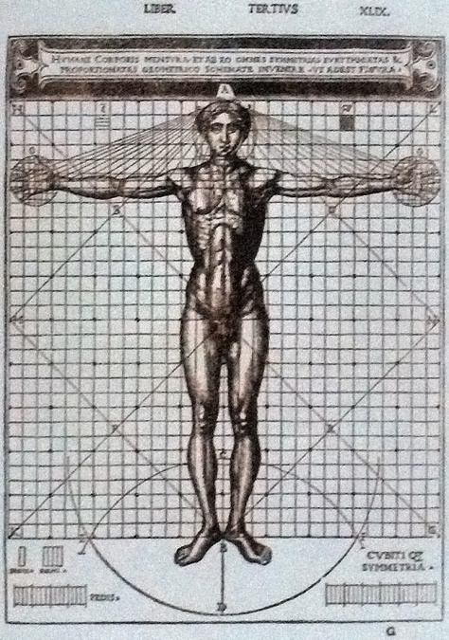

‘Vitruvian Man’, illustration in the edition of "De Architectura" by Vitruvius; illustrated edition by Cesare Cesariano, Como, Gottardus da Ponte, 1521. This drawing demonstrates the proportions of an ideal man’s face and body parts. Attribution in chapter References.

In all matters, but particularly in architecture, there are these two points:—the thing signified, and that which gives it its significance. That which is signified is the subject of which we may be speaking; and that which gives significance is a demonstration on scientific principles. It appears, then, that one who professes himself an architect should be well versed in both directions. He ought, therefore, to be both naturally gifted and amenable to instruction. Neither natural ability without instruction nor instruction without natural ability can make the perfect artist. Let him be educated, skilful with the pencil, instructed in geometry, know much history, have followed the philosophers with attention, understand music, have some knowledge of medicine, know the opinions of the jurists, and be acquainted with astronomy and the theory of the heavens.

The reasons for all this are as follows. An architect ought to be an educated man so as to leave a more lasting remembrance in his treatises. Secondly, he must have a knowledge of drawing so that he can readily make sketches to show the appearance of the work which he proposes. Geometry, also, is of much assistance in architecture, and in particular, it teaches us the use of the rule and compasses, by which especially we acquire readiness in making plans for buildings in their grounds, and rightly apply the square, the level, and the plummet. By means of optics, again, the light in buildings can be drawn from fixed quarters of the sky. It is true that it is by arithmetic that the total cost of buildings is calculated and measurements are computed, but difficult questions involving symmetry are solved by means of geometrical theories and methods.

A wide knowledge of history is requisite because, among the ornamental parts of an architect's design for a work, there are many the underlying idea of whose employment he should be able to explain to Greek inquirers. For instance, suppose him to set up the marble statues of women in long robes, called Caryatides, to take the place of columns, with the mutules and coronas placed directly above their heads, he will give the following explanation to his questioners. Caryae, a state in Peloponnesus, sided with the Persian enemies against Greece; later, the Greeks, having gloriously won their freedom by victory in the war, made common cause and declared war against the people of Caryae. They took the town, killed the men, abandoned the State to desolation, and carried off their wives into slavery, without permitting them, however, to lay aside the long robes and other marks of their rank as married women, so that they might be obliged not only to march in the triumph but to appear forever after as a type of slavery, burdened with the weight of their shame and so making atonement for their State. Hence, the architects of the time designed for public buildings statues of these women, placed so as to carry a load, in order that the sin and the punishment of the people of Caryae might be known and handed down even to posterity.

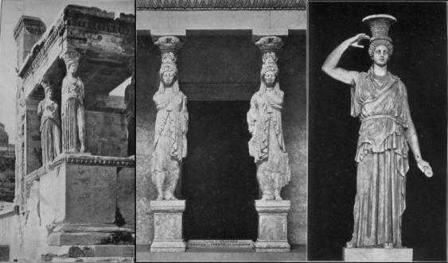

1. Caryatides of the Erechtheum at Athens. Photo, H. B. Warren. 2. Caryatides from the treasury of the Cnidians at Delphi. 3. Caryatides now in the Villa Albani at Rome..

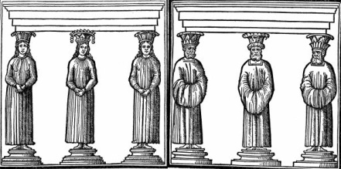

1. Caryatides (From the edition of Vitruvius by Fra Giocondo, Venice, 1511). 2. Persians (From the edition of Vitruvius by Fra Giocondo, Venice, 1511)

Likewise the Lacedaemonians under the leadership of Pausanias, son of Agesipolis, after conquering the Persian armies, infinite in number, with a small force at the battle of Plataea, celebrated a glorious triumph with the spoils and booty, and with the money obtained from the sale thereof built the Persian Porch, to be a monument to the renown and valour of the people and a trophy of victory for posterity. And there they set effigies of the prisoners arrayed in barbarian costume and holding up the roof, their pride punished by this deserved affront, that enemies might tremble for fear of the effects of their courage, and that their own people, looking upon this ensample of their valour and encouraged by the glory of it, might be ready to defend their independence. So from that time on, many have put up statues of Persians supporting entablatures and their ornaments, and thus from that motive have greatly enriched the diversity of their works. There are other stories of the same kind, which architects ought to know.

As for philosophy, it makes an architect high-minded and not self-assuming, but rather renders him courteous, just, and honest, without avariciousness. **This is very important, for no work can be rightly done without honesty and incorruptibility.** Let him not be grasping nor have his mind preoccupied with the idea of receiving perquisites, but let him with dignity keep up his position by cherishing a good reputation. These are among the precepts of philosophy. Furthermore, philosophy treats of physics (in Greek φυσιολογἱα), where a more careful knowledge is required because the problems which come under this head are numerous and of very different kinds; as, for example, in the case of the conducting of water. For at points of intake and at curves, and at places where it is raised to a level, currents of air naturally form in one way or another; and nobody who has not learned the fundamental principles of physics from philosophy will be able to provide against the damage that they do. So the reader of Ctesibius or Archimedes and the other writers of treatises of the same class will not be able to appreciate them unless he has been trained in these subjects by the philosophers.

Music, also, the architect ought to understand, so that he may have knowledge of the canonical and mathematical theory, and besides be able to tune ballistae, catapultae[152], and scorpiones to the proper key. For to the right and left in the beams are the holes in the frames through which the strings of twisted sinew are stretched by means of windlasses and bars, and these strings must not be clamped and made fast until they give the same correct note to the ear of the skilled workman. For the arms thrust through those stretched strings must, on being let go, strike their blow together at the same moment; but if they are not in unison, they will prevent the course of projectiles from being straight.

In theatres, likewise, there are the bronze vessels (in Greek ἡχεια) which are placed in niches under the seats, in accordance with the musical intervals on mathematical principles. These vessels are arranged with a view to musical concords or harmony, and apportioned in the compass of the fourth, the fifth, and the octave, and so on up to the double octave, in such a way that when the voice of an actor falls in unison with any of them its power is increased, and it reaches the ears of the audience with greater clearness and sweetness. Water organs, too, and the other instruments that resemble them cannot be made by one who is without the principles of music.

The architect should also have a knowledge of the study of medicine, on account of the questions of climates (in Greek κλἱματα), air, the healthiness and unhealthiness of sites, and the use of different waters. For without these considerations, the healthiness of a dwelling cannot be assured. And as for principles of law, he should know those which are necessary in the case of buildings having party walls, with regard to water dripping from the eaves, and also the laws about drains, windows, and water supply. And other things of this sort should be known to architects, so that, before they begin upon buildings, they may be careful not to leave disputed points for the householders to settle after the works are finished, and so that in drawing up contracts, the interests of both employer and contractor may be wisely safe-guarded. For if a contract is skilfully drawn, each may obtain a release from the other without disadvantage. From astronomy, we find the east, west, south, and north, as well as the theory of the heavens, the equinox, solstice, and courses of the stars. If one has no knowledge of these matters, he will not be able to have any comprehension of the theory of sundials.

Consequently, since this study is so vast in extent, embellished and enriched as it is with many different kinds of learning, I think that men have no right to profess themselves architects hastily, without having climbed from boyhood the steps of these studies and thus, nursed by the knowledge of many arts and sciences having reached the heights of the holy ground of architecture.

But perhaps to the inexperienced it will seem a marvel that human nature can comprehend such a great number of studies and keep them in the memory. **Still, the observation that all studies have a common bond of union and intercourse with one another, will lead to the belief that this can easily be realized. For a liberal education forms, as it were, a single body made up of these members. Those, therefore, who from tender years receive instruction in the various forms of learning, recognize the same stamp on all the arts, and an intercourse between all studies, and so they more readily comprehend them all.** This is what led one of the ancient architects, Pytheos, the celebrated builder of the temple of Minerva at Priene, to say in his Commentaries that an architect ought to be able to accomplish much more in all the arts and sciences than the men who, by their own particular kinds of work and the practice of it, have brought each a single subject to the highest perfection. But this is in point of fact not realized.

For an architect ought not to be and cannot be such a philologian as was Aristarchus, although not illiterate; nor a musician like Aristoxenus, though not absolutely ignorant of music; nor a painter like Apelles, though not unskilful in drawing; nor a sculptor such as was Myron or Polyclitus, though not unacquainted with the plastic art; nor again a physician like Hippocrates, though not ignorant of medicine; nor in the other sciences need he excel in each, though he should not be unskilful in them. **For, in the midst of all this great variety of subjects, an individual cannot attain to perfection in each, because it is scarcely in his power to take in and comprehend the general theories of them.**

Still, it is not architects alone that cannot in all matters reach perfection, but even men who individually practise specialties in the arts do not all attain to the highest point of merit. Therefore, if among artists working each in a single field, not all, but only a few in an entire generation acquire fame, and that with difficulty, how can an architect, who has to be skilful in many arts, accomplish not merely the feat—in itself a great marvel—of being deficient in none of them, but also that of surpassing all those artists who have devoted themselves with unremitting industry to single fields?

It appears, then, that Pytheos made a mistake by not observing that the arts are each composed of two things, the actual work and the theory of it. **One of these, the doing of the work, is proper to men trained in the individual subject, while the other, the theory, is common to all scholars**: for example, to physicians and musicians the rhythmical beat of the pulse and its metrical movement. But if there is a wound to be healed or a sick man to be saved from danger, the musician will not call, for the business will be appropriate to the physician. So in the case of a musical instrument, not the physician, but the musician will be the man to tune it so that the ears may find their due pleasure in its strains.

Astronomers likewise have a common ground for discussion with musicians in the harmony of the stars and musical concords in tetrads and triads of the fourth and the fifth, and with geometricians in the subject of vision (in Greek λὁγος ὁπτικὁς); **and in all other sciences many points, perhaps all, are common so far as the discussion of them is concerned.** But the actual undertaking of works, which are brought to perfection by the hand and its manipulation, is the function of those who have been specially trained to deal with a single art. It appears, therefore, that he has done enough, and to spare who in each subject possesses a fairly good knowledge of those parts, with their principles, which are indispensable for architecture, so that if he is required to pass judgement and to express approval in the case of those things or arts, he may not be found wanting. As for men upon whom nature has bestowed so much ingenuity, acuteness, and memory that they are able to have a thorough knowledge of geometry, astronomy, music, and the other arts, **they go beyond the functions of architects and become pure mathematicians**. Hence they can readily take up positions against those arts because many are the artistic weapons with which they are armed. Such men, however, are rarely found, but there have been such at times; for example, Aristarchus of Samos, Philolaus and Archytas of Tarentum, Apollonius of Perga, Eratosthenes of Cyrene, and among Syracusans, Archimedes and Scopinas, who **through mathematics and natural philosophy discovered, expounded, and left to posterity many things in connection with mechanics and with sundials**.

Since, therefore, the possession of such talents due to natural capacity **is not vouchsafed at random to entire nations, but only to a few great men**; since, moreover, the function of the architect requires a training in all the departments of learning; and finally, since reason, on account of the wide extent of the subject, concedes that he may possess not the highest but not even necessarily a moderate knowledge of the subjects of study, I request, Caesar[153], both of you and of those who may read the said books, that if anything is set forth with too little regard for grammatical rule, it may be pardoned. For it is not as a very great philosopher, nor as an eloquent rhetorician, nor as a grammarian trained in the highest principles of his art, that I have striven to write this work, but as an architect who has had only a dip into those studies. Still, as regards the efficacy of the art and the theories of it, I promise and expect that in these volumes I shall undoubtedly show myself of very considerable importance not only to builders but also to all scholars.

### Food for Thought

* This writing stresses upon the fact that an architect must have knowledge of multiple branches of study at reasonable depth. Can you draw an analogy with your primary branch of study? What auxiliary areas should you be aware of, to better progress in the field of your choice?

### References

* Vitruvius, The Ten Books On Architecture, Translated by Morris Hicky Morgan, 1914.
* Vitruvian Man, By Georges Jansoone (JoJan) (Own work (Own photo)) [[CC BY 3.0](http://creativecommons.org/licenses/by/3.0) (http://creativecommons.org/licenses/by-sa/3.0)or Public domain], [via Wikimedia Commons](https://commons.wikimedia.org/wiki/File%3ADe_Architectura030.jpg).

Don Quixote, Adventure Of The Lions

Complexity: High

Don Quixote is a Spanish novel by Miguel de Cervantes Saavedra. It is about a nobleman who reads so many chivalric romances that he starts believing those stories, and finally, loses all sanity. He sets out to revive chivalry, undo wrongs, and bring justice to the world, under the name **Don Quixote de la Mancha**. He recruits a simple farmer, **Sancho Panza**, as his **squire**, and goes out in **search of adventure**.

He does crazy things; picks up fights, mistakes windmills to be giants, inns to be castles, a **barber's basin** to be the legendary ‘**Helmet of Mambrino’**. Says that all these were ‘**enchantments**’ done by malicious enchanters, in order to confuse him.

This novel regularly appears high on lists of the greatest works of fiction, such as the Bokklubben World Library collection. It cites Don Quixote as authors' choice for the ‘best literary work ever written’.

This particular extract is one,

“WHEREIN IS SHOWN THE FURTHEST AND HIGHEST POINT WHICH THE UNEXAMPLED COURAGE OF DON QUIXOTE REACHED OR COULD REACH; TOGETHER WITH THE HAPPILY ACHIEVED ADVENTURE OF THE LIONS”

The history tells that when Don Quixote called out to Sancho to bring him his helmet, Sancho was buying some curds the shepherds agreed to sell him, and flurried by the great haste his master was in, did not know what to do with them or what to carry them in; so, not to lose them, for he had already paid for them, he thought it best to throw them into his master’s helmet, and acting on this bright idea he went to see what his master wanted with him. He, as he approached, exclaimed to him:

“Give me that helmet, my friend, for either I know little of adventures, or what I observe faraway is one that will, and does, call upon me to arm myself.”

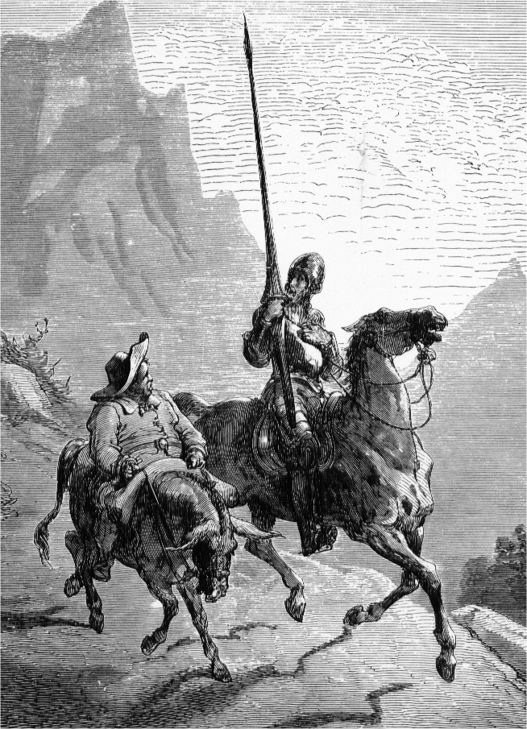

Don Quixote on his horse, Rocinante, and Sancho Panza on his donkey, Dapple, Painting by Gustave Dore, 1863.

He of the green gaban[154], on hearing this, looked in all directions, but could perceive nothing, except a cart coming towards them with two or three small flags, which led him to conclude it must be carrying treasure of the King’s, and he said so to Don Quixote. He, however, would not believe him, being always persuaded and convinced that all that happened to him must be adventures and still more adventures; so he replied to the gentleman, “He who is prepared has his battle half fought; nothing is lost by my preparing myself, for I know by experience that I have enemies, visible and invisible, and I know not when, or where, or at what moment, or in what shapes they will attack me;” and turning to Sancho, he called for his helmet; and Sancho, as he had no time to take out the curds, had to give it just as it was. Don Quixote took it, and without perceiving what was in it thrust it down in hot haste upon his head; but as the curds were pressed and squeezed, the whey began to run all over his face and beard, whereat he was so startled that he cried out to Sancho:

“Sancho, what’s this? I think my head is softening, or my brains are melting, or I am sweating from head to foot! If I am sweating, it is not indeed from fear. I am convinced beyond a doubt that the adventure which is about to befall me is a terrible one. Give me something to wipe myself with, if you have it, for this profuse sweat is blinding me.”

Sancho held his tongue and gave him a cloth, and gave thanks to God at the same time that his master had not found out what the matter was. Don Quixote then wiped himself, and took off his helmet to see what it was that made his head feel so cool, and seeing all that white mash inside his helmet he put it to his nose, and as soon as he had smelt it, he exclaimed:

“By the life of my lady Dulcinea del Toboso[155], but it is curds you have put here, you treacherous, impudent, ill-mannered squire!”

To which, with great composure and pretended innocence, Sancho replied, “If they are curds let me have them, your worship, and I’ll eat them; but let the devil eat them, for it must have been he who put them there. I dare to dirty your helmet! You have guessed the offender finely! Faith, sir, by the light God gives me, it seems I must have enchanters too, that persecute me as a creature and limb of your worship, and they must have put that nastiness there in order to provoke your patience to anger, and make you baste my ribs as you are used to do. Well, this time, indeed, they have missed their aim, for I trust to my master’s good sense to see that I have got no curds or milk, or anything of the sort; and that if I had it, is in my stomach I would put it and not in the helmet.”

“May be so,” said Don Quixote. All this the gentleman was observing, and with astonishment, more especially when, after having wiped himself clean, his head, face, beard, and helmet, Don Quixote put it on, and settling himself firmly in his stirrups, easing his sword in the scabbard, and grasping his lance, he cried, “Now, come who will, here am I, ready to try conclusions with Satan himself in person!”

By this time the cart with the flags had come up, unattended by anyone except the carter on a mule, and a man sitting in front. Don Quixote planted himself before it and said, “Where are you going, brothers? What cart is this? What have you got in it? What flags are those?”

To this the carter replied, “The cart is mine; what is in it is a pair of wild caged lions, which the governor of Oran is sending to court as a present to his Majesty; and the flags are our lord the King’s, to show that what is here is his property.”

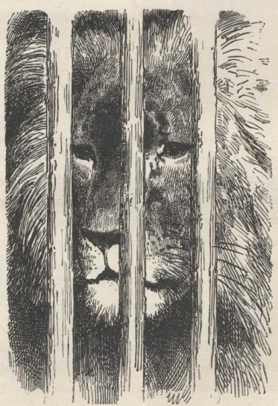

The Caged Lion

“And are the lions large?” asked Don Quixote.

“So large,” replied the man who sat at the door of the cart, “that larger, or as large, have never crossed from Africa to Spain; I am the keeper, and I have brought over others, but never any like these. They are male and female; the male is in that first cage and the female in the one behind, and they are hungry now, for they have eaten nothing today, so let your worship stand aside, for we must make haste to the place where we are to feed them.”

Hereupon, smiling slightly, Don Quixote exclaimed, “Lion-whelps to me! To me whelps of lions, and at such a time![156] Then, by God! those gentlemen who send them here shall see if I am a man to be frightened by lions. Get down, my good fellow, and, as you are the keeper, open the cages, and turn me out those beasts, and in the midst of this plain I will let them know who Don Quixote of La Mancha is, in spite and in the teeth of the enchanters[157] who send them to me.”

“So, so,” said the gentleman to himself at this, “our worthy knight has shown of what sort he is; the curds, no doubt, have softened his skull and brought his brains to a head.[158]”

At this instant Sancho came up to him, saying, “Senor, for God’s sake, do something to keep my master, Don Quixote, from tackling these lions; for if he does they’ll tear us all to pieces here.”

“Is your master then so mad,” asked the gentleman, “that you believe and are afraid he will engage such fierce animals?”

“He is not mad,” said Sancho, “but he is venturesome.”

“I will prevent it,” said the gentleman; and going over to Don Quixote, who was insisting upon the keeper’s opening the cages, he said to him, “Sir knight, knights-errant should attempt adventures which encourage the hope of a successful issue, not those which entirely withhold it; for valour that trenches upon temerity savours rather of madness than of courage; moreover, these lions do not come to oppose you, nor do they dream of such a thing; they are going as presents to his Majesty, and it will not be right to stop them or delay their journey.”

“Gentle sir,” replied Don Quixote, “you go and mind your tame partridge and your bold ferret, and leave everyone to manage his own business; this is mine, and I know whether these gentlemen the lions come to me or not;” and then, turning to the keeper, he exclaimed, “By all that’s good, sir scoundrel, if you don’t open the cages this very instant, I’ll pin you to the cart with this lance.”

The carter, seeing the determination of this apparition in armour, said to him, “Please your worship, for charity’s sake, senor, let me unyoke the mules and place myself in safety along with them before the lions are turned out; for if they kill them on me I am ruined for life, for all I possess is this cart and mules.”

“O man of little faith,” replied Don Quixote, “get down and unyoke; you will soon see that you are exerting yourself for nothing, and that you might have spared yourself the trouble.”

The carter got down and with all speed unyoked the mules, and the keeper called out at the top of his voice, “I call all here to witness that against my will and under compulsion I open the cages and let the lions loose, and that I warn this gentleman that he will be accountable for all the harm and mischief which these beasts may do, and for my salary and dues as well. You, gentlemen, place yourselves in safety before I open, for I know they will do me no harm.”

Once more the gentleman strove to persuade Don Quixote not to do such a mad thing, as it was tempting God to engage in such a piece of folly. To this, Don Quixote replied that he knew what he was about. The gentleman in return entreated him to reflect, for he knew he was under a delusion.

“Well, senor,” answered Don Quixote, “if you do not like to be a spectator of this tragedy, as in your opinion it will be, spur your flea-bitten mare, and place yourself in safety.”

Hearing this, Sancho, with tears in his eyes, entreated him to give up an enterprise compared with which the one of the windmills, and the awful one of the fulling mills, and, in fact, all the feats he had attempted in the whole course of his life were cakes and fancy bread. “Look ye, senor,” said Sancho, “there’s no enchantment here, nor anything of the sort, for between the bars and chinks of the cage I have seen the paw of a real lion, and judging by that I reckon the lion such a paw could belong to must be bigger than a mountain.”

“Fear at any rate,” replied Don Quixote, “will make him look bigger to you than half the world. Retire, Sancho, and leave me; and if I die here you know our old pact; you will repair to Dulcinea—I say no more.” To these he added some further words that banished all hope of his giving up his insane project. He of the green gaban would have offered resistance, but he found himself ill-matched as to arms, and did not think it prudent to come to blows with a madman, for such Don Quixote now showed himself to be in every respect; and the latter, renewing his commands to the keeper and repeating his threats, gave warning to the gentleman to spur his mare, Sancho his Dapple, and the carter his mules, all striving to get away from the cart as far as they could before the lions broke loose. Sancho was weeping over his master’s death, for this time he firmly believed it was in store for him from the claws of the lions; and he cursed his fate and called it an unlucky hour when he thought of taking service with him again; **but with all his tears and lamentations, he did not forget to thrash Dapple** so as to put a good space between himself and the cart. The keeper, seeing that the fugitives were now some distance off, once more entreated and warned him as before; but he replied that he heard him, and that he need not trouble himself with any further warnings or entreaties, as they would be fruitless, and bade him make haste.

During the delay that occurred while the keeper was opening the first cage, Don Quixote was considering whether it would not be well to do battle on foot, instead of on horseback, and finally resolved to fight on foot, fearing that Rocinante might take fright at the sight of the lions; he therefore sprang off his horse, flung his lance aside, braced his buckler on his arm, and drawing his sword, advanced slowly with marvellous intrepidity and resolute courage, to plant himself in front of the cart, commending himself with all his heart to God and to his lady Dulcinea.

It is to be observed, that on coming to this passage, the author of this veracious history breaks out into exclamations. “O doughty Don Quixote! High-mettled past extolling! Mirror, wherein all the heroes of the world may see themselves! Second modern Don Manuel de Leon, once the glory and honour of Spanish knighthood! In what words shall I describe this dread exploit, by what language shall I make it credible to ages to come, what eulogies are there unmeet for you, though they be hyperboles piled on hyperboles! On foot, alone, undaunted, high-souled, with but a simple sword, and that no trenchant blade of the Perrillo brand, a shield, but no bright polished steel one, there stood you, biding and awaiting the two fiercest lions that Africa’s forests ever bred! Your own deeds be your praise, valiant Manchegan, and here I leave them as they stand, wanting the words wherewith to glorify them!”

Here the author’s outburst came to an end, and he proceeded to take up the thread of his story, saying that the keeper, seeing that Don Quixote had taken up his position, and that it was impossible for him to avoid letting out the male without incurring the enmity of the fiery and daring knight, flung open the doors of the first cage, containing, as has been said, the lion, which was now seen to be of enormous size, and grim and hideous mien. The first thing he did was to turn round in the cage in which he lay, and protrude his claws, and stretch himself thoroughly; he next opened his mouth, and yawned very leisurely, and with near two palms’ length of tongue that he had thrust forth, he licked the dust out of his eyes and washed his face; having done this, he put his head out of the cage and looked all round with eyes like glowing coals, a spectacle and demeanour to strike terror into temerity itself. Don Quixote merely observed him steadily, longing for him to leap from the cart and come to close quarters with him, when he hoped to hew him in pieces.

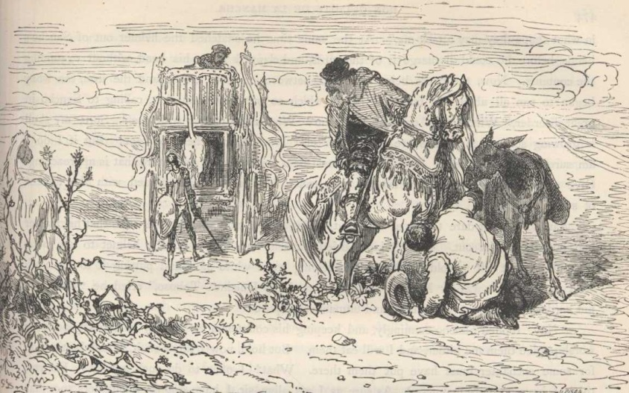

The Lion presents its hind quarters. Others are looking on from far off.

So far did his unparalleled madness go; but the noble lion, more courteous than arrogant, not troubling himself about silly bravado, after having looked all round, as has been said, turned about and presented his hind-quarters to Don Quixote, and very coolly and tranquilly lay down again in the cage. Seeing this, Don Quixote ordered the keeper to take a stick to him and provoke him to make him come out.

“That I won’t,” said the keeper; “for if I anger him, the first he’ll tear in pieces will be myself. Be satisfied, sir knight, with what you have done, which leaves nothing more to be said on the score of courage, and do not seek to tempt fortune a second time. The lion has the door open; he is free to come out or not to come out; but as he has not come out so far, he will not come out today. Your worship’s great courage has been fully manifested already; no brave champion, so it strikes me, is bound to do more than challenge his enemy and wait for him on the field; if his adversary does not come, on him lies the disgrace, and he who waits for him carries off the crown of victory.”

“That is true,” said Don Quixote, “close the door, my friend, and let me have, in the best form you can, what you have seen me do, by way of certificate; to wit, that you did open for the lion, that I waited for him, that he did not come out, that I still waited for him, and that still he did not come out, and lay down again. I am not bound to do more; enchantments avaunt, and God uphold the right, the truth, and true chivalry! Close the door as I bade you, while I make signals to the fugitives that have left us, that they may learn this exploit from thy lips.”

The keeper obeyed, and Don Quixote, fixing on the point of his lance the cloth he had wiped his face with after the deluge of curds, proceeded to recall the others, who still continued to fly, looking back at every step, all in a body, the gentleman bringing up the rear. Sancho, however, happening to observe the signal of the white cloth, exclaimed, “May I die, if my master has not overcome the wild beasts, for he is calling to us.”

They all stopped, and perceived that it was Don Quixote who was making signals, and shaking off their fears to some extent, they approached slowly until they were near enough to hear distinctly Don Quixote’s voice calling to them. They returned at length to the cart, and as they came up, Don Quixote said to the carter, “Put your mules to once more, brother, and continue your journey; and do you, Sancho, give him two gold crowns for himself and the keeper, to compensate for the delay they have incurred through me.”

“That will I give with all my heart,” said Sancho “but what has become of the lions? Are they dead or alive?”

The keeper, then, in full detail, and bit by bit, described the end of the contest, exalting to the best of his power and ability the valour of Don Quixote, at the sight of whom the lion quailed, and would not and dared not come out of the cage, although he had held the door open ever so long; and showing how, in consequence of his having represented to the knight that it was tempting God to provoke the lion in order to force him out, which he wished to have done, he very reluctantly, and altogether against his will, had allowed the door to be closed.

“What do you think of this, Sancho?” said Don Quixote. “Are there any enchantments that can prevail against true valour? The enchanters may be able to rob me of good fortune, but of fortitude and courage they cannot.”

Sancho paid the crowns, the carter put to, the keeper kissed Don Quixote’s hands for the bounty bestowed upon him and promised to give an account of the valiant exploit to the King himself, as soon as he saw him at court.

“Then,” said Don Quixote, “if his Majesty should happen to ask who performed it, you must say THE KNIGHT OF THE LIONS; for it is my desire that into this the name I have hitherto borne of *Knight of the Rueful Countenance* be from this time forward changed, altered, transformed, and turned; and in this I follow the ancient usage of knights-errant, who changed their names when they pleased, or when it suited their purpose.”

The cart went its way, and Don Quixote, Sancho, and he of the green gaban went theirs. All this time, Don Diego de Miranda had not spoken a word, being entirely taken up with observing and noting all that Don Quixote did and said, and the opinion he formed was that he was a man of brains gone mad, and a madman on the verge of rationality. The first part of his history had not yet reached him, for, had he read it, the amazement with which his words and deeds filled him would have vanished, as he would then have understood the nature of his madness; but knowing nothing of it, he took him to be rational one moment, and crazy the next, **for what he said was sensible, elegant, and well expressed, and what he did, absurd, rash, and foolish**; and said he to himself, “What could be madder than putting on a helmet full of curds, and then persuading oneself that enchanters are softening one’s skull; or what could be greater rashness and folly than wanting to fight lions tooth and nail?”

Don Quixote roused him from these reflections and this soliloquy by saying, “No doubt, Senor Don Diego de Miranda, you set me down in your mind as a fool and a madman, and it would be no wonder if you did, for my deeds do not argue anything else. But for all that, I would have you take notice that I am neither so mad nor so foolish as I must have seemed to you. A gallant knight shows to advantage bringing his lance to bear adroitly upon a fierce bull under the eyes of his sovereign, in the midst of a spacious plaza; a knight shows to advantage arrayed in glittering armour, pacing the lists before the ladies in some joyous tournament, and all those knights show to advantage that entertain, divert, and, if we may say so, honour the courts of their princes by warlike exercises, or what resemble them; but to greater advantage than all these does a knight-errant show when he traverses deserts, solitudes, cross-roads, forests, and mountains, in quest of perilous adventures, bent on bringing them to a happy and successful issue, all to win a glorious and lasting renown.[159] To greater advantage, I maintain, does the knight-errant show bringing aid to some widow in some lonely waste, than the court knight dallying with some city damsel. All knights have their own special parts to play; let the courtier devote himself to the ladies, let him add lustre to his sovereign’s court by his liveries, let him entertain poor gentlemen with the sumptuous fare of his table, let him arrange joustings, marshal tournaments, and prove himself noble, generous, and magnificent, and above all a good Christian, and so doing he will fulfil the duties that are especially his; but let the knight-errant explore the corners of the earth and penetrate the most intricate labyrinths, at each step let him attempt impossibilities, on desolate heaths let him endure the burning rays of the midsummer sun, and the bitter inclemency of the winter winds and frosts; let no lions daunt him, no monsters terrify him, no dragons make him quail; for to seek these, to attack those, and to vanquish all, are in truth his main duties. I, then, as it has fallen to my lot to be a member of knight-errantry, cannot avoid attempting all that to me seems to come within the sphere of my duties; thus it was my bounden duty to attack those lions that I just now attacked, although I knew it to be the height of rashness; for I know well what valour is, that it is a virtue that occupies a place between two vicious extremes, cowardice and temerity; but it will be a lesser evil for him who is valiant to rise till he reaches the point of rashness, than to sink until he reaches the point of cowardice; for, as it is easier for the prodigal than for the miser to become generous, so it is easier for a rash man to prove truly valiant than for a coward to rise to true valour; and believe me, Senor Don Diego, in attempting adventures it is better to lose by a card too many than by a card too few; for to hear it said, ‘such a knight is rash and daring,’ sounds better than ‘such a knight is timid and cowardly.’”

“I protest, Senor Don Quixote,” said Don Diego, “everything you have said and done is proved correct by the test of reason itself; and I believe, if the laws and ordinances of knight-errantry should be lost, they might be found in your worship’s breast as in their own proper depository and muniment-house; but let us make haste, and reach my village, where you shall take rest after your late exertions; for if they have not been of the body they have been of the spirit, and these sometimes tend to produce bodily fatigue.”

“I take the invitation as a great favour and honour, Senor Don Diego,” replied Don Quixote; and pressing forward at a better pace than before, at about two in the afternoon they reached the village and house of Don Diego, or, as Don Quixote called him, “The Knight of the Green Gaban.”

### Food for Thought

* It often happens that, by staying in a specific type of environment (books, movies, people, situations, and conversations of a specific type), one starts getting strongly influenced by that. This influence at times converts into an obsession, and strongly affects all thoughts and actions during particular periods. Do you feel this is absurd? Peep into your past and you might find examples.
* Don Quixote is an extreme example of obsession. But isn’t the world crowded with people who preach the greatest of wisdom, with actions completely contradictory to what they preach? What about you?
* Are you wondering why, a novel made up of crazy stories like this adventure of the lions, should be ranked among the greatest of novels ever written? You will find such funny incidents, lovely language, crazy adventures, and talks of wisdom strewn generously throughout the novel.

### References

Don Quixote, by Miguel de Cervantes, Volume II, Chapter 17, Translated by John Ormsby, 1885. Images taken from the 1880 edition of J. W. Clark, Illustrated by Gustave Dore.

Dr. Laennec, Father Of Clinical Auscultation

Complexity: High

The most important step in curing a disease is its correct diagnosis. Dr. Laennec’s prime contribution to medical diagnosis was not just his invention of the stethoscope, but along with that, **Auscultation**, an entire science of diagnosing problems, by interpretation of sounds perceived through that simple looking instrument.

This biography by James J. Walsh, written in 1906, 80 years after Laennec’s death, clearly shows the long lasting effect of his work. It also contains numerous opinions voiced by eminent personalities about this **Martyr To Science**. These somewhat increase the length of the chapter, but also make it all the more inspiring, especially for those wanting to pursue medicine going ahead.

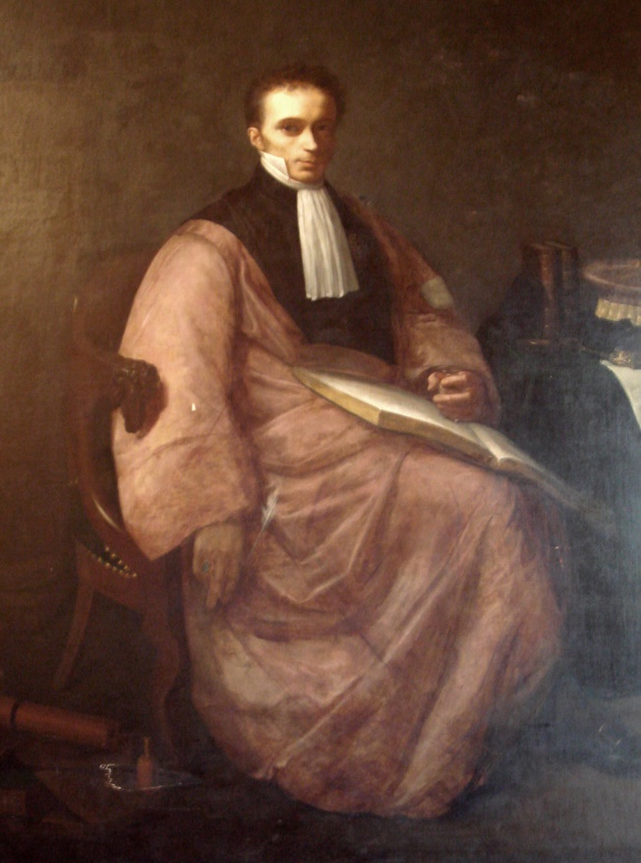

René-Théophile-Hyacinthe Laennec (1781 – 1826), French physician and inventor of the stethoscope, by Paul Dubois, 1854. Attribution in chapter References.

The knowledge which a man can use is the only real knowledge, the only knowledge which has life and growth in it and converts itself into practical power. The rest hangs like dust about the brain, or dries like rain-drops off the stones

--Froude.

On August 13, 1826, there died at Quimper in Brittany[160] at the early age of forty-five, one of the greatest physicians of all time. His name, René Theodore Laennec, was destined to be forever associated with one of the most fruitful advances in medicine that has ever been made, and one which practically introduced the modern era of scientific diagnosis. At the present time, the most interesting phase of medical development is concerned with the early recognition and the prevention of tuberculosis.[161] To Laennec more than to any other is due all the data that enables the physician of the twentieth century to make the diagnosis of tuberculosis with assurance, and to treat it with more confidence than before, and so prevent its spread as far as possible.

The history of pulmonary consumption[162] in its most modern phase is centred around the names of three men, Laennec, Villemin, and Koch. To Laennec will forever belong the honor of having fixed definitely the clinical picture of the disease, and of having separated it by means of auscultation and his pathological studies from all similar affections of the lungs. Villemin showed that it was an infectious disease, absolutely specific in character, and capable of transmission by inoculation from man to the animal. To Koch the world owes the knowledge of the exact cause of the disease and consequently, of the practical method for preventing its spread. The isolation of the bacillus of tuberculosis is the great triumph of the end of the nineteenth century, as the separation of the disease from all others by Laennec was the triumph of the beginning of that century. There is still room for a fourth name in the list, that of the man who will discover a specific remedy for the disease. It is to be hoped that his coming will not be long delayed.[163]

The estimation in which Laennec was held by the most distinguished among his contemporaries, may be very well appreciated from the opinions expressed with regard to him and his work by the best-known Irish and English clinical observers of the period, Dr. William Stokes. Stokes himself was, as we shall see, one of the most important contributors to our clinical knowledge of diseases of the heart and lungs in the nineteenth century. He said with regard to the great French clinician whom he considered his master:

"Time has shown that the introduction of auscultation and its subsidiary physical signs has been one of the greatest boons ever conferred by the genius of man on the world.

"A new era in medicine has been marked by a new science, depending on the immutable laws of physical phenomena, and, like the discoveries founded on such a basis, simple in its application and easily understood--a gift of science to a favored son; one by which the **ear is converted into the eye**, the hidden recesses of visceral disease open to view; a new guide to the treatment, and a new help to the ready detection, prevention and cure of the most widely spread diseases which affect mankind.[164]"

Dr. Addison, who is best known by the disease, which since his original description has been called by his name,[165] was no less enthusiastic in praise of Laennec's work. He said:

"Were I to affirm that Laennec contributed more toward the advancement of the medical art than any other single individual, either of ancient or of modern times, I should probably be advancing a proposition which, in the estimation of many, is neither extravagant nor unjust. His work, De l'Auscultation Mediate, will ever remain a monument of genius, industry, modesty, and **truth**. It is a work in perusing which every succeeding page only tends to increase our admiration of the man, to captivate our attention, and to command our confidence. We are led insensibly to the bedside of his patients; we are startled by the originality of his system; we can hardly persuade ourselves that any means so simple can accomplish so much, can overcome and reduce to order the chaotic confusion of thoracic pathology; and hesitate not in the end to acknowledge our unqualified wonder at the triumphant confirmation of all he professed to accomplish."

These tributes to Laennec, however, from men who were his contemporaries across the channel, have been more than equalled by distinguished physicians on both sides of the Atlantic[166] at the end of the nineteenth and the beginning of the twentieth century. While we might hesitate to accept the opinions of those who had been so close to him at the beginning of the new era of physical diagnosis, there can be no doubt now, after the lapse of three-quarters of a century, of what Laennec's influence really was, and the tributes of the twentieth century place him among the few great geniuses to whom scientific medicine owes its most important advance.

At the annual meeting of the State Medical Society of New York held in Albany at the end of January, 1903, the president of the society, Doctor Henry L. Elsner, of Syracuse, in his annual address devoted some paragraphs to a panegyric of Laennec. He wished to call attention to what had been accomplished for scientific medicine at the beginning of the last century by a simple observant practitioner. In the course of his references to Laennec and his work, he said:

"It is by no means to be considered an accident that, among the greatest advances in medicine made during the century just closed, the introduction of pathological anatomy[167] and auscultation into the practice of medicine at the bedside were both effected by the same clear mind, Laennec. He is one of the greatest physicians of all time."

He then quoted the opinion of a distinguished English clinician, Professor T. Clifford Allbutt, who is well known, especially for his knowledge of the history of medicine. Professor Allbutt is the Regius Professor of Physic (a term about equivalent to our practice of medicine) of Cambridge University, England, and was invited to this country some years ago as the representative of English medicine to deliver the Lane lectures in San Francisco. During his stay in this country, he delivered a lecture at Johns Hopkins University on "Medicine in the Nineteenth Century," in which he said,

"Laennec gives me the impression of being one of the greatest physicians in history; one who deserves to stand by the side of Hippocrates and Galen, Harvey and Sydenham. Without the advances of pathology, Laennec's work could not have been done; it was a revelation of the anatomy of the internal organs during the life of the patient."

René Theodore Hyacinthe Laennec, who is thus conceded by twentieth century medicine a place among the world's greatest medical discoverers, was born February 17, 1781, at Quimper, in Bretagne, that rocky province at the north of France which has been the sturdy nursing mother of so many pure Celtic Frenchmen who have so mightily influenced the thought not only of their own country but of all the world. The names of such Bretons as Renan and Lamennais have a universal reputation and the province was even more distinguished for its scientists.

There was published[168] a few years ago in France a detailed history of Breton physicians. This work sketches the lives of the physicians of Breton birth from the sixteenth to the twentieth century. Only those of the nineteenth century concern us, but the list even for this single century includes such distinguished names as Broussais, whose ideas in physiology dominated medicine for nearly the whole of the first half of the nineteenth century; Jobert, the famous French surgeon whose reputation was world-wide; Alphonse Guerin, another distinguished surgeon, whose work in the protection of wounds in some respects anticipated that of Lister; Chassaignac, to whose inventive genius surgery owes new means of preventing haemorrhage and purulent infection, and who introduced the great principle of surgical drainage; finally Maisonneuve, almost a contemporary, whose name is a household word to the surgeons of the present generation; without mentioning for the moment the subject of this sketch, Laennec, the greatest of them all.

Six greater men never came from one province in the same limited space of time. Bretagne, "the land of granite covered with oaks" as the Bretons love to call it, may well be proud of its illustrious sons in the century just past. Taken altogether, they form a striking example of how much the world owes to the children of the countryside who, born far from the hurrying bustle of city life, do not have their energies sapped before the proper time for their display comes. These Bretagne physicians, illustrious discoverers and ever faithful workers, are at the same time a generous tribute to the influence of the simple, honest sincerity of well-meaning parents whose religious faith was the well-spring of humble, model lives that formed a striking example for their descendants. The foundations of many a great reputation were laid in the simple village homes, far from the turmoil and the excitement of the fuller life of great cities. The Bretons are but further examples of the fact that for genuine success in life the most precious preparation is residence in the country in childhood and adolescent years. The country districts of Normandy, the province lying just next to Bretagne, have furnished even more than their share of the Paris successes of the century, and have seen the Norman country boys the leaders of thought at the capital.

Laennec's father was a man of culture and intelligence, who, though a lawyer, devoted himself more to literature than his case books. His poetry is said to recall one of his better known compatriots, Deforges-Maillard. Laennec was but six years old when his mother died. His father seems to have felt himself too much preoccupied with his own work to assume the education of his son, and so the boy Laennec was placed under the guardianship of his grand-uncle, the Abbé Laennec, and lived with him for some years in the parish house at Elliant.

A relative writing of Laennec after his death says that the boy had the good fortune to be thus happily started on his path in life by a hand that was at once firm and sure. The training given him at this time was calculated **to initiate him in the best possible way into those habits of application that made it possible for him to make great discoveries in after life**. The boy was delicate besides, and the house of the good old rector-uncle was an excellent place for him, because of its large and airy rooms and the thoroughly hygienic condition in which it was kept. Household hygiene was not as common in those days as in our own and child mortality was higher, but the delicate boy thrived under the favorable conditions.

Besides, the parish house was situated in the midst of a beautiful country. The perfectly regular and rather serious life of the place was singularly well adapted to develop gradually and with due progression the precious faculties of a young, active mind and observant intelligence. This development was accomplished besides without any excitement or worry and without any of the violent contrasts or precocious disillusions of city life.

The boy passed some four or five years with his grand-uncle, the priest, and then went to finish his studies with a brother of his father, Dr. Laennec, a physician who has left a deservedly honored name. At this time Dr. Laennec was a member of the Faculty of Medicine at the University of Nantes. The growing lad seems to have been wonderfully successful in his studies, and a number of prizes gained at school show how deeply he was interested in his work. During this time he learned English and German and became really ready to begin the study of the higher sciences. Besides working at his academic studies, Laennec paid some attention to his uncle in his professional work, and by careful observation, laid the foundation of his medical studies. **His character as an observer, rather than a student of books**, showed itself very early. He devoted himself to the clinical investigation of cases in the military hospital and was especially interested in the study of anatomy.

In 1800, at the age of nineteen, he went to Paris. It was typical of the man and his careful thoroughness all through life that the first impulse when he found himself free to work for himself, was to **try to make up for what he considered defects in his elementary studies**. It must not be forgotten that the ten years of Laennec's life, from his tenth to his twentieth year, came in the stormy time of the French Revolution, and that school regularity was very much disturbed. His first care then was to take up the study of Latin again. He learned to read and write the language with elegance and purity. Later on, occasionally, he delivered his clinical lectures, especially when foreigners were present, in Latin. We shall have the occasion to see before the end of this article with what easy grace he learned to use it, from some passages of the preface of his book written in that language.

He did not allow his accessory studies, however, to interfere with his application to his professional work. He was one of those rare men who knew how to **rest his mind by turning it from one occupation to another**. When scarcely more than a year in Paris, Laennec secured the two first prizes for medicine and surgery in the medical department of the University of Paris. In 1804 he wrote two medical theses, one of them in Latin, the other in French. The subject of both was Hippocrates[169], the great Greek father of medicine, whom Laennec admired very much and whose method of clinical observation was to prove the key-note of the success of Laennec's own medical career.

At this time, the Paris school of medicine had two great rival teachers. One of them was Corvisart, who endeavored to keep up the traditions of Hippocrates and taught especially the necessity for careful observation of disease. The other was Pinel, famous in our time mainly for having stricken the manacles from the insane in the asylums of Paris, but who was known to his contemporaries as a great exponent of what may be called "Philosophic Medicine." Corvisart taught principally practical medicine at the bedside, Pinel mainly the theory of medicine by the analysis of diseased conditions and their probable origin.

Needless to say, Laennec's sympathies were all with Corvisart. He became a favorite pupil of this great master, who did so much for scientific medicine by introducing the method of percussion[170], invented nearly half a century before by Auenbrugger, but forgotten and neglected, so that it would surely have been lost but for the distinguished Frenchman's rehabilitation of its practice. Corvisart was a man of great influence. He had caught Napoleon's eye. The great Emperor of the French had the knack for choosing men worthy of the confidence he wished to place in them. His unerring judgment in this matter led him to select Corvisart as his personal physician at a moment when his selection was of the greatest service to practical medicine, for no one was doing better scientific work at the time, and this quasi-court position at once gave Corvisart's ideas a vogue they would not otherwise have had.

Corvisart's most notable characteristic was a sympathetic encouragement of the work of others, especially in what concerned **actual bedside observation**. Laennec was at once put in most favorable circumstances, then, for his favorite occupation of studying the actualities of disease on the living patient and at the **autopsy**. For nearly ten years, he devoted himself almost exclusively to the care and study of hospital patients. In 1812 he was made physician to the Beaujon Hospital, Paris. Four years later, he was transferred to the Necker Hospital, where he was destined to bring his great researches to a successful issue. To the Necker Hospital, before long, students from all over the world flocked to his clinical lectures, to keep themselves in touch with the great discoveries the youthful master was making. In spite of rather delicate health, Laennec fulfilled his duties of physician and professor with scrupulous exactitude and with a self-sacrificing devotion that was, unfortunately, to prove detrimental to his health before very long. One of his contemporaries says of him:

"Laennec was almost an ideal teacher. He talked very easily and his lesson was always arranged with logical method, clearness, and simplicity. He disdained utterly all the artifices of oratory. He knew, however, how to give his lectures a charm of their own. It was as if he were holding a conversation with those who heard him and they were interested every moment of the time that he talked, so full were his lectures of practical instruction."

Another of his contemporaries says, naïvely:

"At the end of the lesson we did not applaud, because it was not the custom. Very few, however, who heard him once, failed to promise themselves the pleasure of assisting at others of his lectures."[171]

The work on which Laennec's fame depended and the discovery with which his name, in the words of our great American diagnostician, Austin Flint, the elder, will live to the end of time, was concerned with the practice of **auscultation. This is the method of listening to the sounds produced in the chest when air is inspired and expired in health and disease, and also to the sound produced by the heart and its valves in health and disease.**

Nearly two centuries ago, in 1705, an old medical writer quoted by Walshe, in his "Treatise on the Disease of the Lungs and Heart" said very quaintly but very shrewdly:

"Who knows but that one may discover the works performed in the several offices and shops of a man's body by the sounds they make and thereby discover what instrument or engine is out of order!"

It was just this that Laennec did. He solved the riddle of the sounds within the human workshop, to continue the quaint old figure, and pointed out which were the results of health and which of disease. Not only this, but he showed the difference between the sounds produced in health and disease by those different engines, the lungs and the heart. The way in which he was led to devote his attention originally to the subject of auscultation is described by Laennec himself with a simplicity and directness so charmingly characteristic of the man, of his thoroughly Christian modesty, of his solicitude for even the slightest susceptibility of others and of his prompt inventive readiness, that none of his biographers has been able to resist the temptation to quote his own words with regard to the interesting incident, and so we feel that we must give them here. He says:

"In 1816 I was consulted by a young person who was laboring under the general symptoms of a diseased heart. In her case, percussion and the application of the hand (what modern doctors call palpation) were of little service because of a considerable degree of stoutness. The other method, that namely of listening to the sounds within the chest by the direct application of the ear to the chest wall, being rendered inadmissible by the age and sex of the patient, I happened to recollect a simple and well-known fact in acoustics and fancied it might be turned to some use on the present occasion. The fact I allude to is the great distinctness with which we hear the scratch of a pin at one end of a piece of wood on applying our ear to the other.

"Immediately on the occurrence of this idea I rolled a quire of paper into a kind of cylinder and applied one end of it to the region of the heart and the other to my ear. I was not a little surprised and pleased to find that I could thereby perceive the action of the heart in a manner much more clear and distinct than I had ever been able to do by the immediate application of the ear.

"From this moment, I imagined that the circumstance might furnish means for enabling us to ascertain the character not only of the action of the heart, but of every species of sound produced by the motion of all the thoracic viscera, and consequently for the exploration of the respiration, the voice, the **râles,** and perhaps even the fluctuation of fluid effused in the pleura or pericardium. With this conviction I forthwith commenced at the Necker Hospital a series of observations from which I have been able to deduce a set of new signs of the diseases of the chest. These are for the most part certain, simple, and prominent, and calculated perhaps to render the diagnosis of the diseases of the lungs, heart, and pleura as decided and circumstantial as the indications furnished to the surgeons by the finger or sound, in the complaints wherein these are of use.



1. One of Laennec’s original stethoscope made of wood and brass. Attribution in chapter References. 2. The modern Stethoscope.

This is the unassuming way in which Laennec announces his great discovery. He did not, in modern fashion, immediately cry "Eureka!" and announce the far-reaching importance of his method of diagnosis. For two years, he devoted himself to the patient study of the application of his method and the appreciation of its possibilities and its limitations. Then he presented a simple memoir to the French Academy of Sciences on the subject. A committee of three, then distinguished members of the Academy, Doctors Portal, Pelletan and Percy were named to investigate the new discovery.

It is rather interesting to notice, though almost needless to say, that the names of these men would be now absolutely unremembered in medical history but for the fortuitous circumstance that made them Laennec's investigators. Such is too often the ephemeralness of contemporary reputation. Fortunately for the committee, they reported favorably upon Laennec's discoveries. It is not always true of new and really great advances in medicine that they are received with proper appreciation upon their first announcement. Even Harvey said of his discovery of the circulation of the blood that he expected no one of any reputation in his own generation to accept it. It is not very surprising to find, then, in the matter of the Laennec investigators, that there is a cautious reserve in their report, showing that they were not too ready to commit themselves to a decided opinion on the importance of the new discovery, nor to any irretrievable commendation.

The important part of the discovery was supposed to consist in the use of the wooden cylinder, which Laennec came to employ instead of the roll of paper originally used. This wooden cylinder, now familiar to us under the excellent name invented for it by Laennec himself is the modern single **stethoscope**. This instrument is of great service. The really important part of Laennec's work, however, was **not the invention of the stethoscope, but the exact observation of the changes of the breath sounds that could be noted with it in various forms of chest diseases**.

Laennec succeeded in pointing out how each one of the various diseases of the heart and lungs might be recognized from every other. Before his time, most of the diseases of the lungs, if accompanied with any tendency to fever particularly, were called lung fever. He showed the difference between bronchitis and pneumonia, pneumonia and pleurisy, and the various forms of tuberculosis and even the rarer pathological conditions of the lung, such as cancer, or the more familiar conditions usually not associated with fever, emphysema, and some of the forms of retraction.

With regard to heart disease, it was before Laennec's discovery almost a sealed chapter in practical medicine. It was known that people died from heart disease often and, not infrequently, without much warning. The possibility that heart conditions could be separated one from another, and that some of them could be proved to be comparatively harmless, some of them liable to cause lingering illness, while others were surely associated with the probability of sudden fatal termination, was scarcely dreamed of. It is to Laennec's introduction of auscultation that modern medicine owes all its exacter knowledge of heart lesions and their significance. He himself did not solve all the mysteries of sound here as he did in the lungs; indeed, **he made some mistakes that render him more sympathetic** because they bring him down to the level of our humanity. He did make important discoveries with regard to heart disease, and his method of diagnosis during his own life was, in the hands of the Irish school of medicine, to prove the key to the problems of disease he failed to unlock.

Almost at once Laennec's method of auscultation attracted widespread attention. From Germany, from Italy, from England, even from the United States, in those days when our medical men had so few opportunities to go abroad, medical students and physicians went to Paris to study the method under the direction of the master himself and to learn from him his admirable technique of auscultation. Those who came found that the main thing to be seen was the patient observation given to every case and Laennec's admirably complete examination of each condition. The services to diagnosis rendered by the method were worthy of the enthusiasm it aroused. Only the work of Pasteur has attracted corresponding attention during the nineteenth century. Physicians practice auscultation so much as a matter of course now, that it is hard to understand what an extreme novelty it was in 1820 and how much it added to the confidence of practitioners in their diagnosis of chest diseases.

Bouilland said, with an enthusiasm that does not go beyond literal truth,

"A **sense** was lacking in medicine, and I would say, if I dared, that Laennec the creator, by a sort of divine delegation of a new sense, supplied the long-felt want. The sense which medicine lacked was hearing. Sight and touch had already been developed in the service of medical diagnosis. Hearing was more important than the other two senses, and in giving it to scientific medicine, Laennec disclosed a new world of knowledge destined to complete the rising science of diagnosis."

Henri Roger said:

"Laennec, in placing his ear on the chest of his patient, heard for the first time in the history of human disease the cry of suffering organs. First of all, he learned to know the variations in their cries and the expressive modulations of the air-carrying tubes and the orifices of the heart that indicate the points where all is not well. He was the first to understand and to make others realize the significance of this pathological language, which, until then, had been misunderstood or, rather, scarcely listened to. Henceforth, the practitioner of medicine, endowed with one sense more than before and with his power of investigation materially increased, could read for himself the alterations hidden in the depths of the organism. His ear opened to the mind a new world in medical science."

The freely expressed opinions of distinguished German, English, and American physicians show that these enthusiastic praises from his French compatriots are well deserved by Laennec for the beautifully simple, yet wonderfully fecund method that he placed before the medical profession in all its completeness.

The first employment of the stethoscope by rolling up sheets of paper is of itself a sign of his readiness of invention. He made his own stethoscopes by hand and liked to spend his leisure time fashioning them carefully and even ornately. One of the stethoscopes certainly used by him and probably made by himself is to be seen at the Museum of the College of Physicians of Philadelphia.

After three years of study and patient investigation of the use of auscultation in pulmonary and cardiac diagnosis, Laennec wrote his book on the subject. **This is an immortal work--a true classic in its complete treatment of the subject**. We have had thousands of books written on the subject since Laennec's time, and yet no physician could do better at the present moment than study Laennec's two comparatively small volumes to learn the art of physical diagnosis.

It is a characteristic of genius to give a completeness to work that endows it with an enduring independent vitality. Almost innumerable disciples follow in the footsteps of a teacher, and each thinks that he adds something to the fulness of the revelation made by the master. At the end of a century, the fourth generation finds that scarcely anything has been added and that the master's work alone stands out, not merely as the great central fact of the new theory or doctrine, but as the absolute vital entity to which the other supposed discoveries are only adventitious and not entirely indispensable accessories.

Dr. Austin Flint, the elder, admittedly one of the greatest diagnosticians in pulmonary and heart diseases that we have ever had in America, said on this subject:

"Suffice it to say here that, although during the forty years that have elapsed since the publication of Laennec's works, the application of physical exploration has been considerably extended and rendered more complete in many of its details, the fundamental truths presented by the discoverer of auscultation not only remain as a basis of the new science, but for a large portion of the existing superstructure. Let the student become familiar with all that is now known on this subject, and he will then read the writings of Laennec with amazement that there remained so little to be altered or added."

Laennec's unremitting devotion to his hospital work finally impaired his health. He was never robust, and strangers who came to Paris and saw him for the first time wondered that he should be able to stand the labor he required of himself. The portraits of him give a good impression of his **ascetic delicacy**; they convey besides a certain wistfulness, the look of one close to human suffering and unable to do all that he would wish to relieve it. Long before his discovery of the mysteries of auscultation, he had accomplished results that of themselves, and without his subsequent master discovery, would have given him an enduring name in medical literature. Laennec's genius enabled him to make a really great discovery, but Laennec's talent, the principal part of which was an inexhaustible faculty for untiring labor, an infinite capacity for taking pains with all that he did, enabled him to make a number of smaller discoveries any one of which would have given a great reputation to a lesser man.

Some idea of the amount of work that he did in preparing himself for the observations that were to result in his discovery, may be gathered from details of his earlier career. During the first three years of his attendance at La Charité Hospital in Paris, he drew up a minute history of nearly four hundred cases of disease. As early as 1805, he read a paper on hydatid cysts. These cysts were formerly thought to be hollow tumors formed within the tissues themselves, somewhat as other cystic tumors are formed. Laennec showed conclusively that their origin was entirely due to certain worms that had become parasites in human beings. The cysts, instead of being tumors, were really one stage of the worm's existence, and had an organization and an independent existence of their own. He gave an exact description of them and even showed that there were several types of the parasite, and described the different changes that various forms produced in the human tissues. This study of the hydatid parasites remains a remarkable contribution to medicine down even to our own day.

During these early years Laennec devoted himself particularly to the study of pathology. Like all the men who have made great discoveries in medicine, he understood that all true medical advance must be founded on actual observation of the changes caused by disease in the tissues, and that this knowledge can only be obtained in the autopsy room. For years he devoted himself to the faithful study of the tissues of patients dead from various forms of disease. He wrote as the result of this work a treatise on peritonitis that was a distinct advance over anything known before his time and which, in the words of Benjamin Ward Richardson, "as a pathological study was shrewdly in anticipation of the later work of one who became his most formidable rival, the famous Broussais."

From the peritoneum his attention was attracted to the liver. As early as 1804, he wrote a description of the membranes of the liver. Pathological changes in the liver continued to occupy his attention for some time, and it is to him we owe the name cirrhosis of the liver, as a term for the changes that are produced by alcohol in this gland. Alcoholic cirrhosis is often spoken of as ‘Laennec's cirrhosis of the liver’, and he was the first to point out the significance of the changes in the organ, their etiology, and the reason for the symptoms that usually accompany this condition. This work alone would have been sufficient to have made Laennec's name a permanent fixture in medical literature.

During the early years of Laennec's career at Paris, the French Anatomical Society was founded, and Laennec became a prominent member of it. Corvisart, who was the moving spirit in the society, was at this time--the early years of the nineteenth century--doing his great teaching at the medical school of the University of Paris. He was Laennec's master, and was at the height of his glory. It was a constant source of surprise to his students to note how well the master's diagnosis agreed with postmortem findings. This is, after all, the only true criterion of scientific diagnosis. It is not surprising that the strict application of this practical method of control of medical theory soon gave rise to a series of distinct advances in medical knowledge of the greatest importance.

Discussions of cases were frequent and Laennec took a prominent part in them. His knowledge of medicine was broadening in this great field of practice, and he was chosen as one of the contributors to the ***Dictionnaire des Sciences Médicales****[172]*. His articles for this work contained much original matter of great value and suggestive views of notable importance. Laennec was the first to give a description of carcinoma encephaloides and certain especially malignant forms of cancers. He showed the distinction between pigmented spots of benignant character and those that were due to malignant disease.

"After all, however," says Benjamin Ward Richardson, "the grand reputation of Laennec must rest on his one immortal work. It is not too much to say that any man of good intelligence could have written the other memoirs. No one less than Laennec could have written the 'Treatise on Mediate Auscultation and the Use of the Stethoscope.' **The true student of medicine, who never wears out, reads this original work of Laennec once in two years at least, so long as he is in practice and takes a living interest in the subject of which it treats.** It ranks equally with the original works of Vesalius, Harvey, and Bichat and as a section of medical literature is quite equal to any section of Hippocrates."[173]

Some quotations from the Latin preface to the book will serve to show that Laennec appreciated the value of the discovery he had made for the diagnosis of chest diseases, yet that he did not expect it to be taken up enthusiastically at once, and in his modest way he adds that he shall be satisfied if it should serve to save but one human being from suffering and death.

In Latin:

"Imo neminem hanc methodum expertum deinceps cum Baglivio dicturum esse spero: O quantum difficile est diagnoscere morbos pulmonum."

"Nostra enim aetas incuriosa quoque suorum (the italics are Laennec's own); et si quid novi ab homine coaevo in medio ponitur, risu ut plurimum ineptisque cavillationibus excipiunt; quippe facilius est aspernari quam experiri."

"Hoc mihi satis est quod bonis doctisque viris nonnullis acceptam aegrotisque multis utilem, hanc methodum fore confidere possim; hominem unum ereptum orco dulce dignumque meae atque etiam majoris operae pretium praemium fore existimem."

Which in English means:

"I may say that no one who has made himself expert with this method will after this have occasion to say with Baglivi[174], Oh! How difficult it is to diagnose disease of the lungs."

"For our generation is not inquisitive as to what is being accomplished by its sons. Claims of new discoveries made by contemporaries are likely for the most part to be met by smiles and mocking remarks. It is always easier to condemn than to test by actual experience."

"It suffices for me if I can only feel sure that this method will commend itself to a few worthy and learned men who will make it of use to many patients. I shall consider it ample, yea, more than sufficient reward for my labor, if it should prove the means by which a single human being is snatched from untimely death."

Unfortunately, as we have said, Laennec's untiring devotion for nearly twenty years to medical investigation caused his health to give way. It is painful to think that in the full tide of the success of his great labors, when the value of his work was only just beginning to be properly appreciated, and when he had attained a position which would satisfy even lofty ambitions, his nerves gave way and he had many of the typical melancholic symptoms that disturb the modern neurasthenic. Fortunately, his habits of life, always extremely abstemious, and his liking for outdoor sports had been a safeguard for him. He retired to the country and for nearly two years spent most of his time in the open air.

It was not long before surcease from intellectual labor and indulgence in field sport restored him to health and to activity. He foresaw, however, that to go back to the city and to his scientific work would almost surely lead to another breakdown. One of his biographers states that it was the great regard that he had for his family and the powerful influence of his religious principles which alone had sufficient weight to make him leave his retreat in the country. After an absence of two years, he returned to Paris and once more took up his hospital duties.

Soon after his return, he received the appointment of physician to the Duchesse de Berri. One of the main objections to this position in Laennec's mind seems to have been the necessity for occasionally wearing court dress with a sword and regalia. Ordinarily he went dressed very plainly, and it was noted that, when men of much less authority and much less practice used their own carriages, he usually took a hired cab. His position at court gave him enough influence to bring about the proper recognition of his merit as a teacher. At this time his lectures on auscultation, though he held no regular professorship, were crowded by students from all nations. The year after his return to Paris he was appointed Professor of Medicine in the College of France, and afterward, of clinical medicine at the Hospital La Charité, where he had made his own studies as a medical student.

About this time he was offered a position of importance as a member of the Royal Council of Public Instruction. This he refused, however, because it would deprive him of some of the precious time that he wished to devote to the further investigation of important subjects in clinical medicine and especially to the elaboration of his method of auscultation.

One of the most striking features of Laennec's character was his absolute placidity and lack of personal ambition. His life was passed in the most complete calm. He devoted himself to his work, and had the supreme joy of duty accomplished, seeming to look for no other enjoyment in life. Those who knew him best said that they had never seen him angry or even impatient. In the midst of his discussion with Broussais, it might have been expected that there would occasionally have been some flashes of impatience, for the great protagonist of medical theory was a man of satiric character, and his supposedly scientific discussion was stained by some very bitter personalities. In spite of all Broussais' sarcasm, Laennec remained absolutely unmoved. Occasionally, his friends saw a smile at some of Broussais' emphatic asseverations, but Laennec simply continued at his work, and looked straight ahead, convinced that what he was doing was for the cause of truth, and the truth would finally prevail.

He was known for the kindness of his disposition, and his readiness to help his friends whenever it was possible. He was never known to injure anyone, and a certain quiet elevation of spirit preserved him from all conceit. One of his most intimate Breton friends, Kergaradec, said, "I have never heard Laennec express by a single word, or even by the slightest insinuation, anything that might seem to indicate pride in what he had accomplished or that might **provoke a listener to say something in praise of him**." The friends he made were bound to him with hoops of steel. They were not many, for he had not the time to waste on many friends. He was too devoted to his work, and too deeply interested in the great problem whose solution he foresaw meant so much for the good of humanity, to have much time for anything but his studies and his patients.

With regard to Laennec's personal character, his most recent biographer Dr. Henri Saintignon, has said:[175]

"I have shown in the course of this life just what was the character of Laennec and his intellectual and moral qualities, so that it will not be necessary for me to dwell at length on this subject, in concluding. His great piety, which had never been abandoned from his earliest infancy, was his main guide during all his life. Without ostentation, yet without any weakness, absolutely ignoring human respect, he obeyed with utter simplicity the prescriptions of his faith. **While he did not conceal his convictions when during the first empire[176] they might have proved a source of lessened esteem, or positive prejudice, he made no noise about them when under the Restoration they might have proved the means of advancement and of fortune.** He had not in the slightest degree what is so often objected to, in devoted persons, namely, **the love of making proselytes**.

The words of Prof. Desgenettes might very well have been applied to him: as he did not believe himself to have any mission to lead others to his opinions, he limited himself to preaching by example. The reproach of being rabidly clerical or propagandist, which was urged against him, when he first became a member of the faculty of medicine, was absolutely unjustified. Laennec never occupied himself with politics nor with religion in public. As a physician he devoted himself exclusively to his profession, receiving at his clinic all those who desired to follow his teaching, whatever might be their opinions or their beliefs."

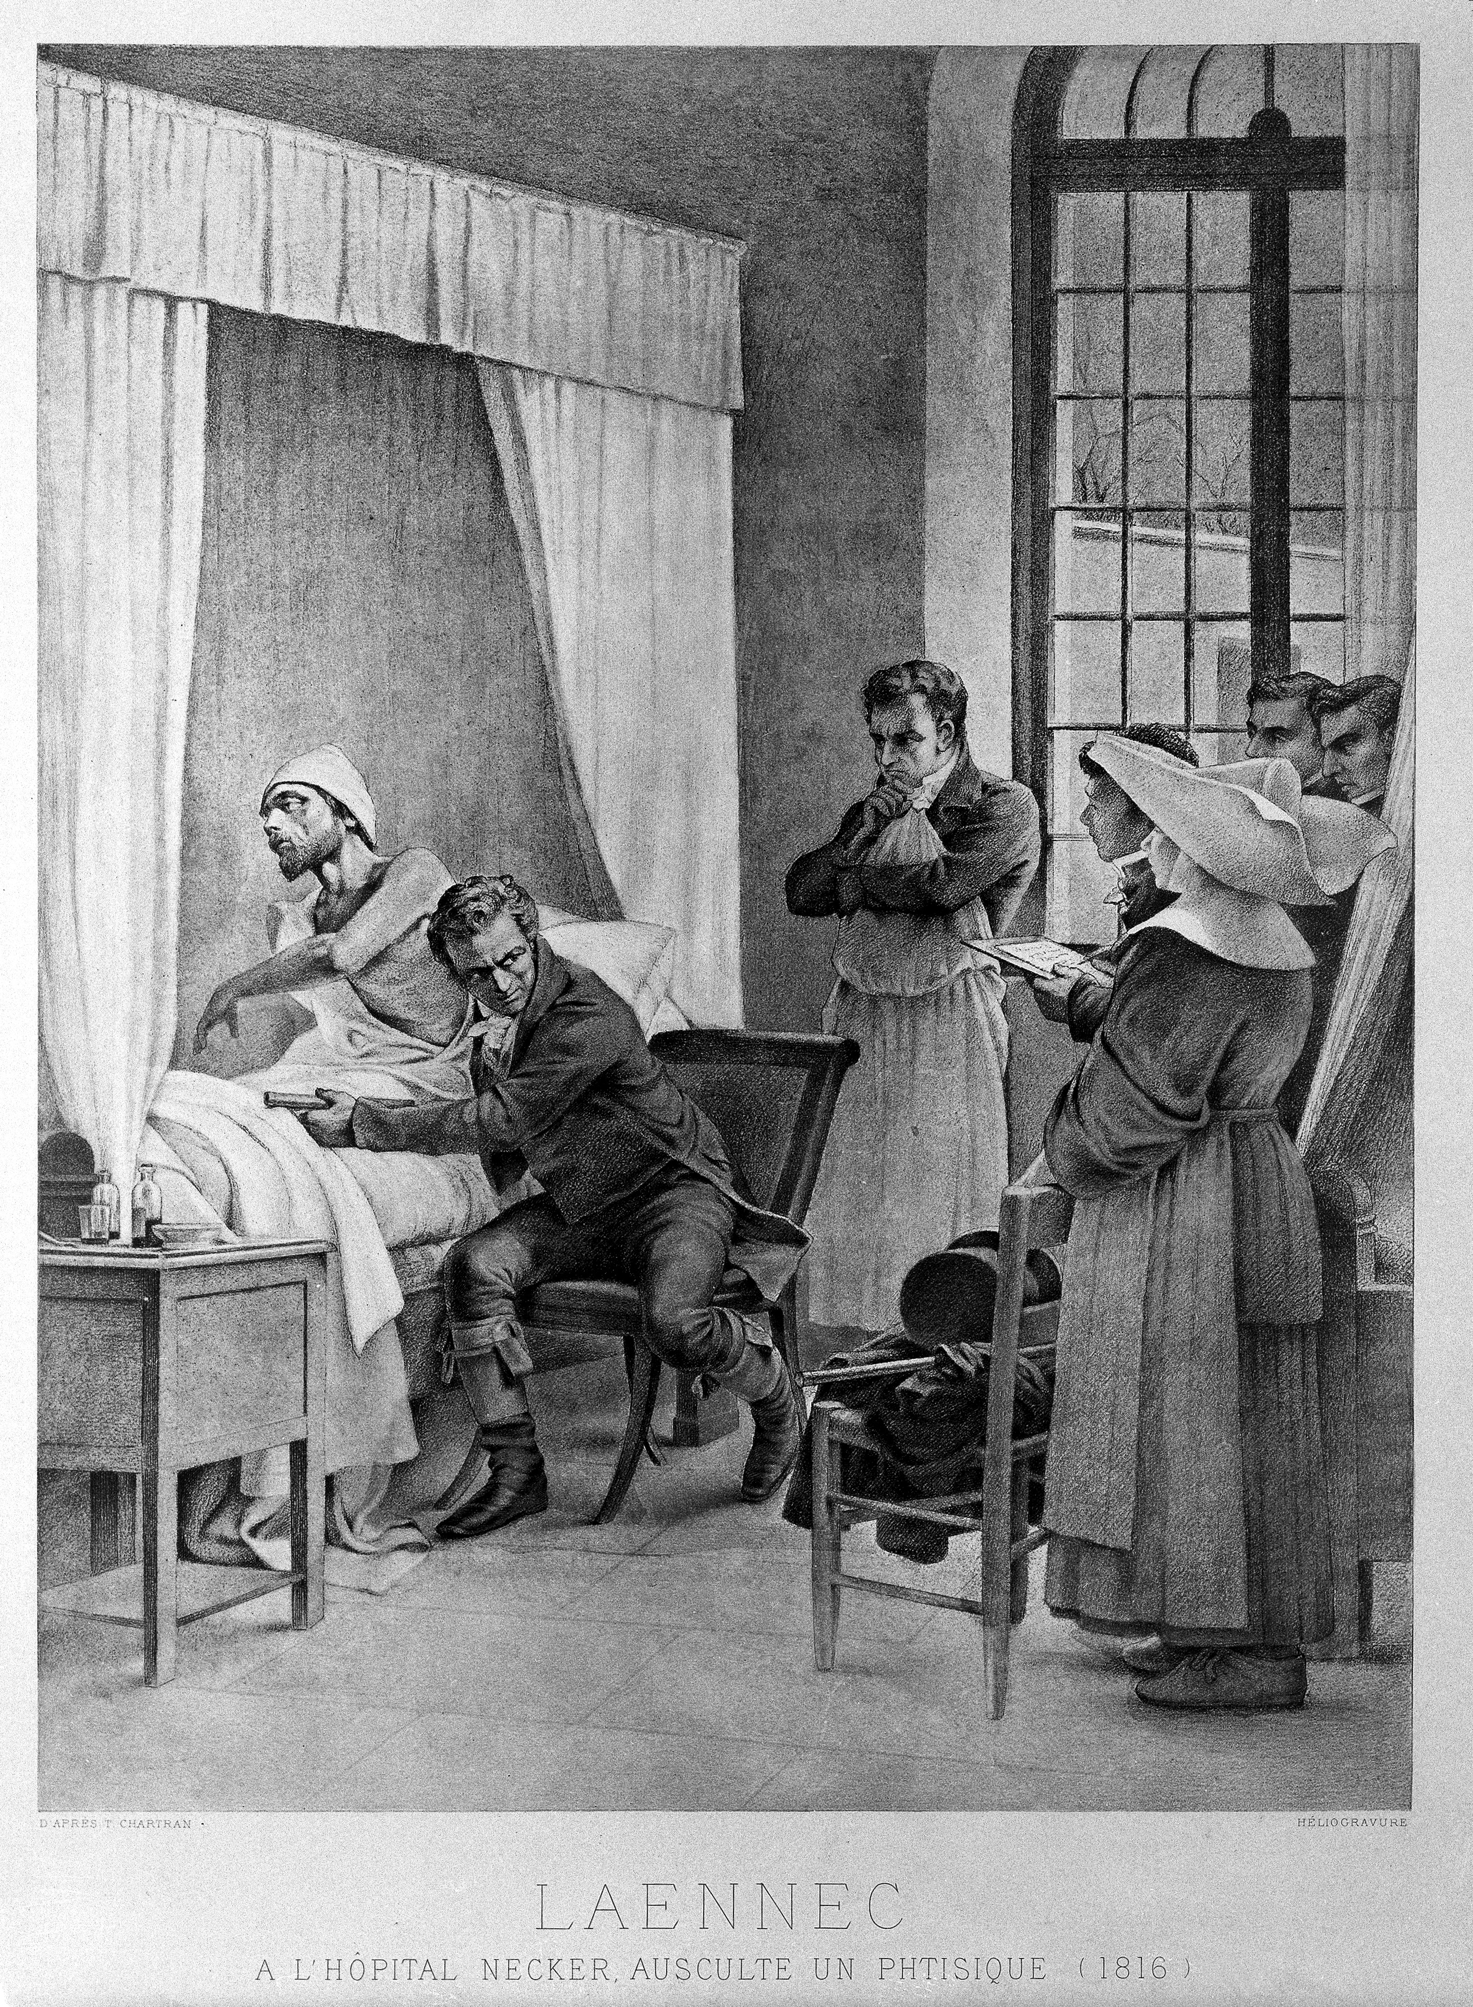

Laennec examines a consumptive patient with a stethoscope in front of his students at the Necker Hospital. Painting by Théobald Chartran, 1816. Attribution in chapter References.

It was not long, however, before Laennec's many labors in Paris began to tell on his health once more. His practice after his return to health and his attachment to the court became large and lucrative. It is characteristic of the man and his ways that he frequently refused, owing to lack of time, to go to see wealthy patients, from whom he would have received large fees, but it is said that he never refused to go to see a poor patient. His hospital patients always received the most solicitous attention, and his time was almost entirely at their disposal. It was not long before Laennec himself, who had taught modern physicians so much about the diagnosis of pulmonary diseases, began evidently to suffer from pulmonary disease himself. There seems no doubt now that almost constant association with tuberculous patients in an overworked subject inclined naturally to be of underweight, and therefore especially susceptible, led to the contraction of the disease.

After about four years in Paris, a dry, hard cough developed insidiously, gradually increased in annoyance, and finally grew so serious as to demand a return once more to his native Bretagne. He lost flesh, became subject to intermittent attacks of fever and suffered from some pleuritic and pulmonic pains. For some time after his return to his native air, he improved. He was treated by the usual method employed at the time whenever fever accompanied any ailment. Venesection was the main part of what was then called the antiphlogistic treatment. It is needless to say he did not improve. He was suffering from exhausting disease and the treatment became really an accessory to further exhaustion.

At last, there could be no longer any doubt that the end was approaching. The old curate of the village came often to visit him, and brought him all the consolations of religion. With his sincere Christian faith and firm conviction, it was not hard for Laennec to find the moral force and the calm necessary to secure an easy death. Finally, one day, on August 13th, his wife saw him take off his fingers one after another the rings he wore, and place them softly upon the table. When she asked him why he did so, he replied, "It will not be long now before someone else would have to do this service for me, and I do not wish that they should have the trouble." Even in death, he was thinking of others rather than of himself, and he was **calmly facing the inevitable, thoroughly prepared for it**. Two hours afterward, at five o'clock in the afternoon, without there having been at any time the slightest loss of consciousness, Laennec passed away.

How faithfully his family had watched over him, and how simple was the feeling of Christian confidence in all of them, may very well be gathered from the letter of his cousin Ambrose to Laennec's brother Meriadec in Paris.

"My dear Meriadec:--Poor Renè is no more. His life was passed in the midst of labor and of benevolence. While he had all the virtues of the true Christian, and a wisdom far beyond what was usually granted to men, they have not sufficed to obtain for him the grace of a longer life. Somehow, it was ordained that this glory and ornament of our family was not to remain with us. What a sad reflection it is on our restless eagerness in this life, and on the vanity of our hopes, that a genius like this must perish just when it was about to receive the fruit of its labors! He leaves to us a name, a name difficult to sustain and the example of virtues that it will not be easy to imitate. Let us hope that he will watch over us in the future, as he has done in the past, and that he will still continue to aid us after his death. Although I have been prepared for this sad event, I could not suspect how much grief I was to experience in losing my second master, my friend from earliest infancy, and him whom I had become accustomed to consider as my eldest brother. I must confess that, for some years now, we have all had to pay dear for the short intervals of happiness that it has pleased heaven to accord to us."

Laennec's burial took place in the cemetery of Ploare. The attendance at the funeral was very large. Practically the entire population of the countryside came to mourn for the benefactor that they loved so much. He had made friends even among the simplest of the country people and knew most of them by name. After his return to the country, he had improved somewhat in appearance, and the neighbors had been very glad to express their feelings of gratitude for his apparent improvement in health. Undoubtedly, not a little of this state of better spirits was due to the fact that he liked Brittany and the peasants of the neighborhood so well, and always felt so much at home among them.

He was mild and agreeable in his manners, and of a quiet and even temper. His conversation was lively and full of quiet humor, and his friends often said that they never came away from a conversation with him without having learned something. Toward the end of his life, when his great reputation caused him to be honored by medical men from all over the world, and when his reputation made him the lion of the hour, he lost none of his natural affability and kindness of heart. He was remarkable, especially for his great kindness and courtesy to foreigners, and he is said to have taken special care to make himself understood by English-speaking medical visitors.

It must be confessed that he was somewhat less popular with his contemporaries who did not belong to his immediate circle of friends and students. One of the reasons for this was his genius, which no generation seems ready to acknowledge in any of its members. Another reason was his continued misunderstanding with Broussais. Broussais was the medical theorist of the hour, and medical theories have always been popular, while medical observation has had to wait for due recognition. There were undoubtedly good points in Broussais' theories that Laennec failed to appreciate. This is the only blot on a perfect career, taking it all in all, whether as man or as physician. It can easily be understood with what impatience Laennec, entirely devoted himself to observation, would take up the study of what he considered mere theory, and it is easy to forgive him his lack of appreciation.

Benjamin Ward Richardson says: "It was a common saying regarding Laennec by his compeers that, while he was without a rival in diagnosis, he was not a good practitioner; which means that he was not a good practitioner, according to their ideas of practice, heroic and fearful. To us, Laennec would now be a very heroic practitioner; so much so, that I doubt if any medical man living would, for the life of him, take some of his prescriptions. But in his own time, when so little was known of the great system of natural cure, he would be easily out of court. It was amply sufficient against him that he had a glimmering of the truth as to the existence of a considerable run of cases of organic disease, for which the so-called practice of remedial cure by drugs, bloodlettings and other heroic plans, could do no good but was likely to do grievous harm." **We are reminded of Morgagni's refusal to permit bloodletting in his own case, though he practised it himself on others.** Like Laennec, Morgagni seems to have doubted the efficacy of bloodletting at a time when unfortunately all medical men were agreed that it was the sovereign remedy.

If Laennec was not popular with his immediate contemporaries, succeeding generations have more than made up for the seeming neglect. Less than twenty-five years after his death, Austin Flint, here in America, hailed him as one of the five or six greatest medical men of all times. Forty years after his death, Professor Chauffard, himself one of the distinguished medical men of the nineteenth century, said:

"Without exaggeration, we can call the glory which has come to French medicine because of the great discovery of auscultation a national honor. It must be conceded that, for a long time before Laennec, the great man of medicine, those to whom medical science owed its ground-breaking work, did not belong to France. Harvey, Haller, and Morgagni had made the investigations on which are founded the circulation of the blood, experimental physiology, and pathological anatomy, in other lands than ours. It almost seemed that we were lacking in the fecund possibilities of daring and successful initiative. Auscultation, however, as it came to us perfect from the hands of Laennec, has given us a striking revenge for any objections foreigners might make to our apathy. This discovery has rendered the scientific medicine of the world our tributary for all time. It was an immortal creation, and its effects will never fail to be felt. More than this, it will never be merely an historical reminiscence, because of the fact that it guided men aright, but it will in its actuality remain as an aid and diagnostic auxiliary. Auscultation will not disappear but with medical science itself, and with this stage of our civilization which guides, directs and enlightens it."

Laennec was known for his simple Bretagne faith, for his humble piety, and for uniformly consistent devotion to the Catholic Church, of which he was so faithful a member. His charity was well known, and while his purse was very ready to assist the needy, he did not hesitate to give to the poor what was so much more precious to him, and it may be said to the world also, than money--his time. After his death, and only then, the extent of his charity became known.

Dr. Austin Flint said of him: "Laennec's life affords an instance among many others **disproving the vulgar error that the pursuits of science are unfavorable to religious faith**. He lived and died a firm believer in the truths of Christianity. He was a truly moral and a sincerely religious man."

Of his death, his contemporary, Bayle, who is one of his biographers, and who had been his friend from early youth, said:

"His death was that of a true Christian, supported by the hope of a better life, prepared by the constant practice of virtue; he saw his end approach with composure and resignation. His religious principles, imbibed with his earliest knowledge, were strengthened by the conviction of his maturer reason. He took no pains to conceal his religious sentiments when they were disadvantageous to his worldly interests, and he made no display of them when their avowal might have contributed to favor and advancement."

Surely in these few lines is sketched a picture of ideal Christian manhood. There are those who think it wonderful to find it in a man of genius as great as Laennec. It should not be surprising, however, for surely genius can bow in acknowledgment to its Creator.

Shortly after the death of Pasteur, it was well said that two of the greatest medical scientists of the nineteenth century have given to the physicians of France a magnificent, encouraging, and comforting example. It is almost needless to say these two were **Laennec and Pasteur**, and their example is not for France alone, but for the whole medical world. **They were living nineteenth century answers to the advocates of free thought, who would say that religious belief and especially Catholic faith make men sterile in the realm of scientific thought.**

No better ending to this sketch of Laennec's life seems possible than the conclusion of Dr. Flint's address to his students in New Orleans, already so often quoted from. It has about it the ring of the true metal of sincere Christian manhood and unselfish devotion to a humanitarian profession:

"The career of the distinguished man whose biography has been our theme on this occasion is preeminently worthy of admiration. In his character were beautifully blended the finest intellectual and moral qualities of our nature. With mental powers of the highest order were combined simplicity, modesty, purity, and disinterestedness in such measure that we feel he was a man to be loved not less than admired. His zeal and industry in scientific pursuits were based on the **love of truth for its own sake** and a desire to be useful to his fellow-men. To these motives to exertion much of his success is to be attributed. Mere intellectual ability and acquirements do not qualify either to make or to appreciate important scientific discoveries. The mind must rise above the obstructions of self-love, jealousy, and selfish aims. **Hence it is that most of those who have attained to true eminence in the various paths of scientific research have been distinguished for excellencies of the heart as well as of the head**. The example of Laennec is worthy of our imitation. **His superior natural gifts we can only admire, but we can imitate the industry without which his genius would have been fruitless**. Let us show our reverence to the memory of Laennec by endeavoring to follow humbly in his footsteps." **Quod faustum vertat![177]**

### Food for Thought

* Let us do a quick recap of elementary knowledge. What are the most important entities in the following institutions among those provided below?
  + **Hospital**: Great Rooms, Latest Diagnostic Equipment, Knowledgeable and Dedicated Doctors.
  + **School**: Furniture, Smart Uniform, Building, Auditorium, Sports facilities, Knowledgeable and Dedicated Teachers.
  + **Restaurant**: Furniture, Ambience, Surrounding music, Rich menu, Smartly Dressed Waiters, Tasty and Hygienic Food.
* As time progressed, many more diagnostic methods got added to a physician’s repertoire. Starting from close observation of a patient’s appearance, questioning, and so on up to various pathological tests and X-Rays, to modern methods like advanced scanning techniques. What methods are you aware of, and what are they used for?
* Even today, the most common instrument a physician is seen with is the stethoscope. Isn’t it surprising to note that, one of the most inexpensive of diagnostic techniques should also be among the most popular techniques of examination, even centuries after it was first put to practice?
* Why do you think Laennec remained disinterested in attractions of riches, power, and fame, even when it was possible to have those in plenty? His desire to do more for mankind due to religious beliefs? Purely his passion to discover more secrets of nature not yet revealed to him, that is, science for the love of science?

### References

* Makers of Modern Medicine, by James J. Walsh, 1906.
* Laennec by Dubois, 1854, Photograph By PHGCOM (Own work) [[CC BY-SA 3.0](http://creativecommons.org/licenses/by-sa/3.0) (http://creativecommons.org/licenses/by-sa/3.0)], [via Wikimedia Commons](https://commons.wikimedia.org/wiki/File%3ALaennec_by_Dubois_1854.jpg).
* Made of wood and brass, this is one of the original stethoscopes belonging to the French physician Rene Theophile Laennec (1781-1826), who devised the first stethoscope in 1816. It consists of a single hollow tube. The familiar binaural stethoscope, with rubber tubing going to both ears, was not developed until the 1850s. Regarded as the father of chest medicine, Laennec demonstrated the importance of the instrument in diagnosing diseases of the lungs, heart, and vascular systems. Ironically, he died of tuberculosis. By Science Museum London / Science and Society Picture Library [[CC BY-SA 2.0](http://creativecommons.org/licenses/by-sa/2.0) (http://creativecommons.org/licenses/by-sa/2.0)], [via Wikimedia Commons](https://commons.wikimedia.org/wiki/File%3ALaennecs_stethoscope%2C_c_1820._(9660576833).jpg)
* Laennec and the use of the stethoscope at the Hospital Necker Wellcome. See page for author [[CC BY 4.0](http://creativecommons.org/licenses/by/4.0) (http://creativecommons.org/licenses/by/4.0)], [via Wikimedia Commons](https://commons.wikimedia.org/wiki/File%3ALaennec_and_the_use_of_the_stethoscope_at_the_Hospital_Necker_Wellcome_L0007797.jpg).

Sherlock Holmes, The Adventure Of The Speckled Band

Complexity: Medium

Here is a magnificent Sherlock Holmes story from the Master of Mystery, Arthur Conan Doyle. Mr. Watson, detective Sherlock Holmes’ friend and assistant, begins the narration.

On glancing over my notes of the seventy odd cases in which I have during the last eight years studied the methods of my friend Sherlock Holmes, I find many tragic, some comic, a large number merely strange, but none commonplace; for, working as he did rather for the love of his art than for the acquirement of wealth, he refused to associate himself with any investigation which did not tend towards the unusual, and even the fantastic. Of all these varied cases, however, I cannot recall any which presented more singular features than that which was associated with the well-known Surrey family of the Roylotts of Stoke Moran. The events in question occurred in the early days of my association with Holmes, when we were sharing rooms as bachelors in Baker Street. It is possible that I might have placed them upon record before, but a promise of secrecy was made at the time, from which I have only been freed during the last month by the untimely death of the lady to whom the pledge was given. It is perhaps as well that the facts should now come to light, for I have reasons to know that there are widespread rumours as to the death of Dr. Grimesby Roylott, which tend to make the matter even more terrible than the truth.

It was early in April in the year ’83 that I woke one morning to find Sherlock Holmes standing, fully dressed, by the side of my bed. He was a late riser, as a rule, and as the clock on the mantelpiece showed me that it was only a quarter-past seven, I blinked up at him in some surprise, and perhaps just a little resentment, for I was myself regular in my habits.

“Very sorry to knock you up, Watson,” said he, “but it’s the common lot this morning. Mrs. Hudson has been knocked up, she retorted upon me, and I on you.”

“What is it, then—a fire?”

“No; a client. It seems that a young lady has arrived in a considerable state of excitement, who insists upon seeing me. She is waiting now in the sitting-room. Now, when young ladies wander about the metropolis at this hour of the morning, and knock sleepy people up out of their beds, I presume that it is something very pressing which they have to communicate. Should it prove to be an interesting case, you would, I am sure, wish to follow it from the outset. I thought, at any rate, that I should call you and give you the chance.”

“My dear fellow, I would not miss it for anything.”

I had no keener pleasure than in following Holmes in his professional investigations, and in admiring the rapid deductions, as swift as intuitions, and yet always founded on a logical basis with which he unravelled the problems that were submitted to him. I rapidly threw on my clothes and was ready in a few minutes to accompany my friend down to the sitting-room. A lady dressed in black and heavily veiled, who had been sitting in the window, rose as we entered.

“Good-morning, madam,” said Holmes cheerily. “My name is Sherlock Holmes. This is my intimate friend and associate, Dr. Watson, before whom you can speak as freely as before myself. Ha! I am glad to see that Mrs. Hudson has had the good sense to light the fire. Pray draw up to it, and I shall order you a cup of hot coffee, for I observe that you are shivering.”

“It is not cold which makes me shiver,” said the woman in a low voice, changing her seat as requested.

“What, then?”

“It is fear, Mr. Holmes. It is terror.” She raised her veil as she spoke, and we could see that she was indeed in a pitiable state of agitation, her face all drawn and grey, with restless frightened eyes, like those of some hunted animal. Her features and figure were those of a woman of thirty, but her hair was shot with premature grey, and her expression was weary and haggard. Sherlock Holmes ran her over with one of his quick, all-comprehensive glances.

“You must not fear,” said he soothingly, bending forward and patting her forearm. “We shall soon set matters right, I have no doubt. You have come in by train this morning, I see.”

“You know me, then?”

“No, but I observe the second half of a return ticket in the palm of your left glove. You must have started early, and yet you had a good drive in a dog-cart, along heavy roads, before you reached the station.”

The lady gave a violent start and stared in bewilderment at my companion.

“There is no mystery, my dear madam,” said he, smiling. “The left arm of your jacket is spattered with mud in no less than seven places. The marks are perfectly fresh. There is no vehicle save a dog-cart which throws up mud in that way, and then only when you sit on the left-hand side of the driver.”

“Whatever your reasons may be, you are perfectly correct,” said she. “I started from home before six, reached Leatherhead at twenty past, and came in by the first train to Waterloo. Sir, I can stand this strain no longer; I shall go mad if it continues. I have no one to turn to—none, save only one, who cares for me, and he, poor fellow, can be of little aid. I have heard of you, Mr. Holmes; I have heard of you from Mrs. Farintosh, whom you helped in the hour of her sore need. It was from her that I had your address. Oh, sir, do you not think that you could help me, too, and at least throw a little light through the dense darkness that surrounds me? At present it is out of my power to reward you for your services, but in a month or six weeks I shall be married, with the control of my own income, and then at least you shall not find me ungrateful.”

Holmes turned to his desk and, unlocking it, drew out a small case-book, which he consulted.

“Farintosh,” said he. “Ah yes, I recall the case; it was concerned with an opal tiara. I think it was before your time, Watson. I can only say, madam, that I shall be happy to devote the same care to your case as I did to that of your friend. **As to reward, my profession is its own reward**; but you are at liberty to defray whatever expenses I may be put to, at the time that suits you best. And now I beg that you will lay before us everything that may help us in forming an opinion upon the matter.”

“Alas!” replied our visitor, “the very horror of my situation lies in the fact that my fears are so vague, and my suspicions depend so entirely upon small points, which might seem trivial to another, that even he to whom of all others I have a right to look for help and advice looks upon all that I tell him about it as the fancies of a nervous woman. He does not say so, but I can read it from his soothing answers and averted eyes. But I have heard, Mr. Holmes, that you can see deeply into the manifold wickedness of the human heart. You may advise me how to walk amid the dangers which encompass me.”

“I am all attention, madam.”

“My name is Helen Stoner, and I am living with my stepfather, who is the last survivor of one of the oldest Saxon families in England, the Roylotts of Stoke Moran, on the western border of Surrey.”

Holmes nodded his head. “The name is familiar to me,” said he.

“The family was at one time among the richest in England, and the estates extended over the borders into Berkshire in the north, and Hampshire in the west. In the last century, however, four successive heirs were of a dissolute and wasteful disposition, and the family ruin was eventually completed by a gambler in the days of the Regency. Nothing was left save a few acres of ground, and the two-hundred-year-old house, which is itself crushed under a heavy mortgage. The last squire dragged out his existence there, living the horrible life of an aristocratic pauper; but his only son, my stepfather, seeing that he must adapt himself to the new conditions, obtained an advance from a relative, which enabled him to take a medical degree and went out to Calcutta, where, by his professional skill and his force of character, he established a large practice. In a fit of anger, however, caused by some robberies that had been perpetrated in the house, he beat his native butler to death and narrowly escaped a capital sentence. As it was, he suffered a long term of imprisonment and afterwards returned to England a morose and disappointed man.

“When Dr. Roylott was in India, he married my mother, Mrs. Stoner, the young widow of Major-General Stoner, of the Bengal Artillery. My sister Julia and I were twins, and we were only two years old at the time of my mother’s re-marriage. She had a considerable sum of money—not less than *£*1000 a year—and this she bequeathed to Dr. Roylott entirely while we resided with him, with a provision that a certain annual sum should be allowed to each of us in the event of our marriage. Shortly after our return to England, my mother died—she was killed eight years ago in a railway accident near Crewe. Dr. Roylott then abandoned his attempts to establish himself in practice in London and took us to live with him in the old ancestral house at Stoke Moran. The money that my mother had left was enough for all our wants, and there seemed to be no obstacle to our happiness.

“But a terrible change came over our stepfather about this time. Instead of making friends and exchanging visits with our neighbours, who had at first been overjoyed to see a Roylott of Stoke Moran back in the old family seat, he shut himself up in his house and seldom came out save to indulge in ferocious quarrels with whoever might cross his path. Violence of temper approaching to mania has been hereditary in the men of the family, and in my stepfather’s case it had, I believe, been intensified by his long residence in the tropics. A series of disgraceful brawls took place, two of which ended in the police-court, until at last he became the terror of the village, and the folks would fly at his approach, for he is a man of immense strength, and absolutely uncontrollable in his anger.

“Last week he hurled the local blacksmith over a parapet into a stream, and it was only by paying over all the money that I could gather together, that I was able to avert another public exposure. He had no friends at all save the wandering Gypsies, and he would give these vagabonds leave to encamp upon the few acres of bramble-covered land that represent the family estate, and would accept in return the hospitality of their tents, wandering away with them sometimes for weeks on end. He has a passion also for Indian animals, which are sent over to him by a correspondent, and he has at this moment a cheetah and a baboon, which wander freely over his grounds and are feared by the villagers almost as much as their master.

“You can imagine from what I say that my poor sister Julia and I had no great pleasure in our lives. No servant would stay with us, and for a long time we did all the work of the house. **She was but thirty at the time of her death, and yet her hair had already begun to whiten, even as mine has.**”

“Your sister is dead, then?”

“She died just two years ago, and it is of her death that I wish to speak to you. You can understand that, living the life which I have described, we were little likely to see anyone of our own age and position. We had, however, an aunt, my mother’s maiden sister, Miss Honoria Westphail, who lives near Harrow, and we were occasionally allowed to pay short visits at this lady’s house. Julia went there at Christmas two years ago, and met there a half-pay major of marines, to whom she became engaged. My stepfather learned of the engagement when my sister returned and offered no objection to the marriage; but within a fortnight of the day which had been fixed for the wedding, the terrible event occurred, which has deprived me of my only companion.”

Sherlock Holmes had been leaning back in his chair with his eyes closed and his head sunk in a cushion, but he half opened his lids now and glanced across at his visitor.

“Pray be precise as to details,” said he.

“It is easy for me to be so, for every event of that dreadful time is seared into my memory. The manor-house is, as I have already said, very old, and only one wing is now inhabited. The bedrooms in this wing are on the ground floor, the sitting-rooms being in the central block of the buildings. Of these bedrooms, the first is Dr. Roylott’s, the second my sister’s, and the third my own. There is no communication between them, but they all open out into the same corridor. Do I make myself plain?”

“Perfectly so.”

“The windows of the three rooms open out upon the lawn. That fatal night, Dr. Roylott had gone to his room early, though we knew that he had not retired to rest, for my sister was troubled by the smell of the strong Indian cigars which it was his custom to smoke. She left her room, therefore, and came into mine, where she sat for some time, chatting about her approaching wedding. At eleven o’clock she rose to leave me, but she paused at the door and looked back.

“ ‘Tell me, Helen,’ said she, ‘have you ever heard anyone whistle in the dead of the night?’

“ ‘Never,’ said I.

“ ‘I suppose that you could not possibly whistle, yourself, in your sleep?’

“ ‘Certainly not. But why?’

“ ‘Because during the last few nights I have always, at about three in the morning, heard a low, clear whistle. I am a light sleeper, and it has awakened me. I cannot tell where it came from—perhaps from the next room, perhaps from the lawn. I thought that I would just ask you whether you had heard it.’

“ ‘No, I have not. It must be those wretched Gypsies in the plantation.’

“ ‘Very likely. And yet if it were on the lawn, I wonder that you did not hear it also.’

“ ‘Ah, but I sleep more heavily than you.’

“ ‘Well, it is of no great consequence, at any rate.’ She smiled back at me, closed my door, and a few moments later I heard her key turn in the lock.”

“Indeed,” said Holmes. “Was it your custom always to lock yourselves in at night?”

“Always.”

“And why?”

“I think that I mentioned to you that the doctor kept a cheetah and a baboon. We had no feeling of security unless our doors were locked.”

“Quite so. Pray proceed with your statement.”

“I could not sleep that night. A vague feeling of impending misfortune impressed me. My sister and I, you will recollect, were twins, and you know how subtle are the links that bind two souls that are so closely allied. It was a wild night. The wind was howling outside, and the rain was beating and splashing against the windows. Suddenly, amid all the hubbub of the gale, there burst forth the wild scream of a terrified woman. I knew that it was my sister’s voice. I sprang from my bed, wrapped a shawl round me, and rushed into the corridor. As I opened my door I seemed to hear a low whistle, such as my sister described, and a few moments later a clanging sound, as if a mass of metal had fallen. As I ran down the passage, my sister’s door was unlocked, and revolved slowly upon its hinges. I stared at it horror-stricken, not knowing what was about to issue from it. By the light of the corridor-lamp I saw my sister appear at the opening, her face blanched with terror, her hands groping for help, her whole figure swaying to and fro like that of a drunkard. I ran to her and threw my arms round her, but at that moment her knees seemed to give way and she fell to the ground. She writhed as one who is in terrible pain, and her limbs were dreadfully convulsed. At first I thought that she had not recognised me, but as I bent over her she suddenly shrieked out in a voice which I shall never forget, ‘Oh, my God! Helen! It was the band! The speckled band!’ There was something else that she would fain have said, and she stabbed with her finger into the air in the direction of the doctor’s room, but a fresh convulsion seized her and choked her words. I rushed out, calling loudly for my stepfather, and I met him hastening from his room in his dressing-gown. When he reached my sister’s side she was unconscious, and though he poured brandy down her throat and sent for medical aid from the village, all efforts were in vain, for she slowly sank and died without having recovered her consciousness. Such was the dreadful end of my beloved sister.”

“One moment,” said Holmes, “are you sure about this whistle and metallic sound? Could you swear to it?”

“That was what the county coroner asked me at the inquiry. It is my strong impression that I heard it, and yet, among the crash of the gale and the creaking of an old house, I may possibly have been deceived.”

“Was your sister dressed?”

“No, she was in her night-dress. In her right hand was found the charred stump of a match, and in her left a match-box.”

“Showing that she had struck a light and looked about her when the alarm took place. That is important. And what conclusions did the coroner come to?”

“He investigated the case with great care, for Dr. Roylott’s conduct had long been notorious in the county, but he was unable to find any satisfactory cause of death. My evidence showed that the door had been fastened upon the inner side, and the windows were blocked by old-fashioned shutters with broad iron bars, which were secured every night. The walls were carefully sounded, and were shown to be quite solid all round, and the flooring was also thoroughly examined, with the same result. The chimney is wide, but is barred up by four large staples. It is certain, therefore, that my sister was quite alone when she met her end. Besides, there were no marks of any violence upon her.”

“How about poison?”

“The doctors examined her for it, but without success.”

“What do you think that this unfortunate lady died of, then?”

“It is my belief that she died of pure fear and nervous shock, though what it was that frightened her I cannot imagine.”

“Were there Gypsies in the plantation at the time?”

“Yes, there are nearly always some there.”

“Ah, and what did you gather from this allusion to a band—a speckled band?”

“Sometimes I have thought that it was merely the wild talk of delirium, sometimes that it may have referred to some band of people, perhaps to these very Gypsies in the plantation. I do not know whether the spotted handkerchiefs that so many of them wear over their heads might have suggested the strange adjective which she used.”

Holmes shook his head like a man who is far from being satisfied.

“These are very deep waters,” said he, “pray go on with your narrative.”

“Two years have passed since then, and my life has been until lately lonelier than ever. A month ago, however, a dear friend, whom I have known for many years, has done me the honour to ask my hand in marriage. His name is Armitage—Percy Armitage—the second son of Mr. Armitage, of Crane Water, near Reading. My stepfather has offered no opposition to the match, and we are to be married in the course of the spring. Two days ago, some repairs were started in the west wing of the building, and my bedroom wall has been pierced, so that I have had to move into the chamber in which my sister died, and to sleep in the very bed in which she slept. Imagine, then, my thrill of terror when last night, as I lay awake, thinking over her terrible fate, I suddenly heard in the silence of the night the low whistle which had been the herald of her own death. I sprang up and lit the lamp, but nothing was to be seen in the room. I was too shaken to go to bed again, however, so I dressed, and as soon as it was daylight I slipped down, got a dog-cart at the Crown Inn, which is opposite, and drove to Leatherhead, from whence I have come on this morning with the one object of seeing you and asking your advice.”

“You have done wisely,” said my friend. “But have you told me all?”

“Yes, all.”

“Miss Roylott, you have not. You are screening your stepfather.”

“Why, what do you mean?”

For answer, Holmes pushed back the frill of black lace that fringed the hand that lay upon our visitor’s knee. Five little livid spots, the marks of four fingers and a thumb, were printed upon the white wrist.

“You have been cruelly used,” said Holmes.

The lady coloured deeply and covered over her injured wrist. “He is a hard man,” she said, “and perhaps he hardly knows his own strength.”

There was a long silence, during which Holmes leaned his chin upon his hands and stared into the crackling fire.

“This is a very deep business,” he said at last. “There are a thousand details which I should desire to know before I decide upon our course of action. Yet we have not a moment to lose. If we were to come to Stoke Moran today, would it be possible for us to see over these rooms without the knowledge of your stepfather?”

“As it happens, he spoke of coming into town today upon some most important business. It is probable that he will be away all day, and that there would be nothing to disturb you. We have a housekeeper now, but she is old and foolish, and I could easily get her out of the way.”

“Excellent. You are not averse to this trip, Watson?”

“By no means.”

“Then we shall both come. What are you going to do yourself?”

“I have one or two things which I would wish to do now that I am in town. But I shall return by the twelve o’clock train, so as to be there in time for your coming.”

“And you may expect us early in the afternoon. I have myself some small business matters to attend to. Will you not wait and breakfast?”

“No, I must go. My heart is lightened already since I have confided my trouble to you. I shall look forward to seeing you again this afternoon.” She dropped her thick black veil over her face and glided from the room.

“And what do you think of it all, Watson?” asked Sherlock Holmes, leaning back in his chair.

“It seems to me to be a most dark and sinister business.”

“Dark enough and sinister enough.”

“Yet if the lady is correct in saying that the flooring and walls are sound, and that the door, window, and chimney are impassable, then her sister must have been undoubtedly alone when she met her mysterious end.”

“What becomes, then, of these nocturnal whistles, and what of the very peculiar words of the dying woman?”

“I cannot think.”

“When you combine the ideas of whistles at night, the presence of a band of Gypsies who are on intimate terms with this old doctor, the fact that we have every reason to believe that the doctor has an interest in preventing his stepdaughter’s marriage, the dying allusion to a band, and, finally, the fact that Miss Helen Stoner heard a metallic clang, which might have been caused by one of those metal bars that secured the shutters falling back into its place, I think that there is good ground to think that the mystery may be cleared along those lines.”

“But what, then, did the Gypsies do?”

“I cannot imagine.”

“I see many objections to any such theory.”

“And so do I. It is precisely for that reason that we are going to Stoke Moran this day. I want to see whether the objections are fatal, or if they may be explained away. But what in the name of the devil!”

The ejaculation had been drawn from my companion by the fact that our door had been suddenly dashed open, and that a huge man had framed himself in the aperture. His costume was a peculiar mixture of the professional and of the agricultural, having a black top-hat, a long frock-coat, and a pair of high gaiters, with a hunting-crop swinging in his hand. So tall was he that his hat actually brushed the cross bar of the doorway, and his breadth seemed to span it across from side to side. A large face, seared with a thousand wrinkles, burned yellow with the sun, and marked with every evil passion, was turned from one to the other of us, while his deep-set, bile-shot eyes, and his high, thin, fleshless nose, gave him somewhat the resemblance to a fierce old bird of prey.

“Which of you is Holmes?” asked this apparition.

“My name, sir; but you have the advantage of me,” said my companion quietly.

“I am Dr. Grimesby Roylott, of Stoke Moran.”

“Indeed, Doctor,” said Holmes blandly. “Pray take a seat.”

“I will do nothing of the kind. My stepdaughter has been here. I have traced her. What has she been saying to you?”

“It is a little cold for the time of the year,” said Holmes.

“What has she been saying to you?” screamed the old man furiously.

“But I have heard that the crocuses promise well,” continued my companion imperturbably.

“Ha! You put me off, do you?” said our new visitor, taking a step forward and shaking his hunting-crop. “I know you, you scoundrel! I have heard of you before. You are Holmes, the meddler.”

My friend smiled.

“Holmes, the busybody!”

His smile broadened.

“Holmes, the Scotland Yard Jack-in-office!”

Holmes chuckled heartily. “Your conversation is most entertaining,” said he. “When you go out close the door, for there is a decided draught.”

“I will go when I have said my say. Don’t you dare to meddle with my affairs! I know that Miss Stoner has been here. I traced her! I am a dangerous man to fall foul of! See here.” He stepped swiftly forward, seized the poker, and bent it into a curve with his huge brown hands.

“See that you keep yourself out of my grip,” he snarled, and hurling the twisted poker into the fireplace, he strode out of the room.

“He seems a very amiable person,” said Holmes, laughing. “I am not quite so bulky, but if he had remained I might have shown him that my grip was not much more feeble than his own.” As he spoke, he picked up the steel poker and, with a sudden effort, straightened it out again.

“Fancy his having the insolence to confound me with the official detective force! This incident gives zest to our investigation, however, and I only trust that our little friend will not suffer from her imprudence in allowing this brute to trace her. And now, Watson, we shall order breakfast, and afterwards I shall walk down to Doctors’ Commons, where I hope to get some data which may help us in this matter.”

It was nearly one o’clock when Sherlock Holmes returned from his excursion. He held in his hand a sheet of blue paper, scrawled over with notes and figures.

“I have seen the will of the deceased wife,” said he. “To determine its exact meaning, I have been obliged to work out the present prices of the investments with which it is concerned. The total income, which at the time of the wife’s death was little short of *£*1100, is now, through the fall in agricultural prices, not more than *£*750. Each daughter can claim an income of *£*250, in case of marriage. It is evident, therefore, that if both girls had married, this beauty would have had a mere pittance, while even one of them would cripple him to a very serious extent. My morning’s work has not been wasted, since it has proved that he has the very strongest motives for standing in the way of anything of the sort. And now, Watson, this is too serious for dawdling, especially as the old man is aware that we are interesting ourselves in his affairs; so if you are ready, we shall call a cab and drive to Waterloo. I should be very much obliged if you would slip your revolver into your pocket. An Eley’s No. 2 is an excellent argument with gentlemen who can twist steel pokers into knots. That and a tooth-brush are, I think, all that we need.”

At Waterloo we were fortunate in catching a train for Leatherhead, where we hired a trap at the station inn and drove for four or five miles through the lovely Surrey lanes. It was a perfect day, with a bright sun and a few fleecy clouds in the heavens. The trees and wayside hedges were just throwing out their first green shoots, and the air was full of the pleasant smell of the moist earth. To me at least, there was a strange contrast between the sweet promise of the spring and this sinister quest upon which we were engaged. My companion sat in the front of the trap, his arms folded, his hat pulled down over his eyes, and his chin sunk upon his breast, buried in the deepest thought. Suddenly, however, he started, tapped me on the shoulder, and pointed over the meadows.

“Look there!” said he.

A heavily timbered park stretched up in a gentle slope, thickening into a grove at the highest point. From amid the branches there jutted out the grey gables and high roof-tree of a very old mansion.

“Stoke Moran?” said he.

“Yes, sir, that be the house of Dr. Grimesby Roylott,” remarked the driver.

“There is some building going on there,” said Holmes, “that is where we are going.”

“There’s the village,” said the driver, pointing to a cluster of roofs some distance to the left, “but if you want to get to the house, you’ll find it shorter to get over this stile, and so by the footpath over the fields. There it is, where the lady is walking.”

“And the lady, I fancy, is Miss Stoner,” observed Holmes, shading his eyes. “Yes, I think we had better do as you suggest.”

We got off, paid our fare, and the trap rattled back on its way to Leatherhead.

“I thought it as well,” said Holmes as we climbed the stile, “that this fellow should think we had come here as architects, or on some definite business. It may stop his gossip. Good-afternoon, Miss Stoner. You see that we have been as good as our word.”

Our client of the morning had hurried forward to meet us with a face that spoke her joy. “I have been waiting so eagerly for you,” she cried, shaking hands with us warmly. “All has turned out splendidly. Dr. Roylott has gone to town, and it is unlikely that he will be back before evening.”

“We have had the pleasure of making the doctor’s acquaintance,” said Holmes, and in a few words he sketched out what had occurred. Miss Stoner turned white to the lips as she listened.

“Good heavens!” she cried, “he has followed me, then.”

“So it appears.”

“He is so cunning that I never know when I am safe from him. What will he say when he returns?”

“He must guard himself, for he may find that there is someone more cunning than himself upon his track. You must lock yourself up from him tonight. If he is violent, we shall take you away to your aunt’s at Harrow. Now, we must make the best use of our time, so kindly take us at once to the rooms which we are to examine.”

The building was of grey, lichen-blotched stone, with a high central portion and two curving wings, like the claws of a crab, thrown out on each side. In one of these wings, the windows were broken and blocked with wooden boards, while the roof was partly caved in, a picture of ruin. The central portion was in little better repair, but the right-hand block was comparatively modern, and the blinds in the windows, with the blue smoke curling up from the chimneys, showed that this was where the family resided. Some scaffolding had been erected against the end wall, and the stonework had been broken into, but there were no signs of any workmen at the moment of our visit. Holmes walked slowly up and down the ill-trimmed lawn and examined with deep attention the outsides of the windows.

“This, I take it, belongs to the room in which you used to sleep, the centre one to your sister’s, and the one next to the main building to Dr. Roylott’s chamber?”

“Exactly so. But I am now sleeping in the middle one.”

“Pending the alterations, as I understand. By the way, there does not seem to be any very pressing need for repairs at that end wall.”

“There were none. I believe that it was an excuse to move me from my room.”

“Ah! That is suggestive. Now, on the other side of this narrow wing runs the corridor from which these three rooms open. There are windows in it, of course?”

“Yes, but very small ones. Too narrow for anyone to pass through.”

“As you both locked your doors at night, your rooms were unapproachable from that side. Now, would you have the kindness to go into your room and bar your shutters?”

Miss Stoner did so, and Holmes, after a careful examination through the open window, endeavoured in every way to force the shutter open, but without success. There was no slit through which a knife could be passed to raise the bar. Then, with his lens, he tested the hinges, but they were of solid iron, built firmly into the massive masonry. “Hum!” said he, scratching his chin in some perplexity, “My theory certainly presents some difficulties. No one could pass these shutters if they were bolted. Well, we shall see if the inside throws any light upon the matter.”

A small side door led into the whitewashed corridor from which the three bedrooms opened. Holmes refused to examine the third chamber, so we passed at once to the second, that in which Miss Stoner was now sleeping, and in which her sister had met with her fate. It was a homely little room, with a low ceiling and a gaping fireplace, after the fashion of old country-houses. A brown chest of drawers stood in one corner, a narrow white counterpaned bed in another, and a dressing-table on the left-hand side of the window. These articles, with two small wicker-work chairs, made up all the furniture in the room save for a square of Wilton carpet in the centre. The boards round and the panelling of the walls were of brown, worm-eaten oak, so old and discoloured that it may have dated from the original building of the house. Holmes drew one of the chairs into a corner and sat silent, while his eyes travelled round and round and up and down, taking in every detail of the apartment.

“Where does that bell communicate with?” he asked at last, pointing to a thick bell rope which hung down beside the bed, the tassel actually lying upon the pillow.

“It goes to the housekeeper’s room.”

“It looks newer than the other things?”

“Yes, it was only put there a couple of years ago.”

“Your sister asked for it, I suppose?”

“No, I never heard of her using it. We used always to get what we wanted for ourselves.”

“Indeed, it seemed unnecessary to put so nice a bell pull there. You will excuse me for a few minutes while I satisfy myself as to this floor.” He threw himself down upon his face with his lens in his hand and crawled swiftly backward and forward, examining minutely the cracks between the boards. Then he did the same with the woodwork with which the chamber was panelled. Finally, he walked over to the bed and spent some time in staring at it and in running his eye up and down the wall. Finally, he took the bell-rope in his hand and gave it a brisk tug.

“Why, it’s a dummy,” said he.

“Won’t it ring?”

“No, it is not even attached to a wire. This is very interesting. You can see now that it is fastened to a hook just above where the little opening for the ventilator is.”

“How very absurd! I never noticed that before.”

“Very strange!” muttered Holmes, pulling at the rope. “There are one or two very singular points about this room. For example, what a fool a builder must be to open a ventilator into another room, when, with the same trouble, he might have communicated with the outside air!”

“That is also quite modern,” said the lady.

“Done about the same time as the bell-rope?” remarked Holmes.

“Yes, there were several little changes carried out about that time.”

“They seem to have been of a most interesting character—dummy bell-ropes, and ventilators which do not ventilate. With your permission, Miss Stoner, we shall now carry our researches into the inner apartment.”

Dr. Grimesby Roylott’s chamber was larger than that of his step-daughter, but was as plainly furnished. A camp bed, a small wooden shelf full of books, mostly of a technical character, an armchair beside the bed, a plain wooden chair against the wall, a round table, and a large iron safe were the principal things which met the eye. Holmes walked slowly round and examined each and all of them with the keenest interest.

“What’s in here?” he asked, tapping the safe.

“My stepfather’s business papers.”

“Oh! You have seen inside, then?”

“Only once, some years ago. I remember that it was full of papers.”

“There isn’t a cat in it, for example?”

“No. What a strange idea!”

“Well, look at this!” He took up a small saucer of milk, which stood on the top of it.

“No; we don’t keep a cat. But there is a cheetah and a baboon.”

“Ah, yes, of course! Well, a cheetah is just a big cat, and yet a saucer of milk does not go very far in satisfying its wants, I daresay. There is one point which I should wish to determine.” He squatted down in front of the wooden chair and examined the seat of it with the greatest attention.

“Thank you. That is quite settled,” said he, rising and putting his lens in his pocket. “Hullo! Here is something interesting!”

The object that had caught his eye was a small dog lash hung on one corner of the bed. The lash, however, was curled upon itself and tied so as to make a loop of whipcord.

“What do you make of that, Watson?”

“It’s a common enough lash. But I don’t know why it should be tied.”

“That is not quite so common, is it? Ah, me! It’s a wicked world, and when a clever man turns his brains to crime it is the worst of all. I think that I have seen enough now, Miss Stoner, and with your permission we shall walk out upon the lawn.”

I had never seen my friend’s face so grim or his brow so dark as it was when we turned from the scene of this investigation. We had walked several times up and down the lawn, neither Miss Stoner nor myself liking to break in upon his thoughts before he roused himself from his reverie.

“It is very essential, Miss Stoner,” said he, “that you should absolutely follow my advice in every respect.”

“I shall most certainly do so.”

“The matter is too serious for any hesitation. Your life may depend upon your compliance.”

“I assure you that I am in your hands.”

“In the first place, both my friend and I must spend the night in your room.”

Both Miss Stoner and I gazed at him in astonishment.

“Yes, it must be so. Let me explain. I believe that that is the village inn over there?”

“Yes, that is the Crown.”

“Very good. Your windows would be visible from there?”

“Certainly.”

“You must confine yourself to your room, on pretence of a headache, when your stepfather comes back. Then when you hear him retire for the night, you must open the shutters of your window, undo the hasp, put your lamp there as a signal to us, and then withdraw quietly with everything that you are likely to want into the room you used to occupy. I have no doubt that, in spite of the repairs, you could manage there for one night.”

“Oh, yes, easily.”

“The rest you will leave in our hands.”

“But what will you do?”

“We shall spend the night in your room, and we shall investigate the cause of this noise which has disturbed you.”

“I believe, Mr. Holmes, that you have already made up your mind,” said Miss Stoner, laying her hand upon my companion’s sleeve.

“Perhaps I have.”

“Then, for pity’s sake, tell me what was the cause of my sister’s death.”

“I should prefer to have clearer proofs before I speak.”

“You can at least tell me whether my own thought is correct, and if she died from some sudden fright.”

“No, I do not think so. I think that there was probably some more tangible cause. And now, Miss Stoner, we must leave you, for if Dr. Roylott returned and saw us, our journey would be in vain. Good-bye, and be brave, for if you will do what I have told you, you may rest assured that we shall soon drive away the dangers that threaten you.”

Sherlock Holmes and I had no difficulty in engaging a bedroom and sitting-room at the Crown Inn. They were on the upper floor, and from our window we could command a view of the avenue gate, and of the inhabited wing of Stoke Moran Manor House. At dusk we saw Dr. Grimesby Roylott drive past, his huge form looming up beside the little figure of the lad who drove him. The boy had some slight difficulty in undoing the heavy iron gates, and we heard the hoarse roar of the doctor’s voice and saw the fury with which he shook his clinched fists at him. The trap drove on, and a few minutes later we saw a sudden light spring up among the trees as the lamp was lit in one of the sitting-rooms.

“Do you know, Watson,” said Holmes as we sat together in the gathering darkness, “I have really some scruples as to taking you tonight. There is a distinct element of danger.”

“Can I be of assistance?”

“Your presence might be invaluable.”

“Then I shall certainly come.”

“It is very kind of you.”

“You speak of danger. You have evidently seen more in these rooms than was visible to me.”

“No, but I fancy that I may have deduced a little more. I imagine that you saw all that I did.”

“I saw nothing remarkable save the bell-rope, and what purpose that could answer I confess is more than I can imagine.”

“You saw the ventilator, too?”

“Yes, but I do not think that it is such a very unusual thing to have a small opening between two rooms. It was so small that a rat could hardly pass through.”

“I knew that we should find a ventilator before ever we came to Stoke Moran.”

“My dear Holmes!”

“Oh, yes, I did. You remember in her statement she said that her sister could smell Dr. Roylott’s cigar. Now, of course that suggested at once that there must be a communication between the two rooms. It could only be a small one, or it would have been remarked upon at the coroner’s inquiry. I deduced a ventilator.”

“But what harm can there be in that?”

“Well, there is at least a curious coincidence of dates. A ventilator is made, a cord is hung, and a lady who sleeps in the bed dies. Does not that strike you?”

“I cannot as yet see any connection.”

“Did you observe anything very peculiar about that bed?”

“No.”

“It was clamped to the floor. Did you ever see a bed fastened like that before?”

“I cannot say that I have.”

“The lady could not move her bed. It must always be in the same relative position to the ventilator and to the rope—or so we may call it, since it was clearly never meant for a bell-pull.”

“Holmes,” I cried, “I seem to see dimly what you are hinting at. We are only just in time to prevent some subtle and horrible crime.”

“Subtle enough and horrible enough. When a doctor does go wrong he is the first of criminals. He has nerve and he has knowledge. Palmer and Pritchard were among the heads of their profession. This man strikes even deeper, but I think, Watson, that we shall be able to strike deeper still. But we shall have horrors enough before the night is over; for goodness’ sake, let us have a quiet pipe and turn our minds for a few hours to something more cheerful.”

About nine o’clock the light among the trees was extinguished, and all was dark in the direction of the Manor House. Two hours passed slowly away, and then, suddenly, just at the stroke of eleven, a single bright light shone out right in front of us.

“That is our signal,” said Holmes, springing to his feet, “It comes from the middle window.”

As we stepped out, he exchanged a few words with the landlord, explaining that we were going on a late visit to an acquaintance, and that it was possible that we might spend the night there. A moment later we were out on the dark road, a chill wind blowing in our faces, and one yellow light twinkling in front of us through the gloom to guide us on our sombre errand.

There was little difficulty in entering the grounds, for unrepaired breaches gaped in the old park wall. Making our way among the trees, we reached the lawn, crossed it, and were about to enter through the window, when out from a clump of laurel bushes there darted what seemed to be a hideous and distorted child, who threw itself upon the grass with writhing limbs and then ran swiftly across the lawn into the darkness.

“My God!” I whispered. “Did you see it?”

Holmes was for the moment as startled as I. His hand closed like a vice upon my wrist in his agitation. Then he broke into a low laugh and put his lips to my ear.

“It is a nice household,” he murmured. “That is the baboon.”

I had forgotten the strange pets that the doctor affected. There was a cheetah, too; perhaps we might find it upon our shoulders at any moment. I confess that I felt easier in my mind when, after following Holmes’ example and slipping off my shoes, I found myself inside the bedroom. My companion noiselessly closed the shutters, moved the lamp onto the table, and cast his eyes round the room. All was as we had seen it in the daytime. Then creeping up to me and making a trumpet of his hand, he whispered into my ear again so gently that it was all that I could do to distinguish the words:

“The least sound would be fatal to our plans.”

I nodded to show that I had heard.

“We must sit without light. He would see it through the ventilator.”

I nodded again.

“Do not go asleep; your very life may depend upon it. Have your pistol ready in case we should need it. I will sit on the side of the bed and you in that chair.”

I took out my revolver and laid it on the corner of the table.

Holmes had brought up a long thin cane, and this he placed upon the bed beside him. By it he laid the box of matches and the stump of a candle. Then he turned down the lamp, and we were left in darkness.

How shall I ever forget that dreadful vigil? I could not hear a sound, not even the drawing of a breath, and yet I knew that my companion sat open-eyed, within a few feet of me, in the same state of nervous tension in which I was myself. The shutters cut off the least ray of light, and we waited in absolute darkness.

From outside came the occasional cry of a night-bird, and once at our very window a long drawn catlike whine, which told us that the cheetah was indeed at liberty. Far away, we could hear the deep tones of the parish clock, which boomed out every quarter of an hour. How long they seemed, those quarters! Twelve struck, and one and two and three, and still we sat waiting silently for whatever might befall.

Suddenly, there was the momentary gleam of a light up in the direction of the ventilator, which vanished immediately, but was succeeded by a strong smell of burning oil and heated metal. Someone in the next room had lit a dark-lantern. I heard a gentle sound of movement, and then all was silent once more, though the smell grew stronger. For half an hour, I sat with straining ears. Then suddenly, another sound became audible—a very gentle, soothing sound, like that of a small jet of steam escaping continually from a kettle. The instant that we heard it, Holmes sprang from the bed, struck a match, and lashed furiously with his cane at the bell-pull.

“You see it, Watson?” he yelled. “You see it?”

But I saw nothing. At the moment when Holmes struck the light I heard a low, clear whistle, but the sudden glare flashing into my weary eyes made it impossible for me to tell what it was at which my friend lashed so savagely. I could, however, see that his face was deadly pale and filled with horror and loathing. He had ceased to strike and was gazing up at the ventilator when suddenly there broke from the silence of the night the most horrible cry to which I have ever listened. It swelled up louder and louder, a hoarse yell of pain and fear and anger all mingled in the one dreadful shriek. They say that away down in the village, and even in the distant parsonage, that cry raised the sleepers from their beds. It struck cold to our hearts, and I stood gazing at Holmes, and he at me, until the last echoes of it had died away into the silence from which it rose.

“What can it mean?” I gasped.

“It means that it is all over,” Holmes answered. “And perhaps, after all, it is for the best. Take your pistol, and we will enter Dr. Roylott’s room.”

With a grave face, he lit the lamp and led the way down the corridor. Twice he struck at the chamber door without any reply from within. Then he turned the handle and entered, I at his heels, with the cocked pistol in my hand.

It was a singular sight that met our eyes. On the table stood a dark-lantern with the shutter half open, throwing a brilliant beam of light upon the iron safe, the door of which was ajar. Beside this table, on the wooden chair, sat Dr. Grimesby Roylott clad in a long grey dressing-gown, his bare ankles protruding beneath, and his feet thrust into red heelless Turkish slippers. Across his lap lay the short stock with the long lash that we had noticed during the day. His chin was cocked upward and his eyes were fixed in a dreadful, rigid stare at the corner of the ceiling. Round his brow he had a peculiar yellow band, with brownish speckles, which seemed to be bound tightly round his head. As we entered, he made neither sound nor motion.

“The band! the speckled band!” whispered Holmes.

I took a step forward. In an instant his strange headgear began to move, and there reared itself from among his hair the squat diamond-shaped head and puffed neck of a loathsome serpent.

“It is a swamp adder!” cried Holmes, “the deadliest snake in India. He has died within ten seconds of being bitten. Violence does, in truth, recoil upon the violent, and the schemer falls into the pit which he digs for another. Let us thrust this creature back into its den, and we can then remove Miss Stoner to some place of shelter and let the county police know what has happened.”

As he spoke, he drew the dog-whip swiftly from the dead man’s lap, and throwing the noose round the reptile’s neck, he drew it from its horrid perch and, carrying it at arm’s length, threw it into the iron safe, which he closed upon it.

Such are the true facts of the death of Dr. Grimesby Roylott, of Stoke Moran. It is not necessary that I should prolong a narrative which has already run to too great a length by telling how we broke the sad news to the terrified girl, how we conveyed her by the morning train to the care of her good aunt at Harrow, of how the slow process of official inquiry came to the conclusion that the doctor met his fate while indiscreetly playing with a dangerous pet. The little I had yet to learn of the case was told me by Sherlock Holmes, as we travelled back next day.

“I had,” said he, “come to an entirely erroneous conclusion which shows, my dear Watson, **how dangerous it always is to reason from insufficient data**. The presence of the Gypsies, and the use of the word ‘band,’ which was used by the poor girl, no doubt, to explain the appearance which she had caught a hurried glimpse of by the light of her match, were sufficient to put me upon an entirely wrong scent. I can only claim the merit that I instantly reconsidered my position when, however, it became clear to me that whatever danger threatened an occupant of the room could not come either from the window or the door. My attention was speedily drawn, as I have already remarked to you, to this ventilator, and to the bell-rope that hung down to the bed. The discovery that this was a dummy, and that the bed was clamped to the floor, instantly gave rise to the suspicion that the rope was there as a bridge for something passing through the hole and coming to the bed. The idea of a snake instantly occurred to me, and when I coupled it with my knowledge that the doctor was furnished with a supply of creatures from India, I felt that I was probably on the right track. The idea of using a form of poison which could not possibly be discovered by any chemical test was just such a one as would occur to a clever and ruthless man who had had an Eastern training. The rapidity with which such a poison would take effect would also, from his point of view, be an advantage. It would be a sharp-eyed coroner, indeed, who could distinguish the two little dark punctures that would show where the poison fangs had done their work. Then I thought of the whistle. Of course, he must recall the snake before the morning light revealed it to the victim. He had trained it, probably by the use of the milk which we saw, to return to him when summoned. He would put it through this ventilator at the hour that he thought best, with the certainty that it would crawl down the rope and land on the bed. It might or might not bite the occupant, perhaps she might escape every night for a week, but sooner or later, she must fall a victim.

“I had come to these conclusions before ever I had entered his room. An inspection of his chair showed me that he had been in the habit of standing on it, which of course would be necessary in order that he should reach the ventilator. The sight of the safe, the saucer of milk, and the loop of whipcord were enough to finally dispel any doubts that may have remained. The metallic clang heard by Miss Stoner was obviously caused by her stepfather hastily closing the door of his safe upon its terrible occupant. Having once made up my mind, you know the steps I took in order to put the matter to the proof. I heard the creature hiss as I have no doubt that you did also, and I instantly lit the light and attacked it.”

“With the result of driving it through the ventilator.”

“And also with the result of causing it to turn upon its master at the other side. Some of the blows of my cane came home and roused its snakish temper, so that it flew upon the first person it saw. In this way I am no doubt indirectly responsible for Dr. Grimesby Roylott’s death, and I cannot say that it is likely to weigh very heavily upon my conscience.”

### Food for Thought

* Along with the thrills and chills that good Mystery stories provide, they also provide great examples of logical thinking which one can benefit from, isn’t it?

### References

Adventures Of Sherlock Holmes, By Arthur Conan Doyle, 1892.

The Great Stone Face, by Nathaniel Hawthorne

Complexity: Medium

What follows is an excellent short story by this American author. It sets us thinking; not just about the paths to success, but even about our basic definitions of success and failure.

One afternoon, when the sun was going down, a mother and her little boy sat at the door of their cottage, talking about the Great Stone Face. They had but to lift their eyes, and there it was plainly to be seen, though miles away, with the sunshine brightening all its features. And what was the Great Stone Face? Embosomed amongst a family of lofty mountains, there was a valley so spacious that it contained many thousand inhabitants. Some of these good people dwelt in log-huts, with the black forest all around them, on the steep and difficult hillsides. Others had their homes in comfortable farmhouses, and cultivated the rich soil on the gentle slopes or level surfaces of the valley. Others, again, were congregated into populous villages, where some wild, highland rivulet, tumbling down from its birthplace in the upper mountain region, had been caught and tamed by human cunning, and compelled to turn the machinery of cotton-factories. The inhabitants of this valley, in short, were numerous, and of many modes of life. But all of them, grown people and children, had a kind of familiarity with the Great Stone Face, although some possessed the gift of distinguishing this grand natural phenomenon more perfectly than many of their neighbors.

The Great Stone Face, then, was a work of Nature in her mood of majestic playfulness, formed on the perpendicular side of a mountain by some immense rocks, which had been thrown together in such a position as, when viewed at a proper distance, precisely to resemble the features of the human countenance. It seemed as if an enormous giant, or a Titan, had sculptured his own likeness on the precipice. There was the broad arch of the forehead, a hundred feet in height; the nose, with its long bridge; and the vast lips, which, if they could have spoken, would have rolled their thunder accents from one end of the valley to the other. True it is, that if the spectator approached too near, he lost the outline of the gigantic visage, and could discern only a heap of ponderous and gigantic rocks, piled in chaotic ruin one upon another. Retracing his steps, however, the wondrous features would again be seen; and the farther he withdrew from them, the more like a human face, with all its original divinity intact, did they appear; until, as it grew dim in the distance, with the clouds and glorified vapor of the mountains clustering about it, the Great Stone Face seemed positively to be alive.

It was a happy lot for children to grow up to manhood or womanhood with the Great Stone Face before their eyes, for all the features were noble, and the expression was at once grand and sweet, as if it were the glow of a vast, warm heart, that embraced all mankind in its affections, and had room for more. It was an education only to look at it. According to the belief of many people, the valley owed much of its fertility to this benign aspect that was continually beaming over it, illuminating the clouds, and infusing its tenderness into the sunshine.

As we began with saying, a mother and her little boy sat at their cottage-door, gazing at the Great Stone Face, and talking about it. The child's name was Ernest.

'Mother,' said he, while the Titanic visage miled on him, 'I wish that it could speak, for it looks so very kindly that its voice must needs be pleasant. If I were to see a man with such a face, I should love him dearly.' 'If an old prophecy should come to pass,' answered his mother, 'we may see a man, some time for other, with exactly such a face as that.' 'What prophecy do you mean, dear mother?' eagerly inquired Ernest. 'Pray tell me all about it!'

So his mother told him a story that her own mother had told to her, when she herself was younger than little Ernest; a story, not of things that were past, but of what was yet to come; a story, nevertheless, so very old, that even the Indians, who formerly inhabited this valley, had heard it from their forefathers, to whom, as they affirmed, it had been murmured by the mountain streams, and whispered by the wind among the tree-tops. The purport was, that, at some future day, a child should be born hereabouts, who was destined to become the greatest and noblest personage of his time, and whose countenance, in manhood, should bear an exact resemblance to the Great Stone Face. Not a few old-fashioned people and young ones likewise, in the ardor of their hopes, still cherished an enduring faith in this old prophecy. But others, who had seen more of the world, had watched and waited till they were weary, and had beheld no man with such a face, nor any man that proved to be much greater or nobler than his neighbors, concluded it to be nothing but an idle tale. At all events, the great man of the prophecy had not yet appeared.

'O mother, dear mother!' cried Ernest, clapping his hands above his head, 'I do hope that I shall live to see him!'

His mother was an affectionate and thoughtful woman, and felt that **it was wisest not to discourage the generous hopes of her little boy**. So she only said to him, 'Perhaps you may.'

And Ernest never forgot the story that his mother told him. It was always in his mind, whenever he looked upon the Great Stone Face. He spent his childhood in the log-cottage where he was born, and was dutiful to his mother, and helpful to her in many things, assisting her much with his little hands, and more with his loving heart. In this manner, from a happy yet often pensive child, he grew up to be a mild, quiet, unobtrusive boy, and sun-browned with labor in the fields, but with more intelligence brightening his aspect than is seen in many lads who have been taught at famous schools. Yet Ernest had had no teacher, save only that the Great Stone Face became one to him. When the toil of the day was over, he would gaze at it for hours, until he began to imagine that those vast features recognized him, and gave him a smile of kindness and encouragement, responsive to his own look of veneration. We must not take upon us to affirm that this was a mistake, although the Face may have looked no more kindly at Ernest than at all the world besides. But the secret was that the boy's tender and confiding simplicity discerned what other people could not see; and thus the love, which was meant for all, became his peculiar portion.

About this time there went a rumor throughout the valley, that the great man, foretold from ages long ago, who was to bear a resemblance to the Great Stone Face, had appeared at last. It seems that, many years before, a young man had migrated from the valley and settled at a distant seaport, where, after getting together a little money, he had set up as a shopkeeper. His name but I could never learn whether it was his real one, or a nickname that had grown out of his habits and success in life—was Gathergold.

Being shrewd and active, and endowed by Providence with that inscrutable faculty which develops itself in what the world calls luck, he became an exceedingly rich merchant, and owner of a whole fleet of bulky-bottomed ships. All the countries of the globe appeared to join hands for the mere purpose of adding heap after heap to the mountainous accumulation of this one man's wealth. The cold regions of the north, almost within the gloom and shadow of the Arctic Circle, sent him their tribute in the shape of furs; hot Africa sifted for him the golden sands of her rivers and gathered up the ivory tusks of her great elephants out of the forests; the east came bringing him the rich shawls, and spices, and teas, and the effulgence of diamonds, and the gleaming purity of large pearls. The ocean, not to be behindhand with the earth, yielded up her mighty whales, that Mr. Gathergold might sell their oil and make a profit on it. Be the original commodity what it might, it was gold within his grasp. It might be said of him, as of Midas, in the fable, that whatever he touched with his finger immediately glistened, and grew yellow, and was changed at once into sterling metal, or, which suited him still better, into piles of coin. And, when Mr. Gathergold had become so very rich that it would have taken him a hundred years only to count his wealth, he bethought himself of his native valley, and resolved to go back thither, and end his days where he was born. With this purpose in view, he sent a skilful architect to build him such a palace as should be fit for a man of his vast wealth to live in.

As I have said above, it had already been rumored in the valley that Mr. Gathergold had turned out to be the prophetic personage so long and vainly looked for, and that his visage was the perfect and undeniable similitude of the Great Stone Face. People were the more ready to believe that this must needs be the fact, when they beheld the splendid edifice that rose, as if by enchantment, on the site of his father's old weather-beaten farmhouse. The exterior was of marble, so dazzlingly white that it seemed as though the whole structure might melt away in the sunshine, like those humbler ones which Mr. Gathergold, in his young play-days, before his fingers were gifted with the touch of transmutation, had been accustomed to build of snow. It had a richly ornamented portico supported by tall pillars, beneath which was a lofty door, studded with silver knobs, and made of a kind of variegated wood that had been brought from beyond the sea. The windows, from the floor to the ceiling of each stately apartment, were composed, respectively of but one enormous pane of glass, so transparently pure that it was said to be a finer medium than even the vacant atmosphere. Hardly anybody had been permitted to see the interior of this palace; but it was reported, and with good semblance of truth, to be far more gorgeous than the outside, insomuch that whatever was iron or brass in other houses was silver or gold in this; and Mr. Gathergold's bedchamber, especially, made such a glittering appearance that no ordinary man would have been able to close his eyes there. But, on the other hand, Mr. Gathergold was now so inured to wealth, that perhaps he could not have closed his eyes unless where the gleam of it was certain to find its way beneath his eyelids.

In due time, the mansion was finished; next came the upholsterers, with magnificent furniture; then, a whole troop of black and white servants, the harbingers of Mr. Gathergold, who, in his own majestic person, was expected to arrive at sunset. Our friend Ernest, meanwhile, had been deeply stirred by the idea that the great man, the noble man, the man of prophecy, after so many ages of delay, was at length to be made manifest to his native valley. He knew, boy as he was, that there were a thousand ways in which Mr. Gathergold, with his vast wealth, might transform himself into an angel of beneficence, and assume a control over human affairs as wide and benignant as the smile of the Great Stone Face. Full of faith and hope, Ernest doubted not that what the people said was true, and that now he was to behold the living likeness of those wondrous features on the mountainside. While the boy was still gazing up the valley, and fancying, as he always did, that the Great Stone Face returned his gaze and looked kindly at him, the rumbling of wheels was heard, approaching swiftly along the winding road.

'Here he comes!' cried a group of people who were assembled to witness the arrival. 'Here comes the great Mr. Gathergold!'

A carriage, drawn by four horses, dashed round the turn of the road. Within it, thrust partly out of the window, appeared the physiognomy of the old man, with a skin as yellow as if his own Midas-hand had transmuted it. He had a low forehead, small, sharp eyes, puckered about with innumerable wrinkles, and very thin lips, which he made still thinner by pressing them forcibly together.

'The very image or the Great Stone Face!' shouted the people. 'Sure enough, the old prophecy is true; and here we have the great man come, at last!'

And, what greatly perplexed Ernest, they seemed actually to believe that here was the likeness which they spoke of. By the roadside there chanced to be an old beggar woman and two little beggar-children, stragglers from some far-off region, who, as the carriage rolled onward, held out their hands and lifted up their doleful voices, most piteously beseeching charity. A yellow claw, the very same that had dawed together so much wealth,—poked itself out of the coach-window, and dropt some copper coins upon the ground; so that, though the great man's name seems to have been Gathergold, he might just as suitably have been nicknamed Scattercopper. Still, nevertheless, with an earnest shout, and evidently with as much good faith as ever, the people bellowed 'He is the very image of the Great Stone Face!' But Ernest turned sadly from the wrinkled shrewdness of that sordid visage, and gazed up the valley, where, amid a gathering mist, gilded by the last sunbeams, he could still distinguish those glorious features which had impressed themselves into his soul. Their aspect cheered him. What did the benign lips seem to say?

'He will come! Fear not, Ernest; the man will come!'

The years went on, and Ernest ceased to be a boy. He had grown to be a young man now. He attracted little notice from the other inhabitants of the valley; for they saw nothing remarkable in his way of life, save that, when the labor of the day was over, he still loved to go apart and gaze and meditate upon the Great Stone Face. According to their idea of the matter, it was a folly, indeed, but pardonable, inasmuch as Ernest was industrious, kind, and neighborly, and neglected no duty for the sake of indulging this idle habit. They knew not that the Great Stone Face had become a teacher to him, and that the sentiment that was expressed in it would enlarge the young man's heart, and fill it with wider and deeper sympathies than other hearts. They knew not that thence would come a better wisdom than could be learned from books, and a better life than could be moulded on the defaced example of other human lives. Neither did Ernest know that the thoughts and affections which came to him so naturally, in the fields and at the fireside, and wherever he communed with himself, were of a higher tone than those which all men shared with him. A simple soul—simple as when his mother first taught him the old prophecy—he beheld the marvellous features beaming adown the valley, and still wondered that their human counterpart was so long in making his appearance.

By this time poor Mr. Gathergold was dead and buried; and the oddest part of the matter was, that his wealth, which was the body and spirit of his existence, had disappeared before his death, leaving nothing of him but a living skeleton, covered over with a wrinkled, yellow skin. Since the melting away of his gold, it had been very generally conceded that there was no such striking resemblance, after all, betwixt the ignoble features of the ruined merchant and that majestic face upon the mountainside. So the people ceased to honor him during his lifetime, and quietly consigned him to forgetfulness after his decease. Once in a while, it is true, his memory was brought up in connection with the magnificent palace that he had built, and which had long ago been turned into a hotel for the accommodation of strangers, multitudes of whom came, every summer, to visit that famous natural curiosity, the Great Stone Face. Thus, Mr. Gathergold being discredited and thrown into the shade, the man of prophecy was yet to come.

It so happened that a native-born son of the valley, many years before, had enlisted as a soldier, and, after a great deal of hard fighting, had now become an illustrious commander. Whatever he may be called in history, he was known in camps and on the battlefield under the nickname of Old Blood-and-Thunder. This war-worn veteran, being now infirm with age and wounds, and weary of the turmoil of a military life, and of the roll of the drum and the clangor of the trumpet that had so long been ringing in his ears, had lately signified a purpose of returning to his native valley, hoping to find repose where he remembered to have left it. The inhabitants, his old neighbors and their grown-up children, were resolved to welcome the renowned warrior with a salute of cannon and a public dinner; and all the more enthusiastically, it being affirmed that now, at last, the likeness of the Great Stone Face had actually appeared. An aid-de-camp of Old Blood-and-Thunder, travelling through the valley, was said to have been struck with the resemblance. Moreover the schoolmates and early acquaintances of the general were ready to testify, on oath, that, to the best of their recollection, the aforesaid general had been exceedingly like the majestic image, even when a boy, only that the idea had never occurred to them at that period. Great, therefore, was the excitement throughout the valley; and many people, who had never once thought of glancing at the Great Stone Face for years before, now spent their time in gazing at it, for the sake of knowing exactly how General Blood-and-Thunder looked.

On the day of the great festival, Ernest, with all the other people of the valley, left their work, and proceeded to the spot where the sylvan banquet was prepared. As he approached, the loud voice of the Rev. Dr. Battleblast was heard, beseeching a blessing on the good things set before them, and on the distinguished friend of peace in whose honor they were assembled. The tables were arranged in a cleared space of the woods, shut in by the surrounding trees, except where a vista opened eastward, and afforded a distant view of the Great Stone Face. Over the general's chair, which was a relic from the home of Washington, there was an arch of verdant boughs, with the laurel profusely intermixed, and surmounted by his country's banner, beneath which he had won his victories. Our friend Ernest raised himself on his tiptoes, in hopes to get a glimpse of the celebrated guest; but there was a mighty crowd about the tables anxious to hear the toasts and speeches, and to catch any word that might fall from the general in reply; and a volunteer company, doing duty as a guard, pricked ruthlessly with their bayonets at any particularly quiet person among the throng. So Ernest, being of an unobtrusive character, was thrust quite into the background, where he could see no more of Old Blood-and-Thunder's physiognomy than if it had been still blazing on the battlefield. To console himself, he turned towards the Great Stone Face, which, like a faithful and long-remembered friend, looked back and smiled upon him through the vista of the forest. Meantime, however, he could overhear the remarks of various individuals, who were comparing the features of the hero with the face on the distant mountainside.

'Tis the same face, to a hair!' cried one man, cutting a caper for joy.

'Wonderfully like, that's a fact!' responded another.

'Like! Why, I call it Old Blood-and-Thunder himself, in a monstrous looking-glass!' cried a third.

'And why not? He's the greatest man of this or any other age, beyond a doubt.'

And then all three of the speakers gave a great shout, which communicated electricity to the crowd, and called forth a roar from a thousand voices, that went reverberating for miles among the mountains, until you might have supposed that the Great Stone Face had poured its thunder-breath into the cry. All these comments and this vast enthusiasm served the more to interest our friend; nor did he think of questioning that now, at length, the mountain-visage had found its human counterpart. It is true, Ernest had imagined that this long-looked-for personage would appear in the character of a man of peace, uttering wisdom, and doing good, and making people happy. But, taking an habitual breadth of view, with all his simplicity, he contended that providence should choose its own method of blessing mankind, and could conceive that this great end might be effected even by a warrior and a bloody sword, should inscrutable wisdom see fit to order matters so.

'The general! the general!' was now the cry. 'Hush! silence! Old Blood-and-Thunder's going to make a speech.'

Even so, for, the cloth being removed, the general's health had been drunk, amid shouts of applause, and he now stood upon his feet to thank the company. Ernest saw him. There he was, over the shoulders of the crowd, from the two glittering epaulets and embroidered collar upward, beneath the arch of green boughs with intertwined laurel, and the banner drooping as if to shade his brow! And there, too, visible in the same glance, through the vista of the forest, appeared the Great Stone Face! And was there, indeed, such a resemblance as the crowd had testified? Alas, Ernest could not recognize it! He beheld a war-worn and weather-beaten countenance, full of energy, and expressive of an iron will; but the gentle wisdom, the deep, broad, tender sympathies, were altogether wanting in Old Blood-and-Thunder's visage; and even if the Great Stone Face had assumed his look of stern command, the milder traits would still have tempered it.

'This is not the man of prophecy,' sighed Ernest to himself, as he made his way out of the throng. 'And must the world wait longer yet?'

The mists had congregated about the distant mountainside, and there were seen the grand and awful features of the Great Stone Face, awful but benignant, as if a mighty angel were sitting among the hills, and enrobing himself in a cloud-vesture of gold and purple. As he looked, Ernest could hardly believe but that a smile beamed over the whole visage, with a radiance still brightening, although without motion of the lips. It was probably the effect of the western sunshine, melting through the thinly diffused vapors that had swept between him and the object that he gazed at. But—as it always did—the aspect of his marvellous friend made Ernest as hopeful as if he had never hoped in vain.

'Fear not, Ernest,' said his heart, even as if the Great Face were whispering him—'fear not, Ernest; he will come.'

More years sped swiftly and tranquilly away. Ernest still dwelt in his native valley, and was now a man of middle age. By imperceptible degrees, he had become known among the people. Now, as heretofore, he labored for his bread, and was the same simple-hearted man that he had always been. But he had thought and felt so much, he had given so many of the best hours of his life to unworldly hopes for some great good to mankind, that it seemed as though he had been talking with the angels, and had imbibed a portion of their wisdom unawares. It was visible in the calm and well-considered beneficence of his daily life, the quiet stream of which had made a wide green margin all along its course. Not a day passed by, that the world was not the better because this man, humble as he was, had lived. He never stepped aside from his own path, yet would always reach a blessing to his neighbor. Almost involuntarily, too, he had become a preacher. The pure and high simplicity of his thought, which, as one of its manifestations, took shape in the good deeds that dropped silently from his hand, flowed also forth in speech. He uttered truths that wrought upon and moulded the lives of those who heard him. His auditors, it may be, never suspected that Ernest, their own neighbor and familiar friend, was more than an ordinary man; least of all did Ernest himself suspect it; but, inevitably as the murmur of a rivulet, came thoughts out of his mouth that no other human lips had spoken.

When the people's minds had had a little time to cool, they were ready enough to acknowledge their mistake in imagining a similarity between General Blood-and-Thunder's truculent physiognomy and the benign visage on the mountain-side. But now, again, there were reports and many paragraphs in the newspapers, affirming that the likeness of the Great Stone Face had appeared upon the broad shoulders of a certain eminent statesman. He, like Mr. Gathergold and old Blood-and-Thunder, was a native of the valley, but had left it in his early days, and taken up the trades of law and politics. Instead of the rich man's wealth and the warrior's sword, he had but a tongue, and it was mightier than both together. So wonderfully eloquent was he, that whatever he might choose to say, his auditors had no choice but to believe him; wrong looked like right, and right like wrong; for when it pleased him, he could make a kind of illuminated fog with his mere breath, and obscure the natural daylight with it. His tongue, indeed, was a magic instrument: sometimes it rumbled like the thunder; sometimes it warbled like the sweetest music. It was the blast of war—the song of peace; and it seemed to have a heart in it, when there was no such matter. In good truth, he was a wondrous man; and when his tongue had acquired him all other imaginable success—when it had been heard in halls of state, and in the courts of princes and potentates—after it had made him known all over the world, even as a voice crying from shore to shore—it finally persuaded his countrymen to select him for the Presidency. Before this time—indeed, as soon as he began to grow celebrated—his admirers had found out the resemblance between him and the Great Stone Face; and so much were they struck by it, that throughout the country this distinguished gentleman was known by the name of Old Stony Phiz. The phrase was considered as giving a highly favorable aspect to his political prospects; for, as is likewise the case with the Popedom, nobody ever becomes President without taking a name other than his own.

While his friends were doing their best to make him President, Old Stony Phiz, as he was called, set out on a visit to the valley where he was born. Of course, he had no other object than to shake hands with his fellow-citizens, and neither thought nor cared about any effect that his progress through the country might have upon the election. Magnificent preparations were made to receive the illustrious statesman; a cavalcade of horsemen set forth to meet him at the boundary line of the State, and all the people left their business and gathered along the wayside to see him pass. Among these was Ernest. Though more than once disappointed, as we have seen, he had such a hopeful and confiding nature, that he was always ready to believe in whatever seemed beautiful and good.

He kept his heart continually open, and thus was sure to catch the blessing from on high when it should come. So now again, as buoyantly as ever, he went forth to behold the likeness of the Great Stone Face.

The cavalcade came prancing along the road, with a great clattering of hoofs and a mighty cloud of dust, which rose up so dense and high that the visage of the mountainside was completely hidden from Ernest's eyes. All the great men of the neighborhood were there on horseback; militia officers, in uniform; the member of Congress; the sheriff of the county; the editors of newspapers; and many a farmer, too, had mounted his patient steed, with his Sunday coat upon his back. It really was a very brilliant spectacle, especially as there were numerous banners flaunting over the cavalcade, on some of which were gorgeous portraits of the illustrious statesman and the Great Stone Face, smiling familiarly at one another, like two brothers. If the pictures were to be trusted, the mutual resemblance, it must be confessed, was marvellous. We must not forget to mention that there was a band of music, which made the echoes of the mountains ring and reverberate with the loud triumph of its strains; so that airy and soul-thrilling melodies broke out among all the heights and hollows, as if every nook of his native valley had found a voice, to welcome the distinguished guest. But the grandest effect was when the far-off mountain precipice flung back the music; for then the Great Stone Face itself seemed to be swelling the triumphant chorus, in acknowledgment, that, at length, the man of prophecy was come.

All this while the people were throwing up their hats and shouting, with enthusiasm so contagious that the heart of Ernest kindled up, and he likewise threw up his hat, and shouted, as loudly as the loudest, 'Huzza for the great man! Huzza for Old Stony Phiz!' But as yet he had not seen him.

'Here he is, now!' cried those who stood near Ernest. 'There! There! Look at Old Stony Phiz and then at the Old Man of the Mountain, and see if they are not as like as two twin brothers!'

In the midst of all this gallant array came an open barouche, drawn by four white horses; and in the barouche, with his massive head uncovered, sat the illustrious statesman, Old Stony Phiz himself.

'Confess it,' said one of Ernest's neighbors to him, 'the Great Stone Face has met its match at last!'

Now, it must be owned that, at his first glimpse of the countenance that was bowing and smiling from the barouche, Ernest did fancy that there was a resemblance between it and the old familiar face upon the mountainside. The brow, with its massive depth and loftiness, and all the other features, indeed, were boldly and strongly hewn, as if in emulation of a more than heroic, of a Titanic model. But the sublimity and stateliness, the grand expression of a divine sympathy, that illuminated the mountain visage and etherealized its ponderous granite substance into spirit, might here be sought in vain. Something had been originally left out, or had departed. And therefore, the marvellously gifted statesman had always a weary gloom in the deep caverns of his eyes, as of a child that has outgrown its playthings or a man of mighty faculties and little aims, whose life, with all its high performances, was vague and empty, because no high purpose had endowed it with reality.

Still, Ernest's neighbor was thrusting his elbow into his side, and pressing him for an answer.

'Confess! Confess! Is not he the very picture of your Old Man of the Mountain?'

'No!' said Ernest, bluntly, 'I see little or no likeness.'

'Then so much the worse for the Great Stone Face!' answered his neighbor; and again he set up a shout for Old Stony Phiz.

But Ernest turned away, melancholy, and almost despondent: for this was the saddest of his disappointments, to behold a man who might have fulfilled the prophecy, and had not willed to do so. Meantime, the cavalcade, the banners, the music, and the barouches swept past him, with the vociferous crowd in the rear, leaving the dust to settle down, and the Great Stone Face to be revealed again, with the grandeur that it had worn for untold centuries.

'Lo, here I am, Ernest!' the benign lips seemed to say. 'I have waited longer than thou, and am not yet weary. Fear not; the man will come.'

The years hurried onward, treading in their haste on one another's heels. And now they began to bring white hairs, and scatter them over the head of Ernest; they made reverend wrinkles across his forehead, and furrows in his cheeks. He was an aged man. But not in vain had he grown old: more than the white hairs on his head were the sage thoughts in his mind; his wrinkles and furrows were inscriptions that Time had graved, and in which he had written legends of wisdom that had been tested by the tenor of a life. And Ernest had ceased to be obscure. Unsought for, undesired, had come the fame that so many seek, and made him known in the great world, beyond the limits of the valley in which he had dwelt so quietly. College professors, and even the active men of cities, came from far to see and converse with Ernest; for the report had gone abroad that this simple husbandman had ideas unlike those of other men, not gained from books, but of a higher tone—a tranquil and familiar majesty, as if he had been talking with the angels as his daily friends. Whether it were sage, statesman, or philanthropist, Ernest received these visitors with the gentle sincerity that had characterized him from boyhood, and spoke freely with them of whatever came uppermost, or lay deepest in his heart or their own. While they talked together, his face would kindle, unawares, and shine upon them, as with a mild evening light. Pensive with the fulness of such discourse, his guests took leave and went their way; and passing up the valley, paused to look at the Great Stone Face, imagining that they had seen its likeness in a human countenance, but could not remember where.

While Ernest had been growing up and growing old, a bountiful Providence had granted a new poet to this earth. He, likewise, was a native of the valley, but had spent the greater part of his life at a distance from that romantic region, pouring out his sweet music amid the bustle and din of cities. Often, however, did the mountains, which had been familiar to him in his childhood, lift their snowy peaks into the clear atmosphere of his poetry. Neither was the Great Stone Face forgotten, for the poet had celebrated it in an ode, which was grand enough to have been uttered by its own majestic lips. This man of genius, we may say, had come down from heaven with wonderful endowments. If he sang of a mountain, the eyes of all mankind beheld a mightier grandeur reposing on its breast, or soaring to its summit, than had before been seen there. If his theme were a lovely lake, a celestial smile had now been thrown over it, to gleam forever on its surface. If it were the vast old sea, even the deep immensity of its dread bosom seemed to swell the higher, as if moved by the emotions of the song. Thus the world assumed another and a better aspect from the hour that the poet blessed it with his happy eyes. The Creator had bestowed him, as the last best touch to his own handiwork. Creation was not finished till the poet came to interpret, and so complete it.

The effect was no less high and beautiful, when his human brethren were the subject of his verse. The man or woman, sordid with the common dust of life, who crossed his daily path, and the little child who played in it, were glorified if they beheld him in his mood of poetic faith. He showed the golden links of the great chain that intertwined them with an angelic kindred; he brought out the hidden traits of a celestial birth that made them worthy of such kin. Some, indeed, there were, who thought to show the soundness of their judgment by affirming that **all the beauty and dignity of the natural world existed only in the poet's fancy**. Let such men speak for themselves, who undoubtedly appear to have been spawned forth by Nature with a contemptuous bitterness; she plastered them up out of her refuse stuff, after all the swine were made. As respects all things else, the poet's ideal was the truest truth.

The songs of this poet found their way to Ernest. He read them after his customary toil, seated on the bench before his cottage-door, where for such a length of time he had filled his repose with thought, by gazing at the Great Stone Face. And now, as he read stanzas that caused the soul to thrill within him, he lifted his eyes to the vast countenance beaming on him so benignantly.

'O majestic friend,' he murmured, addressing the Great Stone Face, 'is not this man worthy to resemble thee?'

The face seemed to smile, but answered not a word.

Now it happened that the poet, though he dwelt so far away, had not only heard of Ernest, but had meditated much upon his character, until he deemed nothing so desirable as to meet this man, whose untaught wisdom walked hand in hand with the noble simplicity of his life.

One summer morning, therefore, he took passage by the railroad, and, in the decline of the afternoon, alighted from the cars at no great distance from Ernest's cottage. The great hotel, which had formerly been the palace of Mr. Gathergold, was close at hand, but the poet, with his carpetbag on his arm, inquired at once where Ernest dwelt, and was resolved to be accepted as his guest.

Approaching the door, he there found the good old man, holding a volume in his hand, which alternately he read, and then, with a finger between the leaves, looked lovingly at the Great Stone Face.

'Good evening,' said the poet. 'Can you give a traveller a night's lodging?'

'Willingly,' answered Ernest; and then he added, smiling, 'Methinks I never saw the Great Stone Face look so hospitably at a stranger.'

The poet sat down on the bench beside him, and he and Ernest talked together. Often had the poet held intercourse with the wittiest and the wisest, but never before with a man like Ernest, whose thoughts and feelings gushed up with such a natural feeling, and who made great truths so familiar by his simple utterance of them. Angels, as had been so often said, seemed to have wrought with him at his labor in the fields; angels seemed to have sat with him by the fireside; and, dwelling with angels as friend with friends, he had imbibed the sublimity of their ideas, and imbued it with the sweet and lowly charm of household words. So thought the poet. And Ernest, on the other hand, was moved and agitated by the living images which the poet flung out of his mind, and which peopled all the air about the cottage-door with shapes of beauty, both gay and pensive. The sympathies of these two men instructed them with a profounder sense than either could have attained alone. Their minds accorded into one strain, and made delightful music, which neither of them could have claimed as all his own, nor distinguished his own share from the other's. **They led one another, as it were, into a high pavilion of their thoughts**, so remote, and hitherto so dim, that they had never entered it before, and so beautiful that they desired to be there always.

As Ernest listened to the poet, he imagined that the Great Stone Face was bending forward to listen too. He gazed earnestly into the poet's glowing eyes.

'Who are you, my strangely gifted guest?' he said.

The poet laid his finger on the volume that Ernest had been reading.

'You have read these poems,' said he. 'You know me, then—for I wrote them.'

Again, and still more earnestly than before, Ernest examined the poet's features; then turned towards the Great Stone Face; then back, with an uncertain aspect, to his guest. But his countenance fell; he shook his head, and sighed.

'Wherefore are you sad?' inquired the poet. 'Because,' replied Ernest, 'all through life I have awaited the fulfilment of a prophecy; and, when I read these poems, I hoped that it might be fulfilled in you.'

'You hoped,' answered the poet, faintly smiling, 'to find in me the likeness of the Great Stone Face. And you are disappointed, as formerly with Mr. Gathergold, and old Blood-and-Thunder, and Old Stony Phiz. Yes, Ernest, it is my doom.

You must add my name to the illustrious three, and record another failure of your hopes. For—in shame and sadness do I speak it, Ernest—I am not worthy to be typified by yonder benign and majestic image.'

'And why?' asked Ernest. He pointed to the volume. 'Are not those thoughts divine?'

'They have a strain of the Divinity,' replied the poet. 'You can hear in them the far-off echo of a heavenly song. **But my life, dear Ernest, has not corresponded with my thought**. I have had grand dreams, but they have been only dreams, because I have lived—and that, too, by my own choice, among poor and mean realities. Sometimes, even—shall I dare to say it?—-I lack faith in the grandeur, the beauty, and the goodness, which my own works are said to have made more evident in nature and in human life. Why, then, pure seeker of the good and true, shouldst thou hope to find me, in yonder image of the divine?'

The poet spoke sadly, and his eyes were dim with tears. So, likewise, were those of Ernest.

At the hour of sunset, as had long been his frequent custom, Ernest was to discourse to an assemblage of the neighboring inhabitants in the open air. He and the poet, arm in arm, still talking together as they went along, proceeded to the spot. It was a small nook among the hills, with a gray precipice behind, the stern front of which was relieved by the pleasant foliage of many creeping plants that made a tapestry for the naked rock, by hanging their festoons from all its rugged angles. At a small elevation above the ground, set in a rich framework of verdure, there appeared a niche, spacious enough to admit a human figure, with freedom for such gestures as spontaneously accompany earnest thought and genuine emotion. Into this natural pulpit Ernest ascended, and threw a look of familiar kindness around upon his audience. They stood, or sat, or reclined upon the grass, as seemed good to each, with the departing sunshine falling obliquely over them, and mingling its subdued cheerfulness with the solemnity of a grove of ancient trees, beneath and amid the boughs of which the golden rays were constrained to pass. In another direction was seen the Great Stone Face, with the same cheer, combined with the same solemnity, in its benignant aspect.

Ernest began to speak, giving to the people of what was in his heart and mind. **His words had power, because they accorded with his thoughts; and his thoughts had reality and depth, because they harmonized with the life he had always lived**. It was not mere breath that this preacher uttered; they were the words of life, because a life of good deeds and holy love was melted into them. Pearls, pure and rich, had been dissolved into this precious draught. The poet, as he listened, felt that the being and character of Ernest were a nobler strain of poetry than he had ever written.

His eyes glistening with tears, he gazed reverentially at the venerable man, and said within himself that never was there an aspect so worthy of a prophet and a sage as that mild, sweet, thoughtful countenance, with the glory of white hair diffused about it. At a distance, but distinctly to be seen, high up in the golden light of the setting sun, appeared the Great Stone Face, with hoary mists around it, like the white hairs around the brow of Ernest. Its look of grand beneficence seemed to embrace the world.

At that moment, in sympathy with a thought that he was about to utter, the face of Ernest assumed a grandeur of expression, so imbued with benevolence, that the poet, by an irresistible impulse, threw his arms aloft and shouted—

'Behold! Behold! Ernest is himself the likeness of the Great Stone Face!'

Then all the people looked and saw that what the deep-sighted poet said was true. The prophecy was fulfilled. But Ernest, having finished what he had to say, took the poet's arm, and walked slowly homeward, still hoping that some wiser and better man than himself would by and by appear, bearing a resemblance to the GREAT STONE FACE.

### Food for Thought

* A person eventually becomes what he repeatedly thinks, sees, listens to, talks, and believes. Have you noticed this happening to more than one people?
* Can you create an environment around yourself that acts as a catalyst to propel you toward your goal? Your friends, your dress, your reading, your games, everything?
* What is success after all?
* What, in your opinion, is best way to decide upon a career path?
  + Quickly pick up some high aspiration that suits your current taste, or has fascinated you today, and pursue it with single-pointed devotion.
  + Rely on destiny and sincerely do anything that comes across without complaint.
  + Give your best to what you are presently doing, and explore different things in parallel. Keep analyzing what your natural inclination seems to be and gradually change course.
  + There is a strong urge from the depths of your heart to pursue something. It makes you restless, sleepless, and therefore you cannot but help follow that call. Discussion about career choice is irrelevant.

### References

The Snow-Image, And Other Twice-Told Tales, By Nathaniel Hawthorne, 1851.

A Prisoner In The Caucasus, by Leo Tolstoy

Complexity: Low

This short story is based on Tolstoy’s experiences when he was serving in the Russian Military. It was during the Crimean war, in the Caucasus mountain range adjoining Russia and Turkey, around middle of 19th century. Tartars (or Tatars) described here, are nomadic groups of Turkish and Mongol origin inhabiting that region.

This story skillfully weaves many different variations of life in one small short story. It is about adventure, perseverance, family life, maintaining morality even in trying situations, characters of children, animals, people with mediocre mentality and, simplicity and nobleness even in supposedly barbaric tribes.

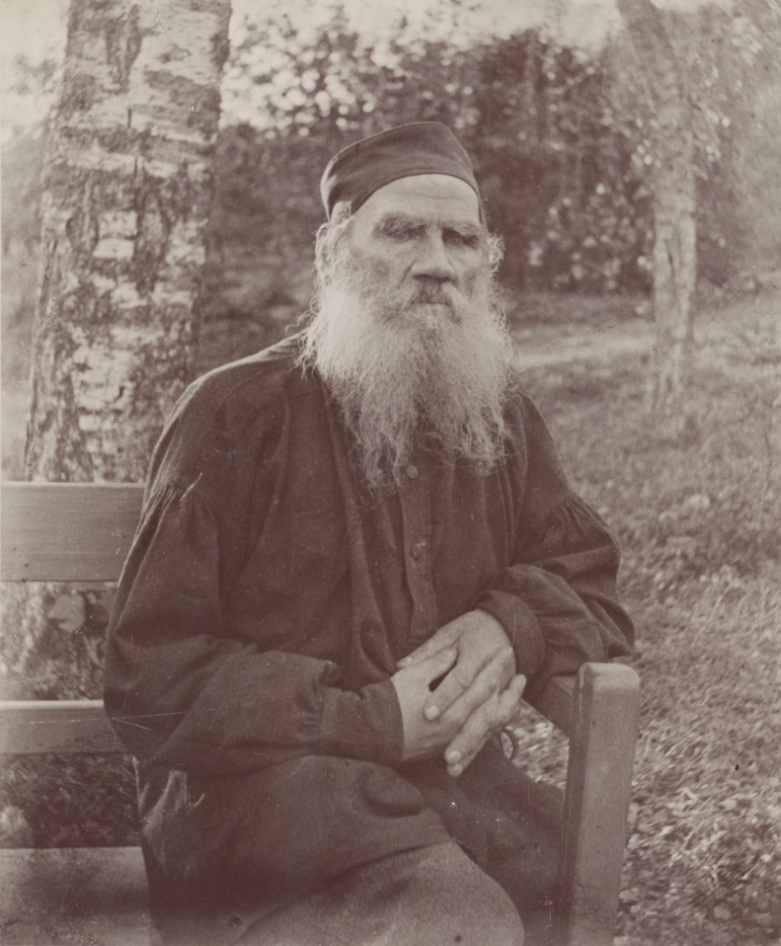

Leo Tolstoy, 1897

### Part I

An officer by the name of Jilin served in the army in the Caucasus.

One day he received a letter from home. It was from his mother, who wrote, “I am getting old now, and I want to see my beloved son before I die. Come and say good-bye to me, and when you have buried me, with God’s grace, you can return to the Army. I have found a nice girl for you to marry; she is clever and pretty, and has some property of her own. If you like her perhaps you will marry and settle down for good.”

Jilin pondered over the letter. It was true; his mother was really failing fast, and it might be his only chance of seeing her alive. He would go home, and if the girl was nice, he might even marry.

He went to his colonel and asked for leave, and bidding good-bye to his fellow-officers, gave his men four bucketfuls of vodka as a farewell treat, and got ready to go.

There was a war in the Caucasus at the time. The roads were not safe by day or by night. If a Russian ventured away from his fort, the Tartars either killed him or took him off to the hills. So it had been arranged that a body of soldiers should march from fortress to fortress to convoy any person who wanted to travel. The soldiers marched in front and behind; the travellers in between them.

It was summer. At daybreak, the baggage-train was loaded behind the fort; the convoy came out and started along the road. Jilin was on horseback; his things were on a cart with the baggage-train.

They had about twenty miles to go. The baggage-train moved along slowly; now the soldiers would stop, now a wheel came off a cart, now a horse would refuse to go on, and then everybody had to wait.

It was already past noon and they had not covered half the distance. It was hot, dusty, the sun scorching and no shade at all—bare steppe, with not a tree or a bush the whole way.

Jilin rode on ahead and stopped to wait until the baggage-train should catch him up. He heard the signal-horn sounded; the company had stopped again. Jilin thought, “Why shouldn’t I go on alone without the soldiers? I have a good horse, and if I come across any Tartars, I can easily gallop away. I wonder if it would be safe?”

As he stood there thinking it over, another officer, by the name of Kostilin, rode up with a rifle and said, “Let us go on alone, Jilin. I’m dreadfully hungry, and the heat’s unbearable. My shirt is wringing wet.”

Kostilin was a big man and stout; his face was burning red, and the perspiration poured from his brow.

Jilin deliberated for a moment and said, “Is your rifle loaded?”

“It is.”

“Very well; come along. Only the condition is to be that we don’t part.”

And they set off down the road alone. They were riding along the steppe talking together and keeping a sharp look-out from side to side. They could see a long way round them. When they left the steppe, they came to a road running down a valley between two hills. And Jilin said, “Let’s go up on that hill and look about; some Tartars might easily spring out from the hills and we shouldn’t see them.”

“What’s the use?” Kostilin said. “We’d better go on.”

Jilin paid no heed to him.

“You wait down here,” he said, “and I’ll just go up and have a look.” And he turned his horse to the left up the hill. Jilin’s horse was a hunter and carried him up the hill as though it had wings. He had bought it for a hundred roubles as a colt, and broken it in himself. When he reached the top of the hill, he saw some thirty Tartars a few paces ahead of him. He turned hastily, but the Tartars had seen him and gave chase down the hill, getting their rifles out as they went. Jilin bounded down as fast as the horse’s legs would carry him, crying out to Kostilin, “Get your rifle ready!” And in thought he said to his horse, “Get me out of this, my beauty; don’t stumble, or I’m lost. Once I reach the rifle, they shan’t take me alive!”

But Kostilin, instead of waiting, when he saw the Tartars, set off full gallop in the direction of the fortress, lashing his horse now on one side, now on the other, and the horse’s switching tail was all that could be seen of him in the clouds of dust.

Jilin saw that it was all up with him. The rifle was gone; with a sword alone, he could do nothing. He turned his horse in the direction of the convoy, hoping to escape, but six Tartars rushed ahead to cut him off. His horse was a good one, but theirs were better, and they were trying to cross his path. He wanted to turn in another direction, but his horse could not pull up and dashed on straight towards the Tartars. A red-bearded Tartar on a grey horse caught Jilin’s eyes. He was yelling and showing his teeth and pointing his rifle at him.

“I know what devils you are!” Jilin thought. “If you take me alive, you’ll put me in a pit and have me flogged. I’ll not be taken alive!”

Though Jilin was a little man, he was brave. He drew his sword and dashed at the red-bearded Tartar, thinking, “I’ll either ride him down or kill him with my sword.”

But he had no time to reach the Tartar; he was fired at from behind and his horse was hit. It fell to the ground full weight, pinning Jilin’s leg. He attempted to rise, but two evil-smelling Tartars were already sitting on him, twisting his arms behind him. He struggled, flung the Tartars off, but three others leapt from their horses and fell on him, beating him on the head with the butt ends of their rifles. A mist rose before his eyes and he staggered. The Tartars seized him, and taking spare girths from their saddles, twisted his hands behind him and tied them with a Tartar knot and dragged him to the saddle. They knocked off his cap, pulled off his boots, searched him all over, took his money and watch, and tore his clothes. Jilin looked round at his horse. The poor creature lay on its side just as it had fallen, struggling with its legs in the air and unable to get them to the ground. There was a hole in its head from which the dark blood was oozing, laying the dust for a yard around.

One of the Tartars approached it and took off the saddle. As it was still struggling, he drew a dagger and cut its windpipe. A whistling sound came from its throat; the horse gave a shudder and died.

The Tartars took off the saddle and strappings. The red-bearded Tartar mounted his horse, the others lifted Jilin into the saddle behind him, and, to prevent his falling off, they strapped him to the Tartar’s girdle, and took him off to the hills.

Jilin sat behind the Tartar, rocking from side to side, his face touching the evil-smelling Tartar’s back. All he could see was the man’s broad back and sinewy neck, the closely-shaven bluish nape peeping out from beneath his cap. Jilin had a wound in his head, from which the blood poured and congealed over his eyes, but he could not shift his position on the saddle, nor wipe off the blood. His arms were twisted so far behind his back that his collar-bones ached. They rode over the hills for some time, then they came to a river which they forded and got out on to a road running down a valley. Jilin wanted to see where they were going, but his eyes were matted with blood and he could not move.

It began to get dark; they forded another river and rode up a rocky hill; there was a smell of smoke and a barking of dogs. They had reached a Tartar village. The Tartars got off their horses; the Tartar children gathered round Jilin, yelling and throwing stones at him. A Tartar drove them away, took Jilin off the horse and called his servant. A man with high cheek-bones came up, clad in nothing but a shirt, and that so torn that his breast was bare. The Tartar gave him some order. The man brought some shackles, two blocks of oak with iron rings attached, and a clasp and lock was fixed to one of the rings.

They untied Jilin’s arms, put on the shackles, took him to a shed, pushed him in and locked the door. Jilin fell on to a dung heap. He groped about in the darkness to find a softer place and lay down.

### Part II

Jilin did not sleep the whole of that night. The nights were short. Through a chink, he saw that it was getting light. He got up, made the chink a little bigger, and peeped out.

He saw a road at the foot of a hill, to the right of which was a Tartar hut with two trees near it. A black dog lay on the threshold and a goat and kids were moving about and swishing their tails. Then he saw a young Tartar woman coming from the direction of the hill. She wore a coloured blouse and trousers with a girdle round her waist, high boots on her feet, and a kerchief on her head, on which she was carrying a tin pitcher of water. Her back moved gracefully as she walked; she was leading a closely-shaven Tartar boy, who wore nothing but a shirt. The Tartar woman went into the hut with the water; the red-bearded Tartar of yesterday came out in a silken tunic, a silver-hilted knife stuck in his girdle and slippers on bare feet. A high, black sheepskin cap was pushed far back on his head. He stretched himself as he came out and stroked his red beard. He gave some order to his servant and went away.

Then two boys rode past. They had been to water their horses and the horses’ noses were still wet. Some more closely-shaven boys came out, dressed only in shirts with no trousers. A whole group of them came up to the shed, and taking up a piece of stick, they thrust it through the chink. Jilin grunted at them and the boys ran off, yelling, their little white knees gleaming as they went.

Jilin was thirsty; his throat was parched. “If only someone would come,” he thought. Soon the door of the shed opened and the red-bearded Tartar entered with another, shorter than he, and dark. He had bright black eyes, a ruddy complexion, and a short beard. He had a jolly face, and was always laughing. This man was dressed better than the first, in a blue silken tunic, trimmed with braid. The knife in his broad girdle was of silver, the shoes on his feet were of red morocco, embroidered in silver thread, and over these he wore a thicker pair of shoes. His cap was high and of white sheepskin.

The red-bearded Tartar entered, muttering some angry words. He leant against the doorpost, playing with his dagger and looking askance at Jilin, like a wolf. The dark man, quick and lively and moving as if on springs, came up to Jilin and squatted down in front of him, showing his teeth. He clapped Jilin on the shoulder and began to jabber something in his own language, blinking his eyes and clacking his tongue. “Good Russ! Good Russ!” he said.

Jilin understood nothing. “I am thirsty; give me some water,” he said.

The dark man laughed. “Good Russ!” he kept on saying.

Jilin made signs with his lips and hands that he wanted some water. The dark man laughed, and putting his head out at the door, he called to someone “Dina!”

A little girl came up. She was about thirteen, slight and thin, her face resembling the dark man’s. She was obviously his daughter. She, too, had bright, black eyes and a rosy complexion. She was clad in a long blue blouse with broad sleeves, and loose at the waist—the hem and front and sleeves were embroidered in red. She wore trousers and slippers and shoes with high heels over them; she had a necklace round her throat made out of Russian coins. Her head was bare. Her black plait was tied with a ribbon, the ends of which were trimmed with silver roubles.

Her father said something to her. She ran away and came back again with a tin jug of water. She gave it to Jilin and also squatted down in front of him, huddled up, so that her shoulders came lower than her knees. She sat staring at Jilin as he drank, as at some strange animal.

Jilin handed her back the jug. She took it and bounded out like a wild goat. Even her father could not help laughing. He sent her off somewhere else. She ran away with the jug and brought back some unleavened bread on a round wooden platter, and huddling down in front of him once more, she again stared at him open-eyed.

The Tartars went out and locked the door.

After a while, the red-bearded man’s servant came up and called to Jilin. He too, did not know Russian, only Jilin understood that he wanted him to go somewhere.

Jilin followed him limping, for the shackles impeded his walking. He followed the servant. They came to a Tartar village, consisting of about ten houses, a Tartar church with a dome on top in the midst of them. In front of one house stood three saddled horses; some boys were holding them by their bridles. The dark little Tartar rushed out of this house and beckoned to Jilin to come to him. He laughed, jabbered something in his own tongue and went in again. Jilin came to the house. The room was large, the mud walls smoothly plastered. Near the front wall lay a pile of brightly coloured feather beds, on the side walls hung rich rugs with rifles and pistols and swords fastened to them, all inlaid in silver. At one wall was a small stove on a level with the earthen floor, which was beautifully clean. In the near corner a felt carpet was spread on which were rich rugs and down cushions. On these rugs, in slippers only, sat some Tartars—the dark one, the red-bearded one, and three guests. All had down cushions at their backs. In front of them, on a wooden platter, were some millet pancakes, some melted butter in a cup, and a jug of Tartar beer. They took the pancakes up with their fingers, and their hands were all greasy with the butter.

The dark Tartar jumped up and bade Jilin sit down, not on the rugs, but on the bare floor. Then he sat down on his rug again, and treated his guests to more pancakes and beer. The servant made Jilin sit down in the place assigned to him, took off his overshoes, which he placed by the door where the other shoes were standing, and sat down on the felt carpet, nearer to his master. He watched the others eating, his mouth watering. When the Tartars had finished, a woman came in dressed like the girl in trousers and a kerchief on her head. She cleared away the remains, and brought a basin and a narrow-necked jug of water. The Tartars washed their hands, laid them together, fell on their knees, and said their prayers in their own tongue. When they had finished, one of the guests turned to Jilin and addressed him in Russian.

“You were captured by Kasi-Mohammed,” he said, indicating the red-bearded Tartar, “but he has given you to Abdul-Murat.” And he indicated the dark Tartar. “Abdul-Murat is now your master.”

Jilin was silent.

Abdul-Murat now began to speak, pointing at Jilin and laughing. “A soldier Russ, a good Russ,” he said.

And the interpreter said, “He wants you to write home asking your people to send a ransom for you. When the money comes, he will let you go.”

Jilin reflected and said, “How much does he want?”

The Tartars deliberated among themselves; the interpreter said, “Three thousand roubles.”

“I can’t pay as much as that,” Jilin said.

Abdul leapt up and began to gesticulate violently. He was saying something to Jilin, thinking that he would understand.

“How much will you give?” the interpreter asked.

After reflection Jilin said, “Five hundred roubles.”

At this the Tartars all began talking together. Abdul shouted at the red-bearded Tartar, jabbering away till he foamed at the mouth. The red-bearded Tartar merely frowned and clacked his tongue.

They grew silent and the interpreter said, “The master thinks a ransom of five hundred roubles is not enough. He himself paid two hundred roubles for you. Kasi-Mohammed was in his debt, and he took you in payment. He wants three thousand roubles and refuses to let you go for less. If you won’t pay the money you’ll be flung into a pit and flogged.”

“The more you show you’re afraid of them, the worse it is,” Jilin thought. He leapt to his feet and said, “Tell the dog that if he begins to threaten me, he shan’t have a farthing! I won’t write home at all! I was never afraid of you, and I’m not going to be now, you dogs!”

The interpreter conveyed his words, and again the Tartars began to speak all at once.

They jabbered for a long time, then the dark one sprang up and came to Jilin.

“Russ,” he said, “djigit, djigit Russ!” (Djigit in their tongue means brave.) He laughed and said a few words to the interpreter, who turned to Jilin.

“Will you give a thousand roubles?”

Jilin stuck to his own.

“I won’t give more than five hundred, not if you kill me.”

The Tartars conferred together, and sent the servant off somewhere, and when he was gone, they stared now at Jilin, now at the door.

The servant returned, followed by a stout, bare-footed man, in torn clothes. On his feet were also shackles. Jilin gave an exclamation of surprise. It was Kostilin. He, too, had been captured then. The Tartars sat them down side by side, and they began to tell each other of their experiences, the Tartars looking on in silence. Jilin told Kostilin what had happened to him, and Kostilin told Jilin that his horse had got tired, his rifle missed fire, and that this same Abdul had caught him up and captured him.

Abdul jumped up and began to speak, pointing at Kostilin. The interpreter explained that they both belonged to the same master, and that the one who would produce the money first would be the first to be set free.

“See how quiet your comrade is,” he said to Jilin. “You get angry and he has written home asking to have five thousand roubles sent him. He will be well fed, and no one will do him any harm.”

And Jilin said, “My comrade can do what he likes. He may be rich, and I am not. I won’t go back on my word. You can kill me if you like, but you get no advantage by that; I won’t write for more than five hundred roubles.”

The Tartars were silent. Suddenly Abdul sprang up, took out a pen, ink and a scrap of paper from a little box, put them in Jilin’s hands and slapping him on the shoulder, said, “Write.” He had agreed to the five hundred roubles.

“One moment,” Jilin said to the interpreter; “tell him that he must feed and clothe us well, and that he must put us together so that we don’t feel so lonely, and he must remove our shackles.”

He looked at Abdul as he spoke and smiled. Abdul too smiled and said, “You shall have the best of clothes—coats and boots fit to be married in, and you shall be fed like princes, and you can be together in the shed if you like, but I can’t take off the shackles because you might escape. You shall have them removed at night.” He rushed up to Jilin and slapped him on the shoulder. “Fine fellow! Fine fellow!” he said.

Jilin wrote the letter, but did not address it correctly, so that it should not reach home. “I will escape, somehow,” he thought.

Jilin and Kostilin were taken back to the shed. They were given some straw, a jug of water and bread, two old coats and some worn boots, evidently taken from the bodies of dead soldiers. At night, their shackles were removed and they were locked in the shed.

### Part III

Thus Jilin and his comrade lived for a month. Their master was always cheerful. “You, good fellow, Ivan! I, Abdul, good fellow, too!” But he fed them badly. All the food they got was some unleavened bread of millet flour, or millet cakes, and sometimes nothing but raw dough.

Kostilin sent another letter home and did nothing but mope and wait for the money to arrive. He would sit in the barn day after day, either counting the days for the letter to come or sleeping. Jilin knew that his letter would not reach home, but he never wrote another.

“Where on earth could mother get so much money from?” he thought. “She lived mostly on what I used to send her, and if she has to procure five hundred roubles, she’ll be quite ruined. With God’s help I’ll get away myself.”

So he kept his eyes open, planning how to run away.

He would walk about the village whistling, or doing something with his hands, such as modelling dolls out of clay, or plaiting baskets out of twigs. Jilin was very clever with his hands.

One day he modelled a doll with a nose, arms and legs and in a Tartar shirt, and he put this doll on the roof of the shed. The Tartar girls went to fetch water. The master’s daughter Dina caught sight of the doll, and called to the others. They put down their pitchers and looked up laughing. Jilin took down the doll and held it out to them. They laughed, but dared not take it. He left the doll and went into the shed to see what would happen.

Dina ran up, looked about her, snatched up the doll and ran off with it.

The following morning, at daybreak, Dina came out on the threshold with the doll. She had bedecked it in bits of red stuff, and was rocking it to and fro like a baby and singing a lullaby. An old woman came out and began to scold her. She snatched the doll away from the child and broke it, and sent Dina off to her work.

Jilin made another doll—a better one this time—and gave it to Dina.

One day Dina brought Jilin a jug, and sitting down, she looked up at him, laughing and pointing to the jug.

“What is she so pleased about?” Jilin thought. He took up the jug to have a drink, thinking it was full of water, but it turned out to be milk. “How nice!” he said, and finished it. Dina was overjoyed.

“Nice, nice, Ivan!” She jumped up and clapped her hands in glee, then she seized the jug and ran away.

After that she brought Jilin milk in secret every day. When the Tartar women used to make cheese cakes out of goat’s milk, which they baked on the roof, she would steal some and bring them to him. Once the master killed a sheep, and Dina brought Jilin a piece of the flesh hidden in her sleeve. She would throw the things down and run away.

One day there was a terrible storm; the rain poured down in torrents for a whole hour. The rivers became turbid. At the ford, the water rose till it was seven feet high and the current was so strong that it moved the stones along. Rivulets flowed everywhere and there was a roar in the hills. After the storm streams flowed down the village everywhere. Jilin asked his master for a knife, and with it he shaped a small cylinder and made a wheel out of a piece of board, to which he fixed two dolls, one on each side. The little girls brought him some bits of stuff with which he dressed the dolls—one as a peasant, the other as a peasant woman. He made them fast and set the wheel so that the stream should work it. When the wheel began to whirl the dolls danced.

The whole village gathered round—boys and girls and women and men came to look on, the latter clacking their tongues.

“Ah, Russ! Ah, Ivan!” they said.

Abdul had a Russian watch that was broken. He called Jilin and showed it to him. Jilin said, “Give it to me, and I’ll mend it.”

He took it to pieces with the knife, sorted the pieces out, put them together again, and the watch went quite well.

The master was pleased and presented him with one of his old tunics, all in holes. Jilin had to take it; besides, it would come in useful to cover up with at night.

From that day, Jilin’s fame as a man skilled in handiworks spread fast. People began to flock to him from distant villages, one bringing the lock of a rifle or a pistol that wanted mending, another, a watch or a clock. The master gave him some tools—pincers, gimlets and a file.

One day a Tartar fell ill, and they came to Jilin, saying, “Come and heal him.” Jilin did not know how to heal the sick, but he went just the same thinking, “The man will recover of his own accord.” He disappeared into the shed and mixed up some sand and water. In the presence of the Tartars he mumbled some words over the mixture, and gave it to the sick man to drink. Fortunately, the Tartar got well.

Jilin began to understand a little of their tongue. Some of the Tartars got quite used to him, and when they wanted him would call “Ivan, Ivan!” Others again looked at him askance as at some wild beast.

The red-bearded Tartar did not like Jilin. He frowned when he saw him, and either turned away or cursed. There was another old man, who did not live in the village, but somewhere at the foot of a hill. He came to the village only sometimes. Jilin saw him when the man went to the Mosque to say his prayers. He was short and had a white towel wound round his cap. His beard and moustaches were clipped and white as down; his face was wrinkled and brick-red. He had a hooked nose like a hawk’s, and cruel grey eyes. He had no teeth, but two tusks in front. He would pass with his turban on his head, leaning on his staff, and peering round like a wolf. When he saw Jilin, he snorted and turned away.

One day Jilin went to the hills to find out where the old man lived. He strolled down a path and saw a little garden and a stone wall; within the stone wall were wild cherry trees and peaches and a hut with a flat roof. He came a little closer and saw some hives made of plaited straw and humming bees flying hither and thither. The old man was on his knees, doing something to the hives. Jilin stood on tiptoe in order to get a better view; his shackles rattled. The old man turned and gave a yell and pulling a pistol out of his belt, he aimed at Jilin, who just managed to shield himself behind the stone wall.

The old man came to the master to complain. The master summoned Jilin and laughing, asked him, “Why did you go to the old man’s place?”

“I didn’t mean to do him any harm,” he said. “I only wanted to see how he lived.”

The master conveyed his words to the old man.

But the old man was angry. He jabbered away, showing his tusks, and shook his fists menacingly at Jilin.

Jilin could not understand all he said, but he gathered that the old man was warning the master not to keep any Russians about the place, but to have them all killed.

The old man went away.

Jilin asked the master who the old man was, and the master said, “He is a great man! He was the bravest of us all, and killed many Russians, and he was rich, too. He had three wives and eight sons, who all lived in the same village. The Russians came, destroyed the village, and killed seven of his sons. One son only remained, and he surrendered to the Russians. The old man followed them, and also gave himself up. He lived with the Russians for three months, when he found his son. With his own hand he killed him and escaped. After that, he gave up fighting. He went to Mecca to pray to God; that is why he wears a turban. Any man who has been to Mecca is called a Hadji and has to wear a turban. He does not like you Russians. He wanted me to kill you, but I can’t kill you because I paid money for you. Besides, I have taken a fancy to you, Ivan; I would not let you go at all, if I had not given my word.” He laughed and added in Russian, “You are a good fellow, Ivan, and I, Abdul, am a good fellow too.”

### Part IV

Jilin lived in this way for a month. During the day he wandered about the village or busied himself with some handicraft, and at night he dug in his shed. The digging was difficult because of the stones, but he worked away at them with his file and at last made a hole beneath the wall big enough to crawl through. “If only I knew the neighbourhood well and which way to turn,” he thought, “The Tartars would not tell me.”

He chose a day when the master was away, left the village after dinner and went up a hill, hoping to find out the lie of the land from there. But before the master departed, he told one of his boys to look after Jilin and not let him out of his sight. The boy ran after Jilin, crying, “Don’t go away! My father told you not to! I’ll call for help!”

Jilin tried to soothe him.

“I’m not going far,” he said. “I only want to go to the top of that hill to find a certain herb with which to cure your people when they are sick. Come with me; I can’t run away with the shackles on my feet. I’ll make you a bow and some arrows tomorrow.”

After some persuasion, the boy went with him. The hill did not seem very far off, but it was difficult to get there shackled as he was. He struggled and struggled until he got to the top. Jilin sat down and began to look about him. To the south, beyond the shed, a herd of horses could be seen in a valley, and at the bottom of the valley was another village. Beyond the village was a steep hill and another hill beyond that. Between the two hills was a dark patch that looked like a wood; hill upon hill rose beyond it, and higher than all rose the snow-capped mountains as white as sugar, the peak of one standing out above the rest. To the east and west were other such hills; here and there were villages in the valleys from which the smoke curled up. “This is all Tartar country,” he thought. He looked in the direction of Russia—below was a river, and the village he lived in, surrounded by gardens. On the river bank, looking as tiny as dolls, sat Tartar women, washing clothes. Beyond the village was a hill, lower than the one to the south and beyond that two wooded hills. Between these two hills was a plain, and away in the distance on this plain smoke seemed to rise. Jilin tried to recollect where the sun rose and set when he lived in the fort. He came to the conclusion that the fortress must lie in that very valley. Between these two hills would he have to make his way when he escaped.

The sun began to set. The snow-clad mountains turned from white to red; the dark mountains grew darker still; a vapour rose from the valley, and the plain where he supposed the fortress to be seemed on fire with the sunset’s glow. Jilin gazed intently; something seemed to quiver in that plain, like smoke rising from a chimney, and Jilin felt sure that the Russian fortress was there.

It was getting late. The Mullah’s cry was heard. The flocks and herds were driven home; the cows were lowing. The boy kept on begging, “Come home,” but Jilin had no desire to move.

They returned home. “Now that I know the place I must lose no time in running away,” Jilin thought. He wanted to escape that very night, for the nights were dark then; the moon had waned, but as luck would have it, the Tartars returned that evening. Sometimes when they brought cattle home, they would come back in a jolly mood, but this time there were no cattle, and on the saddle of his horse they brought back the red-bearded Tartar’s brother, who had been killed. They returned in a gloomy mood and gathered the village together for the burial. Jilin, too, came out to look on. They wrapped the body in a sheet and without a coffin carried it out and laid it on the grass beneath some plane-trees. The Mullah arrived and the old men; they wrapped towels around their caps, took off their shoes, and squatted down on their heels before the body. In front was the Mullah, behind him three old men in turbans, and behind them three other Tartars. They sat silent, eyes downcast, for a long time, then the Mullah raised his head and said, “Allah!” (meaning God). After this word, he again bowed his head, and there was another long silence. They all sat motionless. Again, the Mullah raised his head and said “Allah!” All repeated “Allah!” and again there was silence. The dead man lay on the grass motionless and the others, too, seemed dead. Not a single man moved. The only sound to be heard was the rustling of the leaves on the plane-trees. After a while the Mullah said a prayer; all rose, and raising the dead man with their hands they carried him away. They brought him to a pit. It was not an ordinary pit, but hollowed out under the ground like a vault. They lifted the dead man under the arms, bent him into a sitting posture and let him down into the pit, gently, his hands folded in front of him.

The master’s servant brought some green rushes, which they stuffed into the pit, then they hastily covered it with earth, levelled the ground properly and placed a stone, upright, at the head of the grave. They stamped down the soil and once more sat down round the grave side by side. For a long time they were silent.

“Allah! Allah!” they sighed and rose.

The red-bearded Tartar gave some money to the old men, then he took a whip, struck himself three times on the forehead and went home.

In the morning, Jilin saw the red-bearded Tartar leading a mare out of the village, followed by three other Tartars. When they left the village behind them, the red-bearded Tartar took off his coat, rolled up his sleeves—his arms were strong and muscular—and taking out a dagger, he sharpened it on a whetstone. The other Tartars raised the mare’s head and he cut her throat. The mare dropped down and he began to skin her with his big hands. Women and girls came up and washed the entrails. The mare was cut up and the pieces carried to the red Tartar’s hut, where the whole village gathered for a funeral feast.

For three days they ate the mare’s flesh and drank beer in honour of the dead man. All the Tartars were at home. On the fourth day, about dinner time, Jilin saw that they were preparing to go away somewhere. The horses were brought out, they got ready, and about ten of the Tartars, the red one among them, went away, Abdul remaining at home. There was a new moon and the nights were still dark.

“Tonight we must escape,” Jilin thought, and he unfolded his plan to Kostilin. But Kostilin was afraid.

“How can we run away? We don’t know the way even.”

“I know the way.”

“We couldn’t get there in one night.”

“If we can’t, we can hide in the wood. I’ve got some cakes here for us to eat. What’s the good of sitting here? If they send your ransom, well and good, but supposing they can’t raise the money? The Tartars are getting vicious because our people have killed one of their men. They will probably kill us.”

Kostilin reflected.

“Very well; let us go,” he said.

### Part V

Jilin went down the hole and made it a little bigger so that Kostilin could crawl through, then they sat down to wait till all grew quiet in the village.

When the Tartars had all retired to rest, Jilin crawled under the wall and got outside. “Follow me,” he whispered to Kostilin.

Kostilin crept into the hole, but his foot hit against a stone and made a clatter. The master had a speckled watch-dog—a vicious creature it was, called Ulashin. The dog growled and rushed forward, followed by other dogs. Jilin gave a low whistle and threw it a cake. Ulashin recognized him, wagged his tail and ceased his growling.

The master heard the dog and called from the hut, “Hait, hait, Ulashin!”

But Jilin **stroked the dog by the ears and it did not move**. It rubbed itself against Jilin’s legs and wagged its tail.

They sat crouching round the corner. All grew quiet; only a sheep was heard to cough in a barn, and below, the water rippled over the stones. It was dark; the stars were high in the sky and the new moon looked red as it set behind the hill, horns upwards. A mist as white as milk lay over the valley.

Jilin got up and turning to Kostilin said, “Let us come, brother.”

They set off, but they had no sooner done so than the Mullah intoned from the roof “Allah Besmilla! Ilrachman!” That meant that the people would be going to the Mosque. They sat down again, crouching behind the wall. For a long time they sat there waiting till the people went past. All grew quiet again.

“Now then; with God’s help we must get away,” Jilin said.

They crossed themselves and started. They went through the yard and downhill to the river, which they forded and came out into the valley. The mist hung low and dense; above, the stars were visible. By the stars, Jilin could tell the direction they had to take. It was cool in the mist and walking was easy, only their boots were uncomfortable, being old and worn out. Jilin cast his off and went bare-foot. He leapt over the stones, gazing up at the stars. Kostilin began to lag behind.

“Slower, please,” he said, “these cursed boots hurt my feet.”

“Take them off and you’ll find it easier.”

Kostilin too went barefoot, but that was still worse. The stones cut his feet and he lagged behind more than ever.

Jilin said to him, “The cuts on your feet will heal up soon enough, but if the Tartars catch us it will be much more serious; they will kill us.”

Kostilin did not say anything, but walked along, groaning.

They walked along the valley for a long time, when suddenly they heard the barking of dogs. Jilin stopped and looked about him. He climbed up the hill on all fours.

“We mistook our way, and turned to the right. Another Tartar village lies here; I saw it from the hill the other day. We must turn back and go to the left up the hill. There must be a wood here.”

And Kostilin said, “Let us rest a while; my feet are all bleeding.”

“They’ll get better in good time, brother. Walk more lightly—like this.”

And Jilin turned back and went up the hill to the left into the wood. Kostilin kept on lagging behind and groaning. Jilin remonstrated with him and walked on ahead.

They reached the top of the hill, where they found a wood, as Jilin had surmised. They went into it. The brambles tore the last of their clothes. At last, they found a path and followed it.

“Stop!” Jilin said. There was a trampling of hoofs on the path. They listened. It sounded like the trampling of horses’ hoofs, but the sound ceased. They moved on, and again they heard the trampling. They stopped again, and the sound ceased. Jilin crept nearer and in a patch of light on the path he saw something standing. It seemed like a horse, yet not like a horse, and it had something queer on its back that was not a man. The creature snorted. “What a strange thing!” Jilin thought, and gave a low whistle. The animal bounded off the path into the thicket and there was a sound of cracking branches as though a storm had swept through the wood.

Kostilin fell to the ground in terror; Jilin laughed, saying, “It’s a stag. Can’t you hear how it’s breaking the branches with its antlers? We are afraid of him and he is afraid of us.”

They went on further. The Great Bear was already setting and the dawn was not far off. They did not know whether they were going in the right direction. It seemed to Jilin that the Tartars had brought him along this path when they captured him and that it was still another seven miles to the fortress, but he had nothing certain to go by, and at night one could easily mistake the way.

Kostilin dropped to the ground and said, “Do what you like, but I can’t go any further. My legs won’t carry me.”

Jilin attempted persuasion.

“It’s no good,” Kostilin said; “I can’t go on.”

Jilin grew angry and vented his disgust.

“Then I’m going alone—good-bye.”

Kostilin jumped up and followed.

They walked another three miles. The mist grew denser; they could not see ahead of them and the stars were no longer visible.

They suddenly heard a trampling of horses coming from the direction in which they were going. They could hear the horse’s hoofs hit against the stones. Jilin lay flat down and put his ear to the ground to listen.

“There is certainly a horseman coming towards us,” he said. They ran off the path into the thicket and sat down to wait. After a while, Jilin crept out into the path to look. A mounted Tartar was coming along, driving a cow and humming softly to himself. When he had passed Jilin turned to Kostilin, “Thank God the danger is over. Come, let us go.”

Kostilin attempted to rise, but dropped down again.

“I can’t, I can’t! I’ve no more strength left.”

The man was heavy and stout and had perspired freely. The heavy mist had chilled him, tired and bleeding as he was, and made him quite stiff. Jilin tried to lift him, but Kostilin cried out, “Oh, it hurts!”

Jilin turned to stone.

“Why did you shout? The Tartar is still near; he will have heard you,” he remonstrated, while to himself he thought, “The man is evidently exhausted; what shall I do with him? I can’t desert him.” “Come,” he said, “climb on to my back, then, and I’ll carry you if you really can’t walk.”

He helped Kostilin up, put his arms under his thighs and carried him on to the path.

“For heaven’s sake don’t put your arms round my neck or you’ll throttle me. Hold on to my shoulders.”

It was hard work for Jilin; his feet, too, were bleeding and tired. He bent down now and then to get him in a more comfortable position, or jerked him up so that he sat higher up, and went on his weary way.

The Tartar had evidently heard Kostilin’s cry. Jilin heard someone following behind, calling out in the Tartar tongue. Jilin rushed into the thicket. The Tartar seized his gun and aimed; the shot missed; the Tartar yelled and galloped down the path.

“I’m afraid we’re lost,” Jilin said. “He’ll collect the Tartars to hunt us down. If we don’t cover a couple of miles before they’ve time to set out, nothing will save us.” To himself he thought, “Why the devil did I saddle myself with this block? I should have got there long ago had I been alone.”

Kostilin said, “Why should you be caught because of me?”

“I can’t go alone; it would be mean to desert a comrade.”

Again, he raised Kostilin on to his shoulders and went on. They walked along for another half-mile. They were still in the wood and could not see the end of it. The mist had dispersed; the clouds seemed to gather; the stars were no longer visible. Jilin was worn out. They came to a spring walled in by stones. He stopped and put Kostilin down.

“Let us rest a minute or two and have a drink and a bite of this cake. We can’t be very far off now.”

He had no sooner lain down to take a drink from the spring than he heard the stamping of horses behind him. Again they rushed into the thicket to the right and lay down on a slope.

They heard a sound of Tartar voices. The Tartars stopped at the very spot where they had turned off the path. They seemed to confer for a bit and then set a dog on the scent. There was a crackling among the bushes and a strange dog appeared. It stopped and began to bark. The Tartars followed it. They were also strangers. They bound Jilin and Kostilin and took them off on their horses.

When they had ridden for about two miles, they were met by the master, Abdul, and two other Tartars. He exchanged some words with the strange Tartars, after which Jilin and Kostilin were removed to his horses and he took them back to the village.

Abdul was no longer laughing, and did not say a word to them.

They reached the village at daybreak and were placed in the street. The children gathered round them and threw stones at them and lashed them with whips, yelling all the time.

All the Tartars collected in a circle, the old man from the hills among them. They began to talk; Jilin gathered that they were considering what was to be done with him and Kostilin. Some said that they should be sent into the hills, and the old man persisted that they should be killed. Abdul would not agree to either plan, saying, “I paid money for them and must get their ransom.”

The old man said, “They will not pay the ransom; they’ll only do a great deal of harm. It is a sin to keep Russians. Kill them and have done with it.”

The Tartars dispersed. The master came to Jilin and said to him, “If your ransom does not come in two weeks, I’ll have you flogged, and if you attempt to run away again, I’ll kill you like a dog. Write home, and write to the point!”

They brought them pen and paper and they wrote home. The shackles were put on them and they were taken behind the Mosque, where there was a pit of about twelve feet deep, into which they were flung.

### Part VI

Life was very hard for them now. Their shackles were never removed, and they were never allowed out into the fresh air. Raw dough was thrown down to them, as one throws a scrap to a dog, and water was let down in a jug. The stench in the pit was awful and it was damp as well. Kostilin grew quite ill; he swelled very much and every bone in his body ached. He either groaned or slept all the time. Jilin, too, was depressed; he saw that their position was hopeless and did not know how to get out of it.

He tried to make a tunnel but there was nowhere to throw the earth, and when the master saw it, he threatened to kill him.

One day when he was most downcast, squatting in the pit and thinking of his freedom, a cake fell from above, then another, and some cherries rained down. Jilin looked up and saw Dina. She looked at him, laughed and ran away.

“I wonder if Dina would help us?” Jilin thought.

He cleared a space in the pit, dug a little clay and began to make some dolls. He moulded some men and horses and dogs, thinking, “When Dina comes, I will throw these up to her.”

But Dina did not come the next day. Jilin heard a stamping of horses; some Tartars seemed to have come and all gathered at the Mosque, shouting and arguing. It was something about the Russians. The voice of the old man was heard, too. Jilin could not understand all they said, but he made out that the Russians were near, that the Tartars were afraid of them and did not know what to do with their prisoners.

After a while, they dispersed. Suddenly Jilin heard a rustling overhead and saw Dina crouching at the edge of the pit, her knees higher than her head. She bent over so that the coins at the end of her plaits dangled over the pit. Her eyes were twinkling like two stars. From her sleeve, she took two cakes made of cheese and threw them down to him. Jilin picked them up and said, “What a long time it is since you’ve been to see me! I’ve made you some toys. Look, here they are!” He threw them up to her one by one. She shook her head and averted her gaze. “I don’t want them, Ivan,” she said. “They want to kill you, Ivan,” she added, pointing to her throat.

“Who wants to kill me?”

“My father. The old man told him to, but I’m sorry for you.”

Jilin said, “If you are sorry for me, bring me a long pole.”

She shook her head, as much as to say that it was impossible.

He put up his hands and implored her, “Please, Dina! Be a dear and bring it!”

“I can’t,” she said, “they’ll catch me at home.” Then she went away.

In the evening Jilin sat in the pit wondering what would happen. He kept looking up; the stars were visible, but the moon had not yet risen. The Mullah’s call was heard, and all grew quiet. Jilin began to doze, thinking, “The child is afraid.” Suddenly some clay dropped on to his head. He looked up, and saw a long pole poking into the opposite wall of the pit; it began to slide down. Jilin took hold of it and lowered it with a feeling of gladness at his heart. It was a stout, strong pole; he had noticed it many times on the roof of the master’s hut.

He looked up. The stars were shining high in the sky and above the pit Dina’s eyes gleamed in the darkness like a cat’s. She leant her head over the pit and whispered, “Ivan, Ivan!” making signs to him to speak low.

“What is it?” Jilin asked.

“They’ve all gone but two.”

“Come, Kostilin,” Jilin said, “let us try our luck for the last time; I’ll help you up.”

But Kostilin would not listen to him.

“No,” he said, “It seems that I can’t get away from here. How can I come when I’ve hardly strength enough to move?”

“Well, good-bye, then. Don’t think ill of me.”

He kissed Kostilin, and seizing the pole, he asked Dina to hold it at the top and swarmed up. Twice he fell back again; the shackles hindered him. But Jilin persevered and got to the top somehow. Dina clutched hold of his shirt and pulled at him with all her might, unable to control her laughter.

When he clambered out, Jilin handed her the pole, saying, “Put it back in its place, Dina, for if they notice its absence they’ll beat you.”

Dina dragged the pole away, and Jilin went down the hill. When he got to the bottom he sat down under its shelter, took a sharp stone and tried to wrench the lock off the shackles. But the lock was a strong one and would not give way, and it was difficult to get at it. Suddenly he heard someone coming downhill, skipping lightly. “It must be Dina again,” he thought.

She came up, took the stone and said, “Let me try.”

She knelt down and tried to wrench the lock off, but her little hands were as slender as little twigs and there was no strength in them. She threw the stone down and burst into tears. Jilin made another attempt, while Dina squatted down beside him and put her hand on his shoulder.

Jilin looked round; to the left the sky was all red; the moon was beginning to rise. “I must cross the valley and be under shelter of the wood before the moon rises,” he thought. He got up and threw away the stone. “I must go as I am in the shackles. Good-bye, Dina, dear; I shall always remember you.”

Dina seized hold of him and groped about his coat with her hand to find a place to thrust some cakes into. Jilin took the cakes.

“Thank you, little one,” he said. “There won’t be anyone to make you dolls when I am gone.” He stroked her head.

Dina burst into tears and, covering her face with her hands, she fled up the hill, bounding along like a wild goat. The coins in her plait could be heard jingling in the darkness.

Jilin crossed himself, took the lock of his shackles in his hand to prevent a clatter and started on his way, dragging his shackled leg and gazing at the red in the sky where the moon was rising. This time he knew the way. He had to go straight on for six miles. If only he could reach the wood before the moon had quite risen! He forded the river. The red light over the hill had paled. He walked along the valley, looking back now and then; the moon was not yet visible. The light grew brighter and brighter; one side of the valley was quite light. The shadows crept along the foot of the hill, drawing nearer to him.

Jilin kept in the shadow. He hurried, but the moon moved faster than he; the hilltops on the right were already lit up. As he neared the wood, the moon rose over the hills, all white, and it grew as light as day. All the leaves on the trees could be seen distinctly. It was still and light on the hills; there was a dead silence, except for the murmur of the river below.

He reached the wood without meeting anyone. He chose a dark spot and sat down to rest.

When he had rested a while and eaten a cake, he found a stone and once more tried to wrench the lock of the shackles. He cut his hands, but could not manage it. He rose and went on his way. After a mile, he was quite worn out and his feet ached terribly. At every dozen steps or so he stopped. “It can’t be helped,” he thought. “I must drag myself on so long as my strength holds out, for if I once sit down I shan’t be able to get up again. I can’t reach the fortress tonight, that is obvious; as soon as it gets light I’ll hide in the wood and go on again when it gets dark.”

He walked the whole night, meeting only two Tartars, but Jilin heard them from a distance and took refuge behind a tree.

The moon began to pale; the dew fell; it was near dawn, but Jilin had not yet reached the end of the wood. “I’ll walk another thirty steps or so then I’ll creep into the thicket and sit down,” he thought. He covered the thirty steps and saw that he had come to the edge of the wood. When he came out it was quite light. Before him stretched the steppe and to the left, near the foot of a hill, he saw a dying fire from which the smoke rose and men were sitting about it.

He looked intently; there was a flash of guns—they were soldiers, Cossacks!

Jilin was overjoyed. He summoned his remaining strength and began to descend the hill, thinking, “God forbid that any mounted Tartar should see me now in the open field; though near my own people, I could not escape.”

The thought had no sooner crossed his mind than he saw three Tartars standing on a hill, not more than a few yards away. They had seen him and dashed down towards him. His heart gave a great bound. He waved his arms and shouted with all his might, “Help, help, brothers!”

The soldiers heard him; a few Cossacks sprang upon their horses and dashed forward to cut across the Tartars’ path.

The Cossacks were far off and the Tartars were near, but Jilin made one last effort; lifting the shackles with his hand, he ran towards the Cossacks. He hardly knew what he was doing and crossed himself wildly, crying, “Help, brothers, help!”

The Cossacks numbered about fifteen.

The Tartars grew afraid and stopped in hesitation before they reached him. Jilin managed to get to the Cossacks. They surrounded him, asking who he was and where he came from, but Jilin was quite beside himself and could only repeat, through his tears, “Brothers, brothers!”

The soldiers came up and crowded round him, one giving him bread, another porridge, another some vodka to drink, another gave him his cloak to cover him, and another wrenched off the shackles.

The officers recognized him and took him to the fortress. His men were delighted to see him; his fellow-officers gathered about him.

Jilin told them all that had happened to him and ended by saying, “That’s how I went home and got married. I wasn’t meant to marry, evidently.”

And Jilin remained in the army in the Caucasus. It was not until a month later that Kostilin was released, after paying a ransom of five thousand roubles. He was brought back in a half-dead condition.

### Food for Thought

* Just spend some time thinking about different characters in this story; their peculiarities, virtues, and weaknesses.

### References

Tolstoi For The Young, Select Tales From Tolstoi, Translated from the Russian By Mrs. R. S. Townsend, 1916.

Rama, On Governance, from The Ramayana

Complexity: High

This is the 100th chapter (or Sarga), of the Ayodhya Kaand, which is the second canto of Sage Valmiki’s, Arsh Ramayan, one of India’s most ancient and respected Epics.

Here, Bharat comes to the forest in Chitrakoot, to take his brother Rama back to Ayodhya. Previously, Rama had been exiled from Ayodhya due to the contrivances of Bharat’s mother and Rama’s step-mother Kaikeyi.

Rama, under the pretext of inquiring about the welfare of his kingdom, gives Bharat a concise discourse on key aspects of politics and good governance. Though ancient, we believe that many principles discussed here are still very relevant, and should benefit those who will hold positions of power and responsibility.

(Note: This chapter has multiple references to the 4 social classes in ancient India, namely, Brahamans, Kshatriyas, Vaisyas, and Shudras. They respectively mean, the scholars, the warriors or rulers, the agriculturists or traders, and the laborers. It should be noted that this social class was **determined based on a person’s propensity or natural inclinations, and his work or actions**. Refer to Bhagavad Gita verse 4.13, or for a more detailed explanation, the dialog between Yudhishthir and Nahush in Chapter 179 of the Vana Parva section of the Mahabharata.

Rama saw (Bharat), dressed in bark and wearing matted locks, lying on the ground with folded palms. It was extremely difficult to look at him, just like it is difficult to look at the Sun at the time of universal dissolution. [v-1]

Bharat had become lean and his face had gone pale. Rama recognized him with great difficulty, and then took his brother by the hand. [v-2]

Smelling Bharat’s forehead and embracing Raghav (the descendant of Raghu), Rama took him on his lap and asked him with a composed mind. [v-3]

Where is your father, O dear, that you have come to the forest? It certainly is not appropriate for you to come to the forest while he is living. [v-4]

I am seeing you after such a long time. It’s a pity to see you coming to this forest from so far-off, with such a lean body. O dear, why have you come to this forest? [v-5]

My child, that you have come here, I hope the king is alive. And also that the king, being distressed with grief, has not suddenly departed to the other world. [v-6]

O, gentle one, since you are still a child, I hope that the kingdom has not fallen to permanent ruin (due to your inexperience). My dear, I hope you take proper care of our father, whose strength is his truthfulness. [v-7]

I trust, the king Dasharath is in good health. He, who is always true to his promise, that performer of the Rajasuya and Asvamedha sacrifices, that staunch follower of righteousness. [v-8]

Dear child, I hope that the exceedingly effulgent and learned Brahman, who is ever steady in morality, that family preceptor of the Ikshvakus (Vasishtha), is duly honored, as usual. [v-9]

My dear, I trust Kausalya and Sumitra, the mothers of good children, are happy. And also hope that the noble queen Kaikeyi is pleased and satisfied.[178] [v-10]

I hope your priest (i.e. Suyajna, Vasistha’s son) is duly honoured; he, who is endowed with modesty, son of a noble family, and well versed in the scriptures, he who bears no ill will, and whose gaze is always fixed upon (our welfare). [v-11]

I hope intelligent and sincere priests well versed in the rules of rituals, take care of the sacrificial fire. And they also regularly inform you regarding what was and what is to be offered as an oblation to that fire. [v-12]

O child, I hope you pay regard to the deities, your ancestral manes (i.e. the souls of your departed ancestors), dependents, the preceptors, relations like your father, the physicians, the Brahmans, and the servants. [v-13]

I trust you (also) regard the preceptor Sudhanwa well equipped with (knowledge of) excellent arrows and other weapons, whether inspired with mantras (i.e. hymns) or not, and a master of the ArthaShastra (i.e. the science of statecraft, economics and military strategy). [v-14]

My child, I hope you have employed valiant persons like your own self, as your ministers. Persons, who are heroic, learned, self-controlled, of noble birth, and skilled at guessing hidden motives, by mere observation of external gestures. [v-15]

O Raghav, (O descendant of Raghu) the root of victory for kings is well guarded counsel. And that too when it is held with clever ministers well versed in sciences, and capable of keeping that counsel secret. [v-16]

I trust you have not come under the influence of sleep, and you wake up at the proper time. I also hope you skillfully think over the means of acquiring prosperity, during the last part of the night. [v-17]

I hope you do not take counsel either with yourself alone or (on the other hand) with a large number of counsellors. And also hope that the decision arrived after the counsel does not leak throughout the kingdom. [v-18]

O Raghav, once you have determined upon a venture that involves little effort but would yield great results, I hope you set about doing it quickly and do not delay it. [v-19]

I hope other kings come to know of your undertakings only after those are complete, or about to be completed. And not the ones you have decided to do in future or not yet started. [v-20]

Dear brother, even if your counsels have not been divulged by you or your ministers, I trust others do not come at know about them, either by strategy or inference. (Likewise, I hope you get to know about the secret counsels of others). [v-21]

I hope, instead of thousand fools, you set your heart on having a single wise person with you. Because a wise person is of great help in difficult situations. [v-22]

Even if a king employs thousands or even ten thousands of fools, he cannot depend upon them for assistance. [v-23]

And even a single minister, who is wise, brave, and clear-sighted, can bring great prosperity to a king or prince. [v-24]

I hope you only assign superior employees to important tasks, mediocre ones to mediocre tasks, and inferior ones to inferior tasks. [v-25]

I trust you employ incorruptible ministers, upon matters of most importance; those who are clean, illustrious, and have been serving since the times of our father and grand-father. [v-26]

O Son of Kaikeyi, I hope, the citizens of your kingdom are not agitated by severe punishment. And your ministers do not just watch as mere witnesses and permit this to happen. [v-27]

Just as priests, performing sacrifices, scorn at a fallen person, or women look upon lustful men with contempt, I hope your subjects do not scorn you for collecting taxes more than what is due of them. [v-28]

A learned person skilled in contrivances, who is brave and desires prosperity, and is engaged in corrupting the minds of servants against their master, should be killed. If the king does not kill such a person, that person kills him. [v-29]

I hope you have chosen a general who is confident, is endowed with wisdom and courage, born in a good family, loyal, and diligent. [v-30]

I trust you respect and honor your foremost warriors, who are powerful, courageous, skilled in warfare, and have given evidence of their heroics already. [v-31]

I hope you give appropriate daily provisions and salary to your soldiers. And you do this at the proper time, without delay. [v-32]

If there is a delay in granting provisions or pay, the employees get enraged with their master and get corrupted. And that occurrence leads to great calamity. [v-33]

I hope the principal descendants of your race are attached to you. And also hope that they are ready to lay down their lives for your cause with steady minds. [v-34]

Bharat, I hope your ambassador is a wise and skillful person staying in your own country, well informed, endowed with presence of mind, and exactly repeats what is told. [v-35]

I hope you acquire intelligence of the eighteen office bearers of the enemy and fifteen of your own side. And you do this through t**hree spies, none of them acquainted with any of the others**. [v-36]

(Note: On 18 office bearers of the enemy:

They are:

1. Minister
2. Priest
3. Crown-prince
4. General
5. Warder
6. Chamberlain, or Gate keeper of the inner-apartments
7. Superintendent of the Jails
8. Treasurer
9. Herald, or Conveyer of royal orders
10. Government Advocate
11. Judge
12. Assessor
13. Distributer of pay and provisions to the army
14. Distributer of workmen’s wages by drawing money from the state exchequer
15. Justice of the peace
16. Protector of frontiers of the kingdom
17. Magistrate
18. Guards of rivers, hills, forests, and fortresses

And the fifteen office bearers of self are the above 18, except the first three, namely, Ministers, Priest, and Crown Prince.)

O destroyer of foes, If enemies, who have been previously expelled, come back you, I hope you do not consider them to be weak and neglect them. [v-37]

And, my child, I hope you do not serve those Brahmans who (are atheists and) think of this material world only. These ignorant people are experts in perverting the mind, and proud of their learning. Such people only bring disaster to others. [v-38]

Even when principal scriptures on righteous behavior are existent, these persons of perverted intellect resort to their own intelligence and logical reasoning and argue meaninglessly. [v-39]

My child, (our Ayodhya) has previously been inhabited by our heroic ancestors. It is worthy to its name, (i.e. Ayodhya, the impregnable), has strong gates, filled with elephants, horses, and chariots. [v-40]

It is filled with Brahmans, Kshatriyas and Vaishyas, always engaged in their respective duties, and thousands of noble, self-controlled, and energetic people. [v-41]

I hope you protect that prosperous and renowned city of Ayodhya, surrounded with palatial mansions of various shapes, and furnished with everything. [v-42]

I hope it is furnished with hundreds of nature reserves, adorned with prosperous people, graced with abodes of deities, water distribution places, and tanks. [v-43]

It has men and women in happy mood, is graceful due to social festivities, has its lands well ploughed, and provided with cattle completely free from cruelty. [v-44]

It does not depend on rain for its water supply, is charming, devoid of fierce animals, free from all kinds of fear, and decked with mines. [v-45]

Free from sinful people, and well governed by my ancestors, O Raghav, I hope our country is prosperous and its people are living happily. [v-46]

I hope people living on agriculture and cattle rearing find favor in your sight. **The world’s prosperity, my dear, depends upon such trade.** [v-47]

I hope you take care of them by providing what they wish for and getting them rid of what they don’t wish for. All the dwellers in his dominions should be protected by the king through righteousness. [v-48]

I hope you keep the women pacified and protect them well. I trust you do not believe their words (blindly), and also do not divulge your secrets to them. [v-49]

I trust you protect the forests where elephants breed, and you also have a large number of cows for milk. And hope that you are not satisfied with the number of mares or elephants that you own. [v-50]

I trust you always present yourself to people well adorned; that you rise early and are seen on the main roads in the morning. [v-51]

I trust your servants do not present themselves before you very boldly. Or neither do they all stay away, at a distance (or hasten away after seeing you). **A middle course is the best means** to be followed in this matter. [v-52]

I hope all the forts are well furnished with wealth, food grains, arms, water, machinery, craftsmen, and archers. [v-53]

I hope your income is great and expenditure minimal. And, O Raghav, I hope your treasury does not go to undeserving people. [v-54]

I trust you spend your wealth in the interests of the deities, the pitaras (i.e. the manes, or souls of departed ancestors), the Brahmans, unexpected visitors, warriors, and friends. [v-55]

If some noble, honest, pure-hearted person is accused of some crime, I trust you do not kill him impatiently, without first having him tried by persons well-versed in the (legal) sciences. [v-56]

O best of men, if a thief is seen or caught stealing, found to be guilty based on interrogation or found possessing the stolen property, I hope (your men) do not set him free from the greed of wealth. [v-57]

O Raghav, whenever there is a matter of contention between a rich and poor person, I hope your well-educated ministers look into that case dispassionately (without being partial to any one party). [v-58]

The tears dropping down from eyes of those who have been falsely charged, (who have failed to obtain justice,) O Raghav, destroy the sons and animals of the ruler who does this for his own pleasure. [v-59]

I hope you honor aged people, children, and principal physicians, with these three presents, namely, gifts, (affectionate) mind, and (polite) speech. [v-60]

I hope you pay homage to preceptors, aged persons, ascetics, deities, unexpected guests, the Chaityas[179], and all the accomplished Brahmans? [v-61]

I hope you do not endanger virtue (or Dharma) for the sake of prosperity (i.e. Artha), or Prosperity for the sake of Virtue. Or endanger both (virtue and prosperity) by the greed for pleasures and desire for sense-gratification (i.e. Kama). [v-62]

O foremost of conquerors, O knower of timely action, O bestower of boons, I trust you adequately divide your time in attending to Prosperity, Virtue and Desire (i.e. Artha, Dharma, and Kama, the three chief objects of human pursuit). [v-63]

O foremost of intelligent men, I hope the Brahmans who are experts at comprehending the meaning of scriptures, and also the inhabitants of the city and provinces, all wish for your happiness. [v-64]

Atheism, falsehood, anger, carelessness, procrastination, evading the wise, laziness, being in control of the five senses, [v-65]

thinking alone about the affairs of the kingdom, taking counsel with those that are proficient in evil, failure to commence on a task that has already been decided upon, divulgence of secrets, [v-66]

omission of auspicious rituals, and marching against all the foes at once, at the same time, I hope, you stay away from all these ten and four (fourteen) faults of kings. [v-67]

O Raghav, I hope you understand the true nature of: ten (classes of evil), five (classes of fortresses), four classes (of contrivances), seven classes (i.e. seven pillars of the state), eight classes (of manifestation of anger, or eight improvements), the three classes (of objects of human pursuit), the three branches of learning, [v-68]

(Note: The above verse and next two (i.e. v-69 and v-70) contain many dictums or maxims such as Six Strategic measures, 20 classes of kings, etc. Their meanings are provided as notes.

Meaning of v-68:

1. Ten Classes of Evil are: Hunting, Gambling, Sleeping in the Day, Slander, Addiction to Women, Wine, Dancing, Singing, Playing and Roaming without purpose.
2. Five Classes of Fortresses are: those in Water, on Mountains, on Trees, in Barren Land, and in Sand. The last two are very difficult to conquer in the summer heat.
3. Four Classes of Contrivances are: the means adopted for governing and maintaining the kingdom, namely, Saama (i.e. conciliation), Daana (or gifts), Bheda (or disunion) and Danda (i.e. punishment).
4. The Seven Classes are: seven pillars of a kingdom including the Sovereign, Ministers, People, Fortress, Treasury, Military, and Friends.
5. Eight Classes:
   1. According to some, they are these kinds of manifestation of anger: Backbiting, Adventurousness, Revolt, Envy, being Cynical, Damaging Property, Harsh Language, and Harsh Punishment.
   2. According to others, they are these items beneficial to the kingdom: improvement in Agriculture, increase in Trade, building Fortresses, building Bridges, catching Wild Elephants, gaining control over Mines, Taxes from Vanquished Kings, and getting Uninhabited Lands Inhabited.
6. Three Classes:
   1. According to some, are these three objects of human pursuit: Dharma (i.e. Virtue or Righteousness), Artha (i.e. Wealth or prosperity), and Kama (i.e. Desire or Pleasure).
   2. According to some others, these are, the three powers: Power of Enthusiasm, Power of Destiny, and Power of Spells.
7. Three Branches of Learning are: the 3 Vedas (or the Trayi), Agriculture and Commerce (or Vaarta), and the Science of Law Enforcement (or Danda).

)

Conquering the (five) senses, six strategic measures, the evils arising from destiny and human agencies, (permissible or allowed) acts (of the king), the twenty classes (of kings), and the Prakriti Mandals (i.e. the complete sphere of a kingdom), [v-69]

(Note:

1. Six Strategic Measures to be used against enemy are: Sandhi (i.e. Friendship), Vigraha (i.e. war), Yaan (i.e. Vehicle or marching), Aasan (i.e. posture or waiting for opportunity), Dwaidhibhaav (i.e. stance of uncertainty), and Samaashray (i.e. seeking protection from someone more powerful).
2. Five Human evils faced by kingdom are: Evils due to Officers, Thieves, Enemies, Close ones of king, and the King himself.
3. Five Evils faced by the kingdom arising from Destiny are: Fire, Flood, Illness, Famine and Epidemic.
4. The Allowed Acts of the King are: Getting these people from the enemy camp, to our own side by way of gifts. Namely, Servants of Enemy kings who have not got salary, insulted servants, people who are angry over their king’s behavior, and people who have been intimidated.
5. The Twenty Classes are: those twenty classes of kings with whom peace should not be contracted. Namely a king who is: a Child, Aged one, one with a Long Standing Illness, Expelled from one’s Caste, Timid, one who Stays with Timid Persons, one who gives Asylum to Greedy People, one whose Ministers, Generals etc. are Dissatisfied, one given to Excessive Merrymaking, one who takes Counsel from Fickle Minded People, one Abusing Deities and Brahmans, one with a Very Bad Destiny, one who, Relying on Destiny Alone Remains Idle, one who is in Great Poverty, one having Troubles with the Army (or without support of the army), one Not Staying in his Own Country, one with Many Enemies, one with Unfavorable Star-signs (or Graha Dasha), and one Devoid of the Virtue of Truth.
6. Prakriti Mandals (or the complete sphere of a kingdom):
   1. According to some, Prakriti Mandal consists of these seven entities. Namely, King, Ministers, Well-wishers, Treasury, Territory, Fortresses, and Army.
   2. In opinion of some others, Prakriti and Mandals are different. The following five, namely, Ministers, Territory, Fortress, Treasury and Punishment are Prakritis, and a group of 12 kings constitute a Mandal.)

Attacking the enemy (or Yatra), Arranging the army in Battle formation (or DandaVidhan), and war and peace, each having two sources. I hope you have properly understood all of these, O foremost of the wise. [v-70]

(Note: Regarding War and Peace with two sources: Marching (i.e. Yaan) and Waiting (i.e. Aasan), together constitute war with two sources, while taking an Uncertain Stance (i.e. Dwaidhibhaav) and taking Help from a Powerful King (i.e. Samaashray) together constitute peace with two sources.)

I hope you deliberate over counsel with your ministers, together with three or four of them, and also separately with each one of them in secret, as laid down in the sacred texts. [v-71]

I hope your study of the Vedas is fruitful, you receive the fruit of your actions, your wives are fruitful (i.e. blessed with children), and your knowledge of the scriptures has also borne fruit. [v-72]

O Raghav, I hope your intellect is going the way that has been indicated above. This course is conducive to long life, fame, virtue, pleasure, and wealth. [v-73]

My dear, I hope you too follow the path followed by our father and forefathers. Which is auspicious and also in accordance with the path of the virtuous. [v-74]

And, Raghav, I hope you do not eat tastily prepared food yourself, but also share it with your friends who might be expecting it.[180] [v-75]

The highly wise and learned king ruling righteously, using punishment (to administer justice), duly obtains and rules the entire earth. He then, after departure from this world, ascends to the celestial regions. [v-76]

### Food for Thought

* Some points described above are specific to the time and place of this Epic, namely India, a few thousand years back. Which ones, do you feel, are not relevant to your culture or today’s times, even in principle, and can be safely ignored?
* From the above discussion, it seems that a leader needs to rate very high on many parameters such as education in multiple branches of knowledge, wisdom, cleanliness of character, good habits, courage, strength of mind, and many others.
  + Which leaders that you know of, possess most of these virtues?
  + Should the above criteria be relaxed for leaders elected by people? How could the remaining gaps be filled in collectively, when democracies are involved?

### References

* Ramayana, Ayodhya Kanda, Sarga 100, Sanskrit Text, By Valmiki
* Ramayana, Translated into English Prose, By Manmatha Nath Dutt, Book 1, Volume 2, 1891.

Micromegas, A Philosophical Sci-Fi, by Voltaire

Complexity: High

Here is a different kind of science fiction story by Voltaire, a leading figure of the Age of Enlightenment in France, around early to mid-18th century. The scientific revolution had already happened, and movements during this period set the stage for the French revolution toward the end of 18th century.

The central theme of that age was the stress on scientific thought and reason, above everything else. Origins (or revivals) of many modern ideas that are commonplace today such as freedom of thought and expression, tolerance, separation of religion and state, and many others, can be traced back to this age.

Micromegas is a short Science Fiction story, among the oldest of this genre. It is a fantasy about the visit of a huge alien being from a far off planet Sirius and his friend from Saturn, to our Earth. It gives fancy descriptions of life on other planets and about how different living beings vary across different aspects of existence such as size, kind of senses perceived (smell, sight, touch etc.), and life spans.

Varying viewpoints on topics such as soul and intelligence even in a minute creature like man, are covered through insightful discussions between the aliens and philosophers of earth.

### Voyage Of An Inhabitant Of The Sirius Star To The Planet Saturn

On one of the planets that orbits the star named Sirius, there lived a spirited young man, who I had the honor of meeting on the last voyage he made to our little ant hill. He was called Micromegas[181], a fitting name for anyone so great. He was eight leagues tall, or 24,000 geometric paces of five feet each.

Certain geometers[182], always of use to the public, will immediately take up their pens, and will find that since Mr. Micromegas, inhabitant of the country of Sirius, is 24,000 paces tall, which is equivalent to 20,000 feet, and since we, citizens of the Earth are hardly five feet tall, and our sphere[183] 9,000 leagues around; they will find, I say, that it is absolutely necessary that the sphere that produced him was 21,600,000 times greater in circumference than our little Earth. Nothing in nature is simpler or more orderly. The sovereign states of Germany or Italy, which one can traverse in a half hour, compared to the empires of Turkey, Moscow, or China, are **only feeble reflections of the prodigious differences that nature has placed in all beings**.

His Excellency's size being as great as I have said, all our sculptors and all our painters will agree without protest that his belt would have been 50,000 feet around, which gives him very good proportions. His nose taking up one third of his attractive face, and his attractive face taking up one seventh of his attractive body, it must be admitted that the nose of the Sirian is 6,333 feet plus a fraction; which is manifest[184].

As for his mind, it is one of the most cultivated that we have. He knows many things. He invented some of them. He was not even 250 years old when he studied, as is customary, at the most celebrated colleges of his planet, where he managed to figure out by pure willpower more than 50 of Euclid's propositions. That makes 18 more than Blaise Pascal, who, after having figured out 32 while screwing[185] around, according to his sister's reports, later became a fairly mediocre geometer[186] and a very bad metaphysician. Towards his 450th year, near the end of his infancy, he dissected many small insects no more than 100 feet in diameter, which would evade ordinary microscopes. He wrote a very curious book about this, and it gave him some income. The mufti of his country, an extremely ignorant worrywart, found some suspicious, rash, disagreeable, and heretical propositions in the book, smelled **heresy**, and pursued it vigorously; it was a matter of finding out whether the substantial form of the fleas of Sirius were of the same nature as those of the snails. Micromegas gave a spirited defense; he brought in some women to testify in his favor; the trial lasted 220 years. Finally, the mufti had the book condemned by jurisconsults who had not read it, and the author was ordered not to appear in court for 800 years.[187]

He was thereby dealt the minor affliction of being banished from a court that consisted of nothing but harassment and pettiness. He wrote an amusing song at the expense of the mufti, which the latter hardly noticed; **and he took to voyaging from planet to planet in order to develop his heart and mind**, as the saying goes. Those that travel only by stage coach or sedan will probably be surprised to learn of the carriage of this vessel; for we, on our little pile of mud, can only conceive of that to which we are accustomed. Our voyager was very familiar with the laws of gravity and with all the other attractive and repulsive forces. He utilized them so well that, whether with the help of a ray of sunlight or some comet, he jumped from globe to globe like a bird vaulting itself from branch to branch. He quickly spanned the Milky Way, and I am obliged to report that he never saw, throughout the stars it is made up of, the beautiful empyrean sky that the vicar Derham[188] boasts of having seen at the other end of his telescope. I do not claim that Mr. Derham has poor eyesight, God forbid! But Micromegas was on site, which makes him a reliable witness, and I do not want to contradict anyone. Micromegas, after having toured around, arrived at the planet Saturn. As accustomed as he was to seeing new things, he could not, upon seeing the smallness of the planet and its inhabitants, stop himself from **smiling with the superiority that occasionally escapes the wisest of us**. For in the end Saturn is hardly nine times bigger than Earth, and the citizens of this country are dwarfs, no more than a thousand fathoms[189] tall, or somewhere around there. He and his men poked fun at them at first, like Italian musicians laughing at the music of Lully when he comes to France. But, as the Sirian had a good heart, he understood very quickly that a thinking being is not necessarily ridiculous just because he is only 6,000 feet tall. He got to know the Saturnians after their shock wore off. He built a strong friendship with the secretary of the academy of Saturn, a spirited man who had not invented anything, to tell the truth, but who understood the inventions of others very well, and who wrote some passable verses and carried out some complicated calculations. I will report here, for the reader's satisfaction, a singular conversation that Micromegas had with the secretary one day.

### Conversation Between The Inhabitant Of Sirius And That Of Saturn

After his Excellency laid himself down to rest, the secretary approached him.

"You have to admit," said Micromegas, "that nature is extremely varied."

"Yes," said the Saturnian, "nature is like a flower bed wherein the flowers—"

"Ugh!" said the other, "leave off with flower beds."

The secretary began again. "Nature is like an assembly of blonde and brown-haired girls whose jewels—"

"What am I supposed to do with your brown-haired girls?" said the other.

"Then she is like a gallery of paintings whose features—"

"Certainly not!" said the voyager. "I say again that nature is like nature. Why bother looking for comparisons?"

"To please you," replied the Secretary.

"**I do not want to be pleased," answered the voyager. "I want to be taught**. Tell me how many senses the men of your planet have."

"We only have 72," said the academic, "and we always complain about it. Our imagination surpasses our needs. We find that with our 72 senses, our ring, our five moons[190], we are too restricted; and in spite of all our curiosity and the fairly large number of passions that result from our 72 senses, we have plenty of time to get bored."

"I believe it," said Micromegas, "for on our planet we have almost 1,000 senses; and yet we still have a kind of vague feeling, a sort of worry, that warns us that there are even more perfect beings. I have traveled a bit; and I have seen mortals that surpass us, some far superior. But I have not seen any that desire only what they truly need, and who need only what they indulge in. Maybe someday I will happen upon a country that lacks nothing; but so far no one has given me any word of a place like that."

The Saturnian and the Sirian proceeded to wear themselves out in speculating; but after a lot of very ingenious and very dubious reasoning, it was necessary to return to the facts.

"How long do you live?" said the Sirian.

"Oh! For a very short time," replied the small man from Saturn.

"Same with us," said the Sirian. "We always complain about it. It must be a universal law of nature."

"Alas! We only live through 500 revolutions around the sun," said the Saturnian. (This translates to about 15,000 years, by our standards.) "You can see yourself that this is to die almost at the moment one is born; our existence is a point, our lifespan an instant, our planet an atom. Hardly do we begin to learn a little when death arrives, before we get any experience. As for me, I do not dare make any plans. I see myself as a drop of water in an immense ocean. I am ashamed, most of all before you, of how ridiculously I figure in this world."

Micromegas replied, "If you were not a philosopher, I would fear burdening you by telling you that our lifespan is 700 times longer than yours; but you know very well when it is necessary to return your body to the elements, and reanimate nature in another form, which we call death. When this moment of metamorphosis comes, to have lived an eternity or to have lived a day amounts to precisely the same thing. I have been to countries where they live a thousand times longer than we do, and they also die. But people everywhere have the good sense to know their role and to thank the Author of nature. He has scattered across this universe a profusion of varieties with a kind of admirable uniformity. For example, all the thinking beings are different, and all resemble one another in the gift of thought and desire. Matter is extended everywhere, but has different properties on each planet. How many diverse properties do you count in yours?"

"If you mean those properties," said the Saturnian, "without which we believe that the planet could not subsist as it is, we count 300 of them, like extension, impenetrability, mobility, gravity, divisibility, and the rest."

"Apparently," replied the voyager, "this small number suffices for what the Creator had in store for your dwelling. I admire his wisdom in everything; I see differences everywhere, but also proportion. Your planet is small, your inhabitants are as well. You have few sensations; your matter has few properties; all this is the work of Providence. What color is your sun upon examination?"

"A very yellowish white," said the Saturnian. "And when we divide one of its rays, we find that it contains seven colors."

"Our sun strains at red," said the Sirian, "and we have 39 primary colors. There is no one sun, among those that I have gotten close to that resembles it, just as there is no one face among you that is identical to the others."

After numerous questions of this nature, he learned how many essentially different substances are found on Saturn. He learned that there were only about thirty, like God, space, matter, the beings with extension that sense, the beings with extension that sense and think, the thinking beings that have no extension; those that are penetrable, those that are not, and the rest. The Sirian, whose home contained 300 and who had discovered 3,000 of them in his voyages, prodigiously surprised the philosopher of Saturn. Finally, after having told each other a little of what they knew and a lot of what they did not know, after having reasoned over the course of a revolution around the sun, they resolved to go on a small philosophical voyage together.

### Voyage Of The Two Inhabitants Of Sirius And Saturn

Our two philosophers were just ready to take off into Saturn's atmosphere with a very nice provision of mathematical instrument, when the ruler of Saturn, who had heard news of the departure, came in tears to remonstrate. She was a pretty, petite brunette who was only 660 fathoms tall, but who compensated for this small size with many other charms.

"Cruelty!" she cried, "After resisting you for 1,500 years, just when I was beginning to come around, when I'd spent hardly a hundred years in your arms, you leave me to go on a voyage with a giant from another world; go, you're only curious, you've never been in love: if you were a true Saturnian, you would be faithful. Where are you running off to? What do you want? Our five moons are less errant than you, our ring less inconsistent. It's over, I will never love anyone ever again."

The philosopher embraced her, cried with her, philosopher that he was; and the woman, after swooning, went off to console herself with the help of one of the dandies of the country.

Our two explorers left all the same; they alighted first on the ring, which they found to be fairly flat, as conjectured by an illustrious inhabitant of our little sphere[191]; from there they went easily from moon to moon. A comet passed by the last; they flew onto it with their servants and their instruments. When they had traveled about one hundred fifty million leagues, they met with the satellites of Jupiter. They stopped at Jupiter and stayed for a week, during which time they learned some very wonderful secrets that would have been forthcoming in print if not for the inquisition[192], which found some of the propositions to be **a little harsh**. But I have read the manuscript in the library of the illustrious archbishop of...., who with a generosity and goodness that is impossible to praise allowed me to see his books. I promised him a long article in the first edition of Moréri, and I will not forget his children, who give such a great hope of perpetuating the race of their illustrious father.

But let us now return to our travelers. Upon leaving Jupiter, they traversed a space of around one hundred million leagues and approached the planet Mars, which, as we know, is five times smaller than our own; they swung by two moons that cater to this planet but have escaped the notice of our astronomers. I know very well that Father Castel will write, perhaps even agreeably enough, against the existence of these two moons; but I rely on those who reason by analogy. These good philosophers know how unlikely it would be for Mars, so far from the sun, to have gotten by with less than two moons. Whatever the case may be, our explorers found it so small that they feared not being able to land on it, and they passed it by like two travelers disdainful of a bad village cabaret, pressing on towards a neighboring city. But the Sirian and his companion soon regretted it. They traveled a long time without finding anything. Finally they perceived a small candle, it was Earth; this was a pitiful sight to those who had just left Jupiter. Nevertheless, from fear of further regret, they resolved to touch down. Carried by the tail of a comet, and finding an aurora borealis at the ready, they started towards it, and arrived at Earth on the northern coast of the Baltic Sea, July 5, 1737, new style[193].

### What Happened On Planet Earth

After resting for some time, they ate two mountains for lunch, which their crew fixed up pretty nicely. Then they decided to get to know the small country they were in. They went first from north to south. The usual stride of the Sirian and his crew was around 30,000 feet. The dwarf from Saturn, who clocked in at no more than a thousand fathoms, trailed behind, breathing heavily. He had to make twelve steps each time the other took a stride; imagine (if it is alright to make such a comparison) a very small lapdog following a captain of the guards of the Prussian king.

Since our strangers moved fairly rapidly, they circumnavigated the globe in 36 hours. The Sun, in truth, or rather the Earth, makes a similar voyage in a day; but you have to imagine that the going is much easier when one turns on one's axis instead of walking on one's feet. So there they were, back where they started, after having seen the nearly imperceptible pond we call the Mediterranean, and the other little pool that, under the name Ocean, encircles the molehill. The dwarf never got in over his knees, and the other hardly wet his heels. On their way, they did all they could to see whether the planet was inhabited or not. They crouched, laid down, felt around everywhere; but their eyes and their hands were not proportionate to the little beings that crawl here, they could not feel in the least any sensation that might lead them to suspect that we and our associates, the other inhabitants of this planet, have the honor of existing.

The dwarf, who was a bit hasty sometimes, decided straightaway that the planet was uninhabited. His first reason was that he had not seen anyone. Micromegas politely indicated that this logic was rather flawed: "For," said he, "you do not see with your little eyes certain stars of the 50th magnitude that I can perceive very distinctly. Do you conclude that these stars do not exist?"

"But," said the dwarf, "I felt around a lot."

"But," answered the other, "you have pretty weak senses."

"But," replied the dwarf, "this planet is poorly constructed. It is so irregular and has such a ridiculous shape! Everything here seems to be in chaos: you see these little rivulets, none of which run in a straight line, these pools of water that are neither round, nor square, nor oval, nor regular by any measure; all these little pointy specks scattered across the earth that grate on my feet? (This was in reference to mountains.) Look at its shape again, how it is flat at the poles, how it clumsily revolves around the sun in a way that necessarily eliminates the climates of the poles? To tell the truth, what really makes me think it is uninhabited is that it seems that no one of good sense would want to stay."

"Well," said Micromegas, "maybe the inhabitants of this planet are not of good sense! But in the end it looks like this may be for a reason. Everything appears irregular to you here, you say, because everything on Saturn and Jupiter is drawn in straight lines. This might be the reason that you are a bit puzzled here. Have I not told you that I have continually noticed variety in my travels?"

The Saturnian responded to all these points. The dispute might never have finished if it were not for Micromegas who, getting worked up, had the good luck to break the thread of his diamond necklace. The diamonds fell; they were pretty little carats of fairly irregular size, of which the largest weighed four hundred pounds and the smallest fifty. The dwarf recaptured some of them; bending down for a better look, he perceived that these diamonds were cut with the help of an excellent microscope. So he took out a small microscope of 160 feet in diameter and put it up to his eye; and Micromegas took up one of 2,005 feet in diameter. They were excellent; but neither one of them could see anything right away and had to adjust them. Finally, the Saturnian saw something elusive that moved in the shallow waters of the Baltic Sea; it was a whale. He carefully picked it up with his little finger and, resting it on the nail of his thumb, showed it to the Sirian, who began laughing for a second time at the ludicrously small scale of the things on our planet. The Saturnian, persuaded that our world was inhabited, figured very quickly that it was inhabited only by whales; and as he was very good at reasoning, he was determined to infer the origin and evolution of such a small atom; whether it had ideas, a will, **liberty**. Micromegas was confused. He examined the animal very patiently and found no reason to believe that a soul was lodged in it. The two voyagers were therefore inclined to believe that there is no spirit in our home, when with the help of the microscope they perceived something as large as a whale floating on the Baltic Sea. We know that a flock of philosophers[194] was at this time returning from the Arctic Circle, where they had made some observations, which no one had dared make up to then. The gazettes claimed that their vessel ran aground on the coast of Bothnia, and that they were having a lot of difficulty setting things straight; but the world never shows its cards. I am going to tell how it really happened, **artlessly and without bias; which is no small thing for an historian**.

### Experiments And Reasonings Of The Two Voyagers

Micromegas slowly reached his hand towards the place where the object had appeared, extended two fingers, and withdrew them for fear of being mistaken, then opened and closed them, and skillfully seized the vessel that carried these fellows, putting it on his fingernail without pressing it too hard for fear of crushing it.

"Here is a very different animal from the first," said the dwarf from Saturn.

The Sirian put the so-called animal in the palm of his hand. The passengers and the crew, who believed themselves to have been lifted up by a hurricane, and who thought they were on some sort of boulder, scurried around; the sailors took the barrels of wine, threw them overboard onto Micromegas hand, and followed after. The geometers took their quadrants, their sextants, two Lappland girls, and descended onto the Sirian's fingers. They made so much fuss that he finally felt something move, tickling his fingers. It was a steel-tipped baton being pressed into his index finger. He judged, by this tickling, that it had been ejected from some small animal that he was holding; but he did not suspect anything else at first. The microscope, which could barely distinguish a whale from a boat, could not capture anything as elusive as a man. I do not claim to outrage anyone's vanity, but I am obliged to ask that important men make an observation here. Taking the size of a man to be about five feet, the figure we strike on Earth is like that struck by an animal of about sixty thousandths the height of a flea on a ball five feet around. Imagine something that can hold the Earth in its hands, and which has organs in proportion to ours—and it may very well be that there are such things—conceive, I beg of you, what these things would think of the battles that allow a vanquisher to take a village only to lose it later.[195]

I do not doubt that if ever some captain of some troop of imposing grenadiers reads this work he will increase the size of the hats of his troops by at least two imposing feet. But I warn him that it will have been done in vain; that he and his will never grow any larger than infinitely small.[196]

What marvelous skill it must have taken for our philosopher from Sirius to perceive the atoms I have just spoken of. When Leuwenhoek and Hartsoëker tinkered with the first or thought they saw the grains that make us up, they did not by any means make such an astonishing discovery.[197] What pleasure Micromegas felt at seeing these little machines move, at examining all their scurrying, at following them in their enterprises! How he cried out! With what joy he placed one of his microscopes in the hands of his traveling companion!

"I see them," they said at the same time, "look how they are carrying loads, stooping, getting up again." They spoke like that, hands trembling from the pleasure of seeing such new objects, and from fear of losing them. The Saturnian, passing from an excess of incredulity to an excess of credulity, thought he saw them mating.

"Ah!" he said. "I have caught nature in the act." But he was fooled by appearances, which happens only too often, whether one is using a microscope or not.

### What Happened To Them Among Men

Micromegas, a much better observer than his dwarf, clearly saw that the atoms were speaking to each other, and pointed this out to his companion, who, ashamed of being mistaken about them reproducing, did not want to believe that such a species could communicate. He had the gift of language as well as the Sirian. He could not hear the atoms talk, and he supposed that they did not speak. Moreover, how could these impossibly small beings have vocal organs, and what would they have to say? To speak, one must think, more or less; but if they think, they must therefore have the equivalent of a soul. But to attribute the equivalent of a soul to this species seemed absurd to him.

"But," said the Sirian, "you believed right away that they made love. Do you believe that one can make love without thinking and without uttering one word, or at least without making oneself heard? Do you suppose as well that it is more difficult to produce an argument than an infant? Both appear to be great mysteries to me."

"I do not dare believe or deny it," said the dwarf. "I have no more opinions. We must try to examine these insects and reason after."

"That is very well said," echoed Micromegas, and he briskly took out a pair of scissors with which he cut his fingernails, and from the parings of his thumbnail he improvised a kind of speaking-trumpet, like a vast funnel, and put the end up to his ear. The circumference of the funnel enveloped the vessel and the entire crew. The weakest voice entered into the circular fibers of the nails in such a way that, thanks to his industriousness, the philosopher above could hear the drone of our insects below perfectly. In a small number of hours he was able to distinguish words, and finally to understand French. The dwarf managed to do the same, though with more difficulty. The voyagers' surprise redoubled each second. They heard the mites speak fairly intelligently. This performance of nature's seemed inexplicable to them. You may well believe that the Sirian and the dwarf burned with impatience to converse with the atoms. The dwarf feared that his thunderous voice, and assuredly Micromegas, would deafen the mites without being understood. They had to diminish its force. They placed toothpicks in their mouths, whose tapered ends fell around the ship. The Sirian put the dwarf on his knees and the ship with its crew on a fingernail. He lowered his head and spoke softly. Finally, relying on these precautions and many others, he began his speech like so:

"Invisible insects, that the hand of the Creator has caused to spring up in the abyss of the infinitely small, I thank him for allowing me to uncover these seemingly impenetrable secrets. Perhaps those at my court would not deign to give you audience, but I mistrust no one, and I offer you my protection."

If anyone has ever been surprised, it was the people who heard these words. They could not figure out where they were coming from. The chaplain of the vessel recited the exorcism prayers, the sailors swore, and the philosophers of the vessel constructed systems; but no matter what systems they came up with, they could not figure out who was talking. The dwarf from Saturn, who had a softer voice than Micromegas, told them in a few words what species they were dealing with. He told them about the voyage from Saturn, brought them up to speed on what Mr. Micromegas was, and after lamenting how small they were, asked them if they had always been in this miserable state so near nothingness, what they were doing on a globe that appeared to belong to whales, whether they were happy, if they reproduced, if they had a soul, and a hundred other questions of this nature.

A reasoner among the troop, more daring than the others, and shocked that someone might doubt his soul, observed the interlocutor with sight-vanes pointed at a quarter circle from two different stations,[198] and at the third spoke thusly: "You believe then, Sir, that because you are a thousand fathoms tall from head to toe, that you are a—"

"A thousand fathoms!" cried the dwarf. "Good heavens! How could he know my height? A thousand fathoms! You cannot mistake him for a flea. This atom just measured me! He is a surveyor, he knows my size; and I, who can only see him through a microscope, I still do not know his!"

"Yes, I measured you," said the physician, "and I will measure your large companion as well." The proposition was accepted; his Excellency laid down flat, for were he to stay upright, his head would have been among the clouds. Our philosophers planted a great shaft on him, in a place that doctor Swift would have named, but that I will restrain myself from calling by its name, out of respect for the ladies. Next, by a series of triangles linked together, they concluded that what they saw was in effect a young man of 120,000 feet.

So Micromegas delivered these words: "I see more than ever that one must not judge anything by its apparent size. Oh God! You who have given intelligence to substance that appears contemptible. The infinitely small costs you as little as the infinitely large; and if it is possible that there are such small beings as these, there may just as well be a spirit bigger than those of the superb animals that I have seen in the heavens, whose feet alone would cover this planet."

One of the philosophers responded that he could certainly imagine that there are intelligent beings much smaller than man. He recounted, not every fabulous thing Virgil says about bees, but what Swammerdam discovered, and what Réaumur has anatomized. He explained finally that there are animals that are to bees what bees are to man, what the Sirian himself was for the vast animals he had spoken of, and what these large animals are to other substances before which they looked like atoms. Little by little, the conversation became interesting, and Micromegas spoke thusly:

### Conversation With The Men

"Oh intelligent atoms, in which the Eternal Being desired to make manifest his skill and his power, you must, no doubt, taste pure joys on your planet; **for having so little matter, and appearing to be entirely spirit, you must live out your life thinking and loving, the veritable life of the mind**. Nowhere have I seen true bliss, but it is here, without a doubt."

At this all the philosophers shook their heads, and one of them, more frank than the others, avowed that if one excepts a small number of inhabitants held in poor regard, all the rest are an assembly of mad, vicious, and wretched people.[199] "We have more substance than is necessary," he said, "to do evil, if evil comes from substance; and too much spirit, if evil comes from spirit. Did you know, for example, that as I am speaking with you[200], there are 100,000 madmen of our species wearing hats, killing 100,000 other animals wearing turbans, or being massacred by them, and that we have used almost the entire surface of the Earth for this purpose since time immemorial?"

The Sirian shuddered, and asked the reason for these horrible quarrels between such puny animals.

"It is a matter," said the philosopher, "of some piles of mud as big as your heel.[201] It is not that any of these millions of men that slit each other's throats care about this pile of mud. It is only a matter of determining if it should belong to a certain man who we call 'Sultan,' or to another who we call, for whatever reason, 'Czar.' Neither one has ever seen nor will ever see the little piece of Earth, and almost none of these animals that mutually kill themselves have ever seen the animal for which they kill."

"Oh! Cruel fate!" cried the Sirian with indignation, "Who could conceive of this excess of maniacal rage! It makes me want to take three steps and crush this whole anthill of ridiculous assassins."

"Do not waste your time," someone responded, "they are working towards ruin quickly enough. Know that after ten years, only one hundredth of these scoundrels will be here. Know that even if they have not drawn swords, hunger, fatigue, or intemperance will overtake them. Furthermore, it is not they that should be punished, it is those sedentary barbarians who from the depths of their offices order, while they are digesting their last meal, the massacre of a million men, and who subsequently give solemn thanks to God."

The voyager was moved with pity for the small human race, where he was discovering such surprising contrasts.

"Since you are amongst the small number of wise men," he told these sirs, "and since apparently you do not kill anyone for money, tell me, I beg of you, what occupies your time."

"We dissect flies," said the philosopher, "we measure lines, we gather figures; we agree with each other on two or three points that we do not understand."

It suddenly took the Sirian and the Saturnian's fancy to question these thinking atoms, to learn what it was they agreed on.

"What do you measure," said the Saturnian, "from the Dog Star to the great star of the Gemini?"

They responded all at once, "thirty-two and a half degrees."

"What do you measure from here to the moon?"

"60 radii of the Earth even."

"How much does your air weigh?"

He thought he had caught them, but they all told him that air weighed around 900 times less than an identical volume of the purest water, and 19,000 times less than a gold ducat. The little dwarf from Saturn, surprised at their responses, was tempted to accuse of witchcraft the same people he had refused a soul fifteen minutes earlier.

Finally, Micromegas said to them, "Since you know what is exterior to you so well, you must know what is interior even better. Tell me what your soul is, and how you form ideas." The philosophers spoke all at once as before, but they were of different views. The oldest cited Aristotle; another pronounced the name of Descartes; this one here, Malebranche; another Leibnitz; another Locke. An old peripatetic spoke up with confidence: "The soul is an entelechy, and a reason gives it the power to be what it is." This is what Aristotle expressly declares, page 633 of the Louvre edition. He cited the passage[202].

"I do not understand Greek very well," said the giant.

"Neither do I," said the philosophical mite.

"Why then," the Sirian retorted, "are you citing some man named Aristotle in the Greek?"

"Because," replied the savant, "one should always cite what one does not understand at all in the language one understands the least."

The Cartesian took the floor and said: "The soul is a pure spirit that has received in the belly of its mother all metaphysical ideas, and which, leaving that place, is obliged to go to school, and to learn all over again what it already knew, and will not know again."

"It is not worth the trouble," responded the animal with the height of eight leagues, "for your soul to be so knowledgeable in its mother's stomach, only to be so ignorant when you have hair on your chin. But what do you understand by the mind?"

"You are asking me?" said the reasoner. "I have no idea. We say that it is not matter—"

"But do you at least know what matter is?"

"Certainly," replied the man. "For example this stone is grey, has such and such a form, has three dimensions, is heavy and divisible."

"Well!" said the Sirian, "this thing that appears to you to be divisible, heavy, and grey, will you tell me what it is? You see some attributes, but behind those, are you familiar with that?

"No," said the other.

"—So you do not know what matter is."

So Micromegas, addressing another sage that he held on a thumb, asked what his soul was, and what it did.

"Nothing at all," said the Malebranchist philosopher. "God does everything for me. I see everything in him, I do everything in him; it is he who does everything that I get mixed up in."

"It would be just as well not to exist," retorted the sage of Sirius. "And you, my friend," he said to a Leibnitzian who was there, "what is your soul?"

"It is," answered the Leibnitzian, "the hand of a clock that tells the time while my body rings out. Or, if you like, it is my soul that rings out while my body tells the time, or my soul is the mirror of the universe, and my body is the border of the mirror. All that is clear."[203]

A small partisan of Locke was nearby, and when he was finally given the floor: "I do not know," said he, "how I think, but I know that I have only ever thought through my senses. That there are immaterial and intelligent substances I do not doubt, but that it is impossible for God to communicate thought to matter I doubt very much. I revere the eternal power. It is not my place to limit it. I affirm nothing, and content myself with believing that many more things are possible than one would think."[204]

The animal from Sirius smiled. **He did not find this the least bit sage, while the dwarf from Saturn would have kissed the sectarian of Locke** were it not for the extreme disproportion. But there was, unfortunately, a little animalcule in a square hat who interrupted all the other animalcule philosophers. He said that he knew the secret: that everything would be found in the Summa of Saint Thomas. He looked the two celestial inhabitants up and down. He argued that their people, their worlds, their suns, their stars, had all been made uniquely for mankind. At this speech, our two voyagers nearly fell over with that inextinguishable laughter which, according to Homer[205], is shared with the gods. Their shoulders and their stomachs heaved up and down, and in these convulsions, the vessel that the Sirian had on his nail fell into one of the Saturnian's trouser pockets. These two good men searched for it a long time, found it finally, and tidied it up neatly. The Sirian resumed his discussion with the little mites. He spoke to them with great kindness, although in the depths of his heart he was a little angry that the infinitely small had an almost infinitely great pride. He promised to make them a beautiful philosophical book, written very small for their usage, and said that in this book they would see the **point of everything**. Indeed, he gave them this book before leaving. It was taken to the academy of science in Paris, but when the ancient secretary opened it, he saw nothing but blank pages. "Ah!" he said, "I suspected as much."[206]

End Of The History Of Micromegas

### Food for Thought

* Earth, a miniscule planet among billions of others, supports life. What are the odds of living beings existing on other planets? Is it possible that our five senses such as sight, etc., are not enough to perceive them? Micromegas mentioned that Sirians had a thousand senses!
* If you feel relieved that the above descriptions of the soul and God are all that exist, hang on. Do a quick survey of more such explanations from cultures outside Europe; Japanese, Chinese, Hindu, Islamic. And if that were not enough, the variations of those base texts leading to specific sub-sects, in turn, and so on, each transforming into an independent faith.
* Similarly, with respect to fundamental matter of creation, views have consistently changed over time. Starting with molecules, then atoms, then neutron-proton-electrons-photons, further down to quarks-leptons and various bosons. Still no clear answer. And add to that the ancient theories of five elements of ether-wind-fire-water-earth created in that order, each from the former ones; and everything eventually being a combination of these five in varying amounts. If you get a chance, try to read Nikola Tesla’s short article, ‘***Man’s Greatest Achievement***’, on this subject.

### References

The Works Of Voltaire, Prefaces, Cautions, Notes, Etc. By M. Beuchot, Volume 33, 1829.

Development Of Modern Social, Economic, And Political Ideas

Complexity: High

A lot of social, economic, and political ideas that we observe today have roots in their development in Europe, between the sixteenth and eighteenth centuries.

These ideas have been concisely covered by H. G. Wells, in his ‘Short History Of The World’, written in 1922. An extract from that book is provided below. You will notice that, even a century later, we seem to be grappling with problems of a similar nature.

By the end of the seventeenth century, we find a considerable and growing literature of political and social science was being produced. Among the pioneers in this discussion was John Locke, the son of an English republican, an Oxford scholar who first directed his attention to chemistry and medicine. His treatises on government, toleration, and education show **a mind fully awake to the possibilities of social reconstruction**. Parallel with and a little later than John Locke in England, Montesquieu (1689-1755) in France subjected social, political and religious institutions to a searching and fundamental analysis. He stripped the magical prestige from the absolutist monarchy in France. He shares with Locke the credit for clearing away many of the false ideas that had hitherto prevented deliberate and conscious attempts to reconstruct human society.

The generation that followed him in the middle and later decades of the eighteenth century was boldly speculative upon the moral and intellectual clearings he had made. A group of brilliant writers, the “Encyclopaedists,” set themselves to scheme out a new world (1766). Side by side with them, were the Economists or Physiocrats, who were making bold and crude enquiries into the production and distribution of food and goods. Morelly, the author of the Code de La Nature, denounced the institution of private property and proposed a communistic[207] organization of society. He was the precursor of that large and various school of collectivist thinkers in the nineteenth century who are lumped together as Socialists.

What is Socialism? There are a hundred definitions of Socialism and a thousand sects of Socialists. Essentially Socialism is no more and no less than a criticism of the idea of private property in the light of the public good.[208] We may review the history of that idea through the ages very briefly. That and the idea of internationalism are the two cardinal ideas upon which most of our political life is turning.

The idea of property arises out of the combative instincts of the species. Long before men were men, the ancestral ape was a proprietor. Primitive property is what a beast will fight for. The dog and his bone, the tigress and her lair, the roaring stag and his herd, these are proprietorship blazing. The Old Man of the family tribe of early stone age insisted upon his proprietorship in his wives and daughters, in his tools, in his visible universe. If any other man wandered into his visible universe, he fought him, and if he could, he slew him. The tribe grew in the course of ages, by the gradual toleration by the Old Man of the existence of the younger men, and of their proprietorship in the wives they captured from outside the tribe, and in the tools and ornaments they made and the game they slew. Human society grew by a compromise between this one’s property and that. It was a compromise with instinct, which was forced upon men by the necessity of driving some other tribe out of its visible universe. If the hills and forests and streams were not your land or my land, it was because they had to be our land. Each of us would have preferred to have it my land, but that would not work. In that case, the other fellows would have destroyed us. Society, therefore, is from its beginning a mitigation of ownership. Ownership in the beast and in the primitive savage was far more intense a thing than it is in the civilized world today. It is rooted more strongly in our instincts than in our reason.[209]

In the natural savage and in the untutored man today there is no limitation to the sphere of ownership. Whatever you can fight for, you can own; women-folk, spared captive, captured beast, forest glade, stone-pit or what not. As the community grew, a sort of law came to restrain internecine fighting, men developed rough-and-ready methods of settling proprietorship. Men could own what they were the first to make or capture or claim. It seemed natural that a debtor who could not pay should become the property of his creditor. Equally natural was it that, after claiming a patch of land, a man should exact payments from anyone who wanted to use it. It was only slowly, as the possibilities of organized life dawned on men, that this unlimited property in anything whatever began to be recognized as a nuisance.[210] Men found themselves born into a universe all owned and claimed, nay! They found themselves born owned and claimed.[211]

The social struggles of the earlier civilization are difficult to trace now, but the history of the Roman Republic shows a community waking up to the idea that debts may become a public inconvenience and should then be repudiated, and that the unlimited ownership of land is also an inconvenience.[212] We find that later Babylonia severely limited the rights of property in slaves.[213] Finally, we find in the teaching of that great revolutionist, Jesus of Nazareth, such an attack upon property as had never been before. **Easier it was, he said, for a camel to go through the eye of a needle, than for the owner of great possessions to enter the kingdom of heaven**.[214]

A steady, continuous criticism of the permissible scope[215] of property seems to have been going on in the world for the last twenty-five or thirty centuries. Nineteen hundred years after Jesus of Nazareth, we find all the world that has come under the Christian teaching persuaded that there could be no property in human beings. And also, the idea that a man may “do what he likes with his own” was very much shaken in relation to other sorts of property.[216]

But this world of the closing eighteenth century was still only in the interrogative stage in this matter. It had got nothing clear enough, much less settled enough, to act upon. One of its primary impulses was to protect property against the greed and waste of kings and the exploitation of noble adventurers. It was largely to protect private property from taxation that the French Revolution began. But the equalitarian formulae of the Revolution carried it into a criticism of the very property it had risen to protect. How can men be free and equal when numbers of them have no ground to stand upon and nothing to eat, and the owners will neither feed nor lodge them unless they toil? Excessively—the poor complained.

To which riddle the reply of one important political group was to set about “dividing up.” They wanted to intensify and universalize property. Aiming at the same end by another route, there were the primitive socialists—or, to be more exact, communists—who wanted to “abolish” private property altogether. The state (a democratic state was of course understood) was to own all property.

**It is paradoxical that different men seeking the same ends of liberty and happiness should propose on the one hand to make property as absolute as possible, and on the other to put an end to it altogether**. But so it was. And the clue to this paradox is to be found in the fact that ownership is not one thing but a multitude of different things.[217]

It was only as the nineteenth century developed, that men began to realize that property was not one simple thing, but a great complex of ownerships of different values and consequences, that many things (such as one’s body, the implements of an artist, clothing, toothbrushes) are very profoundly and incurably one’s personal property, and that there is a very great range of things, railways, machinery of various sorts, homes, cultivated gardens, pleasure boats, for example, which need each to be considered very particularly to determine how far and under what limitations it may come under private ownership, and how far it falls into the public domain and may be administered and let out by the state in the collective interest.

On the practical side these questions pass into politics, and the problem of making and sustaining efficient state administration. They open up issues in social psychology, and interact with the enquiries of educational science.[218] The criticism of property is still a vast and passionate ferment rather than a science. On the one hand are the Individualists, who would protect and enlarge our present freedoms with what we possess, and on the other the Socialists, who would in many directions pool our ownerships and restrain our proprietory acts. In practice, one will find every gradation between the extreme individualist, who will scarcely tolerate a tax of any sort to support a government, and the communist who would deny any possessions at all. The ordinary socialist of today is what is called a collectivist; he would allow a considerable amount of private property but put such affairs as education, transport, mines, land-owning, most mass productions of staple articles, and the like, into the hands of a highly organized state. Nowadays there does seem to be a gradual convergence of reasonable men towards a moderate socialism scientifically studied and planned.

It is realized more and more clearly that the untutored man does not co-operate easily and successfully in large undertakings, and that every step towards a more complex state, and every function that the state takes over from private enterprise, necessitates a corresponding educational advance and the organization of a proper criticism and control. Both the press and the political methods of the contemporary state are far too crude for any large extension of collective activities.[219]

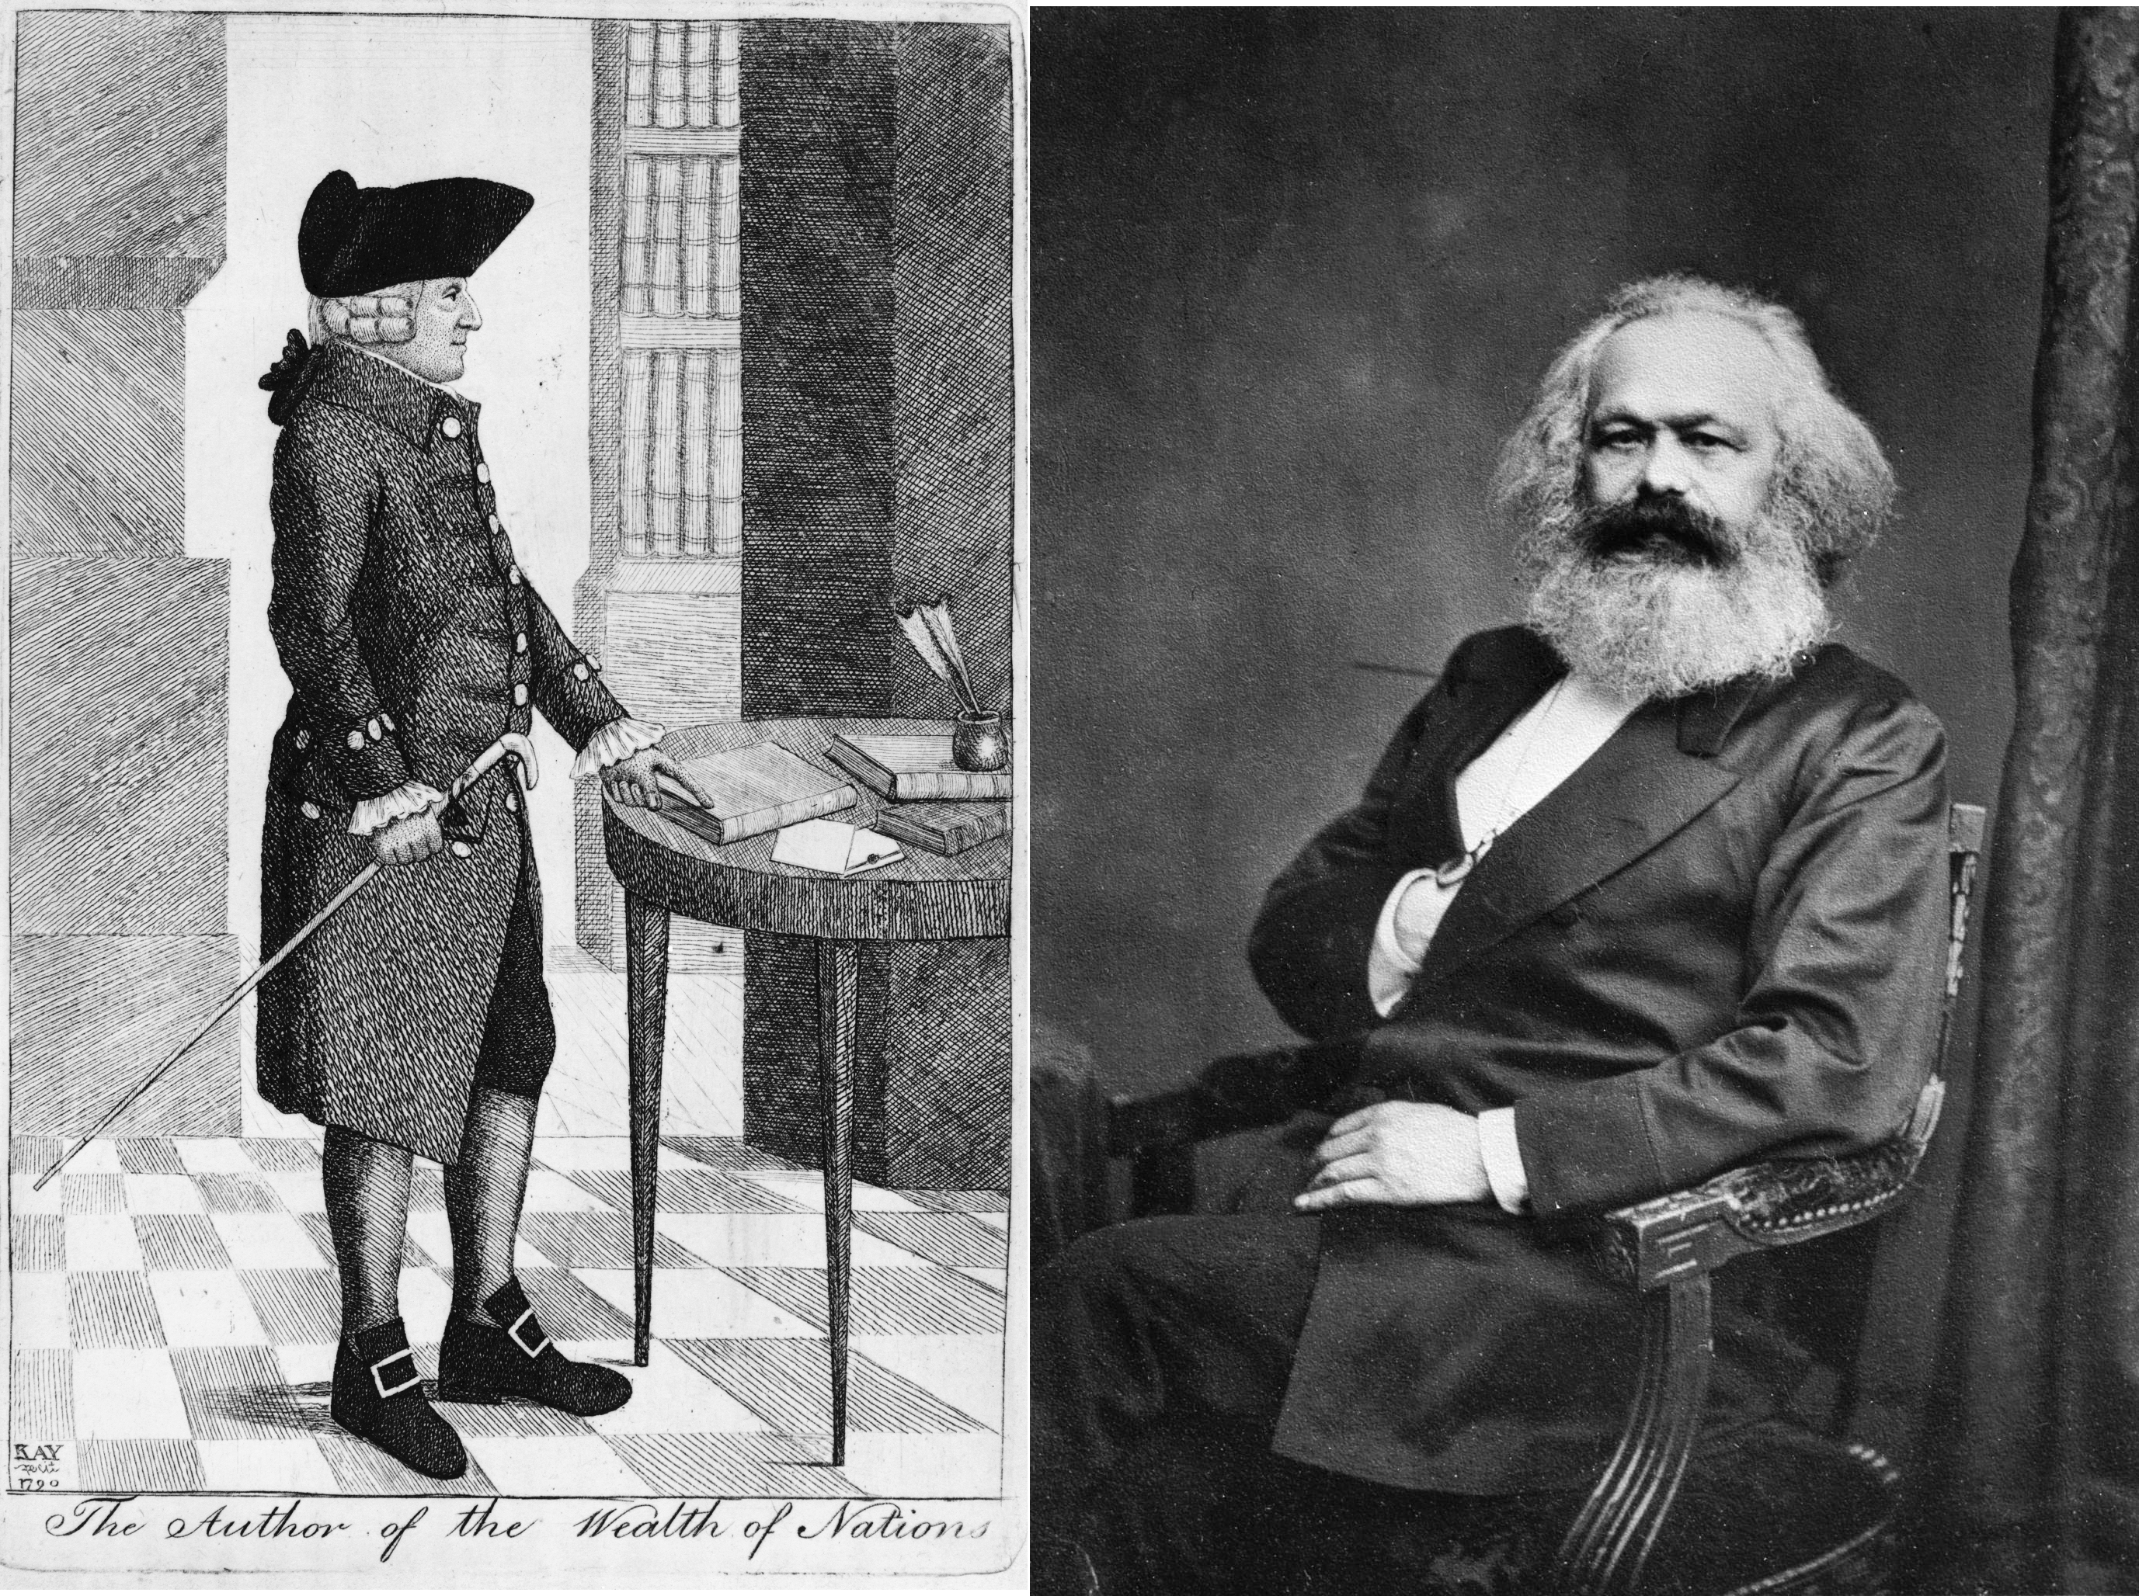

Adam Smith (1723-1790) and Karl Marx (1818-1883), both supporters of blurring national boundaries, but in completely different ways. Smith wanting it for free uncumbered trade across earth, Marx prophesying that class-conscious workers of the world would seize power, and establish a social state crossing national boundaries.

But for a time the stresses between employer and employed and particularly between **selfish employers and reluctant workers**, led to a world-wide dissemination of the very harsh and elementary form of communism which is associated with the name of Marx. Marx based his theories on a belief that men’s minds are limited by their economic necessities, and that there is a necessary conflict of interests in our present civilization between the prosperous and employing classes of people and the employed mass.[220] With the advance in education necessitated by the mechanical revolution, this great employed majority will become more and more class-conscious and more and more solid in antagonism to the (class- conscious) ruling minority. In some way, the class-conscious workers would seize power, he prophesied, and inaugurate a new social state. The antagonism, the insurrection, the possible revolution are understandable enough, but it does not follow that a new social state, or anything but a socially destructive process, will ensue. Put to the test in Russia, Marxism has proved singularly uncreative.[221]

**Marx sought to replace national antagonism by class antagonisms**; Marxism has produced in succession a First, a Second, and a Third Workers’ International.[222] But from the starting point of modern individualistic thought it is also possible to reach international ideas.[223] From the days of that great English economist, Adam Smith, onward there has been an increasing realization that for worldwide prosperity, free and unencumbered trade about the earth is needed. The individualist with his hostility to the state is hostile also to tariffs and boundaries and all the restraints upon free act and movement that national boundaries seem to justify.

It is interesting to see two lines of thought, so diverse in spirit, so different in substance as this class-war socialism of the Marxists and the individualistic free-trading philosophy of the British business men of the Victorian age heading, at last, in spite of these primary differences, towards the same intimations of a new world-wide treatment of human affairs outside the boundaries and limitations of any existing state.

The logic of reality triumphs over the logic of theory. We begin to perceive that, from widely divergent starting points, individualist theory and socialist theory are part of a common search, a search for more spacious social and political ideas and interpretations, upon which men may contrive to work together, a search that began again in Europe and has intensified as men’s confidence in the ideas of the Holy Roman Empire and in Christendom decayed,[224] and as the age of discovery broadened their horizons from the world of the Mediterranean to the whole wide world.

To bring this description of the elaboration and development of social, economic, and political ideas right down to the discussions of the present day, would be to introduce issues altogether too controversial for the scope and intentions of this book. But regarding these things, as we do here, from the vast perspectives of the student of world history,[225] we are bound to recognize that this reconstruction of these directive ideas in the human mind is still an unfinished task—we cannot even estimate yet how unfinished the task may be.

Certain common beliefs do seem to be emerging, and their influence is very perceptible upon the political events and public acts of today; but at present, they are not clear enough nor convincing enough to compel men definitely and systematically towards their realization.[226] Men’s acts waver between tradition and the new, and on the whole they rather gravitate towards the traditional. Yet, compared with the thought of even a brief lifetime ago, there does seem to be an outline shaping itself of a new order in human affairs. It is a sketchy outline, vanishing into vagueness at this point and that, and fluctuating in detail and formulae, yet it grows steadfastly clearer, and its main lines change less and less.[227]

It is becoming plainer and plainer each year that in many respects and in an increasing range of affairs, mankind is becoming one community, and that it is more and more necessary that in such matters there should be a common world-wide control. For example, it is steadily truer that the whole planet is now one economic community, that the proper exploitation of its natural resources demands one comprehensive direction, and that the greater power and range that discovery has given human effort, makes the present fragmentary and contentious administration of such affairs more and more wasteful and dangerous.[228]

Financial and monetary expedients also become world-wide interests to be dealt with successfully only on world-wide lines. Infectious diseases and the increase and migrations of population are also now plainly seen to be world-wide concerns. The greater power and range of human activities has also made war disproportionately destructive and disorganizing, and, even as a clumsy way of settling issues between government and government and people and people, ineffective.[229] All these things clamour for controls and authorities of a greater range and greater comprehensiveness than any government that has hitherto existed.

But it does not follow that the solution of these problems lies in some super-government of all the world arising by conquest or by the coalescence of existing governments. By analogy with existing institutions, men have thought of the Parliament of Mankind, of a World Congress, of a President or Emperor of the Earth. Our first natural reaction is towards some such conclusion, but the discussion and experiences of half a century of suggestions and attempts has on the whole discouraged belief in that first obvious idea. Along that line to world unity, the resistances are too great.[230]

The drift of thought seems now to be in the direction of a number of special committees or organizations, with world-wide power delegated to them by existing governments in this group of matters or that, bodies concerned with the waste or development of natural wealth, with the equalization of labour conditions, with world peace, with currency, population and health, and so forth.

The world may discover that all its common interests are being managed as one concern, while it still fails to realize that a world government exists. But before even so much human unity is attained, before such **international arrangements can be put above patriotic suspicions and jealousies**, it is necessary that the common mind of the race should be possessed of that idea of human unity, and that the idea of mankind as one family should be a matter of universal instruction and understanding.

For a score of centuries or more, the spirit of the great universal religions has been struggling to maintain and extend that idea of a universal human brotherhood, but to this day the spites, angers, and distrusts of tribal, national, and racial friction, obstruct, and successfully obstruct, the broader views and more generous impulses which would make every man the servant of all mankind[231]. Idea of human brotherhood struggles now to possess the human soul, just as the idea of Christendom struggled to possess the soul of Europe in the confusion and disorder of the sixth and seventh centuries of the Christian era.[232] The dissemination and triumph of such ideas must be the work of a multitude of devoted and undistinguished missionaries, and no contemporary writer can presume to guess how far such work has gone or what harvest it may be preparing.

Social and economic questions seem to be inseparably mingled with international ones. The solution in each case lies in an appeal to that same spirit of service that can enter and inspire the human heart. **The distrust, intractability, and egotism of nations, reflects and is reflected by the distrust, intractability, and egotism of the individual owner and worker in the face of the common good. Exaggerations of possessiveness in the individual are parallel and of a piece with the clutching greed of nations and emperors**. They are products of the same instinctive tendencies, and the same ignorances and traditions. Internationalism is the socialism of nations.[233] No one who has wrestled with these problems can feel that there yet exists a sufficient depth and strength of psychological science and a sufficiently planned-out educational method and organization for any real and final solution of these riddles of human intercourse and cooperation.[234] We are as incapable of planning a really effective peace organization of the world today as were men in 1820 to plan an electric railway system, **but for all we know the thing is equally practicable and may be as nearly at hand**.

No man can go beyond his own knowledge, no thought can reach beyond contemporary thought, and it is impossible for us to guess or foretell how many generations of humanity may have to live in war and waste and insecurity and misery before the dawn of the great peace to which all history seems to be pointing, peace in the heart and peace in the world, ends our night of wasteful and aimless living. Our proposed solutions are still vague and crude. Passion and suspicion surround them. **A great task of intellectual reconstruction is going on, it is still incomplete, and our conceptions grow clearer and more exact—slowly, rapidly, it is hard to tell which. But as they grow clearer, they will gather power over the minds and imaginations of men**.

Their present lack of grip is due to their lack of assurance and exact rightness. They are misunderstood because they are variously and confusingly presented. But with precision and certainty, the new vision of the world will gain compelling power. It may presently gain power very rapidly. And a great work of educational reconstruction will follow logically and necessarily upon that clearer understanding.

### Food for Thought

* Another highly acclaimed economic approach that needs mention here, is that expounded by **Henry George** in his 1879 book, **Progress and Poverty**. The book in fact, is much more than an economic theory. Leading personalities from various fields have confessed that this book had a life-changing impact upon them. It explains why poverty exists, in spite of improved economy and technological advances. The author proposes “*a single tax on land*” as a remedy for this. The thought provoking nature of the book, in spite of some criticism of the approach, has led to it being amongst the most successful books on political economy. We strongly suggest readers to go through it sometime.
* Different social, political, and economic ‘isms’/theories have been proposed and tried over centuries. But that goal of universal peace, equality, and liberty seems nowhere in sight even today. Greed, laziness, jealousy, disparities in socioeconomic statuses, environment, intelligence, strength, looks, or differences such as in race, values, country, or language, are **almost natural and inevitable**. Do you agree?
* Since differences cannot be reduced beyond a limit, homogeneity does not seem possible. Perhaps harmony in spite of all these difficulties and differences might be worth attempting. What changes can you bring about in the small world around you to increase this harmony, in your home, locality, school, or workplace?
* Does everyone need to find an ideological ‘ism’/group for himself, and also slot others into such an ‘ism’/group? Can’t people look upon self and others as mere people, and be ready to cross ‘ism’ boundaries? Is it so cumbersome to judge people and situations on a case by case basis, that we need this kind of compartmentalization?
* While we are at it, we would like to point readers to one more ‘ism’ called ‘**Radical Humanism**’, or ‘**Scientific Humanism**’. **In our opinion**, it is something that could become more feasible in the coming decades, considering the increasing maturity of people, and rapid spread of knowledge with the advent of digital technology. It was elaborated by Manabendra Nath Roy (M. N. Roy), who was a firebrand revolutionary of the Indian freedom struggle in his early days of youth. Later, he got inspired by communism, rose in that international hierarchy, observing it from very close quarters. He was among Lenin and Stalin’s chosen men, a **part of the intellectual middle-class crucial in guiding masses during a revolution**. Eventually, Roy got disillusioned by the workings of Socialism / Communism (was finally expelled from the Communist International), as well as parliamentary democracy. All of these he felt, neglected the ‘**freedom of the individual**’ and made the individual a ready slave to various political, social, religious, or similar ‘**power-centers**’. In return, the individual did reap some benefits from that group, often at the expense of some other group. But all freedom of thought was lost in the collective ego of the groups submitted to. **More importantly, individual creativity was also lost due to group prejudice**. Roy, in his later years, used all his experience, to come up with a **manifesto** around that idea of Radical Humanism. **The philosophy is for the individual to set himself free from such power-centers, and focus on rational and scientific thinking (which is also moral or ethical, he claims), and cooperative economy, all so natural to man**. Roy’s comprehensive view of the world, its problems, and his plan of action, consider social, economic, political, scientific, and religious aspects all together, keeping the individual at the center. **His writings are** **thought-provoking, but pretty radical. Occasionally unconvincing, at least unclear; especially when he tries to explain spiritual and religious thoughts purely on the basis of natural science**. Hence we would **request readers to check out his thoughts only after reaching a reasonable level of maturity. Secondly, we suggest reading those in the original, and with utmost discretion.** Because it is possible to get swayed by thoughts on science, faith, and religion, or to mistake the objective of ‘freedom of individual’, with other, even fraudulent movements under the garb of ‘human rights activism’. Ironically some groups also end up becoming **guardians or power-centers in-charge of ensuring freedom** for the weak masses. **Interestingly, Roy and his colleagues too seem to have guessed this possibility**. That is perhaps why they revised the original manifesto draft, to change parts that suggested: ‘**Creating a political party**’ that will bring about the Radical Humanism Revolution. The phrase ‘Political party’, in the manifesto, was later replaced by humbler ones like ‘group of intelligent people’, or ‘spirited individuals’, etc.
* A different kind of elaboration of this aspect of blind adherence to power-centers versus freedom of the individual, is given in the chapter, ‘The Grand Inquisitor’. It is among Fyodor Dostoevsky’s finest writings.

### References

Development Of Modern Political and Social Ideas, from ‘A Short History Of The World’, by H. G. Wells, 1922.

Revolutions: France, Abhinav Bharat, Quit India

Complexity: High

Since time immemorial, the world has seen conflicts between kingdoms or even groups of people across social classes, races, or religions. Loss and gain of life, property, and territory in that thirst for supremacy was also very common. The superior group, in terms of physical, military, intellectual, or financial strength mostly gained power even when numbers were not on their favor. This situation often degenerated to one where a large population of commoners was oppressed by the small group of ‘advanced individuals’.

Prior to the scientific revolution[235] of the 16th and 17th centuries, it was easy for advanced classes to keep doors of knowledge locked to lower classes, and thereby take an easy shortcut to a superior position. After all, the only thing needed was to be relatively better than completely ignorant masses. Improvements in availability of literature, exposure to scientific advances, and similar changes, helped knowledge reach commons better. Individuals within subdued groups took advantage of these modern social, economic, and scientific ideas and boldly stood up against established orders; sometimes for social, or economic justice, sometimes for political independence. From point of view of the ruling group, these were uprisings or rebellions, and for the other side, it was a struggle for freedom from some kind of subjugation. Successful overthrow of an (supposedly oppressive) established authority can be termed as a ‘revolution’.

One revolution that had huge influence on further course of world events was the French Revolution between 1789 and 1799. It showed how changes of a massive scale can be successfully achieved. At the same time, it also pointed out the dangers associated and new problems it creates. H. G. Wells nicely captures this period in the below extract based on his ‘A Short History Of The World’.

This passage first describes the initial disputes between the monarchy supported by nobles, and the lower classes. Then the increase in strife and violent struggle to usurp the dominance of higher classes, followed by the ultimate conversion of government from monarchy to a republic. It then describes the strong, almost fanatic, spirit of nationalism that spread all over, and its increase during times of Napoleon with its rapid spread to other countries; and finally, how it all concluded.

### French Revolution, by H. G. Wells

Britain had hardly lost the Thirteen Colonies in America,[236] before a profound social and political convulsion at the very heart of Grand Monarchy was to remind Europe still more vividly of the **essentially temporary nature of the political arrangements of the world**.[237]

The French monarchy was the most successful of the personal monarchies in Europe. It was the envy and model of a multitude of competing and minor courts.[238] But it flourished on a basis of injustice that led to its dramatic collapse. It was brilliant and aggressive, but it was wasteful of the life and substance of its common people. The clergy and nobility were protected from taxation by a system of exemption that threw the whole burden of the state upon the middle and lower classes. The peasants were ground down by taxation; the middle classes were dominated and humiliated by the nobility.

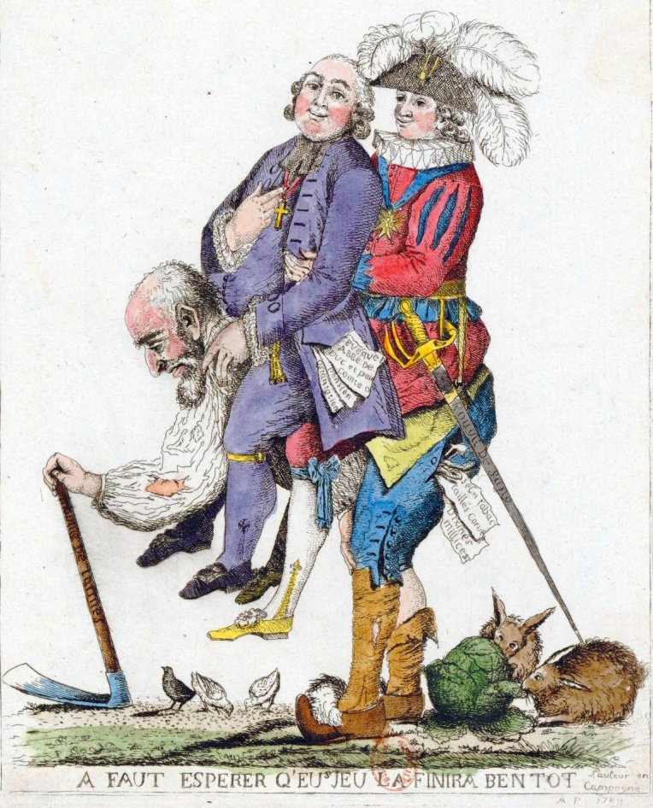

"You should hope that this game will be over soon." The Third Estate carrying the other two, the Clergy and Nobility, on its back, 1789.

In 1787 this French monarchy found itself bankrupt and obliged to call representatives of the different classes of the realm into consultation upon the perplexities of defective income and excessive expenditure. In 1789 the **States General**, a gathering of the nobles, clergy and commons, roughly equivalent to the earlier form of the British Parliament, was called together at Versailles. It had not assembled since 1610. For all that time France had been an absolute monarchy. Now the people found a means of expressing their long fermenting discontent. Disputes immediately broke out between the three estates, due to the resolve of the Third Estate, the Commons, to control the Assembly. The Commons got the better of these disputes and the States General became a **National Assembly**, clearly resolved to keep the crown in order, as the British Parliament kept the British crown in order.[239] The king (Louis XVI) prepared for a struggle and brought up troops from the provinces.[240] Whereupon Paris and France revolted.

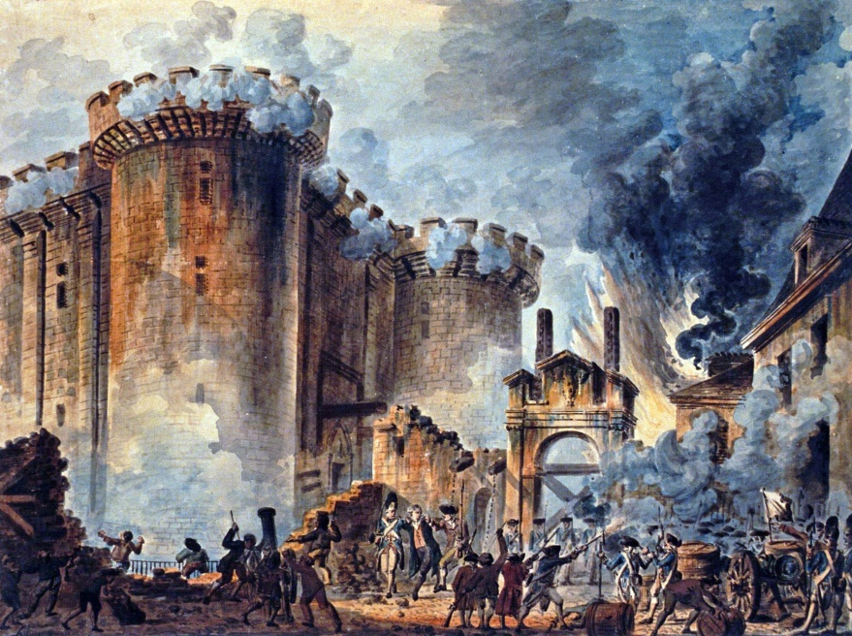

Storming the Bastille by Jean-Pierre Houël, 1789.

The collapse of the absolute monarchy was very swift.[241] The grim-looking prison of the Bastille was stormed by the people of Paris, and the insurrection spread rapidly throughout France. In the east and north-west provinces, many chateaux belonging to the nobility were burnt by the peasants, their title-deeds carefully destroyed, **and the owners murdered or driven away**. In a month, the ancient and decayed system of the aristocratic order had collapsed. Many of the leading princes and courtiers of the queen’s party fled abroad. A provisional city government was set up in Paris and in most of the other large cities, and a new armed force, the National Guard, a force designed primarily and plainly to resist the forces of the crown, was brought into existence by these municipal bodies. The National Assembly found itself called upon to create a new political and social system for a new age.

It was a task that tried the powers of that gathering to the utmost. It made a great sweep of the chief injustices of the absolutist regime;[242] it abolished tax exemptions, serfdom, aristocratic titles, and privileges and sought to establish a constitutional monarchy[243] in Paris. The king abandoned Versailles and its splendours and kept a diminished state[244] in the palace of the Tuileries in Paris.

For two years it seemed that the National Assembly might struggle through to an effective modernized government. Much of its work was sound and still endures, if much was experimental and had to be undone. Much was ineffective. There was a clearing up of the penal code; torture, arbitrary imprisonment, and persecutions for heresy[245] were abolished. The ancient provinces of France, Normandy, Burgundy, and the like gave place to eighty departments. Promotion to the highest ranks in the army was laid open to men of every class. An excellent and simple system of law courts was set up, but its value was much vitiated by having the judges appointed by popular election for short periods of time. **This made the crowd a sort of final court of appeal, and the judges, like the members of the Assembly, were forced to play to the gallery.[246]** And the whole vast property of the church was seized and administered by the state; religious establishments not engaged in education or works of charity were broken up, and the salaries of the clergy made a charge upon the nation. This in itself was not a bad thing for the lower clergy in France, who were often scandalously underpaid in comparison with the richer dignitaries. But in addition, the choice of priests and bishops was made elective, which struck at the very root idea of the Roman Church, which centred everything upon the Pope, and in which all authority is from above downward.[247] Practically the National Assembly wanted at one blow to make the church in France Protestant[248], in organization if not in doctrine. Everywhere there were disputes and conflicts between the state priests created by the National Assembly and the recalcitrant (non-juring) priests who were loyal to Rome.

In 1791, the experiment of Constitutional monarchy in France was brought to an abrupt end by the action of the king and queen, working in concert with their aristocratic and monarchist friends abroad. Foreign armies gathered on the Eastern frontier and one night in June the king and queen and their children slipped away from the Tuileries and fled to join the foreigners and the aristocratic exiles.[249] They were caught at Varennes and brought back to Paris, and France flamed up into a passion of patriotic republicanism[250]. A Republic was proclaimed, open war with Austria and Prussia ensued, and the king was tried and executed (January, 1793) on the model already set by England, for treason to his people.

And now, followed a strange phase in the history of the French people. **There arose a great flame of enthusiasm for France and the Republic**. There was to be an end to compromise at home and abroad; at home, royalists and every form of disloyalty were to be stamped out; abroad, France was to be the protector and helper of all revolutionaries. **All Europe, all the world, was to become Republican**. The youth of France poured into the Republican armies; a new and wonderful song spread through the land, a song that still warms the blood like wine, **the Marseillaise[251]**. Before that chant and the leaping columns of French bayonets and their enthusiastically served guns the foreign armies rolled back; before the end of 1792 the French armies had gone far beyond the utmost achievements of Louis XIV; everywhere they stood on foreign soil.[252] They were in Brussels, they had overrun Savoy, they had raided to Mayence; they had seized the Scheldt from Holland. Then the French Government did an unwise thing. It had been exasperated by the expulsion of its representative from England upon the execution of Louis[253], and it declared war against England. It was an unwise thing to do, because the revolution had given France a new enthusiastic infantry and a brilliant artillery. But due to the release from its aristocratic officers and many cramping conditions, it had destroyed the discipline of the navy, and the English were supreme upon the sea.[254] And this provocation united all England against France, whereas there had been at first a very considerable liberal movement in Great Britain in sympathy with the revolution.[255]

Of the fight that France made in the next few years against a European coalition we cannot tell in any detail. She drove the Austrians forever out of Belgium, and made Holland a republic. The Dutch fleet, frozen in the Texel[256], surrendered to a handful of cavalry without firing its guns. For some time the French thrust towards Italy was hung up, and it was only in 1796 that a new general, Napoleon Bonaparte, led the ragged and hungry republican armies in triumph across Piedmont to Mantua and Verona[257].

Says C. F. Atkinson,[258]

“What astonished the Allies most of all was the number and the velocity of the Republicans. These improvised armies had in fact nothing to delay them. Tents were unprocurable for want of money, untransportable for want of the enormous number of wagons that would have been required, and also unnecessary, **for the discomfort that would have caused wholesale desertion in professional armies was cheerfully borne by the men of 1793- 94**.[259] Supplies for armies of then unheard-of size could not be carried in convoys, and the French soon became familiar with ‘living on the country.’[260] Thus 1793 saw the birth of the modern system of war—rapidity of movement, full development of national strength, bivouacs, requisitions and force as against cautious maneuvering, small professional armies, tents and full rations, and chicane. The first represented the decision-compelling spirit, the second the spirit of risking little to gain a little ... .[261]”

And while these ragged hosts of enthusiasts were chanting the Marseillaise and fighting for la France, manifestly **never quite clear in their minds whether they were looting or liberating the countries into which they poured**, the republican enthusiasm in Paris was spending itself in a far less glorious fashion.[262] The revolution was now under the sway of a fanatical leader, Robespierre. This man is difficult to judge; he was a man of poor physique, naturally timid, and a prig. But he had that most necessary gift for power, faith. He set himself to save the Republic as he conceived it, and he imagined it could be saved by no other man than he. **So that to keep in power, was to save the Republic**. The living spirit of the Republic, it seemed, had sprung from a slaughter of royalists and the execution of the king. There were insurrections; one in the west, in the district of La Vendée, where the people rose against the conscription and against the dispossession of the orthodox clergy, and were led by noblemen and priests; one in the south, where Lyons and Marseilles had risen and the royalists of Toulon had admitted an English and Spanish garrison. To which there seemed no more effectual reply than to go on killing royalists.

The Revolutionary Tribunal went to work, and a steady slaughtering began. **The invention of the guillotine was opportune to this mood**. The queen was guillotined, most of Robespierre’s antagonists were guillotined, atheists who argued that there was no Supreme Being were guillotined; day by day, week by week, this infernal new machine chopped off heads and more heads and more. The reign of Robespierre lived, it seemed, on blood; and needed more and more, as an opium-taker needs more and more opium.

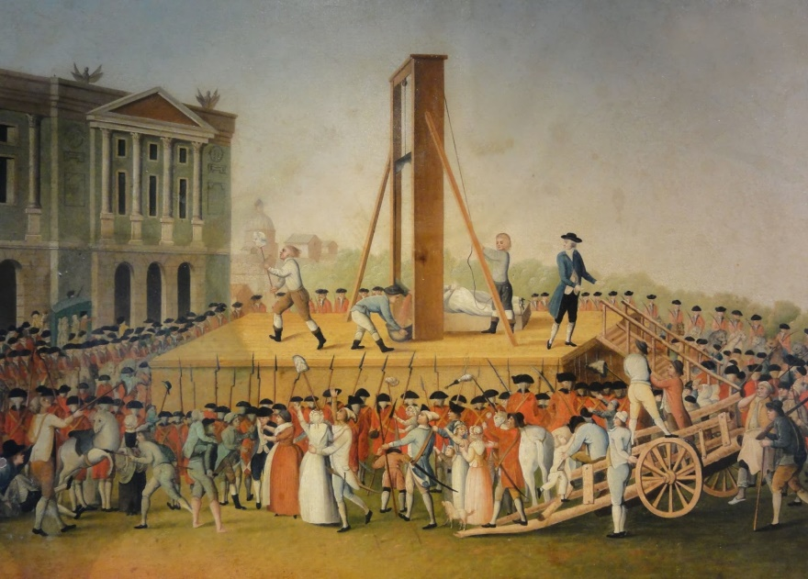

The Execution of Marie Antoinette, Queen of France, October 16, 1793.

Finally, in the summer of 1794, Robespierre himself was overthrown and guillotined. He was succeeded by a Directory of five men that carried on the war of defence abroad and held France together at home for five years. Their reign formed a curious interlude in this history of violent changes. They took things as they found them. The propagandist zeal of the revolution carried the French armies into Holland, Belgium, Switzerland, South Germany, and North Italy. Everywhere kings were expelled and republics set up. But such propagandist zeal as animated by the Directorate did not prevent the looting of the treasures of the liberated peoples to relieve the financial embarrassment of the French Government.[263] Their wars became less and less the holy wars of freedom, and more and more like the aggressive wars of the ancient regime. The last feature of Grand Monarchy that France was disposed to discard was her tradition of foreign policy. One discovers it still as vigorous under the Directorate as if there had been no revolution[264].

Unhappily for France and the world a man arose who embodied in its intensest form this national egotism of the French. He gave that country ten years of glory and the humiliation of a final defeat. This was that same Napoleon Bonaparte who had led the armies of the Directory to victory in Italy.

Throughout the five years of the Directorate, he had been scheming and working for self-advancement. Gradually, he clambered to supreme power. He was a man of severely limited understanding but of ruthless directness and great energy. He had begun life as an extremist of the school of Robespierre; he owed his first promotion to that side; but he had no real grasp of the new forces that were working in Europe. His utmost political imagination carried him to a belated and tawdry attempt to restore the Western Empire. He tried to destroy the remains of the old Holy Roman Empire, intending to replace it by a new one centring upon Paris. The Emperor in Vienna ceased to be the Holy Roman Emperor and became simply Emperor of Austria. Napoleon divorced his French wife in order to marry an Austrian princess.[265]

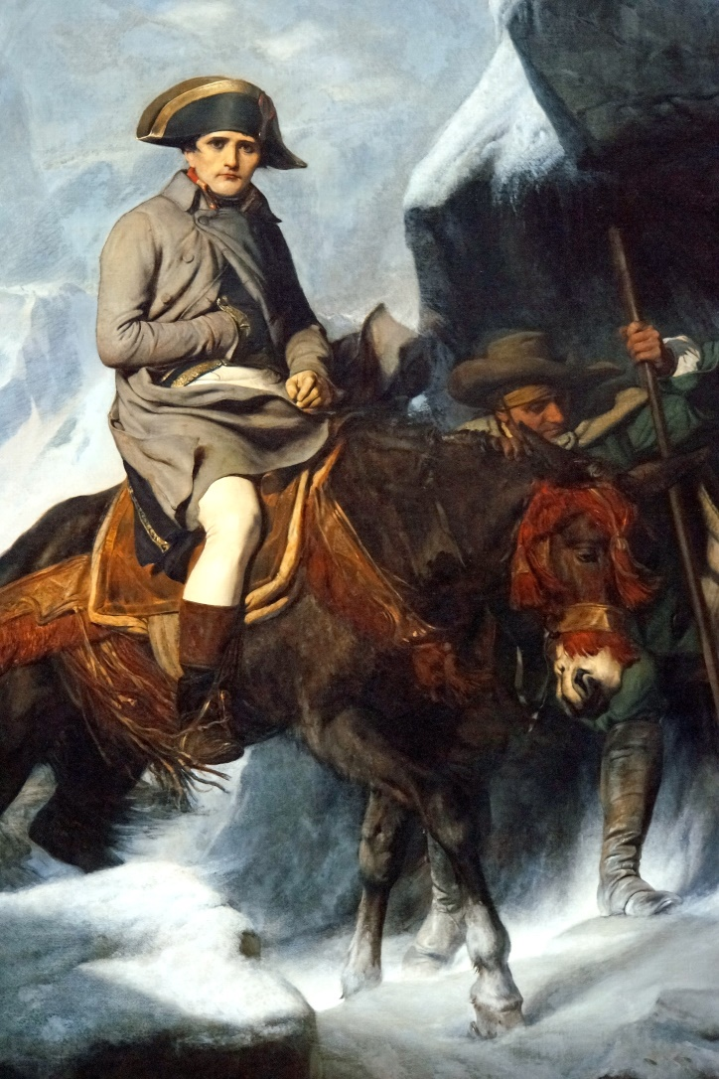

Napoleon Bonaparte Crossing the Alps, by French painter Paul Delaroche, 1848. Attribution in chapter References.

He became practically monarch of France as First Consul in 1799, and he made himself Emperor of France in 1804 in direct imitation of Charlemagne.[266] He was crowned by the Pope in Paris, taking the crown from the Pope and putting it upon his own head himself as Charlemagne had directed. His son was crowned King of Rome.

For some years Napoleon’s reign was a career of victory. He conquered most of Italy and Spain, defeated Prussia and Austria, and dominated all Europe west of Russia. But he never won the command of the sea from the British and his fleets sustained a conclusive defeat inflicted by the British Admiral Nelson at Trafalgar (1805). Spain rose against him in 1808 and a British army under Wellington thrust the French armies slowly northward out of the peninsula. In 1811 Napoleon came into conflict with the Tsar Alexander I, and in 1812 he invaded Russia with a great conglomerate army of 600,000 men, that was defeated and largely destroyed by the Russians and the Russian winter. Germany rose against him, Sweden turned against him. The French armies were beaten back and at Fontainebleau Napoleon abdicated (1814). He was exiled to Elba, returned to France for one last effort in 1815 and was defeated by the allied British, Belgians, and Prussians at Waterloo. He died a British prisoner at St. Helena in 1821.

The forces released by the French revolution were wasted and finished. A great Congress of the victorious allies met at Vienna to restore as far as possible the state of affairs that the great storm had rent to pieces. For nearly forty years, a sort of peace, a peace of exhausted effort, was maintained in Europe.[267]

***

### Influences Of The French Revolution

The ideas of liberty, equality, and fraternity, which formed the basis of French Revolution, influenced the whole of Europe and were accepted over time. They also created an environment for communism to spawn, since that, too, was based on concepts of liberty and equality, but in the extreme form, on the economic position.

The very fact that organized commoners can overthrow a powerful authority, served as an inspiration to many. It inspired freedom struggles of countries under foreign rule, or people preparing to rise against oppressive autocrats.

Another important product of this revolution was the spirit of nationalism that rose in France. With the notion of King no longer present, people saw themselves as proud citizens with equal rights over affairs of the nation. In this spirit, they all rallied under Napoleon’s leadership and felt completely justified of military campaigns to expand France, in order to spread enlightened ideals of liberty, equality and fraternity.

Benefits of this are pretty clear. Revolutions have successfully uprooted oppressive ruling powers. The spirit of Nationalism (or any such social, economic, religious, or political ‘ism’) certainly serves useful to bind a nation (or that group) together, and achieve great results; For instance, rising together against a mighty oppressive foreign power, or progress in military or industrial strength.

But it was also understood that, taken to the extreme, these radical measures have disastrous effects. The brutal mass executions during the French Revolution and disasters of Napoleonic wars are already described above. Extreme nationalistic fervor was an important contributor to the great world wars, the lives it took, and the ethnic cleansing it saw. The Great Russian revolution, with the sacrifice of countless common people behind it, was successful in overthrowing the Czar Rule. But the brutalities, starvations, and deaths that followed, did not provide a happy beginning to the new regime.

### Elsewhere In India

India, which was under British rule during that period, came out of its slumber after a brief period of lull. It followed a well-attempted, but failed effort to regain freedom, by the British Indian Army in 1857.

India was closely watching and learning from international developments to work out answers to its own problems. Social reformers started work on addressing challenges of social injustice such as untouchability, and outdated religious customs such as child marriage. Political organizations such as the Indian National Congress gave a platform for civic and political dialogue between educated people and the British government. Newsletters voicing their opinions on various issues helped educate people about their true situation. Once the above basic awareness was created, the stage was all set for direct action towards political freedom.

From the start itself, along with plans to oust British rule, preparations were being made to ensure that the new order would not have the above mentioned drawbacks seen in previous revolutions. Plans of action had provisions built in to avoid the danger of the new order being worse than the previous one, irrespective of the path chosen.

These preparations can be seen through the following extract translated from the autobiography of Vinayak Damodar Savarkar, a great patriot and advocate of armed struggle. It is an outline of discussions they used to have in meetings of *Abhinav Bharat*, a secret revolutionary group gearing up for armed struggle, also called the *Mitramela* (gathering of friends, in Marathi). The group comprised of lads barely in their teens and youth, around the year 1900. Those were still very early days of a fresh start to the freedom struggle, after the previously mentioned attempt in 1857. Here it is, in Savarkar’s own words translated to English.

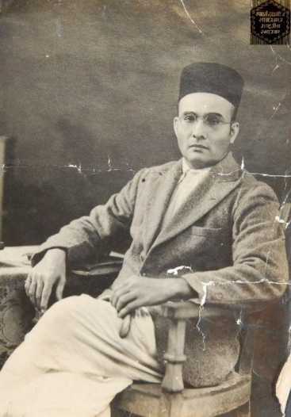

Swatantryaveer Vinayak Damodar Savarkar (1883-1966). Courtesy Swatantryaveer Savarkar Rashtriya Smarak, Dadar, Mumbai.

#### Abhinav Bharat and its Meeting Discussions

When such darkness of midnight filled Hindusthan’s political skies, that bright star of Abhinav Bharat suddenly rose therein. As if the sun had risen prematurely. People too were shocked.

At that hour of midnight, the topmost demand of the National Congress was that the Legislative council should have a local representative with a right to submit a council resolution. So the sleeping population considered the sudden strike of this hour of ‘The Goal of Complete Independence’, to be a bad omen, like premature sunrise!

Obviously, this reaction was not very surprising. The clock struck this hour much earlier than those that should have preceded it; namely, the demand for the legislative council to have a majority of locally elected representatives, the demand for home rule, and full dominion status, in that order.

And a handful of youth boldly asserting, “Armed revolution is the only and inevitable means to complete independence”, and for that purpose, putting the enemy’s as well as their own lives at stake!

In fact, it would have been surprising had the wise and thoughtful people not looked upon them as hysterics, and by this act, falsified the saying that, “slavery pollutes the intellect and makes timidity too look like bravery.”

Seditious! Terrible! Rebels! Started growling the rulers[268]. Hysterics! Fools! Said the wise disdainfully. Undesirable! Premature! Suicidal! Implored well-wishers and began to pull (us) back.

But we had lost consciousness. Like those who had lost complete consciousness, or possessed by a spirit, the only voices we could hear were that of Shivaji and Krishna, of Mazzini and Garibaldi.[269] These voices of the past and welcoming cries of that unknown future saying, “Blessed ones! Blessed ones!”

We had gone mad, drunk from that past, and possessed by that future. Even at that time, we had realized this ourselves.

When this poem composed then, by our poet Govind, started giving a solid proof of this madness saying:

“My goodness, what are you chanting! You are going mad.

Sir Sentry will arrest you, and give a sound thrashing”

On this, the young lunatic of Abhinav Bharat’s mental asylum answers thus:

“Madness, Yes. True Indeed.

I feel like that destroyer of Kamsa and the descendant of Raghu,[270]

Smitten with this madness for freedom, and for deliverance from slavery.

Brothers, hold me please.

Poor foreigner, true, I am delirious.

Of the blood of my homeland’s foe

Truly, make me drink that nectar.

Only then will I be able to live today.

Come! Lock me in the prison of independence,[271]

But let the saffron banner flutter liberally over the lands of Bharata.

But in what form did that Goddess of independence (Swatantrya Laxmi), we worshipped, present herself to us? Was this independence, which had maddened us so much, a mere blood-thirsty, rash, and demonic national independence?

No, no! “Extremist patriotic fervor is as immoral as the absence of patriotism,” was a very clear Abhinav Bharat teaching right since beginning.

The limitations of the duals, violence and nonviolence, truth and falsehood, people’s republics and humanity, were thoroughly brainstormed in the weekly meetings of the Mitramela[272], even in the first two years of its existence.

**‘Utilitarianism’** was that supreme principle of practical morality, having at its core, the *‘achievement of well-being of the maximum number of people’*. As soon as I got this clue and was convinced of it, I put all the above duals to test against that utilitarianism[273]; and at that time itself, delivered lectures in Mitramela meetings explaining the limitations of their beneficial natures.

Our group had many members with excessive religious and vedantic[274] propensities. They had often raised clear doubts about phrases like secret organization, armed struggle and the like, smelling of sin.

Not only that, many a time, Pundalik, Baba[275], sometimes Mhaskar and other excessively god-minded people used to pose arguments in our meetings like: political movements, rather all kind of materialistic movements are useless, and the only goal (of human life) is spiritual liberation through a combination of means such as refuge in the almighty, god’s grace, chanting, austerities, and others.

Therefore, in order to satisfy them by correlating the means and goals of that spiritual and this material movement, I used to repeatedly discuss to satisfaction, philosophical topics like Righteousness, Liberation, and Violence, as per my knowledge at that time.

If I provide some of my selected precepts from that time here, one could easily get a high-level idea of the ideological basis of my opinions, to which the organization ideology was also compliant.

When correlating secrecy and truth, I always used to say that the interest of humanity is the support of all virtues. Meaning, the truth by which, overall human welfare is achieved, that alone, is truth, virtue, or righteousness. But the truth that serves death penalty to a monk instead of a thief is a vice, that truth itself is falsehood.

That:

“Whom burglars caught at night,

To liberate him,

Without thinking even for a moment,

Utter hundred statements of falsity,”

Or,

“The purpose of Dharma (i.e. Righteous or virtuous conduct), is to sustain society. That, which maintains mankind, is Dharma.”[276] **That is the real essence of Shri Krishna’s philosophy. Everything else is jargon.**

Of course, when unjust, evil powers curb expression of the adherents of truth, forcibly take away that freedom of expression, term obviously noble conduct as unlawful, then, getting together, organizing, and operating an army of justice to defeat those powers, if necessary, also becomes religious duty.

It was secrecy with which Shri Krishna grew up in Gokul. If some Nanda or Vasudeva had prematurely informed Kamsa about his growing in this fashion, then that truth itself would have been an unpardonable immorality on his part. That kind of truth would have caused greatest harm to society. Therefore, secrecy was the true ethical policy and virtuous conduct there.

One ought to have cut off the tongue of that Maratha had he informed Aurangzeb that, King Shivaji who escaped from Delhi, was in such and such a basket, and such and such a place.[277] As much as a betrayer and traitor that Suryaji Pisal[278] was, wasn’t he also an honest person almost to the same extent?

Secrecy is neither a vice, nor a virtue. One needs to decide its virtuousness or viciousness depending upon whether its use is being made for the benefit of society or for its harm. Impregnation generally is secretive, but it is not termed sinful just for that reason.

Same is the situation with armed struggle. The same sword considered sinful, blood-thirsty, and unrighteous in the hand of a Ravana or a Kamsa, is considered pure, holy, and bright, like the sacred sacrificial fire, in Rama’s or Krishna’s hand.

Same goes for national pride. The only virtuous national pride is that which fights and drives itself to the protection and progress of our legitimate national rights, through which one can achieve the well-being of maximum number of people.

But that national pride which, falling prey to the demonic air in the fatherland, violates the legitimate existence or rights of other countries, or causes disturbance to humans, that national pride then becomes unrighteous and punishable, similar to an offense of setting fire to someone else’s house for selfish personal interest.

A nation exists, should exist, only for the benefit of humanity. We used to keep repeating this principle from the top of our voices. We never hated, never let others hate the English just because they were English. **The English are our enemies only till England continues its oppression of Hindusthan. They are our friends the moment they give up this oppression; because all of humanity is one, our brethren.**

Not just that, if some other oppressive nation tries to crush England’s legitimate independence using unjust force, we will fight, and strive for the liberation of England in a similar manner. This was our oath we expressed so often.

**Our true caste is human, true religion is humanity, the religion of humans, true nation is this earth, and true king is God, such was our extremely sublime emotion**. Since that time itself, we would express our feelings in precisely these words, spirited by emotion. Of course, the form of independence for which we were battling, similarly, was also extremely comprehensive.

In the current situation, of Hindhusthan, all other types of freedom or liberation, even spiritual liberation of individuals, is being suppressed and restricted without political freedom. Therefore, political freedom was our immediate cause, and goal.

I had to repeatedly prove how political slavery stifles religion, austerities for after-life prospects, or spiritual development, and how political independence was necessary today, even for the sake of religion. I often needed to sermon on Ramdas’s quotes such as ‘Holy places of pilgrimage corrupted’,[279] and such others.

I needed to expound that, philosophy without strength, justice without power, destiny without effort, soul without body, and spiritual without the material, are all handicapped, incomplete. In order to do that, I had to repeatedly clarify that, the current immediate goal of political independence was not just compatible to the individual’s and nation’s ultimate goal of spiritual liberation, but as a matter of fact, the full maturity of that first kind of independence was verily, that other kind of independence, that spiritual liberation.[280]

Because it was the only way by which we could convert the excessively religious followers of our group into followers and adherents of this revolution for people’s welfare; those who considered the first kind of national movement as sinful or at least restrictive, and wished to tread the path of personal liberation only.

For this purpose, The Dasbodh[281], Ramdas’s advice to Shivaji, was also one of our scriptures. That was very useful in converting these excessively religious folks to excessively patriotic ones.

At that time, many ascetics and saints, worshippers (of God Hari, the Haridasas) and mythologists, renunciants and recluses, used to advise us about this political ado being useless, and that it was good enough to gain god’s grace. We used to repeatedly prove to them that India’s political independence is the true means of obtaining God’s grace during this era, and SwaDharma (righteous conduct for self) is handicapped without Swaraj (self-rule), through similar sequences of arguments.

The nature of Independence, the primary goal of Abhinav Bharat was highly comprehensive. The meaning of Independence was the synthesis of a person’s, a nation’s and humanity’s material and spiritual duties, and their completeness – not any other narrow-minded or passionate meaning. Even the witness provided by the following lines from my “Plasm Of Independence” written then, will prove that we had devoted ourselves to Independence in its above comprehensive sense only, since the very beginning.

Victory to you, O prosperous, highly auspicious one, origin of the gracious, bestower of good fortune.

O goddess of liberation, O triumphant one, my salutations to you.

You are the nation’s consciousness personified. Of morality and riches

You are the queen, that prosperity and intellect, O goddess of liberation.

In the sky of enslavement, you verily become that heavenly

Star blinking brightly, O goddess of liberation.

Whether tender flowery cheeks, or flowers like tender cheeks,

O goddess of liberation, you verily are that red glow relaxing within them.

You are the Sun’s brightness as well as ocean’s sobriety.

Without those (properties), O goddess of liberation, the duo would be completely eclipsed.

Deliverance, emancipation are verily your forms, and it is you whom the Vedantic

Yogis hail as the Supreme Spirit, O goddess of liberation.

All that are excellent, sublime, progressive, and most pleasant, they,

All have become your associates, O goddess of liberation.

O prosperous liberation, soaked with the blood of the vicious, worshipped by the virtuous,

Death for your sake is life, and life without you is death.

The entire creation takes asylum in you.

When, O bestower of boons, will you firmly embrace this land of Bharat.

We wanted freedom for the welfare of all mankind including the English, for the ultimate progress of humanity. Not only a person’s mental development, but also his moral and spiritual development is pinned down by political captivity. We desired the Independence of Bharat for that reason.

The political captivity of Bharat was pinning down progress of humanity comprising of thirty crore (300 million) individuals. That was also going to be the cause of deterioration of entire mankind. For that reason, we considered uprooting and beheading that captivity not only our national duty, but also a religious one. Just like Rama considered Ravana’s beheading as his duty, or Krishna considered Kamsa’s beheading, his duty.

Just like old incarnations, we sincerely believed that the almighty has assumed this new incarnation of Abhinav Bharat in order to ‘to defend the pious, destroy the wicked, and strengthen virtue’[282]. And since the very beginning we used to express this belief through more or less similar statements, arguments, scriptural evidences, and philosophical sermons on different occasions and in different ways, from time to time.

***

#### Ahimsa and Satyagraha, a Different Experiment

Let us now talk about another means towards the same goal, Nonviolence (Ahimsa) and Satyagraha (Insistence on Truth).

The process of petitions and propaganda through newsletters had increased public awareness about foreign rule and the injustice being done. But one thing that had not yet happened was the active involvement of the 300 million common people in the freedom struggle. It was necessary to include them not only for their support and numeric strength, but also to make them feel that the nation was their own, and did not belong to any small or elite group. And for this, people needed a mechanism to contribute positively to the effort. Armed resistance was not practical for everyone. For that, it was necessary to arm the multitudes. The most likely result of such action would be devastation of self and family, not an easy option for the common person. Additionally, there was a danger of violence continuing beyond the change, which was already known to create long term problems; especially if uneducated, poor, and hungry masses got violent at such a scale.

The entry of Gandhiji into the Indian political scene, and his belief in the mechanism of nonviolent resistance was the idea that finally clicked and succeeded in attracting common people. It went beyond petitioning, stressed on peaceful demonstrations by large groups, disrespecting oppressive laws in a non-violent manner, and with a belief in the ‘soul-force’ that would make the oppressor realize injustice, and give in.

On first thoughts, it seems absurd to believe that an oppressor magically repents his wrong doings unless compelled to (though there are tales of saints and the like, on similar lines). But leaving that expectation of magic apart, these nonviolent resistances clearly created inconveniences that the British power could not ignore. People breaking laws still needed to be forced into prisons, leading to time, money, and effort spent. Demonstrations did hold up traffic or create hassles, and so on. In short, it created a significant inconvenience to authorities owing to the enormous collective effect comprising of small individual contributions. It was not easy for the British to use exorbitant measures for small offences to completely curb the movement. They also needed to guard their reputation of civility, and other world powers were closely watching. In summary, nonviolent resistance had a huge impact.

Gandhiji gave the following speech at the outset of the ‘Quit India Movement’, on 8 August 1942. It was given to members of the Congress committee before the resolution for Quit India was passed. It gives an idea of the agenda for this kind of struggle, and also an insight into the character of this ordinary looking man. Here it is.

#### Gandhiji’s Quit India Speech

Before you discuss the resolution, let me place before you one or two things, I want you to understand two things very clearly and to consider them from the same point of view from which I am placing them before you. I ask you to consider it from my point of view, because if you approve of it, you will be enjoined to carry out all I say. It will be a great responsibility. There are people who ask me whether I am the same man that I was in 1920, or whether there has been any change in me. You are right in asking that question.

Let me, however, hasten to assure that I am the same Gandhi as I was in 1920. I have not changed in any fundamental respect. I attach the same importance to non-violence that I did then. If at all, my emphasis on it has grown stronger. There is no real contradiction between the present resolution[283] and my previous writings and utterances.

Occasions like the present do not occur in everybody’s and but rarely in anybody’s life. I want you to know and feel that there is nothing but purest Ahimsa in all that I am saying and doing today. The draft resolution of the Working Committee is based on Ahimsa, the contemplated struggle similarly has its roots in Ahimsa. If, therefore, there is any among you who has lost faith in Ahimsa or is wearied of it, let him not vote for this resolution. Let me explain my position clearly. God has vouchsafed to me a priceless gift in the weapon of Ahimsa. I and my Ahimsa are on our trail (trial) today. If in the present crisis, when the earth is being scorched by the flames of Himsa[284] and crying for deliverance, I failed to make use of the God given talent, God will not forgive me and I shall be judged unworthy of the great gift. I must act now. I may not hesitate and merely look on, when Russia and China are threatened.

Ours is not a drive for power, but purely a non-violent fight for India’s independence. In a violent struggle, a successful general has been often known to effect a military coup and to set up a dictatorship. But under the Congress scheme of things, essentially non-violent as it is, there can be no room for dictatorship. A non-violent soldier of freedom will covet nothing for himself, he fights only for the freedom of his country. The Congress is unconcerned as to who will rule, when freedom is attained. The power, when it comes, will belong to the people of India, and it will be for them to decide to whom it placed in the entrusted.[285] May be that the reins will be placed in the hands of the Parsis, for instance-as I would love to see happen-or they may be handed to some others whose names are not heard in the Congress today. It will not be for you then to object saying, “This community is microscopic. That party did not play its due part in the freedom’s struggle; why should it have all the power?” Ever since its inception, the Congress has kept itself meticulously free of the communal taint. It has thought always in terms of the whole nation and has acted accordingly. . . I know how imperfect our Ahimsa is and how far away we are still from the ideal, but in Ahimsa there is no final failure or defeat. I have faith, therefore, that if, in spite of our shortcomings, the big thing does happen, it will be because God wanted to help us by crowning with success our silent, unremitting Sadhana[286] for the last twenty-two years.

I believe that in the history of the world, there has not been a more genuinely democratic struggle for freedom than ours. I read Carlyle’s French Revolution while I was in prison, and Pandit Jawaharlal has told me something about the Russian revolution. But it is my conviction that inasmuch as these struggles were fought with the weapon of violence, they failed to realize the democratic ideal. In the democracy that I have envisaged, a democracy established by non-violence, there will be equal freedom for all. Everybody will be his own master. It is to join a struggle for such democracy that I invite you today. Once you realize this, you will forget the differences between the Hindus and Muslims, and think of yourselves as Indians only, engaged in the common struggle for independence.

Then, there is the question of your attitude towards the British. I have noticed that there is hatred towards the British among the people. The people say they are disgusted with their behaviour. The people make no distinction between British imperialism and the British people. To them, the two are one. This hatred would even make them welcome the Japanese. It is most dangerous. It means that they will exchange one slavery for another. We must get rid of this feeling. Our quarrel is not with the British people, we fight their imperialism. The proposal for the withdrawal of British power did not come out of anger. It came to enable India to play its due part at the present critical juncture. It is not a happy position for a big country like India to be merely helping with money and material obtained willy-nilly from her while the United Nations are conducting the war. We cannot evoke the true spirit of sacrifice and velour, so long as we are not free. I know the British Government will not be able to withhold freedom from us, when we have made enough self-sacrifice. We must, therefore, purge ourselves of hatred. Speaking for myself, I can say that I have never felt any hatred. As a matter of fact, I feel myself to be a greater friend of the British now than ever before. One reason is that they are today in distress. My very friendship, therefore, demands that I should try to save them from their mistakes. As I view the situation, they are on the brink of an abyss. It, therefore, becomes my duty to warn them of their danger even though it may, for the time being, anger them to the point of cutting off the friendly hand that is stretched out to help them. People may laugh, nevertheless that is my claim. At a time when I may have to launch the biggest struggle of my life, I may not harbor hatred against anybody.

***

#### Mission Partly Accomplished, Not Without Its Price

The British had to leave India, thanks to the convergence of so many contributing factors. Some of these were: efforts of millions of votaries of non-violence, sacrifices of revolutionaries, a strong Indian military, toll of the Second World War on British strength, and international pressures for decolonization. Due to the way Indian freedom struggles were designed, irrespective of school of thought, the transfer of power happened without any brutality or organized mass executions, either of the former ruling class, or within leading votaries of opposing schools of thought.

In fact, far from being blinded by hate and passion, genuine respect and personal bonding were often observed even across opponents with ideologies even poles apart. Leaders also did not mind openly expressing that respect.[287] One can find ample examples of this type of mutual respect in pages of Indian history; whether it be a proponent of staunch religious thought, a leader of the underprivileged classes, a revolutionary, votary of nonviolence, or even a die-hard communist; at times, even for their British adversaries.

Unfortunately, one eventuality not well anticipated was, the rapidly increasing communal divide between Hindus and Muslims at that time. It led to a partition of India and unprecedented communal riots resulting in the loss of millions of lives.

India has come a long way since then, trying to formulate a way to blend so many variations into a common fabric, and at the same time, not compromising on the freedom of the individual. Many issues are yet to be put to rest. Strife based on religion, caste, and language, differences in social and economic statuses, or ideological differences. Add to that the modern dangers of terrorism, environmental damage, and degradation due to unmoderated craze for wealth and pleasures, disproportional to the amount of meaningful progress achieved.

All in all, still a lot of work to be done. India is trying her best, but it needs sincere effort **on part of all individuals, not just a select few**. Not just the effort needed for speedy and sustained material development, but also to imbibe the necessary tolerance, make compromises, to together reach that elusive goal of inclusive progress and peace.

Clearly an unclosed chapter at this point, but who knows, if India can crack this tough nut, then, just like the French Revolution served as a blueprint for many modern orders, the solution that emerges in India could serve as a worldwide blueprint for peace and sustainable progress catering to all kinds of diversities. Only time will tell.

### Food for Thought

* *The enthusiastic revolutionaries of France were never quite clear in their minds whether they were looting or liberating the countries into which they poured.* Often, movements of nationalism, or religious, social and economic upheavals, stray into wild passions, personal vendettas, or systematic setups of centers of power, under the garb of ‘**striving for a greater cause’**. Try to recollect instances of such degradations concerning you or your society.
* The effects of a successful revolution are mixed. A new regime sometimes improves condition of people, or often makes it worse. Compare revolutions that you know of, with respect to the following parameters:
  + Longevity of the change.
  + Corruption of the group that spearheaded revolution itself, or their close aides.
  + Saga of revenge, mutual spying, trials, executions, secret killings, especially of those on the losing side.
  + Multitudes always being in fear of authorities.
  + Ethics, intellect, and education of the core team instrumental in bringing about the change.
  + Primary objective of the revolution. E.g. to achieve political freedom, hatred for a certain group, becoming a scientific, economic, or military superpower. Compare quality of new orders based on this single parameter.
* Think about the definition of righteous behavior in Krishna’s opinion, in the Abhinav Bharat discussion above. ‘Dharma (Righteous conduct) sustains the society, Dharma maintains mankind, Dharma ensures well-being and progress of Humanity, Dharma is indeed that, which fulfils these objectives.’
  + Is it so plain and clear that anyone with basic clarity of thought can understand it and act righteously? Kind of meta-religion, setting everyone free to decide how to act as per their reading of a situation?
  + Or is it so high-level and abstract that it is of little practical use for anyone, except those with high prudence? And different religious scriptures, scholars, and other thought leaders are needed from time to time, to elaborate it, and make it practical to follow?
  + Or should low-level religious directives be put to test against the above all-encompassing doctrine as per situation? Especially given the possibility that interpretation of directives in scriptures could be faulty, perhaps errors could have crept in texts due to passage of time and other corruptions, or reduced relevance of scriptural rules in current time and place?
  + Does this principle (or Utilitarianism) legitimize oppression of innocents for the well-being of maximum number of people? In fact, is long-term well-being of mankind based on such a ‘**habit of small oppressions**’, even possible?

### References

* French Revolution from ‘A Short History Of The World’, by H. G. Wells, 1922.
* Napoleon Crossing the Alps, By Dennis Jarvis from Halifax, Canada (France-003349 - Bonaparte Crossing the Alps) [[CC BY-SA 2.0](http://creativecommons.org/licenses/by-sa/2.0) (http://creativecommons.org/licenses/by-sa/2.0)], [via Wikimedia Commons](https://commons.wikimedia.org/wiki/File%3AFrance-003349_-_Bonaparte_Crossing_the_Alps_(16212572906).jpg).
* V. D. Savarkar’s Autobiography, Part I: Mazya Athwani (My Reminiscences), 1949.
* Quit India Speech by M. K. Gandhi, to the All India Congress Committee, 8 August 1942.

The Grand Inquisitor, by Fyodor Dostoevsky

Complexity: **Very High**

This is an extract from Fyodor Dostoevsky’s final novel, ‘**The Brothers Karamazov**’. It is a discussion between **Alyosha**, the youngest of the Karamazov brothers, with his brother **Ivan**, when Ivan has made up his mind to leave the town.

Alyosha is a noble-hearted young boy with mature faith in Christian teachings. He is presently living the life of a **monk** under his elder, **Father Zossima**. Ivan is extremely brilliant, well educated, and also moved by human suffering.

Ivan talks passionately about philosophical topics such as God, Free Will, Morality, and the Church controlling people and their thoughts; with Alyosha also arguing based on his previous conditioning and character. There are a lot of complex narrations and arguments that cannot be summarized easily. But the following outline of the talk would help readers get a sense of the big picture and avoid getting lost in the complexity of this long passage.

Ivan starts about his belief in God deep within. At the same time, he refuses to accept and love God considering all the hatred and evil in the world, which God allows. Especially about the cruelties on innocent children (some descriptions of cruelty here are pretty loathsome) who are too young to commit sin. He argues that even a perfect world based on cruelties to a few innocents is not acceptable.

When Alyosha reminds him of Christ who suffered for others, Ivan narrates his poem in prose, **‘The Grand Inquisitor’**. The idea is that Christ revisits earth, coming to Spain during the period of **Inquisition**[288]. He is immediately arrested as a **heretic** by the Grand Inquisitor[289], who then explains his position to Christ. The inquisitor reminds Christ of his (Christ’s) efforts for people to have **free will and strength to do what is right. That, he says, is actually disastrous to mankind; most people need security of food and other necessities of life, and not such moral freedom**. And so, the Church was justified in getting society rid of free will, and giving them security in return of their child-like submission to the church; something that Christ ought to have done himself because he had a chance to be in that position of power (at time of the three temptations, explained later).

Though the example revolves around Russia, Christian teachings, and the institution of Church, readers will find parallels within their own cultures, or religious, political, and social institutions. It does not try to be too judgmental about right and wrong, and is open to different interpretations. But it puts forward different social and philosophical viewpoints, which everyone would certainly benefit from.

Especially for this chapter, we will advise readers not to hurry through it. Readers could pause for a while or take a break, if they seem to be losing track of things. In fact, multiple readings of this passage might uncover fresh viewpoints not noticed in previous readings.

The brothers are chatting in a tavern, and Alyosha continues the conversation:

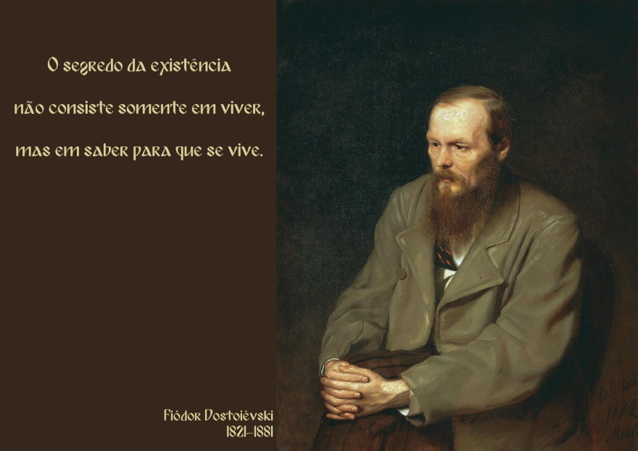

Portrait of Fyodor Dostoevsky, by Vasily Perov, 1872. His quote, a part of this extract too, can be translated from Portuguese as: ‘The secret of existence consists not only in staying alive, but in knowing what to live for.’ Attribution in chapter References.

“Have you settled to go tomorrow morning, then?”

“Morning? I didn't say I should go in the morning.... But perhaps it may be the morning. Would you believe it, I dined here today only to avoid dining with the old man[290], I loathe him so. I should have left long ago, so far as he is concerned. But why are you so worried about my going away? We've plenty of time before I go, an eternity!”

“If you are going away tomorrow, what do you mean by an eternity?”

“But what does it matter to us?” laughed Ivan. “We've time enough for our talk, for what brought us here. Why do you look so surprised? Answer: why have we met here? To talk of my love for Katerina Ivanovna, of the old man and Dmitri[291]? Of foreign travel? Of the fatal position of Russia? Of the Emperor Napoleon? Is that it?”

“No.”

“Then you know what for. It's different for other people; but we in our green youth have to settle the eternal questions first of all. That's what we care about. Young Russia is talking about nothing but the eternal questions now. Just when the old folks are all taken up with practical questions. Why have you been looking at me in expectation for the last three months? To ask me, ‘What do you believe, or don't you believe at all?’ That's what your eyes have been meaning for these three months, haven't they?”[292]

“Perhaps so,” smiled Alyosha. “You are not laughing at me, now, Ivan?”

“Me laughing! I don't want to wound my little brother who has been watching me with such expectation for three months. Alyosha, look straight at me! Of course, I am just such a little boy as you are, only not a novice. And what have Russian boys been doing up till now, some of them, I mean? In this stinking tavern, for instance, here, they meet and sit down in a corner. They've never met in their lives before and, when they go out of the tavern, they won't meet again for forty years. And what do they talk about in that momentary halt in the tavern? Of the eternal questions, of the existence of God and immortality. And those who do not believe in God talk of socialism or anarchism, of the transformation of all humanity on a new pattern, so that it all comes to the same, they're the same questions turned inside out. And masses, masses of the most original Russian boys do nothing but talk of the eternal questions! Isn't it so?”

“Yes, for real Russians the questions of God's existence and of immortality, or, as you say, the same questions turned inside out, come first and foremost, of course, and so they should,” said Alyosha, still watching his brother with the same gentle and inquiring smile.

“Well, Alyosha, it's sometimes very unwise to be a Russian at all, but one can hardly imagine anything stupider than the way Russian boys spend their time. But there's one Russian boy called Alyosha I am awfully fond of.”

“How nicely you put that in!” Alyosha laughed suddenly.

“Well, tell me where to begin, give your orders. The existence of God, eh?”

“Begin where you like. You declared yesterday at father's that there was no God.” Alyosha looked searchingly at his brother.

“I said that yesterday at dinner on purpose, to tease you, and I saw your eyes glow. But now I've no objection to discussing with you, and I say so very seriously. I want to be friends with you, Alyosha, for I have no friends and want to try it. Well, only fancy, perhaps I too accept God,” laughed Ivan, “that's a surprise for you, isn't it?”

“Yes, of course, if you are not joking now.”

“Joking? I was told at the elder's[293] yesterday that I was joking. You know, dear boy, there was an old sinner in the eighteenth century who declared that, if there were no God, he would have to be invented. S'il n'existait pas Dieu, il faudrait l'inventer.[294] And man has actually invented God. And what's strange, what would be marvelous, is not that God should really exist; the marvel is that such an idea, the idea of the necessity of God, could enter the head of such a savage, vicious beast as man. So holy it is, so touching, so wise, and so great a credit it does to man.

As for me, **I've long resolved not to think whether man created God or God man**. And I won't go through all the axioms laid down by Russian boys on that subject, all derived from European hypotheses; for what's a hypothesis there, is an axiom with the Russian boy, and not only with the boys but with their teachers too, for our Russian professors are often just the same boys themselves. And so, I omit all the hypotheses. For what are we aiming at now? I am trying to explain as quickly as possible my essential nature, that is what manner of man I am, what I believe in, and for what I hope, that's it, isn't it? And therefore, I tell you that I accept God simply. But you must note this: if God exists and if He really did create the world, then, as we all know, He created it according to the geometry of Euclid and the human mind with the conception of only three dimensions in space.[295] Yet there have been and still are geometricians and philosophers, and even some of the most distinguished, who doubt whether the whole universe, or to speak more widely the whole of being, was only created in Euclid's geometry; they even dare to dream that two parallel lines, which according to Euclid can never meet on earth, may meet somewhere in infinity. I have come to the conclusion that, since I can't understand even that, I can't expect to understand about God. I acknowledge humbly that I have no faculty for settling such questions, I have a Euclidian earthly mind, and how could I solve problems that are not of this world? And I advise you never to think about it either, my dear Alyosha, especially about God, whether He exists or not. All such questions are utterly inappropriate for a mind created with an idea of only three dimensions.

And so, I accept God and am glad to, and what's more, I accept His wisdom, His purpose—which are utterly beyond our ken; I believe in the underlying order and the meaning of life; I believe in the eternal harmony[296] in which they say we shall one day be blended. I believe in the Word to Which the universe is striving, and Which Itself was ‘with God,’ and Which Itself is God and so on, and so on, to infinity. There are all sorts of phrases for it. I seem to be on the right path, don't I?

Yet would you believe it, in the final result I don't accept this world of God's, and, although I know it exists, I don't accept it at all. It's not that I don't accept God, you must understand, it's the world created by Him I don't and cannot accept. Let me make it plain.

I believe like a child that suffering will be healed and made up for, that all the humiliating absurdity of human contradictions will vanish like a pitiful mirage, like the despicable fabrication of the impotent and infinitely small Euclidian mind of man, that in the world's finale, at the moment of eternal harmony, something so precious will come to pass that it will suffice for all hearts, for the comforting of all resentments, for the atonement of all the crimes of humanity, of all the blood they've shed;[297] that it will make it not only possible to forgive but to justify all that has happened with men—but though all that may come to pass, I don't accept it. I won't accept it. Even if parallel lines do meet and I see it myself, I shall see it and say that they've met, but still I won't accept it. That's what's at the root of me, Alyosha; that's my creed. I am in earnest in what I say. I began our talk as stupidly as I could on purpose, but I've led up to my confession, for that's all you want. You didn't want to hear about God, but only to know what the brother you love lives by. And so I've told you.”

Ivan concluded his long tirade with marked and unexpected feeling.

“And why did you begin ‘as stupidly as you could’?” asked Alyosha, looking dreamily at him.

“To begin with, for the sake of being Russian. Russian conversations on such subjects are always carried on inconceivably stupidly. And secondly, the stupider one is, the closer one is to reality. The stupider one is, the clearer one is.[298] Stupidity is brief and artless, while intelligence wriggles and hides itself. Intelligence is a knave, but stupidity is honest and straightforward. I've led the conversation to my despair, and the more stupidly I have presented it, the better for me.”

“You will explain why you don't accept the world?” said Alyosha.

“To be sure I will, it's not a secret, that's what I've been leading up to. Dear little brother, I don't want to corrupt you or to turn you from your stronghold, perhaps I want to be healed by you.” Ivan smiled suddenly quite like a little gentle child. Alyosha had never seen such a smile on his face before.

### Rebellion

“I must make you one confession,” Ivan began. “I could never understand how one can love one's neighbors. It's just one's neighbors, to my mind, that one can't love, though one might love those at a distance. I once read somewhere of John the Merciful, a saint, that when a hungry, frozen beggar came to him, he took him into his bed, held him in his arms, and began breathing into his mouth, which was putrid and loathsome from some awful disease. I am convinced that he did that from ‘self-laceration[299],’ from the self-laceration of falsity, for the sake of the charity imposed by duty, as a penance laid on him. For anyone to love a man, he must be hidden, for as soon as he shows his face, love is gone.”

“Father Zossima has talked of that more than once,” observed Alyosha. “He, too, said that the face of a man often hinders many people not practiced in love, from loving him. But yet there's a great deal of love in mankind, and almost Christ-like love.[300] I know that myself, Ivan.”

“Well, I know nothing of it so far, and can't understand it, and the innumerable mass of mankind is with me there. The question is, whether that's due to men's bad qualities or whether it's inherent in their nature. To my thinking, Christ-like love for men is a miracle impossible on earth. He was God. But we are not gods. Suppose I, for instance, suffer intensely. Another can never know how much I suffer, because he is another and not I. And what's more, a man is rarely ready to admit another's suffering (as though it were a distinction). Why won't he admit it, do you think? Because I smell unpleasant, because I have a stupid face, because I once trod on his foot. Besides, there is suffering and suffering; degrading, humiliating suffering such as humbles me—hunger, for instance—my benefactor will perhaps allow me; but when you come to higher suffering—for an idea, for instance—he will very rarely admit that,[301] perhaps because my face strikes him as not at all what he fancies a man should have who suffers for an idea. And so he deprives me instantly of his favor, and not at all from badness of heart.

Beggars, especially genteel beggars, ought never to show themselves, but to ask for charity through the newspapers. One can love one's neighbors in the abstract, or even at a distance, but at close quarters it's almost impossible. If it were as on the stage, in the ballet, where if beggars come in, they wear silken rags and tattered lace and beg for alms dancing gracefully, then one might like looking at them.[302] But even then we should not love them. But enough of that. I simply wanted to show you my point of view. I meant to speak of the suffering of mankind generally, but we had better confine ourselves to the sufferings of the children. That reduces the scope of my argument to a tenth of what it would be. Still we'd better keep to the children, though it does weaken my case. But, in the first place, children can be loved even at close quarters, even when they are dirty, even when they are ugly (I fancy, though, children never are ugly). The second reason why I won't speak of grown-up people is that, besides being disgusting and unworthy of love, they have a compensation—they've eaten the apple and know good and evil, and they have become ‘like gods.’[303] They go on eating it still.

But the children haven't eaten anything, and are so far innocent. Are you fond of children, Alyosha? I know you are, and you will understand why I prefer to speak of them. If they, too, suffer horribly on earth, they must suffer for their fathers' sins, they must be punished for their fathers, who have eaten the apple; but that reasoning is of the other world and is incomprehensible for the heart of man here on earth. The innocent must not suffer for another's sins, and especially such innocents! You may be surprised at me, Alyosha, but I am awfully fond of children, too. And observe, cruel people, the violent, the rapacious, the Karamazovs[304] are sometimes very fond of children. Children while they are quite little—up to seven, for instance—are so remote from grown-up people; they are different creatures, as it were, of a different species. I knew a criminal in prison who had, in the course of his career as a burglar, murdered whole families, including several children. But when he was in prison, he had a strange affection for them. He spent all his time at his window, watching the children playing in the prison yard. He trained one little boy to come up to his window and made great friends with him.... You don't know why I am telling you all this, Alyosha? My head aches and I am sad.”

“You speak with a strange air,” observed Alyosha uneasily, “as though you were not quite yourself.”

“By the way, a Bulgarian I met lately in Moscow,” Ivan went on, seeming not to hear his brother's words, “told me about the crimes committed by Turks and Circassians in all parts of Bulgaria through fear of a general rising of the Slavs. They burn villages, murder, outrage women and children, they nail their prisoners by the ears to the fences, leave them so till morning, and in the morning they hang them—all sorts of things you can't imagine. People talk sometimes of bestial cruelty, but that's a great injustice and insult to the beasts; a beast can never be so cruel as a man, so artistically cruel. The tiger only tears and gnaws, that's all he can do. He would never think of nailing people by the ears, even if he were able to do it. These Turks took a pleasure in torturing children, too; cutting the unborn child from the mother's womb, and tossing babies up in the air and catching them on the points of their bayonets before their mothers' eyes. Doing it before the mothers' eyes was what gave zest to the amusement. Here is another scene that I thought very interesting. Imagine a trembling mother with her baby in her arms, a circle of invading Turks around her. They've planned a diversion: they pet the baby, laugh to make it laugh. They succeed, the baby laughs. At that moment, a Turk points a pistol four inches from the baby's face. The baby laughs with glee, holds out its little hands to the pistol, and he pulls the trigger in the baby's face and blows out its brains. Artistic, wasn't it? By the way, Turks are particularly fond of sweet things, they say.”

“Brother, what are you driving at?” asked Alyosha.

“I think if the devil doesn't exist, but man has created him, he has created him in his own image and likeness.”

“Just as he did God, then?” observed Alyosha.

“ ‘It's wonderful how you can turn words,’ as Polonius says in Hamlet,” laughed Ivan. “You turn my words against me. Well, I am glad. Yours must be a fine God, if man created Him in his image and likeness. You asked just now, what I was driving at. You see, I am fond of collecting certain facts, and, would you believe, I even copy anecdotes of a certain sort from newspapers and books, and I've already got a fine collection. The Turks, of course, have gone into it, but they are foreigners. I have specimens from home that are even better than the Turks.

You know we prefer beating—rods and scourges—that's our national institution. Nailing ears is unthinkable for us, for we are, after all, Europeans. But the rod and the scourge we have always with us and they cannot be taken from us. Abroad now they scarcely do any beating. Manners are more humane, or laws have been passed, so that they don't dare to flog men now. But they make up for it in another way just as national as ours. And so national that it would be practically impossible among us, though I believe we are being inoculated with it, since the religious movement began in our aristocracy. I have a charming pamphlet, translated from the French, describing how, quite recently, five years ago, a murderer, Richard, was executed—a young man, I believe, of three and twenty, who repented and was converted to the Christian faith at the very scaffold. This Richard was an illegitimate child who was given as a child of six by his parents to some shepherds on the Swiss mountains. They brought him up to work for them. He grew up like a little wild beast among them. The shepherds taught him nothing, and scarcely fed or clothed him, but sent him out at seven to herd the flock in cold and wet, and no one hesitated or scrupled to treat him so. Quite the contrary, they thought they had every right, for Richard had been given to them as a chattel, and they did not even see the necessity of feeding him. Richard himself describes how in those years, like the Prodigal Son in the Gospel[305], he longed to eat of the mash given to the pigs, which were fattened for sale. But they wouldn't even give him that, and beat him when he stole from the pigs. And that was how he spent all his childhood and his youth, till he grew up and was strong enough to go away and be a thief. The savage began to earn his living as a day laborer in Geneva. He drank what he earned, he lived like a brute, and finished by killing and robbing an old man. He was caught, tried, and condemned to death. They are not sentimentalists there. And in prison he was immediately surrounded by pastors, members of Christian brotherhoods, philanthropic ladies, and the like. They taught him to read and write in prison, and expounded the Gospel to him. They exhorted him, worked upon him, drummed at him incessantly, till at last he solemnly confessed his crime. He was converted. He wrote to the court himself that he was a monster, but that in the end God had vouchsafed him light and shown grace. All Geneva was in excitement about him—all philanthropic and religious Geneva. All the aristocratic and well-bred society of the town rushed to the prison, kissed Richard and embraced him; ‘You are our brother, you have found grace.’ And Richard does nothing but weep with emotion, ‘Yes, I've found grace! All my youth and childhood I was glad of pigs' food, but now even I have found grace. I am dying in the Lord.’ ‘Yes, Richard, die in the Lord; you have shed blood and must die. Though it's not your fault that you knew not the Lord, when you coveted the pigs' food and were beaten for stealing it (which was very wrong of you, for stealing is forbidden); but you've shed blood and you must die.’ And on the last day, Richard, perfectly limp, did nothing but cry and repeat every minute: ‘This is my happiest day. I am going to the Lord.’ ‘Yes,’ cry the pastors and the judges and philanthropic ladies. ‘This is the happiest day of your life, for you are going to the Lord!’ They all walk or drive to the scaffold in procession behind the prison van. At the scaffold, they call to Richard: ‘Die, brother, die in the Lord, for even you have found grace!’ And so, covered with his brothers' kisses, Richard is dragged on to the scaffold, and led to the guillotine. And they chopped off his head in brotherly fashion, because he had found grace. Yes, that's characteristic. That pamphlet is translated into Russian by some Russian philanthropists of aristocratic rank and evangelical aspirations, and has been distributed gratis for the enlightenment of the people. The case of Richard is interesting because it's national. Though to us it's absurd to cut off a man's head, because he has become our brother and has found grace, yet we have our own speciality, which is all but worse.

Our historical pastime is the direct satisfaction of inflicting pain. There are lines in Nekrassov describing how a peasant lashes a horse on the eyes, ‘on its meek eyes,’ everyone must have seen it. It's peculiarly Russian. He describes how a feeble little nag has foundered under too heavy a load and cannot move. The peasant beats it, beats it savagely, beats it at last not knowing what he is doing in the intoxication of cruelty, thrashes it mercilessly over and over again. ‘However weak you are, you must pull, if you die for it.’ The nag strains, and then he begins lashing the poor defenseless creature on its weeping, on its ‘meek eyes.’ The frantic beast tugs and draws the load, trembling all over, gasping for breath, moving sideways, with a sort of unnatural spasmodic action—it's awful in Nekrassov. But that's only a horse, and God has given horses to be beaten. So the Tatars have taught us, and they left us the knout as a remembrance of it.

But men, too, can be beaten. A well-educated, cultured gentleman and his wife beat their own child with a birch-rod, a girl of seven. I have an exact account of it. The papa was glad that the birch was covered with twigs. ‘It stings more,’ said he, and so he began stinging his daughter. I know for a fact there are people who, at every blow, are worked up to sensuality, to literal sensuality, which increases progressively at every blow they inflict. They beat for a minute, for five minutes, for ten minutes, more often and more savagely. The child screams. At last the child cannot scream, it gasps, ‘Daddy! Daddy!’ By some diabolical unseemly chance, the case was brought into court. A counsel is engaged. The Russian people have long called a barrister ‘a conscience for hire.’ The counsel protests in his client's defense. ‘It's such a simple thing,’ he says, ‘an everyday domestic event. A father corrects his child. To our shame be it said, it is brought into court.’ The jury, convinced by him, give a favorable verdict. The public roars with delight that the torturer is acquitted. Ah, pity I wasn't there! I would have proposed to raise a subscription in his honor! Charming pictures.

“But I've still better things about children. I've collected a great, great deal about Russian children, Alyosha. There was a little girl of five who was hated by her father and mother, ‘most worthy and respectable people, of good education and breeding.’ You see, I must repeat again, it is a peculiar characteristic of many people, this love of torturing children, and children only. To all other types of humanity these torturers behave mildly and benevolently, like cultivated and humane Europeans; but they are very fond of tormenting children, even fond of children themselves in that sense. It's just their defenselessness that tempts the tormentor, just the angelic confidence of the child who has no refuge and no appeal, that sets his vile blood on fire. In every man, of course, a demon lies hidden—the demon of rage, the demon of lustful heat at the screams of the tortured victim, the demon of lawlessness let off the chain, the demon of diseases that follow on vice, gout, kidney disease, and so on.

“This poor child of five was subjected to every possible torture by those cultivated parents. They beat her, thrashed her, kicked her for no reason till her body was one bruise. Then, they went to greater refinements of cruelty—shut her up all night in the cold and frost in a privy, and because she didn't ask to be taken up at night (as though a child of five sleeping its angelic, sound sleep could be trained to wake and ask), they smeared her face and filled her mouth with excrement, and it was her mother, her mother did this. And that mother could sleep, hearing the poor child's groans! Can you understand why a little creature, who can't even understand what's done to her, should beat her little aching heart with her tiny fist in the dark and the cold, and weep her meek unresentful tears to dear, kind God to protect her? Do you understand that, friend and brother, you pious and humble novice? Do you understand why this infamy must be and is permitted?

Without it, I am told, man could not have existed on earth, for he could not have known good and evil.[306] Why should he know that diabolical good and evil when it costs so much? Why, the whole world of knowledge is not worth that child's prayer to ‘dear, kind God’! I say nothing of the sufferings of grown-up people, they have eaten the apple,[307] damn them, and the devil take them all! But these little ones! I am making you suffer, Alyosha, you are not yourself. I'll leave off if you like.”

“Never mind. I want to suffer too,” muttered Alyosha.

“One picture, only one more, because it's so curious, so characteristic, and I have only just read it in some collection of Russian antiquities. I've forgotten the name. I must look it up. It was in the darkest days of serfdom at the beginning of the century, and long live the Liberator of the People! There was in those days a general of aristocratic connections, the owner of great estates, one of those men—somewhat exceptional, I believe, even then—who, retiring from the service into a life of leisure, are convinced that they've earned absolute power over the lives of their subjects. There were such men then. So our general, settled on his property of two thousand souls, lives in pomp, and domineers over his poor neighbors as though they were dependents and buffoons. He has kennels of hundreds of hounds and nearly a hundred dog-boys—all mounted, and in uniform. One day a serf-boy, a little child of eight, threw a stone in play and hurt the paw of the general's favorite hound. ‘Why is my favorite dog lame?’ He is told that the boy threw a stone that hurt the dog's paw. ‘So you did it.’ The general looked the child up and down. ‘Take him.’ He was taken—taken from his mother and kept shut up all night. Early that morning the general comes out on horseback, with the hounds, his dependents, dog-boys, and huntsmen, all mounted around him in full hunting parade. The servants are summoned for their edification, and in front of them all stands the mother of the child. The child is brought from the lock-up. It's a gloomy, cold, foggy autumn day, a capital day for hunting. The general orders the child to be undressed; the child is stripped naked. He shivers, numb with terror, not daring to cry.... ‘Make him run,’ commands the general. ‘Run! Run!’ shout the dog-boys. The boy runs.... ‘At him!’ yells the general, and he sets the whole pack of hounds on the child. The hounds catch him, and tear him to pieces before his mother's eyes!... I believe the general was afterwards declared incapable of administering his estates. Well—what did he deserve? To be shot? To be shot for the satisfaction of our moral feelings? Speak, Alyosha!”

“To be shot,” murmured Alyosha, lifting his eyes to Ivan with a pale, twisted smile.

“Bravo!” cried Ivan, delighted. “If even you say so.... You're a pretty monk! So there is a little devil sitting in your heart, Alyosha Karamazov!”

“What I said was absurd, but—”

“That's just the point, that ‘but’!” cried Ivan. “Let me tell you, novice, that the absurd is only too necessary on earth. The world stands on absurdities, and perhaps nothing would have come to pass in it without them. We know what we know!”

“What do you know?”

“I understand nothing,” Ivan went on, as though in delirium. “I don't want to understand anything now. I want to stick to the fact. I made up my mind long ago not to understand. If I try to understand anything, I shall be false to the fact, and I have determined to stick to the fact.”

“Why are you trying me?” Alyosha cried, with sudden distress. “Will you say what you mean at last?”

“Of course, I will; that's what I've been leading up to. You are dear to me, I don't want to let you go, and I won't give you up to your Zossima.”

Ivan for a minute was silent; his face became all at once very sad.

“Listen! I took the case of children only to make my case clearer. Of the other tears of humanity with which the earth is soaked from its crust to its center, I will say nothing. I have narrowed my subject on purpose. I am a bug, and I recognize in all humility that I cannot understand why the world is arranged as it is. Men are themselves to blame, I suppose; they were given paradise, they wanted freedom, and stole fire from heaven,[308] though they knew they would become unhappy, so there is no need to pity them. With my pitiful, earthly, Euclidian understanding, all I know is that there is suffering and that there are none guilty; that cause follows effect, simply and directly; that everything flows and finds its level—but that's only Euclidian nonsense, I know that, and I can't consent to live by it! What comfort is it to me that there are none guilty and that cause follows effect simply and directly, and that I know it?—I must have justice, or I will destroy myself.[309]

And not justice in some remote infinite time and space, but here on earth, and that I could see myself. I have believed in it. I want to see it, and if I am dead by then, let me rise again, for if it all happens without me, it will be too unfair. Surely I haven't suffered, simply that I, my crimes and my sufferings, may manure the soil of the future harmony for somebody else. I want to see with my own eyes the hind[310] lie down with the lion and the victim rise up and embrace his murderer. I want to be there when everyone suddenly understands what it has all been for. All the religions of the world are built on this longing[311], and I am a believer.

But then there are the children, and what am I to do about them? That's a question I can't answer. For the hundredth time I repeat, there are numbers of questions, but I've only taken the children, because in their case what I mean is so unanswerably clear. Listen! If all must suffer to pay for the eternal harmony, what have children to do with it, tell me, please? It's beyond all comprehension why they should suffer, and why they should pay for the harmony. Why should they, too, furnish material to enrich the soil for the harmony of the future?[312] I understand solidarity in sin among men. I understand solidarity in retribution, too; but there can be no such solidarity with children. **And if it is really true that they must share responsibility for all their fathers' crimes, such a truth is not of this world and is beyond my comprehension.** Some jester will say, perhaps, that the child would have grown up and have sinned, but you see, he didn't grow up, he was torn to pieces by the dogs, at eight years old.

Oh, Alyosha, I am not blaspheming! I understand, of course, what an upheaval of the universe it will be, when everything in heaven and earth blends in one hymn of praise and everything that lives and has lived cries aloud: ‘Thou art just, O Lord, for Thy ways are revealed.’ When the mother embraces the fiend who threw her child to the dogs, and all three cry aloud with tears, ‘Thou art just, O Lord!’ then, of course, the crown of knowledge will be reached and all will be made clear.[313] But what pulls me up here is that I can't accept that harmony. And while I am on earth, I make haste to take my own measures. You see, Alyosha, perhaps it really may happen that if I live to that moment, or rise again to see it, I, too, perhaps, may cry aloud with the rest, looking at the mother embracing the child's torturer, ‘You are Just, O Lord!’ but I don't want to cry aloud then. While there is still time, I hasten to protect myself, and so I renounce the higher harmony altogether. It's not worth the tears of that one tortured child who beat itself on the breast with its little fist and prayed in its stinking outhouse, with its unexpiated tears to ‘dear, kind God’! It's not worth it, because those tears are unatoned for. They must be atoned for, or there can be no harmony. But how? How are you going to atone for them? Is it possible? By their being avenged? But what do I care for avenging them? What do I care for a hell for oppressors? What good can hell do, since those children have already been tortured? And what becomes of harmony, if there is hell? I want to forgive. I want to embrace. I don't want more suffering. And if the sufferings of children go to swell the sum of sufferings which was necessary to pay for truth, then I protest that the truth is not worth such a price.[314] I don't want the mother to embrace the oppressor who threw her son to the dogs! She dare not forgive him! Let her forgive him for herself, if she will, let her forgive the torturer for the immeasurable suffering of her mother's heart. But the sufferings of her tortured child she has no right to forgive; she dare not forgive the torturer, even if the child were to forgive him! And if that is so, if they dare not forgive, what becomes of harmony? Is there in the whole world a being who would have the right to forgive and could forgive? I don't want harmony. From love for humanity I don't want it. I would rather be left with the unavenged suffering. I would rather remain with my unavenged suffering and unsatisfied indignation, even if I were wrong. Besides, too high a price is asked for harmony; it's beyond our means to pay so much to enter on it. And so I hasten to give back my entrance ticket,[315] and if I am an honest man I am bound to give it back as soon as possible. And that I am doing. It's not God that I don't accept, Alyosha, only I most respectfully return Him the ticket.”

“That's rebellion,” murmured Alyosha, looking down.

“Rebellion? I am sorry you call it that,” said Ivan earnestly. “One can hardly live in rebellion, and I want to live. Tell me yourself, I challenge you—answer. Imagine that you are creating a fabric of human destiny with the object of making men happy in the end, giving them peace and rest at last, but that it was essential and inevitable to torture to death only one tiny creature—that baby beating its breast with its fist, for instance—and to found that edifice on its unavenged tears, would you consent to be the architect on those conditions? Tell me, and tell the truth.”

“No, I wouldn't consent,” said Alyosha softly.

“And can you admit the idea that men for whom you are building it would agree to accept their happiness on the foundation of the unexpiated blood of a little victim? And accepting it would remain happy forever?”

“No, I can't admit it. Brother,” said Alyosha suddenly, with flashing eyes, “you said just now, is there a being in the whole world who would have the right to forgive and could forgive? But there is a Being and He can forgive everything, all and for all, because He gave His innocent blood for all and everything.[316] You have forgotten Him, and on Him is built the edifice, and it is to Him they cry aloud, ‘You are Just, O Lord, for Your ways are revealed!’ ”

“Ah! The One without sin and His blood! No, I have not forgotten Him; on the contrary, I've been wondering all the time how it was you did not bring Him in before, for usually all arguments on your side put Him in the foreground. Do you know, Alyosha—don't laugh! I made a poem about a year ago. If you can waste another ten minutes on me, I'll tell it to you.”

“You wrote a poem?”

“Oh, no, I didn't write it,” laughed Ivan, “and I've never written two lines of poetry in my life. But I made up this poem in prose and I remembered it. I was carried away when I made it up. You will be my first reader—that is listener. Why should an author forego even one listener?” smiled Ivan. “Shall I tell it to you?”

“I am all attention,” said Alyosha.

“My poem is called ‘The Grand Inquisitor’; it's a ridiculous thing, but I want to tell it to you.”

### The Grand Inquisitor

“Even this must have a preface—that is, a literary preface,” laughed Ivan, “and I am a poor hand at making one. You see, my action takes place in the sixteenth century, and at that time, as you probably learnt at school, it was customary in poetry to bring down heavenly powers on earth. Not to speak of Dante[317], in France, clerks, as well as the monks in the monasteries, used to give regular performances in which the Madonna, the saints, the angels, Christ, and God himself were brought on the stage. In those days it was done in all simplicity. In Victor Hugo's Notre Dame de Paris, an edifying and gratuitous spectacle was provided for the people in the Hôtel de Ville of Paris in the reign of Louis XI, in honor of the birth of the dauphin. It was called ‘Le bon jugement de la très sainte et gracieuse Vierge Marie’[318], and she appears herself on the stage and pronounces her bon jugement. Similar plays, chiefly from the Old Testament, were occasionally performed in Moscow too, up to the times of Peter the Great. But besides plays there were all sorts of legends and ballads scattered about the world, in which the saints and angels and all the powers of Heaven took part when required. In our monasteries the monks busied themselves in translating, copying, and even composing such poems—and even under the Tatars.

There is, for instance, one such poem (of course, from the Greek), The Wanderings of Our Lady through Hell, with descriptions as bold as Dante's. Our Lady[319] visits hell, and the Archangel Michael leads her through the torments. She sees the sinners and their punishment. There she sees among others one noteworthy set of sinners in a burning lake; some of them sink to the bottom of the lake so that they can't swim out, and ‘these God forgets’—an expression of extraordinary depth and force. And so, Our Lady, shocked and weeping, falls before the throne of God and begs for mercy for all in hell—for all she has seen there, indiscriminately. Her conversation with God is immensely interesting. She beseeches Him, she will not desist, and when God points to the hands and feet of her Son, nailed to the Cross, and asks, ‘How can I forgive His tormentors?’ she bids all the saints, all the martyrs, all the angels and archangels to fall down with her and pray for mercy on all without distinction. It ends by her winning from God a respite of suffering every year from Good Friday till Trinity Day, and the sinners at once raise a cry of thankfulness from hell, chanting, ‘You are Just, O Lord, in this judgment.’ Well, my poem would have been of that kind if it had appeared at that time. He comes on the scene in my poem, but He says nothing, only appears and passes on. Fifteen centuries have passed since He promised to come in His glory, fifteen centuries since His prophet wrote, ‘Behold, I come quickly’; ‘Of that day and that hour knows no man, neither the Son, but the Father,’ as He Himself predicted on earth. But humanity awaits him with the same faith and with the same love. Oh, with greater faith, for it is fifteen centuries since man has ceased to see signs from heaven.

No signs from heaven come today

To add to what the heart does say.

There was nothing left but faith in what the heart does say. It is true there were many miracles in those days. There were saints who performed miraculous cures; some holy people, according to their biographies, were visited by the Queen of Heaven herself. But the devil did not slumber, and doubts were already arising among men of the truth of these miracles. And just then there appeared in the north of Germany a terrible new heresy. “A huge star like to a torch” (that is, to a church) “fell on the sources of the waters and they became bitter.” These heretics began blasphemously denying miracles.[320] But those who remained faithful were all the more ardent in their faith. The tears of humanity rose up to Him as before, awaited His coming, loved Him, hoped for Him, yearned to suffer and die for Him as before. And so many ages mankind had prayed with faith and fervor, “O Lord our God, hasten Your coming,” so many ages called upon Him, that in His infinite mercy He deigned to come down to His servants. Before that day He had come down, He had visited some holy men, martyrs, and hermits, as is written in their lives. Among us, Tyutchev, with absolute faith in the truth of his words, bore witness that

Bearing the Cross, in slavish dress,

Weary and worn, the Heavenly King

Our mother, Russia, came to bless,

And through our land went wandering.

And that certainly was so, I assure you.

“And behold, He deigned to appear for a moment to the people, to the tortured, suffering people, sunk in iniquity, but loving Him like children.

My story is laid in Spain, in Seville, in the most terrible time of the Inquisition, when fires were lighted every day to the glory of God, and ‘in the splendid auto da fé[321] the wicked heretics were burnt.’ Oh, of course, this was not the coming in which He will appear according to His promise at the end of time in all His heavenly glory, and which will be sudden ‘as lightning flashing from east to west.’ No, He visited His children only for a moment, and there where the flames were crackling round the heretics. In His infinite mercy, He came once more among men in that human shape in which He walked among men for three years, fifteen centuries ago.[322] He came down to the ‘hot pavements’ of the southern town in which on the day before almost a hundred heretics had, ad majorem gloriam Dei,[323] been burnt by the cardinal, the Grand Inquisitor, in a magnificent auto da fé, in the presence of the king, the court, the knights, the cardinals, the most charming ladies of the court, and the whole population of Seville.

“He came softly, unobserved, and yet, strange to say, everyone recognized Him. That might be one of the best passages in the poem. I mean, why they recognized Him. The people are irresistibly drawn to Him, they surround Him, they flock about Him, follow Him. He moves silently in their midst, with a **gentle smile of infinite compassion**. The sun of love burns in His heart, light and power shine from His eyes, and their radiance, shed on the people, stirs their hearts with responsive love. He holds out His hands to them, blesses them, and a healing virtue comes from contact with Him, even with His garments. An old man in the crowd, blind from childhood, cries out, ‘O Lord, heal me and I shall see You!’ and, as it were, scales fall from his eyes and the blind man sees Him. The crowd weeps and kisses the earth under His feet. Children throw flowers before Him, sing, and cry hosannah. ‘It is He—it is He!’ all repeat. ‘It must be He, it can be no one but Him!’ He stops at the steps of the Seville cathedral at the moment when the weeping mourners are bringing in a little open white coffin. In it lies a child of seven, the only daughter of a prominent citizen. The dead child lies hidden in flowers. ‘He will raise your child,’ the crowd shouts to the weeping mother. The priest, coming to meet the coffin, looks perplexed, and frowns, but the mother of the dead child throws herself at His feet with a wail. ‘If it is Thou, raise my child!’ she cries, holding out her hands to Him. The procession halts, the coffin is laid on the steps at His feet. He looks with compassion, and His lips once more softly pronounce, ‘Maiden, arise!’ and the maiden arises. The little girl sits up in the coffin and looks round, smiling with wide-open wondering eyes, holding a bunch of white roses they had put in her hand.

“There are cries, sobs, confusion among the people, and at that moment the cardinal himself, the Grand Inquisitor, passes by the cathedral. He is an old man, almost ninety, tall and erect, with a withered face and sunken eyes, in which there is still a gleam of light. He is not dressed in his gorgeous cardinal's robes, as he was the day before, when he was burning the enemies of the Roman Church—at this moment he is wearing his coarse, old, monk's cassock. At a distance behind him come his gloomy assistants and slaves and the ‘holy guard.’ He stops at the sight of the crowd and watches it from a distance. He sees everything; he sees them set the coffin down at His feet, sees the child rise up, and his face darkens. He knits his thick gray brows and his eyes gleam with a sinister fire. He holds out his finger and bids the guards, **‘Take Him’**. And such is his power, so completely are the people cowed into submission and trembling obedience to him, that the crowd immediately makes way for the guards, and in the midst of deathlike silence they lay hands on Him and lead Him away. The crowd instantly bows down to the earth, like one man, before the old Inquisitor. He blesses the people in silence and passes on. The guards lead their prisoner to the close, gloomy vaulted prison in the ancient palace of the Holy Inquisition and shut Him in it. The day passes and is followed by the dark, burning, ‘breathless’ night of Seville. The air is ‘fragrant with laurel and lemon.’ In the pitch darkness, the iron door of the prison is suddenly opened and the Grand Inquisitor himself comes in with a light in his hand. He is alone; the door is closed at once behind him. He stands in the doorway and for a minute or two gazes into His face. At last, he goes up slowly, sets the light on the table and speaks.

“ ‘Is it You? You?’ but receiving no answer, he adds at once, ‘Don't answer, be silent. What can’t You say, indeed? I know too well what You would say. And You have no right to add anything to what You had said of old. Why, then, have You come to hinder us? For You have come to hinder us, and You know that. But do You know what will be tomorrow? I know not who You are and care not to know whether it is You or only a semblance of Him, but tomorrow I shall condemn You and burn You at the stake as the worst of heretics.[324] And the very people who have today kissed Your feet, tomorrow at the faintest sign from me will rush to heap up the embers of Your fire. You know that? Yes, maybe You know it,’ he added with thoughtful penetration, never for a moment taking his eyes off the Prisoner.”

“I don't quite understand, Ivan. What does it mean?” Alyosha, who had been listening in silence, said with a smile. “Is it simply a wild fantasy, or a mistake on the part of the old man—some impossible quiproquo[325]?”

“Take it as the last,” said Ivan, laughing, “if you are so corrupted by modern realism and can't stand anything fantastic. If you like it to be a case of mistaken identity, let it be so. It is true,” he went on, laughing, “the old man was ninety, and he might well be crazy over his set idea. He might have been struck by the appearance of the Prisoner. It might, in fact, be simply his ravings, the delusion of an old man of ninety, over-excited by the auto da fé of a hundred heretics the day before. But does it matter to us after all whether it was a mistake of identity or a wild fantasy? All that matters is that the old man should speak out, should speak openly of what he has thought in silence for ninety years.”

“And the Prisoner too is silent? Does He look at him and not say a word?”

“That's inevitable in any case,” Ivan laughed again. “The old man has told Him He hasn't the right to add anything to what He has said of old. One may say it is the most fundamental feature of Roman Catholicism, in my opinion at least. ‘All has been given by You to the Pope,’ they say, ‘and all, therefore, is still in the Pope's hands, and there is no need for You to come now at all.[326] You must not meddle for the time, at least.’ That's how they speak and write too—the Jesuits[327], at any rate. I have read it myself in the works of their theologians. ‘Have You the right to reveal to us one of the mysteries of that world from which You have come?’ my old man asks Him, and answers the question for Him. ‘No, You have not; that You may not add to what has been said of old, and may not take from men the freedom which You did exalt when You was on earth. Whatsoever You reveal anew will encroach on men's **freedom of faith**; for it will be manifest as a miracle, and the freedom of their faith was dearer to You than anything in those days fifteen hundred years ago.[328] Did You not often say then, “I will make you free”? But now You have seen these “free” men,’ the old man adds suddenly, with a pensive smile. ‘Yes, we've paid dearly for it,’ he goes on, looking sternly at Him, ‘but at last we have completed that work in Your name. For fifteen centuries we have been wrestling with Your freedom, but now it is ended and over for good. Do You not believe that it's over for good? You look meekly at me and deign not even to be angry with me. But let me tell You that now, today, people are more persuaded than ever that they have perfect freedom, yet they have brought their freedom to us and laid it humbly at our feet. But that has been our doing. Was this what You did? Was this Your freedom?’ ”

“I don't understand again,” Alyosha broke in. “Is he ironical, is he jesting?”

“Not a bit of it! He claims it as a merit for himself and his Church that at last they have vanquished freedom and have done so to make men happy. ‘For now’ (he is speaking of the Inquisition, of course) ‘for the first time it has become possible to think of the happiness of men. Man was created a rebel; and how can rebels be happy? You were warned,’ he says to Him. ‘You have had no lack of admonitions and warnings, but You did not listen to those warnings; You did reject the only way by which men might be made happy. But, fortunately, departing, You did hand on the work to us. You have promised, You have established by Your word, You have given to us the right to bind and to unbind, and now, of course, You can not think of taking it away. Why, then, have You come to hinder us?’ ”

“And what's the meaning of ‘no lack of admonitions and warnings’?” asked Alyosha.

“Why, that's the chief part of what the old man must say.

“ ‘The wise and dread spirit,[329] the spirit of self-destruction and non-existence,’ the old man goes on, ‘the great spirit talked with You in the wilderness, and we are told in the books that he “tempted” You. Is that so? And could anything truer be said than what he revealed to You in three questions and what You did reject, and what in the books is called “the temptation”?[330] And yet if there has ever been on earth a real stupendous miracle, it took place on that day, on the day of the *three temptations*. **The statement of those three questions was itself the miracle.[331]** If it were possible to imagine, simply for the sake of argument, that those three questions of the dread spirit had perished utterly from the books, and that we had to restore them and to invent them anew, and to do so had gathered together all the wise men of the earth—rulers, chief priests, learned men, philosophers, poets—and had set them the task to invent three questions, such as would not only fit the occasion, but express in three words, three human phrases, the whole future history of the world and of humanity—do You believe that all the wisdom of the earth united could have invented anything in depth and force equal to the three questions which were actually put to You then by the wise and mighty spirit in the wilderness? From those questions alone, from the miracle of their statement, we can see that we have here to do not with the fleeting human intelligence, but with the absolute and eternal. For in those three questions the whole subsequent history of mankind is, as it were, brought together into one whole, and foretold, and in them are united all the unsolved historical contradictions of human nature. At the time it could not be so clear, since the future was unknown; but now that fifteen hundred years have passed, we see that everything in those three questions was so justly divined and foretold, and has been so truly fulfilled, that nothing can be added to them or taken from them.

“ ‘Judge Yourself who was right—You or he who questioned You then? Remember the first question; its meaning, in other words, was this: “You would go into the world, and are going with empty hands, with some promise of freedom which **men in their simplicity and their natural unruliness cannot even understand**, which they fear and dread—for nothing has ever been more insupportable for a man and a human society than freedom.[332] But You see these stones in this parched and barren wilderness? Turn them into bread, and mankind will run after You like a flock of sheep, grateful and obedient, though forever trembling, lest You withdraw Thy hand and deny them Their bread.” But You would not deprive man of freedom and did reject the offer, thinking, what is that freedom worth, if obedience is bought with bread? You did reply that man lives not by bread alone. But do You know that for the sake of that earthly bread the spirit of the earth will rise up against You and will strive with You and overcome You, and all will follow him, crying, “Who can compare with this beast? He has given us fire from heaven!”[333] Do You know that the ages will pass, and humanity will proclaim by the lips of their sages that there is no crime, and therefore no sin; there is only hunger? “Feed men, and then ask of them virtue!” that's what they'll write on the banner, which they will raise against You, and with which they will destroy Your temple. Where Your temple stood will rise a new building; the terrible tower of Babel will be built again, and though, like the one of old, it will not be finished,[334] yet You might have prevented that new tower and have cut short the sufferings of men for a thousand years;[335] for they will come back to us after a thousand years of agony with their tower. They will seek us again, hidden underground in the catacombs, for we shall be again persecuted and tortured.[336] They will find us and cry to us, “Feed us, for those who have promised us fire from heaven haven't given it!” And then, we shall finish building their tower, for he finishes the building who feeds them. And we alone shall feed them in Your name, declaring falsely that it is in Your name. Oh, never, never can they feed themselves without us! No science will give them bread so long as they remain free. In the end they will lay their freedom at our feet, and say to us, “Make us your slaves, but feed us.” They will understand themselves, at last, that freedom and bread enough for all are inconceivable together, for never, never will they be able to share between them! They will be convinced, too, that they can never be free, for they are weak, vicious, worthless, and rebellious. You did promise them the bread of Heaven, but, I repeat again, can it compare with earthly bread in the eyes of the weak, ever sinful and ignoble race of man? And if for the sake of the bread of Heaven thousands shall follow You, what is to become of the millions and tens of thousands of millions of creatures who will not have the strength to forego the earthly bread for the sake of the heavenly? Or do You care only for the tens of thousands of the great and strong, while the millions, numerous as the sands of the sea, who are weak but love You, must exist only for the sake of the great and strong?[337] No, we care for the weak too. They are sinful and rebellious, but in the end they too will become obedient. They will marvel at us and look on us as gods, because we are ready to endure the freedom that they have found so dreadful and to rule over them—so awful it will seem to them to be free. But we shall tell them that we are Your servants and rule them in Your name. We shall deceive them again, for we will not let You come to us again. That deception will be our suffering, for we shall be forced to lie.

“ ‘This is the significance of the first question in the wilderness, and this is what You have rejected for the sake of that freedom which You have exalted above everything. Yet in this question lies hid the great secret of this world. Choosing “bread,” You would have satisfied the **universal and everlasting craving of humanity—to find someone to worship**. So long as man remains free, he strives for nothing so incessantly and so painfully as to find someone to worship. But man seeks to worship what is established beyond dispute, so that all men would agree at once to worship it. For these pitiful creatures are concerned not only to find what one or the other can worship, but to find something that all would believe in and worship; what is essential is that all may be together in it. This craving for community of worship is the chief misery of every man individually and of all humanity from the beginning of time. **For the sake of common worship, they've slain each other with the sword. They have set up gods and challenged one another, “Put away your gods and come and worship ours, or we will kill you and your gods**!” And so it will be to the end of the world, even when gods disappear from the earth; they will fall down before idols just the same. You did know, You could not but have known, this fundamental secret of human nature, but You did reject the one infallible banner which was offered You to make all men bow down to You alone—the banner of earthly bread; and You have rejected it for the sake of freedom and the bread of Heaven. Behold what You did further. And all again in the name of freedom! I tell You that **man is tormented by no greater anxiety than to find someone quickly to whom he can hand over that gift of freedom with which the ill-fated creature is born**. But only one who can appease their conscience can take over their freedom. In bread there was offered You, an invincible banner; give bread, and man will worship you, for nothing is more certain than bread.

But if someone else gains possession of his conscience—oh! then he will cast away Your bread and follow after him who has ensnared his conscience. In that You were right. **For the secret of man's being is not only to live but to have something to live for**. Without a stable conception of the object of life, man would not consent to go on living, and would rather destroy himself than remain on earth, though he had bread in abundance. That is true. But what happened? Instead of taking men's freedom from them, You did make it greater than ever! Did You forget that man prefers peace, and even death, to freedom of choice in the knowledge of good and evil? Nothing is more seductive for man than his freedom of conscience, but nothing is a greater cause of suffering. And behold, instead of giving a firm foundation for setting the conscience of man at rest forever, You did choose all that is exceptional, vague and enigmatic; You did choose what was utterly beyond the strength of men, acting as though You did not love them at all—You who did come to give Your life for them! Instead of taking possession of men's freedom, You did increase it, and burdened the spiritual kingdom of mankind with its sufferings forever. You did desire man's free love, that he should follow You freely, enticed and taken captive by You. In place of the rigid ancient law, man must hereafter with free heart decide for himself what is good and what is evil, having only Your image before him as his guide. But did You not know that he would at last reject even Your image and Your truth, if he is weighed down with the fearful burden of free choice? They will cry aloud at last that the truth is not in You, for they could not have been left in greater confusion and suffering than You have caused, laying upon them so many cares and unanswerable problems.

“ ‘So that, in truth, You did Yourself lay the foundation for the destruction of your kingdom, and no one is more to blame for it. Yet what was offered You? There are three powers, **three powers alone, able to conquer and to hold captive forever the conscience of these impotent rebels for their happiness—those forces are miracle, mystery, and authority**. You have rejected all three and have set the example for doing so. When the wise and dread spirit set You on the pinnacle of the temple and said to You, “If You would know whether You are the Son of God then cast Yourself down, for it is written: the angels shall hold him up lest he fall and bruise himself, and You shall know then whether You are the Son of God and shall prove then how great is Your faith in Your Father.” But You did refuse and would not cast Yourself down. Oh, of course, You did proudly and well, like God; but the weak, unruly race of men, are they gods? Oh, You did know then that in taking one step, in making one movement to cast Yourself down, **You would be tempting God and have lost all Your faith in Him, and would have been dashed to pieces against that earth which You did come to save.** And the wise spirit that tempted You would have rejoiced. But I ask again, are there many like You? And could You believe for one moment that men, too, could face such a temptation? Is the nature of men such, that they can reject miracle, and at the great moments of their life, the moments of their deepest, most agonizing spiritual difficulties, cling only to the free verdict of the heart? Oh, You did know that Your deed would be recorded in books, would be handed down to remote times and the utmost ends of the earth, and You did hope that man, following You, would cling to God and not ask for a miracle. But You did not know that when man rejects miracle he rejects God too; **for man seeks not so much God as the miraculous**. And as man cannot bear to be without the miraculous, he will create new miracles of his own for himself, and will worship deeds of sorcery and witchcraft, though he might be a hundred times over a rebel, heretic and infidel. You did not come down from the Cross when they shouted to You, mocking and reviling You, “Come down from the Cross and we will believe that You are He.” You did not come down, for again You would not enslave man by a miracle, and did crave faith given freely, not based on miracle. You did crave for free love and not the base raptures of the slave before the might that has overawed him forever. But You did think too highly of men therein, for they are slaves, of course, though rebellious by nature. Look round and judge; fifteen centuries have passed, look upon them. Whom have You raised up to Yourself? I swear, man is weaker and baser by nature than You have believed him! Can he, can he do what You did? By showing him so much respect, You did, as it were, cease to feel for him, for You did ask far too much from him—You who have loved him more than Yourself! Respecting him less, You would have asked less of him. That would have been more like love, for his burden would have been lighter. He is weak and vile. What though he is everywhere now rebelling against our power, and proud of his rebellion? It is the pride of a child and a schoolboy. They are little children rioting and barring out the teacher at school. But their childish delight will end; it will cost them dear. They will cast down temples and drench the earth with blood. But they will see at last, the foolish children, that, though they are rebels, they are **impotent rebels, unable to keep up their own rebellion**. Bathed in their foolish tears, they will recognize, at last, that He who created them rebels must have meant to mock at them. They will say this in despair, and their utterance will be a blasphemy which will make them more unhappy still, for man's nature cannot bear blasphemy, and in the end always avenges it on itself. **And so unrest, confusion and unhappiness—that is the present lot of man after You did bear so much for their freedom**! The great prophet tells in vision and in image, that he saw all those who took part in the first resurrection and that there were of each tribe twelve thousand.[338] But if there were so many of them, they must have been not men but gods. They had borne Your cross, they had endured scores of years in the barren, hungry wilderness, living upon locusts and roots—and You may indeed point with pride at those children of freedom, of free love, of free and splendid sacrifice for Your name. But remember that they were only some thousands; and what of the rest? And how are the other weak ones to blame, because they could not endure what the strong have endured? How is the weak soul to blame that it is unable to receive such terrible gifts? Can You have simply come to the elect and for the elect? But if so, it is a mystery and we cannot understand it. And if it is a mystery, we too have a right to preach a mystery, and to teach them that it's not the free judgment of their hearts, not love that matters, but a mystery which they must follow blindly, even against their conscience. So we have done. **We have corrected Your work and have founded it upon miracle, mystery and authority. And men rejoiced that they were again led like sheep**, and that the terrible gift that had brought them such suffering was, at last, lifted from their hearts. Were we right teaching them this? Speak! Did we not love mankind, so meekly acknowledging their feebleness, lovingly lightening their burden, and permitting their weak nature even sin with our sanction? Why have You come now to hinder us? And why do You look silently and searchingly at me with Your mild eyes? Be angry. I don't want Your love, for I love You not. And what use is it for me to hide anything from You? Don't I know to Whom I am speaking? All that I can say is known to You already. **And is it for me to conceal from You our mystery? Perhaps it is Your will to hear it from my lips.** Listen, then. We are not working with You, but with him—that is our mystery. It's long—eight centuries—since we have been on his side and not on Yours. Just eight centuries ago, we took from him[339] what You did reject with scorn, that last gift he offered You, showing You all the kingdoms of the earth. We took from him Rome and the sword of Caesar, and proclaimed ourselves sole rulers of the earth, though hitherto we have not been able to complete our work. But whose fault is that? Oh, the work is only beginning, but it has begun. It has long to await completion and the earth has yet much to suffer, but we shall triumph and **shall be Caesars, and then we shall plan the universal happiness of man**. But You might have taken even then the sword of Caesar. Why did You reject that last gift? Had You accepted that last counsel of the mighty spirit, You would have accomplished all that man seeks on earth—that is, someone to worship, someone to keep his conscience, and some means of uniting all in one unanimous and harmonious ant-heap, for the craving for universal unity is the third and last anguish of men. **Mankind as a whole has always striven to organize a universal state.** There have been many great nations with great histories, but the more highly they were developed, the more unhappy they were, for they felt more acutely than other people the craving for world-wide union[340]. The great conquerors, Timours and Genghis-Khans, whirled like hurricanes over the face of the earth, striving to subdue its people, and they too were but the unconscious expression of the same craving for universal unity. Had You taken the world and Caesar's purple[341], You would have founded the universal state and have given universal peace. For who can rule men if not he who holds their conscience and their bread in his hands? We have taken the sword of Caesar, and in taking it, of course, have rejected You and followed him. Oh, ages are yet to come of the confusion of free thought, of their science and cannibalism. For having begun to build their tower of Babel without us, they will end, of course, with cannibalism. But then, the beast will crawl to us and lick our feet and spatter them with tears of blood. And we shall sit upon the beast and raise the cup, and on it will be written, “Mystery.” But then, and only then, the reign of peace and happiness will come for men. You are proud of Your elect[342], but You have only the elect, while we give rest to all. And besides, how many of those elect, those mighty ones who could become elect, **have grown weary waiting for You, and have transferred and will transfer the powers of their spirit and the warmth of their heart to the other camp**, and end by raising their free banner against You. You did Yourself lift up that banner. But with us all will be happy and will no more rebel nor destroy one another as under Your freedom. Oh, we shall persuade them that they will only become free when they renounce their freedom to us and submit to us. And shall we be right or shall we be lying? **They will be convinced that we are right, for they will remember the horrors of slavery and confusion to which Your freedom brought them. Freedom, free thought and science, will lead them into such straits and will bring them face to face with such marvels and insoluble mysteries, that some of them, the fierce and rebellious, will destroy themselves, others, rebellious but weak, will destroy one another, while the rest, weak and unhappy, will crawl fawning to our feet and whine to us: “Yes, you were right, you alone possess His mystery, and we come back to you; save us from ourselves!”**

“‘Receiving bread from us, they will see clearly that we take the bread made by their hands from them, to give it to them, without any miracle. They will see that we do not change the stones to bread, but in truth they will be more thankful for taking it from our hands than for the bread itself! For they will remember only too well that in old days, without our help, even the bread they made turned to stones in their hands, while since they have come back to us, the very stones have turned to bread in their hands. Too, too well will they know the **value of complete submission**! And until men know that, they will be unhappy. Who is most to blame for their not knowing it?—speak! Who scattered the flock and sent it astray on unknown paths?[343] But the flock will come together again and will submit once more, and then it will be once for all. Then we shall give them the quiet humble happiness of weak creatures such as they are by nature. Oh, we shall persuade them at last not to be proud, for You did lift them up and thereby taught them to be proud. We shall show them that they are weak, that they are only pitiful children, but that childlike happiness is the sweetest of all. **They will become timid and will look to us and huddle close to us in fear, as chicks to the hen**. They will marvel at us and will be awe-stricken before us, and will be proud at our being so powerful and clever, that we have been able to subdue such a turbulent flock of thousands of millions. They will tremble impotently before our wrath, their minds will grow fearful, they will be quick to shed tears like women and children, but they will be just as ready at a sign from us to pass to laughter and rejoicing, to happy mirth and childish song. Yes, we shall set them to work, but in their leisure hours we shall make their life like a child's game, with children's songs and innocent dance. Oh, we shall allow them even sin, they are weak and helpless, and they will love us like children because we allow them to sin. We shall tell them that every sin will be expiated, if it is done with our permission, that we allow them to sin because we love them, and the punishment for these sins we take upon ourselves. And we shall take it upon ourselves, and they will adore us as their saviors who have taken on themselves their sins before God. And they will have no secrets from us. We shall allow or forbid them to live with their wives and mistresses, to have or not to have children—according to whether they have been obedient or disobedient—and they will submit to us gladly and cheerfully. The most painful secrets of their conscience, all, all they will bring to us, and we shall have an answer for all. **And they will be glad to believe our answer, for it will save them from the great anxiety and terrible agony they endure at present in making a free decision for themselves. And all will be happy, all the millions of creatures except the hundred thousand who rule over them. For only we, we who guard the mystery, shall be unhappy**[344]. There will be thousands of millions of happy babes, and a hundred thousand sufferers who have taken upon themselves the curse of the knowledge of good and evil. Peacefully they will die, peacefully they will expire in Your name, and beyond the grave they will find nothing but death. But we shall keep the secret, and for their happiness we shall allure them with the reward of heaven and eternity. Though if there were anything in the other world, it certainly would not be for such as they. It is prophesied that You will come again in victory, You will come with Your chosen, the proud and strong, but we will say that they have only saved themselves, but we have saved all.[345] We are told that the harlot who sits upon the beast, and holds in her hands the mystery, shall be put to shame, that the weak will rise up again, and will rend her royal purple and will strip naked her loathsome body. But then I will stand up and point out to You the thousand millions of happy children who have known no sin. And we who have taken their sins upon us for their happiness will stand up before You and say: “Judge us if You can and dare.”[346]

Know that I fear You not. Know that I too have been in the wilderness, I too have lived on roots and locusts, I too prized the freedom with which You have blessed men, and I too was striving to stand among Your elect, among the strong and powerful, thirsting “to make up the number.” But I awakened and would not serve madness. I turned back and joined the ranks of those who have corrected Your work. I left the proud and went back to the humble, for the happiness of the humble.[347]

What I say to You will come to pass, and our dominion will be built up. I repeat, tomorrow You shall see that obedient flock who at a sign from me will hasten to heap up the hot cinders about the pile on which I shall burn You for coming to hinder us. For if anyone has ever deserved our fires, it is You. Tomorrow I shall burn You. Dixi[348].’”

Ivan stopped. He was carried away as he talked, and spoke with excitement; when he had finished, he suddenly smiled.

Alyosha had listened in silence; towards the end he was greatly moved and seemed several times on the point of interrupting, but restrained himself. Now his words came with a rush.

“But ... that's absurd!” he cried, flushing. “Your poem is in praise of Jesus, not in blame of Him—as you meant it to be. And who will believe you about freedom? Is that the way to understand it? That's not the idea of it in the Orthodox Church.... That's Rome, and not even the whole of Rome, it's false—those are the worst of the Catholics, the Inquisitors, the Jesuits!... And there could not be such a fantastic creature as your Inquisitor. What are these sins of mankind they take on themselves? Who are these keepers of the mystery who have taken some curse upon themselves for the happiness of mankind? When have they been seen? We know the Jesuits, they are spoken ill of, but surely they are not what you describe? They are not that at all, not at all.... They are simply the Romish army for the earthly sovereignty of the world in the future, with the Pontiff of Rome for Emperor ... that's their ideal, but there's no sort of mystery or lofty melancholy about it.... It's simple lust of power, of filthy earthly gain, of domination—**something like a universal serfdom with them as masters**—that's all they stand for. They don't even believe in God perhaps. Your suffering Inquisitor is a mere fantasy.”

“Stay, stay,” laughed Ivan, “how hot you are! A fantasy you say; let it be so! Of course it's a fantasy! But allow me to say: do you really think that the Roman Catholic movement of the last centuries is actually nothing but the lust of power, of filthy earthly gain? Is that Father Païssy's[349] teaching?”

“No, no, on the contrary, Father Païssy did once say something rather the same as you ... but of course it's not the same, not a bit the same,” Alyosha hastily corrected himself.

**“A precious admission, in spite of your ‘not a bit the same.’** I ask you why your Jesuits and Inquisitors have united simply for vile material gain? Why can there not be among them one martyr, oppressed by great sorrow and loving humanity? You see, only suppose that there was one such man among all those who desire nothing but filthy material gain—if there's only one like my old Inquisitor, who had himself eaten roots in the desert and made frenzied efforts to subdue his flesh to make himself free and perfect. But yet all his life he loved humanity, and suddenly his eyes were opened, and he saw that it is no great moral blessedness to attain perfection and freedom, if at the same time one gains the conviction that millions of God's creatures have been created as a mockery, that they will never be capable of using their freedom, that these poor rebels can never turn into giants to complete the tower, that it was not for such geese that the great idealist dreamt his dream of harmony. Seeing all that he turned back and joined—the clever people. Surely that could have happened?”

“Joined whom, what clever people?” cried Alyosha, completely carried away. “They have no such great cleverness and no mysteries and secrets.... Perhaps nothing but Atheism, that's all their secret. **Your Inquisitor does not believe in God, that's his secret!”**

“What if it is so! At last you have guessed it. It's perfectly true, it's true that that's the whole secret, but isn't that suffering, at least for a man like that, who has wasted his whole life in the desert and yet could not shake off his incurable love of humanity? In his old age he reached the clear conviction that nothing but the advice of the great dread spirit could build up any tolerable sort of life for the feeble, unruly, ‘incomplete, empirical creatures created in jest.’[350] And so, convinced of this, he sees that he must follow the counsel of the wise spirit, the dread spirit of death and destruction, and therefore accept lying and deception, and lead men consciously to death and destruction, and yet deceive them all the way so that they may not notice where they are being led, that the poor blind creatures may at least on the way think themselves happy. And note, the deception is in the name of Him in Whose ideal the old man had so fervently believed all his life long. Is not that tragic? And if only one such stood at the head of the whole army ‘filled with the lust of power only for the sake of filthy gain’—would not one such be enough to make a tragedy? More than that, one such standing at the head is enough to create the actual leading idea of the Roman Church with all its armies and Jesuits, its highest idea. **I tell you frankly that I firmly believe that there has always been such a man among those who stood at the head of the movement**.[351] Who knows, there may have been some such even among the Roman Popes. Who knows, perhaps the spirit of that accursed old man who loves mankind so obstinately in his own way, is to be found even now in a whole multitude of such old men, existing not by chance but by agreement, as a secret league formed long ago for the guarding of the mystery, to guard it from the weak and the unhappy, so as to make them happy. No doubt it is so, and so it must be indeed. I fancy that even among the **Masons[352] there's something of the same mystery at the bottom, and that that's why the Catholics so detest the Masons as their rivals breaking up the unity of the idea, while it is so essential that there should be one flock and one shepherd**.... But from the way I defend my idea I might be an author impatient of your criticism. Enough of it.”

“You are perhaps a Mason yourself!” broke suddenly from Alyosha. “You don't believe in God,” he added, speaking this time very sorrowfully. He fancied besides that his brother was looking at him ironically. “How does your poem end?” he asked, suddenly looking down. “Or was it the end?”

“I meant to end it like this. When the Inquisitor ceased speaking, he waited some time for his Prisoner to answer him. His silence weighed down upon him. He saw that the Prisoner had listened intently all the time, looking gently in his face and evidently not wishing to reply. The old man longed for Him to say something, however bitter and terrible. But He suddenly approached the old man in silence and softly kissed him on his bloodless aged lips. That was all His answer. The old man shuddered. His lips moved. He went to the door, opened it, and said to Him: ‘Go, and come no more ... come not at all, never, never!’ And he let Him out into the dark alleys of the town. The Prisoner went away.”

“And the old man?”

“**The kiss glows in his heart, but the old man adheres to his idea.**”

“And you with him, you too?” cried Alyosha, mournfully.

Ivan laughed.

“Why, it's all nonsense, Alyosha. It's only a senseless poem of a senseless student, who could never write two lines of verse. Why do you take it so seriously? Surely you don't suppose I am going straight off to the Jesuits, to join the men who are correcting His work? Good Lord, it's no business of mine. I told you, all I want is to live on to thirty, and then ... dash the cup to the ground!”[353]

“But the little sticky leaves, and the precious tombs, and the blue sky, and the woman you love! How will you live, how will you love them?” Alyosha cried sorrowfully. “With such a hell in your heart and your head, how can you? No, that's just what you are going away for, to join them ... if not, you will kill yourself, you can't endure it!”

“There is a strength to endure everything,” Ivan said with a cold smile.

“What strength?”

“The strength of the Karamazovs—the strength of the Karamazov baseness.”

“To sink into debauchery, to stifle your soul with corruption, yes?”

“Possibly even that ... only perhaps till I am thirty I shall escape it, and then—”

“How will you escape it? By what will you escape it? That's impossible with your ideas.”

“In the Karamazov way, again.”

“‘Everything is lawful,’ you mean? Everything is lawful, is that it?”

Ivan scowled, and all at once turned strangely pale.

“Ah, you've caught up yesterday's phrase, which so offended Miüsov—and which Dmitri[354] pounced upon so naïvely, and paraphrased!” he smiled queerly. “Yes, if you like, ‘everything is lawful’ since the word has been said. I won't deny it. And Mitya's version isn't bad.”

Alyosha looked at him in silence.

“I thought that going away from here I have you at least,”[355] Ivan said suddenly, with unexpected feeling, “but now I see that there is no place for me even in your heart, my dear hermit. The formula, ‘all is lawful,’ I won't renounce—will you renounce me for that, yes?”

Alyosha got up, went to him and softly kissed him on the lips.

“That's plagiarism,” cried Ivan, highly delighted. “You stole that from my poem. Thank you though. Get up, Alyosha, it's time we were going, both of us.”

They went out, but stopped when they reached the entrance of the restaurant.

“Listen, Alyosha,” Ivan began in a resolute voice, “if I am really able to care for the sticky little leaves[356] I shall only love them, remembering you. It's enough for me that you are somewhere here, and I shan't lose my desire for life yet. Is that enough for you? Take it as a declaration of love if you like. And now you go to the right and I to the left. And it's enough, do you hear, enough. I mean even if I don't go away tomorrow (I think I certainly shall go) and we meet again, don't say a word more on these subjects. I beg that particularly. And about Dmitri too, I ask you specially, never speak to me again,” he added, with sudden irritation. “It's all exhausted, it has all been said over and over again, hasn't it? And I'll make you one promise in return for it. When at thirty, I want to ‘dash the cup to the ground,’ wherever I may be I'll come to have one more talk with you, even though it were from America, you may be sure of that. I'll come on purpose. It will be very interesting to have a look at you, to see what you'll be by that time. It's rather a solemn promise, you see. And we really may be parting for seven years or ten. Come, go now to your Pater Seraphicus[357], he is dying. If he dies without you, you will be angry with me for having kept you. Good-by, kiss me once more; that's right, now go.”

### Food for Thought

* Replace the Grand Inquisitor above with any social, religious, political, or economic authoritarian powers you are aware of, and try to check whether the above applies. The common strategy is for the controller to keep people engaged in petty struggles, rewarding or punishing them as necessary. Variations lie in the intent of the controller though. Sometimes a loving parent uses the trick for disciplining a child for its long-term benefit. At others, some leader uses it to control people by stifling improvement of their rational faculties, even labeling progressive ideas as infidelity, immorality, or impiety, as needed.
* What is your opinion on the thought maturity of common people in your society? Are they so weak, immature, and imprudent, that free thought will create anarchy and mess up the entire order of society? Are the elites serious about making people capable enough to rise to a position of strength and prudence?
* Which among these two kinds of people would you prefer to live with (if you had to choose one)? People driven by pure selfish motives, but who don’t mind changing loyalties based on what is profitable to them, or people genuinely interested in the well-being of society, but radically opposed to your views of how things should be arranged? Use examples from your local environment.
* In olden days, it was difficult to provide quality education at large scale, due to limitations in scaling scarce teaching resources to a large population. It was easier to focus educational efforts on a select few (e.g. Kings, Nobles, etc.) and to have others follow simpler rules detailed down by these experts.
  + How can things be improved in this digital age, where it is possible to scale out quality knowledge using technology? Do you feel that the time is ripe, to educate people at scale and empower masses to think independently? Not just education on skillsets to earn a living, but also pertaining to prudence, fearlessness, and progressive ideas such as rational, scientific, and ethical thinking, or freedom from hypnotic effects of collective ego. Then, can people solve their problems themselves, or through innovative cooperation, rather than waiting for and relying on, some government sitting far-off, and having its own pace of doing things?
  + Do you then, also see a similar disadvantage of this digital age, where selfish groups can use these avenues for mass-scale manipulation by smartly constructed propaganda? How can one guard oneself from being influenced so easily? Try to read George Orwell’s novel, ‘Nineteen Eighty-Four’, whenever you find free time.
* If common people are appropriately educated, become more rational, and exposed to different ideas of the world, can natural harmony be achieved with minimal centralized control? Maybe only with high-level guidelines from top?
  + Will this situation lead to a **stunningly rapid progress**, in a manner most appropriate to that society? Will it automatically be in tune with the progress objectives of the higher level entities (district, nation or world)? Or will it create a complete mess due to varying style of thought and action, selfishness, or limited intellect of the average person?
* A point about Ivan’s theory, “*Love in mankind is not due to any natural law, but only because people believe in immortality.*” Even Voltaire mentioned “*If there were no God, he would have to be invented.*” Is the belief or fear in God, afterlife, or supernatural so necessary for people to behave morally? Can’t a generally rational person be ethical at the same time?
* Do you notice correlation between the above discussion on *Jesus striving for “Freedom for people to do what is right”* and Savarkar’s discussion in the Revolutions chapter, stating Krishna’s philosophy of right and wrong: ‘*Righteous conduct as that which sustains mankind’*? Think about it.

### References

* The Brothers Karamazov, Translated from the Russian of Fyodor Dostoevsky by Constance Garnett, 1900.
* Fyodor Dostoevsky, by Vasily Perov [[CC BY-SA 3.0](http://creativecommons.org/licenses/by-sa/3.0) (http://creativecommons.org/licenses/by-sa/3.0)], [via Wikimedia Commons](https://commons.wikimedia.org/wiki/File%3AFi%C3%B3dor_Dostoi%C3%A9vski_-_O_segredo_da_exist%C3%AAncia_n%C3%A3o_consiste_somente_em_viver%2C_mas_em_saber_para_que_se_vive.svg).

Jalaluddin Rumi And The Masnavi

Complexity: High

Jalaluddin Rumi was among the foremost of Islamic Sufi saints. At the core of all Sufi thought, is the extreme thirst of the human soul to get united to that beloved almighty, from which it is currently separated.

The biography offers a small glimpse into the gentle character of this noble saint. It also has interesting extracts from his immortal Masnavi, a beautiful collection of poems and anecdotes. It throws light on the broad and inclusive nature of Sufi thought.

Jalaluddin Rumi has been called by Professor Ethé (in the Encyclopedia Britannica) "the greatest pantheistic[358] writer of all ages." However that may be, he is certainly the greatest mystical[359] poet of Persia, though not so well known in Europe as Saadi, Hafiz and Omar Khayyam. Saadi, Jalaluddin’s contemporary, seems to have been conscious of this, for when asked by the Prince of Shiraz to send him the finest poem that had been published in Persia, he sent an ode from Jalaluddin's "Diwan”.

Jalaluddin ("the glory of religion") was born at Balkh[360], in Central Asia (1207 AD), where his father, Behauddin, was a professor of theology under the Sultan Khwarezm Shah. His discourses were largely attended by great and small, but for some reason he seems to have excited the Sultan's displeasure. He therefore left Balkh with the whole of his family and dependents, taking an oath not to return there while the Sultan was on the throne. Behauddin's way led him to Nishapur[361], where he met the Sheikh Fariddudin Attar, who, pointing to Jalaluddin, said, "Take care! This son of yours will light a great flame in the world." Attar also presented the boy with his *Asrarnama*, or "book of secrets." In every town that they visited, the chief men came to see Behauddin and listened to his teaching. Behauddin and his son made the pilgrimage to Mecca, after which the former settled at Konia (Iconium), in Asia Minor ("Roum"), from which the poet received the title "Rumi”.[362] Here Behauddin obtained as great a reputation as he had done at Balkh, and on his death, Jalaluddin succeeded him as "Sheikh," or spiritual instructor. He soon grew tired of the ordinary round of Mohammedan learning and gave himself up to mysticism. This tendency of his received an additional impulse from the arrival in Iconium of an extraordinary man, the fakir Shams-i-Tabriz, a disciple of the celebrated Sheikh Ruknuddin.

One day, Ruknuddin, when conversing with Shams-i-Tabriz, had said to him, "In the land of Roum is a Sufi who glows with divine love; you must go there and fan this glow to a clear flame."[363] Shams-i-Tabriz immediately went to Iconium. On his arrival, he met Jalaluddin riding on a mule in the midst of a throng of disciples who were escorting him from the lecture hall to his house. He at once intuitively recognised that here was the object of his search and his longing. He therefore went straight up to him and asked, "What is the aim of all the teaching that you give, and all the religious exercises which you practise?" "The aim of my teaching," answered Jalaluddin, "is the regulation of conduct as prescribed by the traditions and the moral and religious law." "All this," answered Shams-i-Tabriz, "is mere skimming the surface." "But what then is under the surface?" asked Jalaluddin. "Only complete union of the knower with the known is knowledge,"[364] answered Shams-i-Tabriz and quoted the following verse of Hakim Sanai[365]:—

Only when knowledge frees you from yourself,

Is such knowledge better than ignorance.

These words made a most powerful impression on Jalaluddin, so that he plied Shams-i-Tabriz with questions and resorted with him to lonely desert places for uninterrupted converse. This led to a neglect of teaching on his part, and his pupils and adherents persecuted and ridiculed Shams-i-Tabriz, calling him "a bare-footed and bare-headed fakir, who has come here to lead the pattern of believers astray." Their treatment caused Shams-i-Tabriz to flee to his native city without telling Jalaluddin. The latter, however, overcome by love and longing, went after him, found him and persuaded him to return.

Shams-i-Tabriz did so, and for some time longer, they lived in friendly intercourse together; but Jalaluddin's disciples again began to persecute the former, who departed to Syria, where he remained two years. During this interval, in order to soften the pain of separation, Jalaluddin instituted mystical dances, which he ordered to be accompanied by the flute. This was the beginning of the celebrated order of Mevlevis, or dancing dervishes, which has now existed for over six hundred years, successively presided over by descendants of Jalaluddin. **Their gyrations are intended to symbolise the wheelings of the planets round their central sun and the attraction of the creature to the Creator**. They exist in large numbers in Turkey, and to this day, the coronation of the Sultan of Turkey is not considered complete till he is girded with a sword by the head dervish of the Mevlevi order.

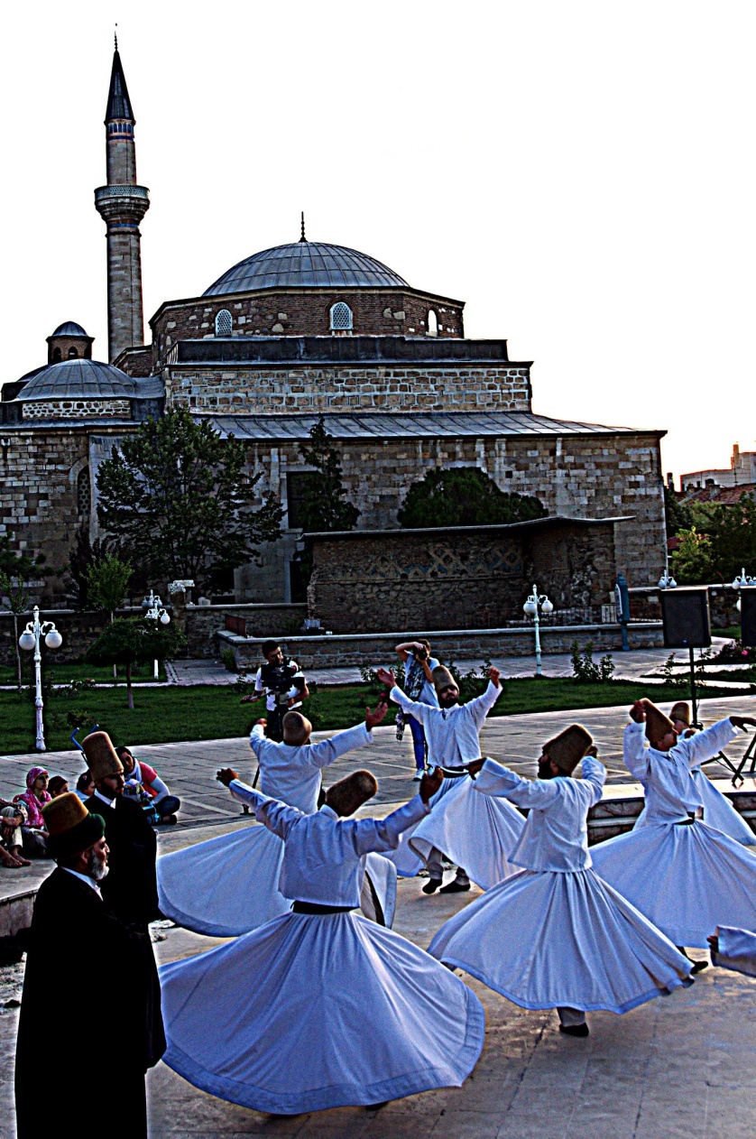

Whirling dervishes at Mausoleum of Mevlana, Konya, Turkey. The Resting Place of Jalaluddin Rumi can be seen in the background. See attribution in chapter References.

Shams-i-Tabriz subsequently returned to Konia and perished there in a tumult, the details of which are not known. To commemorate his friend, Jalaluddin composed his "Diwan-i-Shams-i-Tabriz," putting the latter's name in place of his own as the author. It is a collection of spirited odes setting forth the doctrines of Sufistic Pantheism. The following lines on pilgrimage to the Kaaba[366] afford a good instance of the way in which the Sufi poets endeavour to spiritualise the rites of Islam:—

Beats there a heart within that breast of yours,

Then compass reverently its sacred shrine:

For the essential Kaaba is the heart,

And not a proud pile of perishable art.[367]

When God ordained the rite of pilgrimage (to the Kaaba),

That sign was meant to lead your thoughts to things divine;

A thousand times he treads that round in vain

Who gives one human heart a needless pain[368].

Leave wealth behind; bring God thy heart,

Whose light will guide your footsteps through the gloomiest night

God spurns the riches of a thousand coffers,

And says, 'The saint is he his heart who offers;

Nor gold nor silver seek I,

But above all gifts, the heart, and buy it with My love:

Yea! One sad, remorseful heart which men despise

More than My throne and fixed decree I prize';[369]

The meanest heart that ever man has spurned

Is a clear glass where God may be discerned.

The following ode, translated by the late Professor Falconer, is frankly pantheistic:—

I existed, before a name had been named upon earth,

Before a trace yet existed of anything that has birth:

When the locks of the Loved One streamed forth for a sign

And Being was none, save the Presence Divine.[370]

Named and name were alike emanations from Me,

Before anything that was 'I' yet existed, or 'We';

Before the veil of the flesh for Messiah was created,[371]

To the Godhead I bowed in prostration of thought;

I measured intently, I pondered with heed

(But, ah, fruitless my labour!) the Cross and its Creed:[372]

To the pagod I rushed and the Magian's[373] shrine,

But my eye caught no glimpse of a glory divine;

The reins of research to the Kaaba I bent,

Where hopefully thronging the old and young went;

Candahàr and Herat searched I wistfully through,

Nor above nor beneath came the Loved One to view.[374]

I toiled to the summit, wild, pathless, and lone,

Of the globe-girding Kàf[375], but the Anka[376] had flown!

The seventh earth I traversed, the seventh heaven explored,

But in neither discerned I the court of the Lord.

I questioned the Pen and the Tablet of Fate,

But they whispered not where He pavilions His state;

My vision I strained, but my God-scanning eye

No trace that to Godhead belongs could descry.

My glance I bent inward: within my own breast

Lo, the vainly sought elsewhere! The Godhead confessed![377]

Jalaluddin's chief work, the Masnavi, containing upwards of 26,000 couplets, was undertaken at the instance of one of his disciples and intimates, Husam-ud-din, who had often urged him to put his teaching into a written form. One day, when Husam-ud-din pressed the subject upon him, Jalaluddin drew from his turban a paper containing the opening couplets of the Masnavi, which are thus translated by Mr. Whinfield:—

Listen to the reed flute, how it discourses,

When complaining of the pains of separation:—

'Ever since they tore me from my ozier-bed,

My plaintive notes have moved men and women to tears.[378]

I burst my breast, striving to give vent to sighs,

And to express the pangs of my yearning for my home.

He who abides far away from his home

Is ever longing for the day he shall return;

My wailing is heard in every throng,[379]

In concert with them that rejoice and them that weep.'

The reed flute is one of the principal instruments in the melancholy music that accompanies the dancing of the Mevlevi dervishes. It is a picture of the Sufi or enlightened man, whose life is, or ought to be, one long lament over his separation from the Godhead, for which he yearns till his purified spirit is re-absorbed into the Supreme Unity. We are here reminded of the words of Novalis, "Philosophy is, properly speaking, home sickness;[380] the wish to be everywhere at home."

Briefly speaking, the subject of the Masnavi may be said to be the love of the soul for God as its Origin, to Whom it longs to return, not the submission of the usual pious Moslem to the iron authority of Allah.[381] This thesis is illustrated with an extraordinary wealth of imagery and apologue throughout the six books composing the work. The following fable illustrates the familiar **Sufi doctrine that all religions are the same to God, Who only regards the heart:**—

Moses[382], to his horror, heard one summer day

An ignorant shepherd blasphemously pray:

'Lord!' he said, 'I wish I knew You, where You are,

That for You I might perform a servant's part;

Comb Your hair and dust Your shoes and sweep Your room,

Bring You every morning milk and honeycomb.'

Moses cried: 'Blasphemer! Curb your blatant speech!

Whom are you addressing? Lord of all and each,

Allah the Almighty? Think you He does need

Your officious folly? Will all bounds exceed?

Miscreant, have a care, lest thunderbolts should break

On our heads and others perish for your sake.

Without eyes He seeth, without ears He hears,

Has no son, nor partner through the endless years,

Space cannot contain Him, time He is above,

All the limits that He knows are Light and Love.'

Put to shame, the shepherd, his poor garment rent,

Went away disheartened, all his ardour spent.[383]

Then spake God to Moses: 'Why have you from Me

Driven away My servant, who goes heavily?

Not for severance it was, but union,

I commissioned you to preach, O hasty one!

Most hateful of all things is to Me divorce,

And the worst of all ways is the way of force.

I made not creation, Self to aggrandize,

But that creatures might with Me communion prize.

What though childish tongues trip?[384] 'It is the heart I see,

If it really loves Me in sincerity.

Blood-stains of the martyrs no ablution need,

Some mistakes are better than a cautious creed,

Once within the Kaaba, wheresoever men turn,

Is it much to Him Who spirits doth discern?[385]

Love's religion comprehends each creed and sect,

Love flies straight to God, and outsoars intellect.

If the gem be real, what matters the device[386]?

Love in seas of sorrow finds the pearl of price.'

A similar lesson is taught by the apologue of the "Elephant in the Dark":—

During the reign of an Eastern sovereign, he remarked that the learned men of his time differed widely in their estimate of the Deity[387], each ascribing to Him different characteristics. So he had an elephant brought in secret to his capital and placed in a dark chamber; then, inviting those learned men, he told them that he was in possession of an animal which none of them had ever seen. He requested them to accompany him to the chamber, and, on entering it, said that the animal was before them, and asked if they could see it. Being answered in the negative, he begged them to approach and feel it, which they did, each touching it in a different part. After returning to the light, he asked them what they thought the animal was really like. One declared that it was a huge column, another that it was a rough hide, a third that it was of ivory, a fourth that it had huge flaps of some coarse substance; but not one could correctly state what the animal was. They returned to the chamber, and when the light was let in, those learned men beheld for the first time the object of their curiosity, and learned that, whilst each was correct in what he had said, all differed widely from the truth.

Though a pantheist, Jalaluddin lays great stress on the fact of man's sinfulness and frailty and on the personality of the Devil[388], as in the following lines:—

Many a net the Devil spreads, weaving snare on snare,

We, like foolish birds, are caught captive unaware;

From one net no sooner free, straightway in another

We are tangled, fresh defeats aspirations smother;

Till upon the ground we lie, helpless as a stone,

We, who might have gained the sky, we, who might have flown.

When we seek to house our grain, pile a goodly store,

Pride, a hidden mouse, is there nibbling evermore;

Till upon the harvest day, lo, no golden heap,

But a mildewed mass of chaff maggots overcreep.

Many a brilliant spark is born where the hammers ply,

But a lurking thief is there; prompt, with finger sly,

Spark on spark he puts them out, sparks that might have soared

Perish underneath his touch. Help us then, O Lord!

What with gin and trap and snare, pitfall and device,

How shall we poor sinners reach Thy fair paradise?[389]

Again, in contradiction to logical pantheism, Jalaluddin lays stress on man's free-will and responsibility, as in the following illustration:—

On the frontier set, the warden of a fort,

Far from his monarch and his monarch's court,

Holds the fort, let foemen bluster as they may,

Nor for fear or favour will his trust betray;

Far from his monarch, on the empire's edge,

He, with his master, keeps unbroken pledge;

Surely then his lord his worth will higher own,

Than their prompt obedience who surround his throne;[390]

In the Master's absence a little work done well

Weighs more than a great one when his eyes compel;

Now is the time to show who faith and trust will keep,

Once probation over, faith and trust are cheap.[391]

However much individual Sufis may have fallen into Antinomianism[392] and acted as if there was no essential difference between good and evil, the great Sufi teachers have always enjoined self-mortification, quoting the saying, "Die before you die." This dying is divided by them into three kinds: "black death" (suffering oppression from others), "red death" (mortifying the flesh), and "white death" (suffering hunger). Jalaluddin illustrates this by the following parable:—

A merchant from India a parrot had brought,

And pent in a narrow cage, sorrow-distraught

With longing for freedom. One day the good man

Determined to try with his wares Hindustan;

So he said to his parrot, 'What gift shall I bring

From the land you were born in—what curious thing?'

The parrot replied, 'There are kinsfolk of mine

Flying cheerfully in those woods, for whose freedom I pine;

(Oh, the green woods of India!). Go, tell them my state—

A captive in grip of implacable fate—

And say, "Is it justice that I should despair

While you, where you list, can flash swift through the air,

Can peck at the pineapples and, bathe in the springs,

And spread in the sunlight your green-gleaming wings?"

His message the man took, and made his word good

When he came where the parrots flew free in the wood;

But no sooner the message was given than one

Like lead to the earth fell as dead as a stone.

The merchant upbraided himself, 'It is clear

This parrot of mine was a relative dear,

And the shock has been fatal; myself am to blame.'

When his journey was finished and homeward he came,

His parrot inquired, 'Hast brought me a crumb

Of comfort in sorrow where, caged, I sit dumb?'

The merchant said, 'No; 'twas a pity you sent,

For the message you gave proved of fatal content;

As soon as I gave it, one shuddered and fell

Stone-dead, as if struck by some magical spell.'

No sooner that bird's fate it heard, than his own

On the floor of its cage fell as dead as a stone.

'Alas!' cried the merchant, 'my own bird I've killed—

My own pretty parrot, so Allah has willed!'

Sadly out from the cage the dead body he drew,

When, to his amazement, straight upwards it flew

And perched on a tree. 'Lo! The message,' he said,

'My friend sent—"Die thou, as I make myself dead,

And by dying win freedom." Farewell, master dear,

I caught the plain hint with intelligence clear.

Thyself reckon dead, and then thou shalt fly

Free, free, from the prison of earth to the sky!

Spring may come, but on granite will grow no green thing;

It was barren in winter, 'tis barren in spring;

And granite man's heart is, till grace intervene,

And, crushing it, clothe the long barren with green.

When the fresh breath of Jesus shall touch the heart's core,

It will live, it will breathe, it will blossom once more.'

The last couplet is a good illustration of the different ways in which Christ is regarded by the Sufi poets and by Mohammed in the Koran. In the latter, it is true, He is acknowledged as the Word of God and the Spirit of God, but His work among men is done, having been entirely superseded by the coming of Mohammed, the last and greatest of the prophets. Jalaluddin on the other hand, as in the above couplet, speaks of Christ as still exercising healing influences. Elsewhere he says, referring to the Gospel narrative of Christ's entry into Jerusalem (not mentioned in the Koran), and taking the ass as the symbol of the body pampered by the sensualist:—

You deserted Jesus, a mere ass to feed,

In a crowd of asses, you would take the lead;

Those who follow Jesus, win to wisdom's ranks;

Those who fatten asses get a kick for thanks.

Pity keep for Jesus, pity not the ass,

Let not fleshly impulse intellect surpass.

If an ass could somewhat catch of Jesus' mind,

Classed among the sages he himself would find;[393]

Though because of Jesus you may suffer woe,

Still from Him comes healing, never let Him go.

In another place, speaking of the importance of controlling the tongue because of the general sensitiveness of human nature, he says:—

In each human spirit is a Christ concealed,

To be helped or hindered, to be hurt or healed;

If from any human soul you lift the veil

You will find a Christ there hidden without fail;

Woe, then, to blind tyrants whose vindictive ire,

Venting words of fury, sets the world on fire.[394]

But though he speaks with reverence of Christ, he shares the common Mohammedan animus against St. Paul. As a matter of fact, St. Paul is rarely mentioned in Mohammedan writings, but Jalaluddin spent most of his life at Iconium, where, probably owing to the tenacity of Oriental tradition, traces of St. Paul's teaching lingered. In the first book of the Masnavi, a curious story is told of an early corrupter of Christianity who wrote letters containing contradictory doctrines to the various leaders of their Church, and brought the religion into confusion.[395]

In this case, Jalaluddin seems to have neglected the importance of distinguishing between second-hand opinion and first-hand knowledge, on which he elsewhere lays stress:—

Knowledge has two wings, Opinion has but one,

And opinion soon fails in its orphan flight;

The bird with one wing soon droops its head and falls,

But give it two wings and it gains its desire.

The bird of Opinion flies, rising and falling,

On its wing in vain hope of its rest;

But when it escapes from Opinion and Knowledge receives it,

It gains its two wings and spreads them wide to heaven;

On its two wings it flies like Gabriel

Without doubt or conjecture, and without speech or voice.

Though the whole world should shout beneath it,

'You are in the road to God and the perfect faith,'

It would not become warmer at their speech,

And its lonely soul would not mate with theirs;

And though they should shout to it, 'You have lost your way;

And think yourself a mountain and are but a leaf,'

It would not lose its convictions from their censure,

Nor vex its bosom with their loud reproof;

And though sea and land should join in concert,

Exclaiming, 'O wanderer, you have lost your road!'

Not an atom of doubt would fall into its soul,

Nor a shade of sorrow at the scorner's scorn.[396]

(Professor Cowell's translation.)

Like all quietists, Jalaluddin dwells on the importance of keeping the mind unclouded by anger and resentment, as in the following little parable:—

One day a lion, looking down a well,

Saw what appeared to him a miracle,

Another lion's face that upward glared

As if the first to try his strength he dared.

Furious, the lion took a sudden leap

And o'er him closed the placid waters deep.

You who does blame injustice in mankind,

'It is but the image of your own dark mind;

In them reflected clear your nature is

With all its angles and obliquities.

Around yourself, yourself the noose has thrown,

Like that mad beast precipitate and prone;[397]

Face answers to face, and heart to heart,

As in the well that lion's counterpart.

'Back to each other we reflections throw,'

So spake Arabia's Prophet long ago;

And he, who views men through self's murky glass,

Proclaims himself no lion, but an ass.

As Ghazzali had done before him, Jalaluddin sees in the phenomena of sleep a picture of the state of mind which should be cultivated by the true Sufi, "dead to this world and alive to God":—

Every night, O God, from the net of the body

You release our souls and make them like blank tablets;

Every night you release them from their cages

And set them free: none is master or slave.

At night the prisoners forget their prisons,

At night the monarchs forget their wealth:

No sorrow, no care, no profit, no loss,

No thought or fear of this man or that.

Such is the state of the Sufi in this world,

Like the seven sleepers[398] he sleeps open-eyed,

Dead to worldly affairs, day and night,

Like a pen held in the hand of his Lord.

—(Professor Cowell.)

As we have seen, Jalaluddin's conception of God is a far higher one than is embodied in the orthodox formula of the Koran, *"Say: God is One. He neither begets nor is begotten."* With Jalaluddin God is far more immanent than transcendent. In one place he says, *"He who beholds God is godlike,"* and in another, *"Our attributes are copies of His attributes."*

In a remarkable passage anticipating the theory of Evolution, he portrays man ascending through the various stages of existence back to his Origin:—

From the inorganic, we developed into the vegetable kingdom,

Dying from the vegetable, we rose to animal,

And leaving the animal, we became man.

Then what fear that death will lower us?

The next transition will make us an angel,

Then shall we rise from angels and merge in the Nameless,

All existence proclaims, "Unto Him shall we return."[399]

Elsewhere he says:—

Soul becomes pregnant by the Soul of souls

And brings forth Christ;

Not that Christ Who walked on land and sea,

But that Christ Who is above space.

The work of man in this world is to polish his soul from the rust of concupiscence and self-love, till, like a clear mirror, it reflects God. To this end, he must bear patiently the discipline appointed:—

If thou takest offence at every rub,

How wilt thou become a polished mirror?

He must choose a "pir," or spiritual guide who may represent the Unseen God for him; this guide he must obey and imitate not from slavish compulsion, but from an inward and spontaneous attraction, for though it may be logically inconsistent with Pantheism, Jalaluddin is a thorough believer in free-will. Love is the keynote of all his teaching, and without free-will love is impossible.

Alluding to the ancient oriental belief that jewels are formed by the long-continued action of the sun on common stones, he says:—

For as a stone, so Sufi legends run,

Wooed by unwearied patience of the sun

Piercing its dense opacity, has grown

From a mere pebble to a precious stone,

Its flintiness impermeable and crass

Turned crystalline to let the sunlight pass;

So hearts long years impassive and opaque

Whom terror could not crush nor sorrow break,

Yielding at last to love's refining ray

Transforming and transmuting, day by day,

From dull grown clear, from earthly grown divine,

Flash back to God the light that made them shine.

Jalaluddin did not live to finish the Masnavi, which breaks off abruptly near the end of the sixth book. He died in 1272, seven years after Dante's[400] birth. His last charge to his disciples was as follows:—

I bid you fear God openly and in secret, guard against excess in eating, drinking, and speech; keep aloof from evil companionship; be diligent in fasts and self-renunciation and bear wrongs patiently. The best man is he who helps his fellow-men, and the best speech is a brief one that leads to knowledge. Praise be to God alone!

He is buried at Iconium, and his tomb, like those of all Mohammedan saints, in a greater or lesser degree, is a centre of pilgrimage. The reverence with which he is regarded is expressed in the saying current among Moslems:—

Paigumbar nest, wali darad Kitab

(He is not a prophet, but he has a book)

### Food for Thought

* There are so many faiths that attempt to explain God, human being, soul, and the relation between them. Monotheism, Dualism, Henotheism, Polytheism, Pantheism, Monism, and so many of them. Try to get a sense of what they mean, from the internet.
  + Is there a possibility of Rumi’s anecdote of blind men and the elephant being true with respect to your own religious faith?
  + Or does it even matter? Because even if your faith represents an incomplete or lower truth, you will automatically move to realms of higher truth if you have a clean conscience? Just like that poem on Moses above.
* Rumi touches upon the point of having a ‘Pir’ or spiritual guide. What are your views on the following?
  + If elementary concepts of language and science also need a teacher, advanced matters like that of spirit, clearly need to be taught by experts in that subject, the souls who have realized that truth.
  + Generally, a Graduate teacher is sufficient enough to educate a nursery student. Similarly, a person in the initial stages of spiritual development can benefit from a guide who has not yet gained the full knowledge of spirit. Just like others, their knowledge and character could also have limitations. One should understand, and accept this.
  + Since matters of spirit are very subtle and not easy for mundane senses to comprehend, how does one identify an expert in this subject? In today’s world, there is no dearth of crooks who can feign such elevation by appearance, esoteric talk, proof of authentic pedigree, or even miracles, for selfish purposes. This is probably true for most faiths.
  + One can do some basic priming or self-training through scriptures of varying schools of thought, and in their original form to the extent possible. Many of these have been written by revered individuals, keeping the common person in mind. These too, might have their limitations or even drawbacks, but they can certainly serve as good starting points, and significantly reduce the chances of a person falling prey to mass manipulators and other frauds.
* Rumi was driven by a strong will to be united with his Lord. Is it possible that you too have a strong passion lying dormant within? How do you identify it? Swami Vivekananda said: *“Take up one idea. Make that one idea your life - think of it, dream of it, live on that idea. Let the brain, muscles, nerves, every part of your body, be full of that idea, and just leave every other idea alone. This is the way to success.”*

### References

* Jalaluddin Rumi, Mystics and Saints Of Islam, by Claud Field, 1910.
* Whirling dervishes at Mausoleum of Mevlana, Konya, Turkey. Tim Tregenza [[CC BY-SA 3.0](http://creativecommons.org/licenses/by-sa/3.0) (http://creativecommons.org/licenses/by-sa/3.0)], [via Wikimedia Commons](https://commons.wikimedia.org/wiki/File%3AWhirling_Dervish_-_panoramio.jpg).

# 

Moving Ahead From Here

The preceding chapters barely scratch the surface of treasures stored in great writings. There are a large number of excellent creations that have been instrumental in shaping minds and society over years.

Here is an attempt to put down a compact collection of such, to help readers further progress on the long and arduous road to success. It could open pathways previously hidden from view, and users can decide how to proceed further from there.

We have arrived at this compilation through a synthesis of various reading lists, discussions, opinions and articles over the internet, and other sources. Hope readers find it useful and go through these books according to convenience and desire. Many of them are freely available on the internet.

Another very important aspect of development is to be **in touch with the local culture, developments, and language through local literature**. While it is certainly important to have a global, multi-cultural view, maintaining the connection with one’s own roots has its own charm and benefits. Those obviously are not covered here.

Before listing out the longer reads, we would like to spend some time on the training of very young kids. This would be particularly useful to parents and elders, in early training of the little ones.

### A Word About Children Below Seven

This is an age where children are great at observation and recording/registering what is observed. They are relatively less intent on deeper analysis or reasoning. It is best for them to freely observe, listen, talk, and play, **grasping as much as they can from their natural surroundings**. They often find reading taxing, and so, one might need to **read out to them, or use picture books**.

These formative years, apart from contributing to physical growth, are also crucial in building up of vital pieces of character such as faith, ethics, and inspirations.

The following are some writings that kids can be exposed to at a very young age.

* **Simple Fables, Fairy tales, and Moral stories** such as Aesop’s Fables, or Tales from Jatakas, Fairy Tales from all around, Tales of wit such as Akbar and Birbal, Mulla Nasiruddin, or Tenali Raman.
* **Simple Mythological and Historical Tales** specific to your own culture and faith, as well as a few others. As appropriate, consider narration of the history of your family or your race.
* **Meaningful Poems, Hymns, Psalms, Songs:** Even if their meanings are complex, this is a good age to get the children learn some of these poems, songs, and others by-heart, when the child’s recording capacity is at its maximum. Children learn things even if they listen and recite them in a playful mood. In addition to improvement of pronunciation, these have special value when one grows older and mature enough to decipher their meanings. Such compositions are like vitamin pills stored in their memory, capable of releasing vast amounts of inspiration, knowledge, and vitality at a later time.
* **Mathematical calculations** such as tables up to 20 or 30. They have lifetime usefulness even in today’s digital age.

At this age, not reading, but **listening and repetition** is among the best ways to learn things by heart. Needless to say, it needs efforts on the part of elders.

### Longer Reads

After the initial few years, and after one gets used to reading, longer books can come up next.

In addition to the really long ones, **short stories** by popular authors such as Anton Chekhov, Guy de Maupassant, James Joyce, Flannery O’Connor, O’Henry, Franz Kafka, Allen Poe, among others, are highly recommended.

Again, there are many good short stories, novels, biographies of local heroes, and other writings in local literature and language of every culture, which people should not miss out on.

Readers could also **use chapters in this book as a starting point** and explore more, from mentions in chapter content, as well as books and authors in the references sections.

There is another important thing that needs to be mentioned here. **Audiobooks** are a great way to go through books, and these are getting popular day by day. Not only do they serve as a useful and welcome change from music and other entertainment during travel and the like, but at times attentive listening helps **register information much better** compared to when it is read.

The table below describes some highly acclaimed books of all time grouped by age bands and topics, along with other details such as length, short summary, and others. It would also help users prioritize their reading according to convenience and mood. The total amount of reading material is roughly **2000 hours across all age groups, around 100 book titles in all**. To put it differently, it would need a paltry 2000 hours of a person’s formative years to read each one of these. We have left out books that are very difficult to read, but the list has some titles that are pretty long.

We strongly suggest that readers choose **books of different flavors** rather than sticking to one topic that is more to their liking, and if possible, in the **original language of publication**.

Many of these are already in public domain. They are available for free download on sites such as **gutenberg.org** or **archive.org**, in multiple formats. Their audiobook versions are also commonly available at **libvivox.org**.

|  |  |  |
| --- | --- | --- |
| **Name| Author(s)** | **Culture| Year| Age Group| Hours To Read| Genre / Subject** | **Highlights** |
| **Children And Above** | | |
| Alice’s Adventures In Wonderland| Lewis Carroll | English| 1865| Children| 2.5| Fantasy, Literary Nonsense | Little Alice's adventures after she follows a rabbit down the rabbit hole. |
| Pippi Longstocking| Astrid Lindgren | Norwegian| 1945| Children| 5| Fantasy, Adventure | Hilarious Adventures of a courageous and lovable young girl. |
| The Lion, The Witch, And The Wardrobe| C. S. Lewis | American| 1964| Children| 4.5| Fantasy, Adventure | Four siblings enter the wonder world of Narnia through a wardrobe. |
| The Wind In The Willows| Kenneth Graham | English| 1908| Children| 6.5| Fantasy, Adventure | Adventures of four animal friends. |
| Charlotte’s Web| E B White | American| 1952| Children| 7| Fantasy, Animals | Lovable story of pig Wilbur's friendship with spider Charlotte. |
| The Adventures of Tom Sawyer| Mark Twain | American| 1876| Children, Teens| 6.5| Adventure, Humor | An excessively mischievous Tom's adventures. |
| Around The World In 80 Days| Jules Verne | French| 1873| Children, Teens| 7.5| Adventure | Determined attempt to win a rash bet to go around the world so fast. |
| Fairy Tales And Stories| Hans Christian Andersen | Danish| 1835| Children, Teens| 5| Literary fairy tales | Universally acclaimed fairy tales from the master of that genre. |
| The Time Machine| HG Wells | English| 1895| Children, Teens| 4| Science Fiction | Among the earliest science fiction books, and one responsible for popularizing the concept of time travel. |
| Twenty Thousand Leagues Under The Sea| Jules Verne | French| 1870| Children, Teens| 16| Science Fiction | Dr. Aronnax's expedition to find a sea-monster, and a marvelous underwater journey through Nemo's submarine. |
| The Three Musketeers| Alexandre Dumas | French| 1844| Children+| 25| History, Adventure | Young man wanting to join an elite company of the King's guards. Also brings out injustice of the French monarchy before the Great Revolution. |
| Jonathan Livingston Seagull| Richard Bach | American| 1970| Children+| 1| Inspiration | Jonathan, a seagull who follows his heart to scale new heights, something orthodox elders never understood. |
| The Code Of Woosters| P. G. Wodehouse | English| 1938| Children+| 3| Humor | Funny adventures of Bertie Wooster and his smart valet Jeeves. |
| The Diary Of A Young Girl| Anne Frank | Dutch| 1947| Children+| 9| War, History | Anne Frank's impressions of the times during the Second World War, from her diary. |
| The Story Of Art| E. H. Gombrich | Austrian| 1950| Children+| 17| Art | Introduction to various forms of visual arts from different periods of history. Remains popular even today. |
| Little Women| Louisa Alcott | American| 1868| Children+| 19| Family Drama, Quest, Women | Describes the eventful life of four sisters from childhood to womanhood. |
| Harry Potter Series| J. K. Rowling | English| 1997 - 2007| Children+| 100| Fantasy | Young wizard Harry Potter's determined struggle against the Dark Lord Voldemort. |
| **Teens And Above** | | |
| The Diary Of A Nobody| George and Weedon Grossmith | English| 1892| Teens+| 4.5| Humor | Funny diary of a simple middle-class London clerk Charles Pooter. |
| Hadji Murat| Leo Tolstoy | Russian| 1917| Teens+| 3.5| Historical Fiction | Story of Haji Murad's defection to the Russian side, and his death, depicting horrors of war. |
| Viy| Nikolai Gogol | Russian| 1835| Teens+| 1.5| Horror, Humor | Funny horror of the demonic Viy. |
| Wuthering Heights| Emily Bronte | English| 1847| Teens+| 12| Romance, Violence | A tale of intense love, humiliation, and revenge. |
| Great Expectations| Charles Dickens | British| 1861| Teens+| 18| Relationships, Poverty | Dickens' universally acclaimed novel depicting Pip's great expectations and his journey through thick and thin. |
| Hamlet| Shakespeare | English| 1603| Teens+| 4| Relationships | Story of this prince of Denmark who avenges his father's death. Among Shakespeare's greatest plays. |
| King Lear| Shakespeare | English| 1606| Teens+| 3.5| Relationships | Tragic story of old King Lear and his maltreatment by his daughters. |
| Pride and Prejudice| Jane Austen | British| 1813| Teens+| 18.5| Romance, Humor | Austen's most popular novel with the most popular opening line: "It is a truth universally acknowledged, that a single man in possession of a good fortune, must be in want of a wife." |
| Gone With The Wind| Margaret Mitchell | American| 1936| Teens+| 11.5| Romance, Historical Fiction | Depicts the struggles of a proud young lady, to get out of poverty. Set in the time of American Civil War. |
| A Doll’s House| Henrik Ibsen | Norwegian| 1879| Teens+| 3| Women Rights | A play bringing out issues of women's rights in male dominated society of that time. |
| David Copperfield| Charles Dickens | British| 1850| Teens+| 32.5| Historical Fiction, Adventure | History and adventures of David Copperfield. Dicken's personal favorite among all his creations. |
| The Death of Ivan Ilyich| Leo Tolstoy | Russian| 1886| Teens+| 3| Philosophy | Story of Ivan Ilyich, to whom death suddenly announces itself. Among the best writings on the topic of dying. |
| The Cloak/Overcoat| Nikolai Gogol | Russian| 1842| Teens+| 1.5| Social | Funny touching story of a simple Russian clerk. “We all come out of Gogol’s Overcoat” - Dostoevsky. |
| On The Road| Jack Kerouac | American| 1957| Teens+| 11| Travel, Social | Describing the author's travels through America, his compassion and love for freedom. Highly acclaimed. |
| The Adventures Of Huckleberry Finn| Mark Twain | American| 1885| Teens+| 10.5| Social, Humor | Huck’s Mississippi adventures along with the escaped slave Jim. |
| And Then There were none| Agatha Christie | English| 1939| Teens+| 5.5| Mystery | Story of mysterious killings on an island. |
| The Murder Of Roger Ackroyd| Agatha Christie | English| 1926| Teens+| 7| Mystery | Detective Hercule Poirot solves the case of his friend's murder. |
| The Adventures Of Sherlock Holmes| Arthur Conan Doyle | Scottish| 1892| Teens+| 10| Mystery | Short story collection of a great detective. |
| Key To Health| M. K. Gandhi | Indian| 1954| Teens+| 2.5| Health | Mahatma Gandhi's simple tips for good health. |
| Light On Yoga| B. K. S. Iyengar | Indian| 1968| Teens+| 5| Health | A yoga classic from among the best of yoga teachers. |
| Rich Dad Poor Dad| Robert Kiyosaki | American| 1997| Teens+| 6.5| Business, Wisdom | Learning from two economic perspectives. Advice from an uneducated rich dad, and an educated, but poor dad. |
| Tales From The Arabian Nights| Anonymous | Arabic| Before 900| Teens+| 100| Fantasy | Collection of many tales from different cultures, compiled in Arabic during the Islamic golden age. |
| The Panchatantra (full version)| Vishnu Sharma | Indian| 400 BCE| Teens+| 10| Ethics, Politics, Wisdom | Amusing animal tales on the surface, but in reality, a concise treatise on political science and human conduct. Vishnu Sharma takes up the challenge to train spoilt princes in matters of statesmanship and morality. |
| Steve Jobs| Walter Isaacson | American| 2011| Teens+| 12| Business, Technology | Biography of this awesome nerd of the modern world. |
| The Rise And Fall Of The Third Reich| William Shirer | Germany| 1960| Teens+| 55| War, Politics, History | Depicts the most horrific period of modern world history, the Second World War. |
| My Inventions| Nikola Tesla | Serbian, American| 1919| Teens+| 4| Science | An account of the life, career, and key inventions of this master inventor in his own words, as a series in the Electrical Experimenter magazine. |
| The Periodic Table| Primo Levi | Italian| 1975| Teens+| 8| Science, History | A collection of short stories based on names of elements in the periodic table, based on the author's experiences during the Fascist regime in Italy. |
| Surely You're Joking, Mr. Feynman!| Richard Feynman | American| 1985| Teens+| 13| Science | A collection of this Nobel laureate's personal experiences and experiments. |
| Einstein, His Life And Universe| Walter Isaacson | American| 2007| Teens+| 12| Science | Biography of a great scientist, among the major influencers of the world of science. |
| King Solomon's Ring| Konrad Lorenz | Austrian| 1949| Teens+| 7| Science, Animals | The Austrian zoologist and Nobel Laureate, writes this story of Solomon who has a magic ring that enabled him to speak to animals in their language. |
| Hitchhikers Guide To The Galaxy| Douglas Adams | British| 1980| Teens+| 8| Science Fiction, Humor | Two friends start a tour of space, with help from a Hitchhiker's Guide. |
| A Short History Of Nearly Everything| Bill Bryson | American| 2005| Teens+| 20| Science, History, Humor | Bryson attempts to explain events between the big-bang and now. A very entertaining account of science. |
| Cry Of The Kalahari| Mark Owens | African| 1984| Teens+| 10| Wildlife | Experiences of two zoologists studying wildlife in the Kalahari desert. |
| Silent Spring| Rachel Carson | American| 1962| Teens+| 13| Environment | Among the first books that highlighted problems of environmental degradation due to chemicals. Major contributor to the movement for environmental protection. |
| Raja ShivChatrapati| Babasaheb Purandare | Indian| 2012| Teens+| 25| Politics, Adventure, Social | Among the most popular biographies of the Indian King Shivaji, a statesman par excellence. |
| The Iliad| Homer | Greek| 8 BCE| Teens+| 23| Adventure, History, Epic | First of the Homer's immortal epics, describing the final year of the Greek siege of troy. Full of action and inspiring historical and mythological characters. |
| The Odyssey| Homer | Greek| 1178 BCE| Teens+| 20| Adventure, History, Epic | Homer's second immortal epic, a sequel to the Iliad. |
| Don Quixote| Miguel De Cervantes Saavedra | Spanish| 1605| Teens+| 45| Adventure, Wisdom, Humor | Regarded by many as the most meaningful book of all time. Bitten by the chivalry bug, Don Quixote alternates between a crazy and wise personality, in his search for adventure, along with squire Sancho. |
| The Lord Of The Rings| J. R. R Tolkien | English| 1949| Teens+| 50| Fantasy | Story of a dark lord's ring to become the world’s ultimate power. |
| The Ramayana (full version)| Valmiki | Indian| Unknown BCE| Teens+| 80| Ethics, Adventure, Relationships, Epic | Prince Rama's life story as the basic plot to weave in valuable explanations on economics, nature, politics, morality, and relationships. |
| Bhagavad Gita| Vyasa | Indian| Unknown BCE| Teens+| 2| Religion, Hinduism | Among the foremost and most popular of Hindu philosophical scriptures. |
| Tao Te Ching| Laozi | Chinese| 4 BCE| Teens+| 6| Religion, Taoism | The main text for Taoism. |
| Dhammapada: Sayings Of The Buddha| Translator Gwendolyn Bays | Indian| 300 BCE| Teens+| 4| Religion, Buddhism | Most popular among literature of the Theravada branch of Buddhism. |
| The Koran| Muhammad | Arabic| 632| Teens+| 20| Religion, Islam | The primary scripture of Islam. |
| The 4 Gospels: Mark, Matthew, John, Luke| Bible's New Testament | Christian| 90| Teens+| 9| Religion, Christianity | Books of the Bible's new testament describing the life of Jesus. |
| **Youth and Adults** | | |
| The Great Gatsby| F. Scott Fitzgerald | American| 1925| Adults| 6| Romance | Story of a young millionaire obsessed with a beautiful young lady. |
| Things Fall Apart| Chinua Achebe | Nigerian| 1958| Adults| 7| African Culture | Describes the African culture from their perspective, through the story of Okonkwo, a leader of a Nigerian village. Set around 1900, it depicts eras before and after British colonization. |
| Candide| Voltaire | French| 1759| Adults| 5| Religion, Satire, Education, Politics | A hilarious story of Candide and his friends on a tour to Europe, Asia, and South America. A direct criticism on religion, education, and society. |
| The Sound And The Fury| William Faulkner | American| 1929| Adults| 10| Psychology | A tragedy of the Compson family with members having strong characters traits. |
| One Hundred Years of Solitude| Gabriel Garcia Marquez | Spanish| 1967| Adults| 12| Historical Fiction, Magical Realism | Gradual transformation of a peaceful town of Macondo and its Buendia family; contact of the town with the external world and rise to modernism, which brings its own problems. |
| Nineteen Eighty-Four| George Orwell | British| 1949| Adults| 12| Fantasy, Political, Social | A fantasy world where there are continuous wars, people are manipulated, and independent thought is punished. |
| Dead Souls| Nikolai Gogol | Russian| 1842| Adults| 16| Politics, Satire | Through this story Gogol, in his unique artistic style and sense of humor, brings out the flaws in Russian society of that time. |
| Midnight’s Children| Salman Rushdie | Indian| 1981| Adults| 23| Social, Political, Magical Realism | A mix-up during Saleem's birth, and unexpected happenings. Set during the time of India's independence from British rule and following partition. |
| Anna Karenina| Leo Tolstoy | Russian| 1877| Adults| 35| Realistic Fiction | Among the all-time greatest works of fiction. Parallel storylines of two couples, one gradually progressing in life, and the other sinking. |
| The Brothers Karamazov| Fyodor Dostoevsky | Russian| 1880| Adults| 40| Crime, Relationships, Philosophy | A wonder creation skillfully knitting so many diverse topics together such as love, hate, murder, children, law, and spirituality. Gem of a book by the genius. |
| Les Miserables| Victor Hugo | French| 1862| Adults| 50| Social, Law, Politics, History | A novel highlighting the issues involving politics and judiciary in France of those times, along with so many other topics including architecture. Among the most acclaimed novels of all time. |
| The French Revolution| Thomas Carlyle | French| 1857| Adults| 30| History, Social, Political | Most authors who have written on the French Revolution have used this historical masterpiece as a base. French revolution itself, being a representative one with all colors. |
| The Communist Manifesto| "Karl Marx, Friedrich Engels" | Germany| 1848| Adults| 10| Social, Economics | The manifesto of the communist party. Calls out to the working classes and hits out at capitalist mode of production. |
| The Possessed/Devils| Fyodor Dostoevsky | Russian| 1872| Adults| 26| Social, Political | A violent political satire that many people describe as prophetic, about the nature of the Russian revolution later, and its aftermath. |
| History Of The Russian Revolution| Leon Trotsky | Russian| 1930| Adults| 35| History, Social, Political | A history of this great revolution from one who was actively involved in it. |
| Mao: The Real Story| Alexander Pantsov & Steven Levine | China| 2013| Adults| 16| Politics, Social | Biography of this foremost Chinese and communist leader responsible for converting China from a state of economic backwardness to being a key player on world stage. |
| The Wealth Of Nations| Adam Smith | Scottish| 1776| Adults| 45| Economics | Adam Smith's fundamental work on what builds the wealth of nations. The theories of division of labor, free-market-economics have its roots here. |
| The Essays Of Ralph Waldo Emerson| Ralph Waldo Emerson | American| 1844| Adults| 15| Economics, Politics, Philosophy | Emerson's memorable essays on many diverse topics. |
| Progress and Poverty| Henry George | American| 1879| Adults| 15| Economics, Social | This work expounds the author’s theory about distribution of economic value generated through land and natural resources versus that generated through efforts of the individual. |
| Zero to One, Notes on Startups, or How to Build the Future| Peter Thiel | American| 2014| Adults| 7.5| Business | The legendary entrepreneur explains how to build startups that are not mere increments on something existing, but build something completely new. |
| Business Adventures| John Brooks | American| 1969| Adults| 13.5| Business | Twelve fascinating tales on business and corporate life that are as relevant today as they were 50 years back. Highly praised by Warren Buffet and Bill Gates. |
| The Intelligent Investor| Benjamin Graham | American| 1949| Adults| 20| Business | A very widely acclaimed book on Value Investing, for the layman who wants to invest and grow his money steadily. |
| Lincoln| David Donald | American| 1996| Adults| 15| Politics, Social | An excellent biography of the life and presidency of Lincoln, probably the best of all American presidents. |
| The Art of War| Sun Tzu | Chinese| 5 BCE| Adults| 10| Military | Master Sun's treatise on military strategy, still widely used. |
| The Republic| Plato | Greek| 380 BCE| Adults| 15| Philosophy, Politics | Many of today's experts consider this to be the best book on philosophy ever, even knowing that most of Plato's thoughts are known to be incorrect! |
| The Arthashastra| Kautilya or Chanakya | Indian| 2 BCE| Adults| 30| Economics, Military, Politics | An ancient Indian treatise on economics, politics, and military strategy, by the master statesman Kautilya. |
| The Law Of Success| Napoleon Hill | American| 1925| Adults| 35| Self-Improvement | Written at the behest of Andrew Carnegie, through interviewing various kinds of successful people. A clearly documented path to Personal success. Much more elaborate than his bestseller “Think and Grow Rich”. |
| The Kamasutra (with Jayamangala commentary)| Vatsyayana | Indian| 2| Adults| 15| Love, Enjoyment, Sex | Kama=Pleasure, Sutra=formula. Discusses aspects of pleasure, which is a vital object of Human pursuit ('Purushartha'), along with the other 3, namely, Virtue, Wealth and Spiritual Liberation. Encourages ‘literacy’ in pleasure activities. Discusses courting, sex, happiness in married life, arts, and games for pleasure. Sex is a focus, but covers less than a quarter of the book. |
| The Mahabharata (Complete translation)| Vyasa | Indian| 900 BCE| Adults| 350| History, Epic, Adventure, Philosophy, Politics, Relationships | Vyasa's epic poem about strife between the Pandavas having Krishna as their mentor, with their cousins the Kauravas. A highly entertaining encyclopaedia of all kinds of knowledge such as philosophy, politics, morality, economics, personal relationships. |

### Thank You

We hope our readers enjoyed reading this book and also found useful takeaways.

We will now conclude with this small verse from the Upanishads.

**In Sanskrit:**

Asato ma sadgamaya,

Tamaso ma jyotirgamaya,

Mrityorma amritamgamaya.

Om shantih shantih shantih.

**This in English means:**

Lead us from falsehood to truth,

From darkness to light,

From death to immortality.

Om[401], May there be Peace, Peace, Peace.

--Brihdaranyaka Upanishad 1:3:28.

**~ The End ~**

Editor Bio

Parikshit Samant is the founder of OpulenceSix Digital, a technology based digital media company having education and entertainment, as its key focus areas. He is a technologist with extensive experience of the computer software industry, as well as an avid reader with varied areas of interest.

Among other things, his prior experience includes identification and analysis of quality digital content pertaining to public perception, such as user opinions and popularity lists. This went a long way in helping select a balanced mix of quality extracts for this compilation.

Prior to founding OpulenceSix, Parikshit has engineered software products for some of the world’s leading technology companies, during his long stint with Persistent Systems, and other independent consulting engagements. He holds a Masters Degree in Computer Science and Engineering from Indian Institute of Technology, Mumbai, India.

1. Experts say about Plato’s ‘Republic’. Though most of the points described in the book are known to be incorrect today, it continues to be among the best Philosophical works ever!
2. Famous Buddhist Monastery.
3. Buddhist fellows (Brothers) are supposed to lead a life of righteous behavior.
4. In Uttar Pradesh, North India.
5. People with a propensity of goodness and engaged in the pursuit of knowledge.
6. Or Taxila, currently a part of Rawalpindi district of Punjab, Pakistan.
7. According to Hindu mythology, eclipse is caused by Rahu, a demon planet, swallowing the Moon.
8. Or Pretas, the dead souls.
9. Demon.
10. In Buddhism, the five kinds of wickedness resume to abstinence from: 1. Taking lives. 2. Theft. 3. Adultery, 4. Falsehood, 5. Intoxicants. The Five kinds of virtue are: 1. Compassion. 2. Generosity 3. Contentment. 4. Truthfulness. 5. Watchfulness.
11. Four truths in Buddhism, namely the truths of suffering, cause of suffering, end of suffering, and path to end suffering.
12. Angulimala was initially a fierce dacoit. However, after chancing to meet Buddha, he got completely transformed, shed his unrighteous behavior, and became Buddha’s disciple.
13. Crop is a muscular pouch near the throat of many birds, and used to store food temporarily. In pigeons and a few other birds, the crop also produces crop milk to feed new ones.
14. Lilliput, an island inhabited by tiny people, from Jonathan Swift’s Gulliver’s Travels.
15. Newton’s discovery that white light is composed of many colors.
16. Remember, this is a story being narrated by a Grandfather, Mr. Temple, to his grandchildren. George and Edward are brothers. Edward is afflicted with a disorder of the eyes, and has them covered.
17. Australian fast bowler Fred Spofforth, called ‘The Demon Bowler’.
18. A delivery that hits the cricket pitch around a batsman’s toes. Due to high speed, the ball might hit the stumps or legs before the batsman can get his bat down to block or hit the ball.
19. The story was written in 1918, around the end of the First World War.
20. Having foresight.
21. Three level hierarchy of attendants, to make a show of high status.
22. Or Shravasthi, Uttar Pradesh, North India.
23. Buddhist brotherhood.
24. Clarified butter.
25. I.e. an alms-bowl, three cloths, a girdle, a razor, a needle, and a water-strainer.
26. Pieces of cloth. Not sewn clothes as in present day.
27. I.e. ashamed to act sinfully, even when he was a water-demon in his previous life.
28. In Uttar Pradesh, North India.
29. Moon.
30. Sun.
31. Vessavana is another name for Kubera or Kuvera, the Hindu god of wealth, half-brother of Ravana, the demon-king of Sri Lanka in the Ramayana. As it appears from Jataka No. 74, Vessavana had rule over Tree-sprites as well as Water-sprites, holding his office as directed by Sakka (or Indra), the king of heaven according to Buddhist cosmology.
32. First of the four stages in the path to enlightenment for Buddhists.
33. A pious poem by Robert Southey, ‘The Old Man’s Comforts’, in which Father William explains how, leading a virtuous and restrained life in youth resulted in contentment in his old age.
34. Yes, Alice had messed it completely.
35. E.g. Heaven, Hell, better environment in next birth etc., as per religious faith.
36. White Alley, Bully Taw, fine fancy marbles.
37. Meaning warrior or fierce.
38. Syracuse is now a part of Sicily, a region in South Italy.
39. These two brothers, who became the masters of Syracuse after a sequence of events following the murder of King Hieronymus. And they, along with people of Syracuse, became rivals of the Romans.
40. Attacking the walled city of Syracuse from both sides, land and sea.
41. Strong wooden shelter with sloping roof, under which soldiers take cover and move forward, used during sieges.
42. Battleship, see image of quinqueremes and Sambuca.
43. See figure of quinquereme. One quinquereme in a pair had oars removed from the right, other from left side.
44. See figure of quinquereme and Sambuca. Prow is the front part, and stern is the rear part of the quinquereme.
45. Projectiles/Stones thrown with excessive force went over the battleships and fell farther away.
46. Something like a heavy weight suspended from a rope swinging from a crane raised high above the battlements, and flinged on the Sambucae and ships, to smash them.
47. See the picture of the ‘Claw of Archimedes’.
48. Remember, the Sambuca and quinquereme combination looks like a harp.
49. Hiero of Syracuse had asked Archimedes to fortify the city.
50. Panchatantra Book 1, ‘Mitra Bheda’ or ‘Loss of Friends’, Story of ‘Bhasurak Lion’.
51. Western art music composed between 1720-1830. Somewhat simpler than the previous style, namely, Baroque Music.
52. Period of Romanticism; it was the literary and artistic movement in the second half of 18th century Europe. Music too became more sentimental in this period.
53. Austrian composer (1732-1809).
54. The water falling down from the dam rotates the water turbine that drives the grinding of flour.
55. Glued to the cross bar so that they could move wings, but not fly, and the force generated by their attempt to fly rotates the crossbar. The insects were glued in such a direction that their natural movement of wings led to a rotational movement of the crossbar.
56. Probably transmitting the rotational force through some thread/belt and pulley mechanism to the other disk kept beside.
57. A stadium for chariot or horse races (in ancient Greece or Rome).
58. Go Back Satan! Originally, a spell used by Catholics to repel evil demons and other evil spirits. Also used to express strong objection to some disagreeable action.
59. The prince of monkeys, son of Vali, the dead brother of monkey king Sugriva.
60. Previously, monkey troops had scattered away in fright, just at the sight of the huge Kumbhakarna. Angada had to persuade them to get ready to fight.
61. The divine eagle, king of birds.
62. Warriors fighting from chariots.
63. The foremost of monkeys, son of Varuna, the wind god.
64. Guha (hunter) killing the Krauncha (heron); is the event that led an angry Valmiki (the composer of Ramayana) to compose the Ramayana in the rhythmic structure of words that he used to curse the hunter.
65. Hanuman, son of the wind god, Vayu.
66. King of the demigods.
67. Flame tree petals.
68. Indra, the king of demigods, whose weapon is the thunderbolt.
69. Yama, the god of death.
70. Rama, also called Raghav, the descendant of Raghu.
71. I.e. Angada, grandson of Indra who wielded the thunderbolt.
72. Demon.
73. The father of Sugriva, who was produced from the yawn of Prajapati (or Lord Brahma, the creator of the world).
74. I.e. Hanuman.
75. Mountain in the vicinity of Lanka.
76. According to Hindu religious texts, a Yuga is a cycle of four parts. The Satya Yuga, Treta Yuga, Dwapar Yuga and Kali Yuga. Universal dissolution happens at the end of the Kali Yuga.
77. Lakshmana, son of Sumitra, Rama’s younger brother.
78. Rakshasa, Demon.
79. Lakshmana, Sumitra’s son, the enhancer of her happiness.
80. Airavata, the elephant, vehicle of Indra (the king of demigods).
81. Elephant bearing the weight of earth, Indian mythology.
82. Mighty demons and others that Rama had slain before.
83. Deities (demi-gods) or Danavas (other demons).
84. Rama, a descendant of Ikshvaku.
85. Tall tree found in the Indian subcontinent. Previously, Rama had shot a single arrow that pierced seven Saal trees in a row, to demonstrate his strength to Sugriva.
86. Of Vayu, that weapon of the wind.
87. Mythological celestial deity (god) with a horse’s head.
88. According to Hindu mythology, eclipse is caused by Rahu, a demon planet, swallowing the Moon.
89. Nishachara, demon who moves around at nighttime.
90. Purandara is Indra, cutting off the head of demon Vrita.
91. People with a propensity toward goodness and engaged in the pursuit of knowledge.
92. Guhyakas, Yakshas, Gandharvas, are different types of celestial beings in Hindu mythology.
93. I.e. Ravana.
94. Vaccines for some of these had not been discovered at that time.
95. Books, Guide to Health, or Way to Health.
96. While this extreme opinion would not hold for all cases, it is often true. E.g. Antibiotics rendered ineffective, with bacteria getting more and more resistant to them.
97. As our understanding of the body improves, nature of diseases also changes, so this gap seems to be closing very slowly.
98. Quarter of a Rupee.
99. Again, seems too extreme an opinion, but seeking help of doctors for every minor issue is also another extreme commonly noticed.
100. Spongy.
101. Animals kept for meat.
102. Luxury provided by nature, by itself.
103. Roots for animals in winter, since winter farming is not possible in temperate regions.
104. Tuscany province, Italy.
105. Upset, as in disturbance in digestive system.
106. Six pennies worth.
107. Progressive women.
108. I.e. every science, art, trade etc. is based on the patronage of the wealthy.
109. Trading as best means to earn a living is a conclusion drawn by this trader, considering his background and current position. Likewise, different people might find other options more suitable. What is more important is the description of key challenges in pursuing those means.
110. The Panchatantra was written around the third century BCE when probably, metal utensils were also uncommon. In modern times, it could be a cool electronic gadget or something similar.
111. Background: In 1420, the treaty of Troyes resulted after English King Henry V’s successful military campaign in France. As a part of it, a marriage was arranged between Catherine, daughter of the elder King Charles VI, and King Henry V. **It was further decided that Henry’s heirs would inherit the throne of France, instead of the heir apparent Dauphin Charles VII, who was disinherited from the succession. Joan of Arc’s attempt was to restore Charles VII as the rightful King of France instead of the English King**.
112. North-East France.
113. Visions of Saints and Angels, it is said.
114. Slightly South-West of Orleans.
115. Heir apparent, to the throne of France.
116. It refers to the sixth to fourteenth century Europe, mostly known as the time of ignorance and superstition. This is seen in the treatment of Joan of Arc. Some people say that this age is not valued as high as it should, and there was in fact, “Wisdom in the dark/middle ages” too.
117. Near Orleans.
118. Christian hymn of praise.
119. And the Burgundians, who allied with the English.
120. Also an ally of the Burgundians.
121. Satan or Devil, mythological figure who brings evil and temptation.
122. Enough to understand that these are different internal components of the machine. We need not go into more details in this biography.
123. Manual help needed for the reaping process: Cutting (Sickler), Aligning (Cradler), Gathering (Raker), and Binding (Binder) the crop.
124. The author distinguishes between people who often travel for study, business, leisure, etc., and the carefree, mischievous, adventurous traveler, the group he identifies himself with.
125. Shylock, the main antagonist from Shakespeare’s famous play, ‘Merchant of Venice’, was based in Rialto, the central area and commercial heart of Venice. He lent money to Antonio at a security of a pound of flesh next to Antonio’s heart. Shylock says: *“What news on the Rialto?”*
126. In those days of epidemics like plague, ships were required to be isolated for many days before passengers and crew could go ashore.
127. These greats have helped shape many minds and societies, in diverse spheres of life. Be it philosophy, art, politics, mathematics, or science. Greece had its golden period around 300-500 BC.
128. The part, ‘world and dyspepsia and bile’ probably implies that a person who has not travelled becomes narrow-minded, and feels that the world is made solely for his enjoyment. And the only enjoyment he knows of, because of ignorance, is (over-)eating. He also feels that bile (fluid for digestion, could also mean irritability) or indigestion/dyspepsia that overeating leads to, are for him alone.
129. We don’t see any reason why this should not apply to other vandals as well!
130. People who had migrated to America from all over the world, and had just received American citizenship.
131. Because most of the inhabitants of the US are well qualified people from all over the world who migrated there for better opportunities. Native people are few.
132. Many people coming there do not know English, but they don’t mind it, because liberty and justice are the main desires of their hearts.
133. To trade upon nationality is to show disloyalty to the nation. Stars and Stripes means the US flag.
134. People might get disappointed by what they experience in the US because they had high expectations about the quality of justice, and many other aspects of the country.
135. Because, if a new citizen has dreams of America being much better than what the reality is, that citizen can improve America based on ideas from his dreams.
136. Hunting enthusiast.
137. Packing material.
138. In Russia names have patronymics such as -ich, -vna, and others. For example, a male whose name is Fyodor and father’s name is Mikhail would be called Fyodor Mikhailovich, and a female whose name is Anna and father’s name is Timofey will be called Anna Timofyevna.
139. A huntsman's assistant, who brings straying hounds back into the pack.
140. Vladimir had been a house serf before.
141. Some concepts that seem universally true at a particular point in time often change or reduce in importance, either with time, as new situations form up, or as new discoveries are made. And then, there are those classics that remain truthful and youthful, in principle for sure, for decades or centuries together.
142. Having stood the test of time. What was useful long back, and useful even today.
143. Glorious empires of Rome and Athens continue to inspire many people even today. Similar is the case with classic literature.
144. Study of classics compared to modern languages. The benefit of studying classics is the positive effect that study had, in shaping thought and actions of people over time, therefore, destinies of societies. Has greater and greater collective impact as time progresses.
145. People not exposed to classics will judge excellence based on their narrow view of the world as per their position.
146. Persons without education are often either too stubborn or too wavering in their convictions. This is because they have not been exposed to reading varied literature, which helps make such decisions with confidence.
147. It is not clear which writer he is referring to, but is essentially saying that this writer criticizes classical education because he himself has not studied classics.
148. Knowledge of things like say, knowledge of making furniture. That can be taught by teaching carpentry practically, and not reading about it.
149. I.e. Classical education.
150. Purely theoretical professional knowledge produces frauds who don’t have practical skill, while purely classical knowledge could produce persons interested just in showing off academic learning and finery of language.
151. Falstaff is a character in Shakespeare’s King Henry IV, who gave a speech denouncing ‘Fighting for Honour’, saying that it serves no purpose.
152. Ancient weapons. Some figures are given in the chapter on Archimedes.
153. Vitruvius has dedicated this work to Caesar Augustus.
154. Don Diego de Miranda, a gentleman whom Don Quixote had met previously.
155. Imaginary lovely lady, a fantasy in Don Quixote’s mind, and his primary motivation.
156. Lion whelp (petty cub) against me, and in day time?
157. Remember, this madman felt lions were mere enchantments by malicious enchanters.
158. Brought his brains to a crisis situation.
159. He is explaining the difference between ordinary knights who do heroics for entertaining others, and knight-errants like him, who do it for long lasting glory.
160. North-West of France.
161. This was written in 1906. Diagnostic methods like X-rays were discovered later.
162. Tuberculosis.
163. The fourth name(s) got added to the list long after 1906, when this biography was written. The first antibiotic to cure the disease, Streptomycin, was co-discovered by the American duo, Albert Schatz and Selman Waksman in 1943.
164. Tuberculosis, at that time.
165. Addison’s disease, named after him.
166. Europe and America.
167. Along with Auscultation, Laennec had also written articles on pathological anatomy, diagnosis based on observation of organs and tissues through various means.
168. Les Médecins Bretons par Dr. Jules Roger. Paris, J. B. Baillière, 1900.
169. Hippocrates died over 1500 years before Laennec was born, still was his main inspiration.
170. Method of clinical examination where surface of the chest or abdomen is tapped, to determine underlying structure based on sounds generated.
171. Most of those who heard Laennec’s lecture once, would always attend all others.
172. Dictionary of medical sciences.
173. The full title of this work of Laennec's is "De l'auscultation médiate ou traité du diagnostic des maladies des poumons et du coeur par R. T. H. Laennec." Its modest motto is the Greek sentence: “The most important part of an art is to be able to observe properly.” The book was published in Paris by J. A. Brosson et J. S. Chandé, rue Pierre-Sarrazin, No. 9, 1819.
174. Giorgio Baglivi, Armenian-Italian physician and scientist.
175. Laennec, Sa vie et son oeuvre. Par Dr. Henri Saintignon. Paris, J. B. Baillière et Fils, 1904.
176. Empire before French revolution.
177. Translated from Latin means, “That Happy Turn.”
178. Kausalya, Sumitra and Kaikeyi, wives of Rama’s father, King Dasharatha.
179. One meaning of Chaitya is a kind of tree. But a different meaning of the word is probably intended here, which means sacred public place of worship, like temples. It is unclear whether these contained idols or not, since the Ramayana (or even the Mahabharata for that matter) is not very explicit about idol worship. Additionally, around that time, the deities (or demi-gods, or angels, depending upon what different people call them) were said to interact with people directly.
180. On a lighter note, before concluding.
181. From micros small, megas large.
182. Geometer, a person skilled in Geometry. This is how the text reads in the first editions. Others, in place of "geometers," put "algebraists."
183. Sphere, earth, 1 league is roughly 5 kilometers.
184. Relating to the craze for ideal proportions of a person’s body parts in artists of that time. David, Vitruvian man etc.
185. The hydraulic screw jack is based on Pascal’s law.
186. Pascal became a very great geometer, not in the same class as those that contributed to the progress of science with great discoveries, like Descartes, Newton, but certainly ranked among the geometers whose works display a genius of the first order.
187. Voltaire had been persecuted by the theatin Boyer for having stated in his Letters on the English that our souls develop at the same time as our organs, just like the souls of animals.
188. English savant, author of Astro-Theology, and several other works that seek to prove existence of God through detailing the wonders of nature; unfortunately he and his imitators are often mistaken in their explanation of these wonders; they rave about the wisdom that is revealed in a phenomenon, but one soon discovers that the phenomenon is completely different than they supposed; so it is only their own fabrications that give them this impression of wisdom. This fault, common to all works of its type, discredited them. One knows too far in advance, that the author will end up admiring whatever he has chosen to discuss.
189. One fathom = 6 feet.
190. Many more moons of Saturn were discovered after that. 63 as of this writing, and many moonlets have also being found.
191. Referring to Huygens, who discovered the rings of Saturn.
192. A tribunal whose job was to work on spotting beliefs contradicting the orthodox ones, in order to suppress them.
193. According to Gregorian calendar, which replaced the Julian calendar in 1582.
194. In French *philosophe,* meaning a lover of wisdom.
195. Petty fights of minute people such as conquering and losing small villages here and there, mean nothing to such mighty beings.
196. A small increase in small still is (tends to) small, compared to someone very large.
197. It was said that they believed seeing tiny human beings inside the human sperm while observing it under the microscope!
198. Sight-vane, a piece of metal with a hole in it, attached to an instrument that can make angular measurements, from which lengths can be calculated using geometric principles.
199. That small number of people is the wise minority, whom the remaining majority of mad and wretched masses hold in poor regard. Essentially, both look down upon each other.
200. The story is written in 1737, so Voltaire is referring to the war between the Turks and the Russians, from 1736 to 1739.
201. Refers to Crimea.
202. Here is the passage such as it is transcribed in the edition dated 1750: "Entele'xeia' tis esi kai' lo'gos toû dy'namin e'xontos toude' ei'nai." This passage of Aristotle, On the Soul, book II, chapter II, is translated thus by Casaubon: *Anima quaedam perfectio et actus ac ratio est quod potentiam habet ut ejusmodi sit*.
203. This philosopher gave a complex and seemingly intelligent looking explanation of the soul, finally saying that ‘It was all clear to him.”
204. Just like the previous one, another seemingly intelligent and complex explanation. He says that God could communicate ‘thought’ into ‘matter’ (i.e. the act of thinking within a human body).
205. Iliad, I, 599.
206. There could be different interpretations of this ending unless one believes that “there is no point” interpreting. Could be that Voltaire could not think of anything better, or that the Sirian left it blank because he felt that people here were too egoistic to understand such things; and secretary of the academy (kind of proving him true) remarked that the Sirian had nothing to tell in reality.
207. No person owns property, for it is the ownership of the entire community.
208. I.e. The idea of having all property as a shared resource across all members of society.
209. A person always wants ownership if we go by natural instincts. But on thinking clearly, one could realize that there is benefit in relaxing this ownership.
210. Slowly, as men understood different ways of living in an organized manner, they realized that unlimited property in every respect was actually a nuisance for them too.
211. Child of a slave is a slave, and so on.
212. Piling debts in the Roman Republic created a situation where wealth and land was concentrated in the hands of very few, leaving the multitudes poor. Some people realized this and spoke out.
213. Slaves were considered as ‘property’ that could be exploited as the owner chose. People noticed the injustice in this, and so, severely restricted rights on slaves.
214. One with great possessions locked up, is a sinner, and so, extremely difficult for him to attain heaven.
215. Since long, people have been talking about individuals having only a limited scope of property ownership (type of property as well as quantity).
216. It is only now, 1900 years after Christ, people realize that human beings (slaves) are not property, and the idea of unrestricted rights on other kinds of property (land, water, mines) is starting to be questioned now.
217. Seems weird that in order to achieve the same objectives of liberty and happiness, one group says that personal property should be scrapped entirely, and the other group says that distribution should be done to such an extent that every individual has personal property. And the cause of confusion is that property means much more than house, land and water.
218. These questions span many different branches of study and under control of different kinds of institutions.
219. The more areas the government (state) takes over from Private enterprises, the more complex the government (state) becomes and more sophistication is needed in its control and criticism. Which in turn, needs more mature citizens, press, and political structures.
220. The interests of workers and owners are by nature, conflicting with each other. They cannot be satisfied together.
221. The class conflict is understandable, but it does not mean that a healthy socialist government (state) will result due to that conflict. Rather, due to complications described previously, what is more likely to follow is a socially destructive process. For instance, Marxism (Socialist/Communist theories proposed by Karl Marx and Engels) has not proved creative in Russia.
222. Various international associations of Socialist and Communist groups across national boundaries.
223. International ideas can be reached not just by socialist thoughts, but even through individualist thoughts, like those of Adam Smith described ahead.
224. Loss of confidence on the thought that Roman Empire was Holy, and Rules laid down by the Church were final.
225. This chapter is a part of a book on world history.
226. Because different ideas are unclear or unconvincing, it is difficult for people to start working toward those.
227. Thoughts are getting clearer day by day.
228. Because the world has become one community, disjoint and disputable administration of natural resources by groups owning them, without a common agreement, might cause greater harm to society.
229. War is not even a clumsy way of settling issues between communities, it is purely ineffective. So, settling issues effectively needs controls and authorities of very high comprehensiveness.
230. There are too many resistances for world unity through a common government of the world.
231. Though all religions talk of universal brotherhood, and every man should serve entire mankind, people do not act according to those principles due to ego, distrust and other evils.
232. Christianity had lost its sway over Europe around the sixth and seventh centuries. Islamic powers also rose during that period.
233. Socialism is based on collective national property, Internationalism on collective global property.
234. Anyone who has been exposed to these problems realizes that the basic organization structure and education needed to solve these complex riddles, does not exist yet.
235. The number of scientific discoveries and inventions that transformed the way society looked at nature. Centered in Europe between 16th to 18th centuries.
236. Refers to the American War Of Independence, between Britain and its 13 American colonies (1775-1783).
237. Convulsion refers to the upcoming French revolution, set to strike at the heart of French monarchy and change the political structure from Monarchy to a Democratic Republic.
238. Courts of many small kingdoms envied the French monarchy because it was so successful.
239. National Assembly controlled by commons decided to take charge of affairs and keep monarchy under control.
240. King Louis of France was unhappy with the commons keeping monarchy under control, and so, got together all his troops spread in various French provinces.
241. The absolute rule of the King swiftly collapsed.
242. Changing so many established procedures was a very difficult task for the gathering of commons. They finally abolished all the unjust rules that the absolute rule of monarchy had put up.
243. Monarch/King that operates under rules set down by the constitution rulebook. Powers of monarch are limited.
244. Limited size of government machinery under the King’s control; palace of Tuileries was in Paris, and could be kept under closer observation than Versailles.
245. Opinion contradicting with orthodox Christian doctrines.
246. Judges were appointed for temporary periods by common people, who had become very powerful. So, judges had to act according to popular will of people (ones supposed to be sitting in the gallery, as spectators). As if people were actual judges, and judges were helpless spectators.
247. Authority of the church headquartered in Rome to appoint lower members like priests, was also disregarded. They too were elected by people directly.
248. Not following the Roman Catholic Church (headquartered in Rome), but only in term of its hierarchy (from Pope, downward). Other religious rituals would remain same.
249. The king fled to join the aristocrats who were in exile, to fight the uprising of commons with support of foreign armies from the East of France.
250. Support for government of people and their elected representatives.
251. Became the National Anthem of France.
252. Foreign armies could not hold against these highly inspired armies. France was the leading European power during the time of Louis XIV.
253. King Louis of France was executed by the new Government. And England in protest of this act, expelled the representative of France in England.
254. The navy needs special skill and discipline. Due to the release of aristocratic officers who possessed those skills, the French navy suffered badly.
255. Initially, Britain had showed support for the French revolution through a liberal movement.
256. In North Holland.
257. Provinces toward North of the Italian peninsula.
258. In his article, “French Revolutionary Wars,” in the Encyclopedia Britannica.
259. Normally, soldiers of an army without basic supplies like tents, rations etc., would have got upset and deserted the army. But the French Army was highly inspired by national pride, and so, was prepared to face all hardships.
260. Instead of carrying heavy supplies, which also add to delays, the troops sustained on whatever they could find wherever they went.
261. Old style warfare that compelled to take a thoughtful decision before action, against the new strategy of taking quick action even with some risk. Compare each of these new techniques with older ones: Rapidity of movement vs. cautious maneuvering, inexperienced but full nation involved in war vs. small but professional armies, tentless camps (bivouacs) vs. proper tents, requesting supplies as needed vs. taking full stock of rations, and use of force vs. clever treachery.
262. Enthusiasm was misdirected, the French troops were unclear on whether they were liberating countries or merely looting them.
263. Finances of French Government were not in good shape, so looting treasures relieved its stress somewhat.
264. Foreign policy of France under the Directorate was still like that of the Monarchy.
265. The Austrian princess agreed to marry him, and a brief period of friendship between France and Austria followed that marriage.
266. Charlemagne, King of Franks, also had got himself recognized by the Pope, to grant himself divine legitimacy in everyone’s eyes.
267. All nations were weary of the long wars.
268. British rulers.
269. Shivaji, the valiant Indian king who initiated the fatal assault against oppressive Muslim rulers of foreign origin (1630-1680); Krishna, from the Mahabharata, who urged a deluded Arjuna to battle his own kin without worrying about the results, since it was his holy duty to fight for righteousness; Mazzini and Garibaldi, two among the trio of Cavour, the brain, Mazzini, the soul, and Garibaldi, the sword, that spearheaded the movement of Unification of Italy during Austrian domination (mid-19th century).
270. Krishna, the destroyer of Kamsa, and Rama the descendant of Raghu.
271. I don’t mind being put into prison, if that prison is within my independent nation.
272. Meaning ‘Gathering of Friends’ in Marathi
273. Elsewhere in the book, Savarkar says that it was Krishna who actually lived as per principles of Utilitarianism, much before it was proposed as an ethical theory by Bentham in its modern form, “To maximize well-being of entities having feelings.” Also mentioned later in this passage.
274. Followers of Vedanta, a Hindu philosophy based on the Upanishads.
275. Vinayak. D. Savarkar’s elder brother, Ganesh.
276. The entire verse from Mahabharata, Karna Parva 69-58 is: धाराणाद् धर्ममित्याहुधर्मो धारयते प्रजाः। यत् स्याद् धारण संयुक्तं स धर्म इति निश्चयः।।

     Dharanaat dharma mityahu dharmo dharayate prajaha, Yat syad dhaaranasamyuktam sa dharma iti nischayaha. It means: Dharma (Righteous conduct) sustains the society, Dharma maintains mankind, Dharma ensures well-being and progress of Humanity, Dharma is indeed that, which fulfils these objectives.
277. King Shivaji had escaped from the Mogul King Aurangzeb’s confinement from Agra (near Delhi).
278. A traitor in the history of Marathas.
279. Part of a composition by the poet saint Samartha Ramdas: “Tirthakshetre Bhrashtavili”
280. Liberation from Political domination was one big step toward that ultimate goal of spiritual liberation. All practices for spiritual liberation could not be freely followed without Political freedom. In other words, mature and advanced stages of political liberation mean spiritual liberation.
281. Dasbodh, a spiritual text in poetic form, in Marathi language, by Samartha Ramdas. Along with spirituality, it also has a detailed description on day-to-day living with smartness and prudence.
282. From the BhagwadGita verse 4.8: ‘Paritranaya Sadhunan Vinashay Cha Dushkritam Dharmasansthapanarthay’.
283. Resolution of Quit India, need to be passed before the struggle began.
284. Violence.
285. I.e. whom the people put in a position of trust.
286. Disciplined, dedicated practice.
287. These genuine gestures should not be confused with those needed to maintain political protocols, or ordinary hypocritical ones wanting to put up a show of magnanimity or even worse, ordinary crooks. Anyone with reasonable alertness and common sense can differentiate between these.
288. In the thirteenth century, the Roman Catholic Church, which had control over teachings of Christianity, established a court to try heretics (i.e. people with beliefs opposing orthodox Christian doctrines as per the Catholic Church). Those convicted would be punished, even executed. This was the dark period of inquisition.
289. Cardinal, head of the inquisition committee that punishes heretics.
290. Their father, not a man of good character.
291. Their elder (and step-) brother, who also disliked his father, and had a big quarrel with him earlier.
292. Philosophy, as a topic, had gained popularity among youth at that time, all eager to have endless philosophical talk. Young Alyosha had already become a monk, and was eager to know learned Ivan’s philosophy of life. Ivan had already guessed this.
293. Elder means Alyosha’s mentor monk, Father Zossima.
294. French, by Voltaire.
295. I.e. God created the world based on the principle that common people will be equipped to understand only simple and intuitive phenomena and not something imperceptible or out of the world.
296. Religious doctrine which says, finally, a day will dawn after which, all will live together in harmony, forever.
297. Ivan says, he might believe like an innocent child in what the religious texts promise: “Even after all this hatred and suffering in mankind, one fine day, something grand will appear. It will compensate for all these sufferings (cause and effect). Finally, everyone will realize that the pains were mere creations of their insignificant minds, for this great day.” But Ivan still rejects it.
298. People can easily make out that a stupid statement is clearly incorrect and find truth somewhere else. But for intelligently structured statements/arguments, it is very difficult to make out honesty from dishonesty, and so, can confuse and mislead people.
299. Troubling self because one repents having done wrong earlier.
300. People not habituated to loving others often do not like a person just because they dislike his face. But there are a few who don’t have this drawback.
301. The benefactor does not care if the beneficiary suffers from ordinary hunger, but if the beneficiary ‘suffers for a higher cause’ (e.g. hunger strike against oppressive ruler), the benefactor does not like this ‘elevation in status’ of the other person, and so, no longer favors him. Just because maybe, his face was not good enough to qualify as one who suffers for a higher cause.
302. People dislike beggars more, if they look like and dress up like beggars, while the feeling of dislike is slightly reduced if they dress up and behave like normal people.
303. Forbidden apple from the Bible story, after eating which, the knowledge of good and evil dawned upon Adam and Eve.
304. These negative character traits were present in some Karamazov family members too.
305. ‘Prodigal son’ is a parable narrated by Jesus, where a destitute spoiled son returns back to his father and asks his father to hire him as a servant. Gospels within the Bible describe the life of Christ.
306. People say that such wicked acts exist so that others can understand the difference between good and evil.
307. Grown-ups have already got corrupted.
308. Mythological story about Prometheus stealing fire from Zeus for benefit of mankind. Zeus refused to give fire, arguing that mankind was ignorant, and not strong enough to handle the power of fire responsibly.
309. He needs no explanations such as nobody is actually at fault etc. (though they might be true), and demands immediate justice, at least as far as sufferings of children are concerned.
310. Female deer.
311. That one day, everything will be fine; there will be justice for all.
312. Why should suffering of children be used as price for peace and harmony that would come at some unknown future date?
313. Maybe, magically, the Mother forgives that Major who threw her child to the dogs, and the three of them embrace each other and sing praises of the Lord for the eternal harmony that he finally brought.
314. If sufferings of children are price for reaching the truth, then that truth is not worth that price.
315. He rejects God’s entrance ticket to the world of eternal harmony at some future time, since that is built on suffering of people, especially children.
316. Referring to Jesus Christ.
317. The great Italian poet, writer of, ‘The Divine Comedy’.
318. Translation: The good judgment of the most holy and gracious Virgin Mary.
319. Mother Mary.
320. People started claiming that bitter waters with healing powers were due to scientific phenomena and not miracles.
321. The burning of a heretic by the Spanish Inquisition.
322. He, Christ, reappeared in human shape.
323. Translated from Latin: “To the greater glory of God.”
324. Even if the person caught was actually Christ, the inquisitor had made up his mind to declare him a heretic and punish him. He said that Christ had come to hinder the work of the Church, and even he (Christ) had no right to add to what he had said before (i.e. when he was alive).
325. French, means, mistake.
326. Christ himself had made the Church and Pope in charge of his teachings, and so, even Christ need not now add to what he had said before.
327. Society of Jesus, an organization of the Catholic Church.
328. Possible interpretation: ‘Freedom of faith’ as desired by Jesus, is the freedom for people to act righteously in spite of all difficulties, resulting due to intense faith in God. ’Freedom of faith’ that Church promised was the freedom from worries of day-to-day necessities of life by laying Faith on the Church. This meant abiding Church rules, else face punishment (Inquisition). This was actually people losing real freedom that Jesus wished. If Christ showed himself again to add more to his teachings 1500 years back, people would believe it to be a miracle, and would waver in faith on the Church. Hence that act of Christ would encroach upon people’s ‘freedom of faith’ on the Church.
329. The Devil, or Satan.
330. From Bible Gospels, three temptations of Jesus by Satan. First two were for Jesus to prove he was son of God by: 1. Miraculously converting stones to bread (which Jesus rejected by saying that “Man does not live by bread alone, but by words from God”), 2. Jumping from a peak and relying on God’s angels to rescue him (which Jesus rejected by saying that one should not put the Lord to test). The last temptation was: 3. To worship the Devil and in return, get all the kingdoms of the world (which Jesus rejected by saying that He will worship and serve only the Lord).
331. Irrespective of whether the event of temptations actually happened, or was just a creation of intelligent minds, it was still a miracle (excellently constructed statement).
332. Freedom is dreaded because it is unknown, and free thinking individuals are a trouble to society because they mess with established orderly rule owing to their natural unruliness.
333. People will follow the ‘Spirit of the Earth’ who rises against Christ. People will say that this beast (Devil) has given them food, which is like fire from heaven for benefit of mankind.
334. Tower of Babel story in the Bible, where people wanted to build a tower to heaven, an act that God did not like and wish to happen. Similarly, people would all come together and attempt to build another Tower of Babel to eradicate hunger, and fail to do so.
335. Jesus could have prevented that futile effort, had he given them their bread by accepting the first temptation.
336. After failing to eradicate hunger themselves, they would approach People of the Church, who would give them bread, but those in turn, would already have been prosecuted due to their sinful deeds.
337. As if numerous weak ones exist only for the sake of the great ones who can endure. Neither do they get earthly bread, nor do they have the strength to forego earthly bread for bread of heaven.
338. Resurrection mentioned in the Bible (Book of Revelations - 20), where 1000 persons each, from twelve tribes, would rise from the dead. Many paintings depict this.
339. The Devil.
340. You will find numerous examples of advanced races, nations, groups with religious, political, or economic faiths, wanting world-wide union (rather, domination, under their leadership of course).
341. Purple robe or cloak, symbol of Kingship.
342. Apostles of Jesus.
343. Alleging Jesus that He, by wishing for free will of people, scattered them, and did not show them the value of complete submission to a powerful authority (who is all powerful, but earthly, can be seen).
344. The people with authority are few, but need to work hard and keep thinking about keeping commons under control, like children. Hence, these are unhappy.
345. Heaven and eternity would not be for weak minded people anyways, so there was no harm in making that false promise to them. They could then live happily like children with their simple wants and worries. By doing so, though Jesus and his true followers emerge victorious, the Inquisitor’s party can rightfully claim that they saved all, not just the strong few.
346. Eventually, the Inquisitor’s party, grabbing authority on the power of mystery, will be punished by the weak, who will finally rise. But the Inquisitor will fearlessly stand up before Jesus and dare him to judge them. He will claim that the commoners knew no sin because they were kept in ignorance, and it is actually the Inquisitor and his people who had taken all the sin on themselves by helping people to remain sinless, like innocent children.
347. The Inquisitor was also, at some point of time, a sincere aspirant striving to be one of Jesus’s lofty followers, but later, realizing the madness of this effort, joined the ranks of the humble.
348. “I have spoken” in Latin.
349. Another senior father figure in Alyosha’s monastery.
350. Even though it might be true that the real mystery that the Inquisitor held was that he did not believe in God, yet it was true that he suffered a lot, and genuinely felt for mankind. He sincerely believed that the common people could be happy (at least while alive) only if ruled over in such ways of mystery and authority.
351. Though it might be true that most, in the massive movement of the Catholic Church, might be ones with ordinary lust of power, there could be at least one who is genuine about his feelings for people, like the old Grand Inquisitor.
352. Freemasons, part of an organization with some secret rituals, who don’t believe in God. Ivan says, different organizations wanting to organize a large group of people under one common ideology have at least a few people who genuinely believe in its ideals. Whatever those ideals may be, they are not among the ordinary selfish lot. And therefore, enmity between groups that have such genuine people is very high. People interested in selfish gains don’t bother so much about holding on to their ideals!
353. Enjoy life up to thirty while in youth, and then just put an end to it (Ivan probably knew that he could not bear the burden of his thoughts for long).
354. Dmitri, Mitya for short. Their elder brother, somewhat rash in behavior. On a previous occasion there is a discussion about Ivan’s theory that “Love in mankind is not due to any natural law, but only because people believe in immortality (God, heaven, hell, etc.). Without that belief, people would have considered ‘Anything to be lawful’.” Dmitri had naively interpreted that statement to mean: “It is obvious that every infidel (non-believer in god, heaven etc.) will commit crime as the most natural action,” and further said, “I’ll remember it.”
355. He felt that even Alyosha believed in the naive interpretation of his “All is lawful” theory like Dmitri above, and so, disliked him.
356. Love for beautiful things in life such as, “Sticky little leaves that open in spring.” He refers to the earlier discussion.
357. Ivan uses the phrase ‘Pater Seraphicus’, an epithet applied to Saint Francis, to describe Father Zossima, Alyosha’s spiritual guide, who was on his deathbed.
358. Pantheism is a philosophy based on the belief that this entire universe and therefore human beings too, are extensions of that one God.
359. Mystics, who try to obtain absorption into the Deity of worship through various rituals.
360. Present-day Afghanistan.
361. In Iran.
362. Konya, in the Central Anatolia region of Turkey.
363. I.e. Nurture the young child so that his divine love grows to full bloom, like fanning a small glow of fire so that it becomes a clear flame.
364. Extreme devotion of the devotee (the Knower), to the object of devotion (God, the Known), where the two cannot be identified as being separate from each other.
365. Who wrote the first Persian mystical epic on Sufism.
366. The most sacred site in Islam, inside the Mosque Al-Masjid Al-Haram in Mecca.
367. One should reverently go round the Kaaba, the sacred shrine. The Kaaba is not like ordinary artistic work that will perish someday, but like the heart that beats within a person’s breast.
368. Pilgrimage to Kaaba is in vain if a person pains even one human heart needlessly.
369. God buys a person’s remorseful heart (which that person has started hating due to repentance) and gives his love in return. He prizes that heart more than his own throne and his divine rule.
370. I, the soul, existed since the beginning of the world, when there was no creation. Only the divine presence existed, with me being a part of that divinity.
371. Probable Explanation: The name, and one who is named, all originated from ‘Me’, (because there was nothing but one Divinity from which I was not different). So, concepts like ‘I’ and ‘We’ did not exist, till the body (veil of flesh) was created, so that the Messiah could appear, and ‘I’ started having an existence separate from that Loved one.
372. Searched for god in churches and religious beliefs.
373. Priest of ancient Persia.
374. I searched for him in Kandahar and Herat (places in Afghanistan), but did not get his glimpse either from above, or beneath.
375. The mountain encircling the world.
376. The Eastern Phoenix, a legendary bird with a long life that gets a renewed life after burning itself in a funeral pyre.
377. I looked everywhere for my beloved, and finally found him in my heart.
378. I was separated from my original dwelling place with God (ozier bed is a forest of willow trees). Due to that sorrow, the sound emanating from the flute has moved people to tears.
379. My wailing is heard at every Throng of drums in the rhythmic dance, in synchronization with those who rejoice, as well as those who are sorrowful.
380. The strong desire to return home (back to God) when one is in a foreign place.
381. Beyond the belief that Allah is all-powerful and merciful, and that is why he should be dreaded and people should act according to his will, or ask for forgiveness. Masnavi stresses that Allah is the natural object of intense love of the soul.
382. A prophet in Abrahamic religions (Judaism, Christianity, Islam) who received the Ten Commandments, containing instructions on worship and ethics.
383. Ashamed, the shepherd went away disheartened and lost all enthusiasm, his poor garment torn (rent).
384. Nobody minds if small children falter in their speech due to their tongues tripping.
385. Muslims pray toward the direction of the Kaaba, since they are outside it. But once within the Kaaba, wherever they turn, they are praying in the correct direction. Similarly, if sincere love for God exists, then it does not matter even if rituals are performed incorrectly.
386. Design of ornament.
387. God represented through symbols or idols, each with different characteristics.
388. Devil or Satan is a figure (also God’s creation) who tempts people to do evil as per some religions, such as the Abrahamic ones.
389. Sparks are generated when hammers are at work (i.e. effort starts paying off, slowly giving small results). Devil’s touch itself is bad enough to extinguish sparks of progress arising from effort. Then, what to say when he also has special devices like various temptations?
390. Services of a guard on a fort far away from the king and his court, are more valuable to the king than of those who surround his throne, and do his bidding.
391. Faith and Trust of devotees are most valuable to God when they are not united with Him, Those are not so valuable after probation is over (i.e. after union with God).
392. The belief that once a person attains salvation or divine grace, he is not bound by the laws of good and evil.
393. If the body (ass) could somehow get hold of the mind of Jesus, that person would find himself classified among sages.
394. A Christ is concealed in each human being, yet some tyrants vent harsh words and set the world on fire.
395. Apostle of Christ, who taught Christ’s Gospel. The author says that in the Masnavi, Jalaluddin Rumi criticized St. Paul by saying that he brought religion into confusion. This conclusion was probably based on a second-hand opinion only. But in the poem below, he lays stress on (first-hand) knowledge compared to (second-hand) opinion. Here he says that opinion has only one wing, while knowledge has two.
396. Even though the world below rebukes in many ways, the one flying with two wings of knowledge flies confidently; does not get sad, angry, or unsettled at their rebukes such as, “You have lost your way,” or “You think you are a mountain, but are a leaf”.
397. Your nature is reflected clearly, in all its details (angles and obliquities), when you blame mankind of injustice. It is as if you have thrown a noose around yourself like a rash (precipitate) beast ready to charge on others. The more you charge, the more the noose tightens.
398. Story of seven sleepers in Quran, Surah 18, where a group of youths hide inside a cave to escape religious persecution. When they wake up, they feel that only a day had passed, when actually 300 years had passed in between.
399. It has similarity to the concept of rebirth across species, in other faiths like Hinduism.
400. Italian poet and moral philosopher, who wrote the famous epic poem ‘The Divine Comedy’.
401. The word Om has multiple meanings; a syllable that represents the Universe, God, Soul, or Knowledge of self, among others.